

A report analysing my Academic and Employability Skills

Name: Veronica Monroy
Student ID: 1906504
Module name: Academic and Employability Skills
Module Lecturer: Timothy Hopkins
Date: January, 2020.
TABLE OF CONTENTS
SUMMARY……………………………………………………………………. 3
- INTRODUCTION…………………..………………………………………4
  - TYPES OF SKILLS……………………………….………………....5
1.1.2 ADAPTIVE SKILLS…………….…………………………….5
1.1.3 ACADEMIC SKILLS………………………………….............5
1.1.4 TRANSFERABLE SKILLS………………………..……….....5
1.1.5 JOB-RELATED SKILLS………….…………………………..5
- METHODOLOGY……………………………………………………….... 6
  - Paraphrasing………………………………………………………….6
  - Summarising………………………………………………..……….. 6
  - SWOT Analysis……………………………………………………... 6
  - Eisenhower Method………..………………………………………... 6
  - To-do weekly list…………………………..…………………………6
- FINDINGS…………………………………………………………………..7
  - Eisenhower Table…………………………………………...………. 7
  - SWOT Analysis……………………………………………...……….8
  - To-do weekly list……………………………………………………. 8
- DISCUSSION……………………………………………………………… 9
- CONCLUSION………………………………...…………………………. 12
- REFERENCES…………………………………………………………….13
- APENDICES……………………………………………………..…......... 14
7.1 Appendix 1 (in-class exercise 1: paraphrasing)……….…………….... 14

SUMMARY
This report analyses my development and skills gained or improved related to my Academic and Employability Skills module throughout the first 10 weeks of my course. In addition, the method used when collecting the data for this report includes in-class exercises, as well as note-taking from my lessons. Additionally, I used articles related to my future career plan which is the human resources management field.

- INTRODUCTION

The purpose of this report is to review my progress throughout my module “Academic and Employability Skills” as well as my in-class exercises which includes paraphrasing and summarising. Additionally on this report I am going to analyse some research that I have carried out on human resources management as is the field I would be interested to study and develop in the future. Furthermore, I am going to talk about the different types of skills required in both the academic and employability sector. I feel that by completing this research, I will be more certain about what I want to do with my studies in the future. Thus, avoiding any doubts or disappointments that might come later on and consequence, retard me from my professional goal.

  - TYPES OF SKILLS
There are many different types of skills including:
- Adaptive Skills
- Academic Skills
- Transferable Skills
- Job-related Skills

    - Adaptive Skills
These skills are usually described as practical skills, those which help us dealing with everyday situations, as well as controlling our interpersonal interactions and the way we handle ourselves. For example, communication skills, decision-making,
    - Academic Skills
These are the skills can be develop throughout our academic life and are used for studying purposes. These skills include: time management, paraphrasing, summarising, etc.
    - Transferable skills
These skills may be used in different situations. A example of this is good communication and teamworking. Additionally, other examples could be technology literacy, dependability, etc.
    - Job-related skills
These skills are specific for the type of job. This type of skill is normally acquired depending on the situation. These skills include teamworking, ability to work under pressure, leadership, adaptability.

- METHODOLOGY

The methodology used in order to write this report was based on reviewing the week by week module, as well as workshops, in-class exercises and homework. These in-class exercises include (2.1) paraphrasing (appendix 1). Additionally, (2.2) summarising (appendix 2). Moreover, I have included my homework and workshops done in class, such as my (2.3) SWOT analysis (appendix 3), my (2.4) Eisenhower Method (appendix 4) and my (2.5) To-do weekly list (appendix 5). Furthermore, I have added some journal articles and a book chapter related to my future professional field, which is the Human Resources management.
  - Paraphrasing consist in re-writing a text by using different techniques such as synonyms, changing word class and changing word order.
  - Summarising consist in expressing the most important ideas in a shorter way
  - SWOT Analysis which analyses my personal strengths and weaknesses as well as my opportunities and threats in different fields of my life, academically, professionally and such.
  - Eisenhower Method, this table helps organising and managing our time better by classifying urgent and important; urgent but not important; not urgent but important and not urgent and not important, the last one, help us to get rid of unnecessary tasks, and as a result, will help us to save time and effort
  - To-do weekly list, this list organise my week for hour, from the morning (7:00 am) until the evening (19:00 pm)

- FINDINGS

My findings includes the Eisenhower table, I found interesting completing this table as it helped me to realise that often we waste time procrastinating our duties or leaving them for the last minute I have attached my Eisenhower table in the appendices (appendix 4). Additionally, I have completed my SWOT analysis. Moreover, I did some research on the professional field that interest me which is the Human Resources. I have also included my To-do weekly list, which help me to better organise my week by time. My first research was a Journal of management on Theoretical perspectives for strategic human resource management (Wright and McMahan, 1992). Secondly, I did some research on The impact of human resource management practices on perceptions of organizational performance (Delaney and Huselid, 1996). Finally, my third research is about Globalizing Human Resources Management (Sparrow, P. Brewster, C. and Chung, C., 2016)
  - Eisenhower Table (SEE 2.4; appendix 4)
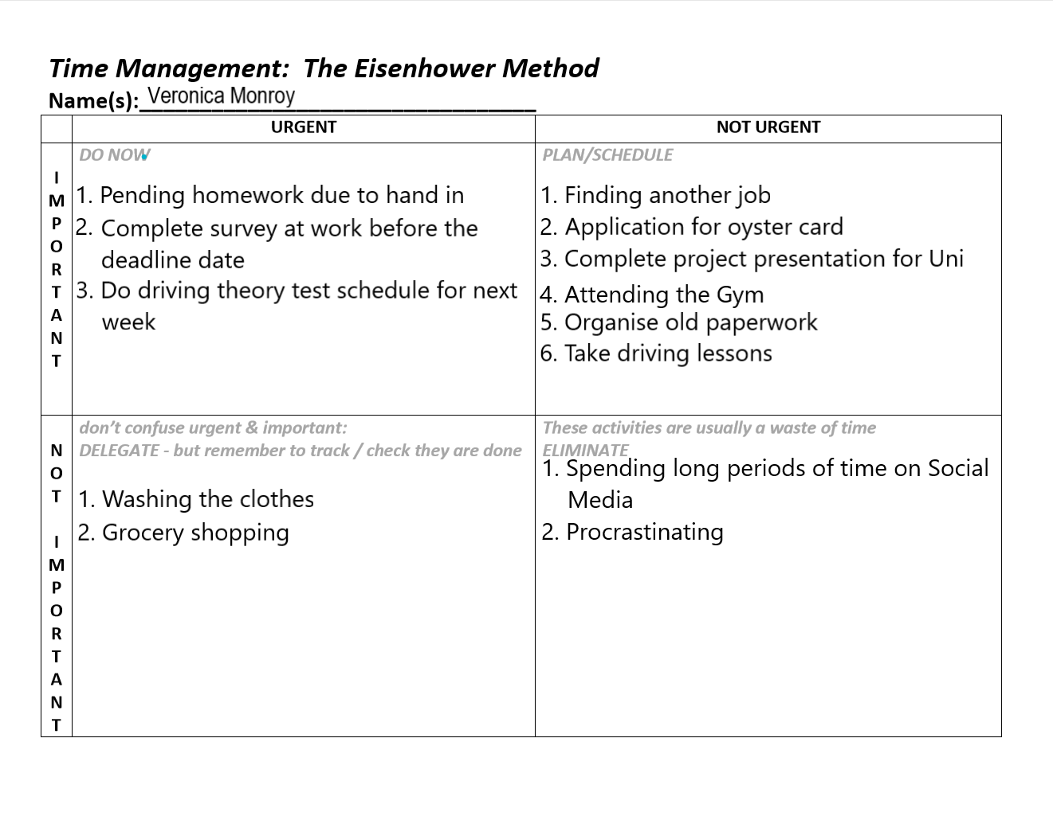

  - SWOT analysis (SEE 2.3; appendix 3)

  - To-do weekly list (SEE 2.5; appendix 5)

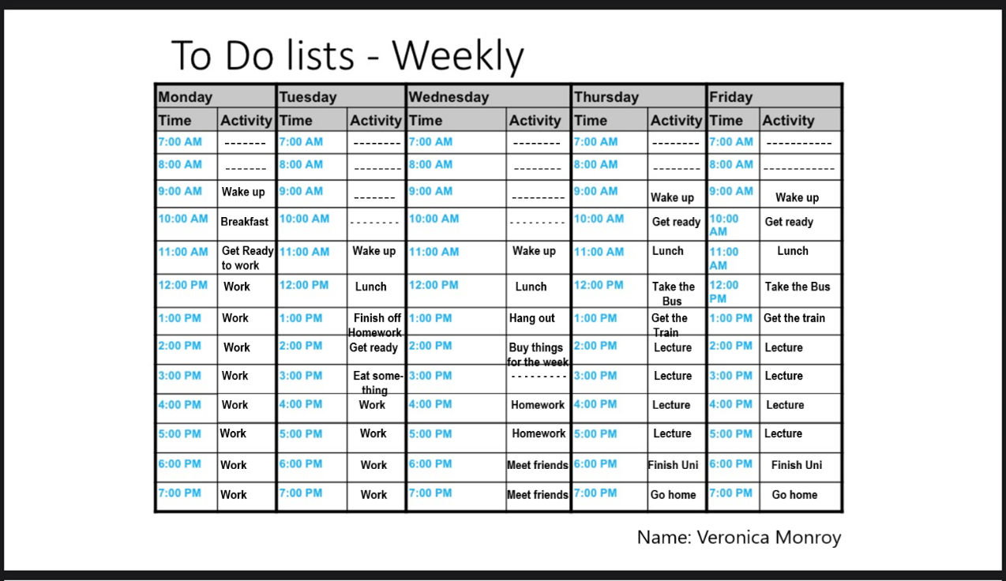
- DISCUSSION

After reviewing all the evidence provided, I am capable of understand time management and its value in both the academic as well as in the employability field. The aspects studied during this module, such as paraphrasing and summarising and the different employability skills learned are going to be useful in my future career as well as in my academic development.
Also, the evidence I have discovered widened my knowledge into the human resources management field. Including my first research which is about strategic human resources, a new discipline which has been implemented into the strategic management process. This journal article aims to provide a better guide for strategic human resources management (SHRM) and also giving a well-explained definition of its meaning and differentiate it from human resources management (HRM). In order to understand the difference between SHRM and HRM firstly we need to understand what does human resources management mean. Human resources consist on the different techniques used in an organisation to manage people. Organisations have became more and more attracted to the idea of strategic management. According to Schuler and Walker (1990) human resource strategy refers to short-term goals in the business needs. Schuler (in press) claims that SHRM refers to all the activities that have an influence on the individuals and the way they present the strategic needs of the company. After reading and analysing this article, I can tell that I have enhanced my knowledge on the practices of human resources from a strategic perspective. Moreover, this article includes a diagram on the different techniques used in human resources which helped me to have a better view and understanding of them, such as skills, abilities, etc.
Next, my second research which is about The impact of human resource management practices on perceptions of organizational performance (Delaney and Huselid, 1996). This journal tells that recently, most of the companies have been looking for new techniques in order to enhance their progress into the human resources performance aiming to increase their global competitiveness. Depending on they way an organisation manage their employees, it will have an influence on the organisation performance. In recent years, studying and analysing the impact on HRM has became more and more popular. This research includes evaluating the performance effects of certain HRM techniques, training, for instance. Even though most of the studies have had a positive impact between the HRM practices and perceptual and objective measures of the organisation performance, Levine and Tyson (1990); Wagner (1994) have expressed some concern because the results may not be accurate due to methodological difficulties. However, the theory is mostly classified as optimist due to the potential for progressive HRM practices to improve the performance of the company and its employees. The first hypothesis is about Progressive HRM Practices, including the ones that affect employee skills, employee motivation and the work structure. This hypothesis poses that progressive HRM practices have a positive effect on the business outcomes. Although, these mechanisms may differ from practice to practice. The second hypothesis proposes that complementarities or synergies within progressive HRM procedures will have a positive influence on the business performance. Finally, it has been widely asserted that people is the key to the success of a firm performance, as Peters and Waterman (1982); Pfeffer (1994) state. The evidence obtained in this investigation have suggested that these assertations are reliable. Overall, relying on the first hypothesis and the results obtained, we can tell that progressive HRM practices such as training, staffing and incentive compensation are positively connected to perceptual measures of firm performance. However, the results obtained from their research did not support the second hypothesis about the assertion that synergies between HRM practices increase the organisation performance, as they were not able to measure complementarity among organisation’s strategy and HRM practices. Nonetheless, they cannot prove whether their outcomes were a product of poor measures of this conduct or the lack of presence of its impact in the sample. Additionally, some studies have considered relevant issues related to whether organisations use HRM practices correctly or not. Consequently, the development of measures of HRM techniques is one of the main challenges to those who want to develop this line of research. Personally, after reading and analysing my second research, I am more aware of the importance of the human resources management within an organisation and how not having a good human resources management will have an impact on its performance. Furthermore, this article shows that if the practices are not accurately applied, the firm-level outcomes may not be as expected.
Finally, my third research is about Globalizing human resources management (Sparrow, P. Brewster, C. and Chung, C., 2016). Recently, the role of international human resources has been increasing, due to the new technologies implement. Thus, transforming geographic and organisational structures. As a consequence, organisations have noticed that without international interaction, with foreign businesses and customers, their future progress may be affected. Any business, whether is small or massive, are noticing how fast competitors and customers are increasing, because of the use of new technologies, online shopping, for instance.
Businesses will have to adapt and change in order to stay in the market and keep their prosperity. Looking ahead to the near future, the highly increasement of online businesses is having an influence on the flow of services provided by businesses. As a result, this causes an impact on the human resources management. In this context, managing employees through the internet is not one of the biggest of the concerns for the company. Alternatively, thinking in an international way is one of the biggest underlying shift for most of the businesses. They are constantly looking towards innovations and inventions in order to remain in the market. Hence, firms have started to change internationally their requirements for new employees. Overall, this article explains how the technology used nowadays and e-commerce have had an impact on the way businesses operates, and therefore, their human resources management has had to be reprofiled in order to remain actively in the market.

- CONCLUSION
Once analysed and interpret the journal articles previously reviewed along my own work completed I am able to conclude that the best way of know what I want to become in the future, requires previous research which allows me to corroborate if Human Resources is really what I want to do.
On the other hand, this module has given me the opportunity to recognise my own academic and employability skills in order to confirm that I am in the right path towards my professional future.

6.0 REFERENCES

Torreno, S. (no date) Bright Hub Education Available at: https://www.brighthubeducation.com/special-ed-learning-disorders/73324-improving-adaptives-skills-in-students-with-intellectual-disabilities/ (Accessed 11th December 2019)
Wright, P.M. and McMahan, G.C. (1992). Theoretical perspectives for strategic human resource management. Journal of management, 18(2), pp.295-320.
Delaney, J.T. and Huselid, M.A. (1996). The impact of human resource management practices on perceptions of organizational performance. Academy of Management journal, 39(4), pp.949-969.
Sparrow, P., Brewster, C. and Chung, C. (2016). Globalizing human resource management. Routledge.

7.0 APENDICES
7.1 Appendix 1 (in-class exercise 1: paraphrasing)
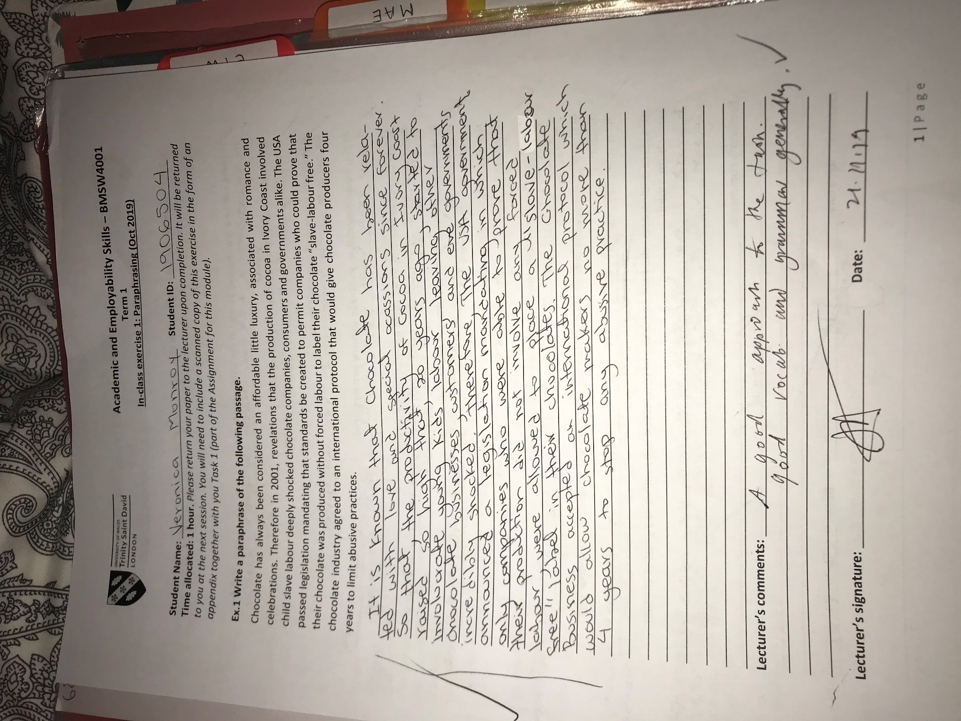
Appendix 1 (in-class exercise 1: paraphrasing) continued
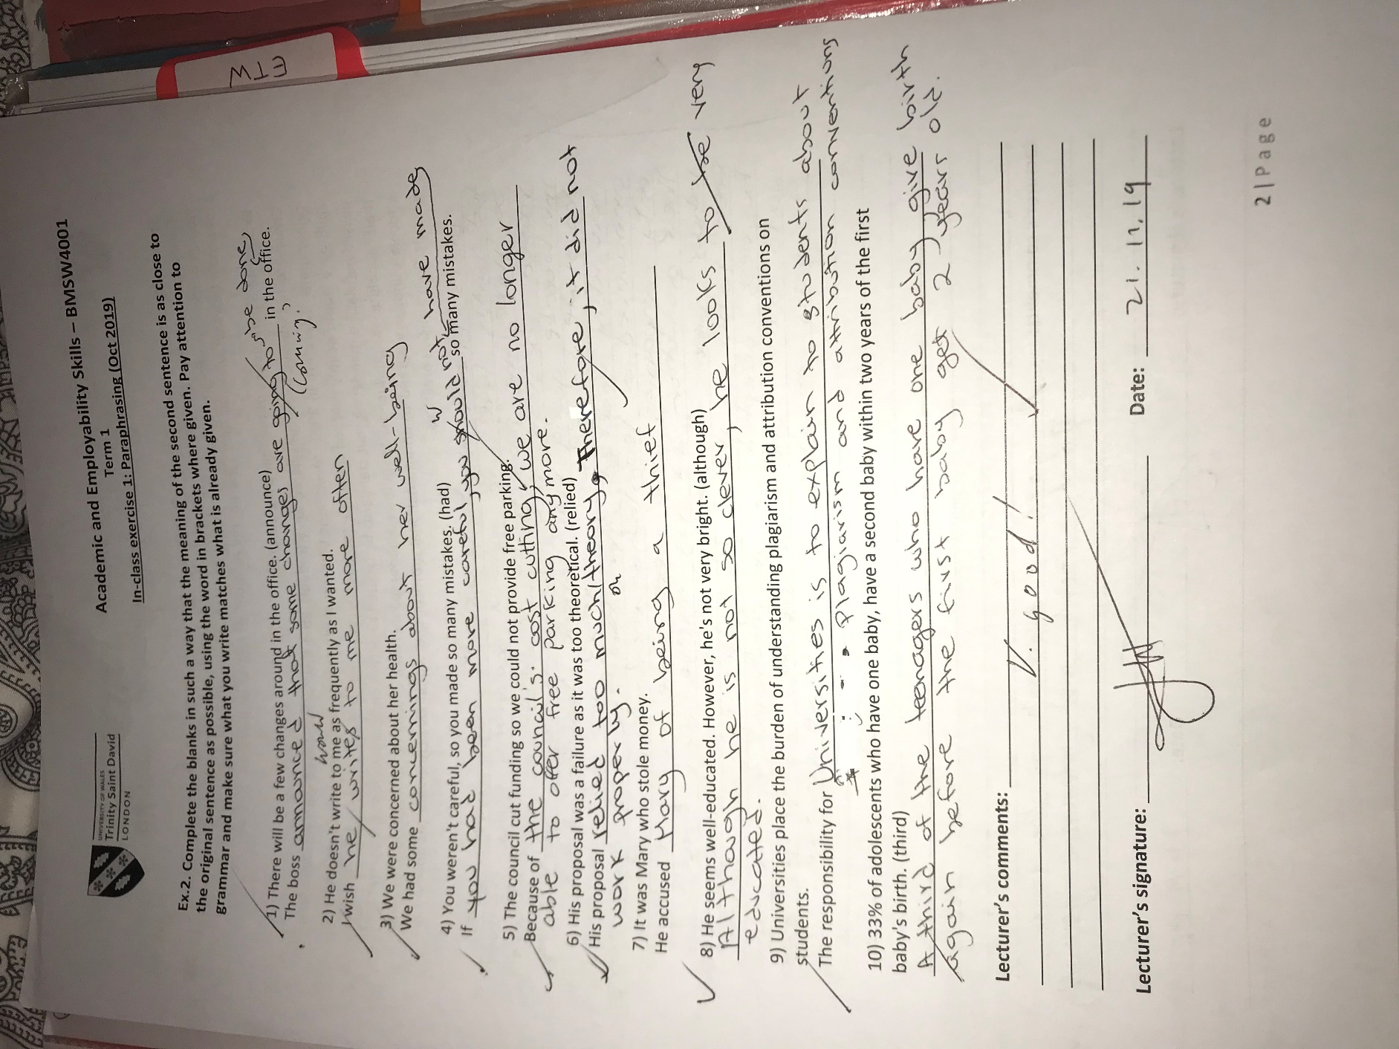

7.2 Appendix 2 (in-class exercise 2: summarising)
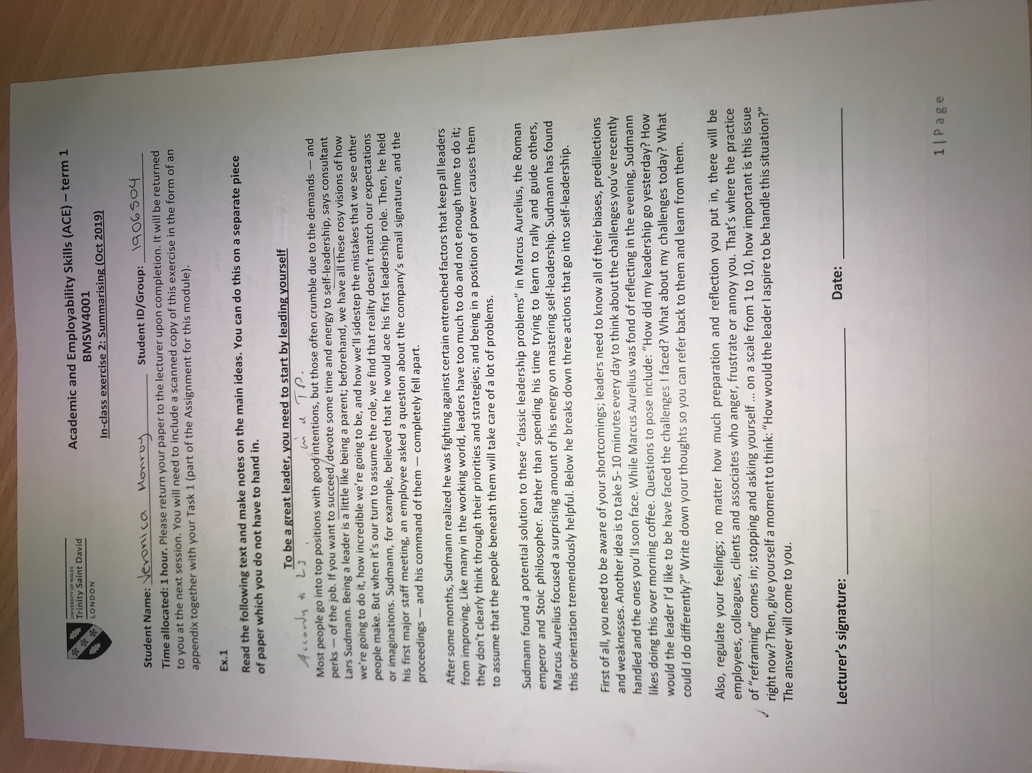

Appendix 2 (in-class exercise 2: summarising) continued
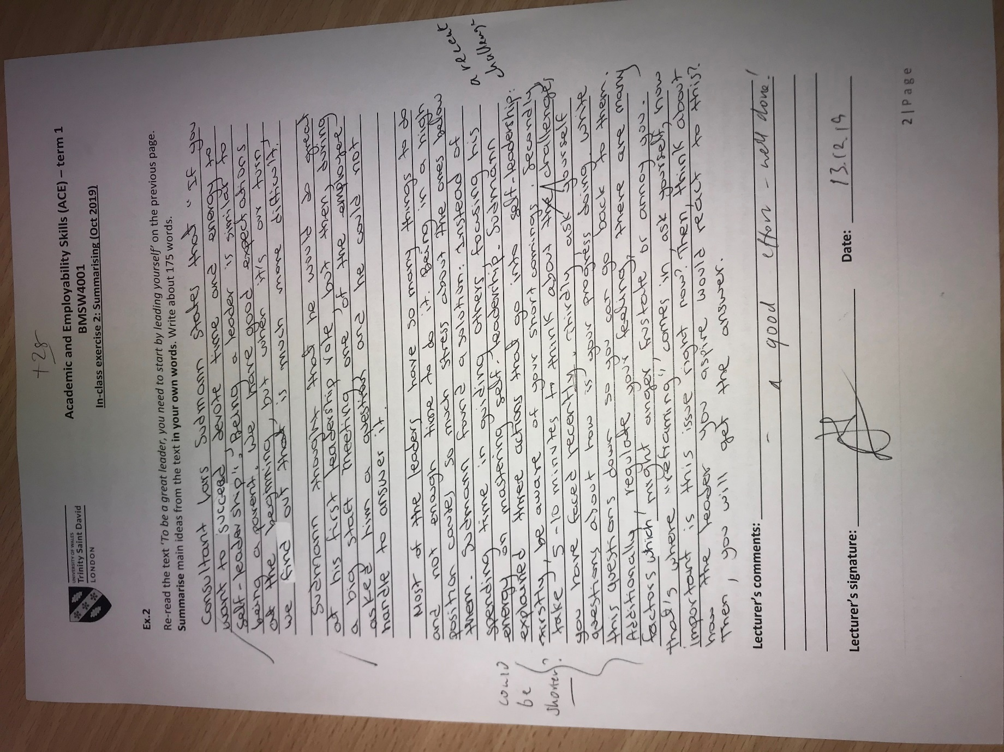

7.3 Appendix 3 (SWOT Analysis)
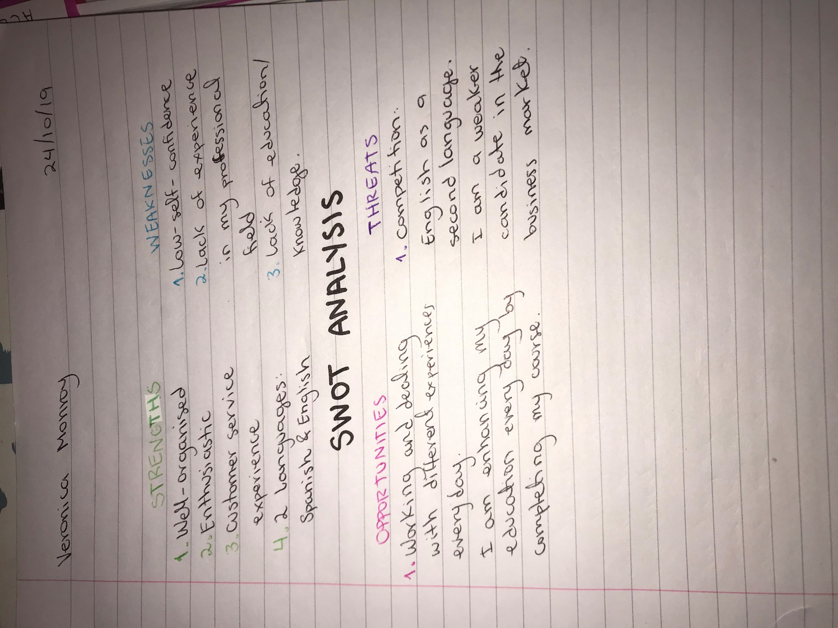

7.4 Appendix 4 (Eisenhower Method)
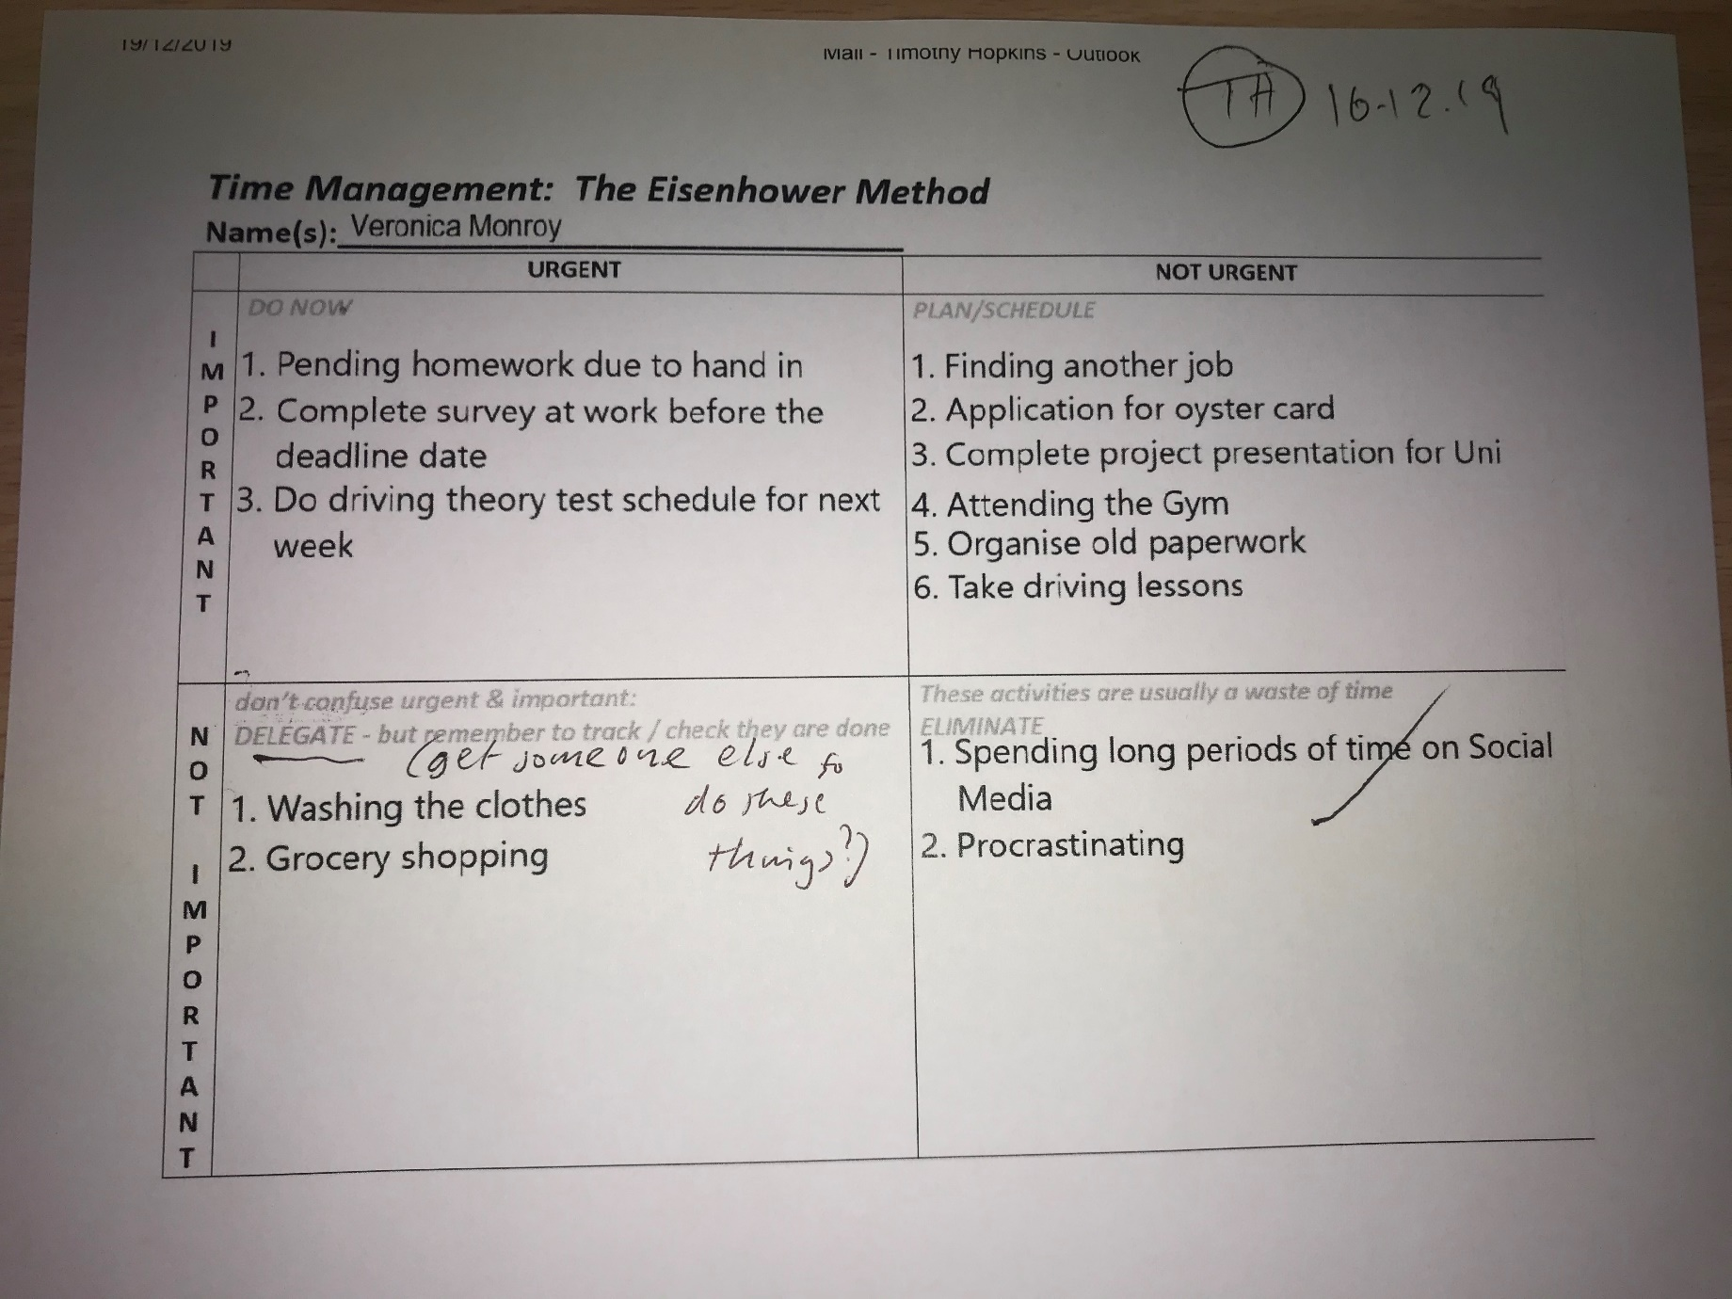

7.5 Appendix 5 (To-do weekly list)


