PROGRAMME:BSC HEALTH AND SOCIAL CARE LEVEL 5
MODULE TITLE:INTRODUCTION TO PHYSIOLOGY
MODULE CODE:BMHP5023
STUDENT NAME:VIHONA AGNES DE OLIVEIRA
STUDENT NUMBER:2422046
LECTURER’S NAME:SOBAN SADIQ
Table of Contents
Introduction 3
Structure of the Respiratory System and Mechanical Respiration 3
Gas Exchange in the Lungs 4
Impact of Irritants on the Respiratory System 5
Monitoring and Recording Respiratory Function 6
Evidence-Based Lifestyle Recommendations 8
Conclusion 8
Reference: 10

Introduction
Asthma is a permanent inflammatory illness of the airways which is marked by reversible airflow limitation, bronchial hyper-responsiveness, frequent incidences of wheezing, dyspnea, tightness of the chest and coughing. It starts often in childhood, but often continues to adolescence and adulthood. In adolescence, behavioural changes including smoked cigarettes, vaped trap, exposure to the pollutants of the environment, and decreasing medication compliance, may also play a role in the development of exacerbations and the aggravation of the symptoms. Risk factors that have been known to cause asthma or worsen it include genetic predisposition, contact to allergens including pollen or dust mites, air pollution, and respiratory infection.
Within a primary care context, more adolescents are presenting themselves with more severe symptoms of asthma, which tend to be associated with adjustable lifestyle behaviours. To manage them effectively, a good understanding of the mechanism of the respiratory system, the manner in which gas exchange is done and the influence of irritants on the structure of airways is necessary (Beachey, 2022). Later, the report will look at the anatomy and physiology of the breathing system, how mechanical respiration and gaseous exchange happen, the effects of irritants on the respiratory system like smoking and infections, as well as discuss the relevance of measuring respiratory functioning and evidence-based lifestyle change as a basis of improving asthma control.

Structure of the Respiratory System and Mechanical Respiration
The respiratory system falls into the upper and the lower respiratory tract. The upper respiratory tract comprises the nasal cavity, pharynx and larynx. Inhaled air is filtered, warmed, and moistened in the nasal cavity and then it is filtered, as mucus and ciliated epithelial cells do. The pharynx serves as a medium that air goes through the nasal cavity to the larynx. The vocal cords are found in the larynx which is commonly referred to as the voice box and which keeps the airway open. Approximately 160,000 people are diagnosed with work-based or occupational asthma each year, making up 9–15% of adult onset asthma in the UK, where 5.4 million people receive asthma medication (NHS, 2023).
The lower respiratory tract comprises trachea, bronchi, bronchioles and lungs. Hyaline cartilage forms C-shaped rings which support the trachea and ensure no airways collapse. It splits into right and left primary bronchi which lead to each lung, and then gives birth to smaller bronchi and bronchioles, creating the bronchial tree. Bronchioles do not have cartilage but rather smooth muscle and are therefore also vulnerable to asthma contracting. In the furthest end of the bronchioles, there is a bunch of alveoli, tiny air tubes enclosed in thickets of capillaries. The alveolar walls are simple squamous and thin making it easy to exchange gases.
Ventilation or mechanical respiration is the physical process of air inflow into and outflow of the lungs. Inspiration is induced in the flattening and contraction of the diaphragm, and in the contraction of the external intermuscles, which cause the rib cage to rise and increase in diameter. This elevates the volume of the thoracic cavity and reduces the pressure within the lungs and the air moves into the lungs with a pressure difference (Sobhan, 2024). Expiration is usually passive; the diaphragm and intercostal muscles relax, the thoracic volume is reduced, there is an increase in intrapulmonary pressure and the air is expelled out of the lungs.
Airway resistance in people with asthma is augmented due to inflammation and broncoconstriction, especially in the course of expiration. Reduced bronchioles and excessive secretion of mucus makes it harder to get the air out resulting in air trapping, wheezing and breathlessness. Therefore, anatomy of the lower airways is directly related to the physiological challenges encountered in response to asthma exacerbation.
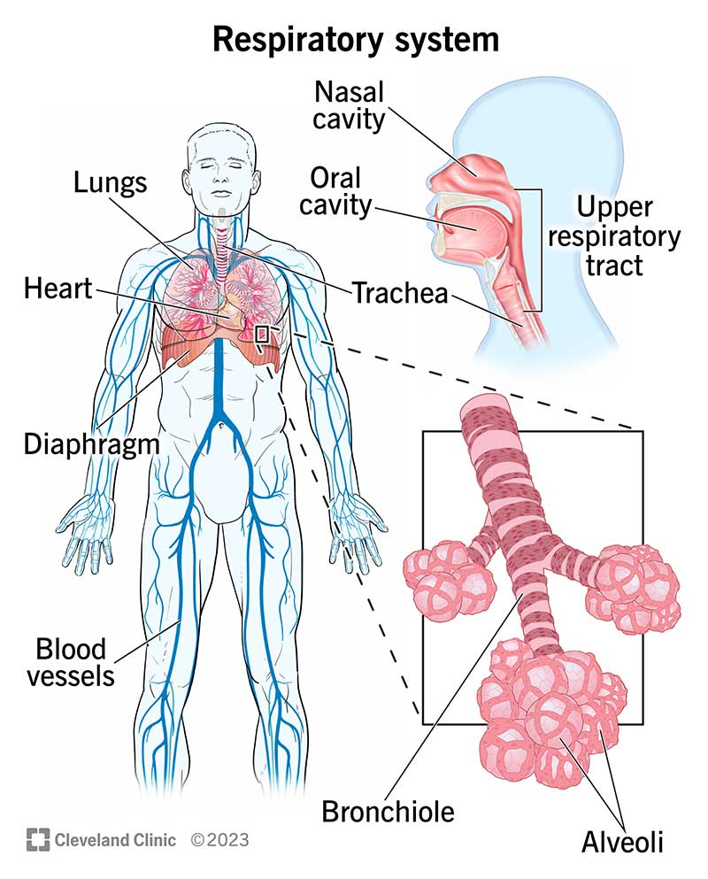
Figure 1: The Respiratory System
(Source: Cleveland Clinic, 2024)

Gas Exchange in the Lungs
Exchange of gases takes place in alveoli, and is critical in the process of cellular respiration. The alveoli give a high area of surface, thin membrane of diffusion, and rich blood supply which all facilitates easy exchange of oxygen and carbon dioxide. It takes place through diffusion, in which gases flow in regions of high concentration to regions of low concentration (Kong et al. 2022).
As inspiration, oxygen is received in the alveoli, where its concentration is greater than that of the surrounding pulmonary capillary deoxygenated blood. The diffusion of oxygen takes place across the alveolar capillary membrane into the blood and binds up haemoglobin in red blood cells to make oxyhaemoglobin. This is an oxygenated blood which is then pumped to body tissues where oxygen is emitted which is used to obtain metabolism and generate energy in the cells.
Meanwhile, the carbon dioxide, which is a by-product of cellular respiration, is carried through the blood to the lungs. In the capillary blood there is more carbon dioxide than in the alveoli hence carbon dioxide diffuses into the alveoli and elimination of carbon dioxide takes place in the lungs as the person exhales. Adults in good health often have blood oxygen levels between 95% and 100% (Curtis, 2024).
During asthma, airflow may be obstructed by inflammation of the airways and mucus secretion to the alveoli. It is possible that even though the alveolar structure is not destroyed, the blockage in the bronchioles is a limiting factor in the administration of oxygen to the gas exchange surfaces. In severe cases, it may result in a decreased oxygen saturation and favor development of such symptoms as fatigue, breathlessness and cyanosis. Thus, proper ventilation is necessary to prevent a lack of gas exchange and general physiological stability.
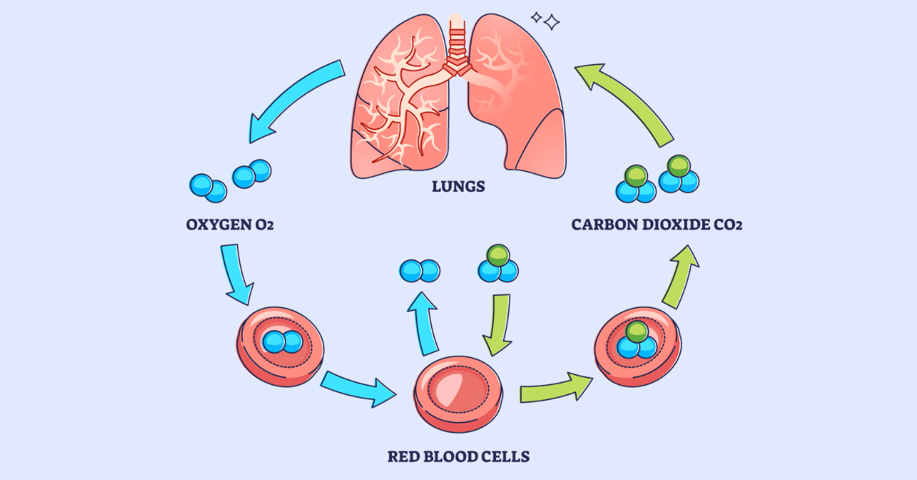
Figure 2: Gas Exchange
(Source: Landry and RRT 2023)

Impact of Irritants on the Respiratory System
Asthma is the chronic inflammation of the airway mucosa. This inflammatory response can be exacerbated with exposure to irritants, vaping aerosolic nicotine consumption as well as respiratory infections. The release of inflammatory mediators such as histamine and cytokines in response to the presence of irritants in the airways involve immune cells. This induces bronchoconstriction, vascular permeability and oedema of airways. The smooth muscle around the bronchioles constricts, making the airway lumen narrow.
Smoking harms the ciliated mucous membrane cells, which are used to remove the debris and mucus in the respiratory system. Ciliary dysfunction causes mucus, as well as predisposition to infection. Tobacco smoking as well encourages chronic airway inflammation and structural alterations, exacerbating the control of asthma. In the same way, vaping causes exposure of the airways to chemicals and fine particles, which would cause irritation and bronchial hyperresponsiveness (Yang et al. 2025).
The most general triggers that cause an asthma exacerbation among adolescents are respiratory infections, especially viral infections. Infection also provides a stimulus to augment further inflammation, which better secretes mucus and swells the airways. When young people are exposed to viruses and passive smoke in a crowded setting, such as a club or a social gathering, there is the possibility of aggravation of acute attacks. 9% of persons 16 years of age and older said they presently use e-cigarettes in 2022. 12% of respondents said they had tried e-cigarettes but were not currently using them, while 79% said they had never used them (NHS, 2024).
These irritants lead to the cumulative outcome of the narrowed airway diameter, resistance to airflow, which is more intense and, coupled with several disappointing ventilations. It shows that the association between environmental exposures and the physiological processes mediate asthma symptoms.

Monitoring and Recording Respiratory Function
Serious breathing is one of the primary modules of an efficient self-management of asthma, especially in teenagers who may not take notice of the symptoms or underestimate them. Objective testing enables patients and medical workers to become aware of a constrained airway prior to the onset of a severe exacerbation. The most common primary care and home-based tool is the peak flow metre, which is used to choose the peak expiratory flow (PEF). PEF is a measure of the maximum rate of forced exhalation of air and gives a clue of the level of airways constriction. Regardless of age, a typical blood oxygen level (SpO2) for the majority of healthy people is between 95% and 100% (Shaikh, 2020).
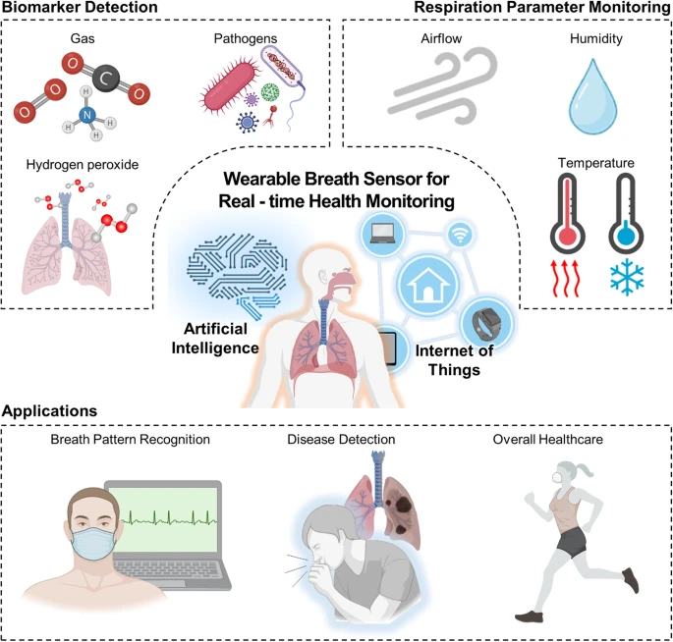
Figure 3: Overview of the wearable breath sensor for real time monitoring
(Source: Kim et al. 2024)
The indicated readings are contrasted with the personal value of the best. The questions are expected to be grouped into three zones on an asthma action plan. Good control of asthma is shown by the green zone. The amber zone is an indicator of warning and implies that the changes in medication, like the increase in the frequency of using the reliever inhalers or analysing the preventer medication plan, may be needed. The red zone represents the acute airway blockage and the necessity of medical assistance.
Frequent cheque-ups facilitates an early detection of deterioration, minimises hospital emergency cases and enables timely clinical assessment. To pinpoint patterns, e.g. when symptoms are worse during viral infections or smoke exposure, it is helpful to record the results in a diary or in a computer programme. Notably, surveillance fosters self-care and responsibility giving adolescents to be involved in the management of their state (Town et al. 2024). Compared to improper inhaler technique combined with compliance with prescribed treatment, regular respiratory evaluation by routine makes a significant difference in long- term asthma outcomes and general quality of life.

Evidence-Based Lifestyle Recommendations
Lifestyle change is an ingredient of good asthma management among teenagers. It has been proven that minimising exposure to modifiable risk factors can make the symptoms considerably better as it will bring down the number of exacerbations. One of the best suggestions is to stop smoking.Cigarette tobacco exacerbates airways inflammation, alters or decreases cilia and inhaled corticosteroid responsiveness. Smoking adolescents tend to get persistent symptoms and hospital admissions. Recommendations to organised smoking quit programmes, behavioural counselling and nicotine replacement therapy may enhance quit rates and long-term respiratory outcomes.
Avoiding vaping is also advised. Whereas e-cigarettes are viewed as safer, chemical irritants and fine particles that may cause bronchial hyperresponsiveness and inflammation are exposed to the airways. Nonetheless, there was no rise in 2021 compared to 2020; 1.2% of respondents reported using e-cigarettes more than once a week, and another 2.0% reported using them less than once a week, as opposed to 1.7% and 2.4% in 2020 (Action on Smoking and Health, 2021). The provision of education concerning possible respiratory damage is necessary to reduce the misconceptions and offer proper decision-making.
Prevention of infection is also high. Asthma attacks often result because of viral respiratory infections. The threat of exacerbation can be decreased by annual vaccination against influenza, good hand hygiene, and keeping a distance between themselves and unwell people. Teenagers who visit large social venues often should be told of risks of exposure.
Asthma is also helped with the help of environmental trigger management. Airway irritation can be reduced by exposure to allergens like dust mites during cleanliness, good air conditioning and allergen-resistant bedding accomplishing that. It is also important to avoid passive smoking.
Exercising should be habitual, and this increases the cardiovascular fitness and functioning of the lungs. Symptoms caused by exercise can be avoided by proper usage of short-acting bronchodilators prior to exercise (Hostrup et al. 2024). Moreover, proper inhaler form and use of prescribed preventer medication are imperative to delivery of the best drug.

Conclusion
Asthma is a persistent inflammatory disease of the airways that is highly prevalent among adolescents, especially at a life stage whereby there is a change in behaviour and surroundings. The structure and mechanism of the respiratory system is imperative in the appreciation of the occurrence of airflow limitation. Anatomical structures of the bronchial tree and bronchioles in particular can be attributed to the fact that inflammation, bronchoconstriction, and the production of mucus lead to the narrowing of airways and rising airway resistance. Mechanical ventilation and sufficient gas exchange play a crucial role in ensuring normal oxygen saturation and physiological stability at large.
Smoking cigarettes, vaping smokes, air pollutants, and viral infections further enhance the airway inflammation and the likelihood of an acute asthma attack. In the UK, there is data related to hospitalisation and prevalence of young people, which clarifies the significance of prevention and early intervention. Peak flow metres and pulse oximetry are examples of some monitoring tools that give objective data on respiratory functioning and assist in early identification of impairment.
Lastly, pharmacological treatment should be used with evidence based lifestyle changes, such as smoking cessation, infection prevention, trigger avoidance and regular physical exercise, to enhance asthma controls. Knowledge and self-management skills of adolescents foster a superior quality of life and improved long-term outcomes.

Reference:
Action on Smoking and Health (2021). Use of e-cigarettes among Young People in Great Britain Purpose. [online] Available at: https://ash.org.uk/uploads/Use-of-e-cigarettes-among-young-people-in-Great-Britain-2021.pdf [Accessed 2 Mar. 2026].
Beachey, W., (2022). Respiratory care anatomy and physiology E-book: Foundations for clinical practice. Elsevier Health Sciences.
Cleveland Clinic (2024) Respiratory System: Functions, Facts, Organs & Anatomy, Cleveland Clinic. Cleveland Clinic. Available at: https://my.clevelandclinic.org/health/body/21205-respiratory-system (Accessed: 5 March 2026).
Curtis, L. (2024). When Should You Be Concerned About Your Blood Oxygen Level? [online] Health. Available at: https://www.health.com/blood-oxygen-level-8425396 [Accessed 2 Mar. 2026].
Hostrup, M., Hansen, E.S., Rasmussen, S.M., Jessen, S. and Backer, V., (2024). Asthma and exercise‐induced bronchoconstriction in athletes: diagnosis, treatment, and anti‐doping challenges. Scandinavian journal of medicine & science in sports, 34(1), p.e14358.
Kim, D., Lee, J., Park, M.K. and Ko, S.H., (2024). Recent developments in wearable breath sensors for healthcare monitoring. Communications Materials, 5(1), p.41.
Kong, Y., Liu, M., Hu, H., Hou, Y., Vesztergom, S., Gálvez‐Vázquez, M.D.J., Zelocualtecatl Montiel, I., Kolivoška, V. and Broekmann, P., (2022). Cracks as efficient tools to mitigate flooding in gas diffusion electrodes used for the electrochemical reduction of carbon dioxide. Small Methods, 6(9), p.2200369.
Landry, J., BS and RRT (2023). Gas Exchange: Overview and Practice Questions (2023). [online] Respiratory Therapy Zone. Available at: https://www.respiratorytherapyzone.com/gas-exchange/ [Accessed 2 Mar. 2026].
NHS (2023). RightCare Asthma Scenario. [online] Available at: https://www.england.nhs.uk/wp-content/uploads/2023/02/Rightcare-Asthma-Scenario-feb-2023.pdf [Accessed 2 Mar. 2026].
NHS (2024). Adults’ health-related behaviours. [online] NHS England Digital. Available at: https://digital.nhs.uk/data-and-information/publications/statistical/health-survey-for-england/2022-part-1/adults-health-related-behaviours [Accessed 2 Mar. 2026].
Shaikh, J. (2020). What Are Blood Oxygen Levels? Chart, Normal, Low & High. [online] MedicineNet. Available at: https://www.medicinenet.com/what_are_blood_oxygen_levels/article.htm [Accessed 2 Mar. 2026].
Sobhan, N., (2024). Narrative Review Article: An Overview of The Anatomy and Physiology of Respiration. Narrative, 3(2).
Town, R., Hayes, D., March, A., Fonagy, P. and Stapley, E., (2024). Self-management, self-care, and self-help in adolescents with emotional problems: a scoping review. European child & adolescent psychiatry, 33(9), pp.2929-2956.
Yang, X., Che, W., Zhang, L., Zhang, H. and Chen, X., (2025). Chronic airway inflammatory diseases and e-cigarette use: a review of health risks and mechanisms. European journal of medical research, 30(1), p.223.

