
Programme: BA (Hons) Leadership and Management Skills in the Workplace
Module: Project Management
Module code: LCLM5003
Assignment Title: A project portfolio
Student Name:Loredana Josan
Student Id:2332191
Table of Contents
Part A- Project proposal poster 3
Part B- Reflections from the feedback from tutor and peer 6
Part C- Project Management Plan 8
1. Introduction 8
2. Project description 8
3. Scope 9
4. Work breakdown structure 10
5. Quad Chart 12
6. Gantt Chart 13
7. Stakeholders’ involvement 13
8. Allocation of resources 14
9. Risk Analysis 15
10. Conclusion 17
11. References 18

Part A- Project proposal poster
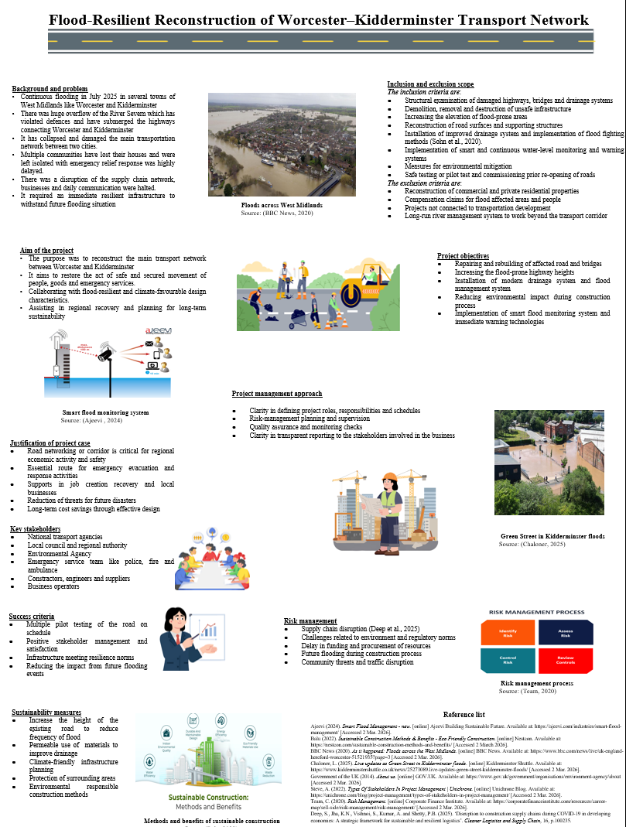
Project Title: Flood-Resilient Reconstruction of Worcester–Kidderminster Transport Network
Background and problem
- Continuous flooding in July 2025 in several towns of West Midlands like Worcester and Kidderminster
- There was huge overflow of the River Severn which has violated defences and have submerged the highways connecting Worcester and Kidderminster
- It has collapsed and damaged the main transportation network between two cities.
- Multiple communities have lost their houses and were left isolated with emergency relief response was highly delayed.
- There was a disruption of the supply chain network, businesses and daily communication were halted.
- It required an immediate resilient infrastructure to withstand future flooding situation
Aim of the project
- The purpose was to reconstruct the main transport network between Worcester and Kidderminster
- It aims to restore the act of safe and secured movement of people, goods and emergency services.
- Collaborating with flood-resilient and climate-favourable design characteristics.
- Assisting in regional recovery and planning for long-term sustainability
Project objectives
- Repairing and rebuilding of affected road and bridges
- Increasing the flood-prone highway heights
- Installation of modern drainage system and flood management system
- Reducing environmental impact during construction process
- Implementation of smart flood monitoring system and immediate warning technologies
Inclusion and exclusion scope
The inclusion criteria are-
- Structural examination of damaged highways, bridges and drainage systems
- Demolition, removal and destruction of unsafe infrastructure
- Increasing the elevation of flood-prone areas
- Reconstruction of road surfaces and supporting structures
- Installation of improved drainage system and implementation of flood fighting methods (Sohn et al., 2020).
- Implementation of smart and continuous water-level monitoring and warning systems
- Measures for environmental mitigation
- Safe testing or pilot test and commissioning prior re-opening of roads
The exclusion criteria are-
- Reconstruction of commercial and private residential properties
- Compensation claims for flood affected areas and people
- Projects not connected to transportation development
- Long-run river management system to work beyond the transport corridor
Justification of project case
- Road networking or corridor is critical for regional economic activity and safety
- Essential route for emergency evacuation and response activities
- Supports in job creation recovery and local businesses
- Reduction of threats for future disasters
- Long-term cost savings through effective design
Key stakeholders
- National transport agencies
- Local council and regional authority
- Environmental Agency
- Emergency service team like police, fire and ambulance
- Constractors, engineers and suppliers
- Business operators
Project management approach
- Following structural methods like PRINCE2 and PMBOK principles
- Clarity in defining project roles, responsibilities and schedules
- Risk-management planning and supervision
- Quality assurance and monitoring checks
- Clarity in transparent reporting to the stakeholders involved in the business
Risk management
- Supply chain disruption (Deep et al., 2025)
- Challenges related to environment and regulatory norms
- Delay in funding and procurement of resources
- Future flooding during construction process
- Community threats and traffic disruption
Sustainability measures
- Increase the height of the existing road to reduce frequency of flood
- Permeable use of materials to improve drainage
- Climate-friendly infrastructure planning
- Protection of surrounding areas
- Environmental responsible construction methods
Success criteria
- Multiple pilot testing of the road on schedule
- Positive stakeholder management and satisfaction
- Infrastructure meeting resilience norms
- Reducing the impact from future flooding events

Part B- Reflections from the feedback from tutor and peer
Reflective writing is a critical aspect of academic practice and knowledge which allows one to critically examine his experience and learning procedures (University of Cambridge, 2025). In order to critically evaluate the feedback received on my project proposal poster, I have applied Gibbs Reflective Cycle. According to this model, it offers a formal structural framework which consists of six stages- description, feelings, evaluation, analysis, conclusion and action plan (Galli and New, 2022). By applying this approach, it has allowed me to systematically examine my performance and identify the clear improvement for undertaking the final Project Management Plan.
Description
After my poster presentation on the proposed reconstruction of the flood-resilient transport corridor between Worcester and Kidderminster, I have received a number of valuable feedback both from my tutor and peers. The comments made by them have focused on strengths in the project management proposal as well as identify the areas which require improvement prior to the submission of the final Project Management Plan.
Feelings
At the initial level, I felt confident about my project selection as it has directly addressed a real and immediate infrastructure issue. The selected project idea based on the July 2025 flooding situation which has affected the towns of Worcester and Kidderminster in the UK. My professor has noted that the project has addressed the immediate need to restore the transport network after the overflow of the River Severn by depicting a strong understanding of disaster management and recovery.
Evaluation
My peers have commented positively that my understanding for selection of the transport corridor reconstruction was rationale and community mobility at the same time. Such feedback has reassured me that the choice of my project was correct and it has aligned with real world infrastructure management challenges. On the basis of the limitation, I have received feedback to improve on the sustainability dimensions of the project. Despite, I have stated about the sustainable construction practices, I have missed on how the project shall help in contributing to the long-run climate resilience and I have failed to align with sustainable principles of construction and infrastructure. The aspects of sustainable elements of construction are using sustainable design, sustainable materials, reduction and management of waste and focusing on energy efficiency (FSC, 2022).
Analysis
On the basis of reflecting the feedback received from my tutor and peers, I have recognised that the project proposal has successfully communicated the importance and feasibility of the project which requires wider details about the analytical aspect of the project to meet the academic and professional expectations. Both my tutor and peers have suggested that they have assisted me to identify the gaps and refine my project management approach. In the final Project Management Plan, I will undertake project management theoretical frameworks, detailed risk management and stakeholder analysis with higher sustainability considerations.
Conclusion
Overall, the entire feedback process was highly beneficial. It has confirmed that my project selection, objectives and overall structure of the project was appropriate. However, it has also focused on the importance of analytical depth and theoretical combination.
Action Plan
However, on the basis of feedback, there are multiple areas of improvement. One of the prominent suggestions was to offer a highly detailed justification by applying different project management theories and methods which have been discussed in the current module. While the project proposal has critically outlined the steps, it has lacked explicit references to different project management frameworks like PRINCE2 or PMBOK. PRINCE2 is a uniform project management approach which is used by government and global businesses to undertake project management (Gurnov, 2022). In order to address the same, I will combine a robust project management approach into the final project plan which has clearly explained each phase by aligning with established best practices.

Part C- Project Management Plan

1. Introduction
In the month of July 2025, an abrupt rainfall caused severe flooding across different areas in the West Midlands of England. It included Worcester, Shrewsbury, Bewdley and Kidderminster. The heavy overflow of the River Severn has caused massive destruction and damage to transport networks, public infrastructure, businesses and households (McAndrew, 2025). The major national highways were submerged and destroyed which has isolated different communities and disrupted the movement of emergency services, goods and people. The current project plan involves reconstruction of the main roadway or transportation network between Worcester and Kidderminster. The aim of the project is to repair the damaged infrastructure- bridges and roadways as well as undertake modern engineering and disaster management solutions to withstand extreme weather in the future.

2. Project description
The planned construction project is based on climate specific upgradation and redevelopment of major transportation network which mergers two major cities- Worcester and Kidderminster. The roadway has suffered from structural destruction due to high rainfall which occurred in July 2025. The roadway well connects and is helpful for economic growth, goods transportation, passengers, trade and commerce and emergency services. The aim of the project is to ease out the congestion and offer improvements on the importance of national, regional and local routes. Moreover, the roadway shall unlock multiple opportunities in terms of economic and job creation prospects. It will enable the delivery of areas for new housing development (Government of Worcestershire, 2024). The failure of the route during the natural disaster has restricted the evacuation plan, delayed emergency response and disrupted the supply network across the West Midlands.
The project involves a robust redevelopment programme which aims to repair the wrecked roads, reconstruct the damaged bridges and culverts, stabilising embankments and newly installed advanced drainage systems. The vulnerable areas of the highway will be elevated above the previous flood levels and water proof materials will be used for expanding durability. Smart and continuous monitoring systems like water-level sensors and early warning technologies will be used to combine improved preparedness for forthcoming floods. The project will be delivered by applying a formal project management framework by undertaking different phases like initiation, planning, design, procurement, construction, testing and closure (Atlassian, 2025). A team of skilled civil engineers, project planners, environmental specialists and contractors will come together under the monitoring of the project manager. A regular progress review and quality inspections will ensure supervision and adherence to standards and timelines.
Apart from the physical restructuring, the project has incorporated sustainable road design principles. Permeable surfaces, improvement of stormwater management, rainwater harvesting and environmental awareness construction methods will help in reducing ecological impact while improving resilience (Sabut et al., 2026). The coordination with environmental authorities as per the Conservation of Habitats and Species Regulations 2017 later amended as Habitats Regulations in the UK will help to decide whether to give license, permit and consent to the project to safeguard the surrounding habitat (Government of the UK, 2021). The project funding will be sourced from the central government disaster to recover initiatives, local authority budgets and potential infrastructure grants. An effective financial management will be crucial to manage costs and ensure accuracy and transparency. Risk management strategies will address contingencies like adverse weather conditions, supply chain network and disruptions and community threats.

3. Scope
The scope of the project involves the reconstruction and improvement of the flood-affected transport system between Worcester and Kidderminster. It involves all the required activities to restore, modify and maintain a safe and reliable transportation system while combining resilience measures against future natural calamity.
The in-scope activities are-
- Structural examination of damaged highways, bridges and drainage systems
- Demolition, removal and destruction of unsafe infrastructure
- Increasing the elevation of flood-prone areas
- Reconstruction of road surfaces and supporting structures
- Installation of improved drainage system and implementation of flood fighting methods
- Implementation of smart and continuous water-level monitoring and warning systems
- Measures for environmental mitigation
- Safe testing or pilot test and commissioning prior re-opening of roads
Out-of-scope activities involve-
- Reconstruction of commercial and private residential properties
- Compensation claims for flood affected areas and people
- Projects not connected to transportation development
- Long-run river management system to work beyond the transport corridor
A clear project scope will ensure effective project implementation, allocation of resources in an optimal manner for the purpose of determining goals, limitations, workflow management strategies, deliverables and prevention of any kind of delays in the project by creeping scope (Adobe, 2025). Any kind of proposed changes will be examined through a formal change controlling process for examining their impact on cost, time, quality and timeline. The project scope is effectively designed to deliver a complete operational, resilient transportation network which should meet safety standards and assists in the regional recovery of the objective while securing achievable objectives within given time and budget.

4. Work breakdown structure
Task Name | Duration | Start | Finish | Predecessors
Project approval | 4 days | Mon 12/1/25 | Thu 12/4/25
Resource purchase | 23 days | Fri 12/5/25 | Tue 1/6/26 | 1
Financial planning | 27 days | Wed 1/7/26 | Thu 2/12/26 | 2
Resource allocation | 22 days | Fri 2/13/26 | Mon 3/16/26 | 3
Risk management planning | 26 days | Tue 3/17/26 | Tue 4/21/26 | 4
Creating the blueprint of the reconstruction of the Principal flood | 19 days | Wed 4/22/26 | Mon 5/18/26 | 5
Purchasing equipment for construction activities for the project. | 17 days | Tue 5/19/26 | Wed 6/10/26 | 6
Execution of the construction | 154 days | Thu 6/11/26 | Tue 1/12/27 | 7
Testing the resilient transport corridor of the flood | 60 days | Wed 1/13/27 | Tue 4/6/27 | 8
Evaluating project resource management and process | 30 days | Wed 4/7/27 | Tue 5/18/27 | 9
Gathering information on the resources used in the project | 18 days | Wed 5/19/27 | Fri 6/11/27 | 10
Project review | 5 days | Mon 6/14/27 | Fri 6/18/27 | 11
Documentation | 3 days | Mon 6/21/27 | Wed 6/23/27 | 12
Project submission | 1 day | Thu 6/24/27 | Thu 6/24/27 | 13
Table 1: Activity list of the project
As per the views of Vázquez-López et al. (2024), the work breakdown structure considers all tasks and the overall cost of building throughout the project lifecycle. The WBS table in the above section indicates a very sequential and organised process of Flood-Resilient Reconstruction of the Worcester-Kidderminster Transport Network. The project approach starts with project approval and follows step-wise, which includes planning, procurement, execution, testing, evaluation and closure. The stringent predecessor relationships characterise a linear dependency model in that every step should be accomplished prior to the next one being initiated. It is indicative of a conventional waterfall-based project management method, which is suitable in an infrastructure project where design and engineering choices have to be determined before the actual construction can commence (Thesing et al., 2021).
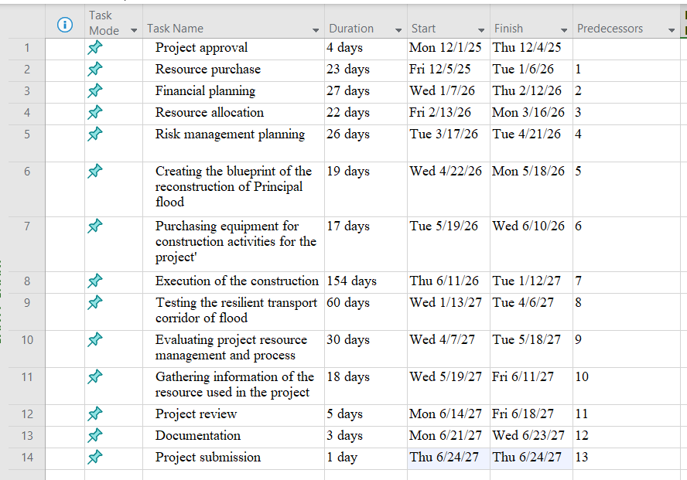
Figure 1: Work breakdown structure
The longest activity in terms of time is the "Execution of the construction", which takes 154 days. This ascertains that construction is the operational stage that is of the essence and the most resource-consuming aspect of the project. Financial planning, risk management planning, blueprint creation, and other activities associated with planning take up a large timeframe, which means that a lot of focus is made on preparation and risk management prior to the implementation. The general time of December 2025 to June 2027 indicates a long-term construction intervention as opposed to a short-term remedy. This is in line with the resilience goal identified in the project plan.

5. Quad Chart
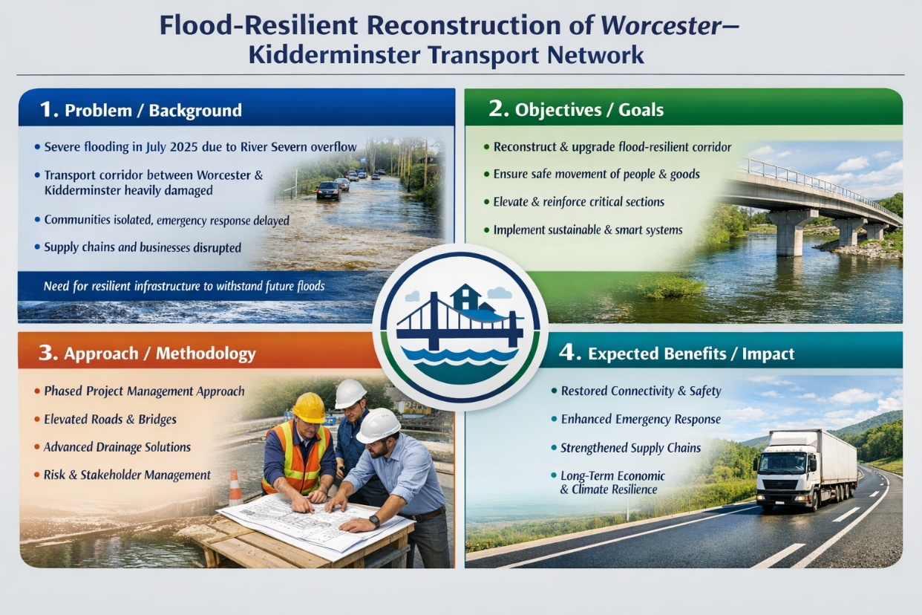
Figure 2: Quad Chart of the project
As opined by Ford and Wei (2015), the quad chart is extremely relevant in the management discipline, and it is becoming widely popular over the years. The Quad Chart provides a concise summary of the objectives, project deliverables, schedule, and the expected outcome of the project. It is there to indicate that the project is no longer being described only as a technical intervention but as a strategic recovery project. The Quad Chart usually captures mission requirements, technical procedures, schedule, and benefits and here flood resilience, infrastructure recovery, and restoration of regional connectivity are highlighted. This kind of strategic representation improves the communication among stakeholders. The Quad Chart is a complex administrative and reporting device, as the project involves a large number of stakeholders, including transportation, environmental, and emergency services. It implies that there is a harmonious match between the activities of the operations and the overall societal good.

6. Gantt Chart
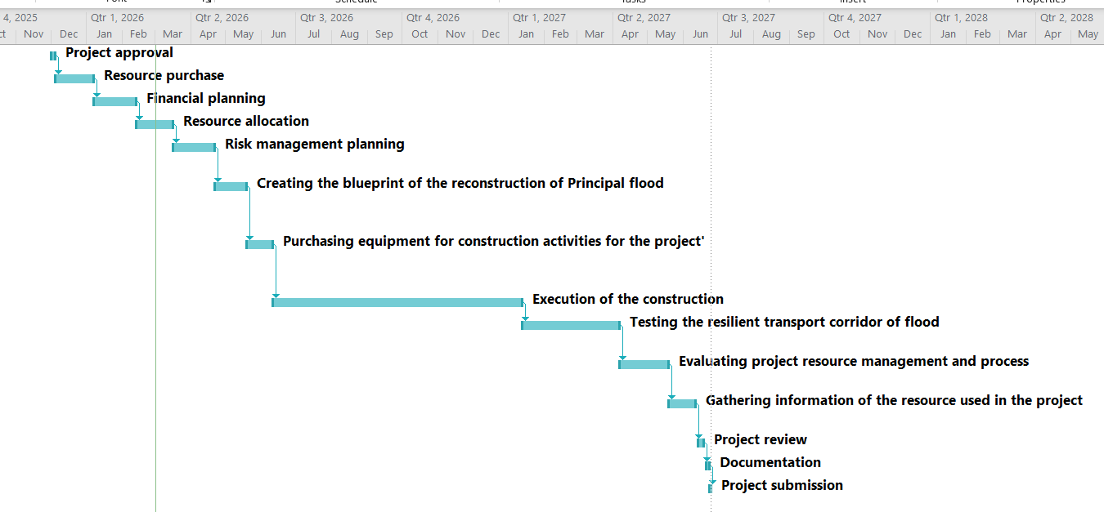
Figure 3: Gantt chart
According to Vasankari (2024), a Gantt Chart gives a visual representation of the whole life cycle schedule of the project on a time basis. It underlines the consecutive role of tasks and displays the fact that there is also a bit of overlap between the significant stages. This implies that there is minimal flexibility in the schedule and high control of process order. Although this method minimises confusion and the chance of coordination, it can make one more prone to delays since any failure during a stage has a direct effect on the next activities. The construction window between June 2026 and January 2027 is quite long, and, therefore, seasonal risks, especially weather-related disruption, are also at risk, and, in this case, it is of great concern due to the flood-prone situation as described in the project description. Thus, time contingency as well as monitoring mechanisms are important to schedule compliance.

7. Stakeholders’ involvement
The key stakeholders involve government authorities, local councils, emergency services, legal and regulatory agencies, businesses, contractors and residents of the affected areas which are Worcester and Kidderminster. An effective stakeholder involvement plays a critical role in the project plan which reflects priority, effective communication and trust among the stakeholders (Dwivedi, 2021). The local councils will play a critical role in securing planning approval, allocation of funding and coordination with the community businesses. The Environmental Agency will recommend flood risk management, adherence to environmental compliance and sustainable design standards. National transport authorities will offer strategic monitoring and ensuring parity with infrastructure policies.
According to Damaševičius et al. (2023), the emergency service institutions like fire department, police and medical representatives will contribute in having operational insights to ensure that the corridor supports quick response potential during the future crisis period. The local business entities and residents of Worcester and Kidderminster act as critical community stakeholders. They are required to measure accessibility, economic recovery and safety compliance to be effectively addressed while consulting, arranging project meetings and feedback. The maintenance of transparent communication will assist in building trust, bridge the difference between different stakeholders and reduce disruption during project phases (Bello, 2025). Contractors, engineers and suppliers will be directly engaged in the project in the form of structural project procurement procedures. A clarity in the contractual agreements will help in critically defining the role, responsibilities, time period and performance expectations. Environmental groups will also participate to ensure environmental consideration.

8. Allocation of resources
Resource Name | Type | Initials | Max. Units | Std. Rate | Ovt. Rate | Cost/Use | Accrue At | Base Calendar
Project manager | Work | P | 100% | $0.00/hr | $0.00/hr | $1,500.00 | Prorated | Standard
Staff members | Work | S | 100% | $0.00/hr | $0.00/hr | $6,500.00 | Prorated | Standard
Construction manager | Work | C | 100% | $0.00/hr | $0.00/hr | $4,500.00 | Prorated | Standard
Construction team | Work | C | 100% | $0.00/hr | $0.00/hr | $8,500.00 | Prorated | Standard
Financial manager | Work | F | 100% | $0.00/hr | $0.00/hr | $6,500.00 | Prorated | Standard
Risk analyst | Work | R | 100% | $0.00/hr | $0.00/hr | $3,100.00 | Prorated | Standard
Construction materials | Material | C |  | $0.00 |  | $65,000.00 | Prorated
Equipment | Material | E |  | $0.00 |  | $58,000.00 | Prorated
Construction technologies | Material | C |  | $0.00 |  | $78,000.00 | Prorated
Table 2: Allocation of resources table
As opined by Allu et al. (2024), appropriate resource allocation is essential for improving productivity and ensuring projects to be completed efficiently. Resources are divided into human (work) and material. Some of the key managerial positions are Project Manager, Financial Manager, Construction Manager, Risk Analyst, and Staff Members. This is an indication of a multidisciplinary governance framework that is in line with professional project management requirements. The material costs are very high: construction materials (65,000), equipment (58,000) and construction technologies (78,000). The large investment towards technology implies a focus on resilience needs, including smart monitoring devices and cutting-edge drainage technology, as stated in the project plan. This helps the long-term climate resilience strategic goal as opposed to short-term repair.
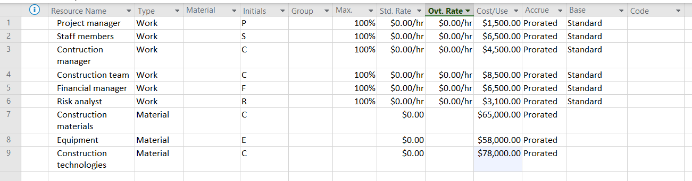
Figure 4: Resource sheet
The prorated method of accrual implies that costs are allocated according to the specific task periods that enhance tracking of finances and budgeting transparency. The hourly rate fields are, however, listed as being at 0.00/hr, meaning that the budgeting model can be simplified or use a fixed-cost allocation and not be based on time-based labour costing. This might decrease the accuracy of the costs and possibly needs to be refined in the ultimate financial control plan.

9. Risk Analysis
As per the views of Pomaza-Ponomarenko et al. (2023), a lack of risk management in a project can lead to losses, project failure and instability, which are not suitable for completing the project in a successful manner. With respect to the current project, risk analysis has been considered as one of the most effective and relevant strategies that can help to mitigate the potential risk of project failure and complete the project activities efficiently. The following project risk register is taken into consideration.
Risks | Potential likelihood | Impact | Severity | Mitigation process
Financial risk | High | High | Catastrophic | The management needs to focus on seeking additional sources of investment, which can help to complete the project activities.
Technological risk (Equipment failure and malfunction) | Moderate | Moderate | High | A proper engineering team needs to be kept on the construction site to fix any machines.
Accidental risk | Low | Low | High | Accidental risk can be seen due to fire hazards and other risks. This can lead to injuries and so on.
Table 3: Risk register
With the assistance of the current risk register, it has been clearly identified that risk has expanded at a constant rate, which can help to enhance the overall performance in the future. In the above section, the mitigation process has been clearly mentioned, which can directly help the project manager to enhance the managerial performance in the future. As a result of that, the uncertain risk can be avoided, and the project's success can grow.

10. Conclusion
The identified project has placed critical attention on the climate-resilient enhancement and reconstruction of the primary national transport route that links Worcester and Kidderminster. It has been severely damaged in several ways through the floods that occurred in July 2025. It is an important passageway to commuters, freight movement, emergency services and domestic trade. The objective of the project is to relieve the congestion and provide enhancements on the significance of the national, regional and local routes. Furthermore, the road will open various opportunities both in the aspect of economic and employment opportunities. It will facilitate the provision of space to build new housing. A Gantt chart emphasises the one after another role of tasks and indicates that there is also some overlap between the significant stages. This means that there is low flexibility of schedule and high control of process order.

11. References
Adobe (2025). Project scope — definition, examples, and templates. [online] Adobe.com. Available at: https://business.adobe.com/blog/basics/project-scope-definition-best-practices-examples-and-more [Accessed 2 March 2026].
Allu, S.R., Bhaumik, A., Ramakrishna, A., Lakavat, M., Allu, H. and Chandini, S. (2024). ‘A Critical Review of Resource Allocation Optimization in Project Management’. International Research Journal on Advanced Engineering Hub (IRJAEH), 2(06), pp.1855-1861.
Atlassian (2025). Project Management Phases: 5-Phase Overview | The Workstream. [online] Atlassian.com. Available at: https://www.atlassian.com/work-management/project-management/phases [Accessed 1 March 2026].
Bello, I. (2025). The Importance of Communication in Project Management. [online] Institute of Project Management (IPM) Ireland. Available at: https://projectmanagement.ie/blog/the-importance-of-communication-in-project-management/ [Accessed 27 February 2026].
Damaševičius, R., Bacanin, N. and Misra, S. (2023). ‘From sensors to safety: Internet of Emergency Services (IoES) for emergency response and disaster management’. Journal of sensor and actuator networks, 12(3), p.41.
Deep, S., Jha, K.N., Vishnoi, S., Kumar, A. and Shetty, P.B. (2025). ‘Disruption to construction supply chains during COVID-19 in developing economies: A strategic framework for sustainable and resilient logistics’. Cleaner Logistics and Supply Chain, 16, p.100235.
Dwivedi, R. (2021). ‘Role of Stakeholders in Project Success: Theoretical Background and Approach’. International Journal of Finance, Insurance and Risk Management, XI(I), pp.38–49.
Ford, J.D. and Wei, T. (2015). ‘Quad charts in the classroom to reinforce technical communication fundamentals’. Journal of Technical Writing and Communication, 45(3), pp.275-284.
FSC (2022). What is sustainable construction? 4 considerations + examples. [online] Forest Stewarship Council. Available at: https://fsc.org/en/blog/sustainable-construction [Accessed 1 March 2026].
Galli, F. and New, K. (2022). ‘Gibbs’ cycle review. Emotions as a part of the cycle’. REVISIÓN DEL CICLO DE GIBBS. LAS EMOCIONES COMO PARTE DEL CICLO, pp.93–101.
Government of the UK (2021). Habitats regulations assessments: protecting a European site. [online] GOV.UK. Available at: https://www.gov.uk/guidance/habitats-regulations-assessments-protecting-a-european-site [Accessed 28 February 2026].
Government of Worcestershire (2024). Relieving congestion | Worcestershire County Council. [online] Worcestershire.gov.uk. Available at: https://www.worcestershire.gov.uk/council-services/planning-and-developments/completed-schemes/relieving-congestion [Accessed 24 February 2026].
Gurnov, A. (2022). What Are the Differences Between PMBOK and PRINCE2? | Wrike. [online] Wrike.com. Available at: https://www.wrike.com/project-management-guide/faq/what-are-the-differences-between-pmbok-and-prince2/ [Accessed 20 February 2026].
McAndrew, T. (2025). The River Severn Floods of 2024: How Management and Mitigation Shaped the Outcome. [online] TrTom’s Geo Insights. Available at: https://www.trtomsgeoinsights.com/post/the-river-severn-floods-of-2024-how-management-and-mitigation-shaped-the-outcome [Accessed 25 February 2026].
Pomaza-Ponomarenko, A., Kryvova, S., Hordieiev, A., Hanzyuk, A. and Halunko, O. (2023). ‘Innovative risk management: identification, assessment and management of risks in the context of innovative project management’. Economic Affairs (New Delhi), 68(4), pp.2263-2275.
Sabut, A., Bhat, A.M. and Mohapatra, P.K. (2026). ‘Stormwater control measures, design aspects, and impact of climate change – a review’. Water-Energy Nexus, 9, pp.46–74.
Sohn, W., Brody, S.D., Kim, J.-H. and Li, M.-H. (2020). ‘How effective are drainage systems in mitigating flood losses?’ Cities, 107, p.102917.
Thesing, T., Feldmann, C. and Burchardt, M. (2021). ‘Agile versus Waterfall Project Management: Decision Model for Selecting the Appropriate Approach to a Project’. Procedia Computer Science, 181, pp.746–756.
University of Cambridge (2025). LibGuides: Reflective Practice Toolkit: Reflective writing. [online] Cam.ac.uk. Available at: https://libguides.cam.ac.uk/reflectivepracticetoolkit/reflectivewriting [Accessed 21 February 2026].
Vasankari, P. (2024). ‘The Effect of Project Communication and Project Performance: The Role of Detailed Gantt Chart in Substation Construction Project’. Technology and Communication, pp.1-74.
Vázquez-López, E., Solís-Guzmán, J. and Marrero, M. (2024). ‘A Work Breakdown Structure for Estimating Building Life Cycle Cost Aligned with Sustainable Assessment—Application to Functional Costs’. Buildings, 14(4), p.1119.

