In this essay, I will be analysing two different sources based upon the Abdication Crisis of King Edward VIII that occurred in 1936. In my analysis, I will explore the context of the sources, as well as the provenance and authorship of the material. In addition, I will also make a clear judgement whether these sources would be of any value to an historian studying this particular historical event, or tasked with the writing of a thesis or piece of extended writing.
I will begin with my analysis of my first chosen source, the official Instrument of King Edward VIII’s Abdication, which was produced in 1936 [fig. 1]. Due to the fact that this source was produced in 1936, the same year of Edward VIII’s Abdication, we can determine that this is a primary source and therefore of substantial credibility due to it being first-hand evidence. Additionally, we can determine that this is a primary source based on the signatures located at the bottom of the Instrument of Abdication. These signatures belonged to Edward VIII’s younger brothers, Prince Henry the Duke of Gloucester, Prince George the Duke of Kent and Prince Albert the Duke of York, who subsequently became King George VI at his coronation in 1937. It is significant that the Instrument of Abdication was signed by the brothers of King Edward VIII, for they were the heirs to the throne, and Edward was not yet married, nor had issue. The fact that no politicians, nor even the Prime Minister at the time, Stanley Baldwin, had signed the Instrument, implies that Edward VIII’s Abdication was seemingly not politically motivated. However, from my own knowledge I am aware that there was much pressure from Parliament for Edward VIII to Abdicate, following unrest amongst the British public due to dislike of Wallis Simpson. Additionally, there was internal pressure from within Edward’s own family, with his sister-in-law, Queen Elizabeth reported to never “want to see them [Wallis and Edward] again”.
We must also consider the significance of the location where the Instrument was signed – Fort Belvedere, of which was essentially the childhood retreat of the royal brothers. Fort Belvedere was described as “the king’s independent home” just on the outskirts of Windsor Great Park in Berkshire, a place where Edward VIII could establish a private life and “escape from the tension and restrictions of court life”. However, perhaps the most significant factor that the Instrument of Abdication was signed at Belvedere Fort, was that it was the first meeting place King Edward VIII had with Wallis Simpson, who ultimately became the reason behind the renunciation of his throne.
As well as the signatures of King Edward VIII and his brothers, the Instrument of Abdication also includes Edward’s own words, indicating that it was he who wrote the Instrument, and that he was not influenced by anyone else. In the first paragraph, Edward states his name and authority, and then declares his determination “to renounce the Throne” not only for himself, but also in the case of any descendants he may have. The Instrument also goes on to stress that Edward’s Abdication should occur “immediately”, no doubt due to the increasing pressure and unrest even within Edward’s most private circles. Contextually, there was much pressure placed upon Edward VIII to abdicate if he wished to marry Wallis Simpson, for it meant that she would become Queen, a notion the British public detested. At the time, there were rumours that Simpson was a Nazi-sympathiser, due to being pictured smiling with Adolf Hitler. As well as pressure to abdicate from every echelon of British society, Edward VIII also had to face tension within his own familial sphere. As mentioned previously, Edward’s sister-in-law Elizabeth Bowes-Lyon was just one member of the royal family who was disapproving of the union between Edward and Wallis. However, despite these factors, in his Farewell Speech, Edward VIII explained that the decision he had made for his Abdication was “mine – and mine alone”, suggesting that he had no desire to continue in his role as King. Edward’s Farewell Speech is examined in further detail below.
In regards to the limitations of the source, it fails to mention whom the next King of England shall be. However, to those with knowledge of the House of Windsor at this time would know that it was Albert who would ultimately succeed to the throne after his elder brother. However, to an historian studying this particular source with no knowledge of the historical context, it would be easy to get confused between Albert, who later styles himself as King George VI, and Prince George, Duke of Kent. Therefore, much attention to detail and a significant knowledge of the historical context of the event must be required whilst analysing this source.
In short, this source would be of much value to an historian studying the Abdication Crisis of 1936, for it is not only a primary source, but also the official Instrument of Abdication. Therefore, an historian would be assured that this particular source is credible and reliable, as well being perhaps the most important contemporary source from the Abdication Crisis of 1936. Additionally, an historian would consider this source to be reliable due to the signatures of the royal family, as well as King Edward VIII’s device at the top of the page, proving that it is the official Instrument of Abdication. It should perhaps be noted that the general British public may not have seen this letter, unless photographed and reproduced in newspapers. It is more likely that the British public would have learnt of the Abdication from Edward VIII’s speech and radio coverage. It is more likely that this letter went directly to Parliament only.
In my opinion, I found this source to be useful during the writing of this essay, yet I did also find it rather limited in alternative opinions. Perhaps an historian studying sources of the Abdication Crisis would find it more pertinent to gather information from newspapers relating to the event rather than solely focus upon this source in order to provide alternative opinions of the event whilst writing a piece of extended writing.
The second source that I will comment on is the Farewell Speech that Edward VIII delivered to the British public via radio on 11 December 1936. The speech, which lasted for a total of seven minutes, was essentially Edward’s confession that the responsibility of the role of King was “too great to bear without the support of the woman he loves”. Additionally, within the speech, Edward insists that he “has not forgotten” the country of which he had served for twenty years, and also that his Abdication was due to his own decisions (implying that Edward was not forced by any party to relinquish his throne). Edward also goes on to attempt to dismiss any rumours or controversy surrounding his love-affair with Wallis Simpson, by claiming that it was Simpson who tried and failed to persuade him “to take a different course” rather than abdicate. This single quote alone could prove to be of value to an historian, for it offers an alternative, insightful view of Wallis Simpson, who was all but considered in a bad light during the time of the event.
In regards to the provenance of the source, it was a speech directly from Edward VIII, meaning that it is wholly reliable and a valuable resource to include in a dissertation or piece of extended writing based on the Abdication Crisis of 1936. Sir John Reith also contributed to the speech, on behalf of the BBC, a reputable company of which was regarded as one of the main sources of news broadcasts during early 20th Century. The birth of television was due to occur in late 1936, making the BBC a platform growing increasingly more accessible and popular to those with radio and television sets. As such, it is likely that Edward VIII’s Abdication was broadcast not only to the British public, but probably also across the globe. Therefore, this source is a perhaps one of the most important resources of the Abdication Crisis of 1936, and one that would be of great value to an historian writing about the event. A final significant point about the provenance of the source, was that the speech was broadcast from Windsor Castle, the seat of the Royal Family, adding yet more credibility to the source.
What is interesting to note about the broadcast, is that Sir John Reith, who introduces the speech, refers to Edward as ‘Prince’, and not the titular Duke of Windsor as he later became known. In fact, it was announced the following day by the new king George VI, that Edward would relinquish his title of Prince of Wales to become Duke. What the source also fails to tell us, is that there is no information available that informs us of whom else was in the room when Edward gave his speech. We can only speculate that the King was not alone when he delivered his speech, but rather accompanied by advisors. Edward indeed goes on to state in his speech that “the ministers of the crown”, particularly the Prime Minister Stanley Baldwin, “always treated me with full consideration”. This information would be valuable in particular to a political historian, for it touches upon the political aspect behind Edward VIII’s Abdication.
In my opinion, this source offered a vast wealth of information regarding the Abdication Crisis of 1936. It is also arguably the most credible and reliable source that I have included in this essay, and thus therefore I would recommend it to an historian writing a piece of extended writing about Edward VIII’s Abdication. Additionally, the source offers unwitting testimony that an historian may consider helpful in their writing, for it offers an alternative opinion of Wallis Simpson (that she was not solely to blame for the Abdication) as well as the politics behind the events.
To conclude, both sources are of much value to historians studying the Abdication Crisis of 1936. These sources touch upon political aspects, making it of interest not only to royal historians, but also political historians. Additionally, it is possible that war historians may have found potential use from the sources due to the date in which they were produced – 1936, just a few years before the outbreak of the Second World War. As well as this, all of these sources provide a degree of unwitting testimony, and offer information that would be of use if one read closely between-the-lines. An example of this unwitting testimony, can be found in Edward’s Farewell Speech, at the mention of Wallis Simpson’s persuasion to take a different course other than Abdication. Therefore, I believe that both of these sources are of great value to an historian studying the Abdication Crisis, and to those who are writing dissertations or extended pieces of writing.

BIBLIOGRAPHY

Alan Travis, “Churchill tried to suppress Nazi plot to restore Edward VIII to British throne”, The Guardian, 20 July 2017, https://www.theguardian.com/uk-news/2017/jul/20/winston-churchill-nazi-telegrams-uk-royals-edward-cabinet-papers [accessed 20 March 2018]

BBC Archive, “Edward VIII: The king who gave up the throne for the woman he loved”, BBC Archive, http://www.bbc.co.uk/archive/edward_viii/12937.shtml [accessed 22 March 2018]

BBC, “History of the BBC – 1930s”, BBC, http://www.bbc.co.uk/timelines/zqbfyrd#zgt2mp3 [accessed 23 March 2018]

Julie Henry, “Letter reveals Queen Mother’s rift with Wallis Simpson”, Telegraph, 23 August 2009, https://www.telegraph.co.uk/news/uknews/theroyalfamily/6075057/Letter-reveals-Queen-Mothers-rift-with-Wallis-Simpson.html [accessed 20 March 2018]

Marc Bloch, “Royal albums: The Prince of Wales’s Souvenir: 1932-36 – The monarch who lost a beloved gothic folly along with his kingdom”, Independent, Friday 13 February 1998, https://www.independent.co.uk/life-style/royal-albums-the-prince-of-waless-souvenir-1932-36-the-monarch-who-lost-a-beloved-gothic-folly-along-1144455.html%3famp [accessed 18 March 2018]

Sebba, A., “That Woman: The Life of Wallis Simpson, Duchess of Windsor” (Hachette UK: 2011)

SOURCES

[FIGURE 1] Official Instrument of Abdication:
The National Archives, “Privy Council Office: Instrument of Abdication”, The National Archives, http://discovery.nationalarchives.gov.uk/details/r/C1933462 [accessed 18 March 2018]

The Farewell Speech of King Edward VIII (audio):
BBC Archive, “Edward VIII: The king who gave up the throne for the woman he loved”, BBC Archive, http://www.bbc.co.uk/archive/edward_viii/12937.shtml [accessed 22 March 2018]

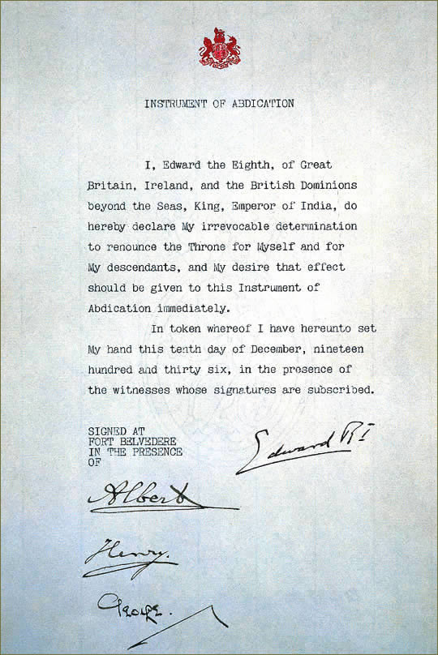
[FIGURE 1]

Julie Henry, “Letter reveals Queen Mother’s rift with Wallis Simpson”, Telegraph, 23 August 2009
Marc Bloch, “Royal albums: The Prince of Wales’s Souvenir: 1932-36 – The monarch who lost a beloved gothic folly along with his kingdom”, Independent, Friday 13 February 1998
Alan Travis, “Churchill tried to suppress Nazi plot to restore Edward VIII to British throne”, The Guardian, 20 July 2017
BBC Archive, “Edward VIII: The king who gave up the throne for the woman he loved”, BBC Archive
BBC Archive, “Edward VIII: The king who gave up the throne for the woman he loved”, BBC Archive
BBC, “History of the BBC – 1930s”, BBC

