Terrace Garden - Campus Waterfront Landscape Design

ABSTRACT
Campus environment landscape design is an important part of creating a campus culture atmosphere and overall image, and at the same time it can map out the spiritual connotation of the campus. The landscape design of the campus environment as a whole needs to create a multifunctional space that is conducive to teacher-student activities, as well as a harmonious atmosphere between landscape planning and nature. However, in recent years, with the rapid growth of the campus, the problems that accompany the landscape design have become more apparent: the patternization and the hollowing out of the landscape have become increasingly fierce; the similarity of the landscape structure among different campuses has caused the lack of campus cultural connotations and landscape features.As a typical comprehensive art school, Zhongnan Art School needs to do some special landscape design to activate campus landscape usage. Through previous site investigations, new planning and design have been carried out in terms of traffic routes, planting of vegetation and spatial functions. Based on the relevant theories and research methods of landscape design of the platform, the corresponding design strategies have been made from the public space and major transportation routes: improving the design of the site traffic routes, promoting the continuity of the landscape environment, and improving the sightline and waterfront area to enhance The atmosphere of the campus. The main contents of the campus waterfront landscape design include the increase of platform design, the addition of main entrances to enhance the exchange and functions of the campus environment, and the design of the major functional nodes of the campus landscape. By adding a mesa landscape design approach, a specific space node has been redesigned functional. It is hoped that through the design of landscape nodes, students' psychological needs will be met, and the extension of campus culture will be strengthened to enhance the vitality of the campus.

Key words：Campus landscape Terrace garden Waterfront landscape

Preliminary investigation of campus waterfront landscape

1.1 Geographical Location
Ningxiang city by Hunan Province directly under the administration of Changsha. Located in the south edge of Dongting Lake in the northeast of Hunan province, it is geographically located at 111°53 '-112°46' EAST longitude and 27°55 '-28°29' north latitude. It is adjacent to Wangcheng in the east, Xiangtan and Xiangxiang in the south, lianyuan and Anhua in the west and Yiyang and Taojiang in the north. It covers an area of 2906 square kilometers and has a population of 1.4 million. It is an important group in the pilot area of Dahexi in Changsha for the comprehensive supporting reform of changsha-Zhuzhou-Xiangtan "two-oriented" society, as shown in Figure 1-1.
The selected campus is located in The Central South Art School in Ningxiang City. The school is currently planning a new campus, which will be built in Yuening
1.2 Analysis of natural conditions
Ningxiang city is a continental monsoon humid climate, from the middle subtropical to the north subtropical transition, four distinct seasons, short cold period, long hot period. The annual average daily temperature of the city is 16.8℃, with an average of 4.5℃ in January and 28.9℃ in July. The annual average frost-free period is 274 days, the annual average sunshine is 1737.6 hours, the territory is abundant rain, the annual average precipitation is 1358.3 mm, the annual average relative humidity is 81%. Water resources are abundant. There are four major rivers in weishan, Wujiang, Chujiang and Jinjiang, among which weishan and Jinjiang are the first tributaries of Xiangjiang and Chujiang and Wujiang are the first tributaries of Weishan. Huangcai Reservoir is one of the three earth dam water conservancy projects in China.
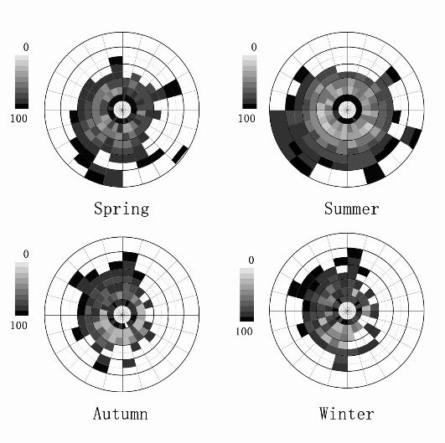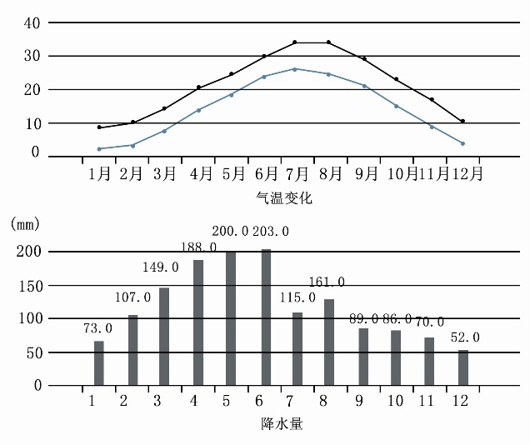
1.3 Traffic Analysis
The site is located in the transition zone between the new Town of Weidong and residential areas. Most of the old and new buildings around the site are distributed in a formation along the line, and several main narrow agricultural roads are curvilinear distribution. Therefore, the design site cannot be directly reached and there is no strong connection with the surrounding streets.
1.4 Revetment analysis
The existing pond revetment in the selected site is mainly divided into three types, namely gentle revetment, steep revetment and hard revetment. In the design process, redesign according to different revetment types, reserve natural revetment, adjust improper revetment. As shown in figure 1-4.
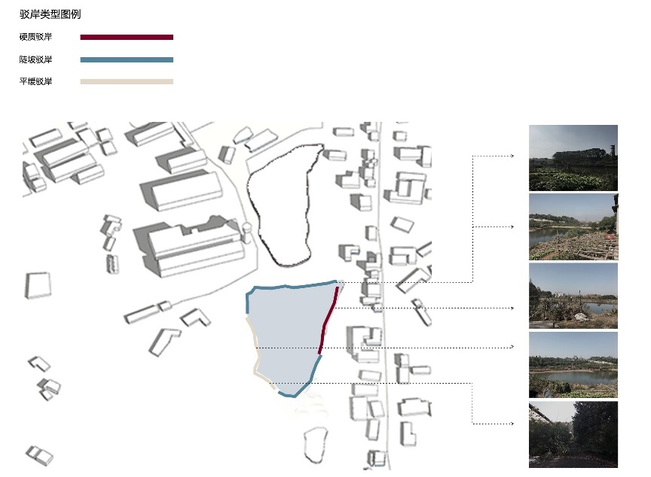
1.5 Analysis of the current situation of the base
Ningxiang city is the xuefeng Mountain to the northeast lakeside plain transition zone, the region has mountains, hills, plains. The outline of the surface is surrounded by mountains in the north, west and south rim, hilly in the southeast, gentle in the north and flat and open in the northeast. The whole terrain is step-like and sloping from west to east. The selected site has a large hilly area and ponds, but because the site has not been developed and used, the surrounding grass is mixed. Currently inhabited mainly by local farmers, the new school will attract a large number of students pursuing artistic dreams, faculty and some tourists. Due to the construction of the school, the existing site can not meet the needs of people to use, lack of necessary landscape public facilities, garbage cans, seats for students and some tourists to rest, resulting in the surrounding of the site is full of household garbage.
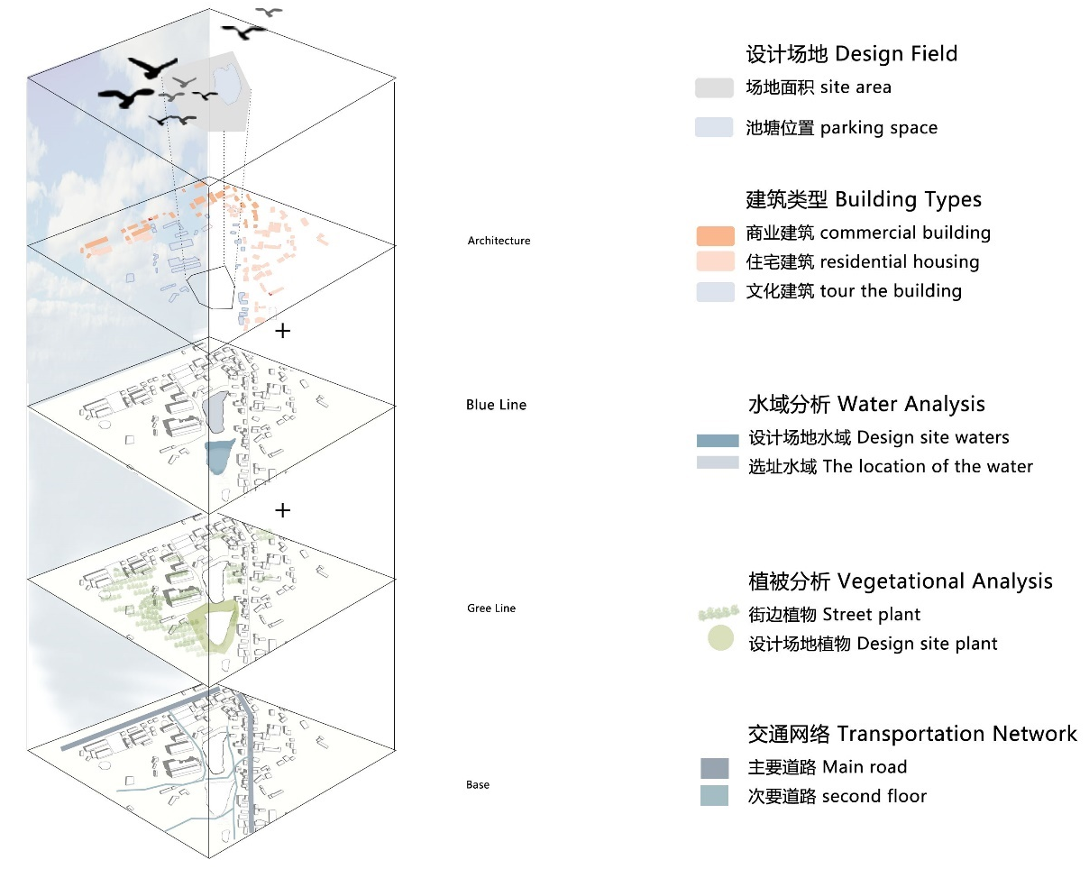
1.6 Population Analysis
The target group of the site selection is the students of the school. The school mainly cultivates comprehensive artistic talents with artistic ability, as well as the faculty and service staff of the school. The potential users are visitors from outside the school and some tourists, as shown in Figure 1-6.
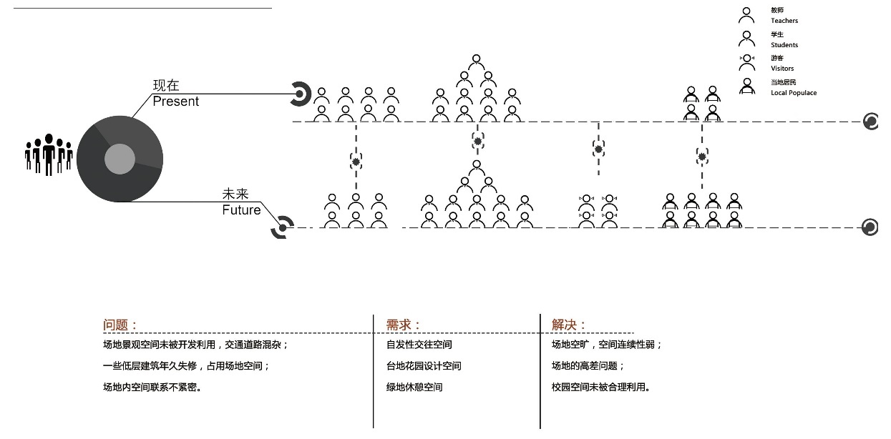

1.7 Survey Introduction
Venue: Weidong New Town, Ningxiang City, Changsha City, Hunan Province
Investigation purpose: To take photos and record the current situation of the site and collect site information in detail through on-site investigation.
1.8 Specific investigation content
(1) Site traffic route: the road is linearly distributed with the hillside as the center. There are three entrances and exits horizontally, one vertically, and a pond in the area on the right. The area consists mainly of vacant lots, water towers, walls and ponds with different elevations.
(2) Site building analysis: there are no main high-rise buildings around the site, but some unused old low-rise buildings. According to the classification of building materials, old buildings can be divided into loess brick houses, gray brick houses and white painted houses.
(3) Landscape resources: clean water pond and hills add tranquility and intimacy to the landscape, and hills and hillsides occupy the main part, which are both ornamental and landscape characteristics. In addition, some unique landscape elements can be found, such as gray brick walls with strong material sense and lush dense forests, such as 1-8- (3).
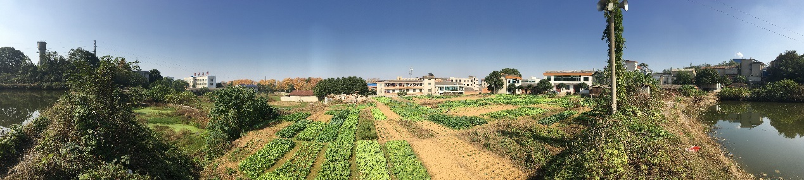
(4) Site problems: First of all, from the point of view of the traffic route, it can be found that the entrance around the pond is too narrow and its width is less than 1m, so it is not easy to be found. Even some agricultural roads and the site between the hybrid, lack of rationality. Secondly, in terms of architecture, it can be seen that the connection between the site and some of the old buildings form a disharmony, some of the buildings fall into disrepair. Due to the lack of humanized public landscape space in the campus, it can not provide a good landscape activity place for students.

Overall planning of campus waterfront landscape design

2.1 Design vision
2.1.1 Design theory
(1) The site significance of campus waterfront landscape and garden
Modern landscape theory emphasize landscape design respect people, respect for nature, respect the ideas of human culture, emphasis on meet the demand of people's material civilization and spiritual culture, and through the specific shape, color, texture, lines, patterns such as the physical form of those spiritual culture into the landscape, known as mental culture landscape materialized. [1] As an indispensable outdoor space on campus, the campus waterfront landscape can not only attract students to participate in a variety of outdoor activities, but also form a prominent point of the campus landscape. During the design process, local characteristics such as water and land were absorbed to create an artistic campus.
Garden campus refers to: in order to meet the requirements of the era of knowledge economy, in the planning and design of campus, with the improvement of environmental quality as the goal, based on humanism, to achieve the optimization of the campus environment, function, economy, technology, to create a sustainable development of the campus environment. It reflects the continuous development of the campus environment. This process includes the planning, design, implementation and management of the campus. [2] The campus environment is a multi-functional complex, and the campus landscape, as an important outdoor activity space of the whole environment, can not only attract students to have leisure, entertainment and reading on the site, but also form natural ornamental activities. As a campus culture, it carries the memories of students from past generations. The overall landscape environment of the campus mainly includes functions, facilities, ecology and the construction of place spirit. In the design of campus garden landscape, reasonable planning and design of these elements make the overall landscape environment reasonable, ecological and humanistic.
(2) Design principles of campus waterfront landscape and garden
To increase the vitality of campus landscape, the theme of garden campus is people-oriented, following the principles of campus landscape design ecology, functionality, landscape, plant landscaping, nature. Various elements of the comprehensive campus environment will follow the principle of humanism as far as possible to achieve low intervention, low destruction of the design, so that the school environment to truly respect people, care about people, shape people, can make people, nature, environment three aspects of coordination. The original building and road should be levelled, the original road's curvature should be retained, the road surface should be widened and supplemented by the method of filling, and the observation platform should be added, so that students can have a rest and stay space during the tour. The increase of pedestrian paths can not only change the original single traffic flow line, but also better collect and disperse the crowd. The road entrance is mixed, some even cut through the middle of the farmland, in the design of the entrance needs to be rationalized. Increase the use of slope space, the use of its own height difference advantage, do some platform design, so that the space has more characteristics, more humanized flow of people.
Garden campus not only advocates naturalism, but also emphasizes the cultural characteristics of campus itself. On the premise of preserving the natural form and landscape elements of the campus as far as possible, the redesign of reasonable landscape environment can not only make the ecological continuation of the campus, but also reflect the campus characteristics, so as to make the campus environment sustainable development. People often go to gardens to enjoy open space and the peace of leisure. The campus garden is not only the planting of a variety of plants, but also the combination of the garden and the pond has become a beautiful landscape in the campus landscape. Road greening is the icing on the cake for campus landscape. Of course, the planting of plants also needs to be combined with specific sites, such as planting some ground cover and shrub vegetation in terrace design, and planting aquatic plants in ponds. Through the redesign, the rationality of the campus landscape is increased, so that the garden becomes the characteristic of the campus.
2.1.2 Design Objectives
The design starts from the problems found in the investigation of the existing site and considers the needs of the crowd in the campus site. It starts from the following aspects: (1) drive the vitality of the campus and improve the artistic and cultural atmosphere of the campus; ② Increase the continuity of campus environment; (3) Adding landscape nodes to strengthen the communication and function of campus environment.
2.1.3 Design strategy
(1) Shape the landscape of terrace and waterfront to increase the overall continuity of the campus;
(2) Improve the campus traffic route and add the main entrance to improve the communication and function of the site;
(3) Add the main functional nodes of campus landscape to enhance the connection of campus space.
2.2 Design concept
From the psychological point of view, the waterfront landscape of campus terrace garden can make people feel kind and comfortable. No matter when you are in the garden, you can enjoy the return to nature and make people feel a sense of belonging and ownership of the school. Through different plant configurations and greening to beautify the campus, so that the cold, hard landscape environment can be softened. The height of the site rises from low to high, optimizing the visual experience of the landscape. In addition, the terrace, combined with the pond and surrounding landscape, presents a strong campus cultural characteristics.
The ecological landscape was designed as tree roots and ponds, natural woodlands and local terrain as branches and leaves. Strive for the harmony between natural landscape and campus culture, to achieve the harmonious coexistence of man and nature, to create a distinctive artistic campus cultural landscape.
2.3 Solution Concept
The scheme takes the campus terrace as the core, with the landscape structure of the pond, connecting the whole site through the way of road extension along the pond. Based on the natural landscape, the design is based on the campus culture. As shown in figure 2-3.
Therefore, I chose "terraced fields" for conceptual design. Three main characteristics of "terraced fields" are summarized: continuity, continuity and change. Continuity reflects the connection between the curves of the middle terrace of the campus garden; Continuity is reflected in the extension between the terrace design and the waterfront landscape; The variation reflects the different artistic and cultural atmosphere on campus.
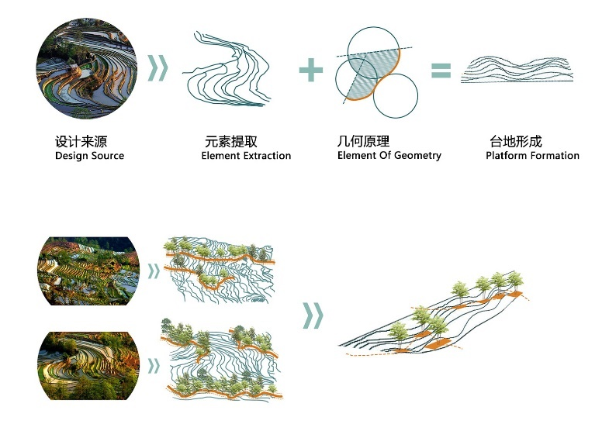

Overall design of campus waterfront landscape
3.1 Overall plan of campus waterfront landscape
This design is mainly for the terrace garden design, combined with the site to do the campus waterfront landscape. As shown in figure 3-1.
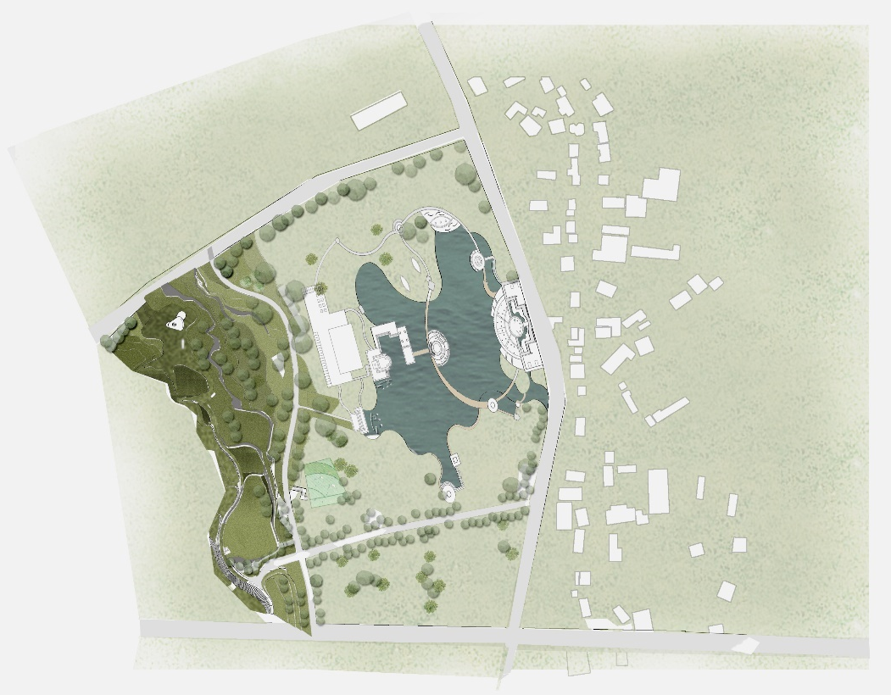

3.2 Functional zoning and detailed planning of campus waterfront landscape
The campus waterfront landscape site design is mainly divided into four parts, namely platform experience area, waterfront culture and performing arts leisure area, culture and art area, water leisure and entertainment area.

A section of the campus waterfront landscape, passing through the area from the terrace to the water area. Figure 3-2- (2).
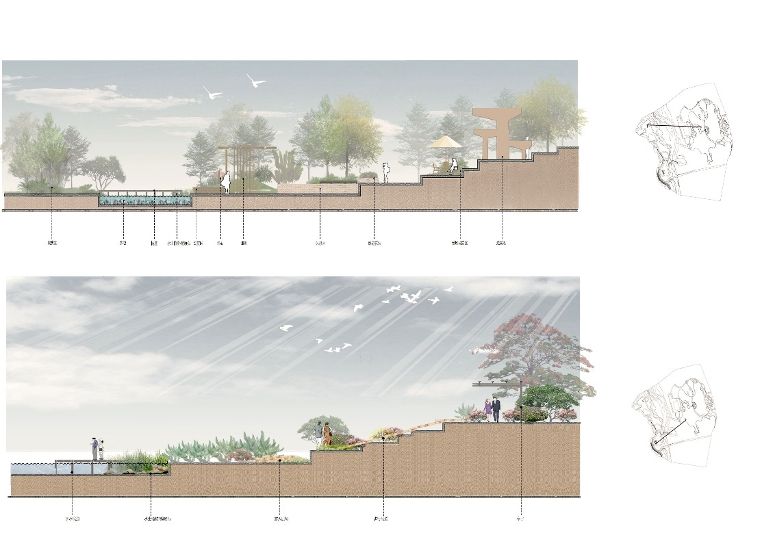

3.3 Function and target positioning
Objective: Design of campus waterfront landscape terrace garden
Function positioning:
(1) A comprehensive multi-functional campus integrating waterfront landscape, terrace garden and natural landscape;
(2) Humanized and landscaped campus activity exchange space;
(3) Cultural and creative art platforms and art campuses with interactive, exhibition and exchange functions;
(4) Drive the appreciation of the surrounding agricultural landscape.

3.4 Aerial view of campus waterfront landscape
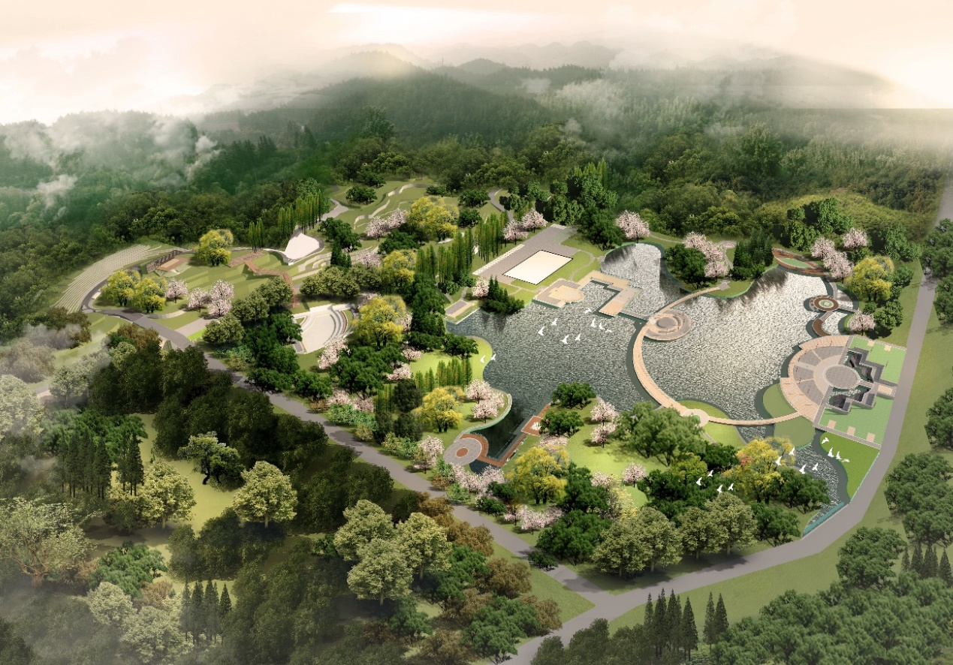

Node design of campus waterfront landscape
4.1 Platform design
4.1.1 Increase overall campus continuity
Before designing the architecture and landscape of any particular site, the isolation of these Spaces and their possible development patterns should be studied. [3] The original site is an undeveloped space with few overall spatial connections. The interior of the site is not closely connected with the external road, so changing the way of the internal campus traffic road is a direct way to improve the lack of continuity of the space.
(1) The hillside of the original site is changed into a platform. The design method of levels and height difference makes the height difference space continue, and also breaks the isolation between the building and the campus environment. This not only preserves the height difference of the hillside, but also makes the site space layered, attracting students to the terrace area.
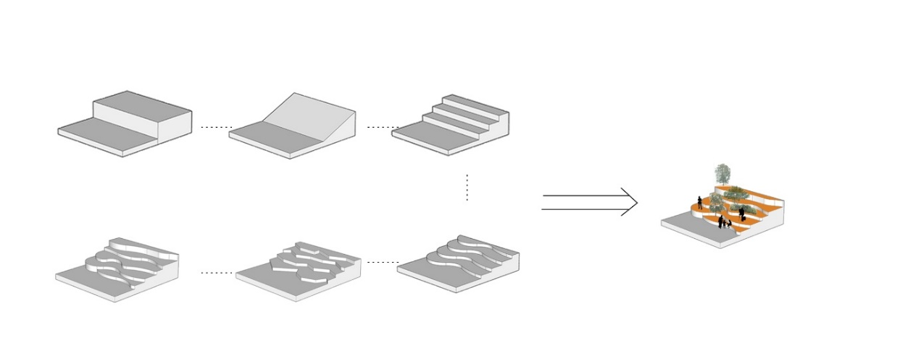
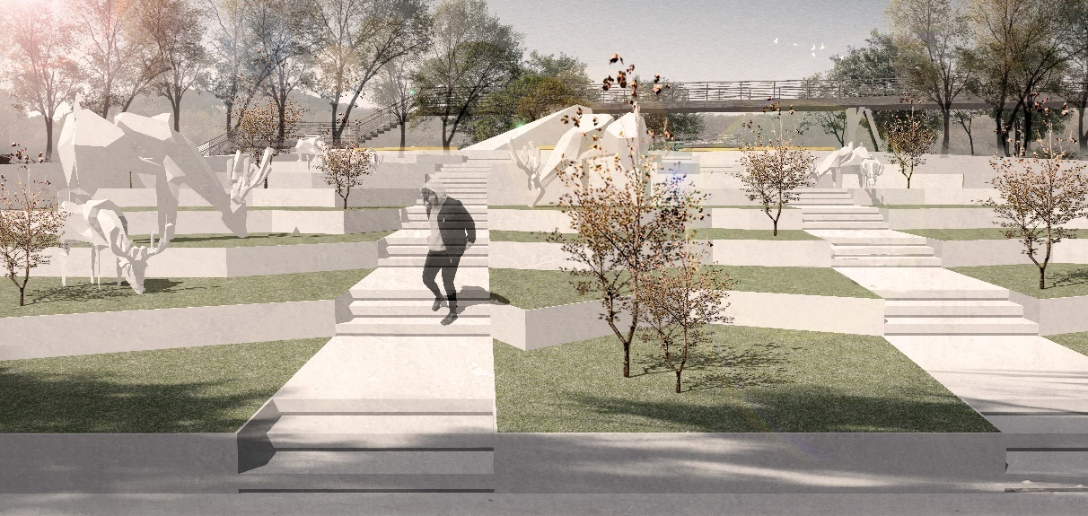(2) Break down the old low-rise buildings that have not been used for a long time and obstruct the traffic line, widen the roads inside the campus, and reduce the traffic obstruction caused by the original site.
4.1.2 Provide leisure gathering space for students on campus
In the original condition of mixed roads, agricultural roads and site routes, few people enter this area for activities, which makes the place a mess of garbage, and the road is even a little blocked. In order to create a good activity space, re-planning the route next to the pond, increasing the meeting place of the school students, staff and local residents, not only can enrich the students' daily leisure activities, but also can increase the vitality of the campus.
4.2 the observation deck
The key to the site selection was an open view point. The original site had an elevation difference and was mainly located in the northwest part of the site, which was irrigated with trees. The design of the observation deck needs to be integrated with the natural landscape, which is the synthesis of the natural landscape, cultural landscape and conceptual form. The construction of viewing platform has become a highlight of campus construction. On the viewing platform, it is convenient for students and tourists to stand on the platform and overlook the street view of campus. It is a place for leisure, sports and rest. As shown in figure 4-2.
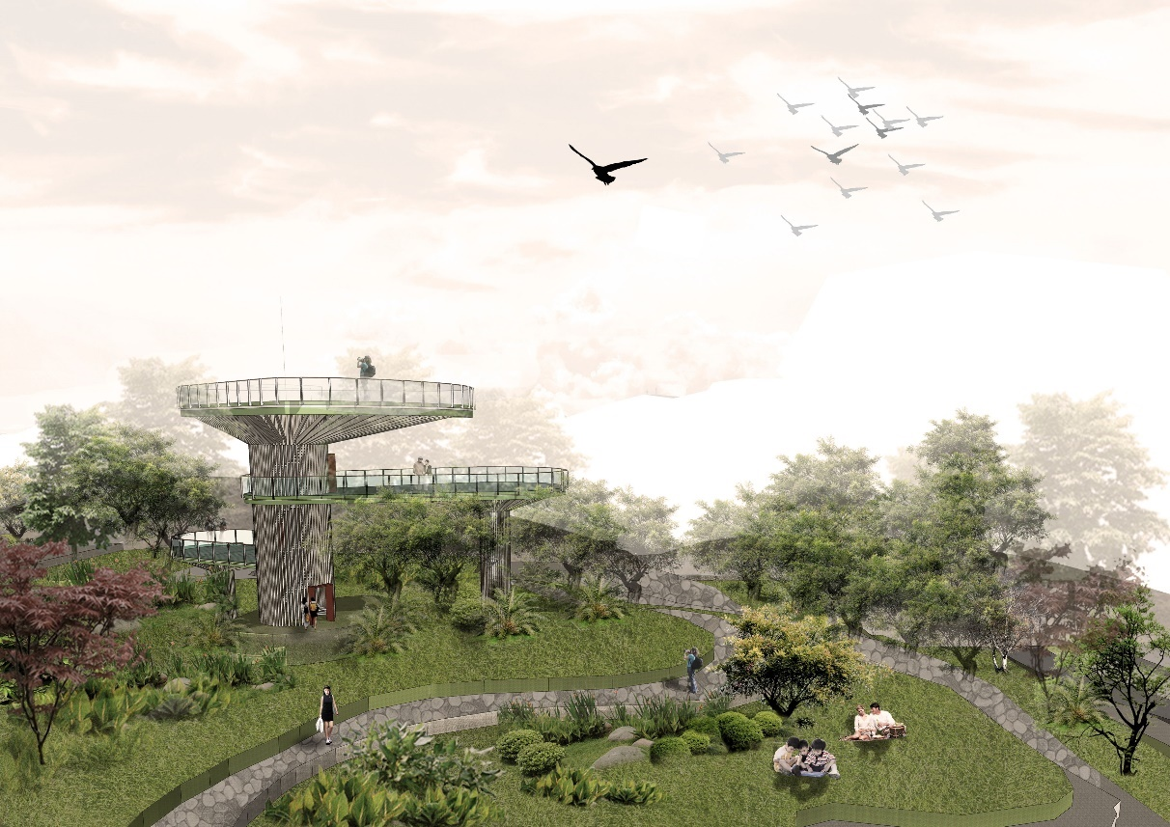

4.3 Water-friendly boardwalk
"The Analects of Confucius" has "the wise enjoy water, benevolence leshan; The wise move, the benevolent quiet "famous sentence, that water has both virtue, courage, good character, reasonable and wisdom. The connotation of water is endowed with wisdom and flowing symbol of humanity. [4] There is a large pond in the center of the campus, and roads run around the pond and connect the surrounding areas. The pond and surrounding garden landscape are used to create space. A water-friendly boardwalk is set around the pond, and stone benches and signs are set up to increase the ecological diversity around the pond. At the same time, functional nodes such as water-friendly grandstand and waterfront platform are connected, which is an important node for the spatial connection of the whole campus. In waterfront area, the construction of anti-corrosion wood is increased, and the guardrail is joined around to improve the safety protection effect. Figure 4-3- (1) and Figure 4-3- (2).
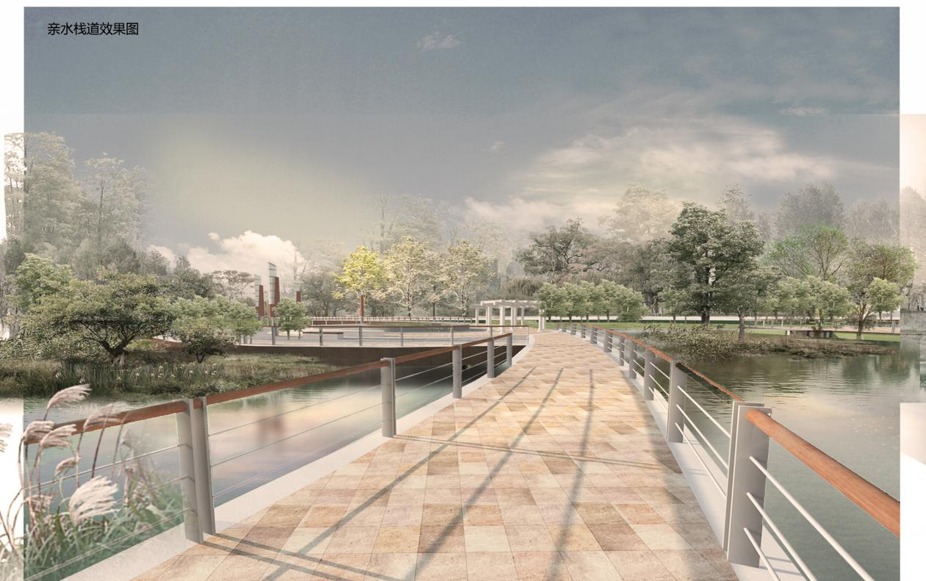
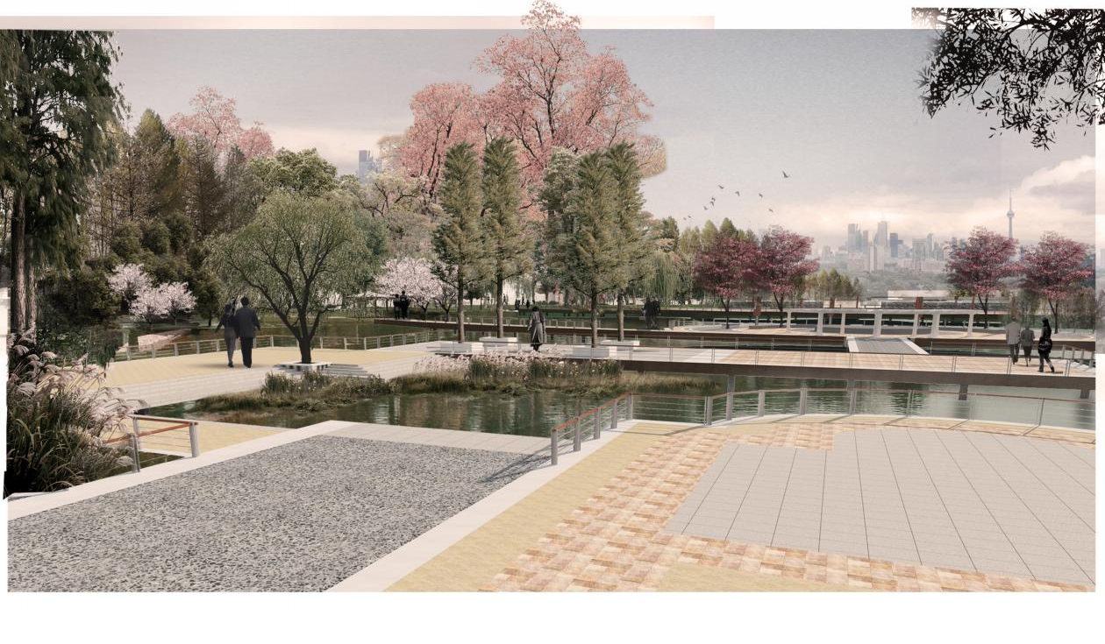
4.4 Outdoor theatre
Different regions condense memory in time and space. Through the organic combination of time and space environment, people can truly understand the environmental significance of their location. The information contained in the scene is selectively enlarged or reduced. [5] Add a small node inside the venue, the performance venue. Use the garden's undulating lawns and designed paths to connect the garden with its surroundings. When the weather is better, there is a better chance to enjoy the art outdoors. Enjoy the fresh air and scenery while watching the performance. Using the terrain in the area to design steps to form natural seats, not only to achieve visual pleasure in the site, but also to cultivate the mind. As shown in figure 4.
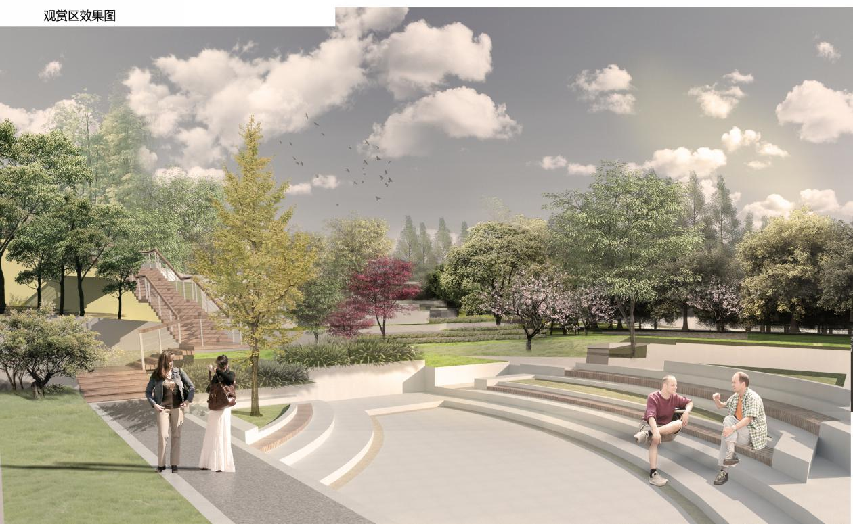

4.5 Reading Area
Place refers to the physical environment composed of specific space and elements distributed according to certain rules, which has specific ecological characteristics and supports certain fixed behavior patterns. [6] Reading area is the bridge and carrier of reading activities. It is an important part of student activity area. During the design, a reading area is set up to facilitate the staff to enter, providing an independent and relaxed communication and learning environment for the groups on campus. Independent reading area in an empty area can protect students from too much external interference when reading, independent space can produce comfortable and safe psychological feelings. As for the specific design materials of the reading area, I chose wood materials as the main materials. The design of the reading area can form a good educational and interactive scene. As shown in figure 4-5.
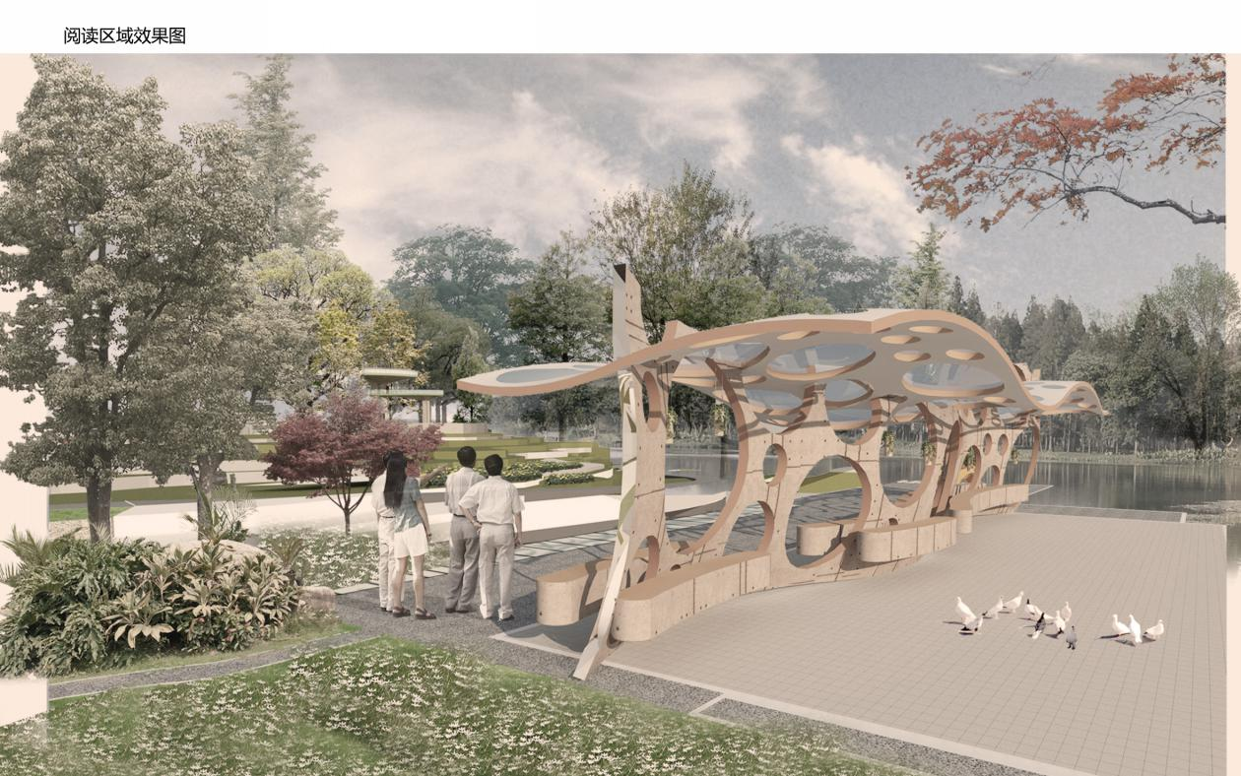

4.6 Walk along the boardwalk
On the basis of respecting the original environment, according to the topography of the site, the topography of the platform and the pond, combined with the local natural conditions, the intervention landscape is minimized. Therefore, the design of the walking trestle is added, so that the walking trestle and the natural environment are integrated into a whole, hidden in the terrain. In the absence of an entire campus facility, a walkway was designed and a high boardwalk was built through the woods. Through the trees. It not only increases the traffic route, connects the platform with the road surface, but also drives the vitality of the platform and provides users with a moment of rest and view. As shown in figure 4-6.
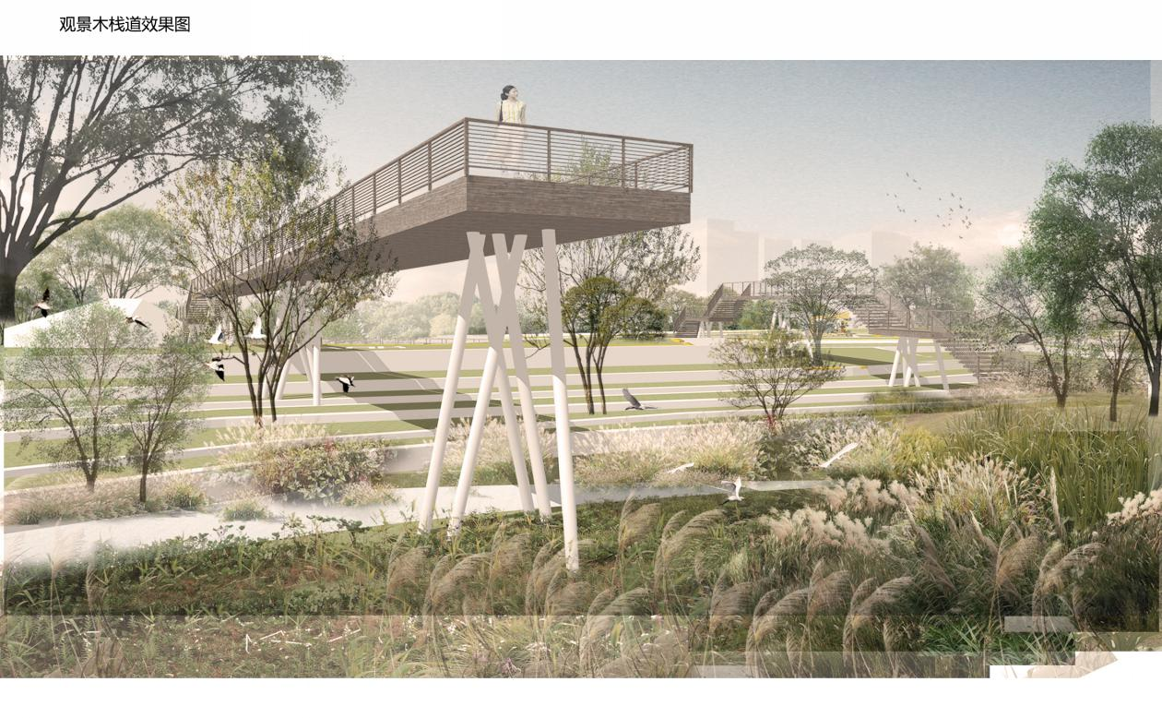
Detailed design of campus waterfront landscape

5.1 Plant Design
The selection of landscape plants can be divided into four categories, namely aquatic plants, terrace plants, trees and shrubs. Among these aquatic plants, there are such species as Tortoise, lotus, black algae, flowering reed, goldfish algae, mainly located in the pond area. Trees such as Ikedyoia sinensis, koelreuteria paniculata, Metasequoia metasequoia, Camphor tree, cedar and ginkgo are planted on the road. In addition, some shrub plants such as magnolia, hibiscus, cherry blossom and crape myrtle are also planted in the leisure and entertainment area. Landscape plants have different effects, such as the sense of temperature, movement, distance, weight, etc., which can be compared, harmonized and matched with various effects to create different artistic atmosphere. Different configurations of plants make the site warm and friendly, giving people different aesthetic feelings. As shown in figure 5-1.
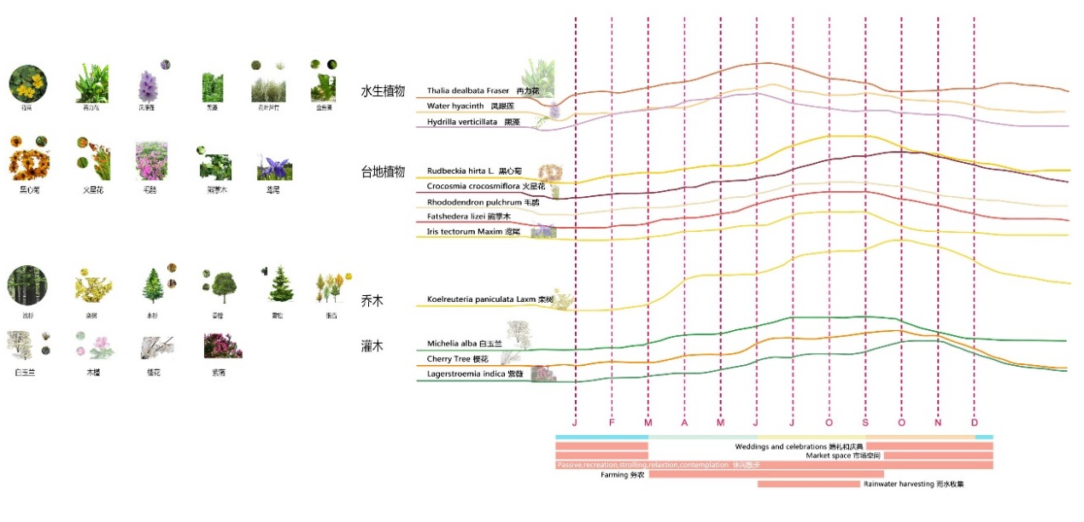
5.2 Lighting Design
Landscape lighting is a part of the campus night landscape, clever use of different types of lamps and lanterns, the landscape and humanities, history, art, into the campus cultural characteristics. The different lighting arrangement and color of the site shape different landscape space before and after. In terms of light color, warm white with color temperature less than 3000K is selected as the main color point to reasonably control the mapping range of light. Through the design, create a warm, quiet overall atmosphere. As shown in figure 5-2.

Below the premise that ensures adornment function and practical function, also want to notice the energy-saving environmental protection of lamps and lanterns. In the design, lighting is applied to the terrace landscape to form a different landscape at night.

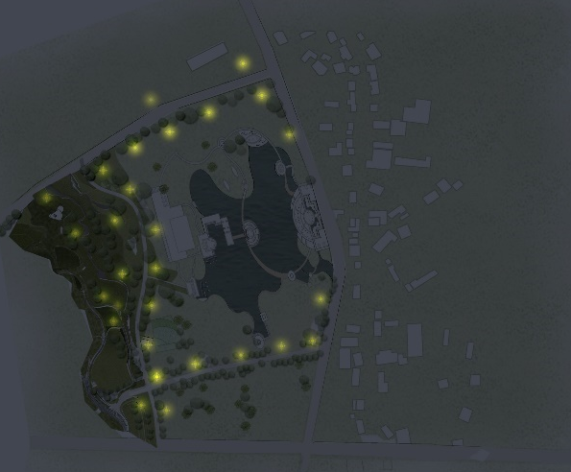

5.3 Pavement design
Campus pavement design not only meets the use function of the site, but also reflects the campus culture and characteristics, and even makes the whole landscape environment have ideas. Landscape a variety of paving materials and unique forms in the design can make the campus landscape more rich. As shown in figure 5-3.
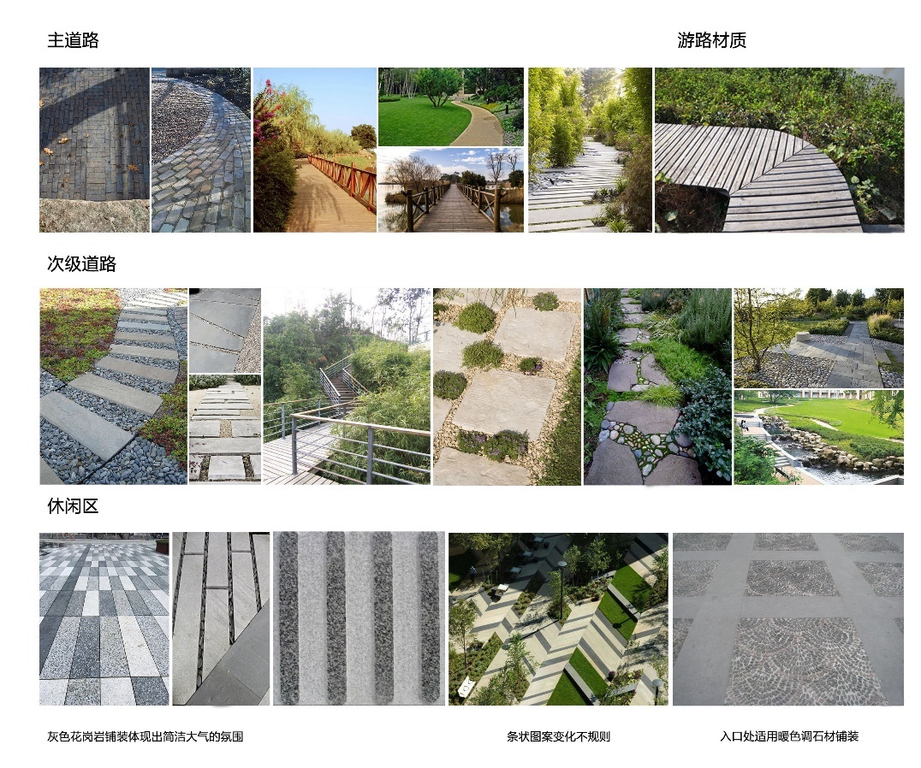

5.4 Garden facilities design
The well-designed campus landscape environment needs to be decorated with various landscape sketches, and the rest seats play a great role. Outdoor lounges on campus are not only for relaxing, but also for students to study. In the design as far as possible to reduce mutual interference in the campus rest chair design and location distribution in the need to be reasonable.
Conclusion

The design of campus waterfront landscape is of great significance in improving the campus life of teachers and students, beautifying the environment and the campus cultural atmosphere. Today the campus landscape is not only to provide teachers and students of the space of study, research, the different artistic styles, different way of life and study in campus culture collision, the landscape cultures also brings new problems and challenges, so when the design should follow the overall concept, strengthen the whole and local connectivity. The addition of new interesting places creates Spaces with different functions in the design, including public, semi-public and private Spaces. The concept of "school in campus, campus in campus" should be combined with "school" and "garden" in the design. To design a humanized place, it is necessary to first understand the space condition, lifestyle and current situation of the users' activities. Only by understanding the activities of users can we design a design full of humanistic atmosphere.

In the design of the waterfront landscape of the campus terrace, the existing problems of the site collected should be redesigned for different points, so as to improve the vitality of the campus from the perspective of functionality and psychology, which is the direction of efforts. Only by truly recognizing the relationship between land and space, can we start from different aspects and knock down the best design of campus terrace waterfront landscape.

