Part 3
Blog - Is the non-maintained sector better prepared for curriculum reform than the maintained sector?
There is no question that the practical implementation of the Foundation Phase within the funded non-maintained sector allows practitioners more autonomy than those of their peers in the maintained sector. Does this mean that the New Curriculum for Wales (2020) (Welsh Government, 2020) will be a smoother transition for those practitioners within the non-maintained sector?
This narrative aims to demonstrate the readiness to transition into the New Curriculum for Wales (2020) (Welsh Government, 2020) that those practitioners in the non-maintained sector possess.
According to Taylor, Rhys and Waldren (2016) practitioners had reservations about the introduction of the Foundation Phase and its formal methods of teaching, learning and assessment for children in the early years. Given the amount of support (both financial and otherwise) that those in the maintained sector receive, has a gap been created between the maintained and non-maintained sectors? However, Estyn (2019) recognised that non-maintained settings fair just as well, and in some cases, better than their peers in the maintained sector. A comparison of Estyn (2019) reports provides evidence of this.
It is worth considering the policies and procedures that influence the implementation of the Foundation Phase for both the maintained and non-maintained settings when we are considering how the new curriculum will be implemented. MacDonald’s (2018) interpretation of Bronfenbrenner’s ecosystem excellently demonstrates the constraints, controls and influences placed on a practitioner in a maintained setting. The hierarchical system consisting of practitioners, class teachers, Foundation Phase leads, head teachers, cluster schools, local authorities and government policy level creates many areas for interpretation of implementation methods and pedagogy.

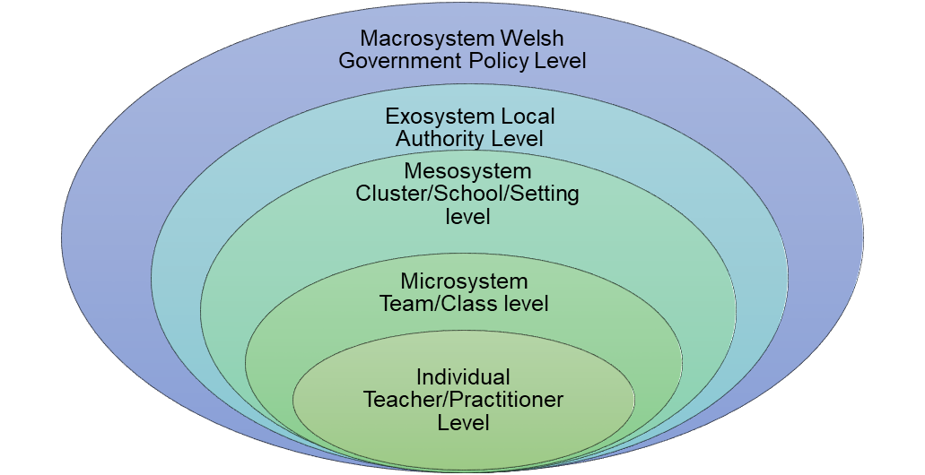

(MacDonald, 2018)

Within a non-maintained setting, the same level of support, control or influence is absent. This means that non-maintained settings are answerable to fewer powers from above. In acknowledgment of MacDonald (2018) below is a comparative representation of the non-maintained setting, whereby there are fewer ‘systems’ in place.

Government policy level

Local Authority

Practitioner/ Teacher

The lack of support/involvement can be both advantageous and disadvantageous when considering implementing the new curriculum. The non-maintained settings are effectively answerable to fewer strata in how they chose to present the Foundation Phase. However, they are still answerable to the same quality assurance processes as a maintained setting, in fact, given that non-maintained settings also have to undergo an inspection process from Care Inspectorate Wales (CIW) (Care Inspectorate Wales, 2020) as well as Estyn (2019), arguably validating the quality of non-maintained settings. The autonomy of non-maintained settings in the implementation of the Foundation Phase undoubtedly puts less stress and pressure on its practitioners. This can only strengthen the non-maintained setting’s position regarding implementing the new curriculum. However, it does also mean that non-maintained settings are very solitary in the way they work, often only having government policy and occasional input from local authority for support.
In comparison, practitioners from maintained settings are restricted in their implementation of the Foundation phase by the stipulations placed on them from the strata above, where instruction and interpretation can often get lost in translation. The same is likely to happen when introducing the new curriculum.
Does the autonomy that non-maintained settings experience better prepare them for the implementation of the new curriculum? The new curriculum puts an emphasis on teachers’ interpretation of it and gives them autonomy to implement in ways that they see fit. Undoubtedly, the practitioners in maintained settings may lack the experience or confidence in taking the lead in introducing the new curriculum.
However, within the non-maintained sector, the confidence and experience that practitioners have gained can only put them at an advantage over their peers in the maintained sector.
Welsh Government (2018) discuss the need for levels of support from Local Authorities to realise the vision of a curriculum The levels of support that the maintained sector receives with regards to implementing, planning and delivering of early years provision far outweighs that which is received by the non-maintained sector. The Welsh Government (2014) Independent Stocktake of the Foundation Phase discusses the need for improved and universally accessible training for all practitioners in all settings in the Foundation Phase and for that training to be bespoke. However, this is simply unachievable in the non-maintained settings due to staffing and support issues. To ensure a smooth and effective transition into the new curriculum, this will have to be a priority.
Welsh Government (2014) recommended that best practice be shared between maintained and non-maintained settings, this is an area where Welsh Government have made some progress, by the introduction of ‘Hwb’. This will be continued throughout the introduction of the New Curriculum.
Welsh Government (2018) state that funding for Foundation Phase Nursery places varies greatly, not only between local authorities but also between maintained and non-maintained settings. This means that non-maintained settings are always working at a disadvantage, one that could be vital in terms of implementing a curriculum. Therefore, to implement the forthcoming curriculum reform, these inequalities need to be addressed.
By complying with the National Minimum Standards as set out by CIW (Welsh Government (2018) it demonstrates that non-maintained practitioners are already competent in interpreting relevant documentation and actioning it appropriately. Many practitioners within the maintained sector won’t have that same experience, therefore disadvantaging them.
There has been little research undertaken to assess the effectiveness of the Foundation Phase in non-maintained setting as compared to maintained settings. The Foundation Phase stocktake (Welsh Government, 2014) looked at how Foundation Phase is implemented. The stocktake does not give a clear picture of how maintained and non-maintained settings fair against each other, further research is needed in this area with regards to the new curriculum.
Welsh Government (2014) also discussed how important it is that Foundation Phase leads in maintained schools possess the skills, knowledge and experience to understand and implement the pedagogy of Foundation Phase, as it identified that currently that these ‘leads’ are sufficiently experienced in leadership. Regulations must be put in place to ensure all leads in all sectors possess the appropriate leadership experience and qualifications.
Blanden, Hansen and McNally (2017) in a paper researching quality and achievements in early years setting discuss the diversity or practitioners’ levels of experience and qualifications within the Early years sector and that this diversity can impact how education is shaped and delivered. Although this research was undertaken in England, its results can be transferred nationwide.
This is the current view of implementing the new curriculum, however, in an ever- changing sector, change is inevitable.

