Thomas Becket (HPMS7006)
Assessment One: Image Commentary
Matthew W. McGinn (2209671@student.uwtsd.ac.uk)

The image for this assessment is taken from the Book of Hours, Use of Sarum. The manuscript’s origin is in the north or northwest of France, circa 1430-1440. The medium is parchment. An image of the murder of Thomas Becket is in the centre of the folio. The margins are filled with flowers, vines, and a bird in flight. Gold paint is used on the leaves of the vines, the background of the leaf pattern surrounding the image, the border of the image of the murder, on the decorations of the altar, and on Thomas’s clerical vestments. A description of Thomas’s martyrdom is written in Latin, with an illuminated capital, underneath the image of the murder.

Five figures appear in this depiction of the murder of Thomas Becket. There are three, not four, knights, Thomas himself, and a tonsured man holding a cross, probably Edward Grim. The appearance of Thomas is very much in alignment with the most hagiographic views of the archbishop’s death. Instead of confronting the knights as he did in the eyewitness accounts of Edward Grim, Thomas kneels before an altar, his back to the knights, and holds his hands together in prayer. Thomas appears to be in the process of celebrating a Mass. The altar has a decorated altarpiece, and on the altar are a book, a chalice, and what looks a communion host directly in front of Thomas’s hands. Thomas’s saint’s aura appears as very thin golden lines, which may be rendered with gold paint, emanating from the top of his head. Two of the knights, who wear a red tunic and a blue tunic, are visibly armed and attacking Thomas. The third knight, wearing a green tunic, does not appear to be armed, although he is obscured behind the other two knights.

The knight in red appears ready to strike the killing blow. What is distinct about him is the scimitar he wields. A scimitar would be extremely unusual in the hands of a twelfth century Anglo-Norman knight. Rather, the scimitar is heavily associated with the Muslim world. Moreover, the knight’s helmet may also be designed to resemble those used by the “Saracen” armies. At the time this work was completed, circa 1430-1440, the Ottoman Empire was rapidly expanding and heavily pressuring the Balkans and Constantinople, which would have been of concern to the noble or clerical audience this artwork was probably intended for. The presence of the scimitar and the design of the helmet suggests the artist was not just depicting the knights as murderers, but as infidels persecuting and slaying a Christian archbishop. The artist is therefore forcefully stating that the knights are not Christian men; no true Christian would commit crimes of such brutality against a priest, to say nothing of the Archbishop of Canterbury.

There may be another implication – depicting the knights as infidels may also suggest that they were never Christian, and that their crime was therefore unforgivable and could not be atoned for. In Matthew 12:31-32, Jesus warns a group of Pharisees that “And so I tell you, every kind of sin and slander can be forgiven, but blasphemy against the Spirit will not be forgiven. Anyone who speaks a word against the Son of Man will be forgiven, but anyone who speaks against the Holy Spirit will not be forgiven, either in this age or in the age to come.” The Pharisees had already rejected the Holy Spirit despite the miracles of Jesus they had just witnessed, and they were already planning to kill Jesus. Now, we see the knights depicted as infidels, who have rejected the testimony of Saint Thomas Becket, a man the artist would have considered guided by the Holy Spirit, and spilled the blood of a man who has given over his life to the Christ. So the artist has issued a powerful condemnation of the knights, who are strongly implied to be fit for no place but hell.

Thomas is heavily compared to the Christ in this work. Jesus warned the Apostles, “The Son of Man must suffer many things, He said. He must be rejected by the elders, chief priests, and scribes, and He must be killed and on the third day be raised to life.” In Canterbury Cathedral on 29 December 1170, the long-suffering Thomas, rejected by his King and many of his colleagues in the clergy, and long exiled from his homeland, was finally delivered into the hands of his enemies.

The knight in blue is holding his sword in an unusual manner. Instead of swinging it forcefully with one or both hands, he holds the pommel in his right hand and the center of the blade with his left. The point of the sword appears to just touch Thomas’s head. The red streak on Thomas’s head suggests the blade has wounded him. This knight may have just struck off Thomas’s miter with the sword, or perhaps, and more significantly, the careful positioning of the sword suggests he may be using it to inflict torture upon Thomas. If this is the case, the artist is likely juxtaposing Thomas’s martyrdom with the Passion and Crucifixion of Jesus. The knight in blue is also stepping on Thomas’s chasuble, a further insult to the Archbishop’s station and status as a priest, made even worse if Thomas is saying Mass.

The altar. The book on the altar is presumably a Bible or missal. The Eucharist in both parts is present on the altar, which is extremely important. Thomas may be in the act of performing the sacrifice or may have just completed it. Either situation is another ferocious condemnation of the knights. If Thomas is performing the sacrifice, the knights are interrupting the holiest sacrament of the Church, in which the wine and bread become the actual body and blood of Christ, and slaying the priest offering the sacrifice. And if Thomas has completed the sacrifice, the wine and bread have been consecrated, and, according to Catholic teachings, Jesus is physically present in the Eucharist; the knights have committed mortal sin in the presence of the Christ.

Many of the other depictions of Becket’s murder include an altar and an altarpiece. The Crucifixion of Jesus is unmistakable on the altarpiece, along with two saints, one of whom is highly likely to be Mary the mother of Jesus; the other may be John the Apostle or Mary Magdalene, given traditional depictions of the Crucifixion in Christian artwork. Thomas has bowed his head in the direction of the altarpiece, directly at the figure of the crucified Christ. The artist unquestionably desires to depict Thomas’s martyrdom as a re-enactment of the Crucifixion. This is a common theme in the written and artistic works describing the murder of Thomas, but this artist is particularly overt about the comparison.

Edward Grim and the cross. Grim is included in most of the depictions of the murder; in some cases, he is alone; in others, he is with a group of other monks. Here, Grim is alone, and he is not attempting to protect Thomas from the knights’ blows. Instead, Grim holds his cross high, well above the heads of the knights. This suggests the presence of God in the cathedral, witnessing Thomas’s martyrdom. Indeed, the base of the cross extends down directly to Thomas’s head, suggesting the will of God is with Thomas.

Someone made a halfhearted attempt to deface Thomas at the orders of King Henry VIII. It is difficult to distinguish without seeing the original manuscript, but there may be a couple of vertical scratches through the middle of Thomas’s head, and down into his collar. The red streaks on his shoulder may either be evidence of defacement, or they may be drops of blood from Thomas’s wound. However, the Latin text on the page has been clearly crossed out, so someone was carrying out Henry’s orders. Looking at the previous folio in the manuscript reveals why the page was not destroyed – it is an image of Saint George, patron Saint of England, slaying the dragon, which Henry’s enforcers would want to leave intact. Attempting to vigorously deface the image of Thomas would run the risk of damaging the image of George – and his shield with the Cross of Saint George – on the reverse. Those that hold to the doctrine of the veneration of saints might say George was providing Thomas with a little support.

Others searching for key characteristics of images of Thomas Becket should look carefully for manifestations of the Trinity, such as a hand from the heavens (the Father, or perhaps the Holy Spirit), a dove (the Holy Spirit), overt depictions of Jesus, especially the Crucifixion, or the two parts of the Eucharist. Regarding the knights, consider the armor and weapons they carry. Is there anything unusual about them? Are there symbols or crests on them? Consider the actions of any others in the image besides Thomas and the knights. Finally, what is Thomas doing? Does Thomas appear to be saying Mass? Is he kneeling at prayer, or is he standing and confronting the knights? Elements such as these may reveal more of the artist’s intent.

At first examination, this representation of the murder is not as visually striking as others – there is very little blood, there are fewer people than in other depictions, and the environment of the cathedral, save the altar, is very simply designed. However, the artist incorporated deep significance in the representation of the scene. Thomas is shown as a holy and innocent victim with clear ties to Christ crucified, and the artist paints the knights as godless, condemned heathens.

Archival Source/Image Source

London, British Library, Harley 2900 (Book of Hours, Use of Sarum), fol. 56v

Bibliography – Primary Sources

The Lives of Thomas Becket, ed. and trans. M. Staunton (Manchester, 2001)

Holy Bible, New International Version, www.biblegateway.com. [Accessed 18 March 2023]

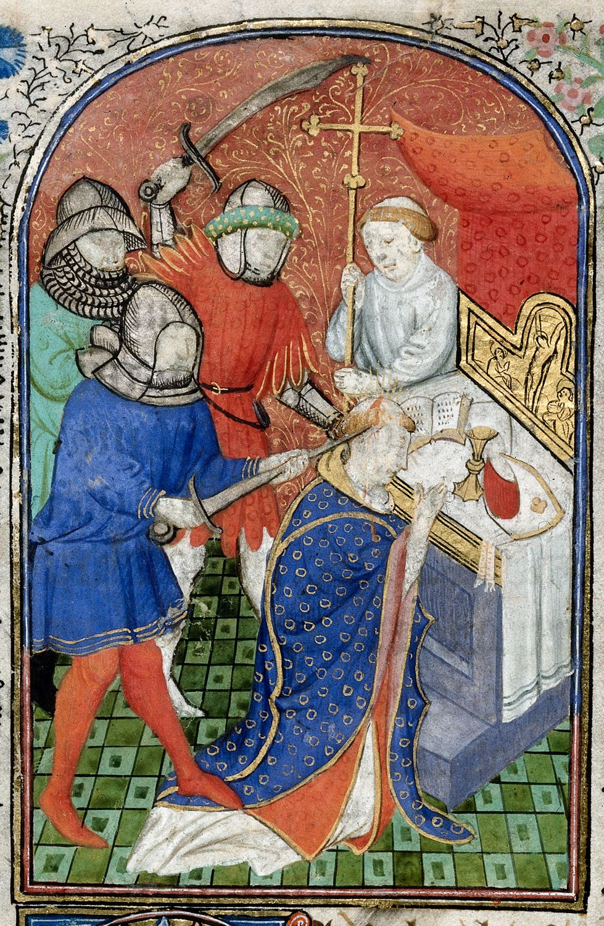
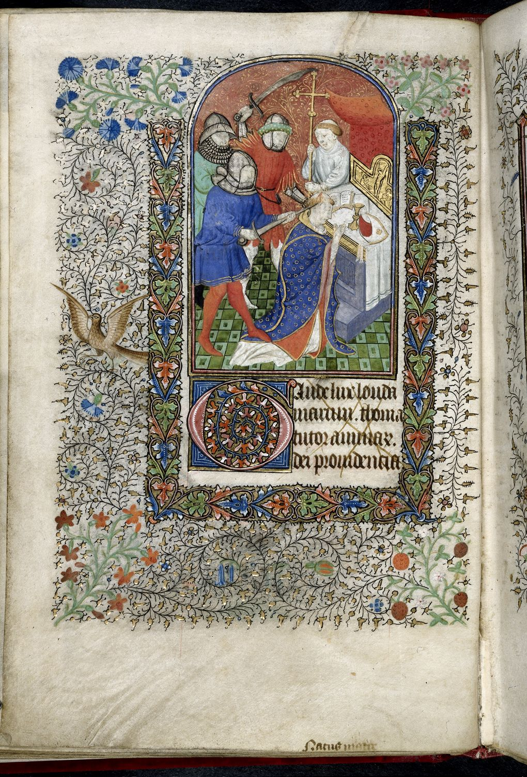

M. Staunton, t. and ed.,The Lives of Thomas Becket. (Manchester, 2001) p. 202
Holy Bible, New International Version, Mt 12: 31-32. www.biblegateway.com. Accessed 18 March 2023.
Ibid., Mt 12:14.
Ibid., Lk 9:22.

