  Intercultural Communication and Culture  River Island | Abstract  With the development of the information age and the continuous strengthening of the trend of global economic integration, international clothing retailers have more and more frequent business activities, and cross-cultural exchanges of business personnel have also played a huge role in it. Based on the theoretical research of cross-cultural business communication, this paper analyzes the importance of cross-cultural communication for apparel retailers when conducting international business activities. In view of the differences in language, social history, and thinking mode of cross-cultural business communication, the author puts forward suggestions for cross-cultural business communication, including: familiarity with the language communication mode of different countries; Respect and tolerance for other cultures; improving conflict resolution capacity; Enhance business capabilities; Cultivate the comprehensive quality of business personnel in cross-cultural communication.  Gwyneth Jones  Business Management

1.0– Introduction
Over the past two decades, the fashion apparel industry has changed significantly, with the global apparel market reaching $758.4 billion by 2021, growing at a compound annual growth rate (CAGR) of 7.5% from 2014. As a result, many apparel retailers are committed to expanding globally, and in order for the UK apparel retail industry to successfully make Asia a key partner for their business, how to develop cross-cultural differences and build professional relationships in cross-cultural communication activities is an important objective of this report.
In 1959, the American anthropologist Edward Hall first proposed the concept of "intercultural communication". In 1983, Canal introduced the well-known concepts of communicative competence, namely grammatical ability, sociolinguistic ability, discursive ability, and strategic ability. Lay the foundation for cross-cultural communication. On this basis, Canal proposes the concept of sociolinguistic competence, emphasizing the ability of communicators to transform in different cultural contexts. Among them, discourse ability refers to the basic knowledge reserve that the communicator needs to have in a specific environment; Strategic competence, on the other hand, refers to mastering language strategies when communicating with people from different cultural backgrounds, thereby improving the effectiveness of communication. From the perspective of language teaching, Bayram sublimates the concept of intercultural communication and proposes the skills that intercultural communicators need to have, thus laying the foundation for the development of intercultural communication skills. With the continuous development of the social economy, cross-cultural communication is also constantly improving.

2.0 – Main Findings
Culture is the spiritual activity and product of human society relative to economy and politics. It is diverse, complex and inclusive, it is the sum of the inner spirit of a country from the past to the future, which will involve history, geography, politics, customs, traditional customs, lifestyle, religious beliefs, literature and art, laws, institutions, ways of thinking, values and so on. Cultural factors play a very important role in international business communication. Understanding the cultural differences between China and the UK and mastering good cross-cultural communication skills can facilitate business cooperation between River Island and China, increase business opportunities, improve work efficiency, and establish good business relationships. Cross-cultural communication is also an important means of solving problems and resolving disputes. When problems arise in business activities, timely communication and consultation can effectively resolve differences, ease tensions, and avoid loss of interests. Therefore, understanding cross-cultural communication is very important for the development and success of River Island.
2.1 – International Business Communication
International Business Communication (IBC): It is the interactive process of communication between countries, sometimes referred to as "global" or "cross-cultural" communication.
If River Island needs to expand its international business in China or other countries, it must understand the importance of cross-cultural communication. Because when dealing with people from different cultures in the field of international trade and business, understanding their cultural background, using the right etiquette and polite expressions, can enhance the sense of trust between both parties. This helps create great partnerships, reduce cultural differences, and ensure that work runs smoothly.
A proper understanding of intercultural communication promotes harmony between cultures and eliminates misunderstandings and prejudices. It can promote the development of international trade, investment, and tourism, and increase contacts and cooperation between different countries. In addition, cross-cultural communication can also foster the development of innovation and creativity, helping us better understand the similarities and differences between different cultures.
Therefore, understanding effective international business communication is essential for individuals, organizations, and society. It can help us better understand and adapt to different cultural environments, enhance our global vision and cultural sensitivity, and can promote the development of cultural exchanges and promote diversified exchanges in the world.
2.2 – Skills Requirements
When conducting international business dealings with China, River Island's business personnel have the following skills to better communicate and cooperate with China or other countries.
1) Cultural sensitivity: Cultivate cross-cultural awareness, understand the differences and characteristics of different cultures, and international business communication needs to pay attention to the communication barriers between different languages and cultural backgrounds. Therefore, before conducting cross-cultural communication and international business exchanges, it is necessary to understand the cultural characteristics of the other party, establish an awareness of cultural differences, and take the initiative to understand the other party's etiquette, customs, beliefs, values, etc., so as to better communicate with the other party. This makes it easier to build trust and cooperation while avoiding offending the other party. After understanding the characteristics of the other party's culture, you can compare the differences between the culture of the person you communicate with and your own, and improve your awareness of the differences between different cultures.
2) Cultural adaptability: Respect each other's cultural differences, in international business communication, enterprises need to correctly recognize the existence of cultural differences, but also need to treat cultural differences correctly, understand and respect the differences and characteristics of different cultures, which can help us better communicate and cooperate in cross-cultural exchanges.
3) Familiarize yourself with communication skills: When conducting international business communication, in language communication, it is necessary to pay attention to the different roles of different levels of oral communication and written communication. Learning how the other person communicates can help you better understand the other person's culture and make communication smoother.
4) Develop non-verbal communication skills. When communicating in international business, you should pay attention to the body language of the other party. We can understand the intentions of the other person by observing his body language, such as gestures, facial expressions, etc.; In addition, we should also be familiar with the use of body language, on the one hand, we can use body language to better express our meaning to make up for the barrier of language communication, and on the other hand, we can avoid the appearance of ambiguous body language and unnecessary misunderstandings.
2.3 – Methods of Communication
International business communication is a communication and exchange activity carried out in different cultural backgrounds, because each culture has its own unique values, beliefs, customs and language, so the way of communication will be different, understanding and adapting to the communication style in different cultural backgrounds is very important to establish a good business relationship, so we must learn to understand the way of communication when communicating in China. Communication is the act of transferring information from one place, individual or group to another, in both verbal and non-verbal ways. Communication is not only a process, but also needs to achieve its results, River Island and the Chinese market to establish communication and cooperation is the ultimate goal, so we need to analyze the communication methods in China, to avoid unnecessary misunderstandings due to communication differences, but also to help our work smoothly and finally reach cooperation.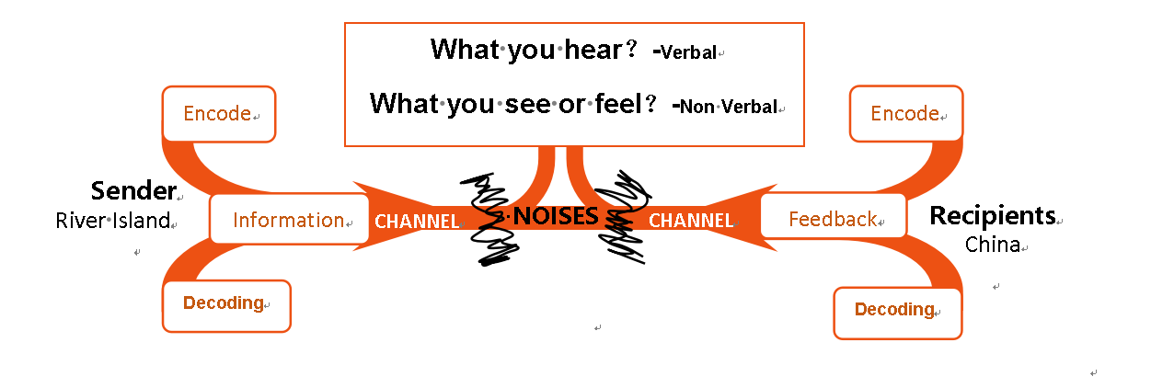
Sender：The subject of information sources may be people or things, and we are talking about people here.
Information：What we need to express, such as words, sounds, images, etc.
Recipients：The person or thing that needs to receive the information is the party that the sender wants to get a response.
Feedback：Feedback here is a noun and is a reaction to the interpretation of information. It is also information in nature, whether it is emotion, silence, or words.
Encode：Refers to the way in which the source sends information.
Decoding：Refers to interpreting information so that it becomes acceptable.
Channel：Carriers and channels of dissemination of information, such as documents, CD-ROMs, telephones, etc.
Noises：Refers to anything that interferes with the transmission of information.

Verbal：
Before communicating with China, if we can analyze it with a communication model, we can grasp the effective communication methods to promote the communication between the two sides until the cooperation is reached. The general practice process should be in line with 5W1H, that is: 1) What: Confirm what the message you want to convey, and will there be any misunderstandings or interferences in the middle? 2) Who: To whom is it to be conveyed to, what is the situation with him or them now? 3) Why: Why do you want to convey such a message, and does it make sense to both parties? 4) When: When is it better to convey this message? 5) Where: Where or on what occasion is it communicated? 6) How: In what way is it communicated? Be clear about the information you need to convey, and will there be any interference in the analysis?
Language: It is a form of communication that distinguishes humans from other living beings, including spoken language, written language, graphics and pictures. For example: meetings, chats, etc., focus on verbal communication; WRITTEN REPORTS, E-MAILS, ETC., ARE WRITTEN LANGUAGE COMMUNICATION.
Non-verbal: If language is the cornerstone of communication between the two parties, then the meaning conveyed by non-language is also very important. Physical, gestural language, proper dress, eye contact, and delicate movements are expressions of attitude, not words. The meaning of different gestures will also vary from region to region.Not only are there linguistic and cultural differences in different regions, but there are also differences in non-linguistic cultures.

2.3.1 - Halls High Low Context
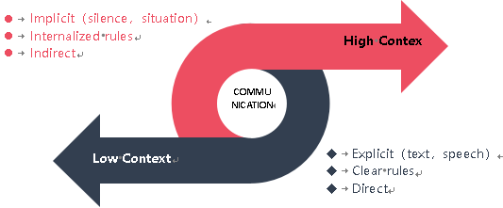
When communicating, we divide the scenarios into two categories, one is low and the other is high. Hall's high-background vs. low-background framework, despite some weaknesses, provides a useful and widely used starting point for assessing cultural differences. Through the framework analysis, it can be seen that both the UK and China belong to high-background cultures, so we focus on the analysis and research of high-background communication cultures, so that we can better communicate and build relationships with China.
A high-context communication culture emphasizes that in many cases, the situation, information, and meaning of communication are not determined by what you say, words, and sentences, but by situational factors such as the way you express yourself, gestures, intonation, and speed of speech. In a high-context communication culture, the meaning of communication is largely indirect, and the words and sentences expressed are often indirect, and to a large extent only a small part of the message to be conveyed, and the rest must be supplemented by the understanding and understanding of the audience. This will be based on the audience's understanding of the communicator's context, sensitivity to the communication situation, and the use of other external information. There is an old Chinese saying that "silence is better than sound at this time", "drums do not need to be hammered", "everything is in silence", etc., which refers to this high-situation communication style. A low-context communication culture emphasizes that the way of communication is direct and clear, and its meaning should be expressed directly by words, and the audience can understand the meaning of the other party from the words spoken and used by the communicator without reprocessing the context and situation. In China's high-background culture, we need to pay attention to the ways, methods and strategies of communication. This requires us to pay attention to the following aspects:
1) Pay attention to the way you communicate
To establish a business relationship in a high-context cultural environment, it is often necessary to follow the communication conversion process from easy to difficult, from indirect to direct, and only when both parties know and are familiar with each other will the purpose and key points of business communication be directly given. In formal business communication, especially in China, where people speak in a high-profile culture, there is often a lot of foreshadowing, and the opening remarks are usually greetings and thanks. Therefore, we need to express the strengths and strengths of our brand in a humble way, and we must emphasize respect for each other and the mutually beneficial goal of cooperation between the two parties.
2) Master and understand a variety of communication styles
Business interactions in high-context cultures depend on the other person's expression and mood, so we need to master the use of non-verbal skills to understand the inner needs of the other party. Because people in high-context cultures use non-verbal means such as gestures, gestures, gaze, and facial expressions to convey information. Compared with people in low-context cultures, Chinese pay more attention to non-verbal behaviors, and therefore more sensitive, which makes them pay more attention to the nonverbal behavior of the other party, not just the other person's speech.
People in China's high-context culture usually pay attention to some subtle, extended meanings. In other words, Chinese people can easily detect differences between each other's words and intentions. Even subtle situational factors can give him sensitive information, such as neatness, organization, and enthusiasm in business meetings, which will be understood as sincerity and readiness to cooperate, while for people in low-context cultures, these details are generally less likely to be interpreted as meaning directly related to the task of business communication.
3) Empathy
Try to put yourself in someone else's shoes as you would be able to see the whole problem and the situation. There are individual differences in every culture, and even in high-context cultures, not all people are high-profile communicators, but many are low-context communicators. When we encounter such a situation, we need to be good at understanding, change our approach, and think more from the perspective of others. In China, for example, there are many rules about what not to do and what to do.
But in reality, the meaning behind the rules may be more meaningful to them, and the things that are not prescribed may be the real message. For example, the understanding of business contracts can be adapted in China.
2.4 – Effective Communication
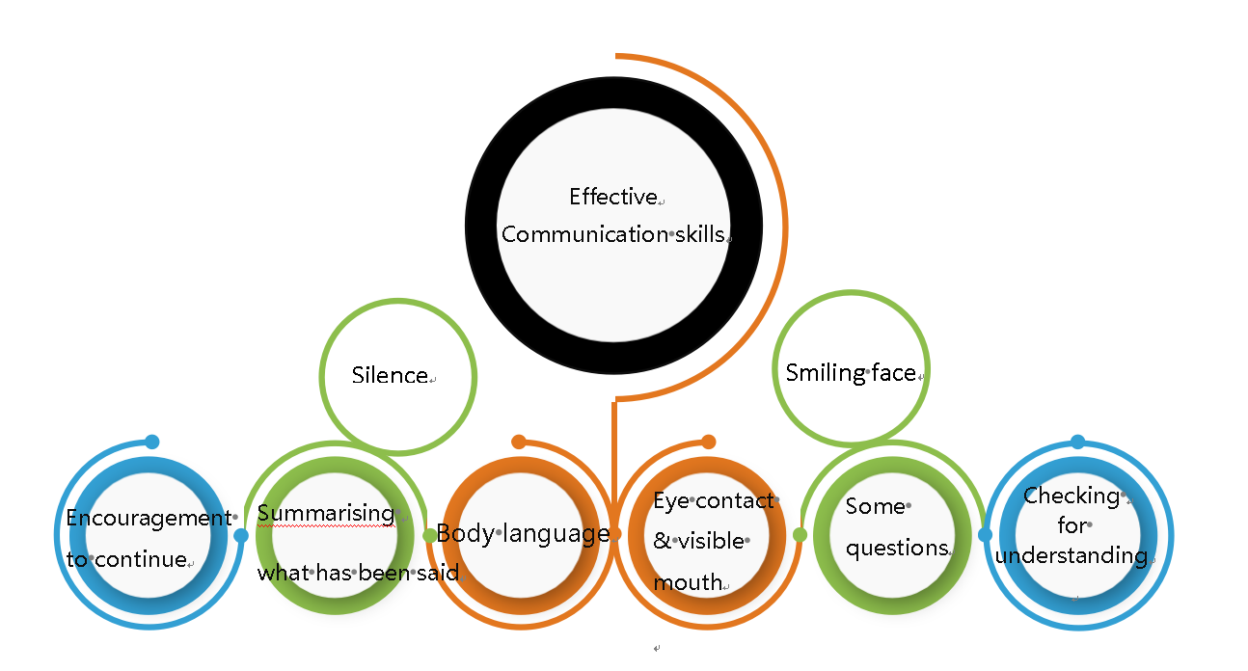
Communication is a two-way process. Although there are some difficulties in international business communication, by applying some successful strategies and techniques, we can better communicate across cultures and achieve effective communication. First, it is necessary to fully understand and study different cultural backgrounds, including language, etiquette, values, and behavioral norms. Understanding the differences between cultures helps us better understand the actions and intentions of others and avoid conflicts due to cultural differences
Second, we should keep an open mind and respect each other's cultures. Although we may disagree with each other's views or practices, we should respect and understand their cultural backgrounds. By showing respect and understanding, we can build trust and promote better intercultural communication
In addition, we can also apply some effective communication skills, such as listening and clear awareness. Listening to each other's perspectives and giving them attention helps build a good relationship. Be clear about the purpose and intent of the communication to avoid ambiguity and misunderstandings. The most important technique is to use non-verbal and body language. These include facial expressions, posture, and eyes, among others. Through the use of non-verbal communication, we can deepen our understanding and empathy for conversations.
Finally, we should be flexible enough to adapt to the cross-cultural environment. In intercultural communication, we may need to adapt our ways and methods to suit the needs and preferences of different cultures. This requires us to be adaptable and flexible to ensure smooth communication.
2.5 – International Culture
Professor Geert Hofstede once defined culture as a "common mental process" of people in the same environment. Culture, therefore, is not an individual trait, but a mental program shared by many people with the same social experience and the same education. The reason why people in different groups and different countries or regions have different common mental programs is that they have always received different educations, different societies and jobs, and thus have different ways of thinking. Hofstede created a framework of knowledge centered on intercultural communication in the 1980s, called Hofstede's theory of cultural dimensions. Together, these dimensions depict the impact of deep-rooted cultures on the values of members of their own society, and they also use structured weight analysis to describe the relationship between these values and people's behavior. In other words, this set of theories explores the multiple dimensions of culture and provides a scoring system that can be used as a comparison of dimensions.
For River Island to do international business, the theory of cultural dimensions is crucial. Understanding the different perspectives of how business issues are viewed in different cultures can help managers successfully understand and succeed in the international business market. Understanding the peculiarities of different cultures is very important for intercultural communication. If we do not understand the characteristics of the other party's culture, misunderstandings and communication barriers may arise, so it is necessary to pay attention to the characteristics and differences of the other party's culture in cross-cultural communication. Always keep in mind that a cultural discussion is necessarily a generalized discussion (sometimes referred to as a "prototype" or "cultural model"), so a particular culture's "score" does not necessarily represent the values of every member of that community.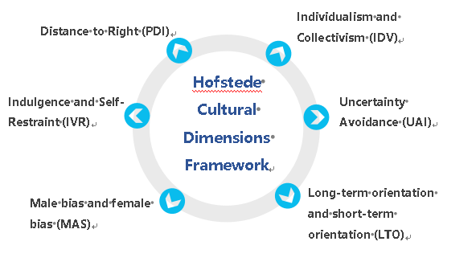
Power Distance (PDI): The degree to which people with low status in a given society accept the unequal distribution of power in society or organization, authoritarian vs. democratic. For example, if the British meet the British Prime Minister on the subway, they will think that it is very common, and the opposite is unimaginable in China, which is a manifestation of the low power distance in the United Kingdom.
Individualism and Collectivism (IDV): Whether a society as a whole is concerned with the interests of the individual or the collective. In an individualistic culture, people pay more attention to individual feelings, while in a collectivist country, they pay more attention to the feelings of the family and team.
Uncertainty Avoidance (UAI): refers to whether uncertainty is avoided and controlled through formal channels when society is threatened by uncertain events or unconventional environmental conditions.
Long-term orientation and short-term orientation (LTO): The degree to which members of a culture are comfortable with delaying the fulfillment of their material, emotional, and social needs. Or whether these people have a tendency to judge their behavior in a future-oriented way.
Male Biased and Female Biased (MAS): Whether a society represents more male qualities such as competitiveness and assertiveness, or female qualities such as modesty and caring for others. The term "masculine or feminine" is also translated as masculine, which does not refer to a simple gender, but to a quality that represents a man and a quality that represents a woman.
Indulgence and self-restraint (IVR): The degree to which a society allows basic human needs and the desire to enjoy life's pleasures.
Understanding cultural and human differences through Hofstede's six dimensions: According to GeertHofstede, culture can be defined as the collective programming that determines people's thoughts and behaviors, and it is this collective process that distinguishes one type of person from another. The word "class" here may mean country, religion, ethnicity, region (part of a country or an area across countries), gender, organization, or occupation.The following data sources:hofstede-insights.com.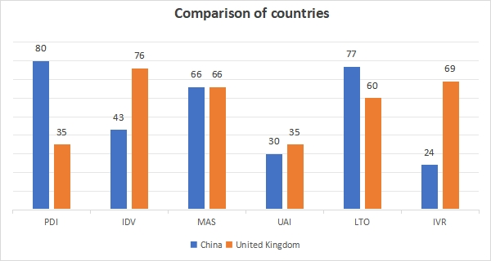
China is ranked 80th in the PDI rankings: inequality between people is an acceptable society. The relationship between subordinates and superiors is often polarized, and there is no defense against abuse of power by superiors. Individuals are influenced by formal authority and sanctions, and are generally optimistic about people's leadership and initiative. People should not have ambitions that go beyond their rank.
China ranks 43rd in the IDV rankings: collectivism is a traditional and mainstream value, and the interests of the state, society, and the collective take precedence over individual interests.
This means that the cultural values of China and the UK are not completely different and completely opposed, but that similarities can be found. On the other hand, it can also be seen that both Chinese and British culture have their diversity and complexity, and these six cultural dimensions do not necessarily reflect the depth and breadth of Chinese and British culture. However, in any case, the cultural dimension model provides an important reference and basis for the comparative study of Chinese and British cultures. It also provides an effective reference for our brand to establish cooperation with China.
2.5.1 - Trompenaar’s 7 dimensions to culture
Hofstead's cultural analysis framework is one of the most complete and systematic cultural analysis models in the field of international business management research, which is a powerful tool for us to understand cultural phenomena and their impact on management. But its cultural model is not perfect and has certain limitations.First of all, culture consists of two parts: the subtle part of values and the part of easily perceptible patterns of behavior. Models provide a powerful tool for people to recognize and understand the values part of culture that is necessary for people to recognize and understand culture. However, the cultural values part is not imperceptible, and it must be analyzed and judged through the perceptible external behavior patterns, and the model does not provide a powerful tool for people to recognize and understand the behavior patterns of culture. The Hofstander model is only applicable to the level of national culture, and is not fully applicable to different levels of culture, such as the analysis of corporate culture as a subculture; Second, Hofstead's study of culture is a static study that does not involve an analysis of the evolution of culture and the factors that affect the change of cultural values, and his research is mainly aimed at managers, not employees.
Management consultants Fons Trompenaars and Charles Hampden-Turner have spent 10 years researching people's preferences and values in dozens of cultures around the world. Their samples were more balanced in gender and background than Hofstede's. They concluded that cultural preferences differed from each other in seven ways.
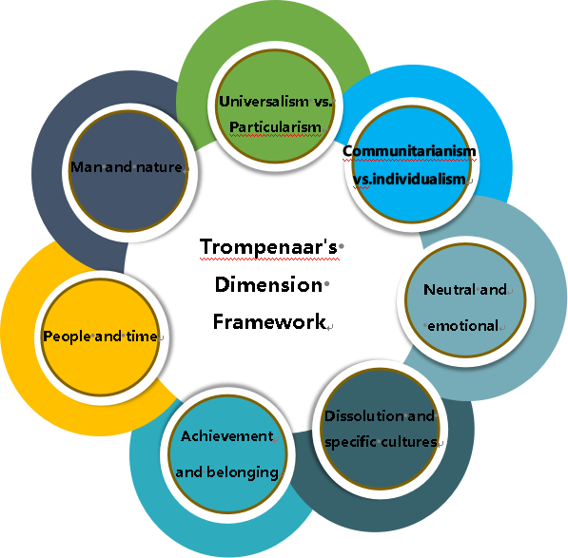

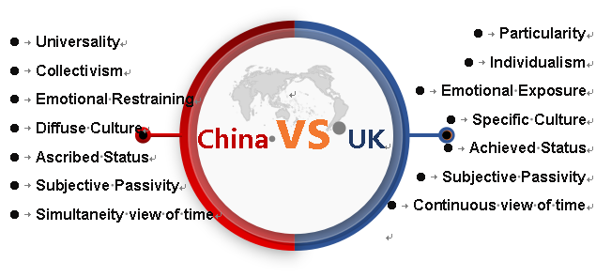

2.6 – Importance of Building Relationships
Successful international business relationships depend on the development of trust, so building relationships is the best way to overcome the many obstacles to doing business in China and is critical to River Island's success in expanding its business impact in China. Different cultures perceive trust in different ways. Pragmatic, task-oriented Americans are likely to trust someone based on their skills, track record, and letters of recommendation. For cultural reasons, China uses interpersonal relationships as the basis of business, and these relationships are based on personal honor, filial piety, friendship, or long-term acts of mutual benefit (favor). On the other hand, South Americans and Arab cultures, who are usually more emotional, trust someone because they like them, they have established common ground, and they feel rapported.
2.7 – How to build Trust
Building trust and cooperation in a cross-cultural environment is a complex and critical issue, especially in the era of globalization, where collaboration between multinational corporations is becoming more common. Here are some suggestions for building cross-cultural trust and cooperation in River Island China: first, understand the cultural differences between China and the UK to avoid misunderstandings and conflicts; Then you need to establish good communication, express your opinions clearly, listen to the other party's point of view, and pay attention to the other party's tone and expression; Then there is the need to establish common interests, we need to find common ground and discuss how to achieve our goals together, by establishing common interests, we can better understand each other's needs and values, so as to build a stronger trust and cooperative relationship. Finally, we need to respect each other's cultural differences, we need to avoid discrimination or denial of each other's culture, but should respect each other's cultural background and habits.
2.8 – Failed Relationships
1) The cooperation agreement is not clear
Statistically, China and the UK belong to a low-uncertainty aversion culture, but in fact, China is more in line with the description of a high-uncertainty avoidance society. The "not fighting unprepared battles" and "being prepared for danger" that the Chinese often say actually reflect China's high degree of uncertainty avoidance. Although China is a high-situation culture, in order to avoid ambiguity, Chinese people have a strong dependence on various written regulations, rules, and plans, and the pursuit of stability is very strong.
2) Placing too much emphasis on business etiquette
Although gift-giving is unavoidable in business dealings, and the predominant Confucianism in Chinese culture says that this business etiquette is not excluded in China, there is a strong sense of exclusivity in China's cultural context, and distrust of "outsiders" is widespread, which poses challenges to building relationships with local business partners, customers, and customers. And because of the size of China, subcultures and people vary from place to place, and the situation in cities varies from region to region. Putting too much emphasis on business etiquette can be seen as a sign of incompetence, so it is necessary to "get to the point".

3.0 – Conclusions
Cultural differences can have a real impact on River Island's international business communication. Problems caused by cultural differences can arise in work, communication, and many other areas. However, if business leaders and even employees understand the theory of the cultural dimension and can actively understand and master multiple types of communication, then problems can be analyzed from different angles and necessary measures can be taken to solve them.
4.0 – Recommendations
Relationships: Chinese value friends, relatives, and people in their own circle. Chinese do business with relationships as the first element, and it seems that Americans are very good at studying Chinese culture.
Intermediaries: Chinese are wary and suspicious of strangers, so when conducting business exchanges in China, there must be an intermediary as a link between the two parties.
Social hierarchy: For Chinese culture-influenced by Confucian culture, rank is very important, and the corresponding position level is always selected at the negotiation table to negotiate. If the Chinese general manager is to attend the negotiations, the general manager of the American company must also attend the negotiation in person.
Harmonious relationship: Chinese people are making friends while doing business, so instead of separating business from friends, they put them together. For Westerners, if you don't want to make friends, then sorry, this negotiation may be difficult to go on.
Overall concept: The overall concept of the Chinese is very strong, mainly because the Chinese hieroglyphs have achieved this characteristic of the Chinese. Michael Harris Bond, a professor of psychology at the University of Chinese Hong Kong, has published a research article on Chinese characters, in which he says that Chinese hieroglyphs are like pictures, and that Chinese children have to recognize thousands of hieroglyphs when they are young, which makes Chinese have a strong sense of wholeness when looking at pictures.
Thrift: The Chinese have a tradition of frugality, which is more evident in business negotiations, and bargaining with the Chinese is a painstaking process, often Chinese have to think carefully and discuss for a long time before they are willing to make concessions on price.
Face: In Chinese culture, a person's face represents his social status and honor. If you don't respect the Chinese's face psychology and embarrass the Chinese negotiators, even if you don't mean to, the entire business negotiation will suffer a lot of losses.
In conclusion, there are huge economic benefits involved in international business communication, so the people involved must be knowledgeable and have certain communication skills. Put the interests of both parties first and strive to achieve a win-win situation.
References
- Hofstede, G et al. (2010) Cultures and organizations: software ofthe mind, P. 561.
- Gilsdorf, J. (2002) Standard Englishes and World Englishes: Living with a Polymorph Business Language, pp. 364-378.
- Carte, P. (2008) Bridging the culture gap (electronic resource) : a practical guide to international business communication, p.216.
- Gumussoy. (2020) Intercultural awareness, communication, and empathy skills in nurses and midwives working in provinces with mass migration, pp. 430-432.
- Marcel, P. (2020) Critical Success Factors in Computer Aided Intercultural Business Communication Course, pp. 143-165.
- Xiaoting, X. (2019)An analysis of effective strategies under international business cooperation, pp. 85-103.
- Ling, G. (2020) Language use and non-verbal communication in the context of intercultural communication, pp.78-91.
- Jingran, H. Silent communication of gaze, gestures, space and time – non-verbal communication in cross-cultural business communication, pp. 107-136.
- Hua, Z. (2019) Non-verbal Communicative Behavior in the Context of Intercultural Communication: A Cross-Cultural Comparative Analysis of Silence, pp. 46-59.
- Ling, Q. (2020) Research on the Differences and Countermeasures of Chinese and Western Business Etiquette from the Perspective of Cross-cultural Communication: Based on Behavior Analysis, p. 98.
- Pei, C. (2021) Research on the Differences and Countermeasures of Chinese and Western Business Etiquette from the Perspective of Cultural Communication: A Context-based Analysis, p. 140.
- Yan, A. (2008) Cultural Impact on the Localization Strategy of Multinationals' Website Messages and Enlightenment, p. 96.
- Xuejiao, S. （2012） A comparative study of the corporate culture of Coca-Cola and Wahaha from the perspective of cross-cultural communication, p. 84.
- Hyunjae, J.（2020）Cross-cultural comparison of interactivity and advertising appeals on antismoking web sites in the United States and South Korea, p. 116.
- Hong, Y. (2018) Analyze cross-cultural communication differences from a contextual perspective, p. 217.
- Kumi, K. (2019) A Cross-Cultural Trust Framework Based on the Law of Thinking: An Attempt to Synthesize Chinese Localization Thought and Western Theory, pp. 67-87.
- Lisa, D.(2018) Analyze the significance and limitations of Hofstede's cultural dimension, p. 249.
- Jeffrey, H. (2017) A Study on the Differences between Chinese and Western Business Etiquette Behaviors: Based on the High and Low Context Theory, pp. 239-242.
- Sawako, J. (2016) This paper explores the impact of cultural differences on business negotiation from the perspective of high and low contextual culture, p.316.
- Steffen, K. （2010) How high and low contextual cultures are formed and cultural communication differences, p. 317.
- Marie, C. (2017) The reasons for the emergence of low context in high context under Chinese culture, p. 83.
- Paretti, L. (2016) Two types of conversational communication in communication, p. 107.
- Ben, A. (2016) The causes and theoretical dissolution of cultural barriers between high and low contexts, pp. 214-216.
- Li, Y. (2021) Pragmatic Strategies for International Business Communication in the Context of Globalization: Based on the Perspective of Contextual Adaptation, p. 61.
- Yuan, S. (2020) The development history and future prospects of China's business culture in the context of globalization, p. 34.

