

Academic Discipline of Hospitality and Tourism Management

BA (Hons) International Hotel Management
BA (Hons) International Hotel Management (with placement year) Certificate of Higher Education International Hotel Management

BMIH6007

International Meetings Management for the
Hotel Industry LEVEL 6
Summer Term 2025
Module Lead: Kathryn Flynn
Assignment 1: Feasibility Plan for an International Meeting / Event. Individual

Student name and ID: Stefan-Berthland Tudor 2240407

Table of Contents
Introduction 3
Event Content and Context 4
Market Factors 5
Operational factors 7
Financial factors 8
Conclusion 11
References 12
Appendix 14

Introduction
- International event management requires careful consideration of different important activities such as planning, organising and execution of activities.
- Cuisine is the food preparation techniques and special food items from different countries.
- Wales is full of key attractions, including Cardiff Castle, Caernarfon Castle, Snowdonia National Park, the Wales Coast Path, and several others (Visit Wales, 2025)
The presentation will highlight the event planning process at Wales and the theme of the event will be “Guess the Cuisine? Cuisine challenges of Asian countries.” Different market factors along with the operational aspects will be described in this context briefly. The target customers and demand of such events will be evaluated in this presentation.

Event Content and Context
- The main content of the event will be the exploration of the cuisine challenges of different Asian countries.
- These countries include Japan, Thailand, South Korea, Indonesia, Malaysia and others (Gunarto et al., 2024).
- Maintaining food security and mitigating the changing customer preferences are the main problems faced by Asian cuisine (Sari et al., 2024).
- In this event, different food preparation from various countries will be presented and a meeting will be held explaining the challenges faced by the Asian cuisines.
Asian cuisine has different types of food preparation styles, and the perception of people about various countries' food is diverse (Cleveland et al, 2024). Several challenges are faced by Asian cuisine. The main theme of the event in Wales will be to “Guess the Cuisine? Cuisine challenges of Asian countries.”

Market Factors
Target Market
- STP model is a framework that helps to determine the target customers for any organisation or event (Grayson, 2023).
- The international tourists, under the geographic segment, will be the target customers for the proposed event.
- A marketing campaign will be arranged, explaining the main highlights of the event to position the offerings.
STP stands for segmentation, targeting and positioning (Ningrum and Hasmarini, 2024). Using this framework determining the potential customers for the event becomes easier (Thomas and George, 2021). The international tourists will be the main target of this event and geographic criteria (visitors coming outside the country) is mainly followed among several types of market segmentation.
Demand
- Value of the market of Asian food is 1,15,95,85,30,602.00 Pound sterling in 2023 (Market Research Future, 2025).
- The Asian food industry is expected to have a growth with a percentage of 7.20 as per the predictions of Market Future Research (2025).
- This type of event is necessary to conduct to reduce the misconceptions of people regarding various Asian food items.
The rising health awareness and the development of the culinary tourism are the reasons for increased value of the Asian food market (Marketresearchfuture, 2025). Therefore, the changing customer preferences of the customers worldwide, changes the demand or priority (Stanelyte et al., 2022). It is essential to have a comprehension about the challenges of Asian cuisine to improve the food offerings and develop culinary tourism.
Supply
- Different food events concerning Asian food items can be seen to be held worldwide.
- One of the prominent examples of such events is Taste of Asia, which is also considered as the celebration of innovation and growth (Globenewswire, 2025).
- The speciality of this particular event is that it combines, discussion, debate and food offerings in one event attracting the attention of the international tourists.
Several events focusing on Asian food items can be seen happening (Fan et al., 2021). Therefore, this proposed event is different in this manner, in that it not only offers different Asian food items but also arranges a discussion. The topic for discussion will be the challenges of Asian cuisines, and it will clear out the misconceptions that individuals have about different Asian food items.
Competition
- People are interested in knowing about the various Asian food items, and understanding the story behind their food preparation fulfils their requirements.
- Culinary competition and its offerings may hinder the popularity of this event.
- However, brining all the Asian food cuisines maintaining health standards and quality, taste along with the arrangement of discussion with the industry leaders will help to mitigate the high competition.
Several other food events relating to the culinary competition can give this event a string competition. Differentiating the offerings and the unique arrangements of this event will make it different from the other similar events. Welsh International Culinary Championship 2025, Worldchefs Congress & Expo 2026 are the examples of upcoming events that may hinder this event (Culinary Association of Wales, 2025).
Marketing activity
- A dedicated event website will be built to make the programme interesting.
- Both the traditional and online marketing channels will be used to create awareness about the event.
- A strong theme and unique messaging (in various languages) will be created for attracting international tourists.
For this event, a unique, engaging and attractive website will be prepared to provide the visitors with the necessary information they require. Therefore, as a marketing tactic, both traditional and online channels will be utilised. A strong messaging available in all preferred languages will be created to share in the marketing channels. Running advertising campaigns is the other effective strategy that will be followed to organise this event (Sodiqova and Qudratova, 2024).

Operational factors
Venue availability
- International Convention Centre Wales is a venue that has a 5,000-capacity (Gov.Wales, 2025).
- The event will be organised at that place as it is the most prominent and famous location in the UK, Wales (Visit Wales, 2025).
- The open space and 43,000 sq. ft area without pillars will be suitable for organising the event successfully.
Suitability of venue-Deciding venue is a challenging task while planning any kind of event. International Convention Centre Wales is the selected venue for this location as it is spacious and has good accessibility of all facilities (Meetinwales, 2025).
Skills required
- 300 staff will be recruited to organise the event successfully.
- The main skills that will be evaluated among the staff are good communication and interpersonal skills (Yang et al., 2024).
- Individuals with good knowledge of health and safety standards and people management skills will be hired.
Staffing requirements-300 staffs with the effective skills such as communication, interpersonal, problem solving and others will be recruited.
Skills required-Therefore, people with the good knowledge of people management, flexibility and adaptability will be appointed (O’Toole, 2011).
Resources
- Good catering services will be included to serve the food to the international tourists.
- Attractive lighting arrangements will be done to make the place pleasing.
- Parking facilities will be provided, keeping in mind the congestion and traffic of the city.
- Better seating arrangements and a comfortable banquet style will be followed for the international guests.
Resources allocation-Welcoming staff will be there to guide the international tourists in this event (Rogers and Moylan, 2022). Besides, the seating arrangements will be followed by a banquet style, keeping in mind the comfort of the tourists. Therefore, all other facilities related to lighting and parking will be implemented to enhance the appearance of the venue Fox et al., 2014).

Financial factors
Predicted breakdown of costs
Expenditure | Amount
Fixed Costs
Rent payable for event venue | £ 15,000
Event and venue insurance | £ 6,000
General and event administration expenses | £ 2,500
Marketing and promotional costs | £ 4,000
Machinery and equipment hiring costs | £ 8,000
Licenses and certifications for event | £ 2,500
Professional and solicitor expenses | £ 2,000
Total Fixed Costs | £ 40,000
Variable Costs
Cleaning and sanitation charges | £ 300
Telecommunication costs | £ 800
Stationeries office supplies | £ 250
Set up and decorative event costs | £ 7,550
Sound and lighting expenses | £ 5,300
IT set up costs | £ 3,000
Staff or personnel expenses | £ 30,000
Additional event volunteers | £ 4,000
Catering expenses | £ 13,300
Raw material purchases for food preparation | £ 8,000
Software and installation | £ 10,000
Transportation and travel expenses | £ 2,500
Miscellaneous expenses | £ 5,000
Total Variable Costs | £ 90,000
Total Expenditure | £ 130,000

Proposed income and expenditure table
Income | Amount | Expenditure | Amount
Sale of tickets for the event | £ 45,000 | Rent payable for event venue | £ 15,000
Sponsorships | £ 40,000 | Event and venue insurance | £ 6,000
Donations | £ 80,000 | General and event administration expenses | £ 2,500
 |  | Marketing and promotional costs | £ 4,000
 |  | Machinery and equipment hiring costs | £ 8,000
 |  | Licenses and certifications for event | £ 2,500
 |  | Professional and solicitor expenses | £ 2,000
 |  | Cleaning and sanitation charges | £ 300
 |  | Telecommunication costs | £ 800
 |  | Stationeries office supplies | £ 250
 |  | Set up and decorative event costs | £ 7,550
 |  | Sound and lighting expenses | £ 5,300
 |  | IT set up costs | £ 3,000
 |  | Staff or personnel expenses | £ 30,000
 |  | Additional event volunteers | £ 4,000
 |  | Catering expenses | £ 13,300
 |  | Raw material purchases for food preparation | £ 8,000
 |  | Software and installation | £ 10,000
 |  | Transportation and travel expenses | £ 2,500
 |  | Miscellaneous expenses | £ 5,000
Total Income | £ 165,000 | Total Expenditure | £ 130,000
Profit = £ 35,000

Funding sources
The funding sources, which have been chosen or decided for this event, involve two key elements, which are sponsorships and donations. An amount of £40,000 is expected to be generated from sponsorships whereas an amount of £80,000 is expected to be generated from donations.
Sources of revenue generation
This event is expected to generate a high level of revenue. The main source of revenue generation in the event is the sale of tickets. Each ticket for the event is anticipated to be around £150 and the entire venue capacity is 300. As a result, the expected revenue to be generated from the event is £45,000. Therefore, sale of event tickets is the main source of revenue for this event.

Conclusion
- In conclusion, Asian cuisines are becoming famous internationally and the it is facing several challenges such as misconceptions (about healthy and unhealthy ingredients).
- Therefore, maintaining health and safety standards becomes difficult due to increased demand.
The event will highlight this factor guiding the tourism businesses and erase the misconception of visitors about some food items.

References
Cleveland, M., Zhao, C.F. and Ghebrai, S. (2024) “I’m like, whatever you want me to be. I’m the flavor of the day”: A mixed-methods study of the food dispositions and behaviours of mixed-race individuals. Food Quality and Preference, 121, p.105259.
Culinary Association of Wales (2025)worldchefs congress & expo 2026. Available at:https://www.culinaryassociation.wales/worldchefscongressexpo26/(Accessed: 14 May 2025).
Fan, S., Teng, P., Chew, P., Smith, G. and Copeland, L. (2021) ‘Food system resilience and COVID-19–Lessons from the Asian experience’. Global Food Security, 28, p.100501.
Fox, D., Gouthro, M.B., Morakabati, Y. and Brackstone, J. (2014) Doing events research: from theory to practice. Routledge: Oxford
Globenewswire (2025) 2025 Taste of Asia, A Celebration of Innovation and Growth: Exploring the Future of Asian Food Brands in North America. Available at: https://www.globenewswire.com/news-release/2025/03/17/3044140/0/en/2025-Taste-of-Asia-A-Celebration-of-Innovation-and-Growth-Exploring-the-Future-of-Asian-Food-Brands-in-North-America.html (Accessed: 14 May 2025).
Gov.Wales (2025)Construction of International Convention Centre Wales begins. Available at: https://www.gov.wales/construction-international-convention-centre-wales-begins(Accessed: 14 May 2025).
Grayson, R. (2023) Target Market and Audiences. Foundations in Digital Marketing.
Gunarto, T., Ciptawaty, U., Yuliawan, D., Mahyudin, A., Pratama, A.D. and Wahyudi, H. (2024) ‘Comparison of energy consumption to economic growth in developing Asian and developed Asian countries’. International Journal of Energy Economics and Policy, 14(1), pp.264-271.
Market Research Future (2025) Global Asian Food Market Overview.Available at: https://www.marketresearchfuture.com/reports/asian-food-market-22100 (Accessed: 14 May 2025).
Meetinwales (2025) This is brilliance. This is ICC Wales. Available at: https://www.meetinwales.com/choose-wales/wales-for-associations/information-on-icc-wales (Accessed: 14 May 2025)
Ningrum, H.K. and Hasmarini, M.I. (2024) ‘Marketing Strategy Analysis Using STP Strategy (Segmentation, Targeting, Positioning) at PT. Berkah Ridho Cinta Indonesi’a. Income Journal of Economics Development, 4(1), pp.15-19.
O’Toole, W. (2011) Events feasibility and development: from strategy to operations. Elsevier: Oxford
Rogers, T. Wynn-Moylan, P (2022) Conferences and conventions: a global industry. 4th Edition. Routledge: Oxford
Sari, R., Muslim, M. and Ameliana, Y. (2024) ‘Strategies for Improving Local Food Security in Developing Countries.’ Advances in Community Services Research, 2(2), pp.98-110.
Sodiqova, N.T. and Qudratova, G.M. (2024) ‘ENTERPRISE MARKETING STRATEGY’. MODERN EDUCATIONAL SYSTEM AND INNOVATIVE TEACHING SOLUTIONS, 1(3), pp.259-265.
Stanelyte, D., Radziukyniene, N. and Radziukynas, V. (2022) ‘Overview of demand-response services: A review’. Energies, 15(5), p.1659.
Thomas, M.R. and George, G. (2021) ‘Segmenting, targeting, and positioning (stp) ofgenerational cohorts Y, Z and Alpha.’ IIMS Journal of Management Science, 12(2), pp.115-129.
Visit Wales (2025) 870 miles to enjoy along the Welsh coast. Available at: https://www.visitwales.com/things-do/nature-and-landscapes/discover-wales-coast-path (Accessed: 14 May 2025).
Visit Wales(2025)Things to do. Available at:https://www.visitwales.com/things-do(Accessed: 14 May 2025).
Yang, D., Ziems, C., Held, W., Shaikh, O., Bernstein, M.S. and Mitchell, J. (2024) ‘Social skill training with large language models’. arXiv preprint arXiv:2404.04204.

Appendix
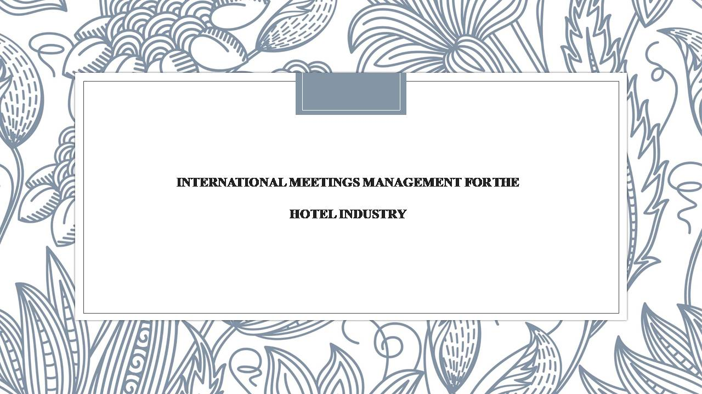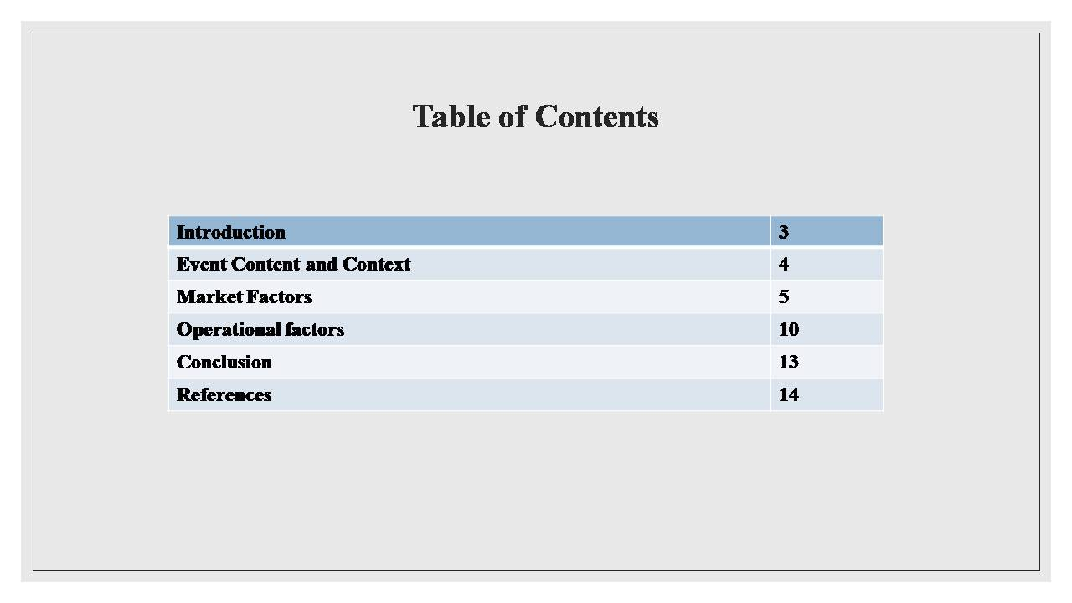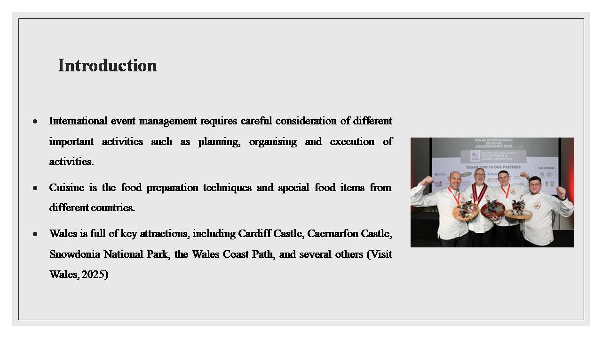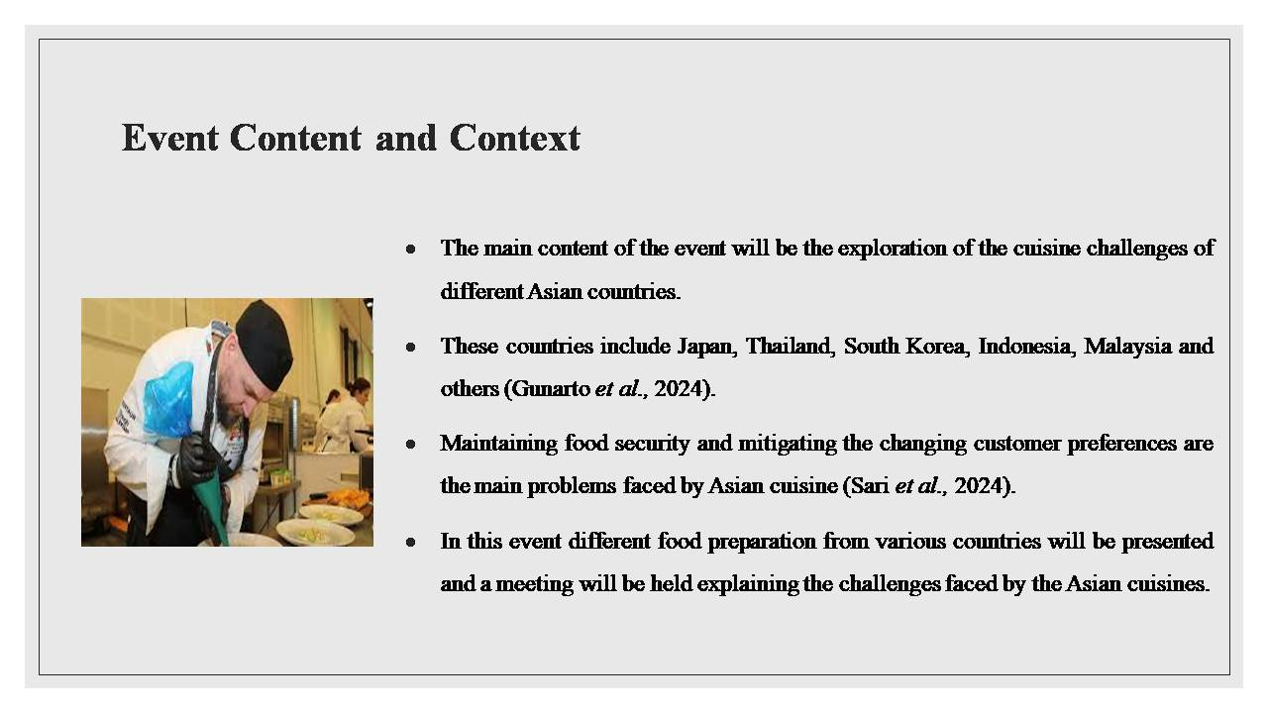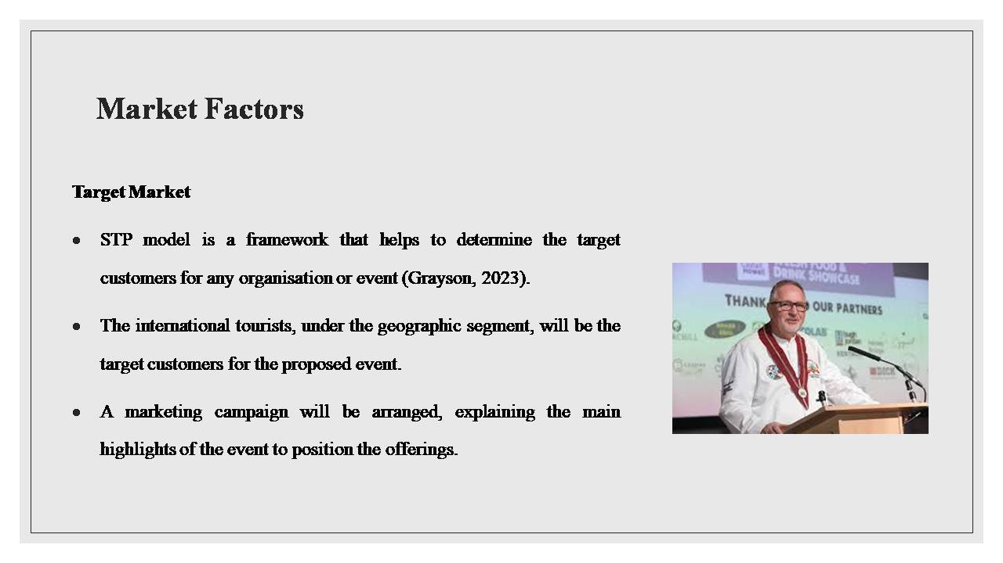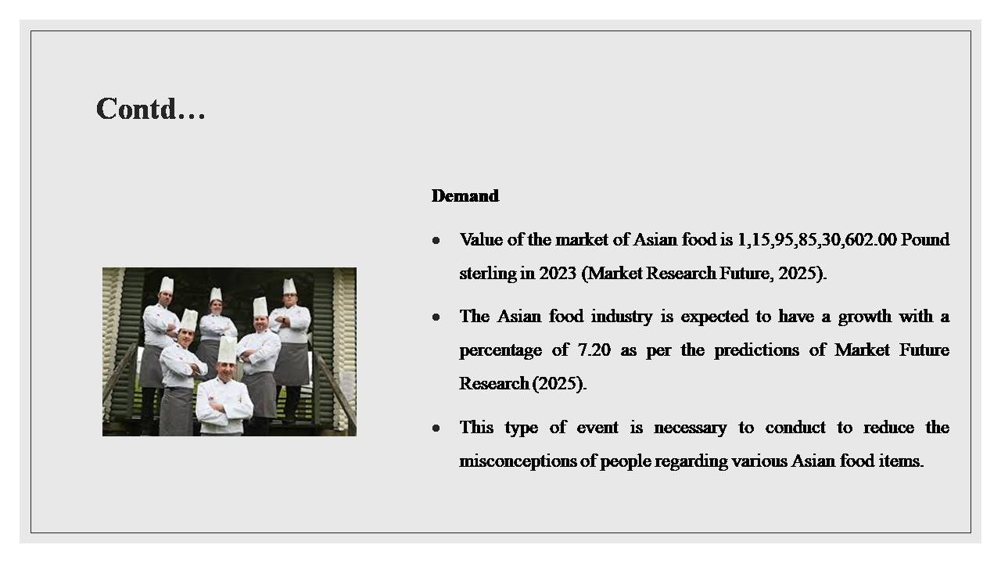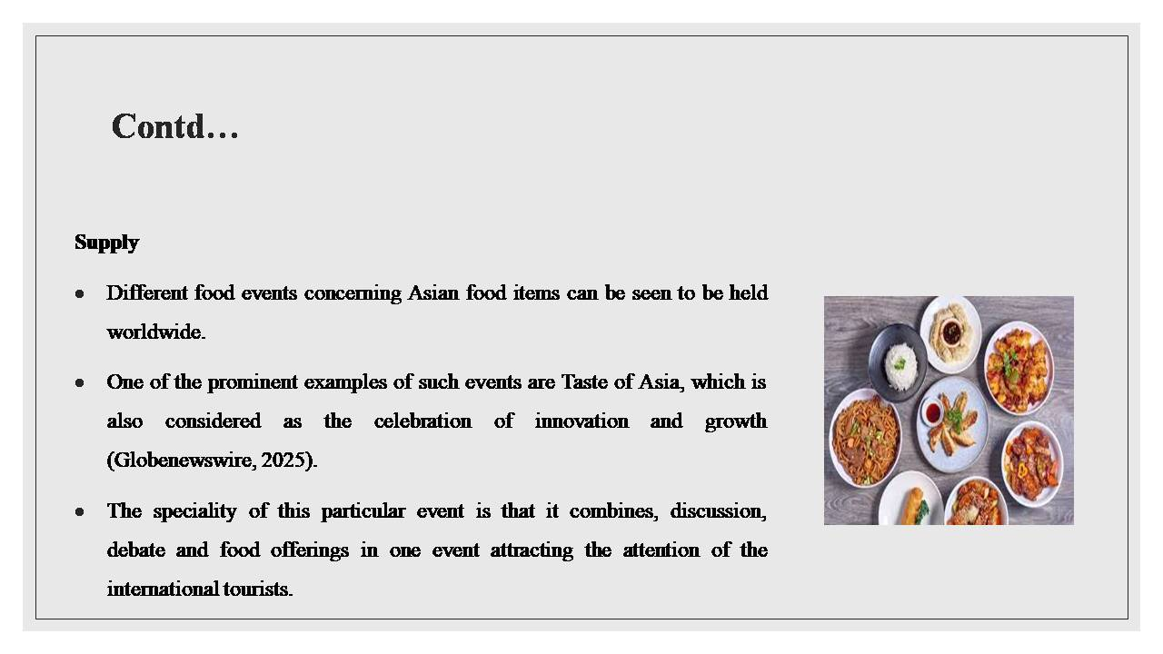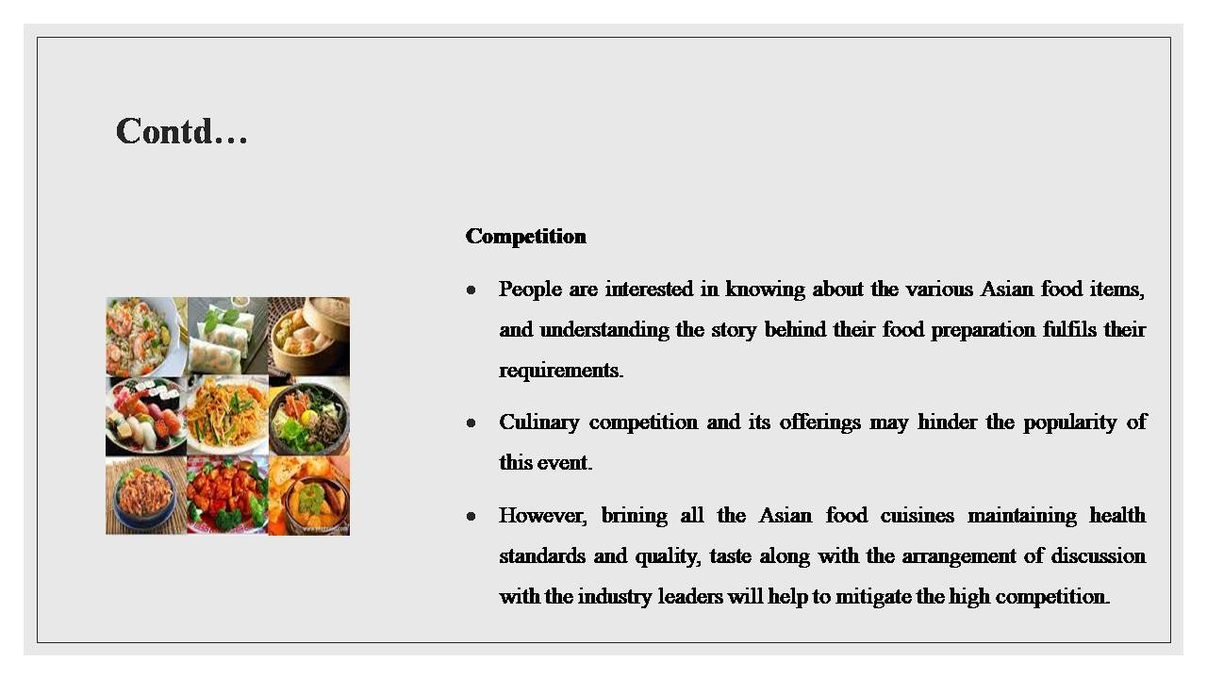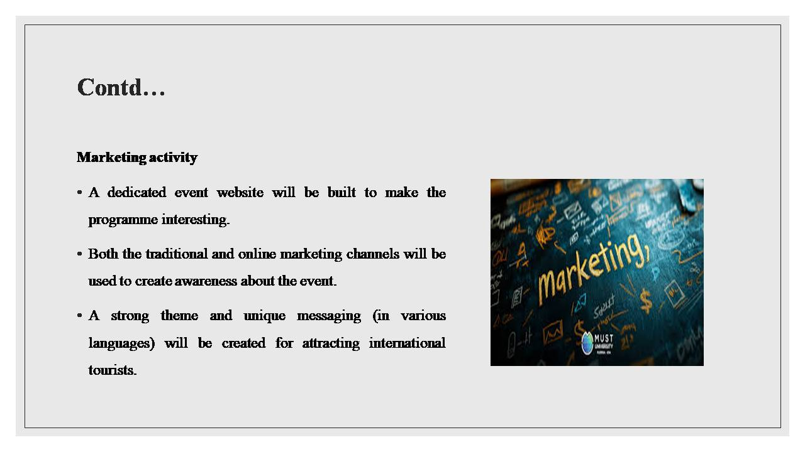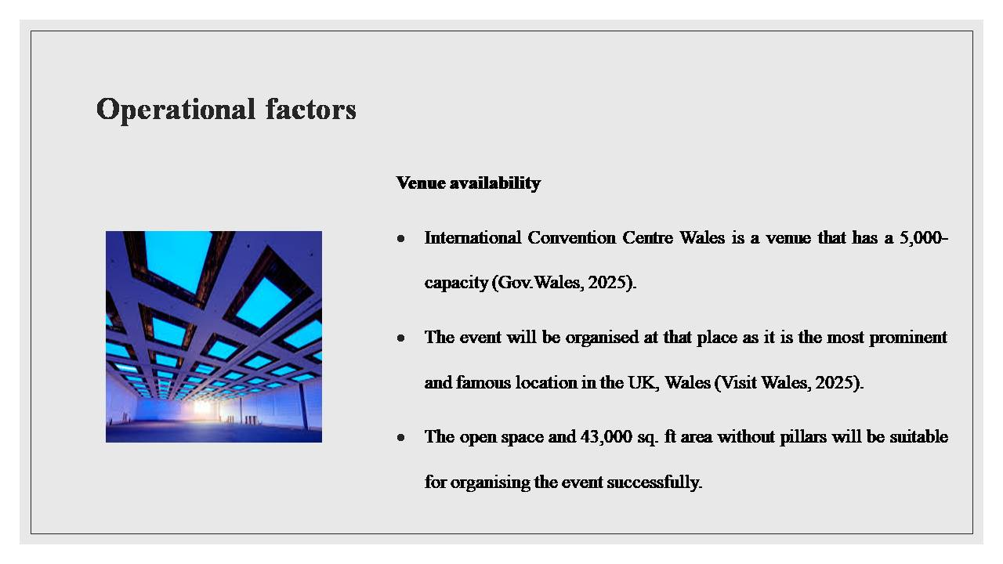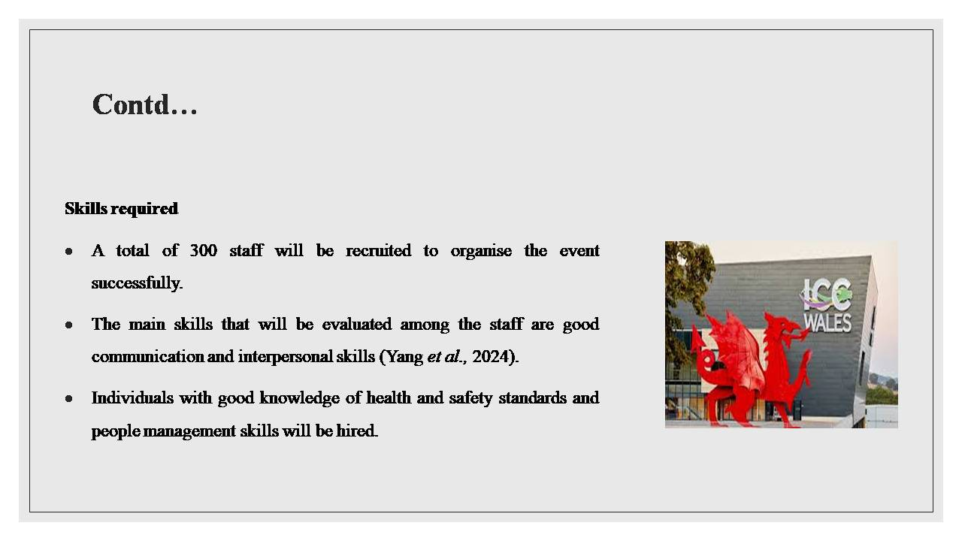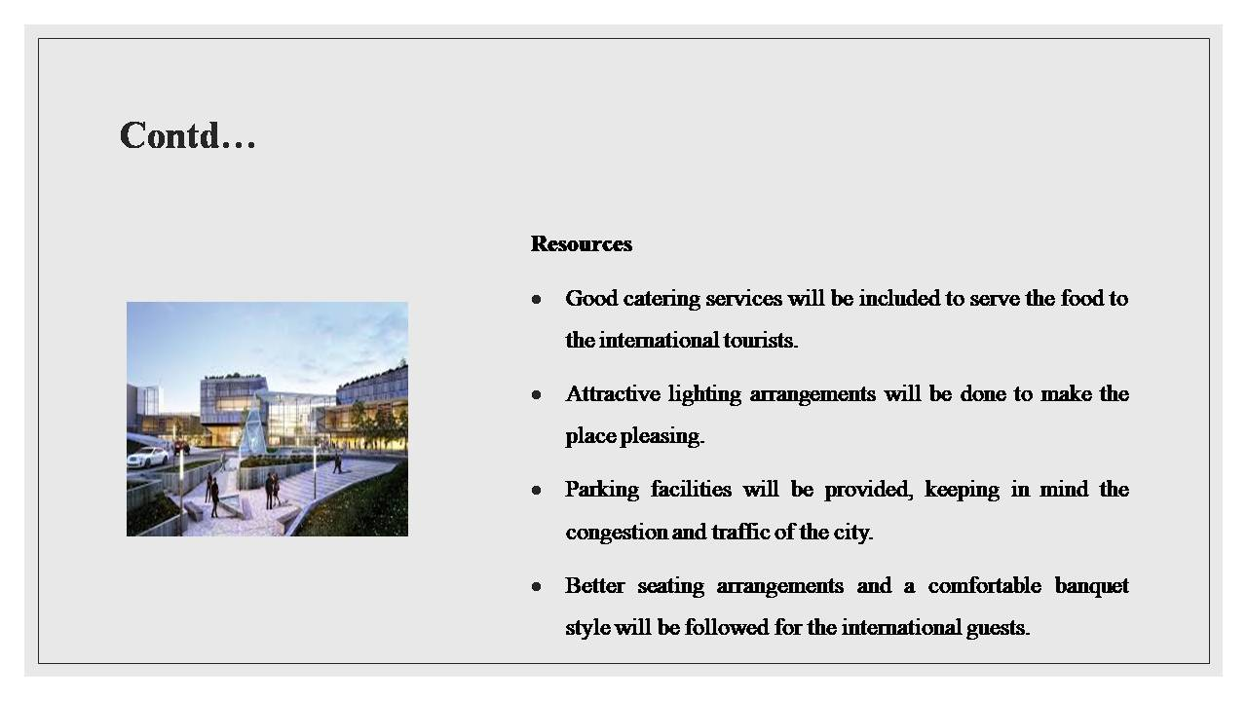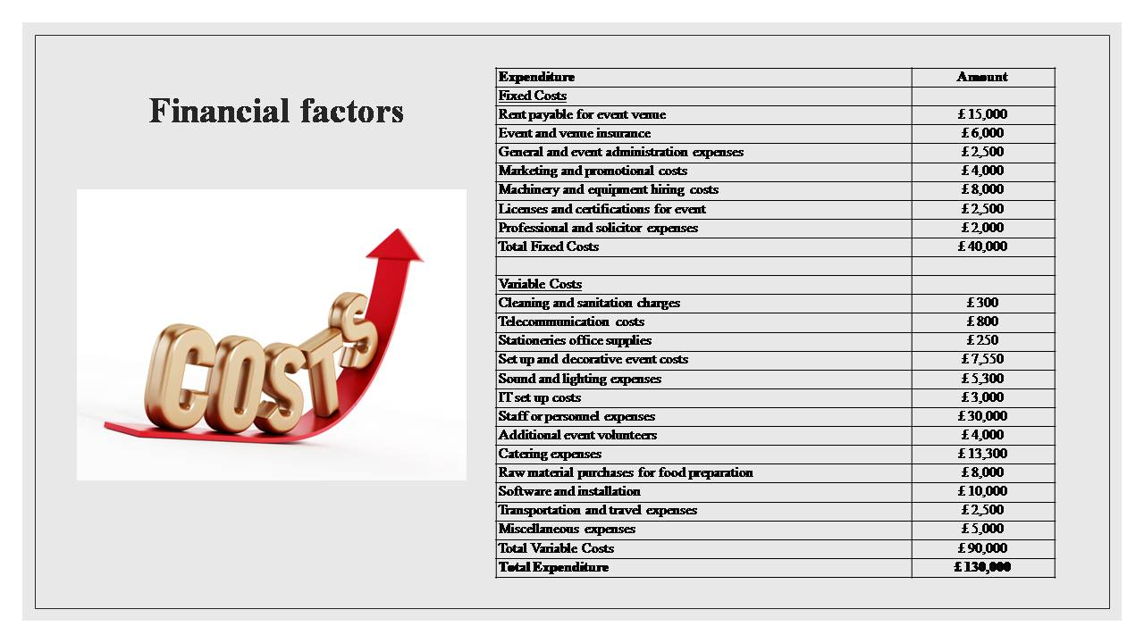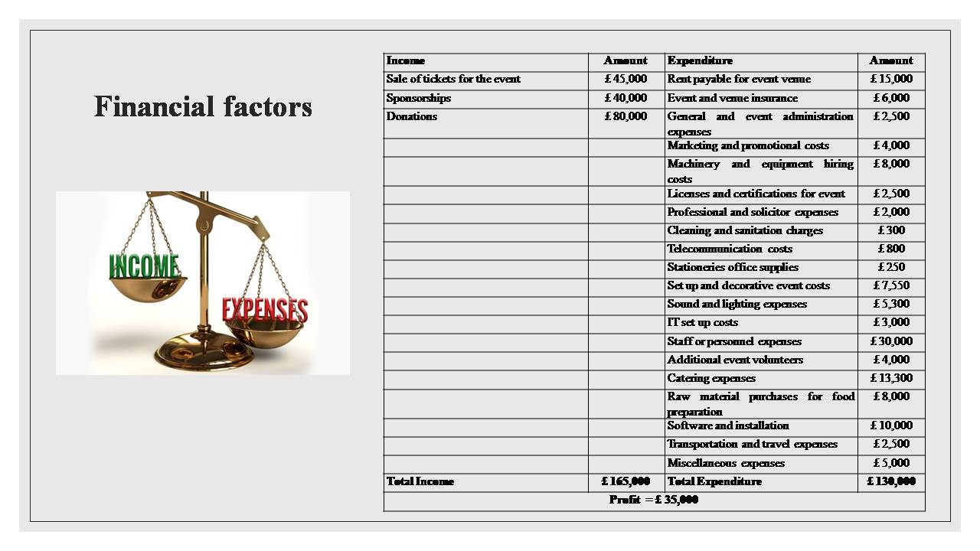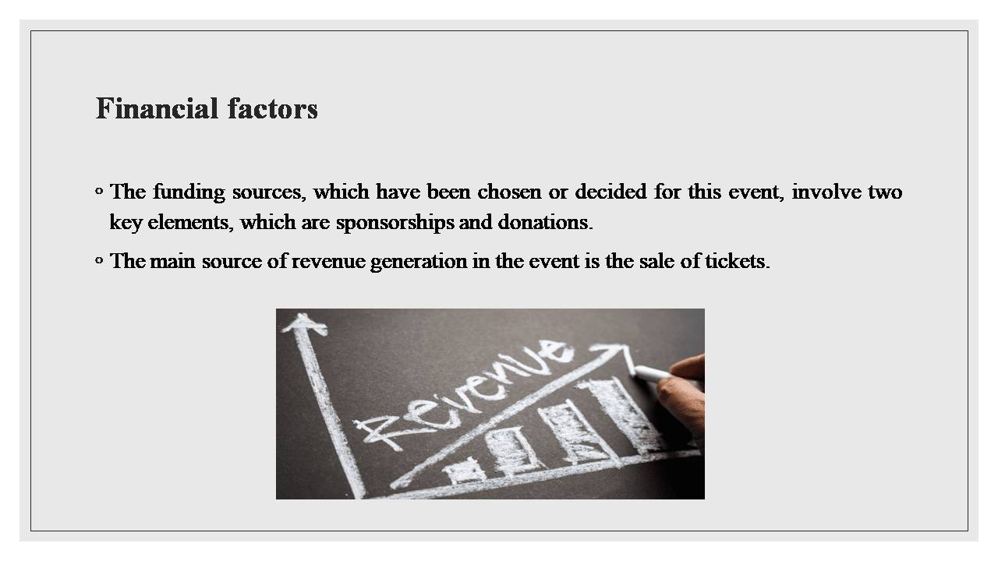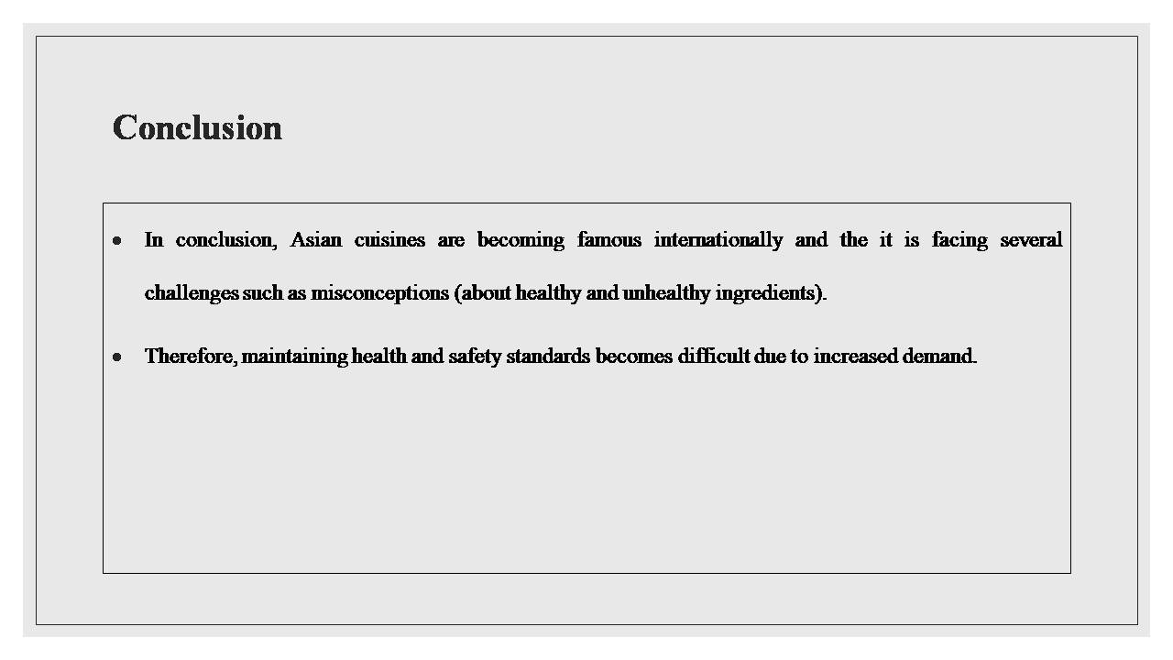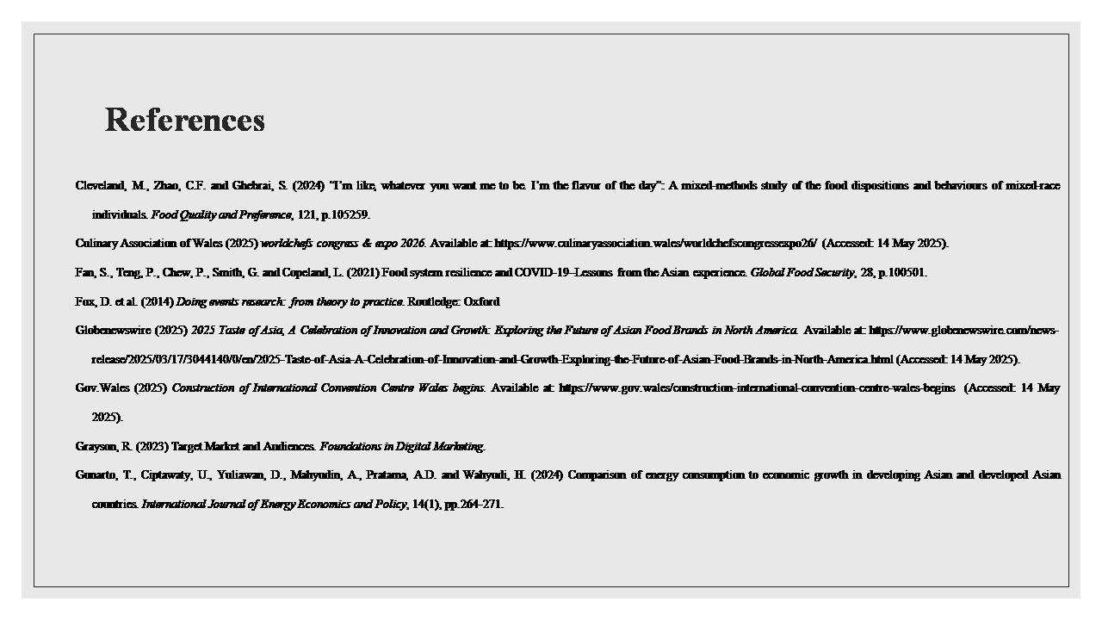
I declare that this assignment is all my own work and that I have acknowledged all materials used from the published or unpublished works of other people. All references have been duly cited. No software tools including Generative AI (GAI) applications has been used in developing and completing the assessment.

