Lab – Understanding Ethernet Cable Standards
Topology
Addressing Table
Device | Interface | IP Address | Subnet Mask | Default Gateway
PC-A | NIC | 192.168.10.1 | 255.255.255.0 | N/A
PC-B | NIC | 192.168.10.2 | 255.255.255.0 | N/A
Objectives
Part 1: Analyze Ethernet Cabling Standards and Pinouts
Part 2: Build an Ethernet Crossover Cable
Part 3: Test an Ethernet Crossover Cable
Background / Scenario
In this lab, you will build and terminate an Ethernet crossover cable and test it by connecting two PCs together and pinging between them. You will first analyze the Telecommunications Industry Association/Electronic Industries Association (TIA/EIA) 568-A and 568-B standards and how they apply to Ethernet cables. You will then construct an Ethernet crossover cable and test it. Finally, you will use the cable you just constructed to connect two PCs together and test it by pinging between them.
Note: With autosensing capabilities available on many devices, such as the Cisco 1941 Integrated Services Router (ISR) switch, you may see straight-through cables connecting like devices.
Required Resources
- One length of cable, either Category 5 or 5e. Cable length should be 0.6 to 0.9m (2 to 3 ft.)
- 2 RJ-45 connectors
- RJ-45 crimping tool
- Wire cutter
- Wire stripper
- Ethernet cable tester (optional)
- 2 PCs (Windows 7 or 8)
- Analyze Ethernet Cabling Standards and Pinouts
The TIA/EIA has specified unshielded twisted pair (UTP) cabling standards for use in LAN cabling environments. TIA/EIA 568-A and 568-B stipulates the commercial cabling standards for LAN installations; these are the standards most commonly used in LAN cabling for organizations and they determine which color wire is used on each pin.
With a crossover cable, the second and third pairs on the RJ-45 connector at one end of the cable are reversed at the other end, which reverses the send and receive pairs. The cable pinouts are the 568-A standard on one end and the 568-B standard on the other end. Crossover cables are normally used to connect hubs to hubs or switches to switches, but they can also be used to directly connect two hosts to create a simple network.
Reflection:
Write a research report (Max word count 600) on Cat 5e and 6 Ethernet cable standards.
Table 1: Cable Comparison
As described in the EIA/TIA-586 standards, there are 5 grades of UTP (Unshielded Twisted Pair) cabling, which include Cat 3 and Cat 4. There are three typical cables used in modern networking, as shown in table 1. [1, 2, 3]
Cat 5 is a common networking cable which is still used throughout some networks. It consists of four twisted pairs of 24-gauge copper wire, the wire comes as either solid or stranded, the solid is designed for transmitting data further, whereas the stranded cat 5 are more flexible/durable and are used for local uses such as residential premises. However, due to the limited throughput capacity of only 100Mbps, this cable category has become obsolete. [1, 2, 3]
Cat 5e is the successor to the Cat 5. Much like the Cat 5, Cat 5e cables use the same RJ45 connector. Cat 5e cable main difference from the Cat 5 is the increased speed capacity through the cable. The cable has a significantly improved throughput capacity of 1000Mbps or 1Gbs and the cable pairs have a reduced crosstalk, further improving the cables overall performance. Cat 5e stranded is currently the most commonly used cable within a household. [1, 2, 3]
Cat 6 cabling also uses the common RJ45 connector. Cat 6 networking cable have some improvements over both the Cat 5 and Cat 5e cables. It has a fast throughput capacity of 1000Mbps, much like the Cat 5e. Cat 6 cables also have an improved bandwidth of 250MHz. The cable consists of four twisted pairs of 23-gauge copper wire, opposed to the 24gauge in Cat 5/e, it also has an interior isolator which further reduces noise/crosstalk. The Cat 6 cable does however cost much more than both Cat 5 and Cat 5e and is typically used for industrial application. However, it is now being adopted for residential applications. More expensive Cat 6 cables also have additional defense against crosstalk by using a shielding insulated. Typically, this consists of each twisted pair being wrapped with an insulated foil and the 4 pairs are then further wrapped with a braided layer. [1, 2, 3]

References

[1] | B. A. Oliviero, Cabling Part 1: LAN Networks and Cabling Systems, Indianapolis, Indiana: John Wiley & Sons. Inc, 2014.
[2] | B. Sandberg, Networking The Complete Reference, Third Edition, McGraw-Hill Education., 2015.
[3] | B. Woodward, Cabling: The Complete Guide to Copper and Fiber-Optic Networking, Indianapolis, Indiana: John Wiley & Sons, Inc, 2014.

  - Analyze diagrams and tables for the TIA/EIA 568-A standard Ethernet cable.
The following table and diagrams display the color scheme and pinouts, as well as the function of the four pairs of wires used for the 568-A standard.
Note: In LAN installations using 100Base-T (100 Mb/s), only two pairs out of the four are used.
568-A 10/100/1000Base-TX Ethernet
Pin Number | Pair Number | Wire Color | 10Base-T Signal  100Base-TX Signal | 1000Base-T Signal
1 | 2 | White/Green | Transmit | BI_DA+
2 | 2 | Green | Transmit | BI_DA-
3 | 3 | White/Orange | Receive | BI_DB+
4 | 1 | Blue | Not Used | BI_DC+
5 | 1 | White/Blue | Not Used | BI_DC-
6 | 3 | Orange | Receive | BI_DB-
7 | 4 | White/Brown | Not Used | BI_DD+
8 | 4 | Brown | Not Used | BI_DD-

The following diagrams display how the wire color and pinouts align with an RJ-45 jack for the 568-A standard.
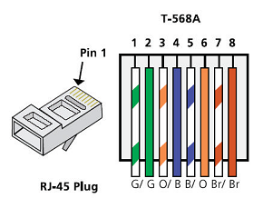
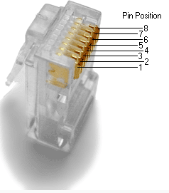
  - Analyze diagrams and tables for the TIA/EIA 568-B standard Ethernet cable.
The following table and diagram display the color scheme and pinouts for the 568-B standard.
568-B 10/100/1000-BaseTX Ethernet
Pin Number | Pair Number | Wire Color | 10Base-T Signal  100Base-TX Signal | 1000Base-T Signal
1 | 2 | White/Orange | Transmit | BI_DA+
2 | 2 | Orange | Transmit | BI_DA-
3 | 3 | White/Green | Receive | BI_DB+
4 | 1 | Blue | Not Used | BI_DC+
5 | 1 | White/Blue | Not Used | BI_DC-
6 | 3 | Green | Receive | BI_DB-
7 | 4 | White/Brown | Not Used | BI_DD+
8 | 4 | Brown | Not Used | BI_DD-
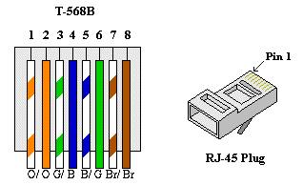

- Build an Ethernet Crossover Cable
A crossover cable has the second and third pairs on the RJ-45 connector at one end, reversed at the other end (refer to the table in Part 1, Step 2). The cable pinouts are the 568-A standard on one end and the 568-B standard on the other end. The two following diagrams illustrate this concept.
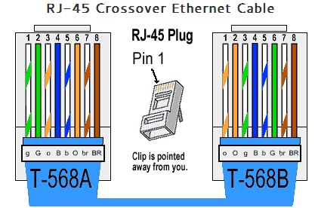
  - Build and terminate a TIA/EIA 568-A cable end.
    - Determine the cable length required. (Your instructor will let you know the cable length you should make.)
Note: If you were making a cable in a production environment, the general guideline is to add another 12 in. (30.48 cm) to the length.
    - Cut off a piece of cable to the desired length and using your wire stripper, remove 5.08 cm (2 in.) of the cable jacket from both ends.
    - Hold the four pairs of twisted cables tightly where the jacket was cut away. Reorganize the cable pairs into the order of the 568-A wiring standard. Refer to the diagrams, if necessary. Take as much care as possible to maintain the twists in the cable; this provides noise cancellation.
    - Flatten, straighten, and line up the wires using your thumb and forefinger.
    - Ensure that the cable wires are still in the correct order for the 568-A standard. Using your wire cutters, trim the four pairs in a straight line to within 1.25 to 1.9 cm (1/2 to 3/4 in.).
    - Place an RJ-45 connector on the end of your cable, with the prong on the underside pointing downward. Firmly insert the wires into the RJ-45 connector. All wires should be seen at the end of the connector in their proper positions. If the wires are not extending to the end of the connector, take the cable out, rearrange the wires as necessary, and reinsert the wires back into the RJ-45 connector.
    - If everything is correct, insert the RJ-45 connector with cable into the crimper. Crimp down hard enough to force the contacts on the RJ-45 connector through the insulation on the wires, thus completing the conducting path. See the following diagram for an example.
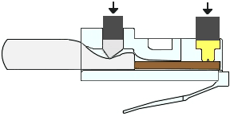
  - Build and terminate a TIA/EIA 568-B cable end.
Repeat steps 1a to 1g using the 568-B color wiring scheme for the other end.
- Test an Ethernet Crossover Cable
  - Test the cable.
Many cable testers will test for length and mapping of wires. If the cable tester has a wire map feature, it verifies which pins on one end of the cable are connected to which pins on the other end.
If your instructor has a cable tester, test the crossover cable for functionality. If it fails, check with your instructor first as to whether you should re-cable the ends and re-test.
  - Connect two PCs together via NICs using your Ethernet crossover cable.
    - Working with a lab partner, set your PC to one of the IP addresses shown in the Addressing Table (see page 1). For example, if your PC is PC-A, your IP address should be set to 192.168.10.1 with a 24-bit subnet mask. You partner’s IP address should be 192.168.10.2. The default gateway address can be left empty.
    - Using the crossover cable you made, connect the two PCs together via their NICs.
    - On the PC-A command prompt, ping the PC-B IP address.
Note: The Windows firewall may have to be temporarily disabled for pings to be successful. If the firewall is disabled, make sure you re-enable it at the conclusion of this lab.
    - Repeat the process and ping from PC-B to PC-A.
Assuming IP addressing and firewall are not issues, your pings should be successful if the cables were properly made.
Reflection
  - Which part of making cables did you find the most difficult?
Ensuring that the wires stayed in the correct location as they were inserted into the RJ-45 Plug, was difficult.
  - Why do you have to learn how to make a cable if you can easily buy pre-made cables?
Learning to connect the cables is critical for customized networking. In addition, it is a cheaper option than store bought

