Beatris Genadieva Gelkova
Student number: 2117954
Module Code: BMSW4003_BIRM
Lecture Name: Abdi Rahman

Research report
Module Title: Digital Skills and Research Methods

ABSTRACT

The motive of this part is to provide a general explanation to the importance of Research design and its application. The chapter start with clear introduction research question, methods, ethical considerations and explaining their meaning and giving examples on how they are used.

Document Content

- Introduction
- Research design
- Four types of characteristics research design
- Five types of research design
- Research question- Which digital tool is most commonly used for collaboration at UWTSD?
- Best online tools for collaboration
- Proposed Methods
- Ethical considerations
- Results
- Discussion
- Conclusion
- Reference List
- Appendix

INTRODUCTION

Research design is a structure of research questions, methods and techniques chosen by researcher. The design of a research topic explains the type of research, there are three main types of design for research: Data collection, Analysis and Report write-up research questions, methods and techniques chosen by researcher that meets of the main characteristics of a design.
There are four main characteristics- Neutrality, Reliability, Validity and Generalization. Also, you can break down the types into five categories. Descriptive research design, Experimental research design, Correlation research design, Diagnostic research design, Explanatory research design and Meta-analytic.
We discuss what research design are, why they are important and how to success professional.

Research design

The design is important because helps you to find methods which will match your research aims, collect high-quality data and you use the right kind of analysis to answer your questions. This allows you to find credible sources and trustworthy conclusion. Research makes as effective as possible by providing maximum information with minimum spending of effort, money, and time.

Four types of characteristics research design

- Neutrality: the result projected in the research should be free from bias and evaluate
- Reliability: your design should indicate how to form research question to ensure the standard of result
- Validity: However, the only correct measuring tools are those which help a researcher in gauging results according to the objective of the research.
- Generalization: The outcome of your design should apply to a population and not just a restricted sample.

Five types of research design

Descriptive research design is a type of research design that aims to obtain information to systematically describe a phenomenon, situation, or population. More specifically, it helps answer the what, when, where, and how questions regarding the research problem, rather than the why.
Experimental research is research conducted with a scientific approach using two sets of variables. The first set acts as a constant, which you use to measure the differences of the second set.
A correlational research design investigates relationships between variables without the researcher controlling or manipulating any of them.
Diagnostic research design: In a diagnostic research design, the researcher is trying to evaluate the cause of a specific problem or phenomenon. This research design is used to understand more in detail about the factors that are creating problems in the company
Explanatory research is a research method that explores why something occurs when limited information is available. It can help you increase your understanding of a given topic, ascertain how or why a particular phenomenon is occurring, and predict future occurrences.
Meta-Analysis is a subset of systematic reviews; a method for systematically combining pertinent qualitative and quantitative study data from several selected studies to develop a single conclusion that has greater statistical power. This conclusion is statistically stronger than the analysis of any single study, due to increased numbers of subjects, greater diversity among subjects, or accumulated effects and results.

Research question- Which digital tool is most commonly used for collaboration at UWTSD

The best online collaboration makes is simple and easy for teams to work together on specific task. This collaboration improved effectively and increased productivity, but you can achieve this productivity if you have the best tools in the first place. These tools for managing daily tasks could provide from cloud document storage and video conferencing for online meetings. When you work in team everything should be clear, easy to understand and simply to use. You must be able to speak right and reduce misunderstanding. And then solve the problem with an acceptable scheduling.

Best online tools for collaboration

Microsoft 365- Microsoft office is the heart of many businesses and schools. This could be anything from making questionnaire in a Form, to a presentation in PowerPoint, to the written report in Word. Microsoft 365 is important because you can use not just with Windows but also Mac, Android, and iOS. Microsoft Teams comes bundled with Microsoft 365 packages. Reason to buy this tool are familiar software, collaborative editing, teams provide UC, cost effective bunding.
Slack- this collaboration tools has millions of users around the globe. You can get it on mobile and desktop devices, it is incredible platform. Slack allows sending direct messages or files to a single person or a group of employees. The app also supports video calling. Also, you can drag, drop share, and share files with your colleagues. It is well matched with services such as Google Drive, Dropbox, and Box. The only reasons to avoid Slack is you might want more depth in security.
Trello- it is project management software and online collaboration tools. Trello is simply organised projects and work on them with your teams. Trello works with apps such as Evernote, GitHub, Google Drive and Slack. There is option to assign comments to carts quick way to give feedback. Reason to avoid there are not many comms features.
Podio- it is flexible and customised online platform for work and communication with teams. It gives you way to organise large stack of work and delegate tasks between staff.

Proposed Methods

- What tools do you use for collaboration at UWTSD?
People cannot collaborate if they do not communication. From direct messaging to video conferencing tools. The best alternative communication is face-to-face meetings. The most used tools for collaboration at university is Microsoft Office.
- How did you collect your data?
Questionnaires tell us what it is, what are the advantages and disadvantages
- Which tool do you use the most?
The most used tool for collaboration is Microsoft world, Office 365. Tools like Word, Excel, Teams, Outlook, and OneDrive must have productivity tools for all people. It is important because you can use not just with Windows but also Mac, Android, and iOS. Microsoft Office 365 allows to manage your data, execute critical functions, organise activity and prepare for new digital era. With tools like Slack or Microsoft Teams, you can create dedicated work groups to ensure that everyone involved in a project, or a team is well informed. This not only allows for better circulation of information, but also better involvement of relevant stakeholders in key processes.
- Why do you use this tool?
Microsoft Office is the most widely used software. It is extremely popular. It’s ease-of-use, accessibility, interactivity, and adaptability across operating systems have made its programs the most commonly used tools within companies around the world.
We will use questionnaire form to discuss the result that have been reported in the result section.

Ethical considerations

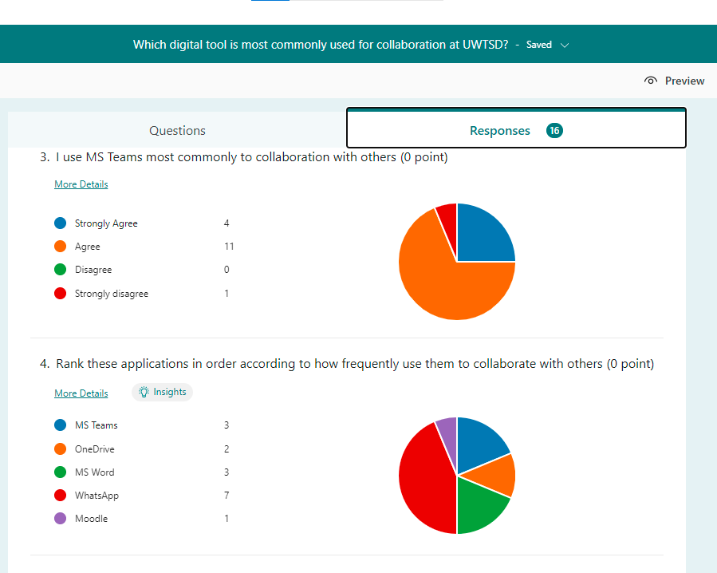
Ethical considerations are a set of principles that guide research design and practices. It conducts research responsibility. Making ethical choices from the inception of the research idea and throughout the research process. Conducting and publishing ethical research is important because of the impact result will have on the profession. There are several ethical issues you should always pay attention to in your research design and these issues can overlap with each other Research participants, Respect, Full consent, Protection of the privacy, Anonymity level of confidentiality, Any types of communication, Any type of misleading information, Potential for harm and voluntary.

Results

The above diagrams illustrate the results of my questionnaires, and it concludes that people Agree with the most commonly to collaborate with others is Ms Teams. Microsoft Teams is extremely useful feature for business and school communication. It is collaboration platform complete with document sharing, online meetings, and many more useful communications. How I said above Microsoft office is the heart of many businesses and schools. This could be anything from making questionnaire in a Form, to a presentation in PowerPoint, to the written report in Word. Having an excellent team space is the best part for one another to make creative decision and communicate.
Most users rank WhatsApp on this application. This app allows users to send text messages and voice massages, make voice and video calls, share images, documents, send locations and other contents. You can use WhatsApp application on mobile device but it also accessible from desktop devices, if the user’s mobile device remains connected to the Internet while they use the desktop app. Most used after WhatsApp are MS Teams and MS Word. MS Teams is extremely useful platform for collaboration completed with document sharing, online meetings, images sharing and other contents. Microsoft Word allows users to write and save documents. You can spell and grammar checker, word count, choice of types, tablets, inserts pictures in documents and prints in different ways. MS Word is a part of Microsoft Office, but you can install separately. Like other word processors, it has helpful tools to make documents.

Discussion

Results of my questionnaires conclude that mostly the users are women, and the highest age range is 18-30. These are the most commonly asked questions. This information is useful for analysts check. After these questions are MS Teams most commonly to collaborate with others and rank these applications in order according to how frequently use them to collaborate with others. How I said above Microsoft Teams is extremely useful feature for business and school communication. The highest range for MS Teams agrees with 69% that this tool is most useful for collaborations with one another. From this platform you can share documents, make online meetings, share images and other contents. Reason to use Microsoft Forms is you can create quizzes, surveys and invite people to respond to it. You can see your time result when they are submitted their responses. It is easy to create forms and collect responses from collaborators and colleagues. Next question is for how often you use these tools to collaborate with others. The highest range they respond is WhatsApp with 44% and MS Teams and MS Word equal 19% of use. The most unused tools are Moodle with only 6%. MS Teams is extremely useful platform for collaboration completed with document sharing and other contents. Microsoft Word allows users to write and save document, word count, choice of types, tablets. Microsoft Word is helpful tools to make documents. Next question is - I do not use any digital tools to collaborate with peers. We have responses with 5 people agree and 5 people disagree with same respond from 31%. 24% response strongly disagree and 13% with strongly agree. Even they do not use any digital tools to collaborate with others, we must improve them that latest technologies results become more and more compromised. Many people do not need access to tools collaboration to get their job done. Some employees carry out their work on spreadsheet program. I believe that those people witch they do not use digital tools have to be given a compelling reason to take up a new tool. Seventh question is: Do you use OneDrive more than you use MS Teams to collaborate with others. The highest respond is Agree and Strongly Agree with equal 38%, and 19% response Disagree and 6% Strongly Disagree. Most users prefer to use OneDrive more than MS Teams because you can save documents, photos, and other files in the cloud, and collaborate on content. When you subscribe to Microsoft 365 you will get premium OneDrive features and storage 1 TB. OneDrive is extremely useful for work or school is online storage and organisation. Microsoft cloud service can connect you to all your files. You store and protect all your files, share files with others and get to them from anywhere. The eighth question is for do you use WhatsApp more than you use MS Teams to collaborate? The highest responses they give YES with 63% and NO with 38%. WhatsApp allows users to send text messages and voice massages, make voice and video calls. MS Teams is similar you can send text messages, make video calls or video but is most useful for work and school. Next question is do you use a rang of different digital tools to collaborate? Most users respond with 69% they use different digital tools to collaboration. And the last question of my questionnaire is for: Do you use both MS Teams and OneDrive equally often when working with others? The highest result of this questionnaire they give is YES with 56% which mean that they use equally often both tools. Other people replied with NO 25% that they do not use both tools often, and other replied with Prefer not to say with 19%.

Conclusion

Improving your research skills would be educational great. The most important part of research design are research questions, methods and techniques chosen by researcher. Research design helps you to find methods which will match your research aims, collect high-quality data and analysis to answer your questions. The most important characteristics research design is- Neutrality, Reliability, Validity and Generalization. Effective research design provide that they are accurate and unbiased. You will need to create a method that meets all this characteristics design that’s why these four types of characteristics are so important. Good research is all about finding answers to your research question. The different types of research design which will help you with finding answers to your research questions are- Descriptive research design, Experimental research design, Correlational research design, Diagnostic research design, Explanatory research design, Meta-Analysis design. My research question is Which digital tool is most used for collaboration at UWTSD. The best online collaboration software makes is simple and easy for teams to work together on specific task. These tools for managing daily tasks could provide from cloud document storage and video conferencing for online meetings. Collaboration is the new normal in the workplace and school, improved efficiency, and productivity if you have the best tools.

Reference
QuestionPro (2022) Research Design: Definition, Characteristics and Type, [online] Available at: https://www.questionpro.com/blog/research-design/?fbclid=IwAR0gfmspWwmdVPm-_7jGYIafOjhNQ0IKG6DTo4ONE13szJ0LgOGM
VOXCO (2021) Descriptive Research Design, Exclusive Step by Step guide to Descriptive Research, [online] Available at: https://www.voxco.com/blog/descriptive-research-design/?fbclid=IwAR2rn7ZBsmShnyVu4e6yltBniK9tTY3c-W9cD1bshth6Q5iNMxf5V6smS5c
QuestionPro (2022) Experimental research – Definition, types of designs and advantages [online] Available at: https://www.questionpro.com/blog/experimental-research/

Bhandari,P. (2021) Correlational Research | When & How to Use [online] Available at: https://www.scribbr.com/methodology/correlational-research/#:~:text=A%20correlational%20research%20design%20investigates,be%20either%20positive%20or%20negative
VOXCO (2021) Diagnostic research design: [online] Available at: https://www.voxco.com/blog/research-design/#:~:text=Diagnostic%20research%20design%3A%20In%20a,creating%20problems%20in%20the%20company.
George,T. (2021) Explanatory Research | Definition, Guide, & Examples: [online] Available at: https://www.scribbr.com/methodology/explanatory-research/#:~:text=Explanatory%20research%20is%20a%20research,occurring%2C%20and%20predict%20future%20occurrences.
Goyal, A., Elminawy, M., Kerezoudis, P., Lu, V., Yolcu, Y., Alvi, M., & Bydon, M. (2019) Meta-Analysis: [online] Available at https://himmelfarb.gwu.edu/tutorials/studydesign101/metaanalyses.cfm
LumApps (2022) 10 Essential Tools to Support Your Digital Transformation: [online] Available at: https://www.lumapps.com/solutions/digital-transformation/digital-transformation-tools/?fbclid=IwAR0w7nJEAq55gl8XkbG6PMaxysnq5YDue9_YQ_UEvTQIsVeRh9AP0Q
Savannah Technical College (2020) THREE REASONS YOU MUST KNOW MICROSOFT OFFICE IN THE WORKPLACE: [online] Available at: https://www.savannahtech.edu/continuing-ed-three-reasons-you-must-know-microsoft-office-in-the-workplace/?fbclid=IwAR1ENrGzOfuroE6nk849749a5HNyj8DIHVSbEqWOo2ntsYZ09t_-BXQg19Q

Appendix 

