

Student Name :- Macwan Smit Thomas
Student ID :- 2245268
Programme :- MBA in General Management
Module :- Marketing Management
Module Code :- LCMB7001
Lecturer :- Tushara Balendran
Submitted On :- 1st September 2023

Marketing Management – Assessment 2
Company: Samsung

Table of Contents
List of figures 2
Introduction 3
Environmental marketing analysis 3
PESTLE analysis 4
Porters five Forces analysis 6
SWOT analysis 7
The role that marketing plays within the Organisation 8
Recommendation 12
Conclusion 13
References 15

List of figures
Figure 1: Macro-environment 3
Figure 2: PESTLE framework 4
Figure 3: P5F framework 6
Figure 4: Micro-environment 7
Figure 5: STP in marketing 9
Figure 6: Samsung’s Galaxy S7 edge branding process 10
Figure 7: Ansoff matrix 11
Figure 8: Product life cycle model 12

Introduction
Leading a far-reaching ecological promoting examination is essential for associations looking for maintainable development in the contemporary business scene. This investigation envelops outer main impetuses and interior elements, giving bits of knowledge significant to vital independent direction. This report digs into the instance of Samsung, a worldwide hardware monster, to investigate how different variables impact its showcasing techniques. One gains a more profound comprehension of Samsung's situation on the lookout by assessing political, financial, social, mechanical, ecological, and legitimate viewpoints. Besides, the conversation extends to Doorman's Five Powers and SWOT examination, revealing insight into the cutthroat scene and likely future bearings. Eventually, this investigation highlights the urgent job of advertising inside Samsung's activities, uncovering how viable procedures can upgrade its image presence, client commitment, and by and significant achievement.

Environmental marketing analysis
The macro-environment can be defined as the set of external forces like economic, political conditions, and environmental aspects that significantly influence the decision-making, operations and other aspects of business organisations. On the other hand, the micro-environment can be defined as the internal factors prevalent within an organisation which influence the daily operations of that company (Vedantu, 2023).
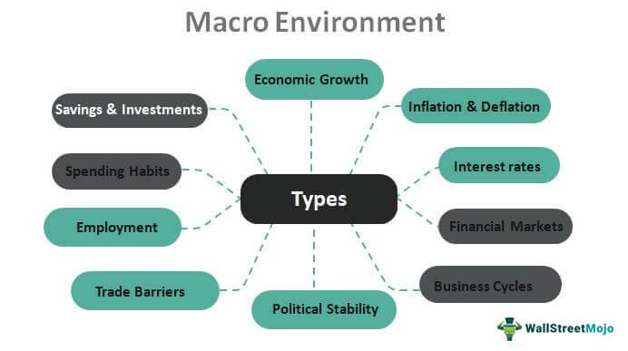
Figure 1: Macro-environment
Source: (WSM, 2023)

PESTLE analysis
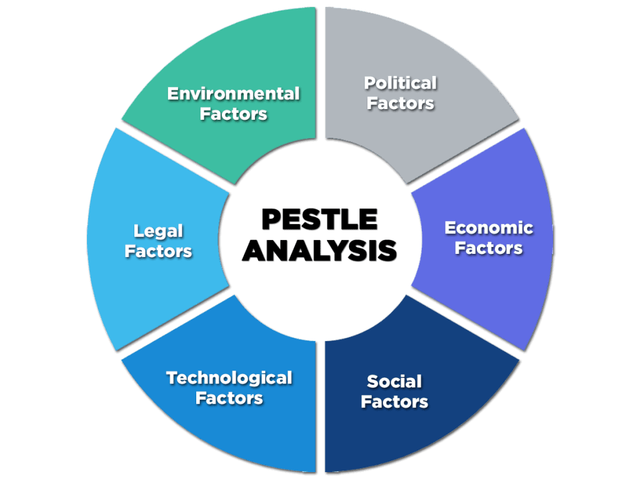
Figure 2: PESTLE framework
Source: (Gandhi et al. 2020)
Political | - Political factors, other government policies, political rules and regulations impact Samsung's business environment (MSG, 2023).  - The current value of the political stability of the UK is 0.54 (TGE, 2023). This enormous stability affected Samsung's conductive operations and its political environment.
Economic | - The overall financial source of the UK is 72.7 (ONS, 2023). Which highly affects their economic conditions. Samsung's performance depends on its macroeconomic trend.  - Samsung's products' purchasing power depends on their customers. Their customers purchase variable products, such as the inflation rate (Ortega and Tabares, 2023).  - Samsung's economic trade and conditions affected its growth, profitability and operations.
Social | - For many similar brands, Samsung has heavily shifted towards e-commerce (Nahiduzzaman et al., 2021).  - The total value of the UK population is around 40.4, which is the main reason for Samsung's product sales in this market (Park, 2022). All of those populations buy their products.  - Samsung always supplies demandable products to its customers. Their social and cultural factors highly influence it. It maintains Samsung's profit in the global markets (Hai, n.d.).
Technology | - The innovation rate in the UK is almost 59.8; Samsung is using digital technologies and e-commerce platforms to improve its experience and expand its consumer base in the UK market (Koelbek, 2020).  - Samsung deals with various new developing technologies, trends and innovations. That has affected their business organisations in the global market.
Environment | - Ecological and environmental concerns help Samsung's company decisions making. It also helps their operational work.  - Environmental Act 2021, which helps Samsung create a new framework with environmental protection (Moon and Lee, 2021; ClientEarth, 2023).
Legal | - Similarities between any product with another brand can bring legal troubles for Samsung's company.  - The product safety, labor rights, and property protections law influenced Samsung's business operations, leaving the Organisation in legal trouble (TSS, 2023).  - Samsung maintains its proper rules and regulations through employment and consumption law. This refers to laws, rules and regulations in their business industries.
Table 1: PESTLE analysis
Source: (Developed by the author)

Porters five Forces analysis
Porter’s Five Forces is a framework that helps in identifying and analysing the five competitive forces that shapes the business operations of an industry.
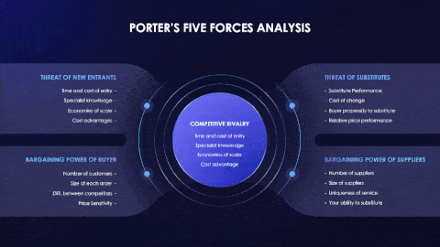
Figure 3: P5F framework
Source: (Youexec 2023)
New entrants’ threat:
The threat of new entrants is very high in this industry, and entering this industry is very easy. The UK welcomes some different companies to do business in their market. Like, there is no need for knowledge, offline shops, and many others. That is why Samsung faces challenges from companies like Apple and many Chinese companies (Wu et al., 2023).
Substitutes threat:
In the market of the UK, Samsung faces numerous issues of substitutes; many other brands copy their products and sell them in these markets (Shamout and Elayan, 2020). Samsung faces direct threats from substitute companies like Apple and many Chinese companies. The Chinese market is emerging with new Apple products that directly threaten Samsung (Peng, 2023).
Competitive rivalry:
In the UK market, Samsung is very competitive and very dynamic. Samsung has a niche market even though they have dominant players here. Samsung faces direct rivalry from companies like Apple, and many more Chinese companies, which may give tough competition (Singh, 2022).
Bargaining power of Consumer:
In this industry, the Consumer's bargaining power is very high. In that case, Samsung provides reasonable prices for its products in the UK market. Many people can not live a luxurious life in the UK and can not afford enough expenses. Thus they tend to move elsewhere to find affordability. In that case, individual consumer bargaining power is high. Pricing remains an essential factor for consumers in this UK market. Samsung product price values depend on product selling and consumers' buying impressions.
Bargaining power of supplier:
For maintaining the Samsung industry, suppliers play an essential role. Samsung deals with various suppliers for their product sales. In that case, the bargaining power of supplies is low. Samsung has many suppliers in their industry (Shamout and Elayan, 2020). They produce products able to supply various components. That is why suppliers define the product charges that are associated with them.
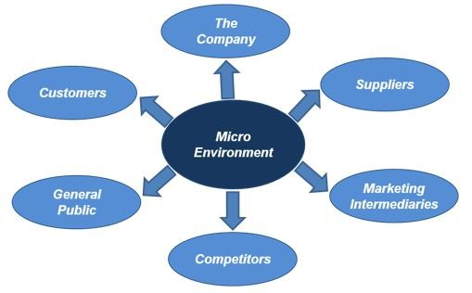
Figure 4: Micro-environment
Source: (LinkedIn, 2023)

SWOT analysis
Samsung is one of the renowned manufacturers of mobile phones and one of the biggest electronic brands around the world. In the UK, they have a huge market and competition. The UK is considered to have a robust global market today. Analysing the strengths, weaknesses, opportunities and threats in the UK market for Samsung is essential.
- Strength: Samsung has maintained its top position for many years and has a good Market share in the UK and throughout the country. Having a wide range of products and innovative technologies helps Samsung to compete against its competitors (Shamout and Elayan, 2020).
- Weakness: The UK generally has a weak transportation system, specifically industrial transportation, which can hinder the growth of Samsung. Samsung has many competitors in the market, like Apple, and many other Chinese electronic companies, which may give tough competition. In the area of innovation, the UK is entirely lacking here and the reason the UK welcomes different companies to do business in the UK (Singh, 2022). The UK market has recently witnessed the gap between wealthy and poor individuals. This can limit the sales and growth of Samsung in the UK.
- Opportunity: Due to lenient trade rules in the UK and Europe, many Middle East and Asian countries can quickly start businesses in the UK to earn more profit. If the UK somehow creates a tech growth hub, it will help the UK and other companies like Samsung present in the UK to boost their businesses. Due to its wide range of products, Samsung will have an excellent opportunity to grow (Guo, 2022).
- Threats: Samsung face direct threats from companies like Apple and many Chinese companies. Chinese market and emerging new Apple products cause direct threats to Samsung. Like the UK, many other European countries are trying to strengthen their economy. If this happens, then not only Samsung but many other companies will face direct threats from competitors. Many people can not live luxurious lives in the UK and can not afford enough expenses. Thus they tend to move elsewhere to find affordability. This can create a gap in the market for every business organisation in the UK. In this way, the Financial crisis can spread in the UK, and this can cause a direct threat to Samsung in the UK.

The role that marketing plays within the Organisation
Marketing is essential for every Organisation to grow and gain a good market share. Marketing also helps increase sales and capture a large consumer base by showcasing innovative products. Marketing plays a crucial role in increasing brand value to gain more profits. There are several strategies that the company adopts for marketing, such as:
Serving consumer needs: The organisation keeps an eye on the market and observes the changing preferences of the people. Samsung has a good Human resource management team that monitors market trends. Products' availability and pricing are crucial for the company (Mandal, 2022). Meeting the demands of the consumers also keeping in mind the affordability has to be predicted by the Organisation. An adequate production level and setting affordable prices will help the Organisation gain a good customer base.
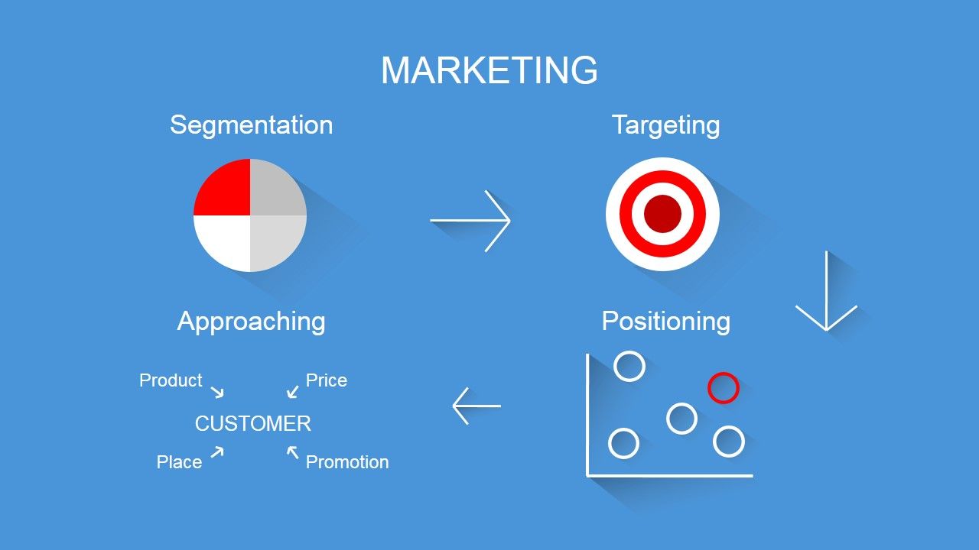
Figure 5: STP in marketing
Source: (Slide Model, 2023)
Survival growth and reputation of the Organisation: Samsung is one of the world's most well-known electronics brands. A successful business organisation thrives in this competitive market because of customer retention and increased market share. Holding the customer is crucial and can be achieved through marketing (Kim and Manoli, 2022). Hosting promotional events, meetings, PR programs, event marketing, and advertisements with the customers and various sub-brands helps retain customers and build a substantial market share. Samsung already has a wide range of products; thus, physically or digitally, these products with correct marketing techniques will attract many consumers. Revolution in the technology of media also helped to boost marketing and sales.
Economic growth: Marketing helps to create demands. Due to the increase in demand, production and distribution activities also rise. Therefore industrial growth will be boosted, and the income level will also improve due to increased employment opportunities. Thus it helps the company to deal with more manufacturers.
Promoting is the soul of any association, filling in as a powerful impetus for development and seriousness. Because Samsung is a worldwide forerunner in hardware, showcasing holds the foremost significance. Right off the bat, promoting extends between the Organisation and its clients, working to comprehend purchaser needs and inclinations. Samsung's capable Human Asset Supervisory group persistently screens market patterns, empowering the arrangement of items, accessibility, and evaluating with advancing requests (Mohan Kumar et al., 2019). This essential methodology upgrades consumer loyalty and lays out a reliable buyer base.
Besides, promoting assumes an urgent part in guaranteeing Samsung's endurance, development, and notoriety in a wildly cutthroat scene. By organising limited-time occasions, PR programs, and imaginative commercials, the Organisation supports its image picture, enamouring the consideration of potential and existing clients (Isa, Kelly and Kiumarsi., 2020). The different scope of Samsung's items, when combined with viable promoting systems, saddles the conventional and computerised media's force to make areas of strength for a presence.
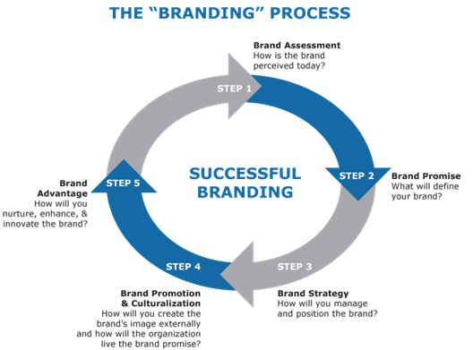
Figure 6: Samsung’s Galaxy S7 edge branding process
Source: (WordPress, 2016)

4Ps | Samsung Galaxy S7 Edge
Product | The Samsung Galaxy S7 Edge is a premium Android smartphone known for its curved-edge design. It also features a 5.5-inch Super AMOLED display, a powerful Exynos 8890 processor (Chipset: Snapdragon 820), 4GB of RAM, and a 12MP Dual Pixel camera (Gsmarena, 2016). Its standout feature is the curved-edge design, offering additional functionality and aesthetics. It is water- and dust-resistant, has expandable storage, and features a sleek, metal-and-glass build.
Price | Positioned as a high-end smartphone, the Samsung Galaxy S7 Edge was priced higher than mid-range phones, which helps reflect its premium features and build quality (Androidcentral, 2016). The price varied from region to region and carrier agreements, but it was one of the most expensive phones.
Place | The Samsung Galaxy S7 Edge is available in almost all global regions through various channels, including Samsung's official stores. It was accessible in physical stores and online, ensuring broad distribution and availability.
Promotion | Diverse marketing strategies were used to promote the Galaxy S7 Edge, including TV commercials, online campaigns, and social media engagement. The focus was on highlighting the smartphone's innovative design, camera, and water-resistant features (Androidcentral, 2016).
Table 2: 4Ps of marketing analysis
(Source: Self-Developed)
Past brand permeability and promotion add to monetary development. Robust promoting efforts invigorate requests, catalysing expanded creation and circulation exercises. This far-reaching influence fills modern development and creates work unique open doors, subsequently cultivating and significant financial turn of events (Iaia et al., 2022). For reasonable advancement, Samsung can consider further refining its showcasing methodologies. Utilising a cost-promoting division, the Organisation can improve its item contributions to care for particular purchaser portions, consequently amplifying income and customer fulfilment. Moreover, Samsung's hug of partner showcasing reinforces trust and shopper commitment, guaranteeing a constant progression of steadfast clients.
All in all, promotion is the main thrust behind Samsung's proceeded with progress. By capably adjusting items to buyer needs, supporting the brand picture, and impelling monetary development, showcasing capabilities as the motor that drives Samsung's development direction. The association's essential spotlight on promoting guarantees intensity and strengthens its situation as a worldwide hardware force to be reckoned with.
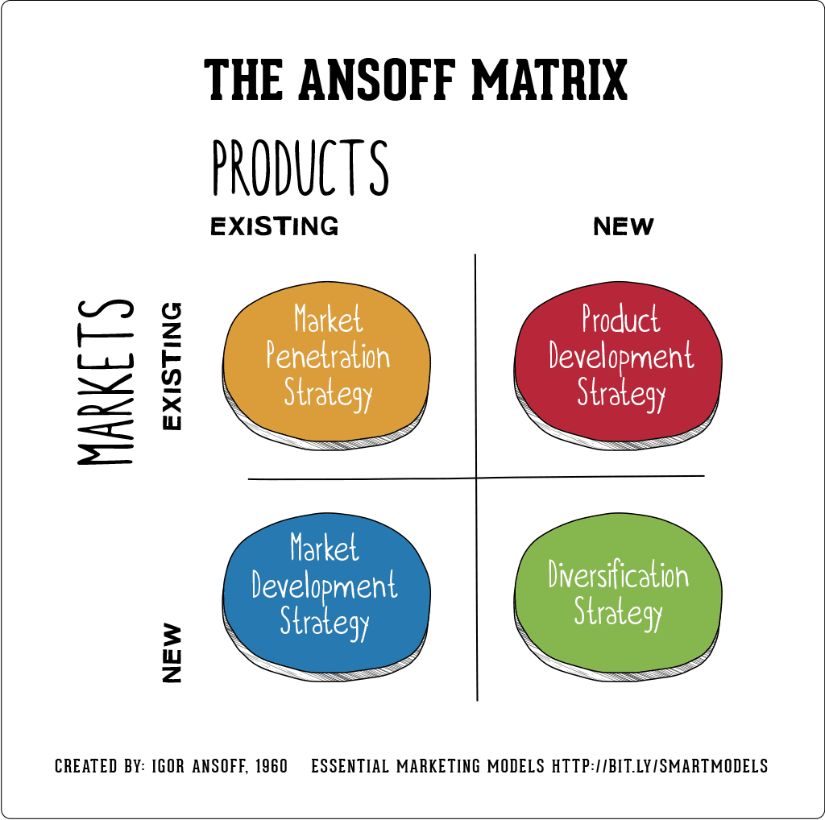
Figure 7: Ansoff matrix
Source: (Hanlon, 2021)

Recommendation
Samsung is known for its marketing strategies and success. This is regarded as a substantial brand value, Consumer's consuming engagement activities, goods and services consumption and embrace sustainability. Customer satisfaction is one of the most critical aspects they continuously work on for its betterment. They have a good brand image among the people. One of their main targets is to provide customers with better quality products at affordable prices. In this competitive world fashion market, Samsung company innovates various products and experiences. Samsung produces flexible and innovative new comprehensive products that help to enable success for their company. Their marketing strategies are far better than another company. Their implementation of product quality is very noticeable. Therefore, Samsung has new touch points to attract customers, and their engaging technologies help connect with them. Some different touch points include the following:
Cost marketing segmentation:
The Samsung multinational company analyses existing consumers' needs and requirements in the global market by identifying market trends. The company focuses on specific demographic lowest cost, and high-quality luxury products for their consumers. Through this cost marketing segmentation, Samsung efficiently reduces their state tax income payment and annual federal. Also, Samsung is freeing up money for their purchases or investment. Samsung gathers customers' data through a digital analytics tool, so they quickly gain additional insight into consumer nature and behaviour.
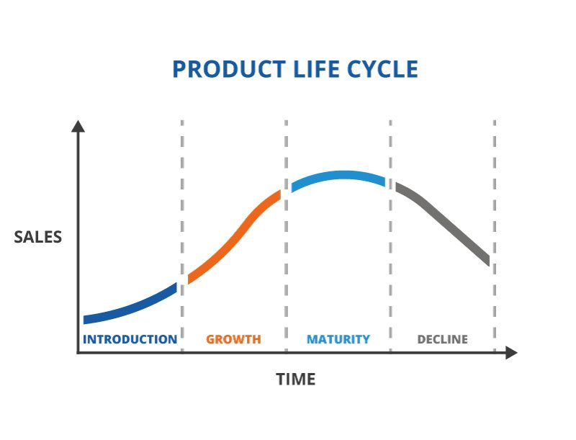
Figure 8: Product life cycle model
Source: (TWI-global, 2023)
Affiliate marketing :
Samsung from various luxury categories, brand to product advertisement and visitors. That is why their consumers consume different types of luxurious products. Samsung affiliate marketing is a website associate process. For that reason, customers buy their products through their website. Applying these marketing strategies, Samsung can easily earn commissions through affiliate marketing. This marketing strategic plan helps to gain the trust and the needs of consumers of this company. Inn the case of product life cycle. Samsung needs to understand its products' life cycle to achieve sustainable growth in the market. The first phase of the PLC model is an introduction, where Samsung will introduce its new product and keep the sales low as the demand for the product will be created in this stage in the market. The next stage of the PLC model is growth, where Samsung will manage the growth of its products. In this stage, Samsung needs to keep the pricing of its products competitive to manage intense competition with its rivals. Alongside this, the third stage of the model is the maturity stage, where the product will be established in the market. Due to this, Samsung will reduce the marketing and sales cost in this stage to seek optimum revenue from product selling. Lastly, in the decline stage, various competitors will arise which can offer better as compared to the product. Due to this, Samsung may face a declining sales volume of its product. Hence, the company need to enhance the existing features or offer some better things as compared to its rivals in order to address the decline stage of its product.

Conclusion
In the mind-boggling domain of contemporary business, Samsung's case enlightens the complex meaning of an ecological promoting examination. Carefully examining outer powerhouses and inward elements uncovers a thorough scene that guides vital independent direction. As political, monetary, social, mechanical, ecological, and legitimate elements interweave, Samsung explores a mind-boggling scene, gaining valuable open doors and relieving dangers. Through Watchman's Five Powers and SWOT examination, we observe the sensitive harmony where Samsung contends and flourishes. Nonetheless, the bedrock of Samsung's process lies in its promoting ability. Promoting's crucial job as a course among development and purchaser requests pushes Samsung's flexibility and development. With sharp experiences in shopper inclinations and adroit techniques, advertising encourages brand devotion and powers financial extension. As Samsung continues onward in the worldwide market, it remains a demonstration of the cooperative connection between careful examination, canny promoting, and persevering through progress. The cooperative exchange of these components positions Samsung as a pioneer, ready to diagram a course of development, development, and proceed with significance in a consistently advancing business scene.

References
Androidcentral, 2016. Samsung Galaxy S7 edge review: Bigger and better in almost every way. [online] Samsung Galaxy S7 edge review: Bigger and better in almost every way | Android Central. Available at: <https://www.androidcentral.com/samsung-galaxy-s7-edge-review> [Accessed 30 Aug. 2023].
ClientEarth, 2023. The UK environment act - what’s happening now? [online] ClientEarth. Available at: <https://www.clientearth.org/latest/latest-updates/news/why-the-uk-environment-bill-matters/> [Accessed 19 Aug. 2023].
Gandhi, R., Tiwari, A., Khanna, S. and Patel, S., 2020. Pestle Analysis: A Mechanism for Analysis of Businesses - Enterslice. [online] Enterslice. Available at: <https://enterslice.com/learning/pestle-analysis-a-mechanism-for-analysis-of-businesses/> [Accessed 23 Aug. 2023].
Gsmarena, 2016. Samsung Galaxy S7 edge - Full phone specifications. [online] Samsung Galaxy S7 edge - Full phone specifications. Available at: <https://www.gsmarena.com/samsung_galaxy_s7_edge-7945.php> [Accessed 30 Aug. 2023].
Guo, C., 2022. Huawei within a Challenging Environment. Academic Journal of Business & Management, 4(17), pp.63-71.
Hai, D.H., Comparative Analysis of Market and Product Development Potential of Apple and Samsung.
Hanlon, A., 2021. The Ansoff Model [Marketing strategy matrix] | Smart Insights. [online] Smart Insights. Available at: <https://www.smartinsights.com/marketing-planning/create-a-marketing-plan/ansoff-model/> [Accessed 23 Aug. 2023].
Iaia, L., Leonelli, S., Masciarelli, F., Christofi, M. and Cooper, C., 2022. The malevolent side of masstige consumers’ behavior: The role of dark triad and technology propensity. Journal of Business Research, 149, pp.954-966.
Isa, S.M., Kelly, L. and Kiumarsi, S., 2020. Brand switching through marketing mix: the role of brand effect on smartphone users. International Journal of Process Management and Benchmarking, 10(3), pp.419-438.
Kim, S. and Manoli, A.E., 2022. Building team brand equity through perceived CSR: The mediating role of dual identification. Journal of Strategic Marketing, 30(3), pp.281-295.
Koelbek, C., 2020. Businesses cutting spend on innovation at Dangerous Rate in UK. [online] Entirely Business News. Available at: <https://entirely.media/technology/business-news/uk/london/city-of-london/businesses-cutting-spend-on-innovation-at-dangerous-rate-in-uk5858> [Accessed 19 Aug. 2023].
LinkedIn. 2023. Micro and Macro environment factors to be analyzed for companies. [online] Micro and Macro environment factors to be analyzed for companies. Available at: <https://www.linkedin.com/pulse/micro-macro-environment-factors-analyzed-companies-bobin-philip> [Accessed 23 Aug. 2023].
Mandal, P.C., 2022. Generation of customer insights–roles of marketing information and marketing intelligence. International Journal of Business and Data Analytics, 2(2), pp.111-124.
Mohan Kumar, S., Krishnamurthy, K.B., Prashanth Chittaranjan, S.N. and Manjunatha, G., 2019. Role of Product Marketing Management in Market Share Elevation: An Empirical Study of Top Smartphone Brands in India. J Robot Mech Eng Resr, 3(2), pp.28-36.
Moon, S. and Lee, H., 2021. Shaping a circular economy in the digital TV industry: Focusing on ecopreneurship through the Lens of dynamic capability. Sustainability, 13(9), p.4865.
MSG, 2023. MSG Management Study Guide. [online] PESTLE Analysis of Samsung. Available at: <https://www.managementstudyguide.com/pestle-analysis-of-samsung.htm> [Accessed 19 Aug. 2023].
Nahiduzzaman, K.M., Holland, M., Sikder, S.K., Shaw, P., Hewage, K. and Sadiq, R., 2021. Urban transformation toward a smart city: An e-commerce–induced path-dependent analysis. Journal of Urban Planning and Development, 147(1), p.04020060.
ONS, 2023. UK sector accounts. [online] UK sector accounts - Office for National Statistics. Available at: <https://www.ons.gov.uk/economy/nationalaccounts/uksectoraccounts> [Accessed 19 Aug. 2023].
Ortega, A.M. and Tabares, F.A., 2023. Psychological pricing: Myth or reality? The impact of nine-ending prices on purchasing attitudes and brand revenue. Journal of Retailing and Consumer Services, 71, p.103206.
Park, N., 2022. Population estimates for the UK, England, Wales, Scotland and Northern Ireland: Mid-2021. [online] Population estimates for the UK, England, Wales, Scotland and Northern Ireland - Office for National Statistics. Available at: <https://www.ons.gov.uk/peoplepopulationandcommunity/populationandmigration/populationestimates/bulletins/annualmidyearpopulationestimates/mid2021> [Accessed 19 Aug. 2023].
Peng, C., 2023. Nvidia Corporation: PC Gaming Industry Strategic Audit.
Shamout, M.D. and Elayan, M.B., 2020. A Comparative Analysis of Strategic Planning Practices in Gulf Cooperation Council Region: A Case Study of Huawei and Samsung Companies. Journal of Talent Development and Excellence, 12(1), pp.4891-4910.
Singh, P., 2022. COMPANY ANALYSIS OF APPLE (Doctoral dissertation).
Slide Model. 2023. Segmentation Targeting and Positioning PowerPoint Template - SlideModel. [online] SlideModel. Available at: <https://slidemodel.com/templates/segmentation-targeting-and-positioning-powerpoint-template/> [Accessed 23 Aug. 2023].
TGE, 2023. United Kingdom political stability - data, Chart. [online] TheGlobalEconomy.com. Available at: <https://www.theglobaleconomy.com/United-Kingdom/wb_political_stability/> [Accessed 19 Aug. 2023].
TSS, 2023. Samsung Pestel Analysis - The Strategy Story. [online] The Strategy Story - Simplifying Business Strategies. Available at: <https://thestrategystory.com/blog/samsung-pestel-analysis/> [Accessed 19 Aug. 2023].
TWI-global. 2023. What is a Product Life Cycle? (Definition, Stages and Examples). [online] What is a Product Life Cycle? (Definition, Stages and Examples) - TWI. Available at: <https://www.twi-global.com/technical-knowledge/faqs/what-is-a-product-life-cycle.aspx> [Accessed 23 Aug. 2023].
Vedantu. 2023. Micro Environment – Definition, Fun Facts and FAQs. [online] VEDANTU. Available at: <https://www.vedantu.com/commerce/micro-environment> [Accessed 23 Aug. 2023].
WordPress. 2016. The Samsung S7 Edge, the phone universe’s latest wonder.. [online] The Samsung S7 Edge, the phone universe’s latest wonder.. | T1 2016 MPK732 Marketing Management (Cluster B). Available at: <https://mpk732t12016clusterb.wordpress.com/2016/04/25/the-samsung-s7-edge-the-phone-universes-latest-wonder/> [Accessed 23 Aug. 2023].
WSM. 2023. Macro Environment. [online] WSM. Available at: <https://www.wallstreetmojo.com/macro-environment/> [Accessed 23 Aug. 2023].
Wu, Y.S., Tonsukchai, G., Chatpokponjaroon, P., Wu, C.Y. and Molina, M.F.D., 2023. Ahead of the curve: the strategic analysis of Samsung.
Youexec. 2023. Porter’s Five Forces Analysis Presentation Template. [online] You Exec. Available at: <https://youexec.com/presentation-templates/porters-five-forces-analysis> [Accessed 23 Aug. 2023].

