

Databases and Application Development
ACCA5022
Osvaldas Stanelis
1802408
25/01/2021

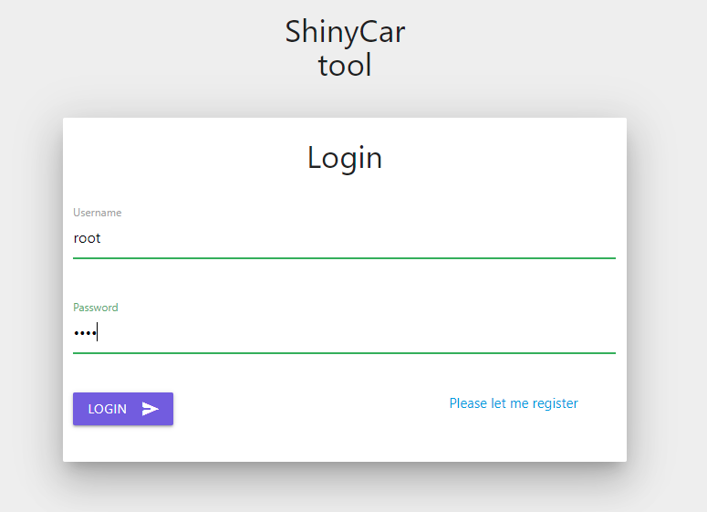
We got working login (username root, password root) and register. 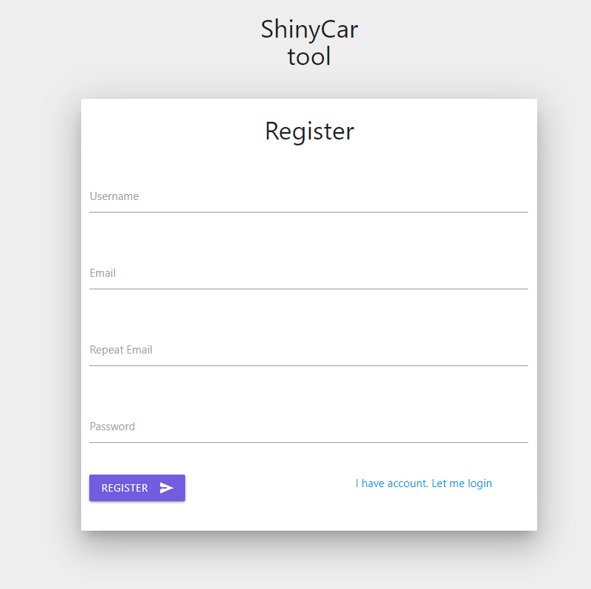
Client management tool: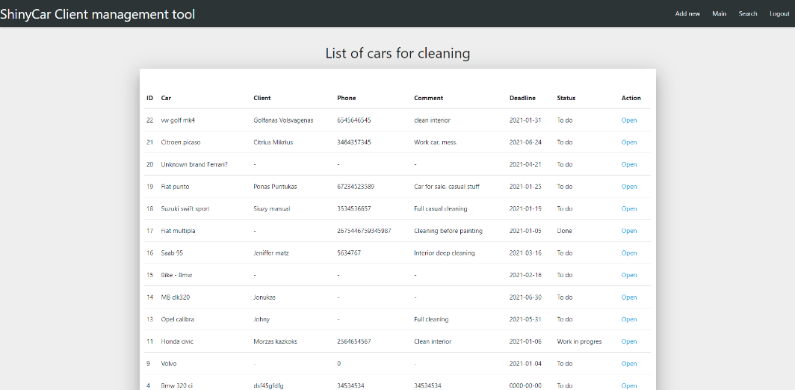
New added customer shown in top:
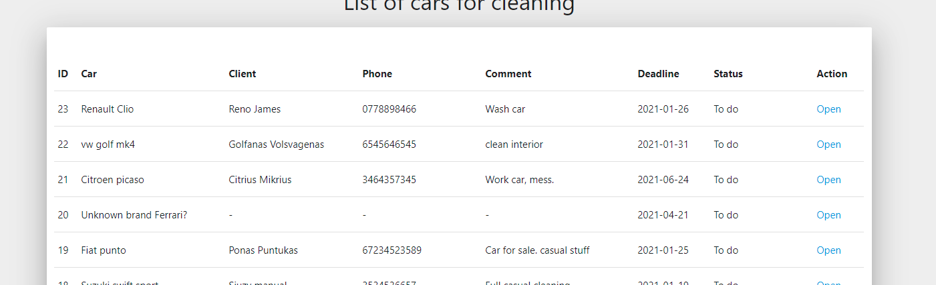
You cannot create empty blank because it will show error.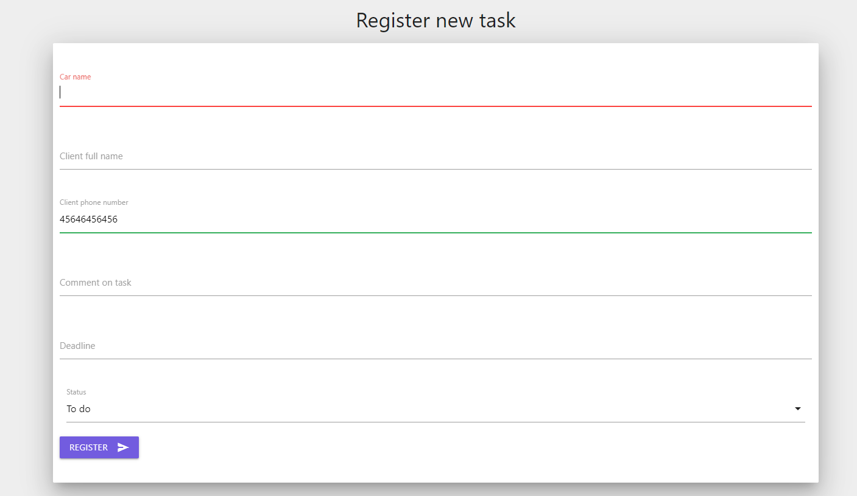
Working search engine:
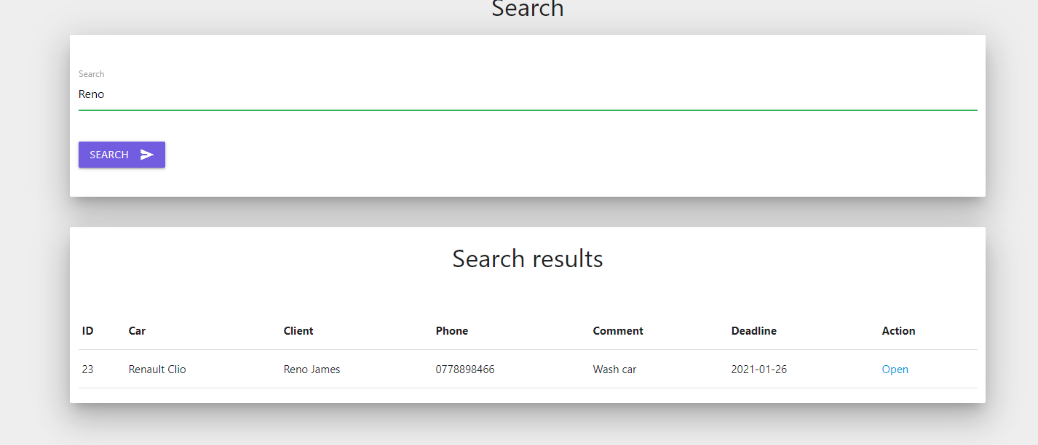
Edit tab: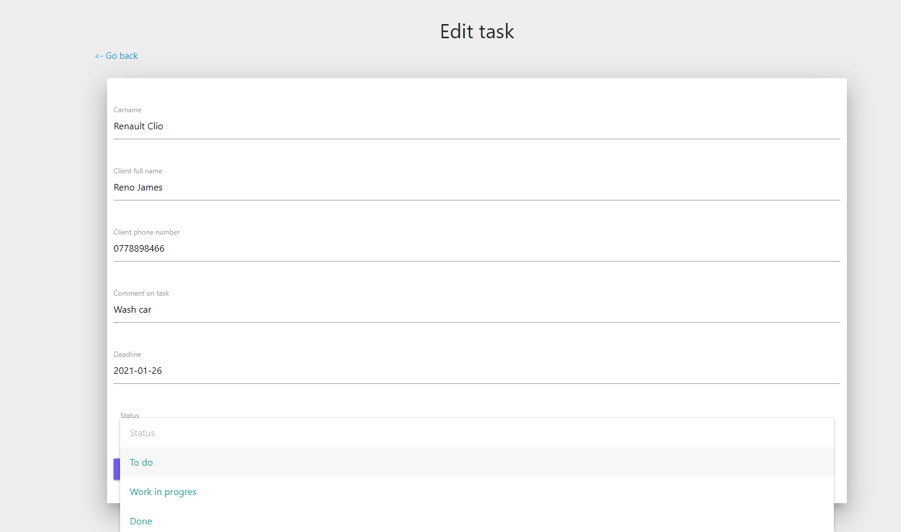
IMPORTANT: Can be you have to edit config.php file to get connected with server. I have used XAMPP program not WAMPSERVER because with it I had errors with new computer.


