the Welsh language in education
  - An activity that promotes the Welsh Language in my setting.
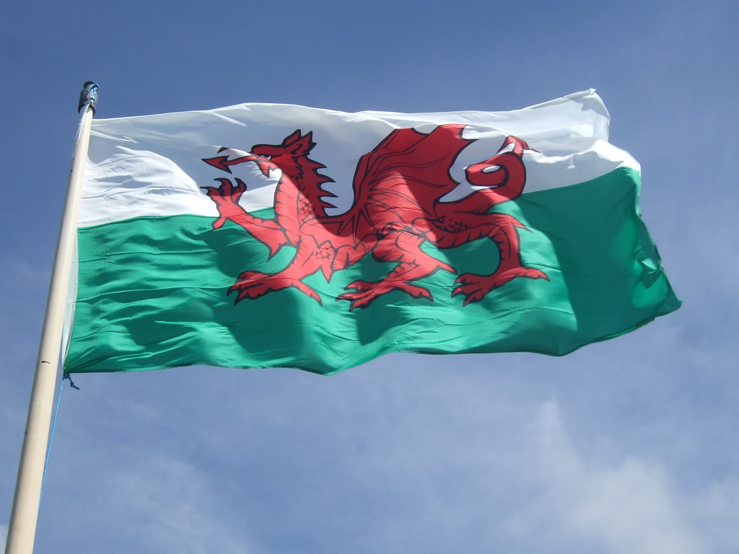

Contents

Introduction - Page 1

Rationale - Pages 2-6

Overview of Activities - Page 7

Evaluation - Pages 8-10

Appendix - Pages 11-14

References - Pages 15-18

Introduction
This portfolio will discuss and explore the Welsh Language in education by exploring an activity which is used in an educational setting in rural Carmarthenshire. A rationale will be included, which will highlight relevant policies and theories behind the activity. Finally, I will evaluate and share how effective the activity is by using the Welsh Language curriculum and other relevant sources to further discuss my findings.
The Welsh Language is one of the oldest languages in Europe and has an incredibly long, bizarre history. (See Appendix A). Once a language unable to be spoken in classrooms or workplaces, it is now one of the Welsh Governments biggest priorities. With plans to have 1 million Welsh speakers by 2050.
By promoting the Welsh language in schools, teaching staff are engraining the language in children as young as 3 years old. With the hope they will continue to use the language long into adulthood. According to Carmarthenshire County Council, bilingualism benefits an individual’s education, career and health. In schools, children who speak two or more languages ‘perform better in tasks’ and when entering the world of work, earn on ‘average 11% more’ than people who are monolingual. (Carmarthenshire County Council, 2023).
Bilingualism has also been found to be beneficiary to an individual’s health. The ability to speak more than one language can delay ‘the onset of dementia and other symptoms of Alzheimer’s’. (Carmarthenshire County Council, 2023).

Rationale
Being a Welsh medium primary school, my setting is committed to promoting the Welsh language every day. Carmarthenshire County Council have released a Welsh Language Promotion Strategy, with the strategies dated for the years 2023-2028. Their aim is ‘to make Welsh the main language of the County.’ (Carmarthenshire County Council, n.d).
The Welsh language has made a remarkable comeback. Since the Act of Union 1536 where the Welsh language was outcast and major events such as the industrial revolution. During the industrial revolution, Wales was the epicenter of production. In the early 18th century, production in Wales included,

(BBC, n.d)
- Iron making in Pontypool and Bersham
- Lead and silver mining in Flintshire and Cardiganshire
- Copper smelting in Neath and Swansea
- Coal mining in West Glanmorgan and Flintshire

The Industrial Revolution brought massive changes, both in terms of population movement and communications. (See Appendix A). Meaning the Welsh language was lost because of workers moving to Wales from other countries and sometimes meaning Welsh speaking workers had to leave Wales to seek work elsewhere. Thereby, taking the language away with them.
The Welsh language was delivered another blow with the First World War. As stated in appendix A, an estimated 20,000 Welsh speakers were killed during the 4-year conflict, only 7 years after the 1911 census revealed that only 43.5% of the population could speak Welsh. Making Welsh a minority language for the first time in 2000 years.
Although the 1911 census recorded the highest number of Welsh speakers since records began, research shows that citizens who could speak the language were not able to speak their native tongue in school.
The Welsh Not was usually a wooden slab with the initials ‘W.N’ carved into it. (See Appendix F). It would be hung around the necks of children who were caught speaking Welsh in schools. Used during the 18th and 19th century ‘At the end of the school day, the child wearing the 'Welsh Not' would be punished by the schoolteacher.’ (People’s collection Wales, n.d).
‘The earliest date of the Welsh Not seems to be in the early 1850's and it had largely died out by the end of the nineteenth century.’ (FelinFach, 2023). Although there are some reported cases of the Welsh Not being used into the early 20th century. It has proved difficult to determine when this corporal punishment was stopped.
The economic downturn of the 1920’s proved even more fatal to the Welsh Language. With Welsh speaking natives once again forced to leave their country in search of work. As a result the 1921 census recorded ‘the percentage of speakers drop from 43.5% to 38%’. (Hollis, 2020).
The 19th century saw a rise in what is known as Welsh Nationalism. In the 1950’s, plans were made to drown a village called Capel Celyn in Bala, North Wales in order to provide the city of Liverpool with drinking water. The reservoir was completed in 1965. The plans angered the Welsh people as ‘the village of Capel Celyn was perceived as being a stronghold of the Welsh language and its traditional rural culture which was being sacrificed on the altar of an English city’s needs.’ (James, 2005).
History was made in 1993, when the Welsh Language Act was created.
‘The Welsh Language Act 1993 established the principle that in the conduct of public business and administration of justice in Wales the English and Welsh languages should be treated on a basis of equality. The Act also made provisions for the preparation and approval of Welsh language schemes.’ (Welsh Language Commissioner, n.d).
For the first time since 1536, the Welsh language was deemed equal to the English language. And was therefore no longer discriminated against. Giving Welsh people their rights to their language.
The Welsh Language promotion strategy has taken information from the 2021 population census and was able to calculate the amount of people who speak the Welsh Language by area. (See Appendix D). As shown, approximately 30%-50% of the population in Carmarthenshire speak the Welsh Language. The results from the 2021 population census ‘means the county has lost its position of being the local authority with the most Welsh speakers in Wales.’ (Carmarthenshire County Council, n.d). The council also reported that Gwynedd, North Wales, now has the most Welsh speakers in the country.
Another administration looking to further the Welsh Language in education is the Welsh Government themselves. Children aged four to seven years old have been introduced to characters ‘Seren a Sbarc’ (See Appendix E). The Government called the framework the ‘Welsh Language Charter’ or ‘Siarter Iaith’ in Welsh. And according to the framework ‘the two heroes on posters and badges will encourage children between 4 and 7 years old to use the Welsh language in the playground, at home and the classroom.’ (Welsh Government, n.d).
Whilst the Siarter Iaith framework is a key tool in promoting the Welsh Language in schools. The framework itself emphasises ‘that the Welsh Language Charter is not an addition, but rather an integral part of the Curriculum of Wales’. (Welsh Government, n.d).
The Curriculum of Wales or Cwricwlwm Cymreig was established so that pupils in Wales had an education that would teach ‘the culture, environment, economy and history of Wales, and the influences which have shaped the country of today.’ (Welsh Government, n.d). We follow both the Cwricwlwm Cymreig and Siarter Iaith frameworks in my setting.
Each term, each Progression Step has a new theme. Progression Steps came in as a replacement for the term Key Stage. They are arranged in terms of how old the students are.

(Twinkl, n.d)
- Progression Step 1 - age 3-5
- Progression Step 2 - age 5-8
- Progression Step 3 - age 8-11
- Progression Step 4 - age 11-14
- Progression Step 5 - age 14-16

Pupils’ knowledge of their culture is also mentioned in Donaldson’s Successful Futures review. He states that ‘Our children and young people need to be rooted in their own cultures and to have a strong sense of identity as citizens of Wales, the United Kingdom, Europe and the wider world.’ (Donaldson, 2015).
These themes are connected to Welsh culture. An example of which being a whole school theme in the Spring term of 2023, ‘Cymru am Byth’. Although the school was under the same theme, each Progression Step was taught different aspects of Welsh culture. As a staff member in Progression Step 2 at the time, our children were learning about castles. Another example being our most recent theme in the Autumn term of 2023, ‘What’s on the menu?’ Or ‘Beth sydd ar y fwydlen?’ in welsh. In which children learned about the traditional foods of Wales.
Being a Welsh medium school, we encourage children to use the Welsh language throughout the school day. Whether it be in the classroom or on the playground. We as teaching staff only use the Welsh language when speaking to children and only translate to English when necessary, for example, if a child has recently moved to the area from England/English medium school or if it is necessary due to additional learning needs.
Linking to Welsh Language Framework, I have chosen to discuss an activity which celebrates the Welsh language and the Welsh culture. My activity is a school-based show, held on St David’s Day, known as the ‘Eisteddfod’.

Overview of Activities
Activity 1 – St David’s’ Day.
‘St David is the patron saint of Wales, and he is celebrated on the 1 March. To mark the day, many Welsh people around the world wear one or both of Wales's national emblems - a daffodil and a leek.’ (BBC, 2023).
In my setting in rural Carmarthenshire, we celebrate St David’s Day in this the traditional way as stated above. (See appendix B). As well as serving the children a traditional Welsh soup, cawl, we also teach the children about the patron saint and plan activities for the children on the subject.

Activity 2 – School Eisteddfod.
The Eisteddfod is a cultural festival celebrating Welsh culture, music and poetry. The Eisteddfod is ‘the largest cultural festival in Europe, held in a different part of Wales every year.’ (Eisteddfod, n.d). In primary schools throughout Wales, children from nursery to year 6 perform to fellow pupils, teaching staff and parents, in a day spent celebrating their culture. Traditional eisteddfod ceremonies such as ‘Y gadair’ take place in which a pupil who writes an exceptional piece of Welsh literature is awarded in the traditional manner. (See appendix C). In my setting, our school eisteddfod takes place on St David’s Day, where pupils have the opportunity to perform Welsh songs and poetry. While also submitting pieces of Welsh literature written by them.

Evaluation
To evaluate, there can be no doubt that the Welsh language has fought hard to be where it is today. From being one of Europe’s oldest languages to laws being created to ban its use. It is my opinion that those who are able to speak the language should be incredibly proud and do all they can to pass the language on to others.
As a Welsh speaking member of staff at a Welsh Medium primary school in rural Carmarthenshire, it is important to me that our pupils celebrate their culture, heritage and language. Furthermore, celebrating St Davids Day and hosting a school eisteddfod is essential so that pupils can feel proud and a part of the Welsh culture.
While not all children in my setting were born in Wales or to Welsh speaking families, my setting goes to great lengths to make them feel proud to be living in Wales and being able to speak any level of the language. We speak a poetic language that’s different from English, and a lot older.’ (Wales.com, n.d).
Schools throughout Wales celebrate St David’s Day. Whether they are Welsh medium, bilingual medium or English medium. ‘It is a day of showing Welsh pride’ (Birt, 2023). Children come to school in traditional Welsh garments or wearing Welsh sporting apparel and spend the day embracing the country that they live in.
Linking to Donaldson’s Successful Futures review, St Davids Day is a good example of helping children ‘be rooted in their own cultures and to have a strong sense of identity as citizens of Wales’ (Donaldson, 2015).
Holding a school based ‘eisteddfod’ on St David’s Day is again a way to ensure children have a strong sense of identity and understanding of their culture. Seeing their culture and language celebrated on this day gives them a strong sense of pride and respect. While the older children understand more about Welsh history, all of the pupils get to enjoy the day by singing and celebrating who they are.
To conclude, the activities my setting conducts are vital in promoting the Welsh Language. By ensuring the Welsh language is used regularly, it normalizes bilingualism to our pupils and by using positive reinforcement and careful nurturing, almost all of the children in my setting will leave Year 6 as fluent Welsh speakers. This sets them up for better career prospects and better earning potential.
By promoting the Welsh Language in education, the Welsh Governent strategy to reach one million Welsh speakers by 2050 is within reach. As stated in the framework ‘The Welsh language is one of the treasures of Wales’. (Welsh Government, n.d).
While the Siarter Iaith Framework is being used in all schools in Wales, including English medium schools. We as teaching staff need to be careful to not force the Welsh language on to our pupils. As it has been reported that ‘Welsh is one of the toughest Western European languages to master’ (Coates, 2021).
With careful nurturing and patience, all pupils in Wales have the capability of speaking the mother tongue. And given the history of the language, no matter what level of Welsh people can speak, they are contributing to the Welsh Governments goal of regaining a large number of Welsh speakers.

Appendix
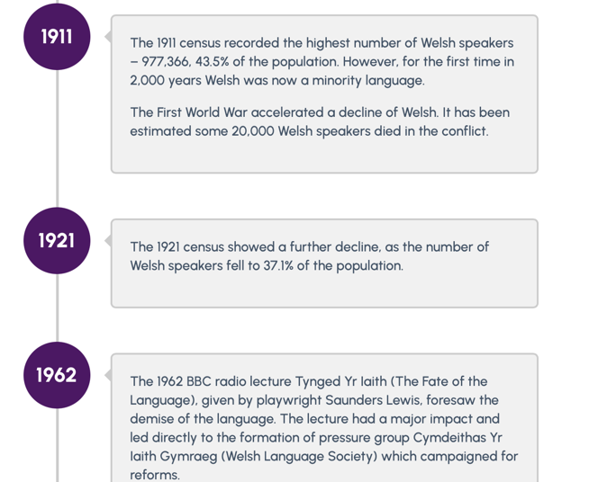
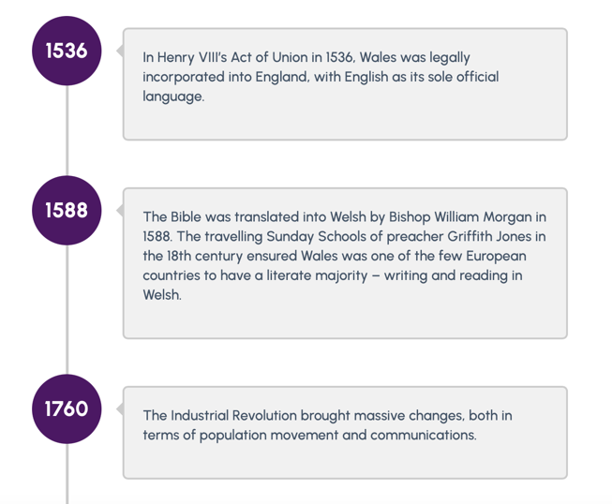
A
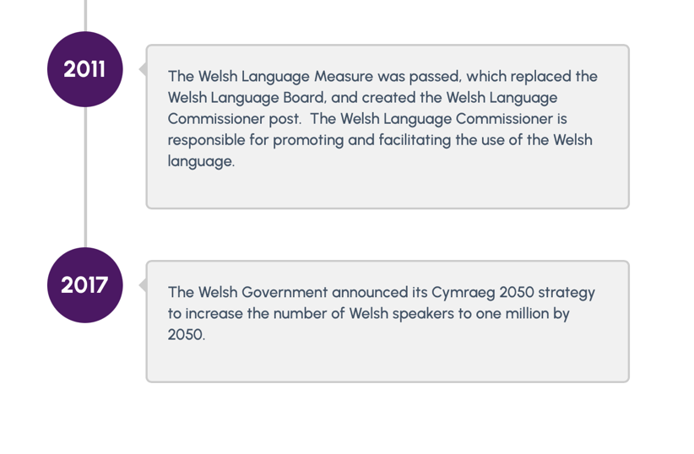
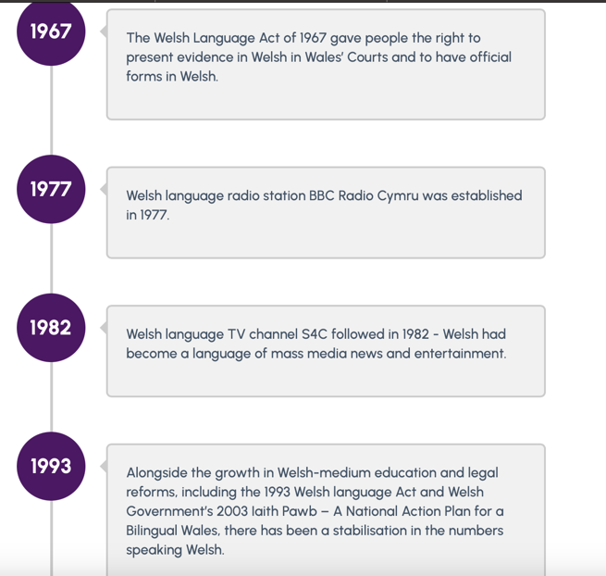

B
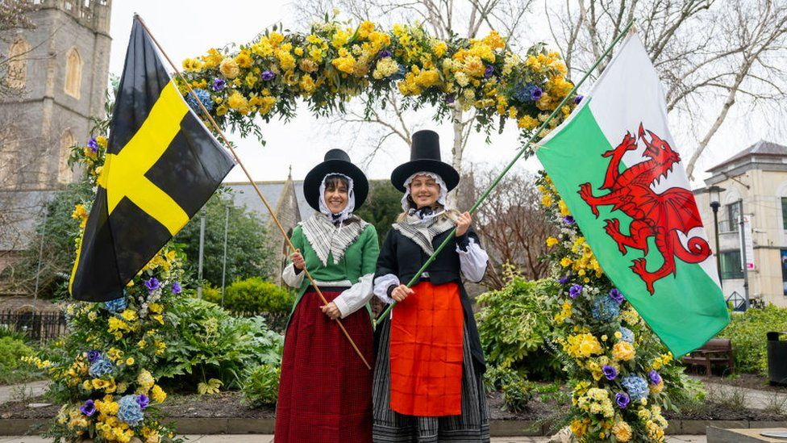

C
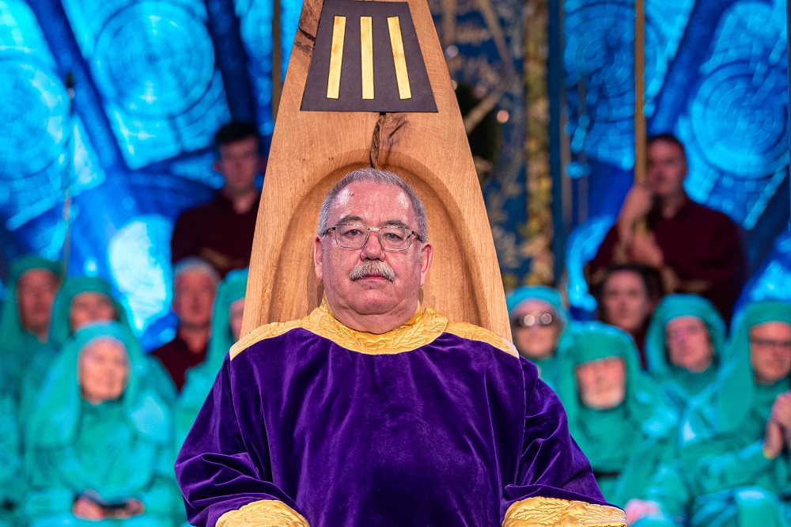

D
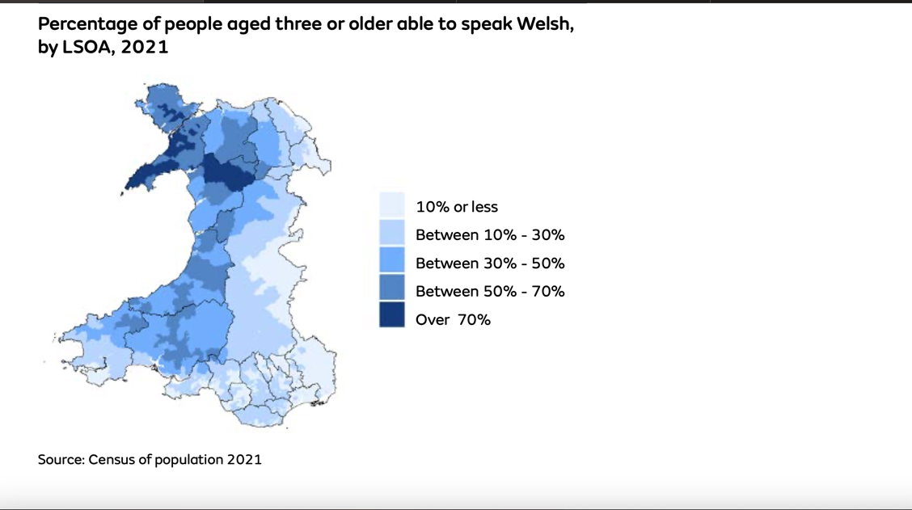

E
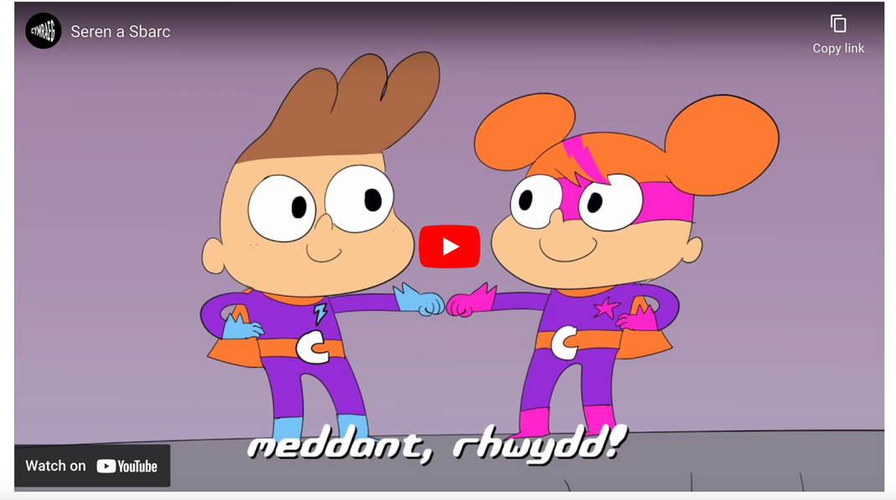

F
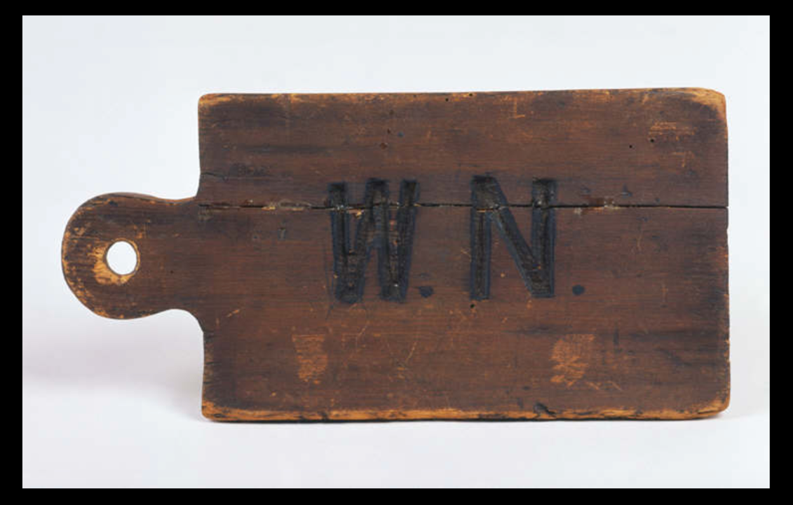

References
BBC (2023). St David’s Day 2023: Everything you need to know. Available at https://www.bbc.co.uk/newsround/43240280# (Accessed on 1st January 2024).
BBC (2022). St David’s Day: Fresh calls to make 1 March a Welsh holiday. Available at https://www.bbc.co.uk/news/uk-wales-60562540 (Accessed on 1st January 2024).
BBC (n.d). 15: The Industrial Revolution. Available at https://www.bbc.co.uk/wales/history/sites/themes/guide/ch15_industrial_revolution.shtml (Accessed on 4th January 2024).
Birt E (2023). Carmarthenshire schools celebrate St David’s Day. Available at https://www.southwalesguardian.co.uk/news/23356431.carmarthenshire-schools-celebrate-st-davids-day/ (Accessed on 6th January 2024).
Carmarthenshire County Council (2023). Advantages of being bilingual. Available at https://www.carmarthenshire.gov.wales/home/council-services/education-schools/bilingual-education/advantages-of-being-bilingual/ (Accessed on 1st January 2024).
Carmarthenshire County Council (n.d). Welsh Language Promotion Strategy. Available at https://www.carmarthenshire.gov.wales/media/1232209/welsh-language-promotion-strategy-23-28.pdf (Accessed on 1st January 2024).
Coates S (2021). Is Welsh really hard to learn? Available at https://sam-coates.medium.com/is-welsh-really-hard-to-learn-64af6e7588bc#:~:text=“Welsh%20is%20one%20of%20the,the%20easiest%20of%20languages%20examined.” (Accessed on 6th January 2024).
Donaldson G (2015). Successful Futures. Available at https://www.gov.wales/sites/default/files/publications/2018-03/successful-futures.pdf (Accessed on 1st January 2024).
dysgucymraeg.com (n.d). Available at https://learnwelsh.cymru/about-us/wales-and-the-welsh-language/#:~:text=Welsh%20is%20one%20of%20the,poetry%20survives%20from%20this%20period. (Accessed on 1st January 2024).
Eisteddfod (n.d). Croeso. Available at https://eisteddfod.wales (Accessed on 1st January 2024).
FelinFach (2023). Welsh Not – The Welsh Not a form of punishment. Available at https://www.felinfach.com/pages/welsh-not-welsh-knot#:~:text=schooling%20and%20education.-,When%20did%20the%20Welsh%20Not%20end%3F,Meirionnydd%20prior%20to%20the%201870s. (Accessed on 4th January 2024).
Hollis P (2020). The Welsh Language in the 20th Century. Available at https://pjhollis123.medium.com/the-welsh-language-in-the-20th-century-9daa5f3f5df6 (Accessed on 4th January 2024).
James E.Wyn (2005). Painting the world green: Dafydd Iwan and the Welsh protest ballad (2005). Available at https://www.cardiff.ac.uk/special-collections/subject-guides/welsh-ballads/dafydd-iwan#:~:text=The%201960s%20had%20witnessed%20significant,valleys%20of%20south%2Deast%20Wales. (Accessed on 4th January 2024).
Nation Cymru (2023). National Eisteddfod Chair awarded to one of Wales’ most prominent poets. Available at https://nation.cymru/culture/national-eisteddfod-chair-awarded-to-one-of-wales-most-prominent-poets/ (Accessed on 1st January 2024).

People’s collection Wales (n.d). ‘Welsh Not’ from Garth School, Bangor. Available at https://www.peoplescollection.wales/items/7689#:~:text=The%20%27Welsh%20Not%27%2C%20which,be%20punished%20by%20the%20schoolteacher. (Accessed on 4th January 2024).
Twinkl (n.d). CfW Description of Learning Statements Spreadsheets. Available at https://www.twinkl.co.uk/resource/cfw-descriptions-of-learning-assessment-spreadsheets-wl-pa-13#:~:text=Progression%20Step%202%20%2D%20age%205,Step%204%20%2D%20age%2011%2D14 (Accessed on 1st January 2024).
Wales.com (n.d). This is Wales. Available at https://www.wales.com/about/culture/wales#:~:text=Although%20Wales%20is%20part%20of,the%20true%20soul%20of%20Wales. (Accessed on 6th January 2024).
Welsh Government (n.d). Cymraeg 2050. Available at https://www.gov.wales/sites/default/files/publications/2018-12/cymraeg-2050-welsh-language-strategy.pdf (Accessed on 6th January 2024).
Welsh Government (n.d). Siarter Iaith: National Framework. Available at https://hwb.gov.wales/api/storage/075c1fa4-4f3b-452f-9656-70abe3779804/48543_siarter_e_merged.pdf (Accessed on 1st January 2024).
Welsh Government (n.d). The Cwricwlwm Cymreig, history and the story of Wales. Available at https://www.gov.wales/sites/default/files/publications/2018-11/the-cwricwlwm-cymreig-history-and-the-story-of-wales-final-report.pdf (Accessed on 1st January 2024).
Welsh Government (n.d). Welsh Language Charter. Available at https://www.gov.wales/cymraeg-education/schools/welsh-language-charter (Accessed on 1st January 2024).

