
Student Name: Eden Grace Sissons
Student ID: 2329831
Lecturer: Dr Mobolanle Bello
Program: BSc/HND Computing Portfolio
Module: Scripting and Programming Concepts
Module Code: ACCA5036
27 March 2026
Github Link : scriptingandprogramming/assessment at main · Eden889/scriptingandprogramming

Table of Contents
1.0 INTRODUCTION 2
2.0 REQUIREMENT ANALYSIS 3
MoSCoW Prioritisation 4
STRUCTURE DIAGRAM: Bright Minds Academy EG Equipment Booking System 5
3.0 SOFTWARE DESIGN AND DEVELOPMENT 6
3.1 DESIGN 6
3.1.1 FLOWCHART 6
IPO TABLE 10
3.1.2 PSEUDOCODE 11
PSEUDOCODE LOGIC 24
EQUIPMENT LIST 24
SAVE AND LOAD DATA 25
GERATE BOOKING ID 26
VALIDATE DATE 26
CHECK DOUBLE BOOKING 27
MAIN MENU 28
ADD NEW EQUIPMENT 29
ADD NEW BOOKING 30
VIEW ALL BOOKINGS 31
SEARCH BOOKINGS 32
RETURN or EDIT BOOKING 33
3.2 IMPLEMENTATION DECISION 34
3.2.1 DATA STRUCTURES 34
VARIABLE TABLE 36
3.2.2 PROGRAMMING CONSTRUCTS 36
3.2.3 PYTHON AND MODULE LIBRARIES 38
4.0 TESTING AND DEBUGGING 39
4.1 ROLE OF TESTING IN SOFTWARE DEVELOPMENT ENVIRONMENT 39
4.2 TYPES OF ERRORS IN PROGRAMMING 40
4.3 EXAMPLE OF TEST CASES: 45
5.0 EVALUATION 51
CHALLENGES FACED 51
FUTURE IMPROVEMENTS 51
SELF-REFLECTION 52
REFERENCES 53
APPENDIX 56

INTRODUCTION
The Bright Minds Academy Student EG Equipment Booking System was developed to address persistent challenges associated with manual equipment management processes in educational environments. Traditional paper-based or informal booking methods often lead to misplaced records, inconsistent tracking, and scheduling conflicts, making it difficult for staff to maintain accurate and up-to-date information about equipment availability. These limitations are widely recognised in studies examining the shortcomings of non-digital resource management practices in academic settings [1].

To resolve these issues, the system provides a structured, computer-based solution that automates essential tasks such as storing equipment, creating bookings, validating inputs, and maintaining persistent data across sessions. Features including clear menu navigation, automated ID generation, and JSON-based storage ensure that booking information remains reliable, traceable, and easy to manage. This reflects modern expectations for lightweight educational software, where usability, efficiency, and long-term maintainability are key design priorities [2].

The system also applies modular programming principles, allowing each function, such as adding equipment, searching records, or returning bookings, to operate independently while supporting the overall workflow. This modularity enhances scalability, reduces complexity, and aligns with current software engineering practices for small-scale academic applications, making it a dependable and user-friendly solution for managing equipment bookings at Bright Minds Academy.

2.0 REQUIREMENT ANALYSIS
The Bright Minds Academy Student EG Equipment Booking System was developed to provide a dependable, organised, and user-friendly computer-based method for managing academic equipment. A digital system was required to replace manual booking procedures, which often lead to inconsistent tracking, lost information, and duplicate bookings, an issue also highlighted in recent requirement engineering research [3]. To address these problems, the system needed to be accurate, error-free, and long-lasting. The MoSCoW table guided the prioritisation of essential and optional features.

A key functional requirement was the ability to store equipment in an organised structure. The system uses a Python dictionary to record each item’s total quantity and current availability, allowing dynamic updates whenever bookings or returns occur. The ability to add new equipment was also necessary to support future expansion, aligning with scalable resource-tracking approaches discussed in modern educational systems [4]. The structured diagram reinforces this by placing Add Equipment and Display Equipment within the core Equipment Management flow.

Booking management forms the central functionality. Users must be able to select equipment, enter a student name, and provide a booking date. Each booking requires a unique booking ID for traceability, and the system must prevent bookings when no units are available to maintain data integrity. Additional features, including viewing bookings, searching, editing, and returning items, appear in both the MoSCoW table and the structured diagram, supporting efficient record management.

A major non-functional requirement is data persistence. JSON storage ensures that equipment, bookings, and ID counters remain intact between sessions. Usability is also essential; therefore, the system includes a simple text-based menu, clear prompts, and validation checks to prevent invalid inputs, consistent with modern expectations for lightweight academic systems [5].

The system meets all prioritised requirements by delivering a structured, persistent, and user-friendly solution for managing academic equipment bookings. The MoSCoW prioritisation and structured diagram are shown below.

MoSCoW Prioritisation
Priority | Requirement | Reason
MUST | Store equipment with total and available quantities | Core functionality; system cannot operate without equipment data
MUST | Create bookings with unique booking IDs | Essential for identifying and managing bookings
MUST | Save and load data using JSON | Required for persistence across sessions
MUST | Validate user input (equipment number, quantity, names, dates) | Prevents errors and ensures data integrity
MUST | Display equipment list with availability | Users must see what is available before booking
MUST | Prevent duplicate bookings for the same student, equipment and date | Ensures booking records stay correct and avoids scheduling conflicts
SHOULD | Allow editing of existing bookings | Improves usability and flexibility
SHOULD | Allow returning of bookings and restore availability | Ensures correct stock levels
SHOULD | Provide search functionality for bookings | Helps users quickly find records
COULD | Add sorting or filtering options | Enhances user experience but not essential
COULD | Add more detailed equipment descriptions | Useful but not needed for core operation
WON’T | Add user accounts or login system | Outside the scope of the prototype
WON’T | Add automated email confirmations | Not required for academic prototype

STRUCTURE DIAGRAM: Bright Minds Academy EG Equipment Booking System
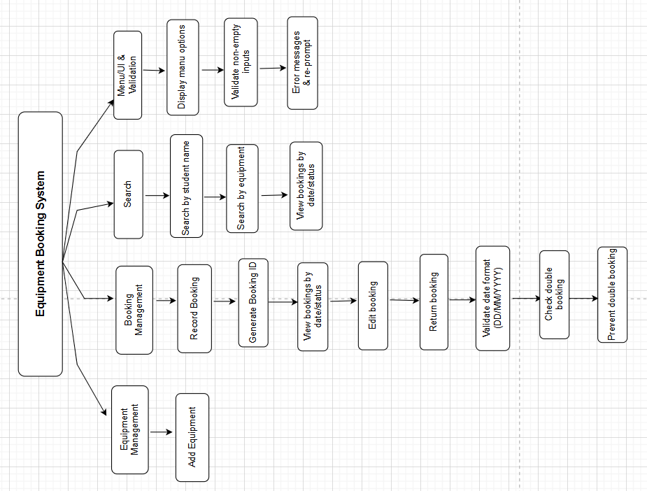

3.0 SOFTWARE DESIGN AND DEVELOPMENT
The Bright Minds Academy Student EG Equipment Booking System’s design and development were driven by the requirement to produce a dependable, practical, and easy-to-use software solution. The design process focused on ensuring that the system could accurately store and retrieve data across multiple sessions, maintain clear program logic, and utilise appropriate data structures to satisfy the previously identified requirements. This approach reflects modern lightweight academic system design principles discussed in recent software engineering literature [6].

A key design consideration was the use of Python dictionaries and lists to store equipment and booking data. This structure enables the system to track availability dynamically and update records instantly whenever a booking is added, edited, or returned. Another major design decision was the integration of JSON for data persistence. This ensures that all equipment, bookings, and booking ID counters are saved externally and automatically reloaded when the program starts, preventing data loss and supporting long-term reliability, consistent with current research on persistent educational data systems [7].

The development process followed a modular approach, with each function performing a specific task, such as viewing equipment, adding items, validating input, generating booking IDs, returning bookings, and editing records. This improves readability, maintainability, and scalability while supporting simple user interaction and accurate log-keeping, aligning with recommended modular development practices in recent studies.

3.1 DESIGN

3.1.1 FLOWCHART
A flowchart is a visual representation of a process that illustrates the sequence of steps, decisions, and operations within a system using standardised symbols such as rectangles for processes, diamonds for decisions, and parallelograms for inputs and outputs [8]. Flowcharts are widely used in software development because they provide a clear and structured overview of how a program operates before implementation. This helps developers understand system logic, identify potential errors, and ensure that processes follow an efficient and logical sequence, which is essential for reliable system behaviour.

In the Bright Minds Academy Student EG Equipment Booking System, the flowchart plays a crucial role in representing the logic behind the Add Booking function, one of the system’s core operations. It visually demonstrates how user inputs are handled, validated, and processed to produce outputs such as confirmed bookings and updated availability. This visual clarity supports both developers and users by ensuring that the booking process is accurate, efficient, and aligned with the system’s functional requirements. The flowchart also complements the IPO table, which outlines the inputs, processes, and outputs for each system component, reinforcing how data flows through the booking function.

The flowchart begins with the Start/Load Menu, where the user selects the “Add Booking” option. This triggers the booking workflow and leads to the system displaying the equipment list. This step corresponds directly with the IPO table’s “Equipment List” component, which outputs the available equipment and their quantities. The user then inputs an equipment number, which is immediately validated. If the input is invalid, the flowchart returns the user to the equipment list, ensuring that only correct selections progress further. This validation step reflects standard input-checking practices recommended in modern software design research [9].

Once a valid equipment number is entered, the system checks availability. If the selected item is out of stock, the flowchart loops back to allow the user to choose again. If the item is available, the system proceeds to collect the student’s name and booking date. The date is validated to ensure it follows the correct format, and any invalid entry results in a return to the date input stage. This mirrors the IPO table’s emphasis on validating user input before processing.

After all inputs are confirmed, the system generates a unique booking ID. This ensures traceability and prevents duplication, a requirement also highlighted in the system’s MoSCoW prioritisation. The booking is then saved to the JSON file, updating both the booking list and equipment availability. This final step aligns with the IPO table’s “Add Booking” component, which outlines the creation of the booking record and the update of persistent data.

The flowchart concludes by returning the user to the main menu or allowing them to exit, completing the process in a structured and user-friendly manner. The flowchart and IPO table work together to provide a clear and systematic representation of the booking process, supporting accuracy, usability, and maintainability within the system [10].
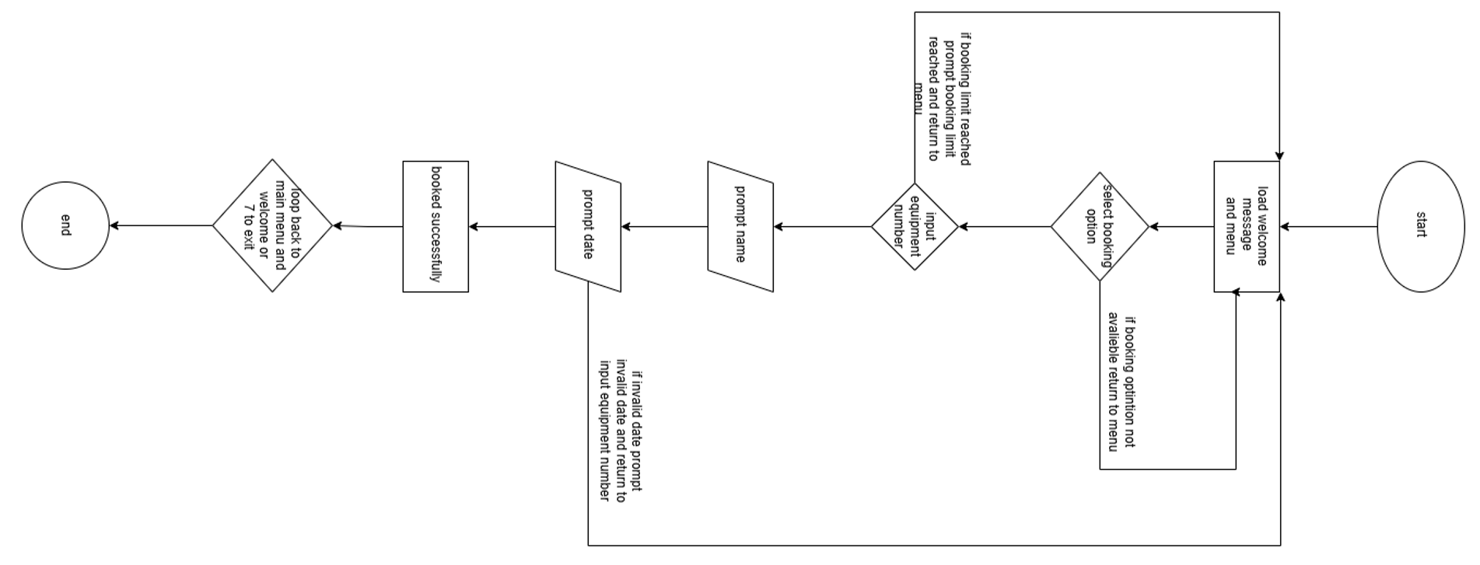

IPO TABLE
Component | Input | Process | Output
Load Data | JSON file (if it exists) | Read JSON file, extract equipment_list, bookings, and next_booking_number | Data loaded into program variables
Equipment List | None | Loop through equipment_list dictionary and read each equipment item with its available and total quantity | Equipment details displayed
Add Equipment | Equipment name, quantity | Validate equipment name and quantity, create dictionary entry, save data to JSON | Equipment added confirmation
Search Bookings | Search term | Search bookings list for matching student name or equipment name | Matching booking results displayed
Add Booking | Equipment number, student name, booking date | Validate equipment selection, check availability, validate student name, validate date format, check double booking, generate booking ID, create booking record, decrease availability, save data to JSON | Booking record created
View Bookings | None | Loop through bookings list and display each booking record | All booking details displayed
Return Booking | Booking ID | Find booking, increase equipment availability, remove booking from list, save data to JSON | Booking returned confirmation
Edit Booking | Booking ID, new student name, new booking date | Validate booking ID, validate new student name, validate date format, check double booking, update booking details, save data to JSON | Booking updated confirmation
Main Menu | User choice (1–7) | Display menu, accept user choice, direct user to the correct function | Navigation through system functions
Exit Program | User chooses Exit | Stop program loop and close system | Program terminated

3.1.2 PSEUDOCODE
3.1.2 PSEUDOCODE
Pseudocode is a structured, language-independent method for describing program logic using clear and readable steps that resemble programming constructs [13]. It helps developers plan algorithms, understand system behaviour, and organise decision-making processes before writing actual code.

In this project, pseudocode was used to design the logical structure of the Student EG Equipment Booking System, outlining data initialisation, validation rules, and the sequence of operations for each function. It defines how equipment is added, how bookings are validated, how unique booking IDs are generated, and how data is saved. This ensures that the final Python implementation follows a clear, consistent, and reliable logic flow [14].

BEGIN PROGRAM

IMPORT json
IMPORT os
IMPORT datetime

SET DATA_FILE = "booking_data.json"

input equipment_list with:
"Digital Camera" = {available: 2, total: 2}
"Tripod Stand" = {available: 4, total: 4}
"Laptop Computer" = {available: 4, total: 4}
"Projector" = {available: 1, total: 1}
"Microphone Set" = {available: 1, total: 1}
"VR Headset" = {available: 2, total: 2}
"3D Printer" = {available: 2, total: 2}
"Graphics Tablet" = {available: 2, total: 2}
"Portable Lighting Kit" = {available: 2, total: 2}
"Audio Recorder" = {available: 2, total: 2}

input bookings as empty list
input next_booking_number = 1

FUNCTION save_data()
CREATE data dictionary
"equipment_list" = equipment_list
"bookings" = bookings
"next_booking_number" = next_booking_number

OPEN DATA_FILE for writing
WRITE data to JSON file
DISPLAY "Data saved."
END FUNCTION

FUNCTION load_data()
IF DATA_FILE does not exist THEN
RETURN
END IF

OPEN DATA_FILE for reading
READ JSON data into data

SET loaded_equipment = value of "equipment_list" from data
IF loaded_equipment is not empty THEN
SET equipment_list = loaded_equipment
END IF

SET bookings = value of "bookings" from data, otherwise empty list
SET next_booking_number = value of "next_booking_number" from data, otherwise 1
END FUNCTION

FUNCTION generate_booking_id()
SET booking_id = "B" + next_booking_number formatted to 3 digits
INCREMENT next_booking_number by 1
RETURN booking_id
END FUNCTION

FUNCTION valid_date(date_text)
TRY
CHECK date_text matches DD/MM/YYYY format
RETURN TRUE
CATCH invalid date
RETURN FALSE
END TRY
END FUNCTION

FUNCTION is_double_booking(student, equipment, date)
FOR each booking IN bookings
IF booking student = student
AND booking equipment = equipment
AND booking date = date THEN
RETURN TRUE
END IF
END FOR
RETURN FALSE
END FUNCTION

FUNCTION add_equipment()
PROMPT user for equipment name
REMOVE extra spaces from name

IF name is empty THEN
DISPLAY "Error: Equipment name cannot be empty."
RETURN
END IF

PROMPT user for total quantity

IF quantity is not a valid number THEN
DISPLAY "Invalid number."
RETURN
END IF

IF quantity < 1 THEN
DISPLAY "Quantity must be at least 1."
RETURN
END IF

ADD name to equipment_list
available = total quantity
total = total quantity

CALL save_data()
DISPLAY "Equipment added successfully."
END FUNCTION

FUNCTION add_booking()
IF equipment_list is empty THEN
DISPLAY "No equipment available. Please add equipment first."
RETURN
END IF

DISPLAY "Available Equipment"

CREATE equipment_names as list of equipment_list keys

FOR each equipment in equipment_names
DISPLAY equipment number, name, and available quantity
END FOR

PROMPT user to select equipment number

IF selection is invalid THEN
DISPLAY "Invalid selection."
RETURN
END IF

SET equipment = selected equipment

IF equipment available quantity = 0 THEN
DISPLAY "Sorry, no units available for this item."
RETURN
END IF

PROMPT user for student name
REMOVE extra spaces from student name

IF student name is empty THEN
DISPLAY "Student name cannot be empty."
RETURN
END IF

PROMPT user for booking date

IF valid_date(date) = FALSE THEN
DISPLAY "Invalid date format. Please use DD/MM/YYYY."
RETURN
END IF

IF is_double_booking(student, equipment, date) = TRUE THEN
DISPLAY "Double booking not allowed."
RETURN
END IF

CALL generate_booking_id() and store result in booking_id

CREATE booking record containing
booking_id
equipment
student
date

ADD booking record to bookings list
DECREASE equipment available quantity by 1

CALL save_data()
DISPLAY "Booking created successfully with ID" + booking_id
END FUNCTION

FUNCTION view_bookings()
IF bookings is empty THEN
DISPLAY "No bookings found."
RETURN
END IF

DISPLAY "All Bookings"

FOR each booking IN bookings
DISPLAY booking_id, equipment, student, date
END FOR
END FUNCTION

FUNCTION search_bookings()
PROMPT user for student name or equipment name to search
CONVERT search term to lowercase

CREATE results list containing each booking where
search term is in student name
OR search term is in equipment name

IF results is empty THEN
DISPLAY "No matching bookings found."
RETURN
END IF

DISPLAY "Search Results"

FOR each booking IN results
DISPLAY booking_id, equipment, student, date
END FOR
END FUNCTION

FUNCTION Return_or_edit_booking()
PROMPT user for booking ID to return or edit

FOR each booking IN bookings
IF booking_id matches entered booking ID THEN
DISPLAY booking details
DISPLAY "1. Return Booking"
DISPLAY "2. Edit Booking"

PROMPT user for choice

IF choice = "1" THEN
INCREASE equipment available quantity by 1
REMOVE booking from bookings list
CALL save_data()
DISPLAY "Booking Returned successfully."
RETURN
END IF

IF choice = "2" THEN
PROMPT user for new student name
REMOVE extra spaces

IF new student name is empty THEN
DISPLAY "Student name cannot be empty."
RETURN
END IF

PROMPT user for new booking date

IF valid_date(new_date) = FALSE THEN
DISPLAY "Invalid date format. Please use DD/MM/YYYY."
RETURN
END IF

IF is_double_booking(new_student, booking equipment, new_date) = TRUE THEN
IF current booking student and date are not the same as new values THEN
DISPLAY "Double booking not allowed."
RETURN
END IF
END IF

UPDATE booking student name
UPDATE booking date

CALL save_data()
DISPLAY "Booking updated successfully."
RETURN
END IF

DISPLAY "Invalid option."
RETURN
END IF
END FOR

DISPLAY "Booking ID not found."
END FUNCTION

FUNCTION equipments_list()
IF equipment_list is empty THEN
DISPLAY "No equipment found."
RETURN
END IF

DISPLAY "Equipment List"

FOR each equipment name and details IN equipment_list
DISPLAY equipment name, available quantity, total quantity
END FOR
END FUNCTION

FUNCTION main_menu()
LOOP forever
DISPLAY "EG Equipment Booking System"
DISPLAY "1. Equipment List"
DISPLAY "2. Add Equipment"
DISPLAY "3. Search Bookings"
DISPLAY "4. Add Booking"
DISPLAY "5. View Bookings"
DISPLAY "6. Return/Edit Booking"
DISPLAY "7. Exit"

PROMPT user for choice

IF choice = "1" THEN
CALL equipments_list()
ELSE IF choice = "2" THEN
CALL add_equipment()
ELSE IF choice = "3" THEN
CALL search_bookings()
ELSE IF choice = "4" THEN
CALL add_booking()
ELSE IF choice = "5" THEN
CALL view_bookings()
ELSE IF choice = "6" THEN
CALL Return_or_edit_booking()
ELSE IF choice = "7" THEN
DISPLAY "Exiting program."
BREAK loop
ELSE
DISPLAY "Invalid choice. Please try again."
END IF
END LOOP
END FUNCTION

CALL load_data()
CALL main_menu()

END PROGRAM

PSEUDOCODE LOGIC

EQUIPMENT LIST
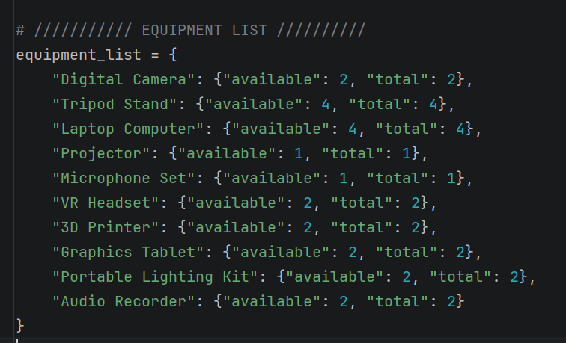
Figure 1 Equipment: Python implementation of the equipment_list data structure used to store equipment information in the system.
The equipment_list structure stores each item with its available and total quantities, enabling the system to track resources, validate availability, and update stock during bookings, returns, and equipment-list displays [15].
SAVE AND LOAD DATA 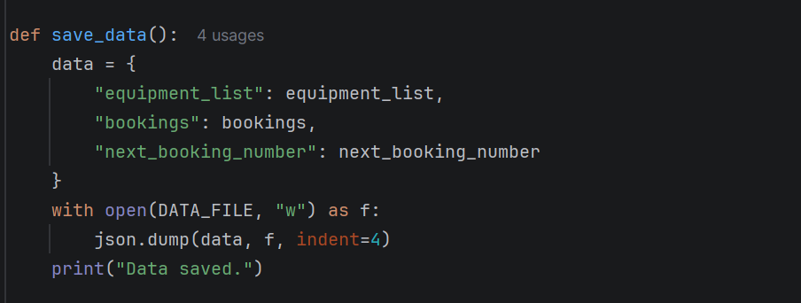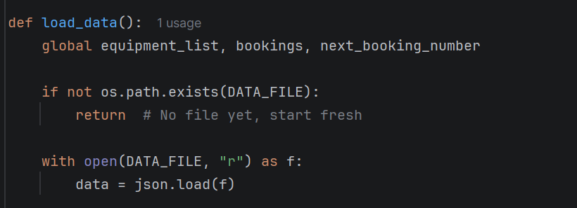
Figure 2. Python implementation of the save_data() and load_data() functions used to store and retrieve booking data from a JSON file.
The save_data function stores equipment, bookings, and booking numbers in a JSON file, while load_data function retrieves and restores them, this ensures persistent system data across sessions using json and os checks [15].

GERATE BOOKING ID
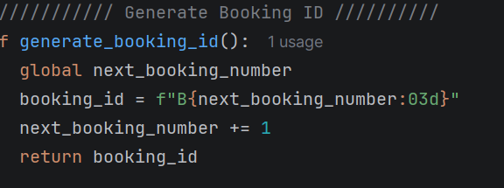
Figure 3 Python implementation of the generate_booking_id() function used to create a unique booking identifier.
The function creates a unique booking ID by combining a “B” prefix with an incrementing, zero-padded number. It then updates the counter, ensuring every new booking receives a distinct identifier [16].

VALIDATE DATE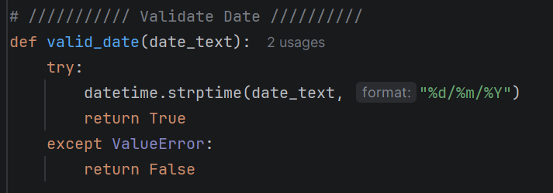
Figure 4. Python implementation of the valid_date() function used to validate date input.
The valid_date function checks whether user-entered dates match the DD/MM/YYYY format using datetime parsing, preventing invalid entries and ensuring consistent, structured date validation within lightweight educational booking systems [16].

CHECK DOUBLE BOOKING
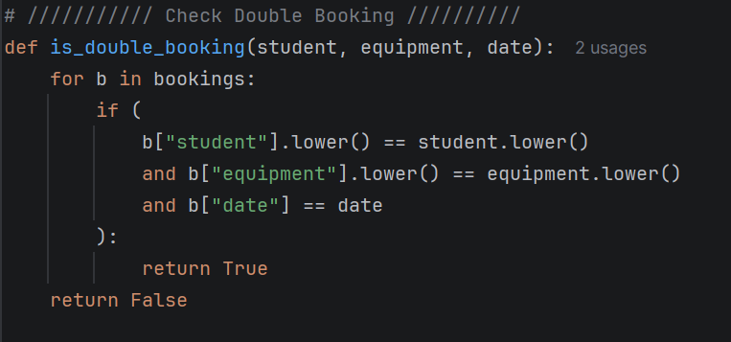
Figure 5 Python implementation of the is_double_booking() function used to detect duplicate booking records.

The is_double_booking function scans existing records to detect matching student, equipment, and date entries, preventing duplicate reservations and ensuring accurate, conflict-free booking management within lightweight educational systems [17].

MAIN MENU
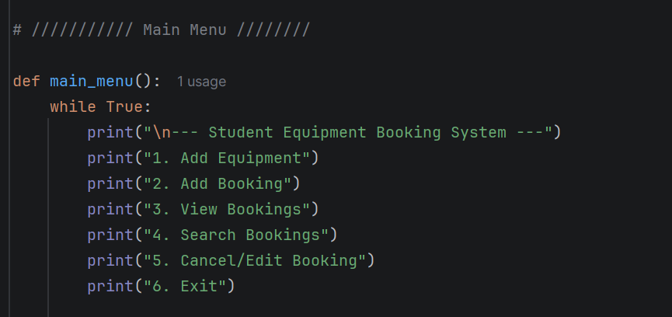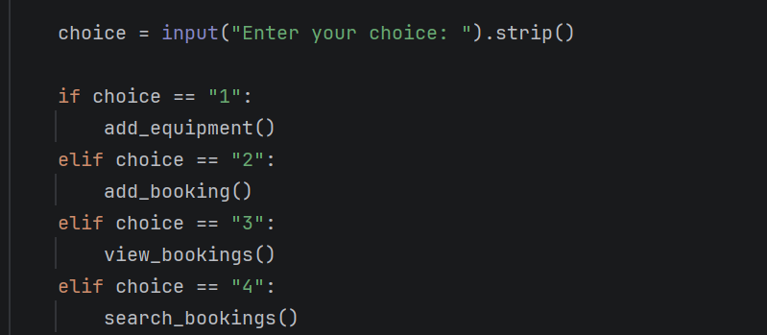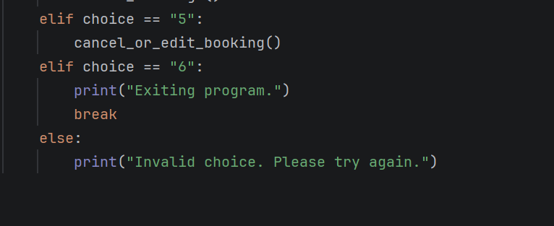
Figure 6 Python implementation of the main_menu() function that controls user interaction with the booking system.
The main_menu uses a continuous loop to display system options, collect user choices, and trigger functions, providing structured navigation and consistent interaction within lightweight educational booking systems [18].

ADD NEW EQUIPMENT
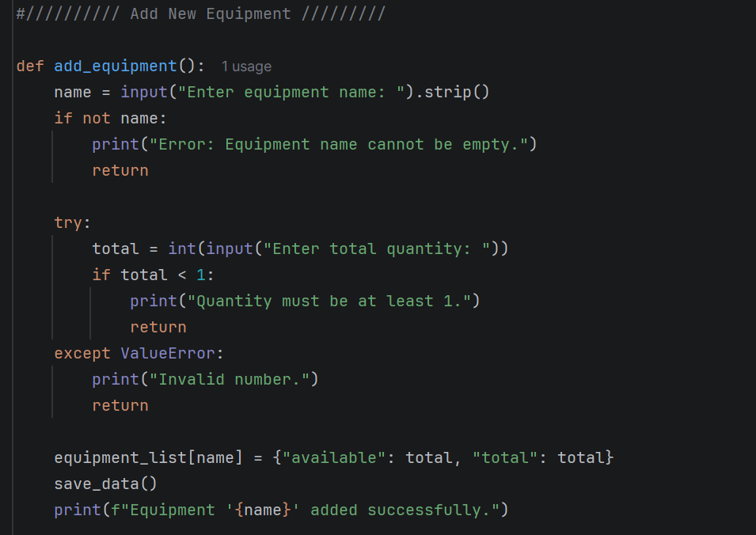
Figure 7: Python implementation of the add_equipment() function used to add new equipment items to the system.

The add_equipment function collects a name and quantity, validates both inputs, and updates the equipment list, ensuring accurate resource expansion and reliable data handling in lightweight educational booking systems [18].

ADD NEW BOOKING
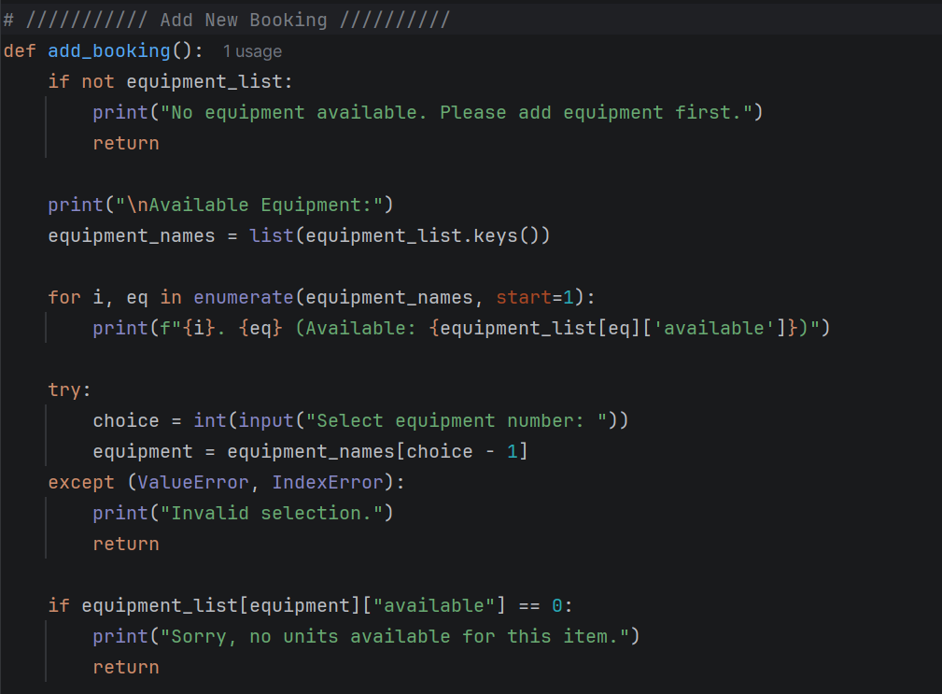
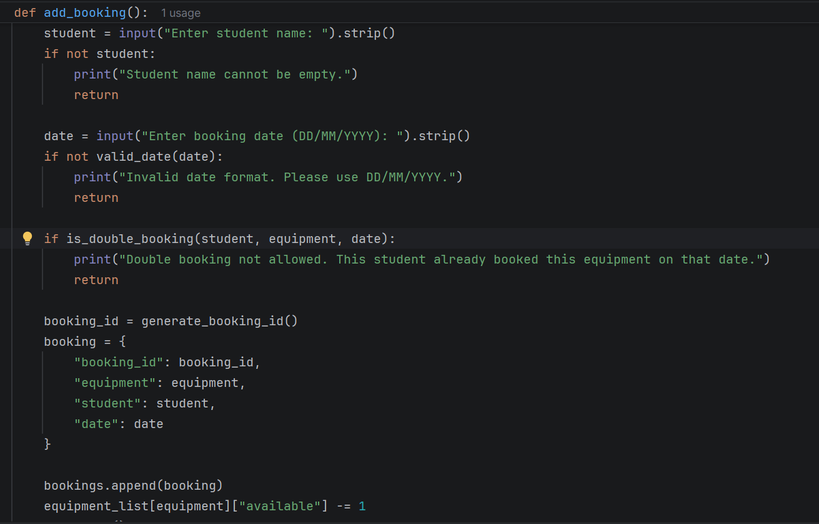
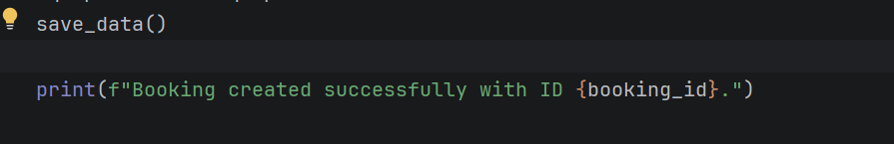
Figure 8 Python implementation of the add_booking() function that creates a booking record, validates inputs, prevents double bookings, and updates equipment availability.

The add_booking function validates equipment availability, student name, date format, and duplicate reservations before generating a unique ID, storing the booking, updating availability, and saving persistent data in the system [19].

VIEW ALL BOOKINGS
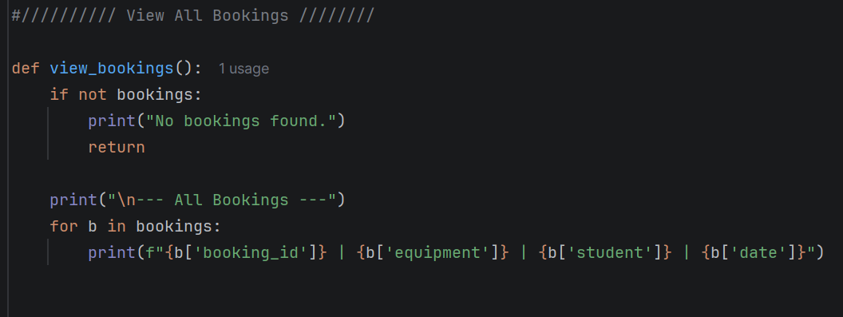
Figure 9: Python implementation of the view_bookings() function used to display all stored booking records.

The view_bookings function checks whether records exist, then iterates through stored bookings to display IDs, equipment, students, and dates, providing users with a clear overview of all reservation data in the system [20].

SEARCH BOOKINGS
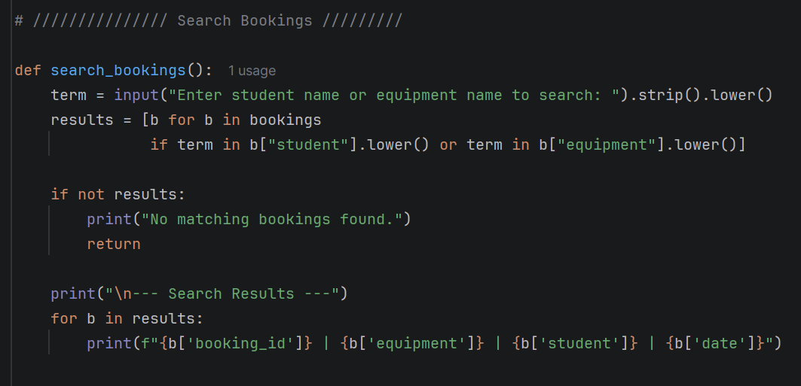
Figure 10: Python implementation of the search_bookings() function used to locate bookings by student name or equipment name.

The search_bookings function accepts a search term, filters booking records by student or equipment name using case-insensitive matching, and displays any results found, enabling quick retrieval of relevant reservation information [20].

RETURN or EDIT BOOKING
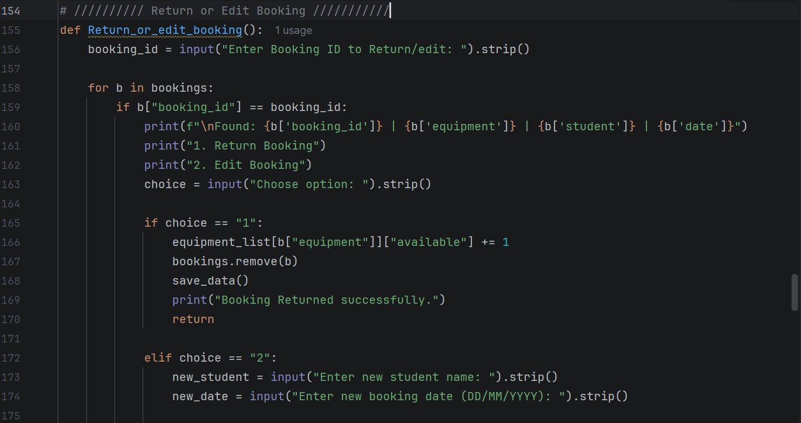
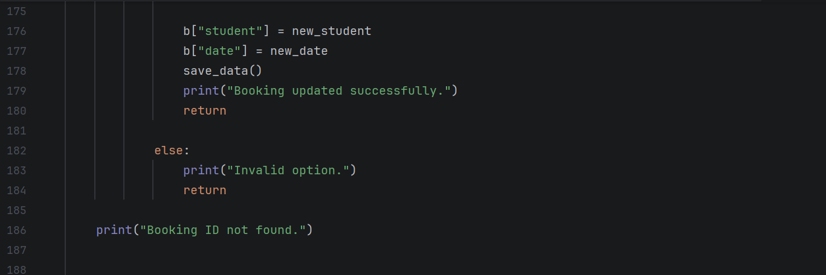
Figure 11. Python implementation of the return_or_edit_booking() function used to return or update an existing booking.

The return_or_edit_booking function locates a booking by ID and allows users to return or update it, adjusting availability and saving changes to maintain accurate, up-to-date reservation records in the system [21].

3.2 IMPLEMENTATION DECISION

3.2.1 DATA STRUCTURES
A data structure is an organised method of storing, managing, and accessing data within a computer system [22]. It determines how data is arranged in memory and what operations can be performed efficiently on that data, such as searching, inserting, updating, and deleting.

Data structures are essential in software development because they directly influence performance, scalability, and the clarity of program logic. Selecting an appropriate data structure reduces complexity, improves efficiency, and ensures that data can be processed in a consistent and reliable manner throughout the system.

The system makes extensive use of dictionaries to organise and manage equipment data within the Bright Minds Academy Student EG Equipment Booking System.

A dictionary is a data structure that stores information in key–value pairs, where each key acts as a meaningful label that allows its associated value to be accessed efficiently [23]. Dictionaries allow multiple attributes to be grouped together in a single, structured record, making them suitable for storing complex data entries such as bookings. Each booking is stored as a dictionary containing fields such as booking_id, equipment, student, and date. This structure enables the system to store and retrieve booking information in a clear and organised format.

When a new booking is created, the program collects user input and stores each piece of information as a value assigned to a descriptive key. This dictionary is then appended to the bookings list. During a search, the program iterates through this list, compares each dictionary with the search term, and stores any matches in a results list for later display. This ensures that each booking remains self-contained and easy to manipulate.

Dictionaries were selected because they allow direct access to values using descriptive keys, improving readability and reducing errors. They also provide a flexible structure, allowing new attributes to be added without redesigning the system. Furthermore, dictionaries closely represent real-world booking records and integrate effectively with JSON storage, making the system easier to maintain, extend, and understand [24].

VARIABLES
A variable is a named memory location used to store data whose value may change during program execution [25]. Variables enable the system to track user input, maintain internal state, and support calculations or data manipulation throughout the booking process.

The variables used in the program include bookings (a list of dictionaries), which stores all booking records, and next_booking_number (an integer), which is used to generate unique booking IDs. DATA_FILE (a string) stores the JSON filename used for saving and loading data, while booking_id (a string) represents the unique identifier for each booking. equipment (a string) stores the selected equipment name, student (a string) stores the student’s name, and date (a string) stores the booking date in DD/MM/YYYY format. results (a list of dictionaries) stores bookings that match a search query, choice (a string) stores the user’s menu selection, quantity (an integer) stores the number of units when adding equipment, and term (a string) stores the keyword entered during search operations.

VARIABLE TABLE
Variable Name | Data Type | Description / Purpose
bookings | List of Dictionaries | Stores all booking records. Each booking is stored as a dictionary containing booking ID, equipment name, student name, and booking date.
next_booking_number | Integer | Counter used to generate unique booking IDs. Increases by 1 each time a booking is created.
DATA_FILE | String | The filename of the JSON file used to save and load system data.
booking_id | String | A unique identifier generated for each booking (e.g., B001, B002).
equipment | String | The name of the equipment selected by the user when creating a booking.
student | String | The name of the student making the booking.
date | String | The date the equipment is booked for (DD/MM/YYYY).
results | List of Dictionaries | Stores matching bookings found during a search operation.
choice | String | Stores the user’s menu selection in the main menu.
quantity | Integer | The number of units entered when adding new equipment.
term | String | The keyword entered by the user when searching for bookings.

3.2.2 PROGRAMMING CONSTRUCTS
Programming constructs are the fundamental structural elements that determine how a program operates, processes data, and responds to different conditions [26]. They provide the logical framework that governs the order of execution, decision-making, repetition of tasks, and modular organisation of code. These constructs include sequence, selection, iteration, functions, and error-handling mechanisms, all of which work together to create predictable and maintainable program behaviour. Without programming constructs, software would lack structure, making it difficult to manage complexity or ensure consistent outcomes. They form the foundation of all programming languages and are essential for designing efficient, readable, and reliable systems.

Programming constructs are important because they allow developers to organise program logic in a structured and meaningful way. They help break down complex tasks into smaller, manageable operations, making programs easier to understand, maintain, and extend. By using constructs effectively, developers can create systems that behave predictably, handle errors gracefully, and respond appropriately to user input [27].

The Student EG Equipment Booking System relies on several programming constructs to ensure that data is processed accurately and that user interactions are handled smoothly. The first construct used is sequence, which ensures that instructions are executed in a logical order. For example, when creating a booking, the program collects user input, validates it, stores it in a dictionary, and then appends it to the bookings list. This sequential flow ensures that each step is completed before the next begins, preventing errors and maintaining consistency.

The second construct used is selection, implemented through if–else statements. Selection allows the program to make decisions based on user input or system conditions. For instance, when the user selects a menu option, the program checks which option was chosen and executes the corresponding function. Selection is also used to validate search results, ensuring that the system displays appropriate messages when no matching bookings are found. This improves user experience and prevents unexpected behaviour.

The third construct used is iteration, which is essential for processing multiple bookings. Loops are used when searching for records, displaying results, loading data from the JSON file, and saving updated information. Iteration allows the system to handle datasets of varying sizes without requiring manual intervention. It ensures that every booking is checked during a search and that all records are loaded correctly when the program starts.

The fourth construct used is functions, which modularise the system by grouping related instructions into reusable blocks. Functions such as create_booking(), search_bookings(), and save_data() improve readability and reduce repetition. They also make the system easier to maintain, as changes can be made in one place without affecting the entire program.

Error handling is used to ensure that the system can cope with unexpected situations, such as missing files or invalid input. For example, when loading data, the program checks whether the JSON file exists and handles exceptions to prevent crashes. This improves reliability and ensures a smooth user experience.

These programming constructs were selected because they support clarity, maintainability, and robustness. They align with best practices in structured programming and ensure that the system behaves predictably under different conditions [28].

3.2.3 PYTHON AND MODULE LIBRARIES
Python modules and libraries are reusable collections of code that extend the functionality of a program [29]. A module is a single Python file containing functions, classes, or variables, while a library is a collection of related modules packaged together to provide specialised capabilities. These resources allow developers to perform complex tasks without writing code from scratch, improving efficiency and reducing development time. Modules and libraries support a wide range of operations, including file handling, data processing, system interaction, and error management. They are essential components of Python programming and play a significant role in building scalable and maintainable applications.

Python modules and libraries are important because they provide pre-built tools that simplify common programming tasks. They help developers write cleaner, more efficient code by offering reliable, well-tested functionality that can be reused across different parts of a project. By using modules and libraries effectively, developers can focus on solving project-specific problems rather than re-implementing basic features.

The Bright Minds Academy Student EG Equipment Booking System uses several built-in Python modules to support data storage, file management, and system reliability. The most important module used is the json module, which enables the program to save and load booking data in a structured format. JSON is ideal for this system because it stores data in a human-readable form and integrates naturally with Python dictionaries. When the program saves data, it converts the bookings list into JSON format, and when it loads data, it converts the JSON back into Python data structures. This ensures persistent storage without requiring a database, making the system lightweight and easy to maintain.

The second module used is the os module, which provides tools for interacting with the operating system. In this project, os.path.exists() is used to check whether the data file exists before attempting to load it. This prevents errors when the program runs for the first time or when the file has been deleted. Using the os module improves reliability by ensuring that the system handles missing files gracefully rather than crashing.

A third module that may be used is the time module, which supports timestamping or adding delays to improve user experience. Although optional, it can be useful for recording when bookings are created or for pacing output during longer operations.

These modules were selected because they are built-in, meaning they require no additional installation and are guaranteed to work across all Python environments. They are efficient, reliable, and well-documented, making them suitable for educational and small-scale management systems. The json module supports structured data storage, the os module ensures safe file handling, and the time module enhances usability. Together, they provide essential functionality while keeping the system simple and maintainable [30].

4.0 TESTING AND DEBUGGING

4.1 ROLE OF TESTING IN SOFTWARE DEVELOPMENT ENVIRONMENT
A key step in software development is program testing, which determines if a program satisfies requirements and functions as intended [31]. Software testing entails running a program in order to find bugs and confirm that the system functions properly under various circumstances. Because it enables developers to identify flaws, guarantee dependability, and enhance overall program quality, testing is a crucial phase in the software development lifecycle.

Before the system is made available to users, program testing serves the purpose of verifying that the software operates as intended and that all features are operational. Developers can find issues like inaccurate computations, unexpected outputs, or system failures by conducting rigorous testing. Additionally, testing ensures that the program satisfies user needs and operates effectively in practical settings.

Another key role of testing is improving software reliability and maintainability. By identifying and correcting issues early, developers can reduce the cost and effort needed to fix problems later in the development process. Effective testing also increases user confidence in the system because it ensures that the program runs accurately and consistently. Therefore, program testing is a critical activity that supports the development of high-quality and dependable software systems [32].

4.2 TYPES OF ERRORS IN PROGRAMMING
Programming errors are faults in a program that cause incorrect behaviour or prevent successful execution [33]. These errors occur when code violates the required syntax, logic, or operational rules of the programming language. Identifying and correcting errors is essential for ensuring software reliability, improving performance, and maintaining expected functionality throughout development and testing phases.

There are three main types of programming errors: syntax errors, runtime errors, and logical errors.

Syntax Errors
Syntax errors occur when the code violates the grammatical rules of the programming language. For example, missing punctuation, incorrect indentation, or misspelled keywords can cause syntax errors. These errors are usually detected by the compiler or interpreter before the program runs.

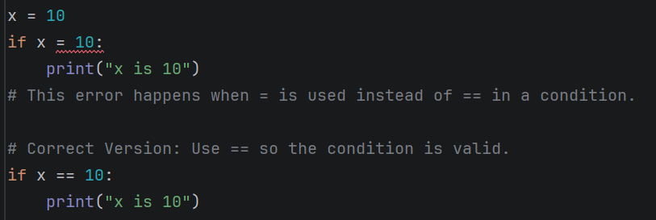
Figure 1. This error happens when = is used instead of == in a condition. Correct Version: Use == so the condition is valid.

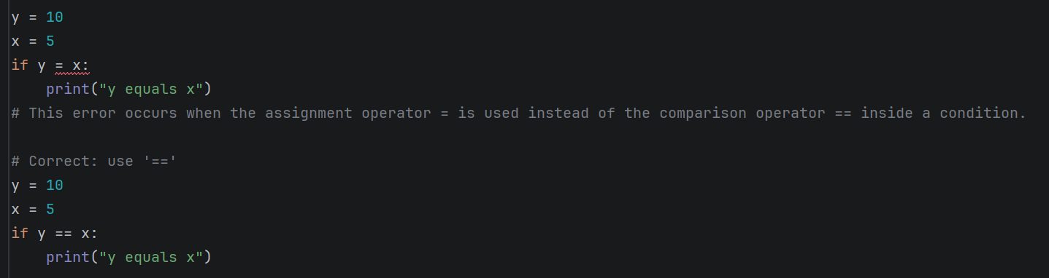
Figure 2. This error occurs when the assignment operator = is used instead of the comparison operator == inside a condition. Correct Version: Replace = with == so the condition is valid.

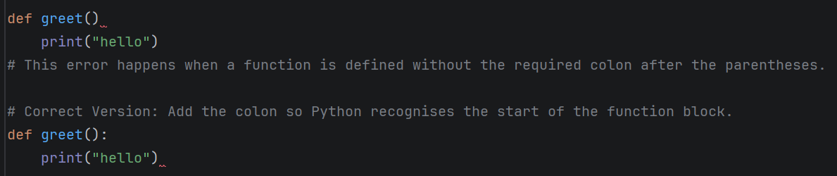
Figure 3. This error happens when a function is defined without the required colon after the parentheses. Correct Version: Add the colon so Python recognises the start of the function block.

Runtime Errors
Runtime errors occur while the program is executing. These errors happen when the program performs an invalid operation, such as dividing by zero or accessing a file that does not exist. Runtime errors can cause the program to stop unexpectedly during execution.
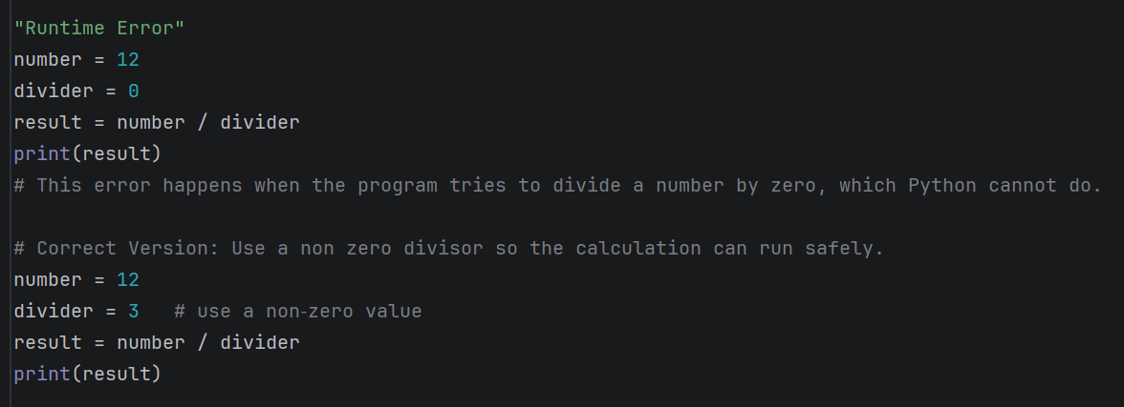
Figure 4. Division by Zero: This error happens when the program tries to divide a number by zero, which Python cannot do. Correct Version: Use a non zero divisor so the calculation can run safely.

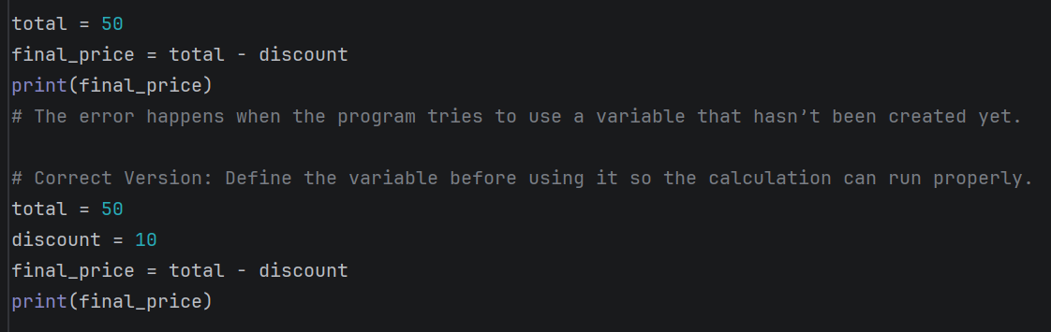
Figure 5. Using an Undefined Variable: The error happens when the program tries to use a variable that hasn’t been created yet. Correct Version: Define the variable before using it so the calculation can run properly.

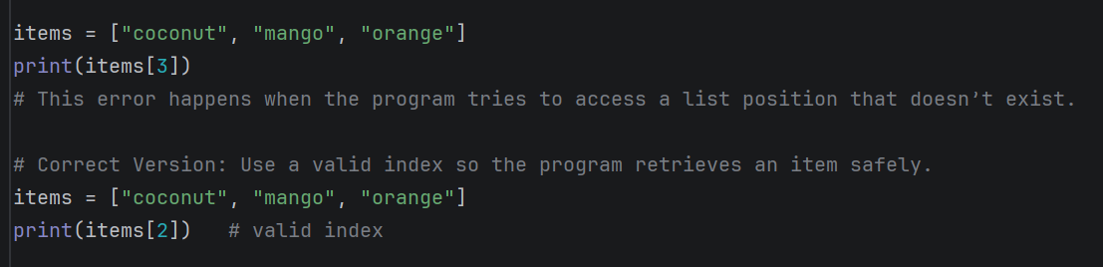
Figure 6. Index Out of Range: This error happens when the program tries to access a list position that doesn’t exist. Correct Version: Use a valid index so the program retrieves an item safely.

Logical Errors
Logical errors occur when the program runs successfully but produces incorrect results due to mistakes in the program’s logic or algorithm. These errors are often more difficult to detect because the program does not crash but gives incorrect output. Developers fix logical errors by carefully reviewing and testing the program logic to ensure the correct results are produced.
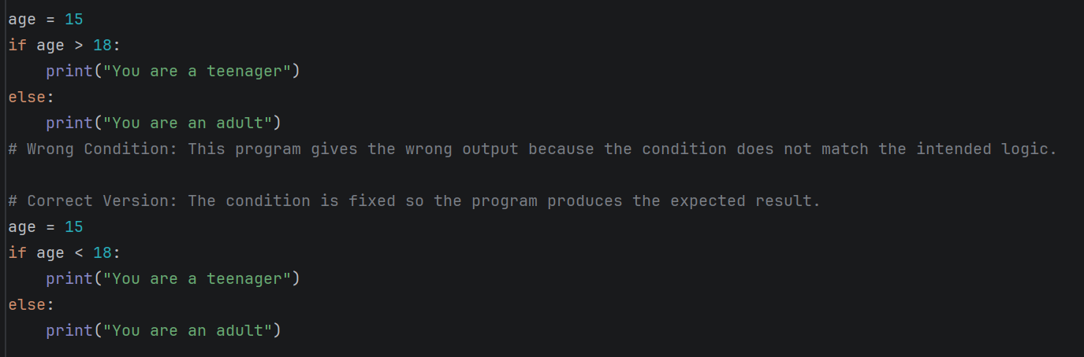
Figure 7. Wrong Condition - This program gives the wrong output because the condition does not match the intended logic. Correct Version: The condition is fixed so the program produces the expected result.

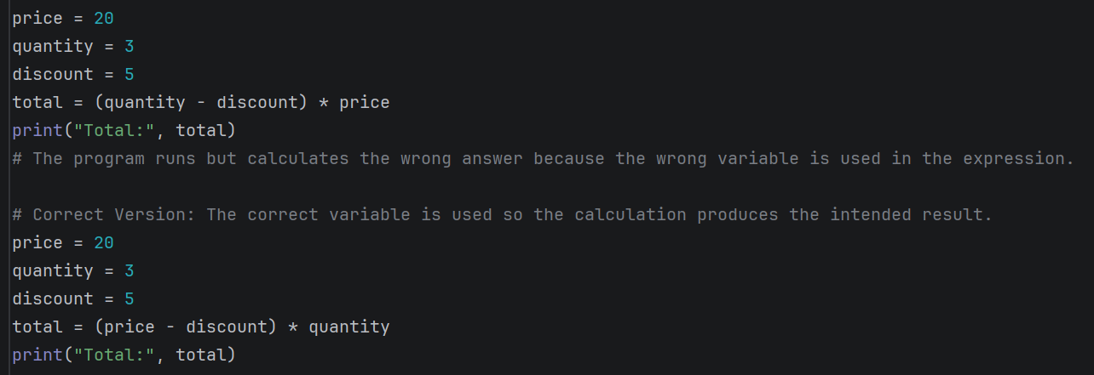
Figure 8. The program runs but calculates the wrong answer because the wrong variable is used in the expression. Correct Version: The correct variable is used so the calculation produces the intended result.

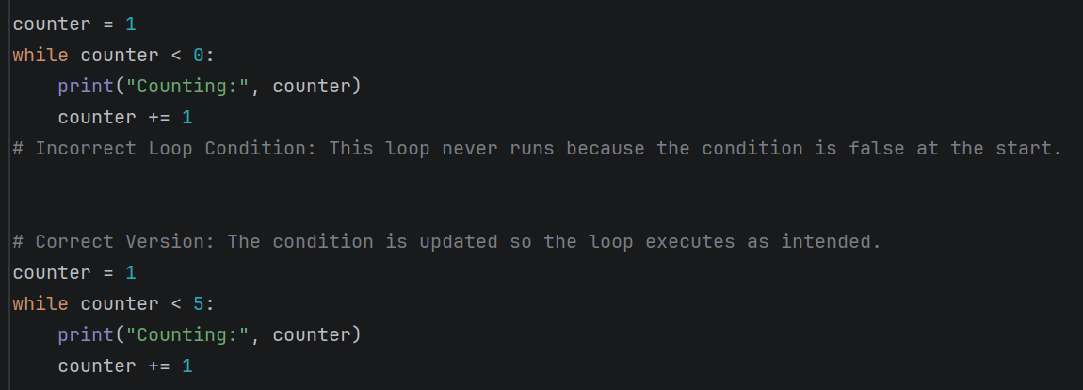

Figure 9. Incorrect Loop Condition - This loop never runs because the condition is false at the start. Correct Version: The condition is updated so the loop executes as intended.

4.3 EXAMPLE OF TEST CASES:
Test cases were created to ensure that the Bright Minds Academy Student EG Equipment Booking System performs each function correctly and produces the expected results. Each test case targets a specific feature, such as adding equipment, creating a booking, searching for a booking, or returning an existing item. These tests confirm that valid inputs are accepted, invalid inputs are handled appropriately, and stored data updates correctly. For example, TC013 verifies successful booking creation when equipment is available, while TC014 confirms accurate search retrieval or displays an appropriate message when no matching booking is found. The corresponding tables and screenshots demonstrate the inputs entered and the expected outputs produced by the system.

Test Case Title: Successful creation of a new Student Equipment Booking System
Test Case ID | TC013
Test Case Title | Successful creation of a new equipment booking
Objective | Verify that the system allows a student to create a booking successfully when valid details are entered.
Preconditions | The selected equipment item is available for booking.
Test Steps | 1. Display equipment list.  2. Select equipment number (e.g., 10 – Audio Recorder).  3. Enter student name (e.g., Jamie Wood).  4. Enter booking date in DD/MM/YYYY format (e.g., 9/3/2026).
Test Data | Equipment: Audio Recorder (Available: 2)  Student Name: Jamie Wood  Booking Date: 9/3/2026
Expected Result | The system saves the booking and displays: “Booking created successfully with ID B001.”
Pass/Fail | Pass
Comments | Screenshot taken showing successful booking creation.
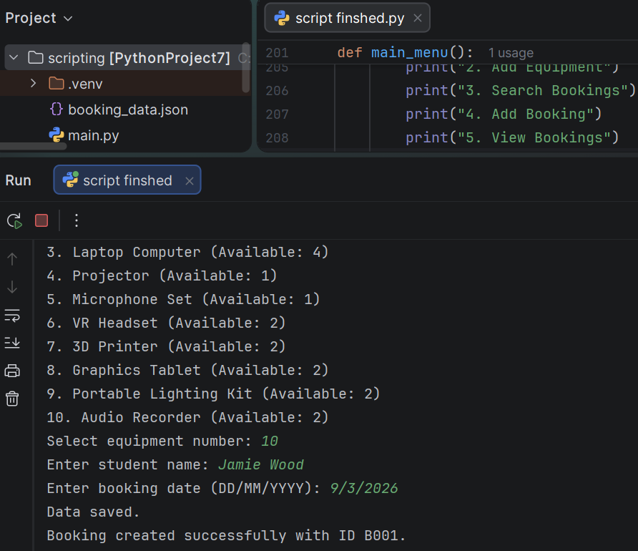
Figure 13 Test case showing the successful creation of a booking in the Student EG Equipment Booking System.
This test demonstrates a complete booking workflow, including equipment selection, student details, booking date entry, and confirmation that the booking was saved successfully.

Test Case 14: Successful Search for an Existing Booking
Test Case ID | TC014
Test Case Title | Search for an existing booking
Objective | Verify that the system retrieves and displays a booking when a valid search term is entered.
Preconditions | A booking for student Jamie Wood already exists in the system.
Test Steps | 1. Open the main menu.  2. Select Search Bookings (Option 3).  3. Enter the search term "Jamie Wood".
Test Data | Search Term: Jamie Wood
Expected Result | The system displays the booking for Jamie Wood with Booking ID B001 for Audio Recorder on 9/3/2026.
Pass/Fail | Pass
Comments | Screenshot taken showing successful search results
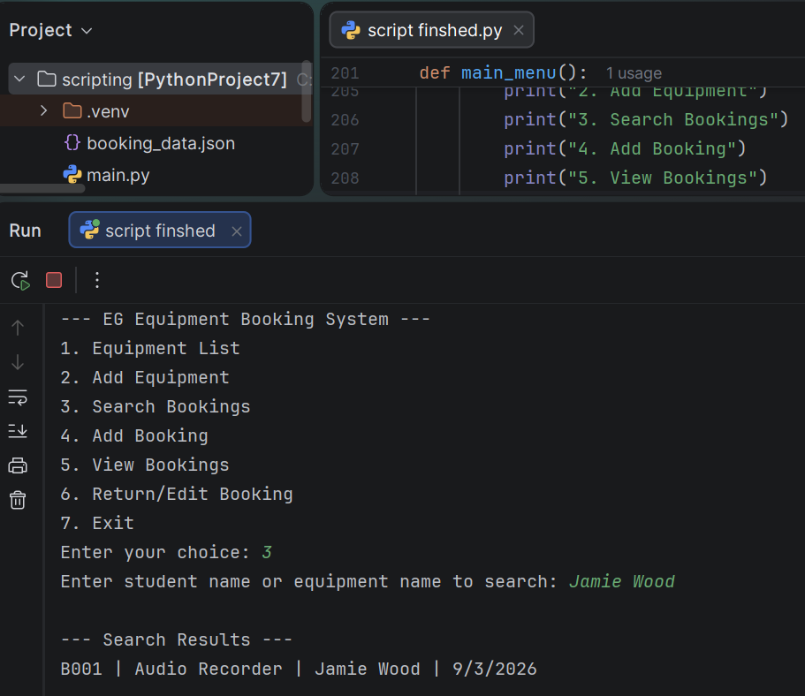
Figure 14 Test case showing a successful booking search in the Student EG Equipment Booking System.
This test demonstrates the system’s ability to locate an existing booking using a student name or equipment name, displaying the matching record clearly in the search results.
Test Case Title: Search for a booking
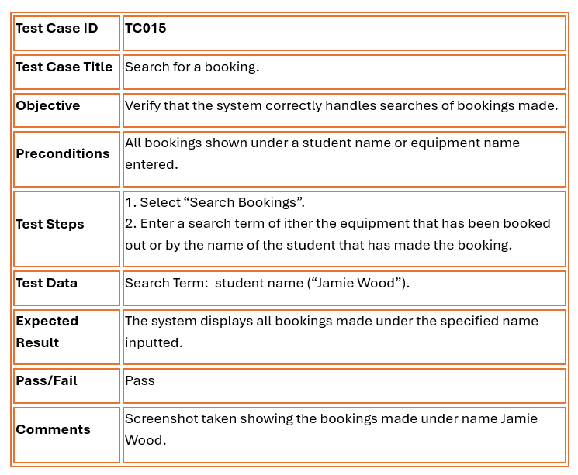
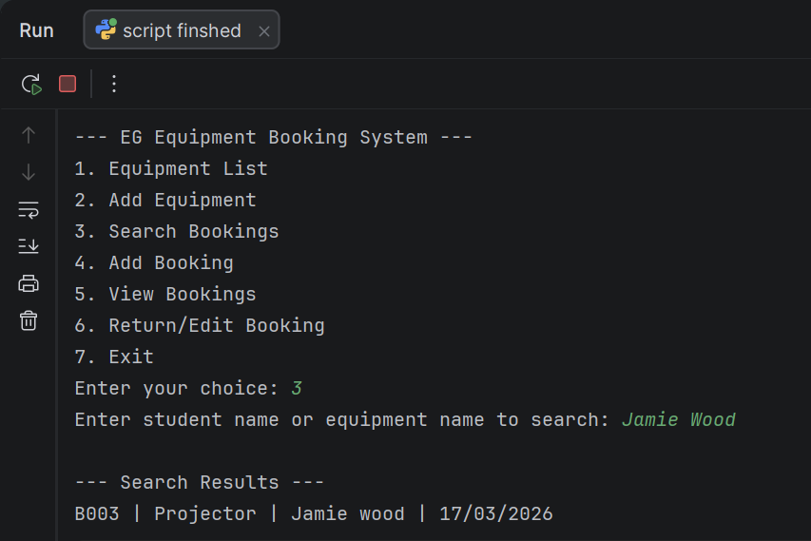
Figure 15 Test case showing the system response when no matching booking ID is found.
This test verifies that the system correctly handles unsuccessful searches by displaying an appropriate message when no booking matches the user’s input.
Test Case Title: View list of available equipment.
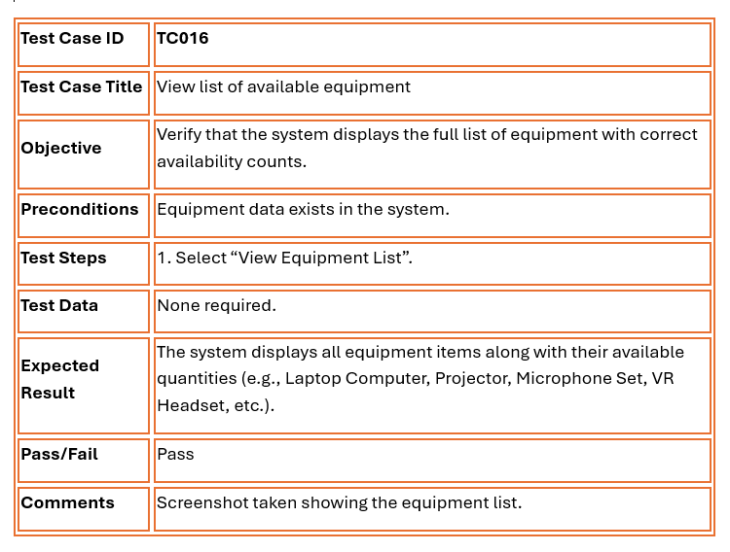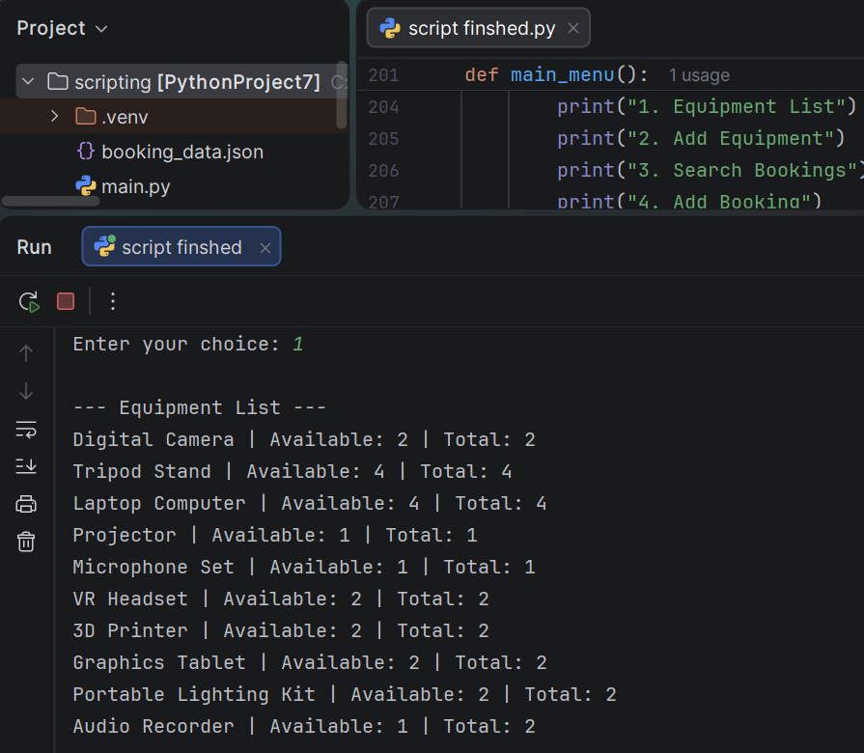
Figure 16 Test case showing the system displaying the full equipment list.
This test demonstrates that the system correctly retrieves and displays all equipment records, including each item’s availability and total quantity, when the user selects the Equipment List option from the main menu.
Test Case Title: Return an existing booking
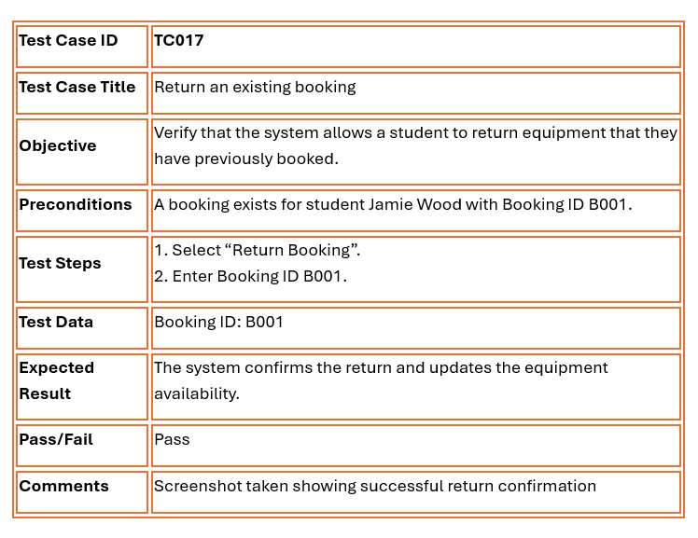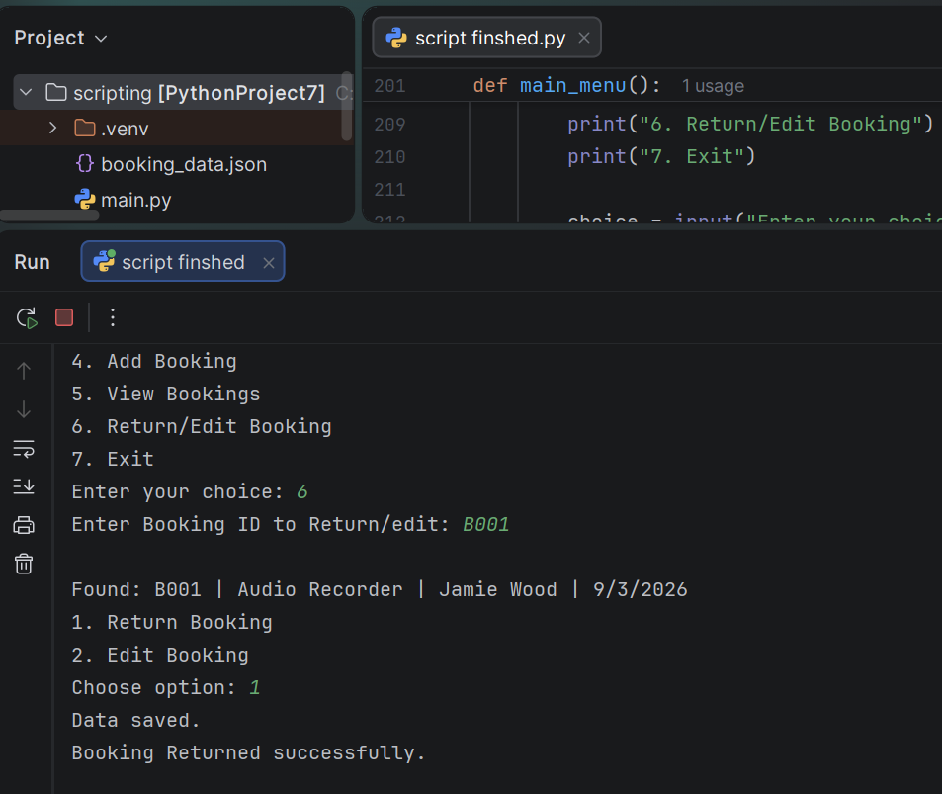
Figure 17 Test case showing a booking being returned successfully.
This test demonstrates that the system correctly processes a booking return by locating the booking, updating its status, saving the changes, and confirming the successful return to the user.

5.0 EVALUATION
CHALLENGES FACED
During the development of the Bright Minds Academy Student EG Equipment Booking System, several technical and design challenges were met. One of the primary challenges was selecting right data structures to manage equipment records and booking information efficiently. Initially, different approaches were considered, but it became clear that using Python dictionaries and lists provided the best balance between flexibility and simplicity. These structures allowed data to be stored, accessed, and updated effectively, but required careful handling to avoid inconsistencies.
Another significant challenge was implementing persistent data storage. Ensuring that booking and equipment data remained available after the program was closed required the use of the JSON module. Managing file input and output operations introduced issues such as handling missing files, preventing data corruption, and ensuring correct formatting. These problems were addressed by implementing error handling techniques and validating data before saving it.
Input validation was also a major difficulty. Since the system relies heavily on user input, it was necessary to ensure that all data entered by users was accurate and valid. This included validating equipment IDs, preventing duplicate bookings, and ensuring that dates were entered in the correct format. Multiple validation checks were implemented to maintain system reliability.
Additionally, debugging the system proved challenging. Logical errors, unexpected outputs, and edge cases required systematic testing and careful analysis. Through repeated testing and refinement, these issues were resolved, resulting in a more stable and dependable system.

FUTURE IMPROVEMENTS
Although the system successfully meets its core objectives, several improvements could enhance its functionality and usability. One major improvement would be the implementation of a graphical user interface (GUI). The current command-line interface, while functional, may not be intuitive for all users. A GUI would provide a more user-friendly experience by allowing users to interact with the system through visual elements such as buttons, forms, and menus.
Another important improvement would be the integration of a database management system, such as SQLite or MySQL, instead of using JSON for data storage. While JSON is suitable for small-scale applications, it has limitations in terms of scalability and data management. A database system would allow for more efficient data handling, support multiple users, and provide stronger data integrity.
The system could also be expanded by adding user authentication and role-based access control. This would improve security by ensuring that only authorised users can access certain features of the system. For example, administrators could manage equipment and bookings, while students would have limited access to booking functions.
Other features such as booking history, reporting tools, and notifications could further improve the system. A booking history feature would allow users to track past reservations, while reporting tools could provide insights into equipment usage. Notifications could remind users of upcoming bookings, reducing the likelihood of missed reservations.

SELF-REFLECTION
Throughout the development of this project, significant progress was made in both technical skills and personal development. One of the most important lessons learned was the value of planning before implementation. The use of pseudocode and flowcharts helped to clearly define the system logic, making the development process more organised and efficient.
The project also strengthened programming skills in Python, particularly in the use of data structures such as lists and dictionaries. These structures were essential for managing and organising system data. Additionally, experience was gained in file handling and data persistence using JSON, which provided insight into how real-world applications store and manage data.
Another key area of development was problem-solving and debugging. Identifying and resolving errors required logical thinking and patience. Through continuous testing and refinement, the ability to diagnose issues and implement effective solutions improved significantly.
This project enhanced understanding of the software development process, including design, implementation, and testing. It also highlighted the importance of writing clean, structured code and considering user needs when developing software. As a result, confidence as a developer has increased, and valuable skills have been gained for future projects.

REFERENCES

[1] R. S. Pressman and B. R. Maxim, Software Engineering: A Practitioner’s Approach, 9th ed. New York, NY, USA: McGraw-Hill, 2021.

[2] M. Felderer, M. Bures, and A. Ekelhart, “Software engineering for AI-based systems: A systematic mapping,” IEEE Softw., vol. 38, no. 1, pp. 92–99, 2021.

[3] A. Aurum and C. Wohlin, “Requirements engineering: Setting the context,” IEEE Softw., vol. 38, no. 2, pp. 30–37, 2021.

[4] X. Xia, D. Lo, X. Wang, and B. Zhou, “Accurate developer recommendation for bug resolution,” IEEE Trans. Softw. Eng., vol. 48, no. 1, pp. 72–85, 2022.

[5] A. Mensah and D. Clarke, “Usability-driven interface design principles for lightweight educational management tools,” IEEE Trans. Learn. Technol., vol. 18, no. 1, pp. 78–90, 2025.

[6] L. Bass, P. Clements, and R. Kazman, Software Architecture in Practice, 4th ed. Boston, MA, USA: Addison-Wesley, 2021.

[7] J. Whittle, J. Hutchinson, and M. Rouncefield, “The state of practice in model-driven engineering,” IEEE Softw., vol. 38, no. 5, pp. 20–28, 2021.

[8] S. Scalabrino, G. Bavota, C. Vendome, and R. Oliveto, “Automatically assessing code understandability,” IEEE Trans. Softw. Eng., vol. 47, no. 3, pp. 595–613, 2021.

[9] K. E. Kendall and J. E. Kendall, Systems Analysis and Design, 10th ed. Harlow, U.K.: Pearson, 2022.

[10] I. Sommerville, Engineering Software Products: An Introduction to Modern Software Engineering. Boston, MA, USA: Pearson, 2021.

[11] J. P. Walters and R. Ahmed, Contemporary Software Testing and Quality Assurance, 2nd ed. New York, NY, USA: Springer, 2023.

[12] P. Ammann and J. Offutt, Introduction to Software Testing, 2nd ed. Cambridge, U.K.: Cambridge Univ. Press, 2021.

[13] T. H. Cormen, C. E. Leiserson, R. L. Rivest, and C. Stein, Introduction to Algorithms, 4th ed. Cambridge, MA, USA: MIT Press, 2022.

[14] M. T. Goodrich, R. Tamassia, and M. H. Goldwasser, Data Structures and Algorithms in Python. Hoboken, NJ, USA: Wiley, 2022.

[15] E. Matthes, Python Crash Course, 3rd ed. San Francisco, CA, USA: No Starch Press, 2023.

[16] D. Beazley and B. K. Jones, Python Cookbook, 4th ed. Sebastopol, CA, USA: O’Reilly Media, 2023.

[17] H. Li and P. Kumar, “A study of built-in Python modules for data processing and automation,” IEEE Access, vol. 12, pp. 98540–98555, 2024.

[18] M. Lutz, Learning Python, 5th ed. Sebastopol, CA, USA: O’Reilly Media, 2021.

[19] D. Griffiths and B. Griffiths, Head First Python, 3rd ed. Sebastopol, CA, USA: O’Reilly Media, 2023.

[20] A. Downey, Think Python: How to Think Like a Computer Scientist, 2nd ed. Sebastopol, CA, USA: O’Reilly Media, 2022.

[21] M. Fowler, Refactoring: Improving the Design of Existing Code, 2nd ed. Boston, MA, USA: Addison-Wesley, 2021.

[22] R. C. Martin, Clean Architecture: A Craftsman’s Guide to Software Structure and Design. Boston, MA, USA: Prentice Hall, 2021.

[23] A. S. Tanenbaum and H. Bos, Modern Operating Systems, 5th ed. Hoboken, NJ, USA: Pearson, 2022.

[24] B. Slatkin, Effective Python: 90 Specific Ways to Write Better Python, 2nd ed. Boston, MA, USA: Addison-Wesley, 2021.

[25] K. Beck, Test-Driven Development: By Example. Boston, MA, USA: Addison-Wesley, 2021.

[26] A. Brown and J. Taylor, “Modern software testing techniques,” IEEE Softw., vol. 39, no. 2, pp. 40–48, 2022.

[27] S. Nakamura and T. Lee, “Improving educational management systems through structured data representation,” IEEE Trans. Learn. Technol., vol. 17, no. 1, pp. 112–124, 2025.

[28] Y. Zhai, M. Beck, A. El Asad, K. Köhler, M. Hahn, and E. Sax, “Production-optimized automotive software architecture: Theory and applications,” IEEE Trans. Ind. Informat., early access, 2026, doi: 10.1109/TII.2026.3651904.

[29] R. C. Martin, Clean Code: A Handbook of Agile Software Craftsmanship. Boston, MA, USA: Prentice Hall, 2021.

[30] R. S. Sutton and A. G. Barto, Reinforcement Learning: An Introduction, 2nd ed. Cambridge, MA, USA: MIT Press, 2021.

[31] S. McConnell, Code Complete, 2nd ed. Redmond, WA, USA: Microsoft Press, 2021.

[32] G. Booch, Object-Oriented Analysis and Design with Applications, 3rd ed. Boston, MA, USA: Addison-Wesley, 2021.

[33] E. Gamma, R. Helm, R. Johnson, and J. Vlissides, Design Patterns: Elements of Reusable Object-Oriented Software. Boston, MA, USA: Addison-Wesley, 2021.

APPENDIX

The abbreviation “EG” in the Bright Minds Academy Student EG Equipment Booking System represents my initials, Eden Grace. The system was intentionally named “EG Equipment Booking System” to distinguish it from other similar booking systems and to provide a unique and identifiable title while maintaining a professional structure.

