Speciesism, can it be Justified?

Speciesism is when a species thinks it is more superior than the others. Singer states that ‘Equal Consideration for different beings may lead to different treatment and different rights.’ (Singer, 1990, p.702). The Idea of Animal Cruelty has only come to light in recent years within Civil Right movements and Feminism. Due to awareness of Global Warming, people are recognising the huge impact human beings have on the animals. The issue has a ripple effect on society. By using different ways of thinking, humans can improve the meat industry and rather than impacting the farmers and the industry we are removing the areas that are unethical and create a better relationship between animals and Humans and at the same time, improving the Environment.
According to the Eco Experts, 1.3 Billion tonnes of food is wasted each year. In comparison that is 1/3 of all food produced for Human consumption. It shows that the Meat produced is more than what the population need leading to waste. By lowering Meat Produce results in reduced waste, reduced Carbon Emissions, reducing the number of forests being cut down and provides better environments and reduces animals habitats killed. According to the Guardian, Transporting ingredients and food products accounts for nearly one-fifth of all carbon emissions in the food system and clearing land for farming, raising livestock and moving food to and from shops adds large amounts of greenhouse gas to the atmosphere. The damage the meat industry does to the environment is clearly something that needs to be addressed. According to our world in data, 41% of Deforestation is due to Beef Production (See Image 1). A new System is needed to create an impact on reducing climate change and create more awareness of Animals. Rather than cutting trees down to create more cattle by using organic foods around us we gain healthier lifestyles and reduce the number of animals killed for Meat.

Thomas Ryan referred to Bavidge and Ground (1994, p170), they say that humans must distinguish between two statements, a) Animal pain is like outs, B) Like us animals experience pain. They say that ‘the first is analogical…we are saying that we must always be engaged in the analogical modelling of the subjective qualities of their experience on the subjective qualities of our own. All our thought and talk about animal minds is an exercise in comparative objective phenomenology.’(Ryan, 2011, p.83). By using this process of thinking we could create a greater impact on animal rights. Rather than thinking about whether or not to eat meat but thinking about the ethical ways we can get the meat. Going back to our Ancient Past, human beings were all Hunter-gatherers. This way of live required people to only kill for food rather than on mass production. National Geographic describes Hunter gatherers as People who hunt for survival, they hunt in ‘Survival Strategy’.

Capitalism proves to be the issue by creating mass production of Animals. According to Saving Oceans, since 1961 beef and dairy products has more than doubled. Believed to be the key motivators behind this expansion are primarily popular rise, urbanisation and income growth. The breeding, raising and slaughtering of cows for consumption, in today’s society, is deeply down to the ‘political economy of Capitalism’. According to the Food and Agriculture Organisation, 20% of Dairy products is wasted per year in 2022 and 20% of meat is wastes. All this is due to mass production. By removing the Capitalist hold on meat industries it allows Farmers to focus on the Animals welfare rather than Profits. Farmers are forced into this system. The Price of food for animals goes up along with taxes so farmers ned to produce more meat to gain profits, the capitalism makes it expensive for farmers to kill ethically. In McMullen’s book, he says that Animals are essentially ‘owned’ by humans. Humans determine their diet, relationships, lifespan, and the nature of their death. He mentions Animal Exploitation (McMullen, 2015, p.126).

In the minds of humans it can be assumed that Humans ignore the suffering of animals. This is where speciesism comes in. Because the meat industry makes it so Humans cannot see how animals die it is easy to remember that the meat was once a living thing that was killed (see Image 2). It is almost like Humanity is gone in consumer. And because Humans forget that they were living things it is easy for Humans to turn a ‘blind eye’ to the injustice of animal cruelty. By buying the meat from the Supermarket in packets, we only see the meat as it is rather then the animal as a whole. this reduces the meat to an object, something humans own rather than a creature that once lived. Even the language used in stores take away the animal’s identity such as using terms like beef, pork etc. This objectifies the animal rather than seeing the animal as an equal Species living on earth.

In the book, Professionals in Food Chains, Springer, Dürnberger and Eggel spoke about the consumers as the last link in the Food chain. They claim that changes can happen with the Will of the consumer and by deciding to challenge Supermarket’s with their meat it will create a change as Businesses main goal is to appease the consumer (Springer, Dürnberger, Eggel, 2019, p.2). This places a different outlook on changing Animal welfare and looking at the Consumer to impact the way that Animals are treated by refusing to eat the meat that is killed unethically. According to the book, in recent years the mistreatment of animals in the meat industry had become more prominent to the Public. In the book why animal suffering matters, Linzey refers to the definitions of Pain and suffering and that you cannot have pain without suffering (Linzey, 2009, p. 9-10). Animals feel pain as it is clear to see in observation. Therefore they suffer and therefore according to Singer, they can have similar interests as us in not wanting to suffer therefore they should have the Equal right to not suffer (Singer, 1990, p.704). Humans advocate for recognising rights of their own species and yet Human beings fail to see the issues that they have about not wanting their own to suffer in pain is exactly the same for other species.

On a Religious context, the idea of allowing Animals to be in pain is against our ‘roles’ as humans. In Jeremiah 2:7, God said to his people, ‘And I brought you into a plentiful land to enjoy its fruits and its good things. But when you came in, you defiled my land and made my heritage an abomination.” This verse is significant for Judaism and Christians. God directly says that he gave everything for Human Beings yet what people have done is harm the earth and exploit it. the situation today is similar then then. Humanity as a whole is damaging the earth. The essence that God created the world should be good enough reason, on a religious element, to change the way Manufacturers kill animals. Some Religions, such as the catholic church, are against Euthanasia of Humans as they were created by God making them sacred. This idea can be the same for Animals as they were also created by God. The Subject of Euthanasia is debated on the most ethical to end suffering by death. The Ethical option would be Quick and painless yet when it comes to Animals the same consideration is not met. Religions are again being Speciesism. They advocate that Human beings are sacred because they are created by God yet turn a blind eye to the abuse and exploitation of Animals. It is unjust.

The conditions that Animals are kept in is horrific. According to Compassion in world farming, Animals in factory farming are often kept in cages or in barren pens. This often causes the Animals to inflict injuries on each other out of sheer boredom, frustration or Stress. An example is an egg-laying Hen in a Barren battery cage often spends her whole life crammed into a space small than an A4 sheet of paper per animal (see image 3). We do not expect our Children to be in such a condition so why would we allow animals to endure the same. It is unjust to treat animals in such a way and claim it is to sustain the vast growing population, which is now at a 0.84% increase according to the World O Meter. However, by using the figures of wasted food shown prior in this essay, it is seen that farmers are producing more meat and produce than is actually needed. This contradicts their argument for a growing population as it is about selling more rather than struggling to feed a growing population. It might be better to reduce killing so many animals and maybe killing ethically is the best way to ensure better quality meat and reduce the amount wasted because we would need to kill animals for food rather than mass production.

Rather than leaving animals to survive independently in the wild because humans have made animals dependant on Farmers. This is why, According to Cody Mitchell in World Animal foundation, 80% of the destruction of the Amazon forest is being used for livestock. This is to keep up with Production demands. And therefore increasing the amount of food we waste. By changing lifestyles and eating less meat and creating less demand on products we can save more forests and save habitats. So by impacting the meat industry we can impact more issues such as Climate change and deforestation. By reducing the demand for meat we can also save extinct Animals and we can gain more resources if we treat the animals with respect. According to Austin Fit, Animal hugging, for example Cow hugging, benefits both humans. For the Animal It reduces stress and makes the Animal feel better. This improves both species and takes away the barrier than Humans are superior.

In conclusion, there are so many reasons to change the meat Industry and reasons that show that Speciesism is a huge issue in the meat industry that impacts the wider society. The statistics show that the Meat Industry creates so many issues because their main goal is mass Production and keeping up with demands. The issues caused are Deforestation, Climate change, animal cruelty and Food waste. Religions, Such as Christianity, are expected to act because that is what is expected. For some people it is easier to give an opinion on the death of other Humans, through things like euthanasia, but then when it comes to death of animals, they cannot give an opinion. Animals are profit and products rather than living creatures on this earth. It is seen with the way they are produced. The consumer buys the meat in a packaging that is labelled, not with the Animal it is from but a different term such as Beef, Pork etc. This shows that the animal is now reduced to an object for human consumption. As previously mentioned, humans see animals as owned rather than equal creature on this earth. Singer’s idea of shared interests reflect the rights they need is a brilliant idea at bringing Animals back from being an object of our consumption but to Species that are Equal to us. Therefore Speciesism is not justified but rather exploiting the environment and is causing us and the world more harm than good.

References

Singer, Peter. 1990. Animal Liberation. 2nd Ed. Ecco, New York

The Eco Experts. 2022. Food Waste Facts and Statistics. Available at https://www.theecoexperts.co.uk/home-hub/food-waste-facts-and-statistics (Accessed: 6th November 2022)

Freda Kreier, 2022, Transporting food generates whopping amounts of carbon dioxide. Available at https://www.nature.com/articles/d41586-022-01766-0 (Accessed: 6th November 2022)

Ryan, Thomas. 2011. Animals and Social Work: A Moral Introduction. Hampshire: Palgrave Macmillan

National Geographic. 2022. Available at https://education.nationalgeographic.org/resource/hunter-gatherer-culture (Accessed: 8th November 2022)

Saving Oceans. 2020. Available at https://savingoceans.org/blog/f/capitalism-and-cows (Accessed: 8th November 2022)

McMullen, Steven. 2015. Journal of Animal Ethics. Vol 5, No.2. Illinois: University of Illinois Press Partnered with Oxford: Ferrater Mora Oxford Centre for Animal Ethics

Springer, Svenja. Dürnberger, Christian. Eggel, Matthias. 2019. Professionals in Food Chains. Vol 3. Cham, Switzerland: Springer International Publishing

The Holy Bible, Jeremiah 2:7. English standard Version. 2001. Wheaton, Illinois: Crossway

Compassion in world farming. 2022. Available at https://www.ciwf.org.uk/factory-farming/animal-cruelty/#animal-cruelty-sources (Accessed: 9th November 2022)

WorldOMeter. 2008. Available at https://www.worldometers.info/world-population/ (Accessed: 9th November 2022)

Mitchell, Cody. 2022. World Animal Foundation. Available at https://worldanimalfoundation.org/advocate/farm-animals/params/post/1280110/animal-agriculture-is-destroying-tropical-forests (Accessed: 9th November 2022)

Lawlor, Shannon. 2022. The Surprising Benefits of Cow Cuddling. Available at https://www.austinfitmagazine.com/the-surprising-benefits-of-cow-cuddling/ (Accessed: 9th November)

Appendix of Images

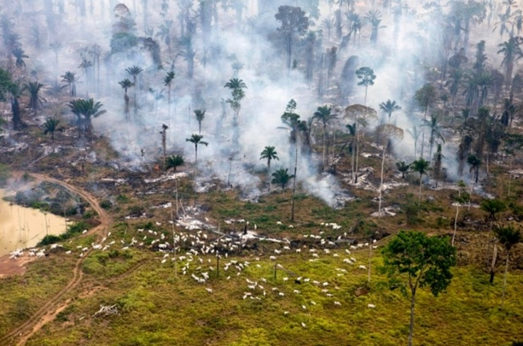 (Image 1)
Online at https://www.buzzworthy.com/ugly-facts-of-meat-industry/ accessed on 9th November 2022 copied from article by Buzzworthy, 15 ugly facts the meat industry doesn’t want you to know, 2018.

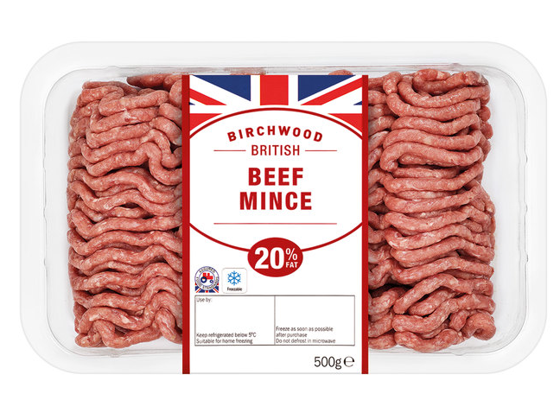 (Image 2)
Online at https://www.lidl.co.uk/p/birchwood-beef/birchwood-british-beef-mince/p24370 accessed 9th November 2022

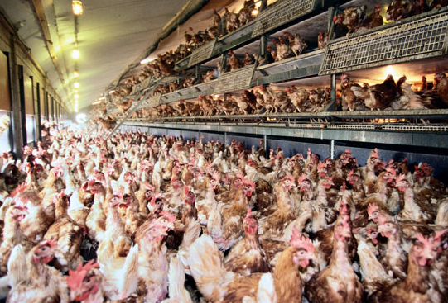 (Image 3)
Online at https://www.petalambs.com/feature/secret-chicken-chains-wont-tell/ accessed on 9th November 2022, Article by Peta Lambs, The secret that Chicken chains won’t tell you

