
M4X01498

Academic writing

Assignment on:
Software project management
Submitted to
John Rees

Daniel Algie 1706977

Introduction
In this assignment the author will be looking into software project management techniques there is a variety of different techniques people have been using for a very long time including waterfall, scrum, agile and Kanban.
The author will be going into depth about two types of project management the author has chosen waterfall vs scrum he will be explaining both techniques whilst explaining advantages and disadvantages of each methods.

The Waterfall
The waterfall methodology is one of the first software management methods to be implemented into software management it was implemented from factory production lines as where the waterfall methodology is set in linear stages so one task must be complete before it can move on to the next stage.

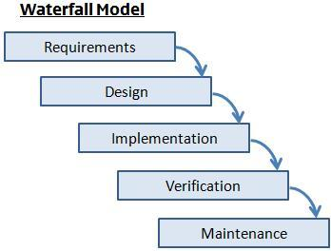

[2] figure 1 waterfall methodology

Stages of the waterfall methodology:
- Requirements this is the base of the whole project the project manager will meet with the client and iron out all the details which must be implemented into the software also go over time and costs.
- Design is to see what will be needed in the coding to see what they want the software to look like before coding begins this could include flow charts to implement the main parts of the software the client requires this could also include colour and the design of what the finished software will look like.
- Implantation this is where the coding for the software begins and implement flow chart to complete the transformation in to software.
- Testing, testing the final project to make sure it works correctly and has no flaws
- Maintenance now the finally program is complete and is available to the public still run the risk of bugs and problems the maintenance team will have to work fast and effective to make sure the program keeps running successfully.
Project manager
The project Manager has the responsibilities of making sure the project is complete in time with no problems and within budget he is the main person between the client and the software team he is the only person who plays a part in every task to make sure everything runs smoothly.

Advantages and Disadvantages
Advantages :
- It is very easy to implement and manage because all parts go through the same process of completion.
- The waterfall method leaves a paper trail making it easier for clients to get a understanding of the project and what stage the project is at.
- Everyone department has there own task which makes it easier for new staff to get up to speed with the project.
- With everyone knowing what task they are doing it easier to meet deadlines to move on to the next task.
- No chance of overlap of task and miss guidance.
Disadvantages
- if there is a error or a problem or missed a requirement for the client you will have to complete rewrite the code.
- when in the testing stage very hard to change a problem you occurred in a previous stage.
- Long time until you have an actual running program.
- Client might add new features to completed task could be very hard to implement.
- Could go over deadline or budget in one off the departments and end up with a low budget product the customer didn’t want.

Scrum
What is scrum?
Scrum is a method of software management unlike your conventional styles scrum is different because there is no project manager to say and control the team instead it is left to the developers to help and push each other to finish task in hand. Unlike the waterfall methodology scrum takes a different approach where it chooses the parts that are most important instead of having a set plan and could skip task depending on importance.

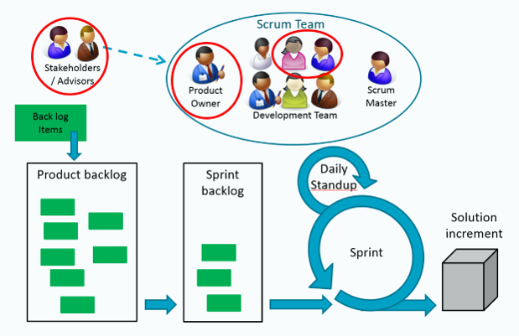
[7] fig 2 This is the sprint using the scrum method

Sprint
Sprint is a timed task which could run from 1 week to 4 this is the time a team have to complete the task in hand once the sprint is complete it will be tested and get feedback and then it will be ready for the client to use . Once the team have the task they hold a sprint planning this includes:
- Setting time for the sprit to be completed
- Discuss the work and the criteria required for the project
- once the tame have they backlog they will choose (vote) which task will be done first.

Daily Scrum
This is where the team have a stand up meeting for 15 minutes everyday (usually in the same place) to go over the work which was completed the day before, the work they will be completing today and any problems they think could happen to stop them completing the sprint.

Scrum master
Although there is no project manger in scrum there is a scrum master. The scrum master was originally created to say the are the master at there job and can help others and coach them thou the scrum master is the leader they have no authority over the rest of the team some of the scrum master task include:
- making sure the team are on the wright track with the sprint
- making sure there are know problems with in the team and task
- keeping a good relationship between the product owner and others outside the team to understand what is needed from the team.

Advantages and disadvantages
Advantages
- daily meetings to understand where ever one is within the task
- very easy to rectify any problems which have occurred in the project or change to accommodate feedback
- no project manager so everyone is in charge to complete the task and help each other get the task in hand complete
- easier to stay on budget because the sprint is short and can be rectified quicker

disadvantages
- Can be difficult to implement if have high staff turnover
- With no end date of the project stakeholders could keep implementing functions they would like to add to the task
- With no set roles or manger your team must be experienced and competent
- Scrum master must have complete faith in the team he is not a project manger and can not tell them what to do if this becomes the case the project could fail.

Conclusion
in conclusion there is no best method both methods have there advantages and disadvantages it comes down to preference and the type of company you want to be other factories such as money and time to complete the task must be considered when choosing a method like everything else in life it comes down to trial and error and if it isnt broke don’t fix it.

[2] [3] [4] [5] [6] [7]

References

[1] | S. Marcello, "smartsheet," 20th september 2016. [Online]. Available: https://www.smartsheet.com/agile-vs-scrum-vs-waterfall-vs-kanban. [Accessed 15th april 2018].
[2] | l. c. team, "lucidchart," 23 october 2017. [Online]. Available: https://www.lucidchart.com/blog/agile-vs-waterfall-vs-kanban-vs-scrum.
[3] | l. c. team, "lucidchart," 23 august 2017. [Online]. Available: https://www.lucidchart.com/blog/waterfall-project-management-methodology. [Accessed 17 4 2018].
[4] | I. t. S. A. a. Design, "eternal sunshine of this is mind," 27 feb 2013. [Online]. Available: https://eternalsunshineoftheismind.wordpress.com/2013/02/27/the-waterfall-model-2/.
[5] | m. g. software, "moiuntain goat software," unknown unknown unknown . [Online]. Available: https://www.mountaingoatsoftware.com/agile/scrum. [Accessed 19 april 2018].
[6] | m. g. software, "montain goat software," [Online]. Available: https://www.mountaingoatsoftware.com/agile/scrum/meetings/daily-scrum. [Accessed 19 april 2018].
[7] | b. ross, "equinox," 11 november 2015. [Online]. Available: https://www.equinox.co.nz/blog/agile-architecture-where-architect-fit-scrum-sprint. [Accessed 18 april 2018].

