ASSIGNMENT REPORT
CARE SUPPORT WORKER
Employability Skills, Personal Brand and Career Development Plan
Student: Folasade Oluwakemi Alabi
Student ID: 1817626
Programme: BSc (Hons) Health and Social Care
Module: Changemakers: Building your Personal Brand for Sustainable Employment
Module code: BMHP5015
Lecturers: Caroline Salami (Module Leader) and Brian Mashumba
Assignment: Component 2: Assignment (Report)
Submission deadline: 7 August 2026, 14:00
Word count: 2,018 words

Introduction
This report evaluates my suitability for the Care Support Worker position advertised by The Rotherham NHS Foundation Trust. The permanent Band 2 role offers full-time, part-time and flexible working, with a salary of £25,272 pro rata. It was posted on 3 August 2026 and closes on 13 August 2026 (NHS Jobs, 2026). I selected the role because its focus on person-centred care, dignity and teamwork matches my values and my aim to begin in a care or support position before progressing towards senior care or service coordination. It is also a realistic entry route because previous care experience is desirable rather than essential. The report first analyses the role requirements, then compares them with my current employability profile. It subsequently explains how I will communicate an authentic personal brand and presents a SMART five-year action plan for closing the identified gaps.
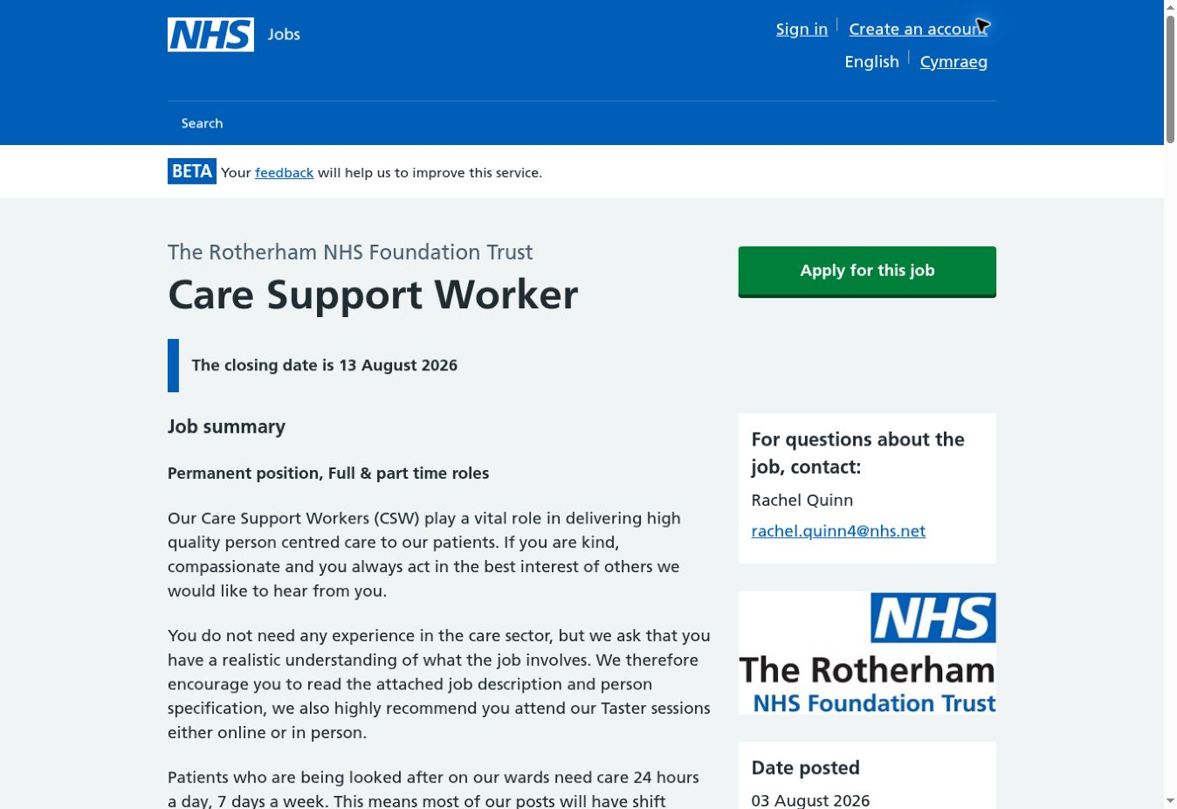
Figure 1. Care Support Worker vacancy at The Rotherham NHS Foundation Trust.
Source: NHS Jobs (2026); screenshot captured 5 August 2026.

1. Analysis of the Personal Employability Skills Required
The advert presents the role as entry-level, but its responsibilities are substantial. Working under a Registered Nurse, the Care Support Worker assists patients with washing, dressing, toileting, nutrition, hydration, mobility, comfort and lifestyle change, while completing relevant documentation (NHS Jobs, 2026). These tasks involve intimate contact and can affect safety, recovery and dignity. A genuine wish to help is therefore necessary but insufficient: compassion must be combined with competence, boundaries and timely escalation. The NHS Constitution reinforces respect, dignity, compassion and working together for patients (Department of Health and Social Care, 2023). In practice, this means asking before providing personal care, supporting choice where possible and reporting any change in a patient’s condition rather than acting beyond the support-worker role.
Communication is central because the person specification requires an effective communicator who is approachable and able to work in a team. A worker must listen to patients who may be anxious, in pain or unable to express themselves easily; explain actions in plain language; check understanding; and give accurate information to colleagues. The 6Cs connect communication with care, compassion, competence, courage and commitment (NHS England, 2012). Their value is practical rather than symbolic: courage may involve raising a safeguarding concern, while commitment includes completing an uncomfortable task respectfully and consistently. Emotional intelligence can support this work by helping a worker recognise emotions and regulate their own response, although it cannot replace clinical judgement or formal training (Mayer, Salovey and Caruso, 2004).
Teamwork, resilience and flexibility are equally important. The post covers days, nights, weekends and bank holidays, and the worker operates alongside nurses and other healthcare professionals (NHS Jobs, 2026). Teamwork requires clear handovers, reliability and willingness to accept supervision. Resilience should not be interpreted as silently tolerating unsafe pressure. Sustainable resilience involves remaining calm enough to prioritise, seeking help when a task is outside competence and reflecting after difficult situations. Flexibility must also remain bounded by safety: adapting to a changing ward is valuable, whereas agreeing to a task without training could expose both the patient and worker to harm.
The vacancy also specifies IT skills, confidentiality, Information Governance and health and safety knowledge. Digital literacy is needed for timely, factual and secure records, not merely for operating a device. Skills for Care’s Digital Skills Framework identifies safe handling of information and effective use of digital systems as core areas of care practice (Skills for Care, n.d.). Poor documentation may interrupt continuity of care, while excessive or casual sharing can breach privacy. The role also requires willingness to complete the Care Certificate and Functional Skills Level 2 in English and mathematics where equivalent qualifications are absent. The 2025 Care Certificate contains 16 standards covering person-centred working, communication, dignity, nutrition, safeguarding, basic life support, health and safety, handling information and infection control (Skills for Care, 2025). Importantly, competence must be assessed in practice; an online certificate alone would not demonstrate safe performance.
The CareerEDGE model explains why subject knowledge by itself does not establish employability. Employability develops through career learning, work experience, degree knowledge, generic skills and emotional intelligence, supported by reflection and self-efficacy (Dacre Pool and Sewell, 2007). This framework fits the vacancy: my degree can strengthen understanding, but employers still need observable evidence of communication, reliability and safe behaviour. The STAR structure—situation, task, action and result—can present such evidence clearly at application or interview. Overall, the post is accessible to a new entrant, yet it demands accountable behaviour from the first shift.

2. Evaluation of My Current Skills
My skills audit draws on the self-assessment activities completed in Component 1 and my current BSc (Hons) Health and Social Care studies. I identified empathy, active listening, reliability and willingness to learn as my strongest brand qualities. These align with the advert’s demand for approachability, teamwork and a genuine desire to care. My studies also provide developing knowledge of health and social care principles and require written communication, independent learning and participation with others. However, this evidence comes mainly from education and reflection rather than observed ward practice. I should therefore describe these qualities as relevant potential, not claim that they already prove competence under clinical pressure.
Role requirement | Current evidence | Development need
Communication and compassion | Empathy and active listening identified through module self-assessment. | Practise communicating during distress and obtain supervisor feedback.
Teamwork, resilience and flexibility | Reliable participation and willingness to learn within university activities. | Build evidence of prioritising safely during shift-based care.
Digital records and confidentiality | General academic digital skills and awareness of privacy. | Develop confidence with care records, Information Governance and concise notes.
Practical care competence | Relevant degree knowledge; no verified direct-care competence claimed. | Gain supervised experience and complete workplace assessment and induction.
Table 1. Skills comparison based on the NHS Jobs person specification and Component 1 self-assessment.
The comparison shows a reasonable values match but a significant evidence gap. Digital confidence, public speaking and prioritisation under pressure were already identified as development needs in Component 1. For this role, public speaking is less important than clear one-to-one communication and assertive escalation, but limited confidence could still make it harder to challenge unsafe practice. My digital gap is also specific: using university software does not automatically demonstrate accurate clinical documentation. I need practice with concise, objective recording and secure information handling. Similarly, knowledge of person-centred care does not prove that I can assist safely with mobility, personal care or nutrition. Those skills require instruction, observation and supervised assessment.
A SWOT interpretation prevents the assessment from becoming either overly positive or discouraging. My strengths are values alignment, developing sector knowledge and openness to feedback. Opportunities include the Trust’s taster sessions, care-related volunteering, employer induction and the fact that previous experience is not essential. Weaknesses are the absence of verified care experience and limited evidence of working calmly across competing needs. Threats include shift demands, emotional strain and competition from applicants who can already demonstrate care practice. These threats can be reduced through realistic preparation, but they cannot be removed by a strong CV alone.
Bandura (1977) argues that self-efficacy influences whether people begin and persist with difficult action. My confidence should therefore grow from small mastery experiences, observation, feedback and reflection rather than unsupported positive statements. At present I am a credible developing candidate for an entry pathway, not a fully evidenced care worker. This is compatible with the advert because the Trust accepts applicants without sector experience, provided they understand the role and are willing to train. My priority is to convert personal qualities and academic understanding into supervised, documented performance.

3. Building My Personal Brand and Professional Identity
My personal brand should communicate an accurate professional promise: I am a developing care professional who listens first, protects dignity and uses feedback to improve safe, person-centred support. This reflects empathy, reliability and willingness to learn without implying competence I have not yet demonstrated. Rampersad (2008) argues that an effective personal brand is authentic and consistent. Consistency matters because employers will compare claims across the application, interview, references and conduct. The statement also aligns with the Trust values of Ambitious, Caring and Together (NHS Jobs, 2026): ambition is expressed through learning, caring through respectful support, and togetherness through teamwork and escalation.
My unique selling point is the combination of health and social care study, a listening-led approach and deliberate openness to supervision. It is modest but relevant. I will communicate it through a tailored two-page CV, a concise supporting statement and a professional LinkedIn profile. The profile headline will identify me as a BSc Health and Social Care student seeking person-centred support experience. Its summary will describe my values, current learning and development goals; training and experience will be added only when verifiable. No service-user information, unverified health advice or misleading course claims will be posted. This approach makes digital visibility evidence-based rather than promotional alone.
Networking will support both learning and opportunity. I will use the university careers service, attend NHS or Trust taster events, connect appropriately with support workers and recruiters, and engage with relevant voluntary organisations. Networking is most useful when relationships involve reciprocal learning rather than collecting contacts (Gibson, Hardy and Buckley, 2014). I will therefore ask focused questions about induction, shift expectations and progression, then record what I learn. A mentor or supervisor can review my development evidence, but their advice will still be checked against policy and professional standards.

4. Action Plan and Timeline
The following plan applies Doran’s (1981) SMART principles by linking each action to a defined timescale and evidence of completion. The sequence moves from preparation to supervised experience, employment and longer-term progression.
Timescale | SMART action | Success measure | Resources/support
0–1 month | Map one live support-worker person specification, tailor my CV and LinkedIn profile, and complete one mock interview. | Reviewed CV, complete profile, vacancy tracker and written interview feedback. | University careers service, NHS Jobs and the Trust taster session.
0–3 months | Complete recognised introductory learning in adult safeguarding, infection control, health and safety, data protection and digital record keeping; verify my English and mathematics evidence. | Certificates or learning records plus a short reflection for each area; qualification evidence organised. | University guidance, approved learning providers and employer information.
3–9 months | Secure care-related volunteering, shadowing or paid support exposure and complete at least 40 supervised hours across six months. | Hours log, confidentiality-safe reflections and two structured feedback discussions. | Voluntary organisations, DBS process where required, supervisor and transport plan.
6–18 months | Submit two tailored applications per month until appointed; after appointment, complete induction and all 16 employer-assessed Care Certificate standards within the employer’s timetable. | Application log, interview feedback and signed workplace competence record. | NHS Jobs, mentor, employer assessor and protected learning time.
2–5 years | Build evidence for senior care or service-coordination work through annual CPD, added responsibility and a reviewed progression plan. | Annual appraisal goals, leadership or coordination learning and evidence of safe delegated responsibility. | Line manager, mentor, employer funding and relevant role profiles.
Table 2. Five-year SMART employability and progression plan.
The plan is ambitious but staged. Bandura’s (1977) theory suggests that completing manageable tasks and receiving credible feedback can strengthen self-efficacy, making later applications and difficult workplace learning more sustainable. Progress will be reviewed every three months against the measures in Table 2. If study workload, transport, course cost or access to experience causes delay, I will prioritise free or employer-supported learning, use a weekly calendar and seek early guidance rather than silently missing the target. The Care Certificate will only be claimed after workplace assessment and sign-off, consistent with Skills for Care (2025). After gaining employment, wellbeing, supervision and safe workload will remain part of the review because career progress should not be achieved by normalising unsafe pressure.

Conclusion
The Care Support Worker vacancy is a realistic but demanding first step towards my longer-term goal of senior care or service coordination. My empathy, active listening, reliability, willingness to learn and developing health and social care knowledge align with the role’s values and interpersonal requirements. The main limitation is evidence: I cannot yet demonstrate supervised personal-care competence, clinical documentation or prioritisation during ward pressure. My personal brand must therefore present credible potential and ethical behaviour rather than exaggerated readiness. The action plan addresses this gap through targeted learning, verified practical exposure, feedback, tailored applications and employer-assessed induction. Completing these actions will allow me to test whether my self-perception is supported by workplace evidence. The process has clarified that employability in care depends on the consistency between values, competence and conduct. By reviewing progress every three months and using supervision responsibly, I can enter support work safely and build a defensible pathway towards future coordination responsibilities.

References
Bandura, A. (1977) ‘Self-efficacy: toward a unifying theory of behavioral change’, Psychological Review, 84(2), pp. 191–215. doi: 10.1037/0033-295X.84.2.191.
Dacre Pool, L. and Sewell, P. (2007) ‘The key to employability: developing a practical model of graduate employability’, Education + Training, 49(4), pp. 277–289. doi: 10.1108/00400910710754435.
Department of Health and Social Care (2023) The NHS Constitution for England. Available at: https://www.gov.uk/government/publications/the-nhs-constitution-for-england/the-nhs-constitution-for-england (Accessed: 5 August 2026).
Doran, G.T. (1981) ‘There’s a S.M.A.R.T. way to write management’s goals and objectives’, Management Review, 70(11), pp. 35–36.
Gibson, C., Hardy, J.H. III and Buckley, M.R. (2014) ‘Understanding the role of networking in organizations’, Career Development International, 19(2), pp. 146–161. doi: 10.1108/CDI-09-2013-0111.
Mayer, J.D., Salovey, P. and Caruso, D.R. (2004) ‘Emotional intelligence: theory, findings, and implications’, Psychological Inquiry, 15(3), pp. 197–215. doi: 10.1207/S15327965PLI1503_02.
NHS England (2012) Compassion in Practice: Nursing, Midwifery and Care Staff – Our Vision and Strategy. Available at: https://www.england.nhs.uk/wp-content/uploads/2012/12/compassion-in-practice.pdf (Accessed: 5 August 2026).
NHS Jobs (2026) Care Support Worker: The Rotherham NHS Foundation Trust, reference C9165-25-12-108-08. Available at: https://www.jobs.nhs.uk/candidate/jobadvert/C9165-25-12-108-08 (Accessed: 5 August 2026).
Rampersad, H.K. (2008) ‘A new blueprint for powerful and authentic personal branding’, Performance Improvement, 47(6), pp. 34–37. doi: 10.1002/pfi.20007.
Skills for Care (2025) Care Certificate standards. Available at: https://www.skillsforcare.org.uk/Developing-your-workforce/Care-Certificate/Care-Certificate-standards.aspx (Accessed: 5 August 2026).
Skills for Care (n.d.) Digital Skills Framework. Available at: https://www.skillsforcare.org.uk/Support-for-leaders-and-managers/Managing-a-service/Digital-technology-and-social-care/Digital-Skills-Framework.aspx (Accessed: 5 August 2026).

