Comparative Analysis of Information Security at NatureGarden
Table of Contents
Abstract 3
1. Introduction 3
2. Methodology 4
3. Information security strategy design 5
3.1. Information security governance 5
3.2. Information security compliance 7
3.3. Information security policies 8
3.4. Data storage policies and cloud service security 9
3.5. Risk management 11
3.6. Security management models and practices 13
3.7. Continuous Improvement 15
4. Conclusion 16
5. References 17

Abstract
With the rapid development of information globalization, information security is increasingly important as the time goes by, In the contemporary digitalized world, information security is not only a technical problem, but also a strategic issue related to a company's reputation, customer's trust, and survivability and development. Under NatureGarden (NG)'s background, protecting its huge informational property from unauthorized access, breach, break, and modification is the key to protect its leading global market position and loyalty of customers. On one hand, its broad international business and applications on cloud computing services made it an urgent requirement for its data security. On the other hand, NG's employers and customers have increasing expectations regarding their information security. Under this circumstance, it is eager to figure out a compliant way to protect the company's data and intellectual property. This article will thoroughly discuss the challenges faced by NG's information security and design a comprehensive and effective information security strategy accompanied by leading security frames and standards in the industry. Through this strategy, NG will build a secure, reliable, and efficient information environment, thus providing a strong support for its global business.

Introduction
Along with the rapid development of information technology and globalization, information security has become one of the most important challenges faced by companies and groups. To concur with this challenge, many countries and international associations have come up with information security standards and frames to guide businesses and provide references for them. Among the frames, Information Technology Infrastructure Library (ITIL) and ISO 27000 family published by International Organization for Standardization are the two most widely applied frameworks being used by business companies.
ITIL is a framework supported by British government to provide a best practice guideline for businesses to manage and optimize their information technology services. It includes aspects from service strategy, service design, service transition, and service operation, providing enterprises with a comprehensive server management. ISO 27000 is an international standard, aiming to provide the best guidelines for information security management, including information security policies, risk management, and control measures.
Even though the two frameworks are widely applied, they also have their own limitations and challenges. For example, choosing and applying appropriate framework according to the given situation of the company and recursively update the framework to comply with the always changing security risks. Based on the research on the current frameworks, this article will provide NG with a comprehensive information security strategy. This strategy will be designed accordingly given NG’s current situation to ensure the integrity, availability, confidentiality of the internal data.

Methodology
The first step is to ensure that NG’s information security strategy complies with the governance and compliance requirements based on legal and moral standards. A governance structure will be made to ensure the business and strategic needs of NG and clarify the responsibilities and authority of each department. At the same time, compliance is also considered to ensure that NG’s strategy complies with relevant laws and industry regulations.
Next, a detailed security policies and standards will be designed according to NG’s actual needs and business characteristics. These policies will include data security, system security, physical security, and so on, to ensure a complete protection on NG’s information assets.
In the aspect of risk management, a complete assessment on NG’s information security risks will be conducted. Potential security threats and vulnerabilities will be detected, evaluated, and corresponding risk response strategies will be made. By lowering the risk level and increasing security protection abilities, NG’s potential loss will be dropped significantly.
Furthermore, advanced information management models and practice experiences will be introduced. ISO 27001, NIST, and COBIT frameworks will be used to create a suitable security management model for NG. Through employee training and improved security awareness, NG will also assemble an effective security management team.

Information security strategy design

Information security governance
NG should establish an information security department consisting of senior management members in charge of designing, publishing, and monitoring the execution of information security policies. This department should have a clear information governance framework to clarify responsibilities and authorities of managers and employees at all levels in terms of information security. It should make information security policies, standards, protocols, and guidelines to ensure the organizational information security behaviors aligns with the business objectives. Figure 1 below is a proposed framework of information security governance.
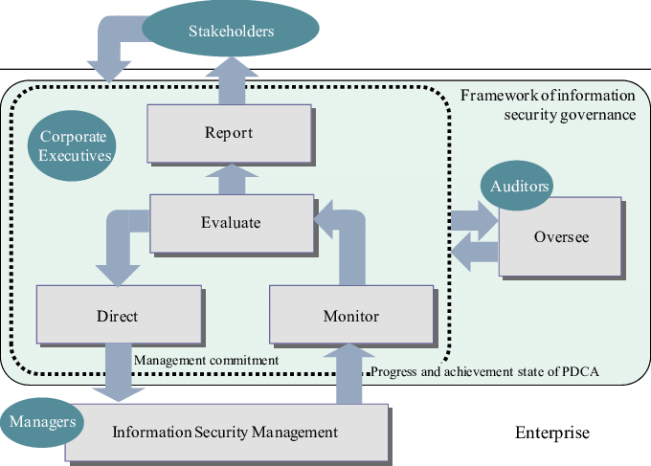
Figure 1. Proposed framework of information security governance [1]
During the decision-making process, it is crucial to develop a transparent process to ensure that information security related policies are carefully reviewed and authorized. In addition, it is also important to take into consideration the factors of laws, regulations, business risks during this process. Establishing communication and collaboration across departments and levels could improve effectiveness in terms of facing information security challenges. This could include having scheduled meetings on the subject of information security to discuss and solve information security related issues. It is also important to practice continuous information security monitoring to promptly detect and response to security incidents. Always keep a cautious mind to regularly assess information security to identify the aspects where the security can be improved and make corresponding improvement measures.

Information security compliance
For an enterprise to avoid legal issues, it is crucial to identify and comply with all the relative laws, regulations, and industry standards that are applicable to the organization’s business operation. To achieve such goal, NG should establish compliance verification mechanism to ensure all business activities are under the requirements of appropriate laws. Conducting regulatory compliance audits is also helpful. Assessing the organization’s level on the area of information security could prevent the organization from getting too dangerous to face legal actions. Issues discovered during the audit process should be immediately fixed and make sure follow-up steps are made to ensure continuous improvement for the organization.
Aside from information security compliance policies, the company should provide employees with compliance training to improve their awareness and understanding of compliance requirements. Promoting employees to participate in the activities of compliance would drastically increase the effectiveness of building an compliance culture in the company. Compliance report could also be used to document the organization’s activities and results of compliance. By presenting this report to the information security department and the high-level management members, they will have an comprehensive understanding of the current compliance status of the organization. After reviewing the result from audit and compliance report, they can make continuous improvement by publishing appropriate adjustments to their compliance policies. And by continuous tracking of the improvement activities, the organization will be able to ensure that they have achieved the expected compliance goals.

Information security policies
In the process of information security practices, policies should be published and enforced to protect the security of data in the company. Policies for confidentiality of data should include data classification, data access control, data transmission and storage protection, and data destruction. Data classification is used to classify and label the level of sensitive data, such as confidential, secret, and restricted data, as well as their types to be either personal data or company’s business secrets. In Figure 2 blow, different types of data and to what extent they can be disclosed.
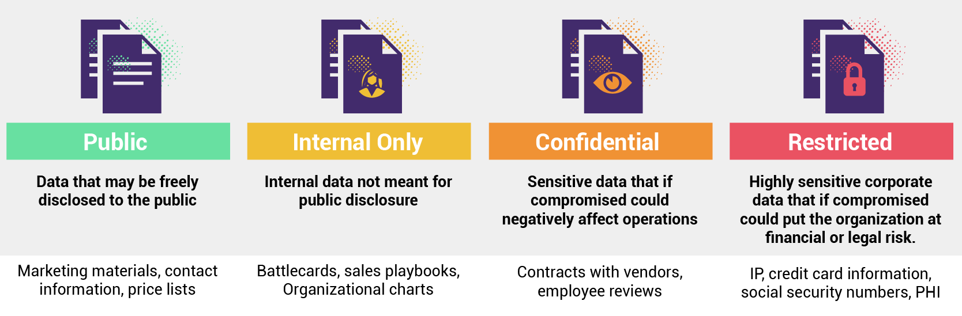
Figure 2. Data classification levels [2]
It should also clearly identify the different handling and access requirements for different levels of data. Specify the access permissions for employees and third parties for company data, making sure only authorized personnel can access sensitive data, including company properties, customer data, and so on. During data transmission and storage, encryption techniques must be used to make sure the data are protected and secured. The company should also have a self-defined data destruction application with the purpose of making sure sensitive data are thoroughly deleted when it is no longer needed.
There are several policies that can be published to ensure the integrity of data. First, data validation is a key process. It requires to validate the input data and output data to ensure the accuracy and integrity of data. Second, making backup and recovery plans can protect the data when the integrity of data is compromised. Is includes making a data backup policy, data recovery application, and testing plans. It is an essential to set up such plans to ensure the data can be rapidly recovered in case of a malfunction or security disaster happens. Third, to prevent the data from being tampered by unauthorized modifications or destructions, actions such as using digital signatures and checksums should be taken.
In terms of protecting the availability of data, there are several mechanisms that can be adopted by the company. During dangerous times, critical parts of the system should still be working properly for a period of time. Also, define mechanisms to increase the fault tolerance and fault recovery abilities of the system. Similarly to protecting the integrity of the system, a backup plan should also be conducted with a defined frequency, and specify the backup storage place, as well as a recovery application to ensure the recovered data is usable. When a security disaster happens, the company should have mature recovery procedures to respond to the emergency by having clearly defined recovery steps and collaboration mechanisms.

Data storage policies and cloud service security
Making good data storage strategies could drastically decrease the risk of data breach, and the ability to recovery from a data disaster. Since NG has extensive presence around the globe, it is important to store some on the data in locally where the business takes place. Local storage means the data could be stored in local data centers or local data servers. It prevents the data from being accessed through internet so that cyberattacks is not possible for these data. In addition, it helps the business by decreasing the time required for data access to avoid latency in time sensitive situations. Other than storing some of the data locally, they can also be stored in distributed geographic locations of nodes to increase the reliability of data. Redundant copies of data can protect data from planned and unplanned events, including transient hardware failures, network or power outages, and massive natural disasters [4].
NG extensively uses cloud services, and this could bring extra security challenges. For this reason, there are several steps that NG can take to reduce the risks. First of all, select cloud services provided by only certified providers with outstanding security records. The could service providers could help the company to solve potential issues caused by using cloud services. Before using cloud services, make sure the users are validated using multi-factor authentication, which could solve a lot of trouble caused by compromised passwords [5]. Like local data, regularly back up all cloud data and ensure a reliable data recovery plan is essential. Last but not least, conduct regular security audits and monitoring on cloud servers to ensure no unauthorized access or misuse of cloud services happened. Figure 3 below briefly shows the security framework for cloud based enterprise system.
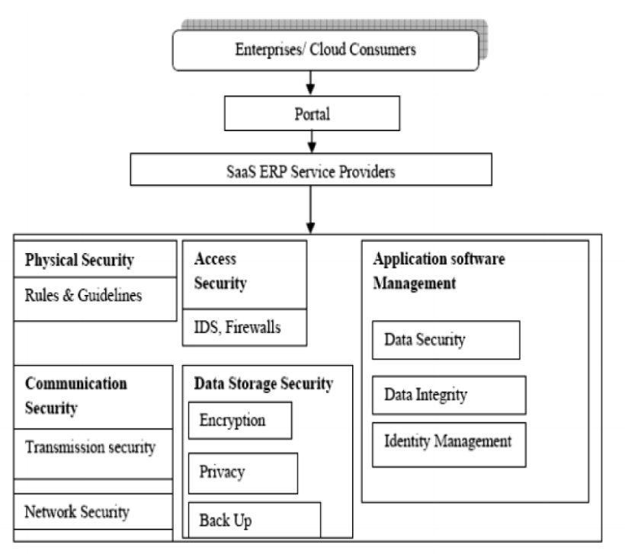
Figure 3. Security framework for cloud-based enterprise system [6]

Risk management
Risk management is responsibility of the organization covering the process of identify, assess, and control risks to ensure the stability and safety of the entire organization. In order to achieve the goal, there are several aspects of risk management for the organization to consider. Risk identification is the first step of risk management. Risks can be classified as internal risks and external risks. Internal risks are factors that can negatively affect the business by impacting information security, business processes, and financial status. Example internal risks includes technical malfunctions, employee lose, and violation of laws and regulations. External risks are effects of external environment on the organization, including the change of market circumstances, opponent companies, and supply chain risks.
The second step of risk management is risk assessment. Through qualitative assessment, risks can be qualitatively assessed to determine the severity of the risk and area of impact of the risk, with the help of expert assessment or surveys to staff and customers. There should also be quantitative assessment to determine the probability of the risk happening and probable loss caused by the risk. This can be achieved by analyzing historical data and statistical data.
The third step of risk management is risk response strategies. Avoiding the risks is the priority and the most effective way to response to potential risks. This could include changing the business process according to the situation or changing the supply chain providers. In case avoiding the risks completely is not possible, reducing the probability that the risk will happen, or the severity and area of effects of the risk becomes the second option. This mitigating risks can be achieved by strengthening security measures or developing emergency plans. There should also be risk acceptance plans in place in case the risk happens. To implement necessary measures, having the company under insurance policies and having risk reserves could reduced the negative consequences caused by the risk.
Figure 4 below represents the process of security risk management process that should be adopted by the company.
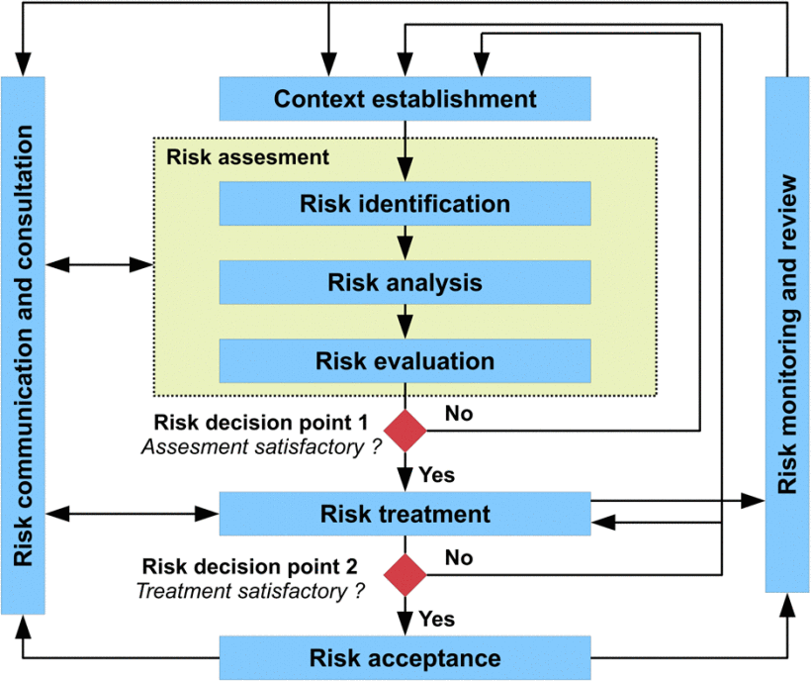
Figure 4. Information security risk management process [7]

Security management models and practices
Security management models and practices are the essential aspects of NG’s overall information security strategy. Adopting effective models will help develop security procedures and practices will ensure the implementation of strong security measures. Three security management models will be discussed to demonstrate how they will be fit given NG’s unique background.
ISO 27001 is an internationally acknowledged standard that provides systematic measures for information security management. NG could adopt the ISO 27001 framework to establish an information security management system. This model can be continuously improved by the Plan-Do-Check-Act methodology [8].
National Institute of Standards and Technology (NIST) developed the NIST cybersecurity framework [9]. This framework has been wildly used to improve the resilience of cybersecurity. It focuses on identifying, protecting, detecting, responding to, and recovering from security incidents. Since NG has extensive usage of cloud services to deliver IT services to its staff and customers, it can adopt the NIST framework to create structured and risk-based security management measures. Figure 5 below shows the 5 parts of NIST framework.
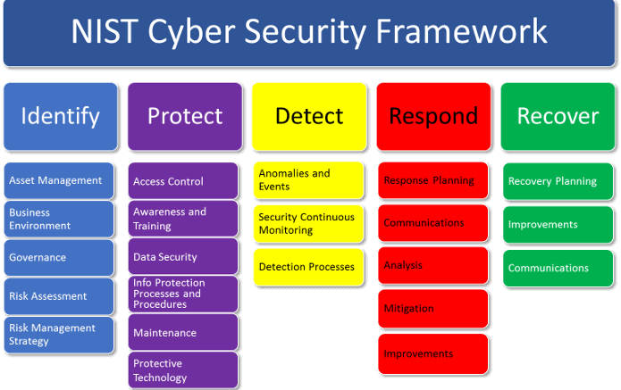
Figure 5. NIST cyber security framework [10]
Control Objectives for Information and Related Technologies (COBIT) is a framework to help align information technology and business objectives. It provides a set of controls and best practices for IT procedures. NG could adopt the COBIT framework to ensure the security measures are aligned with the objectives of its business strategy [11]. Figure 6 below shows the key components of the COBIT framework.
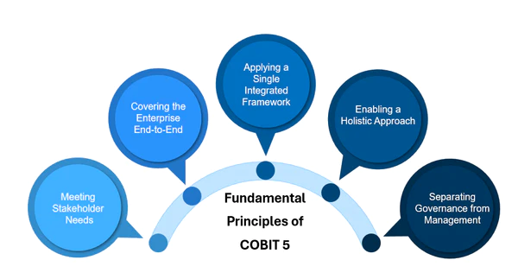
Figure 6. Fundamental principles of COBIT 5 [12]
Beside from making an appropriate security model, other security practices should also be conducted to enhance the effectiveness of the security models. For example, regular staff training should be conducted to raise awareness on the importance of information security and to prove their skills of utilizing security measures. These training meetings will enhance their knowledge of potential security risks faced by their daily work, develop a culture where they are sensitive when it comes to potential disclosure of important business data, and teach them correct protocol to follow in the case of security risk.

Continuous Improvement
Information security strategy is not a one-time thing, NG should stay ahead of potential risks to enhance its ability to handle security threats. It is significant to integrate emerging technologies into its security strategies. Utilizing technologies like artificial intelligence and machine learning to analyze the big data to discover known and unknown security threats. Blockchain technology to enhance the integrity and transparency of critical data to protect its intellectual property. Internet of Things could also be utilized in its strategy to help the process of authentication, encryption, monitoring, and so on.

Conclusion
Information security policies and standards, data storage policies, and risk management policies are essential in the area of information security for NatureGarden. Through the development and implementation of information security policies and standards, NG can clarity the requirements and expectations of their information security, as well as making sure the staff and senior managers understand the importance of information security. Through data storage policies and cloud service security, data confidentiality, integrity, and availability can be protected by granting the safety of data storage the transmission. Risk management can identify, assess and control potential risks to reduce the uncertainty faced by the organization to ensure safety and security. These three aspects are interrelated, and collectively build the foundation of information security system. In developing and implementing these strategies, the organization should consider its own business requirements, technological environments, and security threats to ensure the strategies are effectiveness and adaptability of these strategies. In addition, continuous monitoring and assessment are necessary steps to help the organization to discover and respond to new risks and challenges. By using these security measures, NatureGarden will improve its ability of maximizing information security techniques and minimizing security risks to provide a safer environment for the growth of its businesses.

References
[1] A. Veiga and J. Eloff, “An Information Security Governance Framework,” Oct. 2007, doi: https://doi.org/10.1145/1655168.1655170.
[2] T. Thumasathit, “Data Classification: How to Classify Your Company’s Data and Be Better Prepared for a Data-driven Future,” www.dasera.com. https://www.dasera.com/blog/data-classification-how-to-classify-your-companys-data-and-be-better-prepared-for-a-data-driven-future
[3] U. Rajendranath, N. Singh, B. Manimaran, V. Mohanavel, and K. Dhivya, “A Robust Information Security Model to Preserve Data Integrity in Cloud Computing Environment | IEEE Conference Publication | IEEE Xplore,” ieeexplore.ieee.org. https://ieeexplore.ieee.org/document/9752082/
[4] jimmart-dev, “Data redundancy - Azure Storage,” learn.microsoft.com. https://learn.microsoft.com/en-us/azure/storage/common/storage-redundancy
[5] J. Werner, C. Westphall, A. Vargas, and C. Westphall, “Privacy Policies Model in Access Control | IEEE Conference Publication | IEEE Xplore,” ieeexplore.ieee.org. https://ieeexplore.ieee.org/document/8836759
[6] A. Markandey, P. Dhamdhere, and Y. Gajmal, “Data Access Security in Cloud Computing: A Review,” 2018 International Conference on Computing, Power and Communication Technologies (GUCON), Sep. 2018, doi: https://doi.org/10.1109/gucon.2018.8675033.
[7] V. Lalanne, M. Munier, and A. Gabillon, “Information Security Risk Management in a World of Services,” 2013 International Conference on Social Computing, Sep. 2013, doi: https://doi.org/10.1109/socialcom.2013.88.
[8] M. T. Schmidt, F. Elezi, I. D. Tommelein, and U. Lindemann, “Towards recursive plan-do-check-act cycles for continuous improvement,” IEEE Xplore, Dec. 01, 2014. https://ieeexplore.ieee.org/document/7058886
[9] N. Teodoro, L. Gonçalves, and C. Serrão, “NIST CyberSecurity Framework Compliance: A Generic Model for Dynamic Assessment and Predictive Requirements | IEEE Conference Publication | IEEE Xplore,” ieeexplore.ieee.org, Dec. 03, 2015. https://ieeexplore.ieee.org/document/7345310
[10] R. Avignone, “5 Key Changes Made to the NIST Cybersecurity Framework V1.1 | Giva,” Giva, 2019. https://www.givainc.com/blog/index.cfm/2019/7/24/5-Key-Changes-Made-to-the-NIST-Cybersecurity-Framework-V11
[11] G. Ridley, J. Young, and P. Carroll, “COBIT and its utilization: a framework from the literature,” IEEE Xplore, Jan. 01, 2004. https://ieeexplore.ieee.org/abstract/document/1265566
[12] N. V, “COBIT 5 For Information Security,” ITSM Docs - ITSM Documents & Templates, Sep. 04, 2023. https://www.itsm-docs.com/en-gb/blogs/cobit/cobit-5-for-information-security

