Assignment Title: Individual Business Model Canvas with Entrepreneurial Reflection using appropriate academic models.
Module Title: Entrepreneurship BMIH5001
Lecturer’s Name: Charlotte Joyner
Student Name: Simona Militaru
Student P Number:2214268

Part 1
Essay on "Business Plan: Silken Solace Resort”
Entrepreneurs have some distinctive capabilities that help them to generate unique ideas about a new business (Burns, 2022). They are highly innovative. They can also provide solutions to the existing problems (Barringer and Ireland, 2018). The essay will focus on a new business idea that will demonstrate the author's entrepreneurial capabilities. The business plan aims to offer a unique idea for eco-friendly hotels in the UK. The new business name is Silken Solace Resort. It will be located in Newcastle upon Tyne, England. Using Business Model Canvas (BMC), the different key aspects of the business plan will be explained and visualised for providing a better understanding (Sort and Nielsen, 2018).
Customer segments of BMC show the group of customers that will be targeted by Silken Solace Resort. The targeted customer segments are eco-conscious luxury travellers, business clients, and couples and families. These customer groups are profitable for the business because they show similar interests and demand for the eco-friendly and luxury market offerings of the business. In recent years, there has been a significant shift in the luxury segment in the hospitality industry. Guests have a greater demand and preference for luxury options that are also sustainable. They want to have a unique experience. The business will provide them with the experience of being responsible for the environment (Kapferer and Michaut-Denizeau, 2017). Corporate clients are the ones who are willing to pay premium prices for arranging conferences and events. The business will meet its requirements maintaining sustainable practices. Couples and families also have preferences for sustainable hospitality services (Kunz, May and Schmidt, 2020). They may spend their holidays in an eco-friendly environment. The business aims to meet the needs and preferences of these customer segments.
In the value proposition part of BMC, the business will make unique offerings to the market so that the company can differentiate itself from the existing competitors. The company will offer luxurious and eco-friendly accommodations, and an exceptional dining experience by sourcing locally produced, wellness and spa services, and sustainable practices. Silken Solace Resort will use sustainable materials, water-saving fixtures, and energy-efficient technologies to promote eco-friendly and sustainability practices in its accommodations (Matzembacher et al., 2020). The business will strike a balance between luxury and environmental ethics. The guests will have a farm-to-table dining experience in the resort. The business will ensure freshness in its food offerings by using locally sourced organic ingredients. Local sourcing can reduce carbon emissions by addressing transportation issues. It also supports the UK economy. The business will provide wellness and spa services utilising natural and organic products. Moreover, the value proposition will uphold sustainable practices such as recycling and minimising energy consumption (Kunz, May and Schmidt, 2020).
Channels are the key areas of a business plan. When a new company is introduced, it needs to establish communication with the target customers and it also needs to sell its products and services using appropriate channels. For the new business plan, the company's website and ecotourism platforms will be used to reach the target audiences. The company website will provide the opportunity for the customer to make online bookings. It will be more convenient and easier (Law et al., 2015). Additionally, by making partnerships with various ecotourism platforms, the business can increase its reach. The business will make partnerships with travel agencies who specialise in eco-friendly tourism. Moreover, social media platforms such as Facebook, Instagram, and Twitter can be used to reach a targeted group of people. The business can make this channel effective by creating engaging content and interacting with the guests (Sakas et al., 2022).
Customer relationships are an important aspect of the BMC. The new business must gain a competitive advantage in the long run (Barringer and Ireland, 2018). Hospitality businesses need to focus on customers and ensure that customers are getting their expected services. Considering the importance of the customer's perspective, the new business will maintain a strong and effective customer relationship by offering personalised guest services, loyalty programmes, and community engagement. Personalisation is a key factor in the hospitality industry that can make a significant difference (Nilashi et al., 2021). Businesses that offer personalised services can have greater customer satisfaction. Silken Solace Resort will apply the latest technologies such as AI and big data analytics to get customer insights. Based on those insights, the business will offer personalised guest services. The business will offer loyalty programmes to make repeated purchases by the existing customer base. It may offer special discounts and services for customers using loyalty rewards. The business will engage the local community by arranging various community programmes (Elshaer et al., 2024). The new business will emphasise on these three aspects to maintain a strong customer relationship.
The business plan needs to specify the sources of revenues. To make the business profitable and sustainable in the long term, it should have diversified sources to generate revenues. Silken Solace Resort will depend on some key sources such as room and suite rentals, dining services, spa and wellness services, and arrangement of different events and programmes. The resort will offer accommodation at various prices ranging from standard to luxury options. Premium pricing will be charged on eco-friendly luxury suites and rooms. In addition, a dynamic pricing strategy will be applied to increase the RevPAR (de Bastos, 2022). In dining services, the business will ensure locally produced ingredients to support the UK economy. This source can provide a large amount of revenue. However, spa and wellness services and events and conferences can also contribute a substantial amount of revenue to the business.
Resources are the key factors that are used to provide products and services. The new business has resources such as resort properties, eco-friendly infrastructure, employees, and partnerships with key players in the market. The resort property is essential to provide an exceptional and eco-luxury experience. The resort property will utilise green materials and sustainable amenities. Renewable energy sources will be implemented such as solar panels and water conservation systems because these will ensure that the resort has the least impact on the environment and it can contribute to eco-friendly practices (Abdou, Hassan and Dief, 2020). Employees are another key resource of the business. In the hospitality industry, employees can play a crucial role in service quality because they interact with the guests directly. To improve their skills and experiences, the business will offer them a training and development programme (Pascual-Fernández, Santos-Vijande and López-Sánchez, 2020). The business's key resource is its partnership with the established players in the market. It will make partnerships with local farmers and manufacturers in England to ensure that it has a strong supply chain and sourcing of fresh produce. The partnership is necessary to strengthen the market position in the fiercely competitive market environment.
Key activities of BMC for the business plan show the activities that are required to accomplish the organisational goals and objectives (Lüdeke‐Freund, 2020). The company is committed to providing high-quality and exceptional hospitality services to the guests. It will consider guests' perspectives and their preferences to offer personalised services. The service quality will be maintained by focusing on employee performance, bringing efficiency in the process, responding to guest queries, and resolving issues immediately (Gupta, Dash and Mishra, 2019). The business provides an atmosphere that makes the guests feel relaxed and satisfied. The hospitality operations of the resort must be aligned with the sustainability principles. It will utilise renewable energy sources, and energy efficiency technologies, and source the products from local suppliers of England. The business will undertake a comprehensive marketing strategy. It will utilise both offline and online channels to reach the target customer segments and communicate about the products and services. Its competitors such as Castle Green Hotel, Moss Grove Organic, and Cottage Lodge’s use different marketing channels (SimilarWeb, 2024). Their marketing analysis is attached in Appendix. Moreover, the business will undertake a continuous improvement initiative. It will identify the weaknesses of the processes and recommend to overcome those weaknesses. Hence, the business can create a strong position in the target market.
The key partnership aspects of BMC have identified some key players in the hospitality industry. The business will make partnerships with local farmers and food producers, eco-certification bodies, sustainable tourism networks, and NGOs of England. The local farmers and producers of England will provide fresh ingredients and organic products. Eco-certification bodies will validate the certification claims that Silken Solace Resort makes. The sustainable tourism network will help the business to collaborate with other ecotourism businesses. The partnership with NGOs will facilitate engagement with the local communities to promote sustainability practices within the business (Schweitzer and Meng, 2022).
The cost structure of BMC outlines the possible sources where the business will incur its costs. The business will incur significant costs in operating costs which deal with the daily activities of the hospitality business such as housekeeping, utilities, maintenance, and front office operations. The management must ensure that these costs are effectively managed to increase the profitability of the business. The company will incur capital costs in sustainable technologies and infrastructure. To perform marketing activities, the business may be required to spend on, marketing campaigns, social media marketing, collaboration, and digital marketing sources. The business will also spend on employee development and training activities to improve their performance in the workplace (Williams, 2021).
Silken Solace Resort is a luxurious, eco-friendly, and sustainable hospitality organisation. It targets customers who are self-conscious, business travellers, couples and families. It will use offline and online channels to reach the target customers and offer unique and personalised hospitality services to meet the guest’s expectations. By engaging with the customers, it maintains a strong relationship with them. Its key resources such as resort facilities, establishments, and employees are used to generate revenues from diversified sources. The company will incur costs from its hospitality operations and marketing activities. To achieve success in the long run and become competitive, it will form a partnership with the key market players.
Part 2
Essay on “Personal Reflection on Entrepreneurship”
The essay is on personal reflection on entrepreneurship. The entrepreneurship aspect has become an important topic in the continuously changing business environment. Entrepreneurs have to face various challenges to undertake a new business plan or venture (Burns, 2022). The essay will assess the personal leadership aspects of the author by applying Gibbs’ reflection model.
I have a keen interest in business management and entrepreneurship since I studied in high school. At this stage, I have assessed my personal leadership capabilities by answering the leadership questionnaires. The survey questionnaire consists of 12 questions. I achieved 26 by answering all the questions. The score is crucial to evaluate my entrepreneurial tendencies.
At first, I felt a mix of emotional responses considering the challenges and opportunities that I might encounter if I become an entrepreneur. Because I have secured a 26 score which is above average, it shows that I have an entrepreneurial inclination. It gave me confidence that now I can undertake new challenges and opportunities. However, I felt anxious when I came to know that I needed to work on some areas and become cautious while implementing entrepreneurial initiatives.
My score was 26. It is a good score that explains that I have entrepreneurial spirit. Yet I need to be cautious while making any decisions about the business. I might be influenced by my emotional aspects. I also need motivation to successfully implement my business ideas and venture. I have noticed that I possess some traits that restrict me to make entrepreneurial decisions. I should focus on my entrepreneurial capabilities and motivation to achieve long-term success.
McGregor’s theories X and Y are relevant to analyse the motivational aspects of my entrepreneurial capabilities. Theories X and Y both provide contrasting views on employee motivation and workplace behaviour (Sabri, Mutalib and Hasan, 2019). My score suggests that theory Y is more relevant to me. The theory explains that people like to take on work responsibilities and they are self-motivated. I like to take responsibility that is aligned with the theory. However, I need to be cautious. It takes theory X into consideration (Şahin, 2012). I need a structured environment to support my entrepreneurial potential.
The score that I have achieved shows my entrepreneurial and managerial capabilities. I can be a great entrepreneur if I manage my weaknesses such as being cautious about business decision-making. I need to transform my weaknesses into my strengths.
In my action plan, I aim to overcome my weaknesses. I have limitations in some areas of my managerial skills. I want to be creative in my work. I aim to improve my leadership skills. I should be able to measure the outcome of the business by using appropriate metrics and measures. I seek to engage with industry leaders and professionals to learn from them about entrepreneurship and management of a new business (Harrison, Burnard and Paul, 2018).

Reference List
Abdou, A.H., Hassan, T.H. and Dief, M.M.E. (2020) A Description of Green Hotel Practices and Their Role in Achieving Sustainable Development. Sustainability, [online] 12(22), p.9624. doi:https://doi.org/10.3390/su12229624.
Barringer, B.R. and Ireland, D. (2018) Entrepreneurship. Pearson Education UK.
Burns, P. (2022) Entrepreneurship and Small Business start-up, Growth and Maturity. London Macmillan Education.
de Bastos, B.P. (2022) Contribution of Hotels’ Revenue Management for Supply Chain Sustainability. Journal of Revenue and Pricing Management. doi:https://doi.org/10.1057/s41272-022-00380-z.
Elshaer, I.A., Mansour Alyahya, Alaa M. S. Azazz, Mansour, M.A., Mohammad and Sameh Fayyad (2024) Understanding the Nexus between Social Commerce, Green Customer Citizenship, Eco-Friendly Behavior and Staying in Green Hotels. Sustainability, 16(4), pp.1409–1409. doi:https://doi.org/10.3390/su16041409.
Gupta, A., Dash, S. and Mishra, A. (2019) All That Glitters Is Not green: Creating Trustworthy Ecofriendly Services at Green Hotels. Tourism Management, [online] 70, pp.155–169. doi:https://doi.org/10.1016/j.tourman.2018.08.015.
Harrison, C., Burnard, K. and Paul, S. (2018) Entrepreneurial Leadership in a Developing economy: a skill-based Analysis. Journal of Small Business and Enterprise Development, 25(3), pp.521–548. doi:https://doi.org/10.1108/jsbed-05-2017-0160.
Kapferer, J.-N. and Michaut-Denizeau, A. (2017) Is Luxury Compatible with Sustainability? Luxury Consumers’ Viewpoint. Advances in Luxury Brand Management, [online] pp.123–156. doi:https://doi.org/10.1007/978-3-319-51127-6_7.
Kunz, J., May, S. and Schmidt, H.J. (2020) Sustainable luxury: Current status and perspectives for future research. Business Research, 13, pp.541-601. doi:https://doi.org/10.1007/s40685-020-00111-3
Law, R., Leung, R., Lo, A., Leung, D. and Fong, L.H.N. (2015) Distribution Channel in Hospitality and Tourism. International Journal of Contemporary Hospitality Management, 27(3), pp.431–452. doi:https://doi.org/10.1108/ijchm-11-2013-0498.
Lüdeke‐Freund, F. (2020) Sustainable entrepreneurship, innovation, and business models: Integrative framework and propositions for future research. Business Strategy and the Environment, 29(2), 665-681. https://doi.org/10.1002/bse.2396
Matzembacher, D.E., Raudsaar, M., Barcellos, M.D. de and Mets, T. (2020) Business Models’ Innovations to Overcome Hybridity-Related Tensions in Sustainable Entrepreneurship. Sustainability, 12(11), p.4503. doi:https://doi.org/10.3390/su12114503.
Nilashi, M., Minaei-Bidgoli, B., Alrizq, M., Alghamdi, A., Alsulami, A.A., Samad, S. and Mohd, S. (2021) An Analytical Approach for Big Social Data Analysis for Customer decision-making in eco-friendly Hotels. Expert Systems with Applications, 186, p.115722. doi:https://doi.org/10.1016/j.eswa.2021.115722.
Pascual-Fernández, P., Santos-Vijande, M.L. and López-Sánchez, J.Á. (2020) Harnessing Innovation Success in hotels: the Interplay among Key Drivers of New Service Performance. International Journal of Contemporary Hospitality Management, 32(9), pp.2757–2776. doi:https://doi.org/10.1108/ijchm-12-2019-0988.
Sabri, S.M., Mutalib, H.A. and Hasan, N.A. (2019) Exploring the elements of employees’ motivation in hospitality industry. Journal of Tourism, 4(14), pp.13-23. eISSN: 0128-178X.
Şahin, F. (2012) The Mediating Effect of Leader–member Exchange on the Relationship between Theory X and Y Management Styles and Affective commitment: a Multilevel Analysis. Journal of Management & Organization, 18(2), pp.159–174. doi:https://doi.org/10.5172/jmo.2012.18.2.159.
Sakas, D.P., Reklitis, D.P., Terzi, M.C. and Vassilakis, C. (2022) Multichannel Digital Marketing Optimizations through Big Data Analytics in the Tourism and Hospitality Industry. Journal of Theoretical and Applied Electronic Commerce Research, [online] 17(4), pp.1383–1408. doi:https://doi.org/10.3390/jtaer17040070.
Schweitzer, F. and Meng, Y. (2022) How Collaborating with NGOs Makes Green Innovations More Desirable. Business & Society, p.000765032210847. doi:https://doi.org/10.1177/00076503221084733.
SimilarWeb (2024) Similarweb.com - Digital World Market Intelligence Platform. [online] SimilarWeb.com. Available at: https://www.similarweb.com/ [Accessed 11 May 2024].
Sort, J.C. and Nielsen, C. (2018) Using the Business Model Canvas to Improve Investment Processes. Journal of Research in Marketing and Entrepreneurship, [online] 20(1), pp.10–33. doi:https://doi.org/10.1108/jrme-11-2016-0048.
Williams, S. (2021) The Financial Times Guide to Business Start up 2021/2023 : the Most Comprehensive Guide for Entrepreneurs. Harlow, England ; London ; New York: Pearson.

Appendices
Business Model Canvas
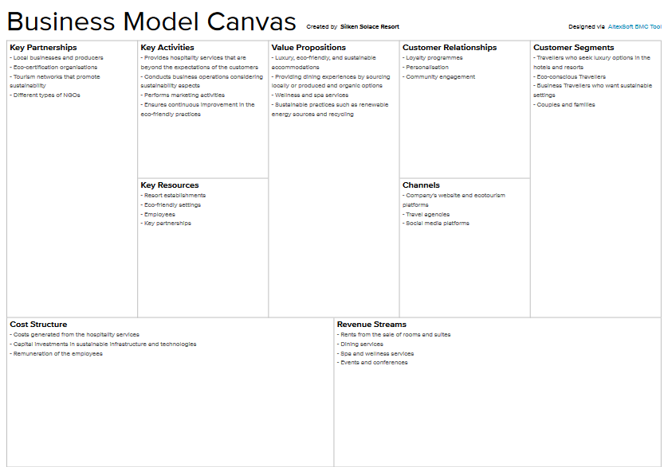

Mindmaps
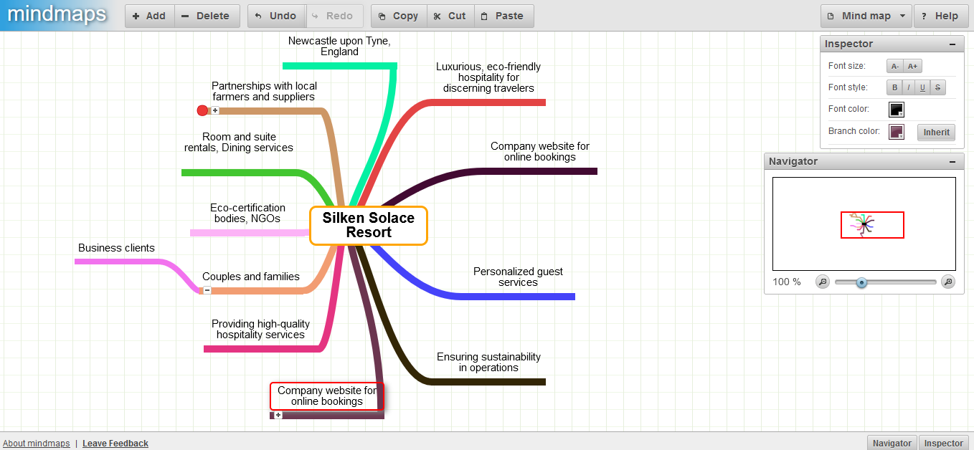

Customer Profile
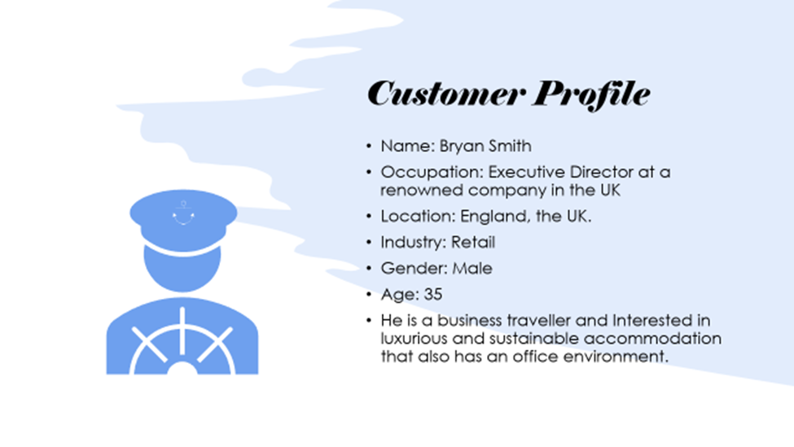

SimilarWeb Competitor Analysis
Castle Green Hotel
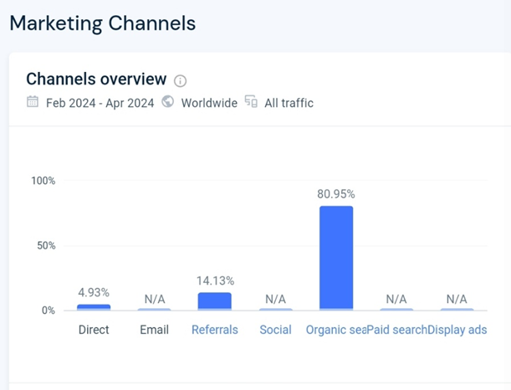
Moss Grove Organic
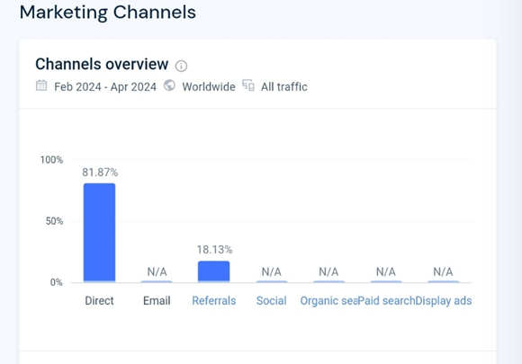
Cottage Lodge


