
Skills for the Workplace
Module Assignment Submission
Student Name: | Renee Kennedy
Student Number: | 2010989
Module No: | BMSK4005
Module Title: | Professional Career Development

Statement of Confirmation of Authenticity
By the act of making this submission, the student declares that this is the work of the student named above. The work has not, in whole or in part, been knowingly presented elsewhere for assessment, or where assessment has been built on a previous assessment, this has been identified. Where materials have been used from other sources it has been properly acknowledged. If this statement is untrue, the student acknowledges that an assessment offence has been committed.
Attention is drawn to the plagiarism and unfair practice policies of both the University and of ILM.

Table of Contents
Section 1: Know how to identify development needs 3
1.1 Identify learning styles for self and another 3
1.2 Use a simple technique for identifying development needs for self & another 4
1.3 Identify potential barriers to learning for self and another. 5
1.4 Explain how these barriers to learning can be overcome. 6
Section 2: Know how to develop self & others to achieve organisational objectives 6
2.1 Analyse learning/development options to meet needs of self & another. 6
2.2 Identify support mechanisms for the development of self & another 6
2.3 Prepare development plans for yourself and another person 7
2.4 Method used to monitor the development of self & another. 8
Section 3: Know how to prepare for the recruitment process 8
Reflection on the recruitment process 8
3.1 Description 8
3.2 Feelings 9
3.3 Evaluation 9
3.4 Analysis 9
3.5 Conclusion 9
3.6 Action Plan 9
References 10
Appendix A 10
Appendix B 10
Appendix C 10
Appendix D 10

Section 1: Know how to identify development needs
My Name is Renee Kennedy. I am 37 years old live in Cardiff and work for British Gas Business.
I have worked for British Gas for over 10 years and I’m looking to progress in my career.
I am attending this course as I wish to start my own business in personalised merchandise.
I don’t have children so feel this is my time to make the most of being able to work full time and study full time.
I see this as a challenge that I am excited to see what I can achieve from it and see positive changes in the years to come.

1.1 Identify learning styles for self and another

The results of the Honey & Mumford questionnaire have shown me that my learning style is a reflector (refer to Appendix A for all learning style results).

Activist -Total circled (10)
Reflector -Total circled (19)
Theorist -Total circled (15)
Pragmatist -Total circled (15)

The results state that I am a good listener. This is not something that I would agree with in all situations. It depends on the situation I am in to determine if I’m going to listen in depth.
Something will need to interest me and grab my attention straight away for me to continue to listen from beginning to end.
I reflect on things and like to confirm why things happened in certain situations.
I perform better in an environment that involves me monitoring my team in terms of both their productivity, and their well-being.

The results of the Honey & Mumford questionnaire show me that Martine’s learning style is a pragmatist.
Activist -Total circled (3)
Reflector -Total circled (12)
Theorist -Total circled (13)
Pragmatist -Total circled (14)

Knowing Martine, I agree with this result she is always looking to see if a plan will work when put into practice and if not then the plan will need to change whether that be slightly or drastically.
Either way Martine will look to find a positive and successful outcome.
Pragmatism translates into results orientation, being proactive, firm, determined and willing to take action quickly. The pragmatists do not know the constant fear that they might not succeed but channel their energy to find solutions to the obstacles they encounter.
Being called a pragmatic is can be considered a compliment, as it means that you have common sense and people trust you that you know how, and you will get things done.

The result of Vark (Aural strategies) also state I am a good listener and I like discussing, talking questioning and recalling.

Total number of V’s circled = 2
Total number of A’s circled = 11
Total number of R’s circled = 8
Total number of k’s circled = 4

I prefer to talk things over in order to resolve the situation. I listen better if I am discussing the issue instead of reading about it.
I tend to listen more to the people who are knowledgeable and can explain things to me with ease.
I ask a lot of questions about things new to me as I like to make sure I am doing things correctly. This is where my lack of confidence comes into it to a certain extent.
I am a note taker and I work better from writing a list whether that be a personal to do list or bullet points during a lecture or training at work.
I take things in more in a group session where I can discuss the situation with others and put forward my thoughts and ideas and debate, the different opinions.

I like to present any meetings or group sessions to people that like to listen and interact with me so ask questions and get involved.
I prefer to present anything face to face rather than online so that now because of
Covid-19 I must learn how to communicate a lot online it has taken me out of my comfort zone a little, but I am getting used to it.

When learning I like to convert information into my way of understanding so re write it in a way I understand and go over it a few times for it to sink in.
When I am listening, I do struggle to write down a lot of notes so our lectures being online now is good for me so I can go back and expand on my notes.
I suppose this is lack of multitasking that I will work on to get better at and turn it into a strength.
Discussing things with the group and with Bob (lecturer) is a good way of learning as you get to listen to other people’s ideas and get to take away things you may not have thought about.
The result of Vark for Martine (Read/write strategies) show that she works well with lists, handouts, printouts.

Total number of V’s circled = 5
Total number of A’s circled = 7
Total number of R’s circled = 10
Total number of k’s circled = 8

Martine is always printing things off, so I agree with that part of the results.
I also see her as a note taker even in her personal life.
She will go over things a few times just to clarify that how she has perceived something is correct.

Martine’s quote for vark is “if it’s not in print, it may not exist” and this couldn’t be more accurate.

The results of Dantec learning styles for myself show the below results –

Total Scores:
CE (Concrete experience) = 12
RO (Reflective Observation) = 15
AC (Abstract Conceptualization) = 14
AE (Active Experimentation) = 18

RO – Reflective observation
I prefer to understand rather than apply ideas. I prefer to know what is true or how things happen rather than how things work. I value patience, impartiality and thoughtful judgment.

AE – Active experimentation
I like to influence people and change situations. I prefer to learn things that have a practical application. I am willing to take a risk to achieve your goals. You like to influence people and see results.
My learning style as a reflector has come up in the results for a second time which has made me aware of my true learning styles even though I can’t relate to some of them yet its taught me something about myself .
Different learning styles have different strengths. A student with the reflective learning style likes to think things through, complete careful research and observe the world around him. Reflectors enjoy notetaking, charts and placing items in groups.
Though reflectors might complete some classroom activities easier than others,
Its recommended to give them projects outside their comfort zones to make sure they are stretching themselves.

1.2 Use a simple technique for identifying development needs for self & another

By 21st September 2021 I would have gained enough experience to start the proceedings of setting up my business.
Person 1

STRENGTHS  - I have had in house training at a higher level for customer service communication skills.  - I Project managed a new system role out across the business.  - I have undertaken intense Credit vet training.  - I deal with difficult customers more effective as I engage in customer complaint handling daily.  - My Workload management is good I prioritize and set myself realistic goals.  - Productivity  - I am a Team player I enjoy working as a team as this drives me to achieve my goals.  - I Multi skilled in different areas of the business.  - Determination | WEAKNESSES  - I don’t like Taking group meetings in front of large groups pf people.  - I Lack concentration sometimes especially if something doesn’t interest me from the beginning.  - I tend to Talk a lot which can be distracting at times  - Lack of patience at times due to a high-pressured job.  - Being shy (don’t like all eyes on me)  - Lack confidence in certain areas I like to be reassured that I am doing things correctly.  - My Computer skills are not the best they could be.
OPPORTUNITIES  - To progress within my company and progress to a manager level  - Complete my 1st year B.A honours degree and go onto the 2nd and 3rd year to complete the full degree.  - A family member of mine is a year ahead on the same course, so I have the opportunity to ask for support when needed.  - University Resources for every assignment I undertake. | THREATS  - Redundancies in the workplace  - Covid-19 causing illness and job loss  - Having the time to fit studying in due to working full time and having a busy social life with family and friends.  - Having the Finances to do the course and pay for laptops stationary books etc.  - Poor marks which would stop me from completing my degree  - illness forcing me to drop out of the course  - I may not achieve the marks I need to pass the course which would result in them not accepting me to finish the  - degree

One of my weaknesses is talking in large groups of people so I will turn this into a strength by practising this over the next few months and putting it in my PDP to monitor my progress.

I will also be taking up some time to learn new computer skills with family members to turn this weakness into a strength.
You can not turn your weakness into strengths if you do not know what your weaknesses are, so first discover them.
This process requires you to be honest with yourself. Once you know your weaknesses, only then can you start finding ways to overcome them and make them into strengths.

Having excellent customer service skills , the experience of being involved in a business wide new system role out project and good workload management are some of the things from my strengths that could be made into opportunities to progress within my company to manager level .

SWOT Person 2

STRENGTHS  - I am a people's person and able to effectively communicate at all levels.  - Effective time management within the workplace.  - I excel in Customer Service based roles.  - Previous inhouse Customer Service, Leadership and Management training.  - Ability to identify people's strengths and development areas. | WEAKNESSES  - I need to ensure I take time out for myself and focus on improving the balance of family/work/studying.  - I am not comfortable with public speaking, which include presentations.  - I have become rusty with my computer skills, as I do not use them as regularly as I did previously when in an office-based role.  - I lack qualifications.
OPPORTUNITIES  - I am currently undertaking the Higher Education, Skills for the Workplace course, which will be completed in one year. By obtaining the ILM qualification I will be in a much better position, as this will open further career opportunities.  - On completion of the above course, I will commit to a further two years’ study to acquire my BA honours degree.  - I will be undertaking a computer course in the new year to enhance my computer knowledge, which is all part of my personal development.  - I have been compiling and practising presentations with family members in order to get comfortable with this task. | THREATS  - COVID-19 has had a significant impact on the business where I currently work. This has resulted in reducing staff and hours. Personally, it has had a negative effect, as my hours have been reduced and differ each week. Having a daughter and a home to run this can be challenging financially.  - At present, when seeking employment, the fact that I do not hold qualifications restricts my job opportunities.  - By not excelling in strong time management of balancing work/family/studying, there is the possibility of failure. My family support network is also paramount.

One of Martine’s weaknesses is time management. Juggling time for work, studying and home life. This could be changed into a strength by organising her to do list in a way that she gives herself enough time to complete each task. That way she won’t feel under pressure.
If she is under pressure this will have a knock-on effect to her studying.
Her computer skills are also a weakness so she could make this into a strength by maybe undertaking an online computer course or taking time out to spend with her daughter who could teach her a few things as she is still in School so uses computers daily.

In her previous job Martine undertook leadership and management training which is one of her strengths that can be made into an opportunity for this course in leadership and management.
This will give her a head start when applying for jobs in a higher position as she has experience.

1.3 Identify potential barriers to learning for self and another.

For myself barriers to learning would be –

My computer skills are not up to scratch and require further training.

My lack of confidence which stops me from putting myself forward for new things.

My Lack of concentration could lead to me not taking in all the information from lectures that are important in order for me to pass the assignments.
- Finding the time to study with working full time and juggling home life and family time.

Martine’s barriers to learning would be –
- Her Computer skills are not as good as they could be due to not working with computers for many years.
- Her Time management may cause her to fall behind on her coursework which then develops into a stressful home life.
- She currently has Childcare for the set days to attend University but if they changed for whatever reason she would then need to re-evaluate it.

1.4 Explain how these barriers to learning can be overcome.

I will spend time with my family members that are computer literate and used to using computers every day in order to up my skills.
My confidence will build through interaction with my new group I’m studying alongside and getting to learn new things at every lecture.
I’m looking forward to growing my knowledge and achieving the goals I have set myself.
My lack of concentration has come from being in the same job for 10 years and knowing the job inside out. This course has grabbed my attention from the start and I’m enjoying learning something new.
Completing assignments and moving onto the next stage will help me stay focused.

Martine could take an online course to overcome the barrier of lack of computer skills and take advise from family members and friends that are more knowledgeable.
Time management is a barrier for Martine but in order to overcome this she will be more organised with her time making sure she doesn’t give herself unrealistic time frames to complete tasks and spend time with her family .
Martine will arrange childcare in advance and have a few back-ups in place in case of emergency childcare is ever needed.

Section 2: Know how to develop self & others to achieve organisational objectives

2.1 Analyse learning/development options to meet needs of self & another.

For Martine and me the University resources will help us develop our knowledge and understanding. Moodle has a lot of resources that we can access to obtain the information we need to pass this course.

Our lecturer (Bob Wilson) Is also always on hand to answer any queries that we have.
Our course group have all joined WhatsApp where we can share thoughts ideas and any questions that we have which is good as the questions asked are probably questions that other people need answered also.

We have discovered our learning styles through honey and Mumford, vark and Dantec in order for us to develop our way of learning.

2.2 Identify support mechanisms for the development of self & another

A Family member that is in her second year of this course will be on hand to support myself and Martine if needed.
Bob (lecturer) along with the university online tools which offer all information for every unit I study.
Work colleagues giving advice and my manager allowing me time off to study if needed.
See Appendix E for my (Go Mad).

University resources like moodle and group members will offer support to myself as well as Martine.
Our Family are there to support us in any way whether that be finances or childcare to give us the best possible chance to succeed in this course.

2.3 Prepare development plans for yourself and another person

Part 1: Personal Analysis
See SWOT Analysis in 1.2

Part 2: Setting Goals

Please Find My PDP below -
What do I want to learn? | What do I have to do? | What support and resources will I need? | How will I measure success? | Target Date for Review
Being able to present in groups comfortably. | Practice in front of family and friends. | Friends, Family & work colleagues. | By the number of group meetings, I present and complete successfully. | 1st March 2021
Complete my first year in certificate of higher education. | Complete all homework and assignments successfully. | Moodle.  Lecturer (Bob).  Students in my group.  Family, Friends, Work colleagues. | By completing and passing the assignments. | 31st September 2021
How to set up my own business by 31st September 2021 | Complete business plan and establish resources and finances required to proceed | University online resources (Moodle).  Family & Friends.  Funds. | Level of learning and knowledge | 31st September 2021

Martine’s PDP I have set for her based on her SWOT -
What do I want to learn? | What do I have to do? | What support and resources will I need? | How will I measure success? | Target Date for Review
Martine is going to learn how to do presentations in groups. | Practice with friends and family. | Friends and family | By the number of presentations, she completes successfully | 1st March 2021
Martine to Complete her first year in higher education in order for her to gain more qualifications. | Complete the homework and assignments successfully. | University online resources, family & friends, lecturer (Bob) | By passing the assignment | 31st September 2021
Martine to work on time management. | Diarise what needs to be and when | Family, work colleagues | By completing the tasks, she has set for herself by the deadline she has put in place | 1st June 2021

Part 3: Personal Objectives

Short Term Goals (next 12 months)
To begin the process into starting my own business. Improve my knowledge and be more confident to lead and manage a team. This will be a challenge for me which is what I need. Alongside working full time and being a full-time student, I have to be organised and use my time well in order to be successful.
I want to Complete my first-year level 4 degree in leadership and management with a pass in order for me to move onto my second year. After my first year I will be in a totally more positive mindset towards studying.
Medium Term Goals (2-3 years)
To be in my second year of my degree and in the early stages of a new business learning different skills throughout the process. Focusing on progressing my business in every aspect in order to obtain an increase in revenue. I will dedicate my time and effort into making this a positive outcome. My life could be totally different in 2-3 years’ time so I have to work hard to get to where i want to be and overcome any obstacles that may come in my way.

Long Term Goals (3-5 years)
To have completed my full BA Honours degree with flying colours and attend the cap and gown ceremony. This is something I have wanted to do for years I just haven’t had the courage to take the plunge and start studying. Making myself and my family and friends proud in what I have achieved and seeing the results get better through the years.
I would like to be in a position to sell my house and upgrade to a bigger house making my success apparent. Also if I have children by then it will be a start to a better life for them. Things like holidays and weekends away will be able to be arranged at the drop of a hat instead of saving up to do these things.

2.4 Method used to monitor the development of self & another.

I will be using the PDP’s that I have set for both myself and Martine to monitor our development.

I will be setting reminders to monitor our progress during, but I have given target dates for review on all aspects of the PDP .
I will regularly assess and review at agreed stages to ensure that myself and Martine are progressing in the required direction (both in a professional and learning capabilities) and meeting the targets which have been set for us.
It is important to ensure that reviews are conducted, and feedback provided as set times.

Feedback will be given at every review.

Section 3: Know how to prepare for the recruitment process

Reflection on the recruitment process
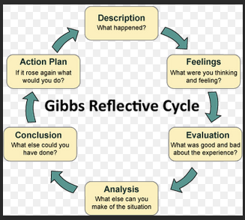

3.1 Description

For this Assignment I had to apply for a job in which Bob would then interview me based on that job spec.
I had to research the company match my CV to this job and provide a cover letter to apply for the job and get accepted to attend an interview.
We attended teams in groups of four but were interviewed one by one.
It was interesting to see how other people interview and how you perceive them.
I was the last one, so it was only me and Bob present at my time of interview which made me a bit more relaxed.
As one of my weaknesses stated in my SWOT I don’t like all eyes on me.

3.2 Feelings

I was nervous even in the morning before I logged on and continued to be nervous until the interview was over.
When the interview had finished, I felt a sigh of relief but felt that it went well.
My observation of the 2 members of my group that interviewed before me was that they were nervous.
It would be interesting to see if Bob thought the same as me being the interviewer and not the candidate.
During the interview I was thinking about how to conduct my answers and conscious of rambling on too much.
I was concentrating on answering the questions that Bob asked in as much detail as I could.
Now I have had my feedback and I done better than I thought it makes me feel like I over analyse things too much which I am aware of.
The positive feedback that Bob gave me has given me much more confidence for future interviews.

3.3 Evaluation

Bob made me feel very at ease, so we were off to a great start. He presented his questions very clearly to me, so I didn’t have to question myself if I was answering the questions correctly.
Although I was very nervous throughout Bob advised I didn’t let it show.
My camera on my laptop that morning decided it wasn’t going to work so I was off to a bad start, but I didn’t let that dwell and affect my performance.

3.4 Analysis

I think it went well because I researched beforehand so I knew a lot about the company in which I was applying for a job for.
I spoke clearly throughout and didn’t rush my answers. I also prepared s few questions to ask Bob about the company and the position I was applying for.
This experience showed me what I am capable of and made me face one of my fears that being interviews.
I voiced one of my weaknesses which is giving presentations in front of groups of people, but I didn’t continue to say I am working on it to make it better.
This is something I have taken onboard for my next interview.

3.5 Conclusion

I have learned from this situation that I am good at hiding my nerves and once I started, I realised it wasn’t as bad as I thought it was going to be.
I have learned how an interview is conducted even though all interviews are different it showed me what to expect from an interview that I may attend in the future.

I learned that if you state one of your weaknesses in an interview follow it up with the fact that you are working on it and making this weakness into a strength.
Its taught me that having weaknesses isn’t all a bad thing as long as you work on making them into strengths and opportunities.

3.6 Action Plan

As I haven’t interviewed for such a long time, I will work on being relaxed and just focus on how I am going to perform in future interviews.

Some further research on how to interview and questions that are frequently asked within interviews will develop the skills I need.
Also putting them in practice with a friend of family member and doing role play interviews.
I will be requesting to my manager that I attend interviews in work to observe what its like to be on the other side and what they see.

References

Mintzberg, H. (2014) Mintzberg’s management roles.
Available at:
https://www.mindtools.com/pages/article/management-roles.htm#:~:text=Monitor%20%E2%80%93%20In%20this%20role%2C%20you,%2C%20and%20their%20well%2Dbeing. [Accessed 27th November 2020]

Skinner, J. (2020) Royal Engineers cpd Getting You Qualified.
Available at:
https://re-cpd.org.uk/is-your-own-personal-development-plan-up-to-date-if-not-visit-our-website-www-re-cpd-org-ukrecentarticles-or-take-a-look-at-our-example-here/ [Accessed 30th November 2020]

Fleming, N.D. & Mills, C. (1992)Vark a guide to learning preferences.
Available at:
https://vark-learn.com/strategies/aural-strategies/ [Accessed 30th November 2020]

Wilson, B. (2020) Learning styles Dantec [Professional career development BMSK4005 2020: CertHE (CARM)]. 3rd December.

Kulkarni, C. (2016) 7 ways to measure true success.
Available at:
https://www.inc.com/chirag-kulkarni/7-ways-to-measure-true-success.html [Accessed 3rd December 2020]

Paringit, D. (2020) Turn your Weaknesses Into Strengths.
Available at:
https://careerbuzz.prosky.co/articles/6-steps-to-turning-your-weakness-into-your-greatest-strengths [Accessed 3rd December2020]

Gibbs, G. (2020) Learning by Doing: A guide to teaching and learning methods.
Available at:
https://www.ed.ac.uk/reflection/reflectors-toolkit/reflecting-on-experience/gibbs-reflective-cycle [Accessed 5th December 2020]

Tonarely, K. (2020) Reflector Learning Styles.
Available at:
https://www.ehow.co.uk/info_7904335_reflector-learning-styles.html [Accessed 5th December 2020]

Romanciuc, N. (2020) The Pragmatist Philosophy (Everything you need to know).
Available at:
https://optimistminds.com/pragmatist/ [Accessed 5th December 2020]

Ritchie, H. (2018) Understand how to implement and monitor a personal professional development plan.
Available at:
https://gloopa.co.uk/understand-how-to-implement-and-monitor-a-personal-professional-development-plan/ [Accessed 5th December 2020]

Appendix A
Learning style scores
(Honey and mumford)- Renee

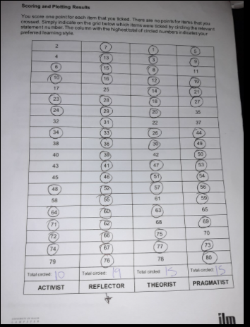

Martine-
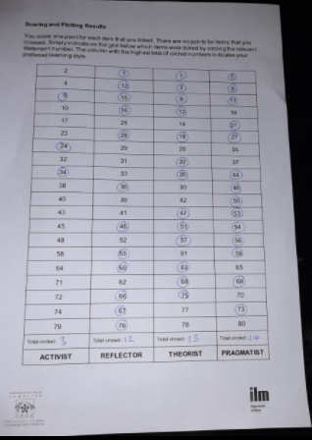

Learning styles (Vark)- Renee
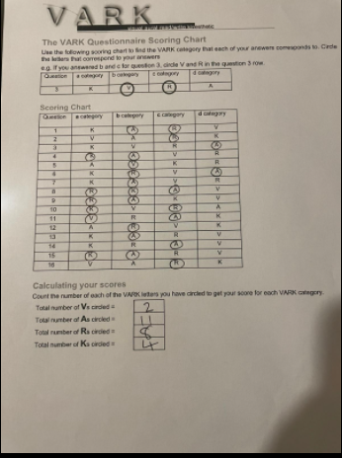
Martine –
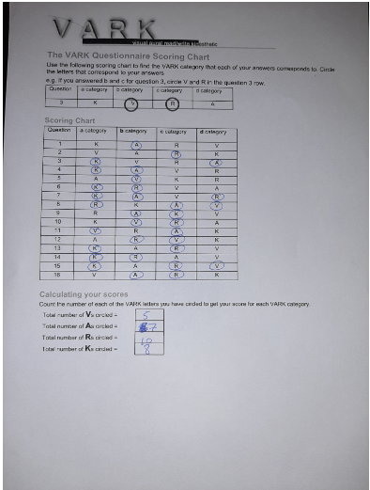

Appendix B
Remote Telesales Energy Advisor (Home Based)
- Bristol (BS1), Bristol
- From £16,000 to £50,000 per annum OTE
- Power21
- Permanent
- Recently
- Check your FitScore
Create alert
Apply
Activate one-click apply. What is one-click apply?
Save
Do you have previous sales experience within a call centre environment?
Do you thrive in a sales environment?
Have you recently found yourself out of work due to the current pandemic or looking to make a switch in your career?
Power 21 is currently looking for hardworking and career driven telesales advisors to join our expanding national contact centre. Due to the current Covid-19 pandemic, Power 21 has successfully adapted its business model to ensure that employees can work remotely, allowing you the opportunity and flexibility to work 100% from home from anywhere in the UK! Following on from the recent success our home based employees have created, we now have the go ahead from our client Scottish Power to double in size, giving many other people across the UK, who may be in a difficult decision, an opportunity to join Power 21.
You would be representing Scottish Power, using a telemarketing campaign to generate sales. We are looking to recruit people who are motivated and have a strong ability to meet targets and thrive in a fast paced and pro-active atmosphere.
As a telesales Advisor, you will be clear spoken, have a warm and friendly telephone manner who will listen carefully to the customer. You will also have targets to meet which our fantastic team will support and help you with.
What we need from you: -
· Previous experience in a sales role or call centre, but not essential.
· Warm, friendly telephone manner.
· The ability to engage in fun, pleasant conversations with customers.
· The ability to work towards and achieve KPI’s
What we expect from you: -
·Operating outbound calls via a dialler system.
·Quotes and comparisons for potential customers.
·Having full understanding of clients and competitors’ products and services.
·Achieving daily KPI’s.
·Adherence to our policies and procedures
What we can offer you: -
· Uncapped commissions, employees earning up to £50k per annum!
· Great working hours.
· Progression Opportunities.
· First Class Training.
· The ability to work from home
Successful candidates would be working on a full-time, permanent basis from home. The hours of work would be Monday – Friday, 10am – 6pm. These are our operating hours as a Home-Based operation. For anyone who would like to join the contact centres when they re-open, these hours may vary.
If you are successful, training will take place Monday – Friday 9AM – 5PM approximately 33 hours. This will be paid training.
We are looking for individuals who are wanting to progress their career and if you are hardworking and goal motivated then we want to hear from you! To apply for this position, please click apply now and forward us a copy of your most up to date CV.

.

Appendix C
CURRICULUM VITAE
Renee Kennedy
28 Penrhos Cresent
Rumney
Cardiff
CF3 3PB

PERSONAL PROFILE

Renee is a dedicated, proactive and focused team player who possesses extensive skills and pride in delivering first class customer service. A naturally organised individual who has a flair for solving problems and leading others to meet and exceed goals and deadlines.

KEY SKILLS

Problem Solving: A strong ability to resolve existing and predict foreseeable problems through a pragmatic and practical approach with a keen focus on attention to detail.

Customer Service: Experienced in handling difficult conversations with an influential approach to exceeding customer expectations. Proven ability to earn respect and credibility amongst customers and staff of all levels.

Communication: A high standard of verbal and written skills. A strong ability to invest attention in others and the use of effective communication in seeking the right combination of words, body language and voice tone.

Team Building: A core team player who develops others through leading by example. Unafraid to work at the bottom line to encourage team members to perform at their best. An influential character who motivates and guides with a compassionate and humanistic approach.

Motivation: An energetic self-starter who motivates others through a positive attitude and dedication to delivering a first-class service at all times.

KEY ACHIEVEMENTS

Joined management team and now holds responsibility to supervise and manage a team of 10. Leads team meetings and reviews performance of staff, targets and practices, implements and manages change.

Through management efforts of coaching and mentoring of staff both in groups and individual meetings, lead team to exceed business target by 60% during last quarter.

As a lead for testing for implementing a new SAP system into the business my duties involved using my extensive knowledge of the electricity industry to carry out system testing to ensure a smooth roll out across the business. As i played a key part in the delivery of new SAP system into the department i regularly liaised with stakeholders throughout other parts of the business including Leicester where i was based for 3 months. I carried out regular Testing and reported any issues and risks to the business. I also liaised with the learning and development department to ensure all training material was accurate from my knowledge of testing the new system.

EDUCATION AND QUALIFICATIONS

Present-
University of wales Trinity Saint David Level 4:
Certificate of Higher Education Skills for the workplace

Rumney High School- GCSE’s:
Mathematics C
English C
Science C
Media Studies B
Physical Education B

WORK EXPERIENCE
British Gas- Customer sales executive - February 2010 to Present
The nation’s largest energy provider: Employed within the Connections & Metering team which focuses on the metering needs of business customers from SMEs up to large industrial and commercial organisations.

- Manages a portfolio of over a hundred customers for the duration of the enquiry life cycle, covering various business customers from long standing relationships to new accounts.
- Supports line manager and other team members in responding to complex queries, complaints, work processes and training.
- Arranges quotations for various aspects of metering work and contracts.
- Educates customers on the energy industry to ensure a clear and transparent approach to account management.
- Guides customers through processes with clear instructions and through being available to respond to queries and offer regular updates.
- Handles incoming sales calls, including business overflow.
- Verifies contracts, ensuring complete records with accurate data are obtained at all times.
- Liaises with customers to develop and maintain effective working relationships.
- Obtains payments from clients.
Pittstop Café- CEO- December 2008 to January 2010

Appendix D

Miss Renee Kennedy
Tel: 07854034383
Email:reneekennedy2621@gmail.com

Job application for vacancy ref 91005295
To whom it may concern,
I am writing to you today to apply for the position of Remote Telesales Advisor (Home Based).
I have over 10 years’ experience in customer service face to face and over the telephone.
I have an excellent telephone manner and the ability to build a rapport with customers.
I am used to working in a target driven environment which is why I will be an asset to your company.

I am the perfect candidate for this role as I currently work in the energy sector and manage a large portfolio of customers from the beginning of their journey to the end.
I deal with complex queries day to day and I am not shy of a difficult customer or situation.
I am a core team player who develops others by leading by example.

I feel my 10 years' experience in energy will have a positive impact on your company.

Thank you for taking the time in considering my application
Yours Faithfully

Renee kennedy ​
Renee Kennedy

Appendix E
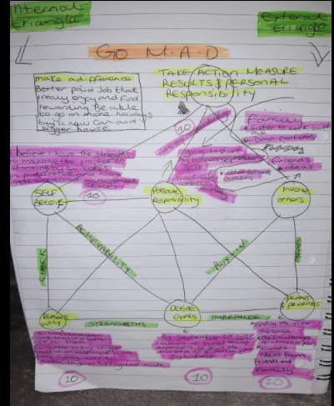
Appendix F


