Syeda Aysha Siddika

BECOMING A DIGITAL LEARNER

Table of Contents
Introduction 3
Refection using Borton’s reflective tool 3
Video presentation on “Becoming a digital learner” 4
Mind map on personal identity 6
Summary 7
Conclusion 7
References 9

Introduction
In the modernised era, becoming a digital learner or increasing digital learning capabilities is highly required. Digital learning is important and necessary for using technologies on multiple devices. The portfolio report has highlighted a reflection with "Borton's reflective tool". A video presentation also has done with skills and techniques of digital learning. A mind map has been made on personal values and beliefs.

Refection using Borton’s reflective tool
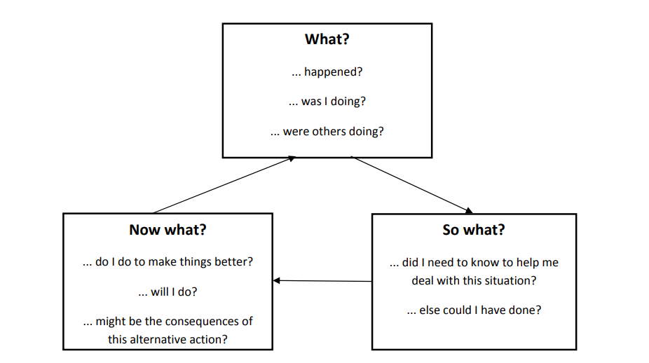
Figure 1: Borton’s Model of Reflection
(Source: bda.uk.com, 2022)
In the preparation for my higher education, I have tried to give my full effort to increase my knowledge and skills for gaining digital agility for higher education. During my preparation, I faced lots of challenges like, I have not got full support and cooperation from my peer group and also, and some of my professors were also not much helpful. However, I have tried to mitigate all the issues with my patience and collaboration. I have got support from my parents and also from some of my teachers. In this context, I have gained the experience to work in difficult circumstances. Additionally, I have also learnt about the ways to deal with different people.
So, I have felt that going away from the difficult situation will not help me to get a solution for my future and career. In the preparation for my higher studies, I have learnt about enriching the content of the digital method and also with the help of online learning materials (bda.uk.com, 2022). The higher studies have helped me to increase the “blended learning experience” for increasing interaction and collaboration I have tried to gather the positive aspects like increasing my skills and learning about networking and communication to mitigate all issues. Moreover, I have also been required to increase my skills in digital learning for eliminating all issues from my future and career.
Now, I have understood that the implementation of strategies for increasing my digital skills will help me to increase my communication and problem-solving. Moreover, it will also help me to build my confidence and increase my opportunities to work in a different field (Ali, 2020). I have learnt about the ways to modify and upgrade my skills. I need to be more conscious and focused on my future and career. Moreover, I also need to improve my learning process to reach my goals.

Video presentation on “Becoming a digital learner”
Importance of digital learning
- Digital learning has brought a revolution in the education
- Digital learning has arranged a “digital and collaborative teaching and learning programme”
- Integrated digital tools for establishing the learning process
Digital learning has become highly important in the present day, as it has helped to gain huge advantages through collaborative learning. Additionally, upskilling and upgrading digital tools have become highly helpful to increase integration in the learning process (Hamburg, 2020). The wide use of technology systems like using smart boards, visualisation, and 3D pictures has helped to increase computation thinking among children.
Significance of these skills for career development
- Digital learning helps in increasing networking skills
- Upgrading communication skills help to interact with new people
- Grammar and punctuation skills help to mitigate errors in the future development
- Developing organisational skills is required to handle organisational issues and conflicts
In higher studies and also to get employed in a reputed organisation, developing and upgrading the skills are highly necessary. Skills like networking, communication, problem-solving and team working are highly important for increasing growth and potentiality in the workplace. Gaining digital learning skills has become highly necessary to increase personalisation among individual students (Ovcharuk et al., 2020). Digital learning skills also help in increasing efficiency and effectiveness in future learning work.
Demonstrating the foundational skills
- Increasing ability to learn independently
- Improving ethics and responsibilities
- Developing team working and flexibility
In higher studies, it is necessary to increase the ability to learn in an independent method. Additionally, it will also help to take responsibility for constant change and also to gain knowledge on own. In higher education, improving ethics and moral values are highly important and required for building trust and also helps in achieving goals in future (Özgenel and Yazici, 2021). A student needs to understand and accept their responsibilities for accomplishing their goals. Additionally, they also need to be aware of the advantages of team working and flexibility in their future workplace.
Practising Principles of understanding digital learning agility
- Digital learning agility helps to boost and increase performance
- Digital learning helps in increasing self-awareness
- Adopting E-learning technology helps increase capabilities and acquiring knowledge
In the digital learning process, all the students need to increase and upgrade their educational performances by boosting their digital skills like problem-solving and adapting to new technologies. Digital learning skills also play a significant role to increase and improve self-awareness (Puspitarini and Hanif, 2019). E-learning technology is important in the present day for identifying the barrier and also it helps in nurturing suitable culture in the effective learning system.
Using technology to increase the learning experience
- Technology like virtual reality helps in increasing the unique experience
- Gamification helps to engage and motivate the students
- The online resources help in increasing diverse knowledge
Virtual reality helps to increase the learning experience of the students by engaging them with a new traditional method. The students can increase their experience by gaining knowledge about natural disasters and other natural calamity (Ferri et al., 2020). The gamification and the online resources have helped to increase the skills in the learning resources. The online resources also help in providing a diverse range of knowledge for increasing experience and also to connect with people in the entire world.

Mind map on personal identity
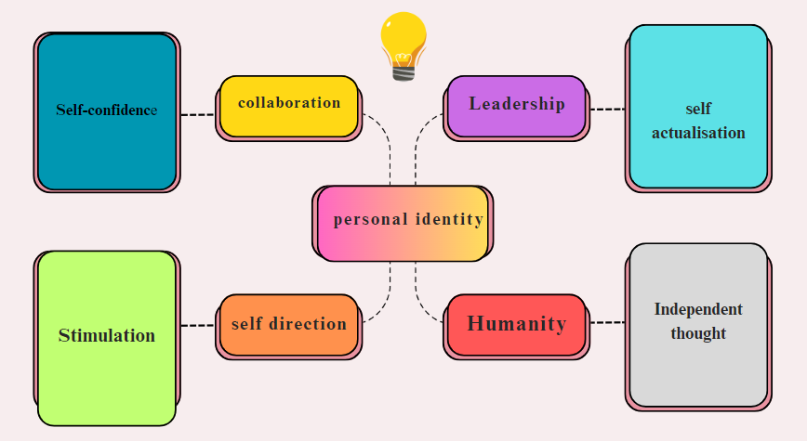
Figure 2: Mind Map
(Source: Created by Author)
A mind map is highly helpful to present the relationship between the elements of the topic. This mind map is based on personality identity, which helps to become a good team player for future workplaces. The aspects shown in the mind map have helped to highlight the key factors of personal identity for the future and career. Building a strong identity is highly essential to reduce workplace conflict and also to maintaining team bonding and strength. A personal identity can be built by boosting confidence level for each work. Additionally, it is also required to acquire proper skills and knowledge to guide other team members (Campo et al., 2019). The skills like “collaboration, leadership, self-direction” and stimulation” are highly required to grow in an individual to protect the team members and also to increase their working performance.
Becoming a team player is important and required to gain experience in the career and also it helps to gain new skills and knowledge for future work. The contribution to the career can be increased by increasing self-efficacy and also by stimulating own skills and knowledge. The core values and beliefs like increasing respect for others and making a strong sense of identity is to help to increase security. Additionally, the team player or the leader must be focused on their goal (Sarkar and Page, 2022). Having a strong identity has a huge advantage, as t helps to increase success in the works. Confidence also helps in increasing decision-making capacity among the team player.

Summary
Academic integrity is a commitment, which consists of six core values, “trust, honesty, responsibility, respect and courage”. In higher studies and also to increase digital learning, academic integrity must be maintained for getting authentic ideas and also to present a fresh thinking approach (Holden et al., 2020). Cultivating originality in schools and colleges helps in increasing consistency in the studies. Additionally, it also helps to express own new thoughts of the students (Zaman et al., 2020). Educators must have the proper knowledge to identify cheating or plagiarism in the produced content by the students.
Plagiarism needs to avoid in the writing for demonstrating and producing original content. The original connection can be present by citing the sources wherever required and also by giving credit to the authors (Gottardello and Karabag, 2022). Moreover, the students also can use their own words by paraphrasing the content available in the books and journals. The key process for writing authentic content is to compare the notes with others and cite the resources as per the requirement. All learning institutions have the access to detect plagiarism for maintaining authenticity and originality (Awasthi, 2019). The original and writing with the owner is a good and effective practice to improve own vocabulary skills. All the writers must need to use the citation for increasing transparency and also to present their thoughts in new and innovative ways.
The students need to increase their knowledge of plagiarism, as sometimes unintentional plagiarism is noticed in their write up. Plagiarism also can raise the issue of academic misconduct, which creates a nagative impact on their future and career (Tripathi and Patel, 2021). Young learners need to increase their knowledge and skills about academic integrity to getting more success and achievement in their higher studies and also it will help to increase their independent thoughts. Plagiarism can be noticed in the write-up of “inexperienced writers” unintentionally, as they do not have adequate knowledge and information.

Conclusion
Digital learning is highly helpful for increasing values and engaging and interacting with digital tools and technologies like "mobile technologies, social networking tools and gaming or virtual reality technologies". The portfolio report will help get ideas about academic integrity and plagiarism. Hence, it can be concluded that this report will help to get ideas about improving digital learning abilities for higher study students.

References
“bda.uk.com (2022), “Borton’s reflective model”. Available at: https://www.bda.uk.com/uploads/assets/071c9b28-7e02-4559-b14130f4745006df/cpdreflecttool.pdf [Accessed on 12th April, 2023]”
“Ali, W., (2020). Online and remote learning in higher education institutes: A necessity in light of COVID-19 pandemic. Higher education studies, 10(3), pp.16-25.”
“Awasthi, S., (2019). Plagiarism and academic misconduct: A systematic review. DESIDOC Journal of Library & Information Technology, 39(2).”
“Campo, M., Champely, S., Louvet, B., Rosnet, E., Ferrand, C., Pauketat, J.V. and Mackie, D.M., (2019). Group-based emotions: Evidence for emotion-performance relationships in team sports. Research quarterly for exercise and sport, 90(1), pp.54-63.”
“Eaton, S.E. and Christensen Hughes, J., (2022). Academic integrity in Canada: An enduring and essential challenge (p. 599). Springer Nature.”
“Ferri, F., Grifoni, P. and Guzzo, T., (2020). Online learning and emergency remote teaching: Opportunities and challenges in emergency situations. Societies, 10(4), p.86.”
“Gottardello, D. and Karabag, S.F., (2022). Ideal and actual roles of university professors in academic integrity management: a comparative study. Studies in Higher Education, 47(3), pp.526-544.”
“Hamburg, I., (2020). Creating innovative structures in workplace and vocational digital learning to ensure social distancing. In The Fourteenth International Conference on Digital Society. 2020a (pp. 124-127).”
“Holden, O., Kuhlmeier, V.A. and Norris, M., (2020). Academic integrity in online testing: a research review.”
“Ovcharuk, O., Ivaniuk, I., Soroko, N., Gritsenchuk, O. and Kravchyna, O., (2020). The use of digital learning tools in the teachers’ professional activities to ensure sustainable development and democratization of education in European countries.”
“Özgenel, M. and Yazici, S., (2021). Learning Agility of School Administrators: An Empirical Investigation. International Journal of Progressive Education, 17(1), pp.247-261.”
“Puspitarini, Y.D. and Hanif, M., (2019). Using Learning Media to Increase Learning Motivation in Elementary School. Anatolian Journal of Education, 4(2), pp.53-60.”
“Sarkar, M. and Page, A.E., (2022). Developing individual and team resilience in elite sport: research to practice. Journal of Sport Psychology in action, 13(1), pp.40-53.”
“Tripathi, S. and Patel, D., (2021). Academic integrity: looking beyond plagiarism.”
“Zaman, N.A.B., Yatin, S.F.M., Saad, N.S., Rashid, S.N., Kamis, Y., Abd Kadir, I.K., Ab Kadir, W. and Dollah, W., (2020). Plagiarism and Academic Integrity. International Journal of Academic Research in Business and Social Sciences, 10(11).”

