
Communication skills in the workplace
1710331 Shahida Miah

July 13, 2018
University of Wales Trinity Saint David

Executive Summary

This report will look at the communication issues within the Social Workers Organisation that leads to various problems such as staff absences, high employee turnover, constant forming of groups, no staff meeting or support mechanism and employees feeling aggravated for not receiving any recognition. The use of only one-way communication is causing a breakdown on not only the staff but also on the quality of the work produced.

The report concluded that the organisation need to introduce more two-way communication models to encourage employees to build trust and respect as well increase productivity. Looking at different models, some are more effective than others but most importantly feedback can support the organisation in reaching goals. Two-way communication is also vital in implementing for staff meetings to encourage employees voice to be heard and acknowledged as well as recognising the abilities and rewarding the individuals

Table of Contents
Executive Summary 1
Terms of Reference 3
Procedure 4
Introduction 5
Findings 6
Barrier of Communication......................................................................................................................6
Highturnover and Absences. Poor Management as Poor Performance is Not Dealt With. Inconsistent of standard...........................................................................................................................................7,8
Lack of Trust, No Two-Way Communication.....................................................................................9,10
Less Face to Face Communication. No Mechanism to Communicate Ideas.........................................11
New Employees Not Having a Proper Induction. Achievement Not Recognised............................11,12
Conclusion............................................................................................................................................13
Recommendations...............................................................................................................................14
Bibliography.....................................................................................................................................15,16
Appendices...........................................................................................................................................17
Acknowledgements..............................................................................................................................18

Terms of Reference

The researcher was requested by Melanie Squire to compile a report on Communication Skills in the organisation. This report is to identify how ineffective the communication is and how this can be improved using different theories and models. The completed copy must be submitted by the 13th July 2018.

Procedure

The researcher has mainly used online websites do complete this report.

Introduction
The report will look into the problems there is in the Social Workers organisation, it was identified many aspects of trouble existing due to lack of communication process leading to factors such as, absences, high turnover, frustration, and barrier to communication. According to Page, (2018) employers who achieve good communication helps build trust, increase productivity and morale.
The researcher will look at different communication models and theories that can help develop the problem of communication and support the organisation in reaching goals. Using different communication models help understand the process metaphorically and symbolically. Models break the communication down to simple terms and in order. Different organisations use models to evaluate situations and develop a good relationship with staff along with increasing productivity (Businesstopia 2018).

Findings
The researcher has read through the case study and realised many communication issues that the organisation have. The first problem identified was:

Barrier To Communication:
The social workers are made up of four teams across the country including other additional teams which are situated in all areas some of which are, fostering and adoption team. Each team have a deputy manager. Two teams out of four are based in the main building, as all teams were separate at first. The other two teams remained separate and are happy to do so because this means less travelling to clients. The teams feel many new procedures get introduced without any interaction just because they are based away from the main building and the other members causing the social workers to complain regularly. The impact this is having on an organisation is reducing motivation as it is making the social workers feel left out and less worthy of being informed of changes in regulations and procedures increasing frustration.
This issue could be improved if the Argyle Communication Cycle developed by Michael Argyle was implemented effectively. Kirbyxo, (2013) stated that the Argyle theory of communication has six stages. The first stage is when an idea occurs, the second stage is when a message is coded, this is when a message is put in a form of telephone, email, letter, voice mail or face-to-face. The third stage is when the communication has been sent using the chosen channel. The fourth stage is when the message is received. The fifth stage is when the message is decoded, sometimes when messages are not clear assumptions could be made causing communication breakdown. The final stage is when the receiver understands the message and gives feedback. This method can support this particular organisation to have effective communication, this also is a two-way communication, this model supports team to interact verbally and non-verbal and give feedback. Model available below.

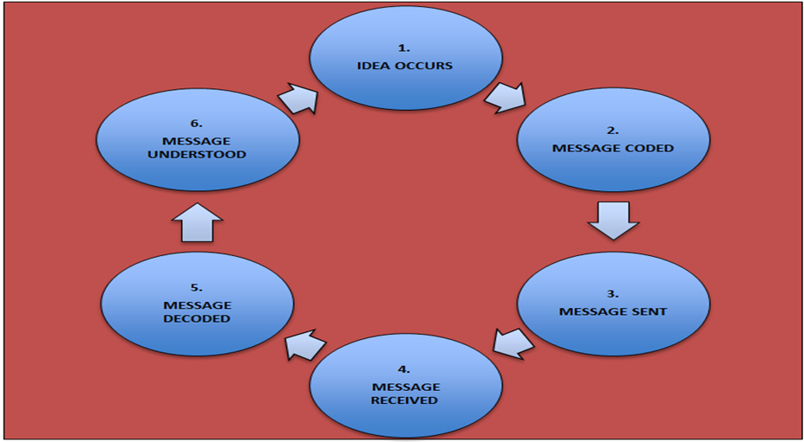

High Turnover and Absences. Poor Management as Poor Performance is Not Dealt With and Inconsistent of Standard :
The organisation suffers badly with high turnover and absences causing downfall on the quality of the work. Andrea Jones was the Head of Social Services that had resigned due to having to constantly find cover for staff and poor performance. Often social workers would return from spending extensive time with families to find new faces in the office. Team members leaving meant the constant forming process, as explained by Mind tool, (2018), Bruce Tuckman a psychologist developed Five stages for teams to follow to achieve high performance. These are Forming is when a team form, teams may suffer conflicts which is the Storming stage. If conflicts are dealt with then starts the Norming stage, then to start reaching goals is when the team are Performing. Adjourn is when the projects end. Below is a model of the Tuckman stages.

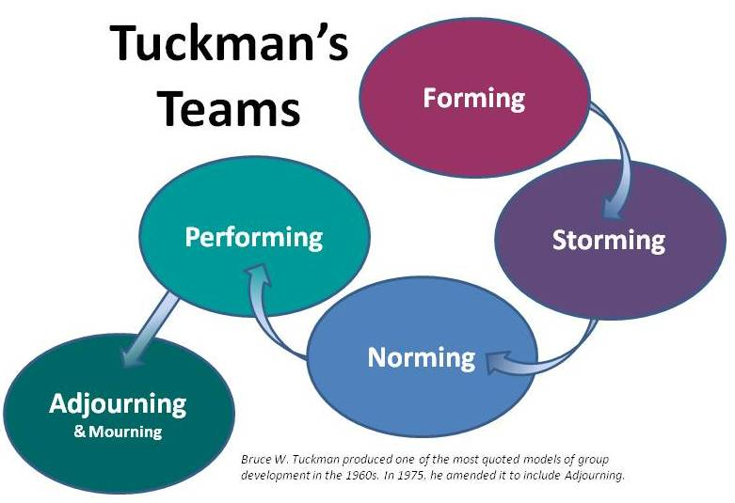
I
The social workers were constantly forming, this meant there were lot of conflicts which is the storming stage, this was due to personality clash, barrier of communication, wanting to take leadership and poor management. This meant no performance were being made, leading staff to be stressed, angered and performing below the standard. Belbin, (2018) identified that there is nine behaviours that come in the form of Resource Investigator, Team-worker, co-ordinator, Plant, Monitor Evaluator, Specialist, Shaper, Implementer and Completer Finisher. In a team an individual can have one or more sometimes all behaviours which can lead to clash. Within this organisation many of the members suffered from not co-ordinating with each team roles. Belbins theory below.

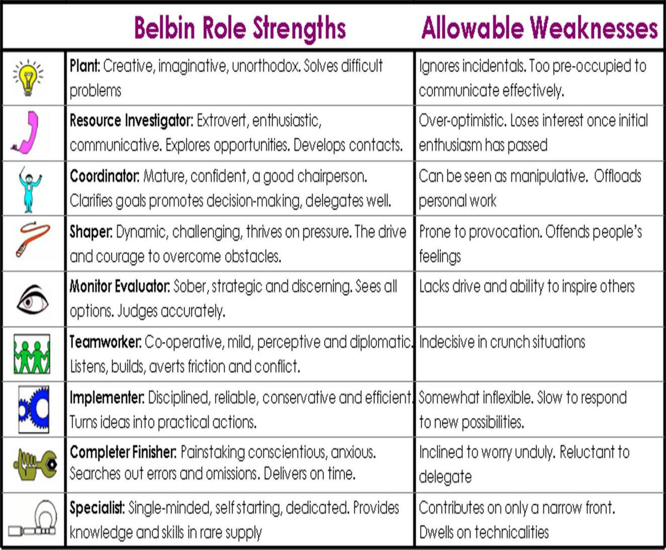

Team managers were not communicating with staff regarding absences. Fairbrother, (2018) stated, in 2016, organisations had lost 137.3 million day’s of working due to sicknesses within the UK, this included minor illnesses as the most common reason. There is a chart available in the appendices to breakdown the sickness absences for the year 2016. According to Halsall, (2014) a study published by the CIPD for the year 2014 revealed £29 billion UK organisation suffered sickness and absences. It was also stated how team managers need to conduct absence reporting procedure and do a Return To Work Interview to manage and support the staff if necessary. In the organisation of social workers, some teams had no team managers which meant vital decisions were overturned demolishing the standard and process of the organisation.

Lack of Trust No Two Way Communication:
The social worker’s would keep busy avoiding any kind of verbal communication, just wanting to complete the day’s work and return home. Never approached one another for help or guidance due to trust issues. The CIPD, (2017) stated that communication between employees is vital so the organisation can develop. In a research it was revealed that employees suffer from low management, CIPD also stated, communication is a critical aspect as employees do perform effectively when information is shared, aware of decisions made within the organisation, this helps manager’s and staff to have a trusted relationship. The impact of the trust issue was that the social worker’s reports were being written poorly and cases were prolonging unnecessarily. Managers were not noticing these failures of performances as there was no two-way communication. Managers often gave instruction informally or verbally, this at times was misinterpreted, managers may communicate with staff but have interference of noise leading to miscommunication.
The organisation must of used the older version of the Shannon and Weaver Model which is a one-way communication, later a feedback process was added which will can support the team members to communicate and build on trust. Businesstopia, (2018) explained, this model was developed in 1949 by Claude Shannon and Warren Weaver. Model consists of five elements which is used for effective communication. The Sender sends the message, Encoder converts the message into signals. Channel is used to send the message. Decoder transfers the message from signals. Receiver is when the message is received. During transmitting the message a noise can cause disturbance such as crowd noise. As much as this model being effective this also outlines how noise can interfere with the communication process.


One-way and two-way communication both transfers information to the destinations. The only difference is with the one-way communication the sender sends a message without receiving any feedback, the two-way communication receives a feedback, this is vital for organisations as it offers advantages of improvement of the quality of work as well as build trust between staff. Below is a model of two-way communication which is needed to be implemented by this particular organisation to improve two-way communication (Business Communication, 2015).
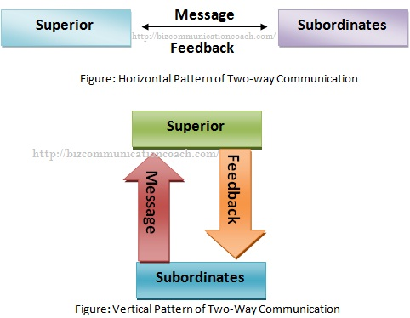

The organisation’s main issue is one-way communication. According to Businesstopia, (2018) stated, David Berlo in 1960 developed four components that are affected by many factors. If the Sender’s communication skills are good, attitude, knowledge, culture and social system. The Message being in the form of content, element, treatment, structure or code. The Channel may be hearing, seeing, touching, smelling or tasting. If the Receiver has communication skills, attitude, knowledge, culture and social system. This model is mainly focused on the encode and decoding and has no feedback concept which is why this is a one-way communication process. This model is for individuals who are in the common ground which is why an issue at the social worker’s organisation acquired as the staff had cultural, knowledgeable, attitude or social difference as for why this kind of one-way process was not convenient. Below is the model available.



Less Face to Face Communication and No Mechanism to Communicate Ideas:
The previous Head of Service only Communicated one-way through emails. There was the odd face to face meeting’s which was also one-way. The managers had no communication mechanism to put across ideas that could be beneficial for the organisation. There was no team meeting to discuss problems. Kimberley, (2016) explained having regular staff meetings gives an opportunity to reflect and improve on services, take information on management, offer ideas and concern, solve problems, employees are heard and encourage positive relationship between staff. This only not just offers support mechanism for communication but also is the most effective form of communication which is face to face.
A way to improve communication during meetings is by using an oral communication theory, exploring a model developed before 300BC by Aristotle a Greek philosopher. The model has five elements these are, Speaker, Speech, Occasion, Audience and Effect. The speaker has the main role in communicating and must prepare beforehand by analysing the audience to be able to influence the audience and receive a response accordingly. This is a one-way communication method but is effective for public speaking. Below is the Aristotle model.

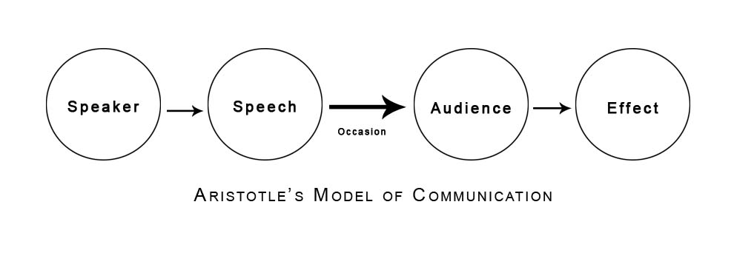
New Employees Not Having A Proper Induction and Achievement Not Recognised:
In any organisation it is vital to provide training to the new employees, in this case, staff were not given that advantage, instead soon after starting big case loads were handed due to the amount of work that piled up. According to 20/20 Project Management, (2018) induction and training is vital to improving employee performance, satisfaction and morale, also addresses any weaknesses and ensures consistency. Increases productivity and quality standards enhances organisations reputation and reduces employee turnover. CIPD, (2018) stated, the basic structure of an induction process includes, tour around department, explanation of required job and probation periods, history explained of any strategic and objectives of the organisation, information on training or learning facilities available, details of benefits and membership and, a one to one meeting with key members.
One of the biggest problem in any organisation is when staff achievement is not noticed. There is no mechanism of communication in the social workers work unit, leading to many employees feeling angry due to the lack of recognition of the hard work made. In an article by Santosh, (2012) stated, it was proven in a research that not praising and giving recognition to staff is the main reason for employees leaving. According to Adams, (2011) rewarding staff could simply be done by treating everyone individually, praise good work, encourage workers, offer staff benefit, give ownership, be flexible and communicate. With these in place, the organisation can tackle staff turnover.
Johari window Model is a tool that can be implemented during induction for training, and understanding. This was developed by Joseph Luft and Harry Ingham in 1955. This increases self-awareness, personal development, improved communication, interpersonal relationship, group dynamics and team development. The model has four areas: Open Area, is anything the individual is aware of and is prepared to share, this helps build a trusted relationship. Blind Area, is an aspect that the individual is not aware of and requires feedback of good and bad which may benefit group dynamics in a team. Hidden Area, is the aspect that the individual of only and nobody else. Unknown Area is the aspect the individual is not aware of as well as others. This tool enhances a person perception and improves performance by taking feedback. It increases the open area, reducing the blind area. This tool helps unleash unseen abilities (Self Awareness 2013). This is the kind of tool that this organisation requires to improve communication which the team is lacking in. The model is available below.

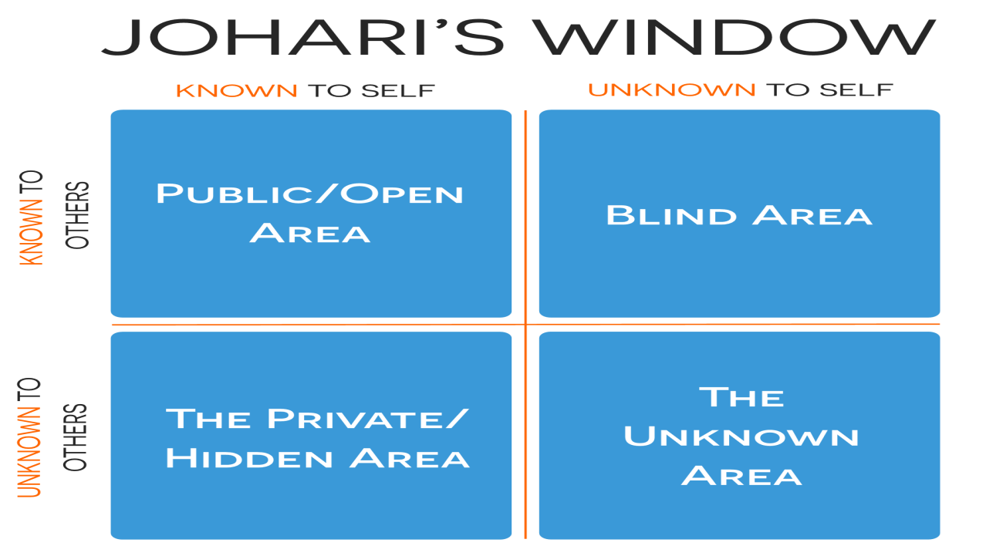

Conclusion
In conclusion of this report, the researcher recognised the major error within this organisation was the communication process. Social Workers had issues of not informed of regulation changes and manager not holding regular staff meetings, these were part of the problem leading to absences and staff turnover. Fairbrother, (2018) stated the rise of 137.3 million in 2016 alone of employees being off work due to sickness. Managers communicated very irregularly causing frustration as staff had no recognition. Santosh, (2012) stated that research has found not praising the employees for hard work is one of the reasons employees leave.
The researcher was also able to conclude the importance of communication models. Businesstopia, (2018) stated that many organisations use the method of communication models to keep staff relationship well and increase productivity. After evaluating different models within this report it was recognised that there are one-way and two-way models that have positive and negative areas. Businesstopia, (2018) explained that models such as Berlos is more one-way communication and is for people with common ground. Kirbyxo, (2013) explained the six stages of the Argyle communication cycle being the most effective method as this offers the process of feedback.

Recommendations

- Placing a regular team meeting and ensuring it is a two-way communication. Chait, (2016) explained, an effective staff meeting is getting all employees involved and engaged, not bringing any data into meetings as this is a period for discussion. Adding some fun into meetings by doing something exciting and less serious in a workplace. One thing that all employers in one organisation should have in common and that is the goal, it really help when employers go through strategies of reaching goals with staff giving them a sense of feeling part of the organisation and plans.

- Give employees recognition and reward more. Heathfield, (2017) explained how this can be done which is, by not excluding any staff and making all employees eligible for recognition and reward. The employer and employee should be clear about what actions lead to recognition by communicating thoroughly. Once the employee performs on the standard of recognition, the employee should be rewarded. The recognition should match up to the performance made. (give examples).

- Using more than one communication method helps build understanding and reach goals in workplace. Workplace-Communication.Com, (2017) stated, the four types of communication essential are, Visual, Written, Verbal and Non-Verbal. Using these four techniques help the employers and employees, express ideas and problems, understand one another, reduce employee turnover, increase productivity, increase efficiency and reach goals.

Bibliography
20/20 Project Management. (2018), The Importance of Training and Development in the Workplaces, [Online]. Available at: http://2020projectmanagement.com/resources/project-management-training-and-qualifications/the-importance-of-training-and-development-in-the-workplace. [Accessed 27th June 2018].
Adams, G.K. (2011), 10 Ways to Motivate Staff, [Online]. Available at: https://startups.co.uk/10-ways-to-motivate-staff/. [Accessed 28th June 2018].
Anastatia. (2015), How To Recognise and Reward your Employee, [Online]. Available at: https://www.cleverism.com/how-to-recognize-reward-your-employees/. [Accessed 2nd July 2018].
Belbin. (2018), The Nine Belbin Team Roles, [Online]. Available at: http://www.belbin.com/about/belbin-team-roles/. [Accessed 23rd June 2018].
Business Communication. (2015), What is Two-way Communication in Business, [Online]. Available at: http://bizcommunicationcoach.com/what-is-two-way-communication-in-business/. [Accessed 23rd June 2018].
Businesstopia. (2018), Aristotle鈥檚 Model of Communication, [Online]. Available at: https://www.businesstopia.net/communication/aristotles-model-communication. [Accessed 27th June 2018].
Businesstopia. (2018), Berlo鈥檚 SMCR Model of Communication, [Online]. Available at: https://www.businesstopia.net/communication/berlo-model-communication. [Accessed 23rd June 2018].
Businesstopia. (2018), Models of Communication, [Online]. Available at: https://www.businesstopia.net/communication. [Accessed 27th June 2018].
Businesstopia. (2018), Shannon and Weaver Model of Communication, [Online]. Available at: https://www.businesstopia.net/communication/shannon-and-weaver-model-communication. [Accessed 22nd June 2018].
Chait, D. (2016), 5 Tips for Effective Team meetings, [Online]. Available at: https://www.entrepreneur.com/article/272078. [Accessed 3rd July 2018].
CIPD. (2017), Employee Communication, [Online]. Available at: https://www.cipd.co.uk/knowledge/fundamentals/relations/communication/factsheet#16373. [Accessed 22nd June 2018].

CIPD. (2018), Induction, [Online]. Available at: https://www.cipd.co.uk/knowledge/fundamentals/people/recruitment/induction-factsheet. [Accessed 4th July 2018].
Fairbrother, D. (2018), How to Keep Sickness Absence Under Control, [Online]. Available at: https://www.thenurseryhrpeople.co.uk/human-resources/keep-sickness-absence-control/. [Accessed 23rd June 2018].
Halsall, K. (2014), How to Manage Recurring Sickness Absences, [Online]. Available at: http://www.hrmagazine.co.uk/article-details/how-to-manage-recurring-sickness-absence. [Accessed 22nd June 2018].
Heathfield, S.M, (2017),聽 5 Tips for Effective Employee Recognition, [Online]. Available at: https://www.thebalancecareers.com/effective-employee-recognition-1919055. [Accessed 3rd July 2018].
Kimberley. (2016), What are the Benefits of Regular Staff Meetings? [Online]. Available at: www.earlyyearscareers.com/eyc/early-years-management/benefits-regular-staff-meetings/. [Accessed 23rd June 2018].
Kirbyxo. (2013), Argyle Theory, [online]. Available at: https://kirbyxo.wordpress.com/2013/11/13/argyle-theory/. [Accessed 21st June 2018].
Mind Tool. (2018), Forming, Storming, Norming and Performing. Understand the Stages of Team Formation, [online]. Available at: https://www.mindtools.com/pages/article/newLDR_86.htm. [Accessed 22nd June 2018].
Page, M. (2018), The Importance of Good Communication, [Online]. Available at: https://www.michaelpage.co.uk/advice/management-advice/development-and-retention/importance-good-communication. [Accessed 28th June 2018].
Santosh, A. (2012), Recognise Employees Achievements to Improve Engagement, [Online]. Available at: https://www.thehindu.com/todays-paper/tp-features/tp-opportunities/recognise-employees-achievements-to-improve-engagement/article3913050.ece. [Accessed 27th June 2018].
Self Awareness. (2013), Understanding the Johari Window, [Online]. Available at: http://www.selfawareness.org.uk/news/understanding-the-johari-window-model. [Accessed 28th June 2018].
Workplace-Communication.Com. (2017), Four Types of Communication in the Workplace to Increase Efficiency and Productivity, [Online]. Available at: http://www.workplace-communication.com/four-types-communication.html. [Accessed 3rd July 2018].

Appendices

Chart for Sickness and Absences for 2016:

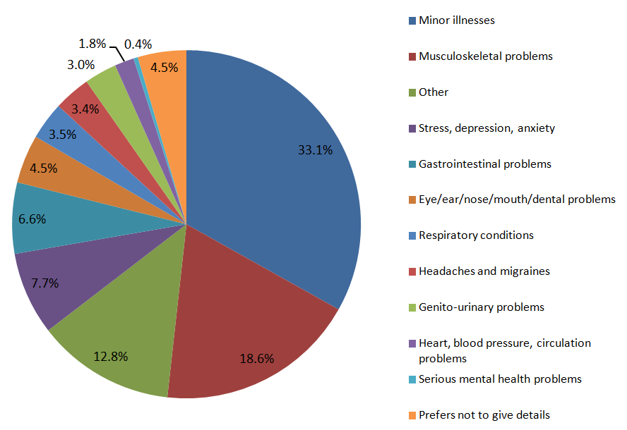

Acknowledgements
The researcher would like to acknowledge Meena the tutor support and Melanie Squire the lecturer

