Design and Manufacturing Process of a 5 inch Anti -Aircraft Shell Fuze
  - Systems Engineering L5
Silas Blevins | OME Degree Apprenticeship | May 2024

Abstract
To respond to a developing threat environment, it is necessary to develop an anti-aircraft shell for the 5-inch mk45 naval gun entering service with the Royal Navy. This report discusses the application of the systems engineering process to that development, with a focus on the fuzing system, and the manufacture of that system. Process techniques, noises, and controls are all identified and the importance of operator training and component inspection is highlighted.

Table of Contents
Abstract 1
Table of Figures 3
List of Tables 3
1 Introduction 4
1.1 Background 4
1.2 Stakeholders Requirements 4
1.3 Functional Analysis 5
2 Manufacturing 6
2.1 Manufacturing Overview 6
2.2 Manufacturing Requirements and Process Flow 7
2.3 Process Means 10
2.4 Design Features 13
2.5 Key Processes and Noises 15
2.6 Process Controls 17
3 Conclusions 19
References 20

Table of Figures
Figure 1: Common Explosive Manufacture Requirements [4] 8
Figure 2: A Process Flow diagram for the manufacture of a radar fuze using a PETN-Based Slapper Detonator 9
Figure 3: QFD 1 Manufacturing, higher numbers indicate stronger relation/importance 10
Figure 4: The Process Importance Chart, Derived from Manufacture QFD1. 11
Figure 5: Means Importance Graph Derived from Manufacture QFD 2 14
Figure 6: Process Techniques Importance, Derived from QFD3 15
Figure 7: A P-Diagram showing the noise and control factors affecting detonator manufacture 16
Figure 8: The Key Controls Graph from the First What/Why 17
Figure 9: Graph of Key Noise Factors from the What/Why Table 18
Figure 10: The Importance Chart from QFD4 19

List of Tables
Table 1: The Customer Requirements for the shell 6
Table 2: FMEA For the whole munition, Green represents a selected means, Yellow indicates multiple selected means 7
Table 3: Process FMA 12
Table 4: Manufacture QFD2 13
Table 5: Manufacture QFD 3 15
Table 6: First What/Why Table 17
Table 7: QFD4 18

1 Introduction

Background
The royal navy is currently in the process of procuring the Type 26 ‘City Class’ Frigate [1]. Unlike other large surface combatants in the Royal Navy, which are armed with the 4.5” Mk8 gun, the type 26 will be armed with the US-Designed 5” Mk45 Naval Gun [2]. Whilst the type 26 is primarily designed for anti-submarine warfare [1] [2], it is shown that the current operational environment may demand anti-submarine warships, such as the Type 23 Frigate HMS Richmond, to support anti-aircraft, anti-missile, and anti-UAS operations [3]. Whilst both the Type 23 and Type 26 Frigates are armed with SEA CEPTOR anti-aircraft missiles, the threat of low-cost One-Way-Attack (OWA) munitions, also known as ‘Suicide Drones’ highlights the need for a lower-cost solution to anti-aircraft warfare for the Type 26. It is therefore proposed to design a proximity-fuzed 5” shell to be compatible with the mk45 gun.

Stakeholders Requirements
The various stakeholder lay out a range of requirements for the overall system, laid out in the table below.

Level 1 | Originator | Level 2 | Level 3
Performance | Crew
 |  | The Ship's Company requires that the munition  be capable of destroying an Airborne Target | NFS
 |  | The Ship's Company Requires that the munition shall  have consistent performance | NFS
 |  | The ship's company Requires that the munition shall be accurate | NFS
 |  | The Ship's Company requires that the munition shall  have a range of at least 5KM | NFS
 |  | The Ship's Company requires that the munition shall  be able to integrate with other onboard AA systems | NFS
User Friendly
 |  | The Ship's Company requires that the Munition  should be easy to handle (Carriage to and from turret) | NFS
 |  | The Ship's Company requires that the Munition  should have easy training characteristics  (Easy to use and understand electronic components) | NFS
 | Crew + Logs | The Ship's Company requires that the  Munition should be lightweight | NFS
Safety | All
 |  | All stakeholders require the munition to be IM Compliant | NFS
 |  | All stakeholders require the munition to be resistant  to environmental conditions, Including exposure to  maratime conditions | NFS
 |  | All stakeholders require the munition to only function  when operationally required | NFS
Availability
 | MOD | The MOD Requires that the munition shall  be available in suitable quantities for any future operations | NFS
Cost
 |  | The MOD Requires that the munition shall  be cost effective to procure and operate | NFS
 |  | The MOD requires that the munition shall have a short  development time | NFS
 |  | The MOD requires the munition to have a high reliability | NFS
 |  | The MOD requires the munition to be fast to produce | NFS
 |  | The MOD requires the munition to have a long service life | NFS
 |  | The MOD requires the munition to be compatible with the  weapon system mounted to surface ships (5" Gun for T26) | NFS
Transport | Logs
 |  | Logistics require the munition to be transportable in bulk | NFS
 |  | Logistics require the munition to not degrade under thermal  cycling in transport | NFS
 |  | Logistics require the munition to not degrade or initiate from  vibrations in transport | NFS
 |  | Logistics require the munition to be transportable by sea | NFS
Table 1: The Customer Requirements for the shell

1.3 Functional Analysis
A functional analysis was performed to identify the critical components of the munition and the means of achieving the function. The FEMA is shown below.
Function | Means
Deliver lethal effect on target | Pre-Formed Fragmentation in Case | Blast | Shrapnel/Balls | Expanding Rod
Load Weapon | AutoLoader | Manual Loading
Aim Weapon | Direct Control | Remote Control | Radar Slaving
Provide Motive Force | Energetic Propellant | Railgun | Onboard Propellant
Seal system for pressure | Obturation | Onboard Propellant
Align fuzing system | Rifling/Spin | Setback | Electronic
Detect Target | Magnetic Fuze | Radar Fuze | Networking with Ship's Radar
Contain and Support Explosive | Plastic | Metal
Initiate Explosive | Fuze+Booster | Slapper Detonator directly on main fill
Initiate Motive Force Provider | Electrical Intiation | Mechanical/Stab primer
Table 2: FMEA For the whole munition, Green represents a selected means, Yellow indicates multiple selected means

Of the critical components, it was decided to focus this report on the fuzing and initation sub-systems as these are vital for the munition to deliver the desired effect.

2 Manufacturing

2.1 Manufacturing Overview
The systems engineering process was applied to determine the most appropriate manufacturing processes and pathways for the fuzing and initiation subsystem. This entailed first identifying the manufacturing requirements and the corresponding functionality.

2.2 Manufacturing Requirements and Process Flow
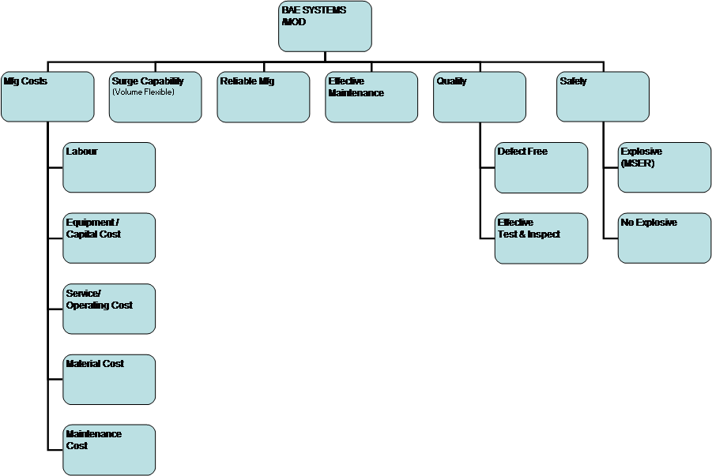
Manufacturing Requirements are common across a range of munitions and so the requirements for this subsystem are based on a well-understood set of requirements.
Figure 1: Common Explosive Manufacture Requirements [4]
To apply these requirements, it is also necessary to consider the processes by which the components will be manufactured. Some flow diagrams for these processes are shown below.

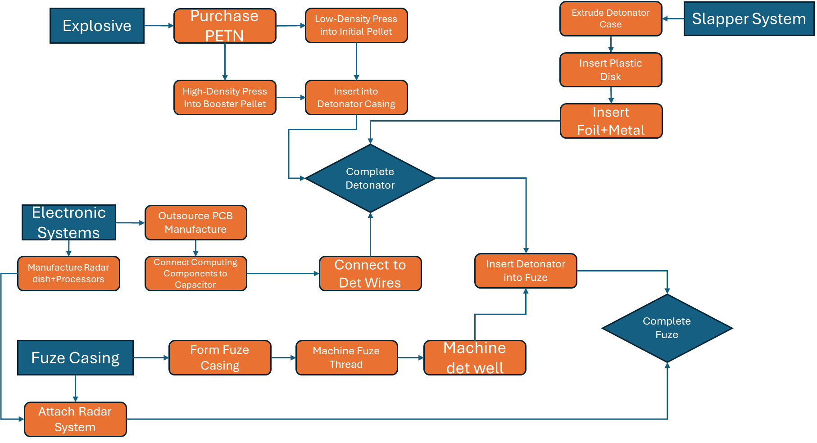
Figure 2: A Process Flow diagram for the manufacture of a radar fuze using a PETN-Based Slapper Detonator

A quality function deployment (QFD) was carried out on the proposed manufacturing flow to allow the most important processes to be determined. The QFD and it’s results graph are shown below.
Manufacturing Functionality | Importance | Low Density PETN Press | High Density PETN Press | Extrude Detonator Case | Insert plastic Dsik | Insert Film and Metal | Attach Radar System | Attach Computing Components to detonation system_Capacitor | Form aerodynamic Fuze Casing | Machine Fuze Thread | Machine well for detonator to sit in | Insert Detonator into Fuze
Manufacturing Requirements
Manufacturing Costs
Labour | 9 | 1 | 1 | 9 | 3 | 3 | 3 | 3 | 9 | 3 | 3 | 9
Equipment capital cost | 9 | 3 | 3 | 1 |  | 3 | 9 | 9 | 3 | 3 | 3 | 1
Service / Operating Cost | 5 | 3 | 3 | 1 |  | 1 | 3 | 3 | 1 | 3 | 1 | 1
Set up cost | 5 | 1 | 1 | 1 |  |  | 9 | 9 | 3 | 3
Material Cost - Metal Bits | 5 |  |  | 3 |  | 9 | 9 | 9 | 3 | 3 | 1
Material Cost - Energetic Bits | 9 | 9 | 9
Material Cost - other | 5 |  |  |  | 3 | 3 | 3 | 1
Maintenance Cost | 9 | 3 | 3 | 1 |  |  | 9 | 9 | 3 | 3 | 3
Manufacturing Capacity
Target production rate XX per month | 9 | 9 | 9 | 3 |  | 3 | 9 | 9 | 3 | 3
Reliable Manufacture
Repeatable performance | 9 | 9 | 9 | 3 | 1 | 3 | 9 | 9 | 3 | 3 | 1 | 1
Effective Maintenance | 5 | 3 | 3 | 1 |  | 1 | 3 | 3 | 1 | 3
Low system outage | 9 | 3 | 3 | 1 | 1 | 1 | 3 | 1 | 1 | 3 | 1 | 1
Quality
Defect Free | 9 | 9 | 9 | 3 | 1 | 3 | 9 | 9 | 3 | 9 | 3 | 1
Effective test and inspection | 9 | 3 | 3 | 3 | 1 | 1 | 9 | 3 | 3 | 3 | 3 | 3
Safety |  |  |  |  |  |  |  |  |  |  |  | 2
Explosive | 9 | 9 | 9 |  |  |  |  |  |  |  |  | 9
Non-Explosive | 5 |  |  | 3 |  |  | 3 | 9 | 3 | 3 | 3 | 3
Figure 3: QFD 1 Manufacturing, higher numbers indicate stronger relation/importance

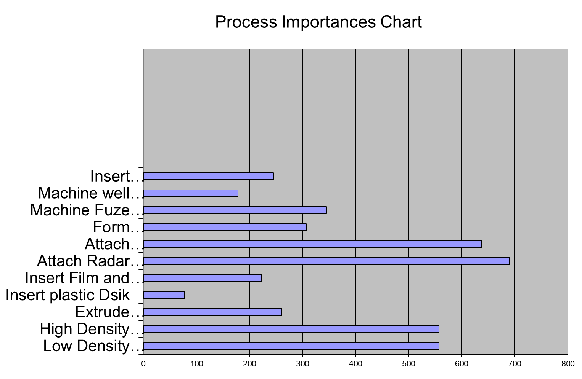
Figure 4: The Process Importance Chart, Derived from Manufacture QFD1.
From this figure, it can be seen that the most important process steps are the attachment of the Radar and electronic components, and the pressing of the PETN.

2.3 Process Means
In order to determine the best methods by which to carry out the processes highlighted in Section 2.2, a process FMA was carried out. This is shown below.

Function | Means
Low Density PETN Press | Manual Operation | Remote Operation with Human-In-The-Loop | Fully Automatic
High Density PETN Press | Manual Operation | Remote Operation with Human-In-The-Loop | Fully Automatic
Extrude Detonator Case | Human Operated-Die in workshop | Robotic
Insert plastic Disk | Human Operated | Robotic Arm
Insert Film and Metal | Human Operated | Robotic Arm
Attach Radar System | Human Mechanic | Robotic Arm
Attach Computing Components to detonation system+Capacitor | Human | Robotics
Form aerodynamic Fuze Casing | Human-Operated Die/Lathe | Robotics
Machine Fuze Thread | Human operation | Robotics
Machine well for detonator to sit in | Human operation of Die | Robotics
Insert Detonator into Fuze | Human operating by hand | Remote Operation with Human-In-The-Loop
Table 3: Process FMA
To determine the importance of the means shown above, a second QFD was carried out, this is shown below.

Design feature |  | Importance | Manual Pressing | Remote Pressingwith human in loop | Human-Operated Die | Robotic Die | Assembly By Hand | Robot Arm
Functionality
Low Density PETN Press | # | 55.7 | 3 | 9
High Density PETN Press | # | 55.7 | 3 | 9
Extrude Detonator Case | # | 26.1 |  |  | 9 | 3
Insert plastic Dsik | # | 7.8 |  |  |  |  | 3 | 9
Insert Film and Metal | # | 22.3 |  |  |  |  | 1 | 9
Attach Radar System | # | 69 |  |  |  |  | 9 | 1
Attach Computing Components to detonation system+Capacitor | # | 63.8 |  |  |  |  | 3 | 1
Form aerodynamic Fuze Casing | # | 30.7 |  |  | 9 | 1
Machine Fuze Thread | # | 34.5 |  |  |  |  | 9
Machine well for detonator to sit in | # | 24.5 |  |  | 9
Insert Detonator into Fuze | # | 0 |  | 9
Table 4: Manufacture QFD2

Figure 5: Means Importance Graph Derived from Manufacture QFD 2
From the table and graph above, it can be understood that the most important means by which the manufacturing functions can be achieved are assembly by hand (for the electronic components) and Remotely-Operated Pressing with a Human-in-the-Loop (for the energetic components.)

2.4 Design Features
In order to progress through the systems engineering process, the design must be considered to identify the important design features. Assuming that the fuze is of aerodynamic, conical design, containing a small radar antenna and accompanying electronics, a slapper detonator configured to be initiated when the radar detects proximity to the target, and an electronic safety and arming unit (SAU), activated by the acceleration and rotation induced by firing, the important features can be defined as:
- Capacitor for supplying current to Slapper.
- Radar Antenna.
- Slapper foil and Gap.
- PETN Pellets in Slapper.
- Electronic SAU.
- Aerodynamic Shape.

To further understand the role of these features and their relation to the manufacturing cycle, a third QFD was carried out, shown below.
Process Features | Importance
Process Features | Importance | Manufacture by hand | Robotic Arms | Pneumatic Press | Human-In-The-Loop-Robotics | Dies, Lathes and Mills (Traditional manufacturing)
Important design features
Capacitor for supplying current to Slapper. | 9 | 9
Radar Antenna. | 6 | 3 | 1 |  |  | 3
Slapper foil and Gap. | 6 |  | 9 |  | 9
PETN Pellets in Slapper. | 9 |  |  | 9 | 9
Electronic SAU. | 5 | 3 | 1
Aerodynamic Shape | 5 | 1 |  |  | 1 | 9
Table 5: Manufacture QFD 3
Figure 6: Process Techniques Importance, Derived from QFD3
From the above, it can be seen that the most important manufacturing feature for the fuze is Human-In-The-Loop Robotics, which allow explosives process workers to have direct input into the process without being exposed to the risk of unexpected initiation.

2.5 Key Processes and Noises
From the QFDs above, it can be concluded that the key process flow is the filling of the detonator with PETN and the slapper initiation foil/metal. To identify the noises affecting this process, a P-Diagram is used, as shown below.
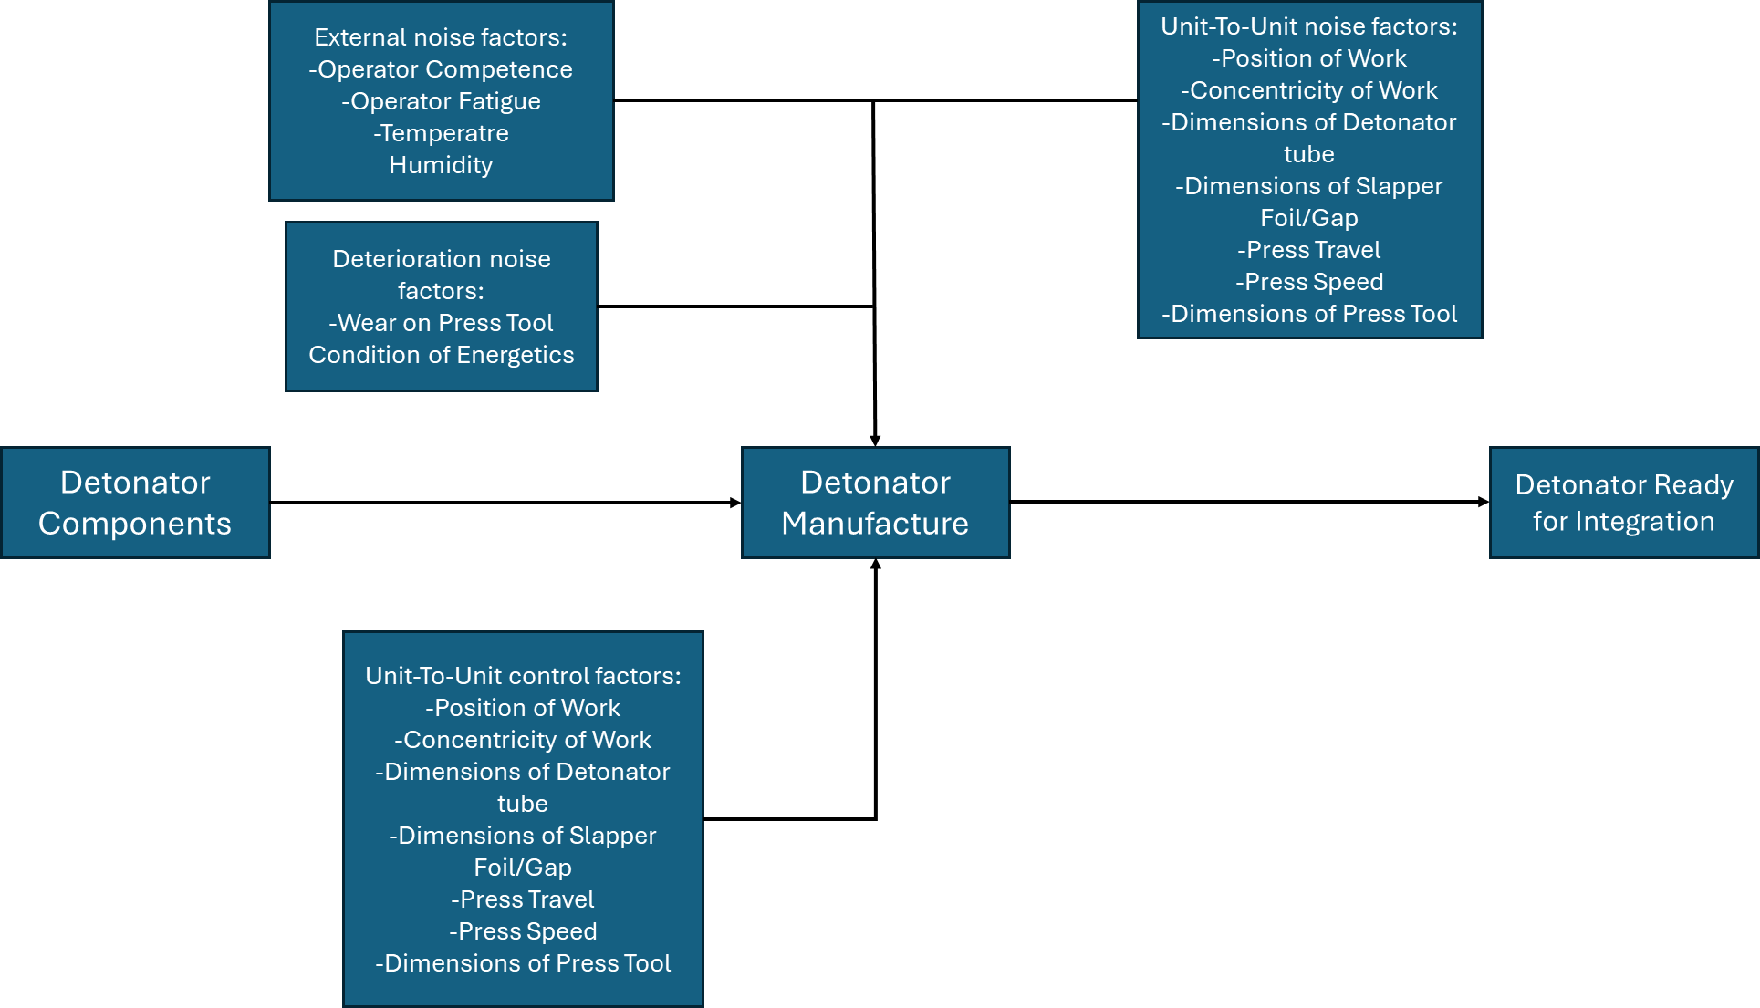
Next, a ‘what-why’ table was produced to represent the relation between the control parameters and the noise factors. This is shown below.
Figure 7: A P-Diagram showing the noise and control factors affecting detonator manufacture

Table 6: First What/Why Table
Figure 8: The Key Controls Graph from the First What/Why
From this, it can be seen that the dimensions of the press are the key control, which is expected as a large portion of the detonator manufacture is robotic, and as such human-factors related controls are of less importance.

Figure 9: Graph of Key Noise Factors from the What/Why Table
The graph above shows the key noise factors identified in the What/Why table showing that the majority of the process noise comes from the press travel, and the dimensions of the detonator components.

2.6 Process Controls
To identify the key controls for the processes, a 4th QFD was carried out. This aimed to identify the most important controls by evaluating their importance against the known noises. Poke-Yoke refers to the use of tooling and techniques that make failure impossible. The QFD and it’s graphs are shown below.
Table 7: QFD4

Figure 10: The Importance Chart from QFD4
The chart above shows that the most important controls are training and work instructions – in the context of detonator manufacture, this means training the staff in the correct operation of the robotic processing tools. The importance of the receipt inspection is also highlighted as it is necessary to inspect the PETN pellets for their condition before inserting them into the detonator.

3 Conclusions
This report has discussed the design process of a fuzing system for an anti-aircraft shell. The critical components of the fuze were identified as the Radar Dish, the Slapper Detonator and the PETN pellets it contains, the capacitor, the SAU, and the Aerodynamic Housing. To manufacture the fuze it was decided to use a mixture of human and robotic techniques, with hand-building for the electronic components and casings, remotely-operated loading of the energetic components of the detonator, and programmed robotic assembly of the non-energetic components of the detonator. Through the use of systems engineering tools, it was identified that the most important manufacturing techniques were manual assembly and Human-In-The-Loop remote operations. Human-In-The-Loop remote operations were found to be most relevant to the manufacture of the key components due to the increased safety offered. In the manufacture of the detonator itself a number of noises were identified which affect the process, including operator training and fatigue, dimensions and performance of the press used to produce the PETN pellets, and environmental factors such as temperature, with the press performance and the dimensions of the slapper detonator components identified as the most important. To minimise the effects of these noises on the manufacture, a series of process controls were derived including operator training, inspection of components, issuing of work instructions, and use of Poke-Yoke tooling and Components, which are designed in such a way that they are theoretically unable to fail. Training, work instructions (for the operators of the robotics/remote control systems), and component inspections (of the energetics and other detonator components) were identified as the most important controls. From this application of the systems engineering process, it can be concluded that robotics and remote operation plays an important role in the manufacture of energetics, especially when working with the more sensitive compositions used in initiation systems, and training of staff to use these systems maximises the safety, efficiency, and productivity of the manufacturing process. In addition, when manual interaction with components is required, it is found that inspection of components for safety and tolerance purposes is also critical.

References

[1] | Royal Navy, “City Class,” Ministry of Defence, 2024. [Online]. Available: https://www.royalnavy.mod.uk/equipment/ships/city-class. [Accessed May 2024].
[2] | NavyLookout, “A Guide to the Type 26 Frigate,” NavyLookout, 28 November 2022. [Online]. Available: https://www.navylookout.com/a-guide-to-the-type-26-frigate/. [Accessed May 2024].
[3] | NavyLookout, “First Kills for Sea Ceptor. HMS Richmond downs 2 Attack Drones,” NavyLookout, 9 March 2024. [Online]. Available: https://www.navylookout.com/first-kills-for-sea-ceptor-hms-richmond-downs-2-attack-drones/. [Accessed May 2024].
[4] | D. Holley, Design Book, Swansea: UWTSD, 2024.

Uncrewed Aerial Systems, including One-Way Attack ‘Suicide’ Drones

