
Skills for the Workplace
Module Assignment Submission
Student Name: | Tracey Hughes
Student Number: | 2008698
Module No: | BMSK5001
Module Title: | Developing Workplace Critical Thinking

Statement of Confirmation of Authenticity
By the act of making this submission, the student declares that this is the work of the student named above. The work has not, in whole or in part, been knowingly presented elsewhere for assessment, or where assessment has been built on a previous assessment, this has been identified. Where materials have been used from other sources it has been properly acknowledged. If this statement is untrue, the student acknowledges that an assessment offence has been committed.
Attention is drawn to the plagiarism and unfair practice policies of both the University and of ILM.
Table of Contents
Introduction 1
1.Critically assess the impact of beliefs, attitudes and values on your own workplace. 1
Heading Style 1 1
1.2 The importance of my values 1
1.3 Importance of attitudes on one’s values and beliefs 1
2.0 Identify a management theory relevant to your role. 1
2.1 The impact of management on my beliefs 1
Appendix 1- 1
Appendix 2 – 1
Appendix 3 – 1
Appendix 4 – 1
Appendix 5 – 1
Appendix 6 – 1
Appendix 7- 1
Appendix 8 – 1

Introduction
This Report will criticize and assess different management theories used within my workplace. it will differentiate between the personal value of beliefs and values and attitudes of organisations and their impact on the workplace.

1.Critically assess the impact of beliefs, attitudes, and values on your own workplace.

  - Importance of my Beliefs

The human being needs a framework of values, a philosophy of life, a religion or religion surrogate to live by and understand by, in about the same sense that he needs sunlight, calcium or love
Source: Abraham Maslow (1943)

I believe respect is a deserved by everyone, especially in a workplace, if not incivility and low morale is caused.
Respect has significant importance in everyday life, as children we are taught to respect others and are led to believe, that at some level all people are worthy of respect., (Rawls, 2000).
Kant, (1779) suggests that how we feel depends on the amount of respect we have for ourselves and others The belief we have in our own self-respect may be something we take for granted, but discover how important it is when its threatened, it’s part of our very core that wisdom and self-respect are deeply connected, and it is highly impossible to respect others if they don’t respect us. (Kant,1779)
Darwall, (1977) most recent challenges to Kant’s ethical theory are that persons should only be respected if they have high standing in society or an organisation. While Kant, (1779) would argue that we have a duty of love to one another, just as we have a duty of respect. (Darwall,1977, Kant,1779)
Darwall, (1977) continues to reiterate that there are two forms of respect that can be given. First being Recognition respect, someone’s feelings, ethnicity, and age. Second being Appraisal respect, where one’s actions and standards are noticed. whilst in every discussion, respect can also be diminished if the person has committed a heinous crime where its morally justifiable to lose it. (Darwall,1977)
Burchell (2011) acknowledged that respect within an organisation is vital as the way leaders treat employees has a direct link on their performance. Respect is a core value within an organisation, in fact most organisations do consider it to be the underlying requirement to create a respectful work environment,” at the end of the day, employees want to know they matter “(Burchell, 2011)

A Harvard business review orchestrated by Christine Porath (2014) conducted a study with over 20,000 participants to gather information how important respect was in a workplace setting. Out of the factors examined, respect was the one behaviour that had the greatest effect on the outcomes measured. Employees agreed that being respected was more important than recognition, appreciation, growth, and development. The study also indicated that respect was the greatest influence in the workplace, the correlation that followed was : the more respect given, the greater the level of employee engagement , whilst this seemed positive , other information that had been gathered showed 54% of employees did not feel respected by their manager on a regular basis and on a deeper level as why some employees can be disrespectful that 60% are overworked and haven’t got the time to be polite whereas 25% claiming they don’t have a respected role model . an interesting and crucial factor to take from this study is “Respect is directly tied to what a particular individual expects – and how the leader makes that person feel. (Porath, 2014).

The epitome of respect can be taken from this quote:
“I speak to everyone in the same way, whether it is the garbage man or the president of the university “
- Albert Einstein. (1879-1955).
Another argument would be that the true grounds of moral worth and respect are wider than rationality, and states that all living things, have equal worth (Taylor, 1986).
Whilst there are many theories about respect for others, including Maslow (1943) whose Hierarchy of needs model (appendix 1) refers to respect on the third rung of his ladder, His theory suggests that people have several basic needs that must be met before people move up the ladder, these are social, emotional, and self-actualising needs. (Maslow,1943)
Olson (2015) suggests that there is a surprising agreement between scholars, that self-respect is something of significant importance in everyday life and is essential in living a satisfying meaning full life. (Olson,2015)

Heading Style 1

The importance of my values

All social values - liberty and opportunity, income and wealth, and the bases for self-respect - are to be distributed equally unless an unequal distribution of any, or all, of these values is to everyone advantage
Rawls, J., (1971) A theory of justice.

Equality in the workplace ensures people are given equal opportunities, equal pay and are accepted for their differences.
Equality doesn’t necessarily translate to equal treatment “companies that embrace diversity and inclusion in all aspects of their business statistically outperform others “, This talent management theory uses staff to fill in suitable vacancies and develop their skills to match the position and so being able to retain staff. (Bersin,2020).
Adams, (1963), developed his job motivation theory, much like previous theories of motivation such as Maslow’s (1947) Hierarchy of needs(appendix 1) and Hertzberg’s (1950) two factor theory,(Appendix 2) Adam’s ((1963) Theory acknowledged that subtle variables could alter an employee’s perception of the workplace and based his belief that this could make the employee become demotivated. Whilst many of his assumptions can’t be quantified, the theory argues that management and leaders should aim for a healthy balance between both. (Adams,1963, Maslow1947, Herzberg 1950).
“The question what do people want from their jobs?” was a question asked by Herzberg (1950) as a means of understanding employee satisfaction. This was to determine the effect of attitudes on motivation, what he concluded was that people were more inclined to be more productive in a job they enjoyed. His findings were that certain characteristics of a job would determine job satisfaction compared with dissatisfaction. These characteristics are called hygiene which are essential for positive satisfaction or dissatisfaction, as shown (appendix 1). (Herzberg,1950)
Herzberg’s (1959) theory caused criticism as it assumed a strong link between job satisfaction and productivity, although didn’t take into consideration the relationships between employees and employers. (Herzberg, 1959)
Abulof, (2017) stated Maslow’s Hierarchy of Needs in its Pyramid formation is a valuable assessment tool and extended his theory to include observations of human behaviour. which reflected the needs of society and took it even further to assess and observe emotional thoughts and actions. Maslow’s (1947) pyramid formation is often used because it helps visualise the needs one must have to reach self-actualisation, he uses the terms, belonging and love and social needs and in order for motivation to arise and each stage must be satisfied. (Abulof, 2017, Maslow,1947)
As indicated in a journal article Link (2018) states that Maslow’s (1947) Hierarchy of needs model could become outdated, even though it has resonated with scholars over the last 75 years it assessed those employees want to work for organisations whose service is adding value to the world rather than lining shareholders pockets and that human nature is something that is recognised and needed in ourselves. (Link,2018)
A journal article focusing on group dynamics by Chemers (2000) conducted a study on whether Relationship Building was considered to be the most basic aspect of leadership. He assessed his data on personality traits and values and beliefs which could pose challenges. It was defined as a process of social influence where an individual is able to manipulate others in the attainment of collective goals. (Cheemers, 2000)
Another finding on his study (Chemers,2000) which focused on favouritism within an organisation found his findings to be quite contradictory as it was seen to be regarded negatively as fairness norms require leaders to treat employees fairly and is considered a general ethic principle to treat everyone alike. (Cheemers,2000)
However, Beekun et al (2010), argued that in organisational cultures where people skills are the norm it considers favouritism as a natural ‘phenomenon’. But this is unfair practice, and it must be taken into consideration that favouritism can be viewed very differently and unfairly due to personal ethical values and beliefs and sometimes unjust experiences with the leader, it is therefore crucially important that the need to be fair and equal towards others is abided by. (Beekun et al, 2010

1.3 Importance of attitudes on one’s values and beliefs

Our beliefs become our thoughts, our thoughts become our words, our words become our habits, our habits become our values, our values become our destiny
-Ghandi. (1921).

If the workman fails to do his task, some competent teacher should be sent to show him exactly how his work can be best be done, to guide, help and to encourage him and at the same time to study his possibilities as a workman. So that, under the plan which individualises each workman, instead of brutally discharging the man or lowering his wages to make good at once, he is given the time and the help required to make him proficient at his job or is shifted to another class of work which he is better mentally or physically better suited.
-Practical approaches to behaviour management (2012)

As specified independently within the first part of the report, Both the above beliefs and values can cause behavioural and attitudes problems detrimental to company morale. (Zinger,2009)
Thorndike, (1911) and Skinner, (1938) both agreed that attitudes and beliefs are interlinked and as human beings we have our own set of values and beliefs, these are the foundations of our existence and how we view the world. if by using our own values and they are followed by positive outcomes, these views are strengthened, whereas being involved in negative scenarios can cause them to be supressed. (Thorndike, 1911, Skinner,1938)
Waller, (1984) observed if the proper behaviour and attitudes cannot be perceived by others and only bad behaviour this would result in employees copying acts of bad behaviour this is called ‘Observational Learning’ and if it is accepted without consequences, this will just reiterate how acceptable the bad behaviour is and can often build resentment, but by contrast if a good behaviour is rewarded, a repeated positive attitude will be created. (Powell & Fazio, 1984, Waller,1984).
According to Herzberg’s (1961)Two Factor Theory(Appendix 2) and based on his findings, Recognition and praise are not there to only make an employee feel valued but also reinforces good performance .The more an employees’ good behaviour is positively recognised the more likely they will repeat this behaviour Ensuring employees are able to understand and feel as if they are in charge of their progression can instil a sense of motivation and increase employee productivity , especially when there are ample opportunities available for all employees to progress and have opportunities to increase their skills and become more efficient which finishes off with a sense of pride and achievement. (Herzberg et al, 1961)
Robbins and judge (2013) noted that Herzberg’s (1950) Two-factor theory wasn’t widely supported by research, as criticisms are made on his methodology and assumptions, and that if hygiene and motivational factors are equally important, then shouldn’t both succeed in motivating employees.
Bassett, jones, and Lloyd (2005) in a journal article stated that new theories of motivation based on behaviourism were more likely to evolve, they recognised that outdated theories such as Hertzberg (1950) Maslow (1947) and were more suited to a more democratic organisations with rigid rules. Whereas Vroom (1964) offered an in-depth critique of these theories and suggested that employees would be naturally inclined towards protecting their egos and couldn’t attribute Herzberg’s results to factors such as favouritism and personalities. (Bassett, Jones, and Lloyd,2005, Herzberg,1950, Maslow,1946, Vroom,1964)

2.0 Identify a management theory relevant to your role.

2.1 The impact of management on my beliefs

The impact of using Mayo (1950) theory in my workplace, emphasises the importance of praise and teamwork as being motivational factors, the focus on managers taking more of an interest in the employees, treating them as having worthwhile opinions and realising that employees need the human interaction of other employees. Mayo (1950) suggested that employees are motivated far more by relational factors such as camaraderie and being treated as equal, whilst also promoting the hypothesis that workers are motivated by social and relational forces than financial or environmental changes. his view that informal relationships help to bind relationships and promote team working as they are able to seek guidance from one another. (Mayo,1950)
My workplace is classed as a serious of social systems with a range of diverse ethnic and social class, relationships and friendships are strengthened and cliques become formed. These impromptu interactions with colleagues add value and trust. Tuckman (1965) suggested trust can be an advantage for management as makes for a more motivated and productive worker, good working relationships make your work more enjoyable while giving the manager an opportunity to focus on the development of employees and be able to influence others to achieve the common goal. (Tuckman,1965)
It is for these reasons that positive work relationships are integral to employee wellbeing. whilst my workplace can become busy and stressful at times with high demand of not only your time but your patience but by being kind to yourself and others, positive relationships can provide compassion and support. Seligman (2011) suggests that whilst misunderstandings and conflicts and opposing ideas might occur in the workplace, it is the managers responsibility to maintain an equilibrium of logic and facts, while being respectful that people are guided by beliefs and feelings. Seligman,2011)
By ignoring the fundamentals of Mayo (1950), it can be detrimental to the workplace as employees are receiving poor communication, inadequate training opportunities which not only cause to demotivate, but an increased workload can raise stress levels and wellbeing.
According to a study conducted by Gallup, found that the leadership styles undertaken by specific managers account for 70% in employee’s motivation and productivity when it comes to selling and implementing company vision and beliefs, leadership is by far their greatest asset, however they must remember to include their team. Belbin (2010) stated ‘a team’s success depends to a great extent to having members who set team goals above their own interests (Belbin,2010. Gallup.com)
The more comfortable co -workers are around each other the more confident they will be in being vulnerable so are able to voice opinions and share ideas and this level of teamwork is essential. (Tuckman.
Mayo (1950) human relations theory is widely recognised as the beginning of the human relations progress in the field of management roles. Wood & Wood (2004) indicated Mayo research emphasized the significance of communication between management and employees and identified the now -accepted notion that work satisfaction and productivity lay in personal recognition, security, and a sense of belonging than monetary rewards. (Mayo, 1950.Wood & Wood,2004.)
Vroom (1964) Expectancy-value theory considered that customers make judgement, not only with the products being sold, also on the value and benefits they would experience, causing employees to behave in a way that’s expected to achieve positive outcomes. Heeler et al (1979) concluded this overall attitude includes a belief about an object’s attributes and the strengths of their beliefs. this is also reiterated with the importance of consumer decision being widely recognised (Heeler et al, 1979, Vroom,1964).

2.2 discussing Management theories based on my value and beliefs in the workplace
My workplace holds unique traditional values, which allows me to introduce Michael Porter (1980) as a theorist, which is very apt as he was the managerial theorist whose theory was widely used. His differentiation strategy wherein a company tries to make its products and services unique from others, this mainly focused on customer loyalty and using their uniqueness to an advantage to be able to charge higher prices than its rivals (History-Debenhams.).
Porter (1980) asserted that in order to be a successful company, it is not enough to be active you need to acquire a dominant position within the industry, my workplace while concentrating on customer service and concentrating on giving the best service, it lacked concentration on employee morale and wellbeing, resulting in lack of staff retention.

As a manager this theory is well suited to my workplace, as its high prestige reputation and customer service was second to none, as an organisation it knows the importance of reputations, as with a strong reputation, attract and perceive as providing more value which can allow them to charge more for their products and service. (Wensley,2016)

2.3 explanation of workplace theories which support my beliefs.

Not finance, not strategy, not technology. it is teamwork that remains the ultimate competitive advantage, both because it is so powerful and rare.
Lencioni, (2002)
Lencioni (2002) believed that while our behaviours are guided by our own personal values and beliefs, it’s important for a workplace to understand and not attempt to change but focus an employee’s value within the company, when an employee’s feels more empowered, they are more engaged and are able to understand how their goals can be accomplished within the company. (Lencioni,2002).
Ansari (2011) criticised mayo’s human relation approach as having lack of scientific validity as he only drew conclusions through his Hawthorn studies which were based on clinical insight rather than any scientific evidence and were not representative of all workers as it was an industrial setting, He also ascertained that the human relations approach cannot be treated as a one fit all package as no study has been shown to analyse human behaviour. While Mayo (1950) pioneered this scientific method of study, more recent research surfaced combining all the social sciences such as psychology and sociology. These became known as ‘behavioural scientists ‘such as Maslow (1954), McGregor (1960) and Herzberg (1959). whilst this approach recognises differences in terms of personality, goals and beliefs, social relationships with one another, another approach consists of techniques methods and procedures needed to perform a job. where these two differences are needed to work together. as roles without people would be unthinkable and unachievable

2.4 management theorists claim put into practice
Mayo (1950) promoted the hypothesis that workers are motivated by social relationships, he states that managers can increase productivity by treating employees as unique individuals.
Regular check ins are a main factor in my workplace, it is an informal chat where the opportunity to discuss anything that bothers you or the need of support, this could be in the form of additional training, shadowing a more experienced staff with sales techniques or a general chat of how I perceive them and what I think they are capable of.
Daily huddles are another major factor of our daily business, this includes store manager, down to senior sale staff, this is to discuss what is happening that day, not only to personal departments but all around the store. when all employees know about current promotions and special offers it gives the opportunity for add on sales when we are engaging with customers about their needs This gives everyone the opportunity to be aware of how well the store is doing down to individual departments who would go away and it would be up to the manager and the team to implement ideas to boost sales, whilst other departments will also be able use their knowledge to support.
Mission and culture survey conducted in 2019, (appendix 2) took a study of over 5,000 adults and discovered over 50% of respondents felt that a company’s culture was more important than salary when it comes to job satisfaction. it seems from an employee perspective, working for a company with values not aligned with your own can be frustrating. It also suggests that company culture mattered significantly more to the younger generation at 66% , whilst also suggesting that 79% of people would regard as a company’s mission statements extremely important when applying for a job and one of the main reasons that almost 65% of employees stay in a job .This survey exposed the importance of culture and a company’s values and beliefs ,it also suggested that 71%of employees would leave and look for alternative employment if core values changed within their workplace .
Another study which backs up this belief aimed at young employees at Harvard Graduate School stated that they often suspended their values to fit in with their workplace. additionally, 40% didn’t feel as if they had support within the workplace to voice their values and opinions (Bhattacharya & Polman)

2.5 Examining differences in values and beliefs in differing organisations.

my workplace is one of a five high end department stores within the retail industry, where it seems on the outside to be very similar and share the importance of reputation and its traditional values and beliefs. although there seems to one main component because a rival store is able to retain their staff, have very high levels of staff morale. And are doing better financially than other retailers, many of whom have ceased to exist in this unstable environment. whilst keeping their traditional values, each permanent staff member ultimately owns part shares in the business, and all receive the same percentage pay out which rises and falls in line with its financial fortunes. This retailer Employee-owned partnership model operated different to my workplace which is owned by private equity businesses and share holders which means rather than profits being shared between listed companies they are shared between staff. using this initiative is rather telling of the culture and values it holds .and its mission statement stipulates that ‘Partners share in the benefits and profits of a business that puts them first’. this shared business equals to, the more an employee achieves more money can be made. additionally with a sense of pride in their workplace as ultimately achieving this company reputation is a goal shared by all. (Johnlewispartnership.co.uk)

Conclusion
The past few years have seen the world, and my workplace transform dramatically, and it seems that behaviours and beliefs have transformed the same time, employees are actively placing a high significance on their values, and expecting a different work culture, shunning employers that seem to put money before values and beliefs.
Burchell, (2011) suggested that if considering oneself as a leader, the ability to communicate, make decisions and interact is what all leaders should be able to do, but to be a great leader it’s not just about job role, it is having the ability to instil certain beliefs as you lead, and create and reinforce these beliefs with every communication, every decision and every interaction. A great workplace is one where people trust and respect their employers, Relationships at work matter they influence people’s loyalty commitment and their willingness to cooperate with organisational goals. (Burchell,2011)
Levering & Moskowitz, (1980) developed, The Great Work Model’ (appendix 3) which suggests that there are five dimensions that are necessary such as credibility. respect. fairness, pride, and camaraderie and asserts that If leaders implemented these main core values and beliefs there would be a critical difference in being a good company and being a great one as a great workplace environment would occur. The outcome suggesting that lack of unnecessary, stress and anxiety, as found in a low trust organisation would significantly raise production and morale within organisations. (Levering &Moskowitz,1980)
Porter (1980) asserted that in order to be a successful company, it is not enough to be active you need to acquire a dominant position within the industry, my workplace while concentrating on customer service and concentrating on giving the best service, and less employee morale and wellbeing became less important resulting in staff retention.
Eldridge and Crombie (1974) The culture of Debenhams refers to its unique configuration of norms, values and beliefs, ways of behaving which characterise what the company and coupled with how the staff work together to get tasks done. It is about their brand, their people and how they market themselves. Sutherland and canwell (1997) stated that all employees are committed to the organisations they believe and share in its cultures and values (Eldridge, Crombie,1974, Sutherland, canwell,1997)

References
Abulof U. (2016), The Morality and Mortality of Nations. Cambridge University Press. hardcover, Social Forces, Volume 95, Issue 1, Available at: https://doi.org/10.1093/sf/sov114 (accessed 2 March 2022)
Adams, J.S. (1963). Inequity in social exchange. Advances in Experimental Social Psychology.
Allen, M. (2004) Smart thinking, skills for critical understanding and writing. (2nd ed) Oxford university press.
Ansari, A.A. (2011) criticism of Human Relations Approach. Neoclassical Theory of management. Available at: https://Karimcitycollege.ac.in/index.php/Kcc-e-quip/item/download/1010_3576e7eb5a478d92367e54a22434f.html.(accesses 15 march 2022)
Bandura, A. (1971). Social learning theory. New York, NY: General learning press.

Beekun, R.I., Steaham, Y., Westerman, J.W., & Yamamura. J.H., (2010) Effects of justice
Bersin, J. (2020) What is talent management [online} available at: https://joshbersin.com/2007/07what-is-talent-management/ (accessed 08 February 2022)
Basset-Jones, N., & Lloyd, G.C. (2005) Does Herzberg’s motivation theory have staying power? Journal of Management.9 (accessed 3 March 2022)
Buchanan, D.A, Huczynski, A. (2019) Organisational Behaviour. United Kingdom. Pearson.
Burchell, M., Robin, J. (2011) The Great Workplace: How to build it, how to keep it and why it matters. Pearson
Chemers, M.M. (2000) Leadership and theory. A functional interrogation. Group Dynamics: theory research practice. 1st edition. Psychology press. Available at:
Chemers, M.M. (1997) An Integrative Theory of Leadership. psychology press. Available at:
Darwall, S. (2014) ‘Respect, concern and membership’. Social Capital. Social Identities, from ownership to belonging. Berlin.
Debenhams Company History (1999) International Directory of company histories, vol.28. St James Press. Available at: https://www.company-histories.com/debenhams-plc-Company-History.html.
Herzberg, F.I., Mausner, B., & Snyderman, B. (1959). The motivation to work (2nd ed) New York: John Willey.
Herzberg, F. (2017). Motivation to work. (1st ed.) Taylor and Francis. Available at: https://www.perelego.com.book/1577917/motivation-to-work-pdf.
John Lewis Partnerships. Our purpose and principles. Available at: Johnlewispartnerships.co.uk (Accessed 21 March 2022)
Kant, I. (1779) Groundwork of the Metaphysics of Morals. Immanuel Kant Practical Philosophy. Mary Gregor (trans. and ed.) New York: Cambridge University Press.
Lencioni, P. (2002) The Five Dysfunctions of a Team. A Leadership Fable. (1st Ed.) John Willey & sons.
Maslow, A.H. (1954) Motivation and Personality, New York, NY. Harper.
Maslow, A.H. (1942) A Theory of Human Motivation. New York, NY. Harper.
Mission culture survey (2019) available at:https://www.glassdoor.com/about-us/app/uploads/sites/2/2019/07/mission-culture-survey-supplement.pdf. (Accessed 21 March 2022)
Myers, D.G. (2006) Social Psychology. (8th ed) Tata McGraw Hill Publishers.
Olson, B. (2015) Does workplace matter? Perceived satisfaction with physical workspace as a driver of worker performance. International journal of Facility Management. Western Reserve University. Available at: https://www.International-journal -of-facility-management-2015. (Accessed 6 March 2022)
Porath, C. (2014), Half of employees don’t feel respected by their bosses. [online] available at: https://hbr.org/2014/11/half-of-employess-don’t-feel-respected-by-their-bosses . (Accessed 26, February 2022)
Powell, M.C.& Fazio, R.H., (1984) Attitude. Accessibility as a function of repeated attitudinal expression. Personality and social Psychology Bulletin, 10(1), Available at: https://doi.10.1177/0146167284101016 .
Fazio, R.H., Powell, M.C., Herr, P.M. (1983) Toward a process model of the attitude- behaviour relation. Accessing one’s attitude upon mere observation of the attitude object. Journal of personality of personality and social psychology, (44) Available at: htpps://doi.org/10.1037/0022-3514.44.4.723 (Accessed 12 March 2022)
Rawls, J.1971, A theory of justice, Cambridge, M.A: Harvard university press.
Robbins, S.P. Judge, T.A. (2013) Organisational Behaviour. 15th ed, Pearson, Boston.
Seligman, M, 2011, flourish: a new understanding of happiness and wellbeing and how to achieve them, Boston& London: Nicholas Brealey
Sensen, O. (2009). Kant’s conception of human dignity [online] Available at: https://doi.10.1515/KANT. (Accessed 3 March 2022)
Taylor, F.W. (1986) Scientific Management Theory. New York, Harper bros.
Thorndike, E. Skinner, B.F. () Higher Power Training. Available at: https://hptinstructional design.wordpress.com
Trahair, R.C.S. (1984) The Humanist Temper: Life and works of Elton mayo. Transaction Books [online] available at: https://Doi:10.1002/1520-6696(198507)21:33.O.co;2-z (accessed 17 March 2022)
Waller, J.A. (1984) Challenge, Change and Commitment. Available at: https://doi.org/10.1243/PIME_PROC_1984_198_123_02. (Accessed 16 March 2022)
Wood, J.C. Wood, M.C. (2004) George Elton Mayo: Critical Evaluations in business and management. Routledge. (Accessed 12 March 2022)
Zinger, D. (2009) Zinger model of employee engagement Available at: https://management study guide. com/Zinger-model-employee-engagement.html. (Accessed 15 March 2022)

Appendix 1-

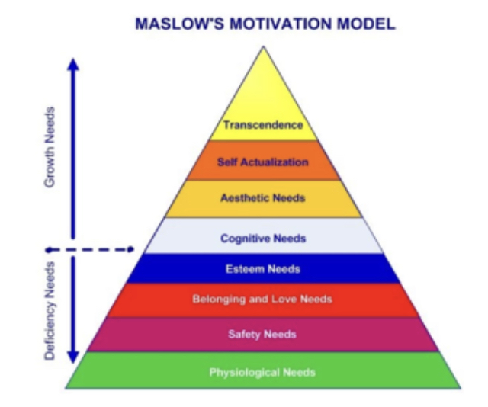

Appendix 2 –

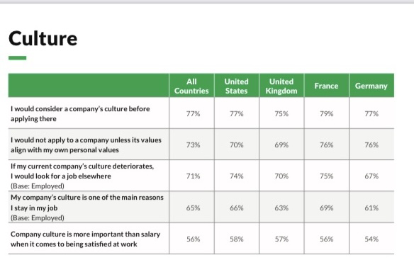

Appendix 3 –

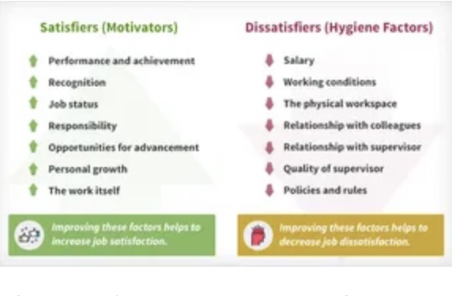

Appendix 4 –

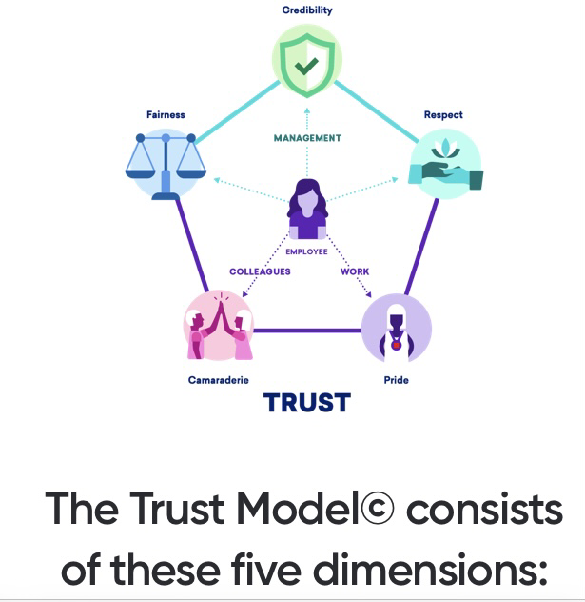

Appendix 5 –

Appendix 6 –

Appendix 7-

Appendix 8 –

