lcmb7002
fINANCIAl management
Fatima-Zahra Lebied (1602154)

TABLE OF CONTENT

. . . . . . . . . . . . . . . . . . . . . . . . . . . . . . . . . . . . .

Introduction ......................................................................................................................2

Part A ................................................................................................................................3
Samsung brief history ...............................................................................................................3

Part B ................................................................................................................................5
How calculation is done ............................................................................................................5
Profitability .............................................................................................................................21
Liquidity ..................................................................................................................................22
Gearing ...................................................................................................................................24
Efficiency ................................................................................................................................26
Recommendation ...................................................................................................................26

Part C ...............................................................................................................................28

Question 1 ..............................................................................................................................28
Question 2 ..............................................................................................................................32

Conclusion ......................................................................................................................33
References ......................................................................................................................34

Introduction:
Developing interest worldwide in the aim of improving the advancement in the business division activities, particularly the innovation, is planned to keep up or increment national monetary intensity, comprehensively as an impact of awareness taking into consideration the impacts coming from economic movement on the utilization of assets and condition.
The market of smartphones has been quick developing as far as advancement. Samsung has a successful strategy called quick follower. Nevertheless, Samsung has higher sales in term of smartphones compared with its market pioneer and main rivalry Apple, the company is presently contending principally on sales than development (Mihaela, 2011).

This is a report of the financial position of Samsung Electronics between 2015 and 2019. The report will examine the company’s liquidity, profitability, gearing and efficient use of resources including views and comments with comparison to main competitor Apple.

Part a:

The organizer, Lee-Byung-Chull began the business as a little fare organization inside Korea in 1938 before Samsung built up their organization in the cell phone industry, and was initially called Samsung Shoe. In the late 1960s, Samsung chose to join the electronic business. During the period between 2000-2010, the organization turned into a pioneer in the advanced, which was additionally the hour of progressive change (Farshed, 2014).
The company is perceived as a main worldwide assembling, budgetary, and administrations combination. It was established in 1938 and concentrated its organizations on territories, for example, chemicals, materials, and shipbuilding. In the semiconductor and electronics industry, Samsung has put enormous investment and efforts since 1980. This made Samsung encountered sensational development in net benefits since the 1990s wherein in 2004, the company was classified as one of just two assembling organizations worldwide to post benefits of more than $10billion (Hong, 2007).
In term of business model, Samsung operates utilizing a vertical incorporation model which use all parts of the manufacturing procedure starting from crude materials to electronics segments to completely collected items. Samsung electronics is additionally one of the world's biggest providers of electronic segments and a top provider of Dell and Sony.
Customers overall know Samsung as one of the top producers of TVs. The organization has additionally joined the market for cell phones when it presented the Samsung Galaxy Tab and the Galaxy S arrangement of smartphones, wherein considered as the head of competition between Apple's iPad and iPhone (Reymond, 2012).
The Samsung company consumed its business to 3 primary advances. In the 1980s, by building plants in cheap labour work areas, for example, Portugal and also by manufacturing huge R&D centres in New York, England, the firm made a major interest in a worldwide electronic industry. Furthermore, Samsung group joint ventures and partnerships with Sony for LCD screens to easier enter and reach more nations. From that point forward, through a global strategy, Samsung started to look for end-client items (Dimitri, 2014).
Following an endorsement from investors, Samsung Electronics named its leader, Sang-Hoon Lee, as director of its board. Oh-Hyun Kwon, the administrator's post alongside that of the South Korean organization's CEO will be replaced by Mr Lee.
For the first time and with Mr Lee's arrangement, Samsung has isolated the jobs of its CEO and load up chairman. The organization anticipates the move to rise self-independence of its top managerial staff. Furthermore, Samsung extended its board from 9 to 11 individuals by selecting the leaders of its three speciality units as 3 independence executives to the board units, Hyunsuk Kim, Dongjin Koh and Kinam Kim (TheEconomist, 2018).
Samsung the world's greatest cell phone producer has fuelled fears that the period of booming smartphones has come to an end where the total sales fell by £3.2billion in 2015 compared by previous years, due to a fall in Samsung ship’s global costs that the company makes for LCD gadgets such as laptops and TVs screens (Micheal, 2016).
Slowing demand for display boards, and accusing a drop-in memory chip costs has given to Samsung an unexpected profit warning. In the amid of global economic slowdown, this is the most recent sign that innovation firms are confronting harder.
In two years, Samsung's figure its first drop in quarterly operating benefits due to weaker smartphones sales, however, Samsung is counted as one of the successful Korean company in the electronics sector (Kollewe, 2019).

Part B:
How Samsung’s ratios have been calculated for the past 5 years in USD dollar$:

Liquidity and gearing ratio:
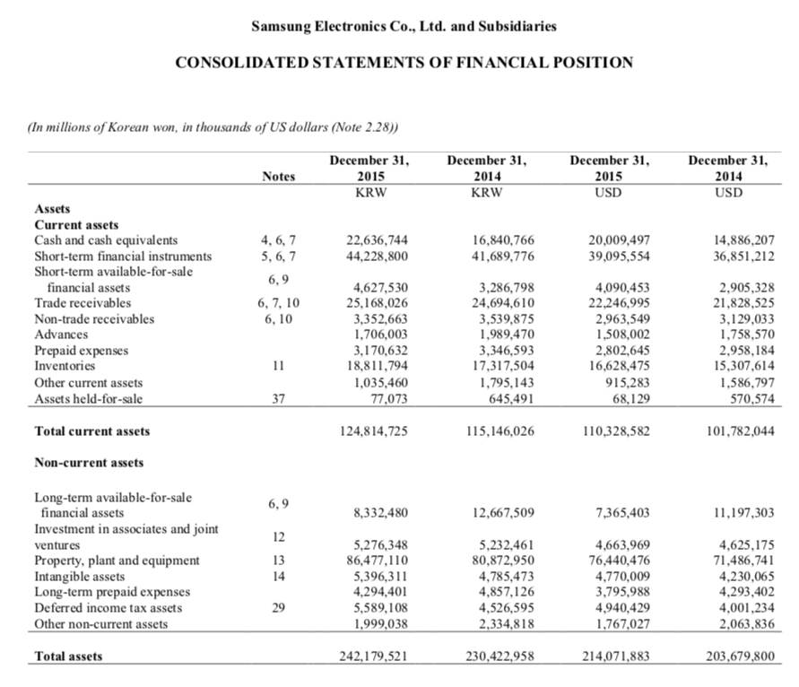
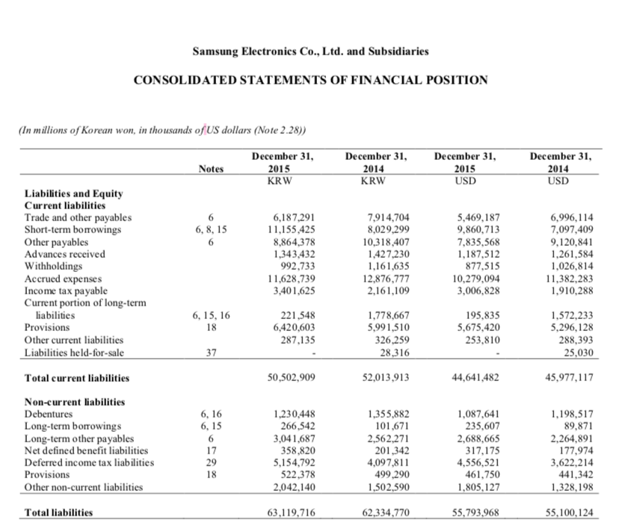
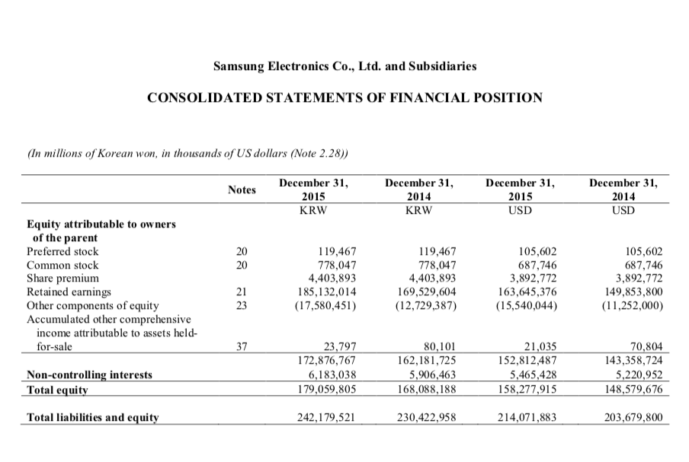

2015:
Liquidity:
Current ratio = $\frac{110,328,582}{44,641,482}$ = 2.47
Quick ratio = $\frac{110,328,582 - 16,628,475}{44,641,482}$ = $\frac{93,700,107}{44,641,482}$ = 2.10
Cash ratio = $\frac{20,009,497}{44,641,482}$ = 0.45

Gearing ratio:
Total debt = 1,087,641 + 235,607 + 9,860,713 = 11,183,961
Debt-equity ratio = $\frac{11,183,961}{158,277,915}$ = 0.0707
Debt-to-capital ratio = $\frac{11,183,961}{158,277,915+11,183,961 }$ = $\frac{11,183,961}{169,461,876}$ = 0.066

2016/2017:
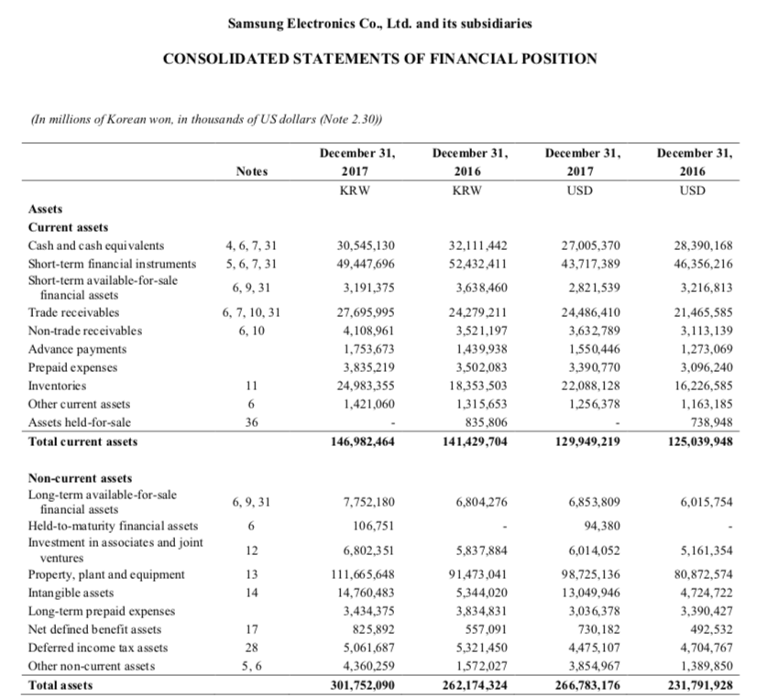
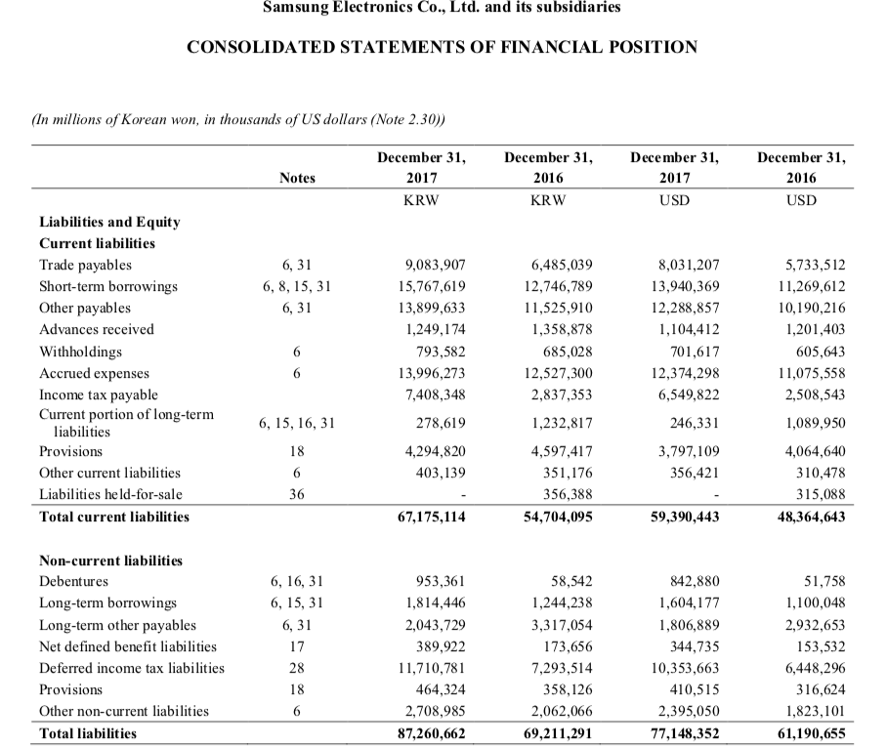
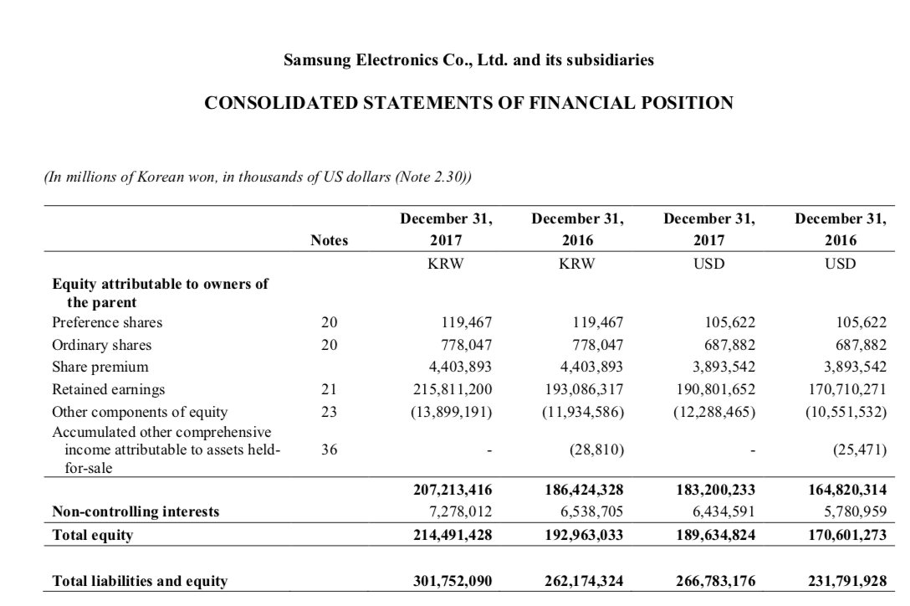

2016:
Liquidity:
Current ratio = $\frac{125,039,948}{48,364,643}$ = 2.58
Quick ration = $\frac{125,039,948 - 16,226,585}{48,364,643}$ = $\frac{108,813,303}{48,364,643}$ = 2.25
Cash ratio = $\frac{28,390,168}{48,364,643}$ = 0.59

Gearing:
Total debt= 11,269,612 + 51,758 + 1,100,048 = 12,421,418
Debt-equity ratio= $\frac{12,421,418}{170,601,273}$ = 0.0728
Debt-to-capital ratio = $\frac{12,421,418}{170,601,273+12,421,418}$ = $\frac{12,421,418}{183,022,691}$ = 0.068

2017:
Liquidity:
Current ratio = $\frac{129,949,219}{59,390,443}$ = 2.19
Quick ration = $\frac{129,949,219 -22,088,128}{59,390,443}$ = $\frac{107861091}{59,390,443}$ =1.82
Cash ratio = $\frac{27,005,370}{59,390,370}$ = 0.45

Gearing:
Total debt= 13,940,369 + 842,880 + 1,604,177 = 16,387,426
Debt-equity ratio= $\frac{16,387,426}{189,634,824}$ = 0.0864
Debt-to-capital ratio = $\frac{16,387,426}{189,634,824+16,387,426}$ = $\frac{16,387,426}{206,022,250}$ = 0.079

2018/2019:
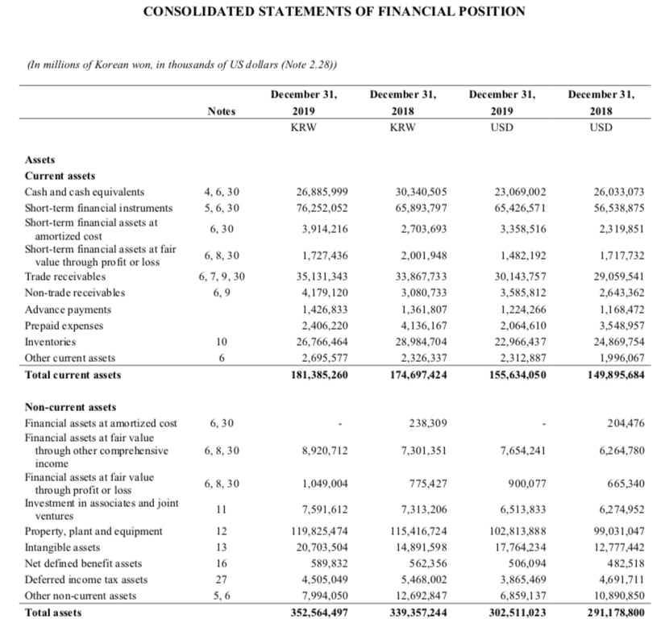
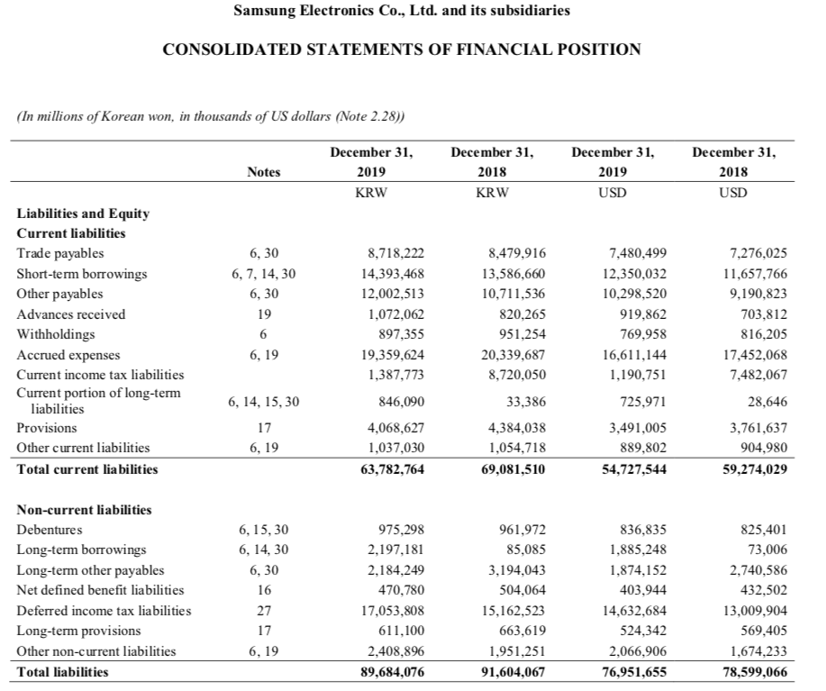
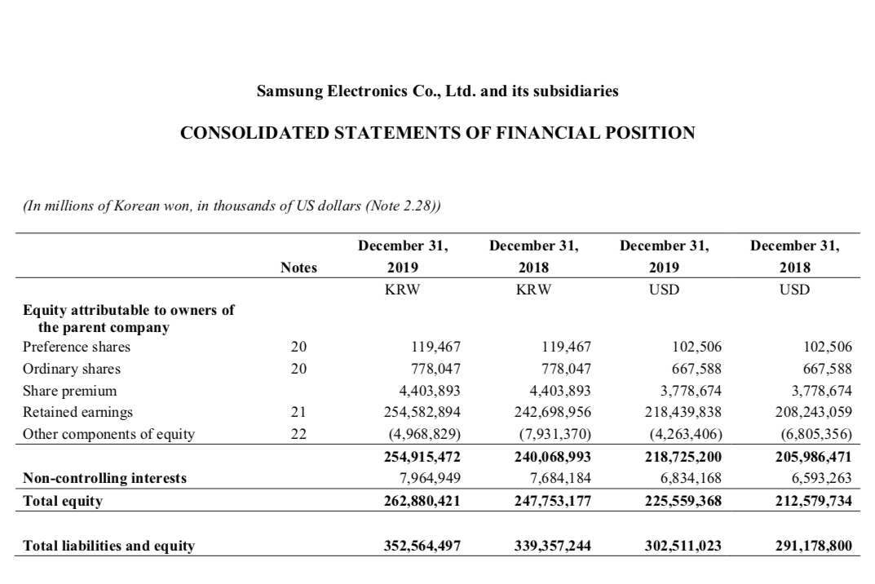

2018:
Liquidity:
Current ratio = $\frac{149,895,684}{59,274,029}$ = 2.53
Quick ratio = $\frac{149,895,684 - 24,869,754}{59,274,029}$ = $\frac{125,025,930}{59,274,029}$ = 2.11
Cash ratio = $\frac{26,033,073}{59,274,029}$ = 0.44

Gearing:
Total debt= 11,657,766 + 825,401 + 73,006 = 12,556,173
Debt-equity ratio= $\frac{12,556,173}{212,579,734 }$ = 0.0590
Debt-to-capital ratio = $\frac{12,556,173}{212,579,734+12,556,173}$ = $\frac{12,556,173}{225,135,907}$ = 0.056

2019:
Liquidity:
Current ratio = $\frac{155,634,050}{54,727,544}$ = 2.84
Quick ratio = $\frac{155,634,050 -22,966,437}{54,727,544}$ = $\frac{132,667,613}{54,727,544}$ = 2.42
Cash ratio = $\frac{23,069,002}{54,727,544}$ = 0.42

Gearing:
Total debt= 12,350,032 + 836,835 + 1,885,248 = 15,072,115
Debt-equity ratio= $\frac{15,072,115}{225,559,368}$ = 0.0668
Debt-to-capital ratio = $\frac{15,072,115}{225,559,368+15,072,115}$ = $\frac{15,072,115}{240,631,483}$ = 0.063

Profitability Ratio:

Gross margin = $\frac{Gross Profit}{Sales Revenue }$

Operating margin = $\frac{Operating Income }{Sales Revenue }$

Net Income Margin = $\frac{Net Income}{Sales Revenue }$

2015:
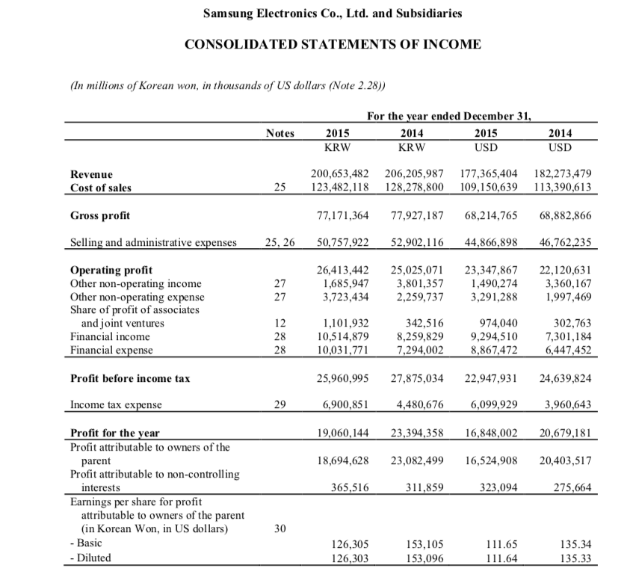
Gross margin = $\frac{68,214,765}{177,365,404}$ = 0.3846
Operating margin =$\frac{23,347,867}{177,365,404}$ = 0.1316
Net Income Margin = $\frac{16,848,002}{177,365,404}$ = 0.095

2016/2017:
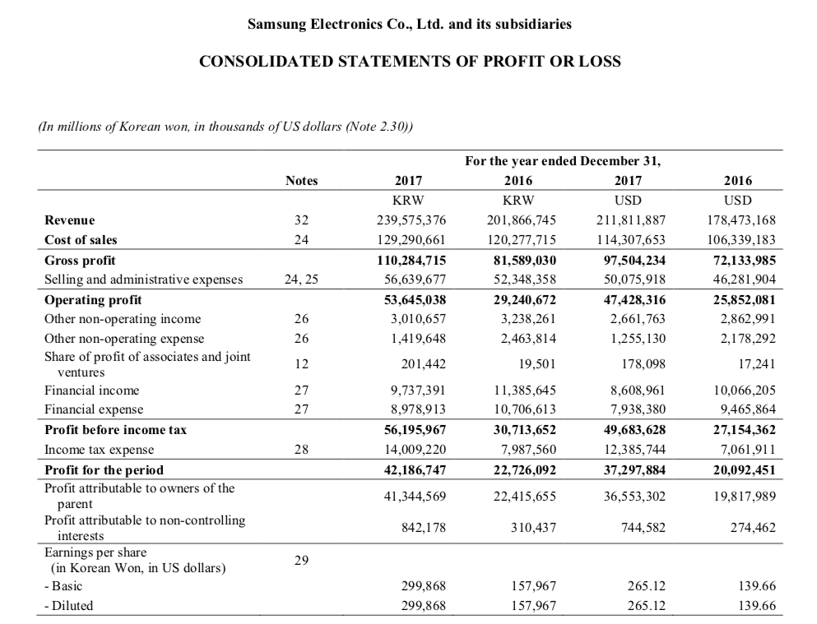

2016
Gross margin = $\frac{72,133,985}{178,473,168}$ = 0.4042
Operating margin = $\frac{25,852,081}{178,473,168}$ = 0.1448
Net income margin = $\frac{20,092,451}{178,473,168}$ = 0.1126

2017:
Gross margin = $\frac{97,504,234}{211,811,887}$ = 0.4603
Operating margin = $\frac{47,428,316}{211,811,887}$ = 0.2239
Net income margin = $\frac{37,297,884}{211,811,887}$ = 0.1761
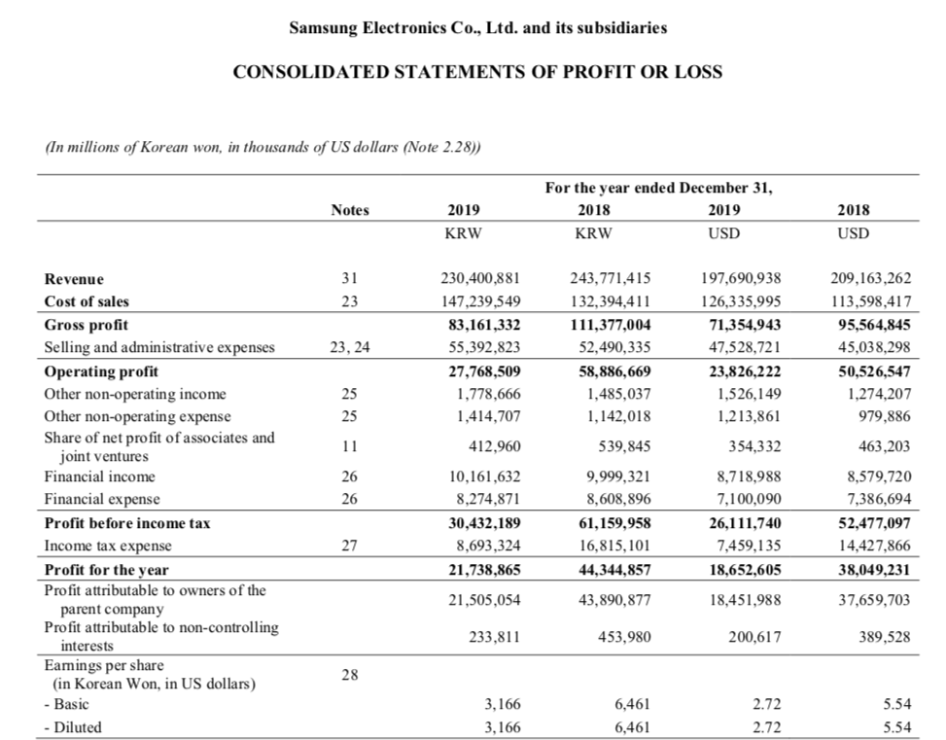

2018:
Gross margin = $\frac{95,564,845}{209,163,262}$ = 0.4569
Operating margin = $\frac{50,526,547}{209,163,262}$ = 0.2416
Net income margin = $\frac{38,049,231}{209,163,262}$ = 0.1819

2019:
Gross margin = $\frac{71,354,943}{197,690,938}$ = 0.3609
Operating margin = $\frac{23,826,222}{197,690,938}$ = 0.1205
Net income margin = $\frac{18,652,605}{197,690,938}$ = 0.0943

Efficiency ratio:
Asset turnover = $\frac{Sales revenue }{Total assets }$
Fixed assets turnover = $\frac{Sales revenue }{Fixed assets }$

2015:
Asset Turnover = $\frac{177,365,404}{214,071,883}$ = 0.83
Fixed assets turnover = $\frac{177,365,404}{76,440,476}$ = 2.32

2016:
Asset turnover = $\frac{178,473,168}{231,791,928}$ = 0.77
Fixed assets turnover = $\frac{178,473,168}{80,872,574}$ = 2.21

2017:
Asset turnover = $\frac{211,811,887}{266,783,176}$ = 0.79
Fixed assets turnover = $\frac{211,811,887}{98,725,136}$ = 2.14

2018:
Asset turnover = $\frac{209,163,262}{291,178,800}$ = 0.72
Fixed assets turnover = $\frac{209,163,262}{99,031,047}$ = 2.11

2019:
Asset turnover = $\frac{197,690,938}{302,511,023}$ = 0.65
Fixed assets turnover = $\frac{197,690,938}{102,813,888}$ = 1.92

Competitor chosen is Apple 2018:
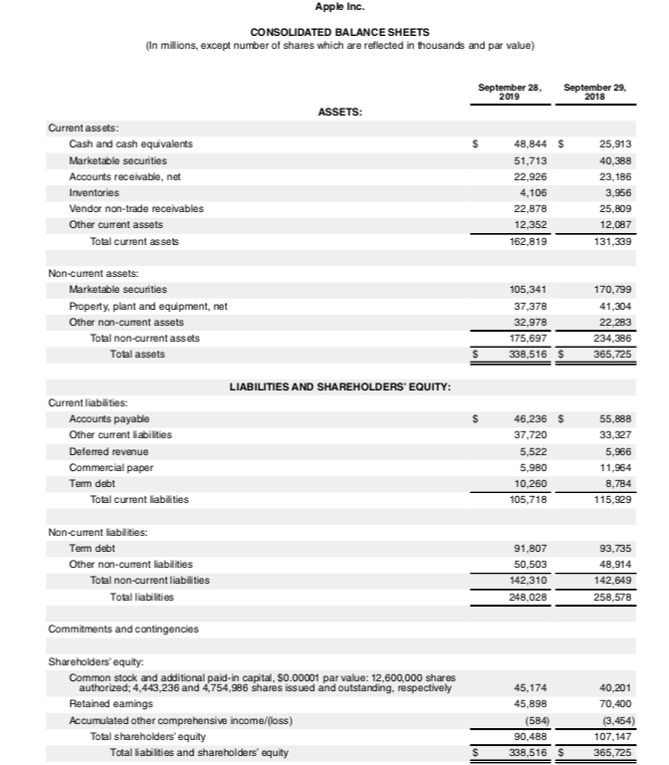
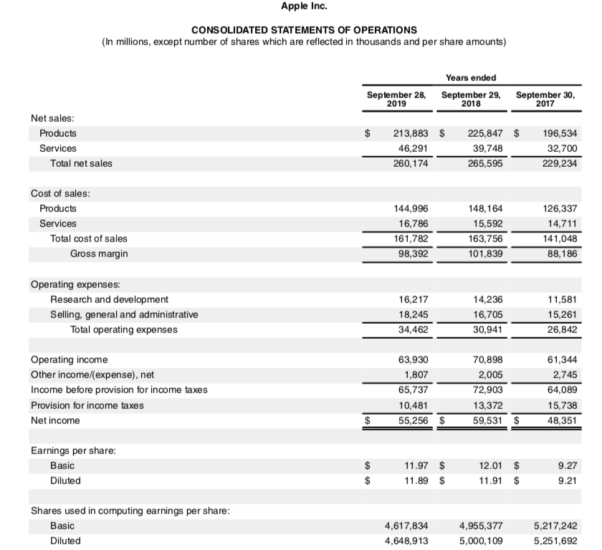
LIQUIDITY
Current ratio = $\frac{131,339}{115,929}$ = 1.13 | Quick ratio = $\frac{131,339 - 3956}{115,929}$ = 1.10 | Cash ratio = $\frac{25,913}{115,929}$  = 0.22

GEARING
Debt-equity ratio = $\frac{8784+93,735}{107,147}$ = 0.9568 | Debt-to-capital ratio = $\frac{102,519}{107,147+102,519 }$ =0.489

PROFITABILITY
Gross margin = $\frac{101,339}{265,595}$ = 0.3815 | Operating margin = $\frac{70,898}{265,595}$ = 0.2669 | Net income margin= $\frac{59,531}{265,595}$ = 0.2241

EFFICIENCY
Asset turnover= $\frac{265,595}{365,725}$ = 0.73 | Fixed asset turnover = $\frac{265,595}{41,304}$ = 6.43

Samsung profitability 2015-2019

Profitability ratio (%) | Years
Samsung | 2015 | 2016 | 2017 | 2018 | 2019 | Apple (2018)
Gross margin | 38.46 | 40.42 | 46.03 | 45.69 | 36.09 | 38.15
Operating profit margin | 13.16 | 14.48 | 22.39 | 24.16 | 12.05 | 26.19
Net income margin | 9.5 | 11.26 | 17.61 | 18.19 | 9.43 | 22.41

There are 3 common ratios which are the gross proﬁt margin, operating proﬁt edge and net proﬁt edge. Every proportion offers an alternate look at the organization's exhibition, however, considerably, they offer a general perspective on how well the organization transforms income into proﬁts (Akhil, 2016).
In general, the gross and operating profit margin are related to sales. During the past 5 years, Samsung has been seen a slight increase in term of its profitability until 2018 which means that the company retains an average of 0.22$ from each dollar of sales revenue in 2017. Samsung uses the funds remained in paying its administrative expenses, satisfying debt obligations, divined distribution to shareholders and for the interest rate.
Samsung's total expenses are generally determined by the cost of sales, which represented 66% of total expenses and 55% of total revenues in 2018.
One of the significant costs for electronic organization is the expense of sales. The cost of sales of Samsung from 2015 has expanded at around $109 billion to 2018 at about $120billion. Samsung's annual tax expense has expanded in 2015 and 2018 from$6 billion to $15 billion, driven by higher productivity (Forbes, 2020).
Net profit margin ratio is characterised as a proportion of the general achievement of a business. A high net profit revenue shows that a business is evaluating its items effectively and is practising acceptable cost control (AccountingTools, 2019).
By soaring memory prices, the net income margins of Samsung have increased since 2015 with a 9% reaching at 18% in 2018. However, in 2019 the gross profit margin ratio has declined which could be explained by two factors either the gross profit of the firm increased slower than the sales or the cost of sales has risen which results to a decrease in Samsung’s profitability.
Since 2015, the world's biggest creator of memory chips and cell phones organization endured its greatest rate drop of net revenue in any event 10 years from 18% to a 9%. Final quarter deals fell to Won59tn by 0.5%.
Due to a low variable cost and a high fixed cost at 20%, Samsung has pummelled the net profit margin compared with Apple which uses a small portion of its fixed costs in 2019.
Furthermore, Apple has the highest net profit margin at 22% similar to Samsung at 18% in 2018, this is could be explained that both companies operate a differentiated targeting strategy where both organisations supply and produce different products and services in order to attract different customers. However, across all available profitability measure, Apple seems to be more profitable when benchmarking against Samsung. Apple’s net profit margin has been stable at about 21.1% for the past 5 years as the company’s products have special features and more advantages than its competitors which give Apple an 87% customer loyalty across Europe and USA and the right to raise its prices in the aim of increasing its profit. As a result, Apple has a strong pricing power and customers loyalty which makes the company more profitable than Samsung.

Samsung Liquidity 2015-2019:
Liquidity proportion portrays organization ability in finishing its present liabilities (Nailal, 2016).

Liquidity ratio | Years
Samsung | 2015 | 2016 | 2017 | 2018 | 2019 | Apple (2018)
Current ratio | 2.47 | 2.58 | 2.19 | 2.53 | 2.84 | 1.13
Quick ratio | 2.10 | 2.25 | 1.82 | 2.11 | 2.42 | 1.10
Cash ratio | 0.45 | 0.59 | 0.45 | 0.44 | 0.42 | 0.22

One of the well-known liquidity ratios is the current ratio which is considered as the general magnitude of each store, additionally is a proportion of the margin of safety that administration keeps up to maintain into account the inescapable lop-sidedness in the cash flow through the liabilities and current assets (David, 2013).
Electronic companies have a relatively high current ratio, as the company hold credit to its customers, and it is the case for Samsung. The current ratio of Samsung in 2015 is high at 2.47 as the company has a large proportion of short-term assets value compared with its short-term liabilities value which means that Samsung is more capable of paying its obligations. In 2016, Samsung current ratio increased by 0.11, meaning that Samsung is more liquid, with a high current ratio, businesses become more vital, but, the ratio that reached 3 is not demanded as the company may not be managing its working capital and not be using the efficiency of its current assets.
The liquidity is relatively stable and the liquidity has slightly decreased in 2017, due to an increase of trade and other payables by 4,396,368$ and the liabilities by 15,957,691$ based on the balance sheet, in term of cash resources, this could be a positive sign of independence, but, holding a big amount of cash may bring about loss of income in ventures or other gainful activities, nevertheless, during the last 2 years, the ratio started to rise again.
Compared to Apple, it can be stated that Samsung have a quite higher current ratio at 2.53, 2.84 in 2018 and 2019 respectively than Apple’s current ratio which is stable at about 1.13-1.5 in 2018/2019, meaning that Samsung is able to pay off its short-term liabilities with its current assets. However, the ideal current ratios vary from 1 to 1.5, as a result, Samsung remain more liquidity then its competitors.
Quick ratio incorporates only the most fluid current liabilities to current assets.
The ratio is more traditionalist than the current ratio since it bars inventories from current resources. The ratio is been named under the way that asset, for example, the marketable security which is a quick wellspring of cash. Inventories, for the most part, set aside some effort to be changed over into cash, and on the off chance that they must be sold rapidly, the organization may need to acknowledge a lower cost than the book estimation of these inventories. Therefore, they are reasonably avoided by assets (Omar,2016).
Samsung has a high quick ratio of 2.10 and increased to 2.25 in 2016 which indicates that the company is quickly converting receivables into cash and is experiencing a significant solid growth which made it easier for the firm to cover its financial obligations, but, in 2017, Samsung has known a slight decrease in the ratio which means that during this year, the company was struggling either by growing sales or collecting receivables slowly. Nevertheless, the electronic industry quick ratio average is 1.24 wherein Samsung can instantly with a 1.82 get rid of its current liabilities.
By the next 2 years, Samsung was able to significantly increase its quick ratio to 2.42 in 2019 due to having a cash conversion cycle and a faster inventory turnover, as a result, Samsung is considered to have a better liquidity position in the market.
When benchmarking with Apple, it can be seen that Samsung is more sufficient by covering its current liabilities through short-term assets at 2.11, 2.42 in 2018 and 2019 respectively than Apple’s quick ratio that has been stable at an average of 0.9 since 2015 and peaked at 1.2 in 2019 which indicates that Apple has enough cash to sustain its operations and cover its financial obligations. However, the quick ratio’s minimum level is 1;1, as a result, Samsung maintains more liquidity then required.
Cash ratio relies upon marketable short-term ventures in addition to its cash credited to current liabilities (Anne, 2007).
Samsung has a relatively stable cash ratio at an average of 1.5 since 2015 until 2019, which means that the company can easily pay off its debt, the same case for Apple with an approximately median average of cash ratio of 0.7 for the past 5 years. As a result, Apple have the same figures as Samsung’s cash ratio.

Samsung Gearing 2015-2019
The gearing ratio is a sort of monetary proportion that looks at organization obligation comparative with various financial related measurements. To evaluate the measure of risk engaged with the picked structure and how an organization structures itself, investors utilize these sorts of proportions.
The higher gearing proportion is demonstrative the greater deal of leverage where an organization is utilizing debt to pay for its proceeding operations.
The lower gearing proportion might be demonstrative of the more conservative financial management is, however, may likewise imply that an organization is situated in a profoundly recurrent industry, thus cannot bear to become overextended even with an inescapable downturn in deals and benefits (Rosemary, 2019).

Gearing ratio | Years
Samsung | 2015 | 2016 | 2017 | 2018 | 2019 | Apple (2018)
Debt-to Equity ratio | 0.0707 | 0.0728 | 0.0864 | 0.0590 | 0.0668 | 0.957
Debt-to Capital ratio (%) | 6.6 | 6.8 | 7.9 | 5.58 | 6.63 | 48.9

The debt-to-equity ratio is seen as an intermediary for evaluating the degree of leverage of an organization (Luisa, 2013).
Samsung has an increasing debt-to-equity ratio from 0.07 in 2015 to 0.08 in 2017.
A high DER can be good for Samsung as it shows through the cash flow that the company can easily service its debt obligations, also it is using the leverage to increase equity returns.
In 2018, the debt-to-equity ratio of the Korean electronics company has fallen to 0.05 due to an increase in sales revenue by 33,338,719$ wherein the company had made more profit than the previous year at 32,297,884$. This can be explained by a rise in smartphone’s prices since 2018 by £365.50 according to the leading UK mobile phone recycling website.
The debt-to-equity ratio started to rise again since 2018 wherein illustrate that Samsung has put resources into long haul extends or bought fixed resources. This additionally may be the sign of a short-term expansion in liquidity.

Looking at Apple’s debt-to-equity ratio which is quite high than Samsung at 0.95, means that the company has been taking on debt, in order to funds its share dividends and repurchases which have together expanded from $47billion to $818biilion in 2015 and 2019 respectively. This has pushed Apple to dramatically change its culture due to its significant rise in DER from an average of 0.3 since 2014 to a 1.2 in 2019. The solution for Apple was to using debt to fund its growing capital return program by taking advantage of low-interest rates.
Based on the electronic industry, the ideal debt-to-equity ratio is between 0.01-1, as a result, the high DER of Apple indicates that the company’s assets are more funded by debt whilst Samsung low DER shows that the firm’s assets are more funded by equity.

Debt-to-capital estimates an organization's utilization of financial obligation in examination with its absolute external financing, including investor value. Most organizations fund their tasks through a blend of equity and debt to appraise the hazard level to an organization's investors and to fund their everyday activities. In the form of interest expenses and other instalments, debt-to-capital likewise quantifies the financial soundness of a firm to meet its liabilities (Charlotte, 2019).
With a high debt-to-capital ratio, more liabilities are acquired without an increase in earnings and the greater the risk is for shareholders and to lenders, which might end up by the company bankrupt.
Samsung has a relatively stable debt-to-capital ratio since 2015 with a slight decrease in 2018 wherein the company has increased its sales by rising prices of its products and the extra cash obtained has been used in order to pay the existing debt.
Compared with Apple, it can be stated that both companies have a ratio less than 1.0 wherein the debts levels are manageable and both organizations are considered as less risky in term of investing or loaning.

Efficiency ratio:
Efficiency ratio | Years
Samsung | 2015 | 2016 | 2017 | 2018 | 2019 | Apple (2018)
Assert turnover | 0.83 | 0.77 | 0.79 | 0.72 | 0.65 | 0.73
Fixed asset turnover | 2.32 | 2.21 | 2.14 | 2.11 | 1.92 | 6.43

The asset turnover is a proportion that estimates how all benefits claimed by a firm are worked in supporting organization deals and it has a huge impact on productivity (Nurlaela, 2019).
Organizations with low asset turnover have a high-profit margin. Samsung make a high profit on its products with a low -profit margin which make the asset turnover of Samsung relatively low. Since 2015, the asset turnover of Samsung has not dramatically changed unless in 2016 where there was a significant rise by 0.06, due to the marketable rise in the revenues by 1,107,764$ making Samsung more efficient. However, since 2017, the ratio started slightly to decrease caused by a decline in sales from 211$miilion to 209$million and 197$million in 2017, 2018 and 2019 respectively. Apple’s has the same asset turnover ratio, as the firm operates in the same kind of businesses.
Fixed resources turnover proportion is an action proportion which quantifies how effectively an organization is creating incomes utilizing its fixed resources. It computes dollars of income earned per one dollar of the book estimation of fixed resources (Obaidullah, 2019).
Samsung has a high fixed asset turnover from 2.32 in 2015, meaning that the electronic company indicates efficiently to generate sales by using its fixed assets, however, this ratio will slightly decrease year by year since 2016 reaching 1.92 in 2019. This can be explained that Samsung indicates an over payment in the investment in its fixed assets.
When benchmarking with Apple, it can be stated that Apple has a quite higher fixed assets turnover which is generally better as the company have a high fixed assets and it is operating over capacity that can be reduced or used in the aim of supporting the company’s revenues through increasing its assets. As a result, Apple is more efficient than Samsung using its fixed assets to generate sales.

Future recommendation:
When comparing Samsung with Apple, there are many important drivers Apple to be more successful than Samsung. Firstly, Apple has a higher ROE with equity multiplier reaching 3 by assuming a sizable obligation at about $110billion compared with 1.4 for Samsung which remains nearly obligation-free at $1billion in the long haul. Besides, the operating margin of Apple is additionally higher, coming in at 27% driven by the company's higher-margin purchaser gadgets items while Samsung margin in the last year was helped by taking off DRAM costs at 21%. Apple's taxation rate is additionally good, coming in at 0.82 whilst Samsung's 0.75. This is driven by the ongoing corporate expense changes in the United States.
On the other hand, in term of interest income and asset turnover, Samsung has a slight edge over Apple (Forbes, 2018).
As a result, Samsung need to improve its equity multiplier by using more equity than debt to purchase its assets, this will help Samsung to be less risky investments by having a lower debt burden.
Furthermore, Samsung have to work to increase its operating margin by attracting new customers maybe by producing new products can help the company grow the business, or by reducing the business inventory or overheads.

Part C:

QUESTION 1:

Payback period PBP

Year | Project A | Cumulative net cash flow (£m)
0 | (85) | (85)
1 | 10 | (75)
2 | 20 | (55)
3 | 25 | (30)
4 | 65 | 35

The payback period is between 3 and 4 years, where the cumulative net cash flow changes from a deficit to a surplus:
3 years + $\frac{Deficit 30}{Deficit 30+Surplus35}$ = $\frac{30}{65}$ = 0.46
The payback period for the project A is 3 years 4 months.

Year | Project B | Cumulative net cash flow (£m)
0 | (90) | (90)
1 | 40 | (50)
2 | 35 | (15)
3 | 7 | (8)
4 | 40 | 32

The payback period is between 3 and 4 years:
3 years + $\frac{Defecit8}{Defecit8+Surplus32}$ = $\frac{8}{40}$ = 0.2
The payback period for the project B is 3 years and 2 months.

Accounting return rate ARR:
- Assuming that the scrap value =0
- Useful economic life is 4 years
Project A:
Initial investment is £85,000,000
First, the depreciation needs to be calculated:
Depreciation = $\frac{85,000,000-0}{4}$ = 21,250,000
ARR = $\frac{21,250,000}{85,000,000}$ * 100 = 25%

Project B:
Initial investment is £90,000,000
Depreciation = $\frac{90,000,000-0}{4}$ = 22,500,000
ARR = $\frac{22,500,000}{90,000,000}$ = 25%

Net present value:
Firstly, calculate the discount factor assuming that the company’s cost of capital is 10.25%
Years | Discount factor
0 | 1.000
1 | $\frac{1}{{(1+0.1025)}^{1}}$ = $\frac{1}{1.1025}$ = 0.907
2 | $\frac{1}{{(1+0.1025)}^{2}}$ = $\frac{1}{1.2155}$ = 0.823
3 | $\frac{1}{{(1+0.1025)}^{3}}$= $\frac{1}{1.3409}$= 0.746
4 | $\frac{1}{{(1+0.1025)}^{4}}$= $\frac{1}{1.4774}$ = 0.677

Year | Discount factor | Project A  Net cash flow | Present value | Project B  Net cash flow | Present value
0 | 1.000 | (85,000,000) | (85,000,000) | (90,000,000) | (85,000,000)
1 | 0.907 | 10,000,000 | 9,070,000 | 50,000,000 | 45,350,000
2 | 0.822 | 20,000,000 | 16,460,000 | 15,000,000 | 12,345,000
3 | 0.746 | 25,000,000 | 18,650,000 | 8,000,000 | 5,968,000
4 | 0.677 | 65,000,000 | 44,005,000 | 32,000,000 | 21,664,000

Based on the formula of PV = Discount factor X net cash flow
The NPV for the project A is 3,185,000
The NPV for the project B is 327,000

Internal rate of return IRR:
IRR = R1 + $\frac{NPV1}{NPV1-NPV2}$ (R2-R1)

Project A:
- R1= 11%
NPV1 = -85,000,000 + $\frac{10,000,000}{{(1+11\%)}^{1}}$ + $\frac{20,000,000}{{(1+11\%)}^{2}}$ + $\frac{25,000,000}{{(1+11\%)}^{3}}$ + $\frac{65,000,000}{{(1+11\%)}^{4}}$

= -85,000,000 + 9,009,009.009 + 16,260,162.60 + 18,248,175.18 + 42,763,157.89
= 1,280,504.68

- R2 = 12%
NPV2 = -85,000,000 + $\frac{10,000,000}{{(1+12\%)}^{1}}$ + $\frac{20,000,000}{{(1+12\%)}^{2}}$ + $\frac{25,000,000}{{(1+12\%)}^{3}}$ + $\frac{65,000,000}{{(1+12\%)}^{4}}$

= -85,000,000 + 8,928,571.43 + 16,000,000 + 17,857,142.86 +41,401,273.88
= -813,011.83

IRR= 11% + $\frac{1,280,504.68}{1,280,504.68-(-813,011.83)}$ * 1%

IRR = 11% + 2.74*1% = 13.74%
Project B:
- R1= 7%
NPV1= -90,000,000 + $\frac{50,000,000}{{(1+7\%)}^{1}}$ + $\frac{15,000,000}{{(1+7\%)}^{2}}$ + $\frac{8,000,000}{{(1+7\%)}^{3}}$ + $\frac{32,000,000}{{(1+7\%)}^{4}}$

= -90,000,000 + 46,728,971.96 + 13,157,894.74 + 6,557,377.05 + 24,427,480.92
= 871,724.67
- R2=11%
NPV2 = -90,000,000 + $\frac{50,000,000}{{(1+11\%)}^{1}}$ + $\frac{15,000,000}{{(1+11\%)}^{2}}$ + $\frac{8,000,000}{{(1+11\%)}^{3}}$ + $\frac{32,000,000}{{(1+11\%)}^{4}}$

= -90,000,000 + 45,045,045.04 + 12,195,121.95 + 5,839,416.06 + 21,052,631.58
= -5,867,785.37

IRR = 7% + $\frac{871,724.67}{871,724.67-(-5,867,785.37)}$ (11%-7%)
IRR = 7% + 0.13*4%
IRR = 7.52%

In the payback period, project B will take 2 months shorter than project A to recover the initial investment, but, it does not mean than the project B is the right project as the PBP does not consider the time value of money, while in the accounting rate of return, both projects have similar ARR which means that both projects make better using their capital by squeezing more earning out from each dollar the company employs in the capital same as the net present value where project A and B are positive and both projects will give a return of more than > 10.25%.
However, the project A should be chosen as it provides a higher return than project B
10% + £3,185,000 > 10% + £327,000.
Furthermore, looking on the internal rate of return, it can be stated that project A proportion is higher than the company’s cost of capital 13.74% >8% which means that the IRR will exceed its cost and that the project that needs to be chosen, while the internal rate of return for project B will not exceed its cost with 7.52% <8%.

QUESTION 2:
Capital planning is a significant choice organization supervisor need to make to boost investor esteem.

The Payback period:
The payback period is an instrument to decide the time required to recoup a venture, and it plays a significant role in financial management to see if the investment made giving a legitimate recuperation time (Mahlia, 2011).

On one hand, one of the advantages of PBP is using numbers of years which make it simple and understandable. Also, it offers a quick evaluation where plenty of managers nowadays use this technique with short-term PBP and the little investment as it is a very significant method to get a faster return. Another benefit is that PBP shows the significance settling investment decisions taking into consideration liquidity.

On the other hand, the most genuine shortcoming is that the time value of money is not considered by the payback period as the technique does not give a reasonable determination to which project should be chosen. Moreover, the PBP ignore the profitability of a project wherein, not all the project that has a short payback period imply beneficially and also disregards incomes got after the compensation time frame (Woodruff, 2019).
When settling on capital choices, numerous organizations utilize a mix of techniques. The payback period is mostly used to limit alternatives, after that, the NPV should be applied in order to recognize the best of the rest of the ventures (Merritt, 2019).

The Net Present Value:
The net present value technique analyzes the incomes of an undertaking over a given period and resolves them to one proportionate present date cash using the financial elements (Donald, 1995).

The conspicuous benefit of the NPV is that it considers that a future dollar is worth not exactly a dollar today. In each period, the incomes are limited by another time of capital expense.
The net present value strategy additionally reveals whether speculation will make an incentive for the organization or the investors, and by how much as far as dollars. Another advantage is that the NPV strategy contemplates the expense of capital and the risk inalienable in making projections about the future (Motley, 2016).
Even though the conventional NPV strategy has its preferences for representing the time estimation of cash and indicating the venture esteems added to the firm, unfortunately, in the business world, it cannot address the adaptability and vulnerability of capital planning. Professionals can consider receiving genuine options strategy to enhance the NPV way to deal with improve the nature of choice in capital planning.
Another weakness for NPV is the investment size wherein higher NPV does not really means superior speculation. It's significant to evaluate the profits from an interest in rate terms to get an exact image of which venture gives a superior return (Chen, 2012).

The internal rate of return:
IRR is a broadly utilized benchmark for evaluating the unwavering quality of the bookkeeping pace of return as a proportion of monetary gainfulness (Peasnell, 2012).
The IRR considers the income and the time estimation of cash all through the undertaking life. Also, the IRR steady with the target of the investor by riches augmentation which is characteristic of productivity (Selvam, 2012).
However, the internal rate of return can complex-esteemed return rates and complex-esteemed capitals are without financial significance, also the IRR can't quantify the arrival on the underlying venture, Another, cons could be that project positioning with the IRR is not perfect with NPV positioning (Magni, 2011).

Conclusion:

The techniques for NPV and of IRR are among the ones most as often as possible utilized in the assessment of speculation ventures dependent on a limited income.

As a rule, the consequences of both NPV and IRR investigations are equivalent, nevertheless, conclusions may contrast if there should be an occurrence of assessment of non-regular venture projects but typically, IRR technique has the priority as it is increasingly justifiable and evident to speculators as a pointer showing the breaking point productivity of the venture.

References:

Mihaela Diaconu (2011) ‘Technological innovation: Concept, process, typology and implications in the economy’ Theoretical and applied economics, 10 (563), pp.127-144. [Online] Available at: https://www.researchgate.net/publication/227364059_Technological_Innovation_Concept_Process_Typology_and_Implications_in_the_Economy [Accessed 1st May 2020].
Farshed Madani (2014) Samsung’s innovation strategy in smart phones market. [Online] Available at: https://www.researchgate.net/publication/319585333_Samsung%27s_Innovation_Strategy_in_Smart_Phones_Market [Accessed 2nd May 2020].
Hong Mo A Yang (2007) Supply chain management six sigma: a management innovation methodology at the Samsung Group. [Online] Available at: https://www.researchgate.net/profile/Hong_Mo_Yang/publication/235291000_Supply_chain_management_six_sigma_A_management_innovation_methodology_at_the_Samsung_Group/links/56e03d0708aec4b3333d0445.pdf [Accessed 2nd May 2020].
Reymond Allan G. Vergara (2012) ‘Samsung Electronics and Apple, Inc.: A case study in contrast in vertical integration in the 21st century’ American international journal of contemporary research, 2 (9), pp.77-81. [Online] Available at: http://www.aijcrnet.com/journals/Vol_2_No_9_September_2012/9.pdf [Accessed 2 May 2020].
Dimitri Simonim (2014) International strategy: The strategy of Samsung Group. [Online] Available at: https://www.researchgate.net/publication/285370984_International_Strategy_The_Strategy_of_Samsung_Group [Accessed 03 May 2020].
The Economist (2018) Samsung reshuffles board of directors. [Online] Available at: https://www.eiu.com/industry/article/656572449/samsung-reshuffles-board-of-directors/2018-03-28 [Accessed 03 May 2020].
Michael Bow (2016) Samsung’s shock profit warning signals end of smartphone sale boom. [Online] Available at: https://www.standard.co.uk/business/samsungs-shock-profit-warning-signals-end-of-smartphone-sales-boom-a3167266.html [Accessed 4 May 2020].
Julia Kollewe (2019) Samsung surprises market with first-quarter profit warning. [Online] Available at: https://www.theguardian.com/technology/2019/mar/26/samsung-surprises-market-with-first-quarter-profit-warning [Accessed 5th May 2020].
Dr. Akhil Goyal (2016) ‘Operating margin ratio (a comparative study of selected public and private sector companies)’ Indian journal of research, 5 (5), pp.133-134. [Online] Available at: https://www.researchgate.net/publication/324684987_Research_Paper_Operating_Margin_Ratio_A_Comparative_Study_of_Selected_Public_and_Private_Sector_Companies [Accessed 6th May 2020].
Forbes (2020) How does Samsung spend its money. [Online] Available at: https://www.forbes.com/sites/greatspeculations/2020/01/07/how-does-samsung-spend-its-money/#15350c68b80b [Accessed 6th May 2020].
AccountingTools (2019) Net profit margin. [Online] Available at: https://www.accountingtools.com/articles/what-is-net-profit-margin.html [Accessed 6th May 2020].
Nailal Husna & Rika Desiyanti (2016) ‘The analysis of financial performance on net profit margin at the coal company’ International journal of management and applied science, 2(4), pp.105-108. [Online] Available at: https://www.researchgate.net/publication/320226746_THE_ANALYSIS_OF_FINANCIAL_PERFORMANCE_ON_NET_PROFIT_MARGIN_AT_THE_COAL_COMPANY [Accessed 8th May 2020].
Dr. David King (2013) ‘Determinants of current ratio: A study with reference to large listed companies in India’ Journal of international business management & research, 4 (12), pp.1-11. [Online] Available at: https://www.researchgate.net/publication/304023161_DETERMINANTS_OF_CURRENT_RATIO_A_STUDY_WITH_REFERENCE_TO_LARGE_LISTED_COMPANIES_IN_INDIA [Accessed 8th May 2020].
Omar Durrah (2016) ‘Exploring the relationship between liquidity ratios and indicators of financial performance: An analytical study on food industrial companies listed in Amman Bursa’ International journal of economics and financial issues, 6 (2), pp.435-441. [Online] Available at: https://www.researchgate.net/publication/297158263_Exploring_the_Relationship_between_Liquidity_Ratios_and_Indicators_of_Financial_Performance_An_Analytical_Study_on_Food_Industrial_Companies_Listed_in_Amman_Bursa [Accessed 9th May 2020].
Anne Britton International financial reporting and analysis. 2007: 3rd Ed. Hong Kong: Thomson Learning. [e-book] Available at: https://books.google.co.uk/books?hl=en&lr=&id=Z8skEGBkqYQC&oi=fnd&pg=PR8&dq=Financial++Reporting++and+Analysis.&ots=XsSRka66ta&sig=vXPPA46s3dnc-38_Wfzjh0d82EE#v=onepage&q=Financial%20%20Reporting%20%20and%20Analysis.&f=false [Accessed 9th May 2020].
Rosemary Carlson (2019) What is a gearing ratio. [Online] Available at: https://www.thebalancesmb.com/calculating-gearing-ratio-393228 [Accessed 10 May 2020].
Luisa Astra Sari (2013) ‘debt to equity ratio, degree of operating leverage stock beta and stock returns of food and beverages companies on the Indonesian stock exchange’ Journal of applied finance and accounting, 2 (2), pp.1-13. [Online] Available at: https://media.neliti.com/media/publications/243484-debt-to-equity-ratio-degree-of-operating-2cd92332.pdf [Accessed 10 May 2020].
Charlotte Edwards (2019) Cost of upgrading your iPhone or Samsung has risen. [Online] Available at: https://www.thesun.co.uk/tech/9662460/upgrading-your-phone-cost-increasing-iphone-samsung/ [Accessed 14 May 2020].
Siti Nucleal (2019) ‘Asset turnover, capital structure and financial performance consumption industry company in Indonesian stock exchange’ International journal of economic and financial issue, 9 (3), pp.297-301. [Online] Available at: https://www.researchgate.net/publication/334100090_Asset_Turnover_Capital_Structure_and_Financial_Performance_Consumption_Industry_Company_in_Indonesia_Stock_Exchange [Accessed 18 May 2020].
Obaidullah Jan (2019) Fixed assets turnover ratio. [Online] Available at: https://xplaind.com/901994/fixed-assets-turnover [Accessed 18 May 2020].
Forbes (2018) Why is Apple’s ROE more than double Samsung’s. [Online] Available at: https://www.forbes.com/sites/greatspeculations/2018/11/28/why-is-apples-roe-more-than-double-samsungs/#7ac6c50220d7 [Accessed 19 May 2020].
T.M. Mahlia (2011) ‘Life cycle cost analysis and payback period of lighting retrofit at the University of Malaya’ Renewable and sustainable energy reviews, 15(2), pp.1125-1132. [Online] Available at: https://www.sciencedirect.com/science/article/pii/S1364032110003618?casa_token=ofEZvCbXMKgAAAAA:AsjD7UD4quY-bch2v1APglOYjvxdF-FXBlHyw2zP2XDKZVQolYMKswN-46jVc5bqlnHsCV1wERpdOQ [Accessed 20 May 2020].
Jim Woodruff (2019) Advantages & disadvantages of payback capital budgeting method. [Online] Available at: https://smallbusiness.chron.com/advantages-disadvantages-payback-capital-budgeting-method-14206.html [Accessed 20 May 2020].
Cam Merritt (2019) Net present value method vs. payback period method. [Online] Available at: https://smallbusiness.chron.com/net-present-value-method-vs-payback-period-method-61578.html [Accessed 20 May 2020].
Donald S. Remer (1995) ‘A compendium and comparison of 25 project evaluation techniques. Part 1: Net present value and rate of return methods’ International journal of production economics, 42 (1), pp.79-96. [Online] Available at: https://www.sciencedirect.com/science/article/pii/0925527395001042 [Accessed 21 May 2020].
Motley (2016) What are the advantages and disadvantages of net present value method. [Online] Available at: https://www.fool.com/knowledge-center/advantages-and-disadvantages-of-net-present-value.aspx [Accessed 21 May 2020].
Jen-Hong Chen (2012) ‘Adding flexibility for NPV method in capital budgeting’ Global conference on business and finance proceedings, 7 (2), pp. 4-1707.
Ken Peasnell (2012) Economic profitability and the accounting rate of return’ Proyecciones Financieras y valoracion. [Online] Available at: https://search-proquest-com.ezproxy.uwtsd.ac.uk/publication/publications_2036240?accountid=130472 [Accessed 22 May 2020].
P. Selvam & N. Punitavati (2012) ‘A fundamental study on long-term investment decision’ International journal of management research and review, 2 (1), pp.13-22. [Online] Available at: http://ijmrr.com/admin/upload_data/journal_selvam%20dawson%20%20%202.pdf [Accessed 22 May 2020].
Carlo Alberto Magni (2011) ‘Average internal rate of return and investment decisions: a new perspective’ The engineering economist, 55 (2), pp.150-180. [Online] Available at: https://www.researchgate.net/profile/Carlo_Magni/publication/46461101_Average_Internal_Rate_of_Return_and_Investment_Decisions_A_New_Perspective/links/0912f5128041196f5a000000.pdf [Accessed 23 May 2020].
Dr. Balaram Bora (2015) ‘Comparison between net present value and internal rate of return’ International journal of research in finance and marketing, 5 (12), pp.61-71.

