Introduction
Despite being one of the biggest and most powerful industries in the world, the fashion industry is coming under more scrutiny for its effects on the environment and ethics. Fast-fashion stores have come under fire recently for their role in environmental degradation, labour exploitation, and excessive consumption. In this regard, Primark, a well-know fast-fashion store in the UK that is well-known for its inexpensive apparel, has faced criticism to enhance its sustainability policies and show more corporate responsibility. Businesses like Primark must figure out how to strike a balance between price and ethical and sustainability as customer knowledge of sustainability grows.

Sustainability in fast fashion at Primark UK: Investigating the impact of ethic supply-chain practices on consumer perceptions and strategies.
Identification of a business problem (Background and Rationale)
Primark is a significant fast-fashion shop in the Uk and around the world. It recently made bold sustainability pledges, such as starting that by 2030|Sky news. All its apparel will be composed of recycled or “more sustainable sourced” materials. However, the fast-fashion business model is heavily criticized due to its huge volumes, quick turnover of clothing, effects on the environment and resources, and issue with working conditions and product durability.” Euronews.
Despite commitments, there is still a disconnect between the business model realities of ultra-low-cost, high-volume supply chains and ambition (e.g., full sustainability materials by 2030). The issue is whether Primark’s supply-chain, sustainability, and ethical activities are strong enough, credibility and competitive standing.
Rationale: This issue is significant because: How can management reconcile Primarks low-cost, fast fashion business strategy with the increasing demands of stakeholders, regulators, and customer for ethics and sustainability?
Management: how can management reconcile Primark’s low-cost, fast fashion business strategy with increasing demands of stakeholders, regulations, and customers for ethics and sustainability?
Industry: Fast fashion is being scrutinised more and from ethical, environmental, and legal standpoint. It will be instructive to see how a significant Uk player handles this.
Academic gap: Although there is a lot of broad study on sustainability in fast fashion, little is known about how low-cost UK businesses like Primark incorporate sustainability into their strategies and how Uk customers react to them. Therefore, the proposed study investigates how supply-chain/sustainability strategy interacts with consumer/market perceptions at Primark Uk.
Research Purpose, Aim, Objectives & Questions
The goal is to investigate how consumers views are impacted by Primark Uk’s sustainable and ethical supply-chain methods, and how this impacts business strategy in the fast- fashion industry. The purpose of the study is to determine how Primark Uk’s ethical and sustainable practice affects consumer perceptions and what that means for the company’s business plan in the Uk fast-fashion industry.
Aim: To conduct a critical analysis of the ways in which Primark’s ethical sourcing and sustainability initiatives affect consumer perception, buying patterns, and brand loyalty in the Uk fast fashion market.
Its evident, quantifiable, and based on a genuine management problem: striking a balance between ethical environmental demands and cost-driven business approaches.
The purpose of this study is to evaluate Primar Uk’s current supply-chain, ethical sourcing, and sustainability policies (documented pledges, progress). To assess how the Uk markets customers see Primarks sustainability and ethical activities. To evaluate how Primark’s brand image, competitive strategy, and potential value creation are affected by these perceptions. To provide suggestions on how Primark Uk may be better link its low-cost-fast-fashion business strategy with ethical and sustainable requirements.
Research objectives: To assess Uk consumer’s knowledge of and opinions of Primark’s ethical and sustainable sourcing methods. To elevate how these actions impact customers’ loyalty, contentment, and faith in Primark’s brand. To determine Primark’s chances and obstacles for putting into practice transparent and successful sustainability plans. To suggest tactical measures that could improve Primark’s competitive edge and brand recognition through moral and ethical business practices.
Research Questions:
RQ1: What Ethical and sustainable sourcing policies has Primark Uk put in place, and how are they explained?
RQ2: What impressions do Uk customers have of Primark Uk’s ethical and sustainable initiatives?
RQ3: How much do these consumers opinions affect Primark Uk’s competitive positionings, business strategy, and brand image?
Review of literature: Important Discussions & Advances 3.1 Criticisms of fast fashion rapid design-to-retail cycles. Many styles, cheap unit costs, and frequent turnover are key components of the fast-fashion business model. However, this strategy has been criticised for social and ethical issues (pay issues, working conditions) and environmental burdens (waste, resource use, microplastics). The concept of “take-make-waste, resource use, microplastics). The concept of “take-make-waste” has long history.
Sustainability Ethics and Supply chain in fashion
The way fashion companies incorporate sustainability into their strategy into their strategy and supply chain has been the subject of increasingly research. Corporate social responsibility (CSR), circular economy, supply-chain transparency, clothing durability, recyclable design, liveable wage, and regenerative agriculture are important subjects. For instance, Primark has pledged to be recyclable by design by 2027, to produce clothing made from recycled or more sustainable material by 2030, to cut carbon emissions in half, and to pay supply-chain employees a liveable wage. However, detectors claim that many businesses engage in “greenwashing” which involves making ambitious but imprecise promises without making significant structural adjustments. Company.primark.com +2 News on Sky +.
Consumer Perceptions and Ethical/Green Consumption
The impacts of ethics and sustainability on consumer behaviour is another important subject. Do customers think ethical fashion is valuable? Does it affect their willingness to pay, brand loyalty, and purchasing decisions? Consumer awareness is rising, according to studies, but there is still a disconnect between intention and conduct. Additionally, buyers may question whether low cost can coexist with good ethical standards, which presents unique difficulties for less expensive products.
Business Strategy Implications for Low-Cost Retailers
Higher margins or premium pricing may make it easier for luxury or mid-premium fashion companies to incorporate sustainability efforts provide conflict for low-cost value fashion retailers. Instead of using premium pricing, some research looks at how they can still be successful through supply chain efficiency, volume scale, and little enhancements. However, there isn’t much research on value stores in the Uk.
Gaps In Literature
Consumer impressions of Primark’s sustainability and ethical activities have not received much attention in Uk-based empirical studies. There is little information on how to value-fashion stores like Primark incorporate sustainable into their business plan (as apposed to only supply-chain procedures) there are a few mixed methods studies in the value segment that combine supply-chain/sustainability strategy with consumer impressions. absence of comparative or longitudinal data regarding the potential of low-cost fashion shops to use environmental commitments as a competitive advantage rather than just a financial burden.
The study’s contribution aims to close a gap in the literature by analysing the strategic and consumer aspects of sustainability in a low-cost setting, with a particular focus on Primark Uk as a value-fashion store. It will provide light on how cost-driven fashion companies may harmonise their business strategy, environmental pledges, and customer attitudes.
Research Methodology & Design
Methodology a mixed method approach is acceptable because the research questions include both an investigation of firm procedures (objective 1) and consume perceptions (objective 2 & 3). While the qualitative component will enable a deeper understanding of views and strategic consequences, the quantitative component will gather data from consumer surveys.

Data Collection Methods
Desk research and secondary data include company annual reports, Primark’s sustainability and ethics and reports, and reports (such as WRAP collaboration and sustainability data for the fashion industry). Primarks corporate websites + 2 Quantitative surveys: A systematic questionnaire given to a sample of 200 – 300 UK customers who have visited Primark over the past 12 months. Important factors include brand image, willingness to buy/loyalty, perceptions of Primark’s ethical performance, understanding of sustainability in purchase decisions. Qualitive focus groups and interview: a smaller subsample, such as 10 -12 people, was selected from the survey participants to thoroughly examine their attitudes, beliefs, and worries regarding Primark’s sustainability claims and how these impact their actions.
Sampling Strategy
Method of sampling convenience sampling should be used in the conjunction with screening (UK residents who are at least 18 years old and have made purchases from Primark during the last 1 2 months). An attempt to es the estimate the demographic distribution
(income, gender, and age). Qualitative sampling: purposive sampling from survey participants with varying levels of sustainability awareness; strive for age, income, and gender diversity.
Ethical Considerations
Assured informed consent for interviews as surveys. Assure secrecy and anonymity; report no personally identifying information. Participants can leave at any moment, and data is retained securely. Clear explanations of study’s objectives and data usages. Make sure your questions are neutral and take bias into account (don’t use leading language).
Limitations
Restrictions generalisability is limited by the convenience sampling. Social desirability bias may be present in self-report survey data, particularly when it pertains to attitudes towards sustainability. The depth and sample size of qualitative research are limited by time and resources limitations.

Data Analysis
Analysing data quantitative data: make a use of inferential statistics
(such as the relationship between purchase intentions and sustainability awareness) and descriptive statistics (such as awareness levels and perceptions). Regression analysis, if the sample size permits. Data qualities: key themes were identified by thematic analysis of interview transcripts (e.g., cynicism, price vs. ethics trade-off, faith in Primark). Combining: findings from a triangulation: how do consumer perceptions and Primarks reported practices match? What are the consequences for strategy?
Business Relevance & Practical Implications
Practical implications and business relevance potential effects on business practices: Primark UK and other fast fashion/value shops will be able to better understand how consumers see sustainability and ethical activities, which might not have an impact on brand image, loyalty and competitive difference. to turn sustainability effort into a competitive advantage rather than just a cost. Primark may need to modify its marketing tactics, transparency initiatives, or even reevaluate certain aspects of its business model (such as durability and circular design) if consumer perceptions are weak or sceptical. Management approach: the study may indicate that greater funding is required for customer education, supply chain traceability, and matching low-cost models with reliable sustainability measures. It might also draw attention to innovation opportunities that are exclusive to the value-retail setting, such as a take-back programs, repair services, and circular economy projects.
Implications for the industry: knowledge regarding how to value fashion retail can develop sustainability will help industry organisations and policymakers, possibly influencing norms or legal frameworks in the UK fast-fashion business.
Decision-making implications
To increase credibility and customer trust, the company can use the findings to strengthen its marketing and sustainability communication. Based on evidence of consumer effect, supply-chain and procurement divisions may give priority to investments in circular design, supplier wage improvements, or durable materials. Considering the results, retail strategy (store experience, pricing vs. sustainability trade-off) may be revalued.

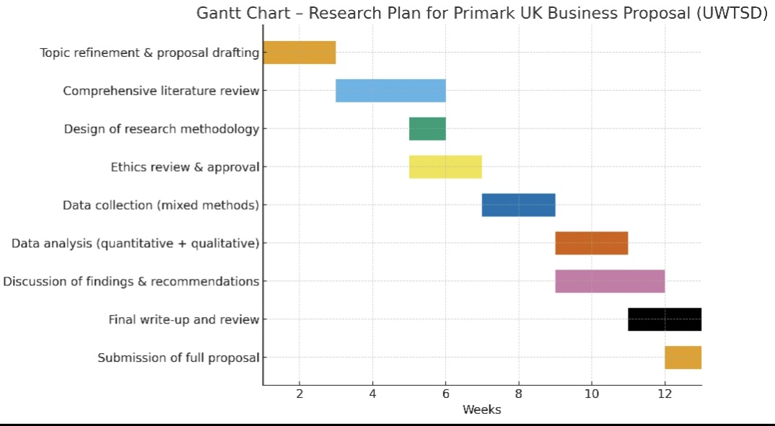

Conclusion
This proposal describes a workable, contemporary, and academically significant research of Primark Uk that focuses on the relationship between customer perception, corporate strategy, and sustainability/ethical practice. Strong investigation of both documentation (business procedures) and customer reactions made possible by the mixed-method approach. It has obvious ramifications for theory (closing knowledges gaps sustainable value fashion) and practice (assisting Primark in improving its approach). The 2,000-word project is reasonable and doable with a 12-week schedule.

References
- Primark Sustainability & Ethics Progress Report. “Primark’s carbon emissions across its value chain decline three years after it published its 2030 sustainability commitments.”25 Nov 2024. Corporate.primark.com
- Retail Gazette. “Primark makes 55%of clothes from sustainable materials.”23 Nov 2023. Retail Gazette
- WRAP.” WRAP and Primark working together to give clothes a longer life.”22 Oct 2024.
- Euronews. “Primark is 100% sustainable- but how will that fix our overconsumption problem?” 15 Sept 2021
- Fashion Capital. “Primark Cares… But is it Enough?”
- Avogaro, A., Capogrosso, L., Taoiari, A., Fummi, F., Cristani, M. (2025). “New Fashion Products Performance Forecasting: A Survey on Evolutions, Models and Emerging Trends.” arXiv.
- Soboleva, D., & Sanchez, A. (2024). “Agent-based Insight into Eco Choices: Simulating the Fast Fashion Shift.” arXiv.
- Bell, E., Bryman, A. amd Harley, B (2022) Business Research Methods. 6th edn, Oxford: Oxford University Press.
- Bryman, A. (2016) Social Research Methods.5th edn. Oxford: Oxford University Press
- Creswell. and Creswell, (2018) Research Design: Qualitative, Quantitative, and Mixed Methods Approach Approaches. 5th edn. thousand Oaks, CA: sage
- Easterby-Smith, M., Lewis, P, and Thornhill, A, (2019) Research Methods for Business’s A Students, 8th edn. Harlow: Pearsons Education
- University of Wales Trinity Saint David (2023) Research Ethics Policy. Available at: https://www.uwtsd.ac.uk/research/ethics (Accessed 7 Nov 2025).
- University of Wales Trinity Saint David (2024) Academic Writing and Research Guide. Swansea: UWTSD Press.

