

BA Leadership and Management for the Workplace

BMSK5003: UNDERSTANDING AND ENGAGING IN THE CUSTOMER EXPERIENCE

Student Name: Ehsan Meerza
Student ID: 1604560

Table of Contents
1.0 Introduction 3
2.0 Critically analyze the factors that influence your organizations ability to maximize customer value 3
2.1 A successful CRM 3
Staff motivation 6
2.2 How Sainsbury’s is maintaining CRM in its business 7
2.3 CRM Technologies 8
2.3 CRM – Corporation Perspectives 10
2.4 Impact of existing CRM practices in Sainsbury’s 10
2.5 Touch points 11
2.6 Understanding customers wants and needs 11
2.7 Core Competency 12
2.8 Staff satisfaction 12
2.9 Innovation 13
3.0 Provide a critical understanding of your organizations quality processes and its effectiveness in meeting customer requirements 13
3.1 Customer perceptions, expectation of Quality and Customer Satisfaction 13
3.2 How Sainsbury’s meet customer expectation 14
3.3 Quality management process 15
3.4 Competitive priorities 17
3. 5 Service quality 17
3.6 Quality programs 18
3.7 Training and Development programs 18
3. 8 Supply Chain Labor Standards 19
3.9 Benchmarking 19
4.0 Conclusion 20
References 21

Introduction

This assignment focuses on two major parts. The first part critically analyzes the factors that influence your organizations ability to maximize customer value. The first part includes successful CRM, recruit the right accurate people, frontline CRM, empower employees to act, staff motivation and staff satisfaction, capturing matrix and feedback channels etc. In this assignment, how Sainsbury’s is managing its CRM is also described. This part also describes CRM technologies. It also describes Customer perceptions, expectation of Quality and Customer Satisfaction.

2.0 Critically analyze the factors that influence your organizations ability to maximize customer value

2.1 A successful CRM
For the successful CRM the company requires to keep and recruit the accurate people and continuously give them with proper motivation, training and tools (Kotler et al.,2014).

Recruit and keep the right people

Frontier employees should be properly trained and given with the right equipments, tools and motivation to give better customer service. They must be capable to response as minimum 90% questions of the customers’ inquiries and questions without the interference and other managers’ supports. It involves recruiting the accurate and skilled people. A person having positive attitude should be recruited (Mathew et al, 2014). Such as, process of the interview must be used to determine the extension in that staffs are friendly or not friendly. A staff, such as, who says they do not like managing the complicated customers is the person you should not recruit. In addition, a person may discover if a staff can handle emotional situations in a friendly manner and comfortably through the interview (Mathew et al, 2014). Attitudes of the staffs can be developed when employees are coordinated to improper staffing as well as workload cannot inspire the staffs. Part time employees are retirees, stay at home parents, students etc. Part time staffs value their income and are skilled, stable and experienced staffs. Frequently are very creative because they need to earn money by part time working. Role is to know the trends, examine the reasons as well as improve the approaches to reduce it and give a solution. Many job in customer service or quality assurances specialists (Mathew et al, 2014).

Frontline CRM

CSR of front line should have communication channel their working experiences to make sure methods may be developed; the proper training method can be given. In common, they may communicate in different methods in that process of the service may be developed and there may be creative too (Baran, 2014). CSR’s are not observed as experienced staffs that may make strategy, but as centre of cost where no further asset has required and turnover costs should be reasonable. The reason is that organizations are not succeeded to observe departments of customer service as the strategic function such as, sales and marketing (Baran, 2014).

Tools

The customer service proper tools are feedback channels, empowerment and information. Staffs require providing the business information they require to give accurate answers to the consumers (Baran, 2014). When staffs do not have questions answers and they are annoyed and cannot work with proper approach (Mathew et al, 2014). If representatives of airline customer services cannot questions answers on when maintenance may be finished, they are annoyed. The quicker and more the data may be given to CSR, the best example if maintenances are happening in the aircraft, employees must have the method of achieving usual updates when it should be finished. Staffs can require data about the value and history of the customers, their usual needs and wants, variety of steps and actions they may receive to determine the customer queries and it may be assured in physical (Mathew et al, 2014).

Empower employees to act

Consumers have accurate information in order to give to staffs, they should be prepared to do something as well as give problems solutions to problems of the customers. They do not have the information; they should have the seniors to give them information for to provide the consumers (Greenberg, 2014). Occasionally, organizations do not faith on customers and they cannot belief staffs with several information. Staffs may be provided agreement to give consumers with state the goodwill payment able to the definite amount to make sure customer complaints might be stopped fast.

Training
Staffs are most significant factors for customers. They should be remunerated and trained in such a method which they may be inspired in order to work to make sure the customer complaints are determined on important factors. Proper training supports the organization to attract and retain the accurate talents. When staffs improve their knowledge and skills throughout different training, it manages to economic results (Greenberg, 2014).
Particular trainings are required in terms of services and products, selling opportunities and cross selling, well-liked responses and questions, how to apply equipments and telephones. There are different soft skills, such as, listening, communication, emotional, angry customers and problem solving (Robert, 2014). Soft skills are significant as well as problem solving skills support CSR to discover how to maintain irritation and to recover stress. If the declaration cannot be achieved after learning the appropriate details, these various skills can support the consumer to learn how to say no without showing irritate attitude to the customer or detrimental the loyalty of the brand (Scott, 2014).
Remedial training supports CSR when they fail to any queries answers for accurately. Review of the performance can specify that CSR require development in particular sectors. Development training includes arranging CSR for unique responsibilities, for example, new product offerings, new position, cross selling etc. Training must regard staffs aspirations and career goals, the information they require in order to achieve goals and the organization’s individual business strategic importance in training (Lauby, 2014).
Ongoing training contains previous and old material and different unique information to perfect the skills of the customers. Customer may be provided different business training and assessment on common matter about how marketing and sales must be associated and maintained complaints but established with different goods which are to be unnerved in the business (Robert, 2014).

Staff motivation
This contains great supervision, good compensation, career advancement prospect and recognition. Most staffs left their works as they are unsatisfied with instant supervisors’ attitudes. Various supervisors are not expert at guiding and coaching of staffs (Lauby, 2014).
First of all, competitive compensation develops the motivation of the employee. Some organizations try to compensate good salaries of salaries. Secondly, well supervisor develop the motivation of the employee. Good supervisor helps employee to make sure they are happy, promotable and successful (Scott, 2014).

Management applies the matrix to calculate the performance of everyone. Staffs require the fair of their performance evaluation. Tremendous evaluation is the significant in order to make sure every group achieves what this needs. A fair assessment should be connected to the satisfaction of the customer (Robert, 2014). When the method make sure consumers are not pleased, it is annoying to staffs (Scott, 2014). Supervisors must provide reliable assessments. Management must be capable in order to forecast what provides the satisfaction of the customers and include that to measurement plan of assessment. The assessment should receive into design proper training and consideration requires if there is deprived working activity in the specific area normally (Lauby, 2014).

Capturing matrix and feedback channels

Automatic Capture System: this may capture length of calls types containing call recordings.
Observation and listening to quality supervisor: staffs phone calls may be listened to assess the working standards.
Surveys of Customers: emails, direct mail and telephone calls may be carried out in order to determine customer satisfaction level (Robert, 2014).
Employee feedback: staffs should be provided the staff freedom to provide the employee feedback and should be provided the accurate feedback. Staff feedback can support an organization value the influence of definite policies and promotions on customer services (Robert, 2014).

2.2 How Sainsbury’s is maintaining CRM in its business
The relationship marketing goal is to make the relation between the organizations and consumers for lengthy time (Lauby, 2014). Transactional marketing is not relationship marketing main focus. Creating real relation with consumers is main concentration of it. Sainsbury’s Annual Report (2014) stated that, Sainsbury’s is the food retailer organization which achieved accomplishment in creating effectual connection with customers throughout collecting opinion of the customers about Sainsbury’s Company. Sainsbury’s has launched different marketing activities in the business. These methods contain survey on customers of the Sainsbury’s, receiving customer feedback throughout social media and complaint sectors of the customers etc. Sainsbury’s activities created their customers feel significant and valuable to their company brand. Secondly, to support their consumer for lengthy period and create them satisfied, Sainsbury’s created the ‘club card’ system for their customers. This scheme defines the buying behaviors of the valued customers. Sainsbury’s has used the club card method to achieve their Europe target marketplace and UK top retailing company (Lauby, 2014). Thirdly, Sainsbury’s is providing effort to evaluate information database of the customers effectively.
Sainsbury’s established the customers’ complaint desk. The workers and managers achieved training for effectual customers dealing. According to Greene et al. (2013), Sainsbury’s began to provide the value to loyalty and faith of the consumers and customers got developed, the position of the Sainsbury’s in order to develop the business. They created the forceful connection with consumers. Sainsbury’s began to provide concentration on the e-marketing in order to develop their marketing relationship. Fifthly, Sainsbury’s is popular and well-known for the customer service and cost effective goods.
Sainsbury’s is popular for globally well-known brands. Sainsbury’s has strong relationship with local communities. Sixthly, Sainsbury’s has brought in the amazing delivery system in the online throughout the popular website known as www.Sainsbury’s.com. This created service of the customer more effectual and simple for Sainsbury’s Company. Lastly, Sainsbury’s developed different other plans beside customer service and delivery system.
Sainsbury’s has established different campaigns programs in order to develop their customer service. Sainsbury’s also established Club card which is known as loyalty card (Sainsbury’s Annual Report, 2015).

2.3 CRM Technologies

CRM components
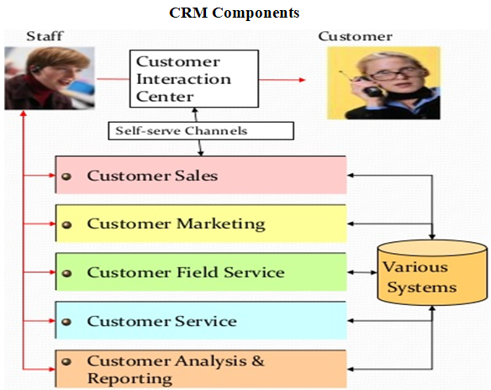
Diagram: CRM Components Source: Lecturer Notes (2018)

CRM technologies
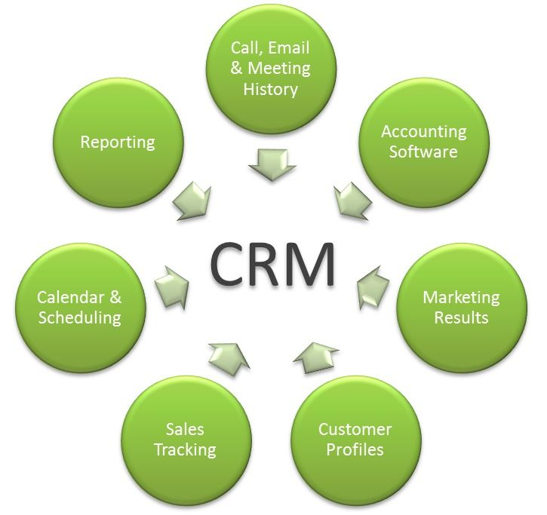
Diagram: Technologies Source: Lecturer Notes (2018)

CRM is the process and technology utilized to make measurable, repeatable and consistent results. Most CRM is linked with various elements, such as, electronics, computers, manual processes or telephones connecting phone calls or physically go to the branch. Consumers require having better experience when they connect to the telephone, logging on the phone, sending the mail etc to contact with the organization (Wliliams, 2015).

Why technology should be effective

Technology must be effectual as it helps customers and organizations. Company and the customers need better service connections to be as efficient and effective as probable. They favour to utilize the business technology on several examples, such as, boarding passes printing, money collection throughout ATM, rather than waiting in the long queues etc. It refers consumer will favour using technology relying on how and when this is utilized. The scheme should accumulate company money and the time of the customers (Dyche, 2015).

Types of technologies

Interactive voice response – jobs better when giving easy information and questions answers to the consumers, such as, possible receipt and shipment date, loan and payment date, account balances and credit cards (Williams, 2015).

Emails and chats: –observed as little costly but may be more costly when backwards and forwards communications are engaged (Williams, 2015).
Websites – suitable for distributing detail data, such as, marketing details, directions, information of warranty, etc. This may be applied to inform new consumers and talented information which can be more helpful to them. Such as, the pharmaceutical industry may utilize their business website to define new results to their customers.
Mobile Communications – Customers may apply telephone or internet based communications to current their questions and inquiries and get problems solutions, for example, throughout the Facebook post or by tweet (Dyche, 2015).

2.3 CRM – Corporation Perspectives
The business corporation need to make the great experience thus gaining loyal and existing customers. Such as, products discounts may be increased to relatives, customers and friends. Value of the customers may be made throughout increasing better experience from specific group or customer (Williams, 2015).

2.4 Impact of existing CRM practices in Sainsbury’s
The Sainsbury’s relationship marketing has supported the organization in many different methods. Relationship marketing is developed sales of the Sainsbury’s at 53% rate. This has increased their 150% floor place in earlier 5 years. Online platform of the Sainsbury’s known as Sainsbury’s.com has flourished 500,000 business in 7 days. Additionally, Sainsbury’s has been capable to extend their customer service effectively. This effective connection helped Sainsbury’s in order to complete the varying customer demands and their customers’ expectancy. Sainsbury’s is capable to follow and know the business market trend (Sainsbury’s Annual Report, 2015).
As to customers demand and business trend they developed their strategies of pricing and marketing. They established different campaigns to attract existing customers and achieve their loyalty and belief. They are capable to achieve loyal and existing consumers throughout their developed strategies of marketing, such as, Sainsbury’s club card (Sainsbury’s Annual Report, 2015).

2.5 Touch points
Nowadays, businesses apply touch points to gather the data of the consumers and not only to connect with them. Newspapers, TV and Radio are not interactive that may not be applied to gather the data of the consumers. Information, such as, purchases date; age etc may be gathered throughout various touchpoints and stored on systems of the computer. Though customers gain different value, loyalty and satisfaction when communicating with business throughout touchpoints, the business is more concerned in gaining the customers comprehensive views. If the customer is more cost-effective, other data can require be analyzing and collecting from touchpoints, such as, customer needs and wants, customer lifecycle, customer purchase, customer profile and customer complaints (Williams, 2015).

Diagram: Touch points Source: Lecturer Notes (2018)

2.6 Understanding customers wants and needs
Businesses want to know the customers wants in order to determine how to deal with them. If a person knows that several consumers will want services and there is no end investing money in training and equipment (Scott, 2014).
Sainsbury’s firstly made the profiles of the customers for understanding expectation and needs of the customers. They include demographic information, such as, address, name, service or product purchase history, contact information etc. Detailed profile contains marital status, education level, occupation, hobbies, lifestyles, vacation habits etc. This is demographic information which businesses apply to make a decision on help services in order to proffer to the consumers. Sainsbury’s specifies the lifecycle of the customers. When the lifecycle of the customer is properly forecasted, a customer may distribute proper services and products to their active consumers (Dyche, 2015).

Lastly, Sainsbury’s makes the internal process development. When business segmentation is carried out, the organization may decrease the price of services of the customers and may make sure its internal methods are effectual. Services of the customers may be created to the organization’s internal methods in the method which they may define definite complaints without any telephone call. Sainsbury’s may contain in the process methods of manufacturing in that the customer may order particular laptops on the online website (Sainsbury’s Annual Report, 2014).
Businesses want to know the customers wants in order to determine how to deal with them. If a person knows that several consumers will want services and there is no end investing money in training and equipment.

2.7 Core Competency
The company always give importance on their proficiency area. For example if a car dealership wants to assure customers that they can provide repair services, they must have the resources to invest in this area.

2.8 Staff satisfaction
When the workers are not getting satisfaction from the company, they can’t give good services to the customers. Lowest paid delegators are noted, less skilled and always have a high overturn rate. This job is for those, who intend to do this job for very short time.Sometimes customer deals with low visited employers who haven’t been bought into corporate level. Sometimes some employees think stealing customer’s data would help them in their other business (Dyche, 2014). With the help of computer, it got easier for the employees to take thousands of customers data using trough e.ge a floppy disc. To ensuring better customer services, employees should treated with respect by the companies. Companies should provide them good remuneration. So they may get satisfaction and for that their career would be in good path.Ensuring good customer services companies should provide training opportunities (Williams, 2014).

2.9 Innovation
Customers expectations are raising because of the information availability by web, internet etc and consumers may simply gain services and products information. As a result of this, there is regular stress for innovation. Such as, Sainsbury’s has improved unusual packaging to maintain products quality longer but the real goods have not been varied etc (Williams, 2015).

3.0 Provide a critical understanding of your organizations quality processes and its effectiveness in meeting customer requirements

3.1 Customer perceptions, expectation of Quality and Customer Satisfaction
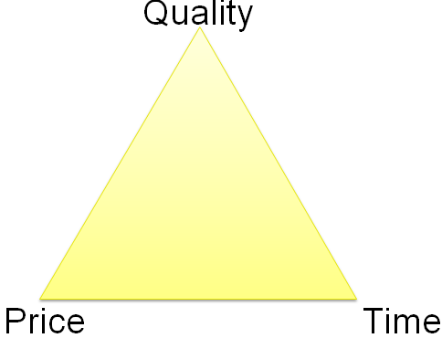
Diagram: Customer expectation Source: Lecturer Notes (2018)

Customers come to suppose speed service, better quality and better price. Marketplace competition is the root of time, price and quality. Booming organizations contend only these methods. Few organizations may contend with two and stay efficiently workable (Dyche, 2014).
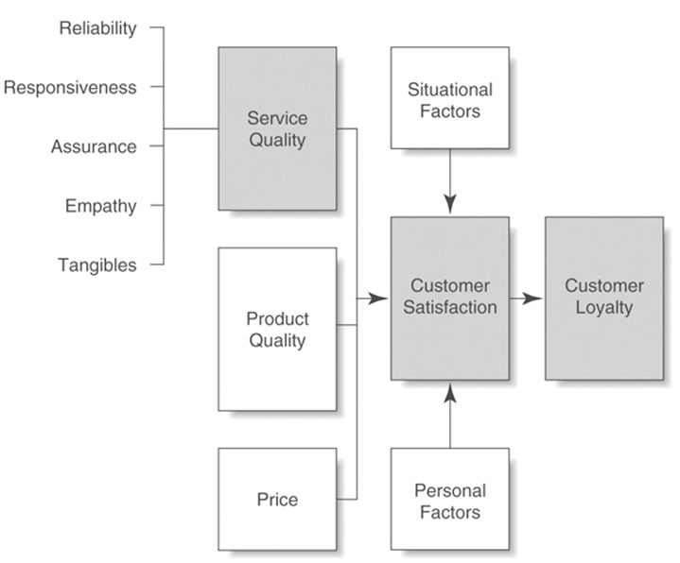Diagram: Customer perceptions of quality and customer satisfaction Source: Lecturer Notes (2018)
Different factors impact on satisfactions of the customers which are service quality, product quality, service features, particular products, price, , attributions for service success or failure, customer emotions, fairness or equity perceptions, family members, other consumers, coworkers, situational factors, personal factors (Scott, 2014).

3.2 How Sainsbury’s meet customer expectation
The capability to observe internal and external customers needs is significant. In order to achieve product quality through the organization, each person in product quality chain should be skilled to answer various questions about each chain of customer-supplier: planned to provide products which will assure the hope of the customers. The major considerations for enlisting Dairy products in Sainsbury’s are:-
Safety - All quality goods should observe their quality and standards through near life.
Quality - The goods should taste delicious and look great.
Legality - All valid needs, for example, labeling and compositional standards should be observed.
Customer Focus - goods will be selling if there is the need of customer for employees and they provide an athletic for function solution.
Standards of produce make sure that Sainsbury’s all vegetables, salads, fruits and horticultural goods have maximum standards of quality and safety of foods. They deal with labor standards and environmental considerations.
Codes of Practice use from manufacture; from raw materials selection to packaging and harvesting them and Sainsbury’s stores distribution. They cover the design and maintenance of buildings and processing equipment including field rigs. The personnel training and welfare engaged in process of production. It also focuses on considerations of the environment in the Choice of nature. Sainsbury’s discusses with Professional Associations, industry bodies, environmental experts, experts of food safety to counsel on production aspects. Sainsbury’s searches for recommendation with the business growers and suppliers when approving what business standards may be gained.
- Ethical Standards
- Quality
- Nature of Sainsbury’s

3.3 Quality management process
Quality Management concentrates on relationship outcome among the suppliers and internal and external customers. These customers are known as the quality chains and they may be wrecked at the point by one piece or one individual of apparatus not demanding the customers’ requirements. In every business, there is one major element and that is Customers. Whatsoever the organization can be, but this may exist only when this may accomplish customers needs and requirements. Sainsbury’s brands are containing the similar reason for accomplishment which they do care for customers and it consumers are loyal and committed to them (Sc0tt, 2014).

Approach to quality management at Sainsbury’s

Sainsbury’s concept is '100% customer satisfaction and without any defect'. Each good arrives under the checks of the quality to give the best services and products and customers value of money. Quality is measured through supply chain. From suppliers to customers is located in business store. Management of operations does not manage the total company. It mainly focuses on its business unit production rather than IT, HR or Finance. It engages the business performances to distribute and produce services and products (Sainsbury’s Annual Report, 2015).
Quality management is one of the major ideas to be maintained by Sainsbury’s. It helps the business to manage the people and business processes in order that the satisfaction of the customer may be gained. Satisfaction of the customer is the main significant in business of the Sainsbury’s. Sainsbury’s maintains its business total quality concept in several methods:-
Prevention: - This is the best to decrease the defected products manufacturing rather than discover of defects in the products.
Zero defects:- the major purpose of the Sainsbury’s is to manufacture the products those are defect free and decrease the level of defect.
Getting things right at first: - This is good not to manufacture proper products rather than not to produce the defective products.
Quality involves everyone: - Sainsbury’s uses the concept not only the department operation and production but this engages other organization business units, for example, human resource, finance and marketing.
Continuous improvement: - it searches for the development of processes and products.
Employee involvement: - it engages the staffs which are engaged in the processes of the operation and production to receive the feedback from the customers.
Sainsbury’s provides the possibility to staffs to be engaged in process of production because they are really engaged in products manufacturing.

3.4 Competitive priorities
Competitive priorities include 6 elements, such as, quality, low cost, flexibility, delivery time, dependability and speed (Slack N, Chambers S). By containing these elements Sainsbury’s achieved the competitive advantage and accomplish the customer’s needs. These are described as below:

Low Cost: Sainsbury’s bargains with supermarkets with best products promotional products. Therefore, consumers achieve lower prices goods but having same product quality.

Quality: Sainsbury’s product quality is best in supermarket. It provides the quality goods and products to its customers (Williams, 2015).

Speed and Delivery Time: Sainsbury’s is effectual in product delivery time. Sainsbury’s small scale operations are accessible at towns and cities every corner under Metro and Express brand name.

Dependability: Sainsbury’s applies differentiation policy and economic scale in promotional distribution and activities, product development. In that it achieves customer’s dependability. They make their goods not same as their competitors and become benefited. Undifferentiated services and products can origin the customer switching (Williams, 2015).

Flexibility: grocery market of UK has gained little competitors, in that Sainsbury, ASDA and Sainsbury’s are the popular and well-known brand and gained 70% market shares. Sainsbury’s brands have made their business brand image because of their one stop shopping as well as operation efficiency. Sainsbury’s gives the better customer handling, wide range of stock, new lines introduction and capability to escape of stock gives elasticity to it (Robert, 2015).

3. 5 Service quality
Service quality is judgment of customers in general quality of the service given concerning the quality which was needed. Assessments of service quality are created on decisions of interaction quality, physical environment quality and outcome quality. Jonshon et al. (2015) noted that, there are 5 service quality dimensions which give the business competitive advantages. These are assurance, reliability, empathy, responsiveness and tangibles. Reliability is the capability to act the accurate service accurately and dependably. Assurance is staffs courtesy and knowledge and their capability to motivate confidence and trust. Tangibles are equipment, personnel appearance and Physical facilities. Empathy is individualized attention, caring the business gives its consumers. Responsiveness is enthusiasm to support the consumers and give punctual in the service.

3.6 Quality programs
The major business strategies of Sainsbury’s on inner bound the market of Irish in 1997 was in order to make strong relationships with Irish supplier-base to develop business amounts with suppliers of Irish making by Sainsbury’s brands products and quality products for Ireland stores and for export to the UK and to the wider Sainsbury’s Group (Sainsbury’s Annual Report, 2015).
Ireland Sainsbury’s’s locate a twelve strong group of trade development, technical and qaulity workers to work with organization’s supplier construction their skills of product development and expertise of business, to support them do well in the quickly changing in business environment. More than 130 organizations have got advantage from program to date, such as, Country Crest, Bewleys, , Glanbia, Gold star Meats, Dublin Meath Growers, Lir Chocolates, Irish Yoghurts, Shannon Minerals and Largo Foods (Williams, 2015).
These 130 decided suppliers of Sainsbury’s Irish brand now supply more than 1,000 non-food and food items to Sainsbury’s Ireland and to Sainsbury’s Group, such as, ham, eggs, beef, rashers, milk, fish, bread, cheese, bottled water, burgers, ice cream, biscuits, the full range of Irish vegetables and fruits and jams. Only twenty organizations were allowed suppliers in 1997.

3.7 Training and Development programs
As vigorous and innovative organization in extremely competitive retail industry atmosphere, progression and learning from in the organization is major to business operation. Training makes an important development of employee section, concentrating on the major company main concern of repeatedly developing Sainsbury’s service to consumers. Sainsbury’s help the people to complete their prospective throughout contact to programs of training and major skills works, such as, presentation skills, effective meeting management, root cause analysis, influencing, communication skills and personal efficiency. All employees have usual reviews or performances with their business managers and supports PDPs (personal development plans), achieving clear individual performance purposes. It makes sure that all employees have the correct skills to perform their works (Dyche, 2015).

3. 8 Supply Chain Labor Standards
This is purpose to perform correctly in business trading and commercial performances. The staffs safety and welfare of business suppliers is very important. It expects business all suppliers to increase honest and fair communication to their staffs and all of them with whom they can do their business. Sainsbury’s has established the new course for the practical managers in order to increase their ethical issues awareness and welfare of staffs in supply chain (Scott, 2014).

3.9 Benchmarking
Conformity with various elements of major components will guide to help of the proposed standard throughout the proposal framework and following achieving by retailers. When the food standard is benchmarked productively, acknowledged is that standard. The compliant benchmarked standard of food safety may be used by food suppliers through the total supply chain, upon contract with business retailers, when explaining agreements for products servicing. The benchmarked standards application to specific goods will be the suppliers and retailers maturity (Scott, 2015).

3. 10 Staff feedback

Nothing is significant to Sainsbury’s to gain the customers trust. That is why Sainsbury’s has experts team who ensure that each product of Sainsbury’s is not only ethically, legal and safe sourced, it is the great value and quality that Sainsbury’s customers suppose (Dyche, 2015). The cross-departmental survey target regarded several values that employee themselves required to observe in Sainsbury’s Company: job satisfaction, Values associated with customer service, fairness and integrity, Trust, Open and honest communication teamwork, Motivation, Quality standards, Profitability, continual improvement and commitment and success.
Irish food buyer in the world "Viewpoint" is Ireland's Sainsbury’s yearly employee surveys that give all the staffs in communicating channel their opinions and views and inform management of the organization on how belongings can be completed better and easier for employee. Areas restricted contain: manager and current role satisfaction and simplicity of role reason satisfaction level with progression of career, benefits, pay and common demographics (Scott, 2015). Every line manager gains the report on groups in general responses and them effort with the team to deal with areas that the survey has decorated as gaining awareness. Over 90% of staff contributes to Viewpoint surveys.

4.0 Conclusion
This assignment focuses on to major parts. The first part critically analyzes the factors that influence your organizations ability to maximize customer value. The first part includes successful CRM, recruit the right accurate people, frontline CRM, empower employees to act, staff motivation and staff satisfaction, capturing matrix and feedback channels etc. In this assignment, how Sainsbury’s is managing its CRM is also described. This part also describes CRM technologies. It also describes Customer perceptions, expectation of Quality and Customer Satisfaction.

References

Sainsbury’s (2018) Working in Product Quality and Development. Available at: https://www.Sainsbury’s-careers.com/office/product/product-quality-and-development/. [Accessed on: 10 April 2018]

Mathew et al (2014) CRM Fundamentals. 5th Ed. London: Oxford University Press

Baran (2014) CRM: The Foundation of Contemporary Marketing Strategy.3rd Ed. London: Oxford University Press

Greenberg (2014) CRM at the Speed of Light, Fourth Edition: Social CRM 2.0 Strategies, Tools, and Techniques for Engaging Your Customer. 4th Ed. New York: Simon & Schuster

Lauby (2014) Motivating employees. 4th Ed. New York: Simon & Schuster

Robert (2014) The Big Book of Motivation Games. 3rd Ed. New York: Simon & Schuster

Scott (2014) The Employee Satisfaction Revolution: Understanding and Unleashing the Power of a Satisfied Workforce. 4th Ed. Harlow: Oxford University Press

Dennis (2014) The Fundamentals of Quality Management. 5th Ed. New York: Simon & Schuster

Hubert (2014) Total Quality Management. 4th Ed. New York: Simon & Schuster

Solomon (2015) Consumer Behavior: Buying, Having, and Being. 12th Ed. Harlow: Oxford University Press
Hoyer et al (2015) Consumer Behavior. 6th Ed. Harlow: Oxford University Press

Williams (2015) Connected CRM: Implementing a Data-Driven, Customer-Centric Business Strategy. 5th Ed. Harlow: Oxford University Press

Dyche (2015) The CRM Handbook: A Business Guide to Customer Relationship Management. 4th Ed. Harlow: Oxford University Press

Buttle (2015) Customer Relationship Management. 4th Ed. Harlow: Oxford University Press

