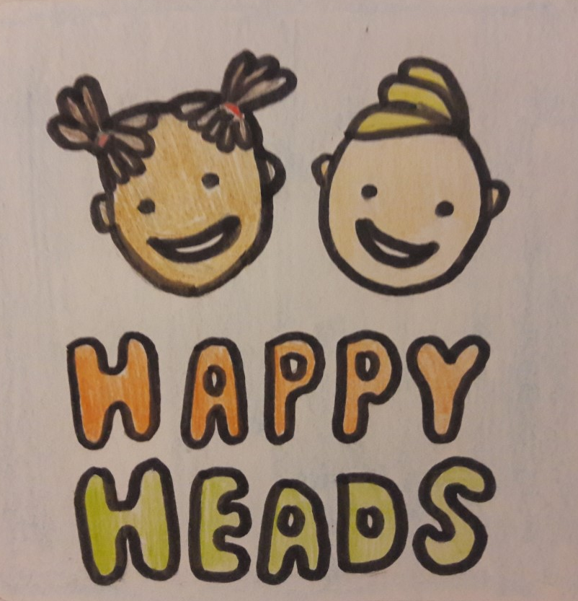
(Source: Bennett, 2018)

Part 1
Introduction
According to Mental Health Foundation (2016) the specialist Child and Adolescent Mental Health Service in Wales (CAMHS) is under more pressure than it has ever been in previous years. From 2010 to 2014 there was a 100% increase in demand. The total number of CAMHS referrals to treatment in Wales near doubled in those four years from 1,204 referrals in April 2010 to 2,342 referrals in June 2014. Young people awaiting outpatient’s treatment has the highest numbers compared to adults. According to the Welsh Government (2018) a large quantity of patients have to wait up to and over 56 days to be assessed; delaying them from being able to access crucial support services. McKeown (no date) identifies that budget cuts of £85 million since 2010 have impacted on mental health services offered to young children. Therefore, it is essential that other methods of support are made available to young children because of the barriers to accessing vital support services for mental health conditions.

My Idea
In the last few years there has been a proliferation of apps to support people with mental health conditions. However, none of them are specifically aimed at young children and all of them concentrate on just one mental health condition (McKeown, no date). Considering that a large number of young children with mental ill health may be suffering from more than one mental health condition at a time, I would like to develop an app specifically aimed at supporting young children who have one or more of mental health conditions; anxiety disorders, depression, panic disorders and/or social phobia. The app will not only be developed to support young children who are receiving treatment and services for mental health conditions, but also to bridge the gap between referral and treatment.

The name of the app is Happy Heads. I have chosen this name because I think it is relatable to children. The idea is to separate the app into different parts, with sections to support the mental health conditions previously noted. Upon opening the app a home screen will pop up with various options to suit the child’s needs at that time. There will be a section dedicated to age appropriate videos of exercises for controlling panic and relieving the fear of panic and panic attacks. This section will aim to help young children to calm and control their breathing when they experience panic. It will guide the child through the panic attack. Another component of the app is a feelings journal where depending on the child’s ability they can jot down their feelings, and/or select a labelled emoticon that demonstrates how they are feeling, for example, sad, angry, lonely. In this section there is also the option of selecting images that demonstrate what they have done during the day and how it made them feel. Depression and mood changes are also supported through incorporating computerised cognitive behaviour therapy with the opportunity to communicate with online therapists and a section dedicated to managing mental wellness by providing children with an area to build their own profile of reasons to feel better. Another component is a dedicated area for uploading pictures and images that make the child feel happy (Mind, 2018).

Art therapy is incorporated into the app with a designated section for drawing digital pictures. I think this is an important element of the app because art expression is a form of non-verbal communication. It may be suitable for very young children using the app or those who may not be able to articulate emotions, thoughts, sensations or perceptions (Malchiodi, 2016). Adults involved with supporting the mental well-being of the child, such as, parents and carers are advised to review and analyse the data within the app so that they can support the child with their mental health recovery. For those children who find it difficult to articulate their feelings, it is essential that practitioners review the information stored in the app.

Why is Happy Heads Innovative?
According to market research my idea is innovative and unique because there is nothing like it on the market. There are no apps currently available that are specifically aimed at supporting young children’s mental health (Marsh, 2016). I think that the idea of an app to support young children’s mental well-being is especially appealing because apps are available 24 hours a day 7 days a week (Shelton, 2018). The app may be beneficial because it is a mobile support system that can be used to reassure young children and their families at any given time when there is no other support available (Corless, 2015). Although there are apps available that can be used generally to support the mental health of a range of ages, such as, Silvercloud, RCPsych Mental Health App, Five Ways to Wellbeing and Wrap, they are too complicated for young children to use. Therefore, Happy Heads in comparison to other apps Happy Heads may be more effective for supporting young children’s mental health because it is specifically aimed at young children and it is accessible to them (McKeowen, no date; Mind, 2018).

How Does Happy Heads Link to the Early Years?
Happy heads links to early years development as it is aimed at benefiting and supporting young children’s emotional and mental well-being and this links to the foundation phase framework in Wales (Department for Children Education Lifelong Learning and Skills, 2015). Happy Heads links to the Digital Competence Framework; through accessing the app children may be supported in the development of digital skills which can be applied to a wide range of subjects and scenarios (South West Grid for Learning, 2015).

What are the Benefits of Happy Heads?
Patel et al. (2007) suggest that the Happy Heads app may benefit children and support them with mental health conditions when other services fail. There is a shortage of mental-health professionals, low capacity and motivation of non-specialist health workers to provide quality mental-health services to young people and stigma associated with mental disorders which all impact on preventing children from receiving the treatment they need for mental health conditions. Furthermore, Hert et al. (2011) emphasise the need for additional services for supporting young children’s mental well-being because those who live with severe mental illness are more likely to face chronic medical conditions and a shorter life span. However, it is important to understand that whilst Happy Heads may be useful, it is not a replacement for medical treatment (Mind, 2018).
What are the Challenges and Barriers of Happy Heads?
Mental health apps may serve a purpose. However it is important to understand there is no regulation, no testing and little research about mental health apps and this is just one of several challenges; the development of the app, providing periodic updates to correct bugs and provide fixes, marketing the app, obtaining feedback and adjusting the app to perform better for user needs, developing the next app that builds on the initial release, for example, a multi-language app that does the same thing. Barriers include: adults who don’t like the app and may be reluctant to use it with the child, children with additional learning needs, limited access to mobile devices and/or internet.

Marketing
Marketing Happy Heads may be challenging. I plan on marketing Happy Heads through advertising it on social media, for example, Facebook, Twitter and Instagram to target parents with children of young children (Tas, 2017). I would advertise it on Mumsnet, Netmums and similar chatrooms. I would also gather a group of ‘super users’ to become ambassadors for Happy Heads so that they would talk about it in their networks. Super users could include representatives from mental health charities, head teachers and support workers. I would also advertise in mental health publications and websites; and send out press releases to them too. I would develop an app promotion website to advertise Happy Heads on the Web, creating an app explainer video to showcase the app’s features & benefits. I would get Happy Heads listed in specialist directories like the NHS Health Apps Library and by app store optimisation (ASO) to achieve better keyword rankings in the app stores (Geneticapps, 2018).

Stakeholders
The stakeholders are:
- the app developer
- the app marketing team
- professional persons who support and use the app
- children
- parents
- carers
- other family members

Why am I Best Placed for this?
I think I am best placed for this business idea because I personally have a lot of experience with mental health conditions. I grew up in a household where my father had numerous mental health disorders. Myself and both of my sisters have had depression and anxiety. Therefore, I have knowledge of how to manage different mental health conditions and an understanding of why it’s so important to seek treatment before mental health problems becomes difficult to reverse. I also have experience of working with young children with mental health conditions and I have taken the time to find support methods to suit each child. I understand the factors that contribute towards poor mental health, such as, biological factors, life experiences and family history. I have a broad knowledge of the negative impacts mental health conditions can have on future life chances. I really want to support young children in gaining positive mental health so that they can realise their full potential, cope with the stresses of life, learn and work productively and make meaningful contributions to their communities.

Part 2
Mental health problems are common in young children (Green et al., 2004). Mental health conditions are persistent with 50% of mental illness in adulthood beginning before the age of 15 years. Mental health disorders cause significant distress for young children and have a negative impact on future social relationships, education, occupational achievement and physical health. Young children who have mental health conditions are at an increased of developing additional mental health problems in adulthood (Woodward and Fergusson, 2001). According to Mental Health Foundation (2018) the emotional and mental well-being of young children is equally as important as their physical health. Good mental health allows young children to develop resilience so that they can cope with whatever life throws at them and develop into healthy and well-rounded adults. According to Fleming et al. (2016) online app interventions for mental health hold promise for increasing access to evidence-based treatments and prevention. Several interventions of this kind have been proven to be effective and acceptable in trials. Kumar et al. (2013) suggest that mental health apps have the potential to reduce the cost of health care and improve well-being in numerous ways.

Although evidence-based interventions are available for many child mental health problems, treatment services are limited and many children and adolescents either cannot or do not access appropriate help (Merikangas et al., 2010). Donker et al. (2013) identify the appropriateness of mental health apps for the benefit of young children’s mental health; significant reductions in depression and stress. However, Eysenbach (2017) identifies a challenge to the effectiveness of supporting young children’s mental health through the use of apps. There is currently insufficient research evidence to support the effectiveness of apps for children with mental health problems. Kumar et al. (2013) suggest that given the number and pace at which mental health apps are being released on app stores, methodological and rigorous research studies evaluating their safety, efficiency, and effectiveness are promptly required. Similarly, Huguet et al. (2016) give an overview of their content analysis of commercially available apps for depression and state that there is a concerning trend that downloadable apps do not reflect evidence-based treatment guidelines. Furthermore, Nicholas et al. (2015) state that the majority of existing mental health apps rarely cite source information and often lack privacy policies. Leigh and Flatt (2015) identify that this is evidenced in the now offline NHS App Library, in which only four of the 27 mental health apps included any evidence of patient-reported outcomes to verify their effectiveness. As such, the majority of mental health apps available for download are not supported by evidence-based research and may not follow evidence-based treatment guidelines.

Mind (2018) suggest that Happy Heads is innovative as there are no other apps currently on the market specifically aimed at supporting the mental health of young children. Similarly, National Health Service (2015) identify that existing apps aimed at supporting mental health are not age appropriate for young children and usually focus on one support mechanism alone. However, for the success of Happy Heads Fleming et al. (2016) recommend including children and therapists in the app design and development process to ensure mental health apps are user-centred and fit for purpose. Similarly, Department for Health (2001) emphasise the importance of the voice of the child when improving and developing mental health services in Wales. Every child has the right under Article 12 of the United Nations Convention on the Rights of the Child to have their voice heard in all decisions that affect them (Unicef, 2018). However, Carmarthenshire County Council (2018) identify that although children and young people with additional learning needs have a unique knowledge of their own needs and circumstances, finding out their views may be challenging. For example, very young children and children with severe communication difficulties may present as a real challenge for professionals when gathering individual opinions and views. But the principle of finding out the views of the child or young person for the app design and development is very important for its effectiveness. According to Children in Wales (2014) gaining the support of the All Wales Children and Young People’s Advocacy Providers Group when gathering young children’s views may be useful for removing this particular barrier.

Pennant et al. (2015) suggests that Happy Heads may benefit young children with anxiety and depression when other treatments are inadequate or inaccessible, emphasising that an app of this type has the potential for treating and preventing anxiety and depression in clinical and general populations of young people. However, further research is required to extend its use and establish its benefit to children. Richardson et al. (2010) suggest that some of the elements of Happy Heads are similar to computerised cognitive behaviour therapy which is beneficial to young children’s mental health, because evidence suggests that it is effective for treating depression and anxiety disorders. Kaltenthaler and Cavanagh (2010) identify several advantages of Happy Heads; considerable cost saving, quick access to psychological therapies, accessible to more people in a variety of settings than other mental health treatments, access to a consistent source of therapeutic expertise that can be readily updated, incorporates regular problem and symptom monitoring and feedback, and the support available is client-led. However, there are also potential disadvantages to Happy Heads app, such as, lack of face-to-face contact with counsellors and psychotherapists. Cuijpers et al. (2010) emphasise that although guided self-help for depression and anxiety disorders has been examined in many studies, it is not clear whether it is equally effective as face-to-face treatments. They conducted a meta-analysis of randomized controlled trials in which the effects of guided self-help on depression and anxiety were compared directly with face-to-face psychotherapies for depression and anxiety disorders. The results showed that online guided self-help and face-to-face treatments can have comparable effects which suggests that Happy Heads may be as beneficial as face-to-face treatments for relieving the symptoms of mental health conditions.

According to Department for Education and Skills (2015) Happy Heads supports several areas of development outlined in the Foundation Phase Profile. Personal and social development, well-being and cultural diversity; language, literacy and communication skills; physical development and creative development are all supported through the use of Happy Heads because when young children use the app it involves learning about themselves, communicating with others, using their imagination and using fine motor skills. Happy Heads is all about managing mental health conditions so that young children can develop to their full potential this involves gaining a self-identity and confidence. As their self-identity develops, children may begin to express their feelings, empathise with others and respect individuality. These challenges may expand their learning. In addition to links to the developmental areas outlined in the foundation phase framework, Happy Heads supports digital literacy. Identity, image and reputation, health and well-being, digital rights, licensing and ownership, online behaviour and cyberbullying come under the citizenship strand of the Digital Competency Framework (Learning Wales, 2018). Children may be supported in gaining these skills through the use of all sections of the app. Within the interacting and collaborating strand of the framework the aim is to support young children in gaining digital communication skills, collaborative skills and storing and sharing. Happy Heads supports the development of the skills outlined within this strand of the framework by the use of the feelings journal, the profile section, the section dedicated to uploading and storing pictures and by using Happy Heads as a means to communicate their feelings and if they chose to by collaborating with family members when storing images and making journal entries (Agored Cymru, 2018).

Gopalan et al. (2010) identify a barrier to the app; parents and professional persons who don’t like the app and are reluctant to use it. The effectiveness of Happy Heads for supporting young children’s mental health somewhat relies on interactions between the child and the adults in their lives. Especially for very young children who are not yet digitally literate or for children with additional learning needs. According to Kindsvatter et al. (2017) parents sometimes present their children for mental health treatment with a reluctance to try methods that they personally dislike even if they are valuable to the child. Yet, parental involvement is important because parents may not only be contributors to the problem that their children are experiencing, but the best resource to assist their children in developing positive mental health. However, Ingoldsby (2010) suggests that there are a few interventions to enhance parent engagement with the app and other mental health treatments; motivational interviewing, family systems, and enhanced family stress and coping support strategies at multiple points throughout the treatment programme.

Gebremichael and Jackson (2006) suggest a barrier to Happy Heads is children living in poverty who have limited access to mobile devices and computers. However, Farrington et al. (2014) argue that mental health apps are more accessible than ever, stating that poorer areas and countries have witnessed significant investments for, and the dramatic expansion of mobile coverage and usage over the past decade. Similarly, National Office for Statistics (2017) suggest that the majority of homes have access to at least one mobile device or computer. In 2017 90% of households in Great Britain had access to the internet, this suggests that they have a computer or mobile device. 73% of adults accessed the internet “on the go” using a mobile phone or smartphone. Unfortunately, children without access to the internet would be unable to benefit from Happy Heads. However, a suggestion would be to provide the child with a tablet they could during school break times.

Future research could include methodological and rigorous studies evaluating the safety, efficacy and effectiveness of mental health apps (Kumar et al., 2013). A future opportunity for the business is expanding the app for vulnerable adults and expanding the app as a beta model to include languages relevant to European migration. Ultimately, expanding the app for language specific countries worldwide.

