MANAGEMENT AND ORGANISATIONAL BEHAVIOUR

BMIH5004

SHAHEDA AHMED

2109892

LECTURER JULIA AULT

CONTENTS

EXECUTIVE SUMMARY………………………………………………………….3

INTRODUCTION……………………………………………………………………4

ORGANISATIONAL STRUCTURE CULTURE AND GOALS……………………4 - 6

CHANGE INITIATIVES AND IMPACTS……………………………………………6

STRATEGIC DIRECTION……………………………………………………………7

CURRENT BUSINESS PERFORMANCE………………………………………….8

CONCLUSION…………………………………………………………………………9

HILTON HOTEL AUDIT CASE STUDY

EXECUTIVE SUMMARY
This is an audit case study for Hilton hotel in this report we critically evaluated each aspect of the hotel in terms of their organisational structure the goals and culture of the hotel, what changes they have initiated and the impacts it has had and where Hilton is going, which strategic direction are they taking and how it will be achieved, there are areas that need improving but mostly just a general overview to see that every goal is aligning well and committed to reaching targets set. And the business revenue, has it reached pre pandemic levels as hospitality had the most hit during Covid-19, and see improvements that need to achieve this.

INTRODUCTION
In this report we will analyse, and critically evaluate Hilton Hotel, at both corporate and individual levels, using these key topics.
- Organisation structure, culture, and goals.
- Recent change initiatives, their impact and how well these were managed.
- The organisations strategic direction and current business performance.
In the Audit case study of Hilton Hotel, we can find out their culture and goals, what they have changed since the pandemic, how did it impact the hotel, was this managed well, where are they going in terms of the future and how well they are performing currently. The general purpose of an Audit is to help hotels improve their internal and external business dealings, help hotels streamline cash flow, and calculate profits and costs of different areas of the hotel. (Gibson, 2021)
Hilton hotels and resort is a global brand of hotels, founded by Conrad Hilton in 1919, with over 6,800 properties across 94 countries from 2019. Many of Hiltons Hotel is owned by a franchise or individual operator and fall under different brand names. These are luxury, upper upscale, upper, upper midscale, and midscale. (Organimi, n.d.)

ORGANISATIONAL STRUCTURE, CULTURE AND GOALS.
An organisational structure outlines how an organisation relays information and directs activities to achieve the goals of the organisation, it also determines how information flows through each level of a company. For example, in a centralised structure decisions will flow from the top down like a pyramid following a chain of commands. and a decentralised structure will give the decision making to each relevant level and department within the company, with an appointed manager. (Kenton, 2023)
An example of a company with a centralised structure is Apple where all its decision making comes from the Tim Cook, the chief executive officer who took the role of leadership after the death of Steve Jobs. (Cooper, Graybeal and Franklin, 2019) The advantages of this include a clear chain of command, focused vision, reduced costs, and quick implementation of decisions. (CFI Team, 2020)
Whilst an example of a company with a decentralised structure is Johnson and Johnson, with over 200 units but all function independently with an assigned manager for each unit which makes decision making on the spot quicker, and gives employees increased motivation. (Bailey, 2021)
Hilton’s organisational structure is hierarchical due to the size of its company with 18 brands serving over 140 million guests in 2015 alone. But its better described as a divisional structure and this is divided into three categories. Ownership division, management and franchise division, time share division. (Dudovskiy, 2016) The first two divisions owner ship, and management and franchise fall under the leadership of Hilton hotels whilst the time share division fall under the management of Hilton Grand Vacations a separate company trading from 2008. (Organimi, n.d.)
The Hilton approach today is different to what it was a few years back, before it was recruiting to fill a gap, today is about culture and how everyone works together. (Lambrano, 2020a)
Hilton’s culture is defined by core values that the employees practice every day, these core values are as follows:
- Hospitality: passionate about delivering exceptional guest experience.
- Integrity: doing the right thing all the time.
- Leadership: leading the way in the industry and the community.
- Teamwork: team players in everything that is done.
- Ownership: owners of your own actions and decisions.
- Now: operating with a sense of urgency and discipline. (Henson, 2021)
These values are recognised by 99% of the Hilton group around the world, this is a massive achievement from where Hilton was years before. Establishing theses values was just the beginning, spreading the message to corporate and individual properties has been a large task for this company, but whenever Hilton corporate had a meeting, their values would be put up not only for employees but for visitors too, to remind them of what Hilton believes in. Hilton kept driving their core values mission and vision, so everyone understood the message. (Lambrano, 2020b)
The culture transformation at Hilton is not the effort of just one person, it required synchronised teamwork executed simultaneously around the globe, and coordination between corporate offices and hotels. The required understanding of people’s motivation and cultural background is never easy for any company however in Hiltons case, Chris Nassetta (Chief Executive Officer of Hilton), achieved this by finding and creating the best possible team to undertake this large task. (Lambrano, 2020b)

CHANGE INITIATIVES AND IMPACTS
Covid 19 has had an extraordinary impact on the hospitality industry, and during that period Hilton developed a number of initiatives, to ensure all their guests feel safe when visiting the hotel. The importance of this has increased vastly since the Covid pandemic. Hilton teamed up with Lysol and Dettol, to develop Hilton clean stay, an enhanced cleaning protocol, to extend their health and safety measures further. This is an initiative that has stayed post pandemic as it has shown guests that Hilton is doing everything to keep guests safe and has had a positive impact. This initiative has been managed by teaming up and partnering up with mayo clinic and RB makers of Lysol and Dettol. (Skift, 2021).
Clean stay has changed to only the luxury brands of Hilton, which of course means some guests are not as satisfied and cleaning of your room is something you have to ask for on request at the front desk. The idea of this is principally for Hilton to save money leading to profitability for the hotels therefore it is sustainable, as guests are not needing extra linen or towels unless requested there for the company saves on laundry services. The United States found that moving away from housework and only doing it upon request will lead to a 39% reduction in the number of employees that will be needed. (Ollila, 2021)
A large proportion of Hiltons revenue comes from corporate events and conferences, which has seen a massive disruption during Covid 19, going forward now Hilton will take a hybrid structure, where attendees can choose to attend an event online or in person. Hilton is offering high speed bandwidth, cameras and any other technical requirements needed to execute this process. (Mixon, 2021) This is a change initiative that is welcomed not just at Hilton, but in offices and other hotels research has shown that peoples work life balance has changed but in a good way people have been able to reduce their commute time, whilst others were able to relax more (37%) exercise or cook dinner (33%) because of hybrid work, this is a small part of a person’s daily routine but has a huge impact. This new model of working is giving people the flexibility and has improved their productivity. (Premier Inn, n.d.)

HILTONS STRATEGIC DIRECTION
Travel with purpose is Hiltons ESG strategy to increase social impact and significantly reduce environmental footprint by 2030.Hiltons 2030 goals are closely aligned with the United Nations sustainability developments goals, to achieve these goals Hilton hotel uses Light stay an ESG management platform. (Hilton, n.d.)
Hilton’s climate goals are reducing greenhouse gas emissions by 75% in its managed hotels an upgrade from its 61% target and 56% from its franchised hotels. Hiltons social impact commitments are to create 5 million career growth opportunities for employees and communities focusing on the underrepresented groups by 2030. (Kerencheva, 2022)
Hilton has forged strategic partnership with airlines, car rental, and credit card companies, this will create value for guests and will provide extra revenue for the hotel (The Strategy Story, n.d.)
Hiltons financial performance in 2022 Hilton generated $8.7billion in revenue and $2.1 billion in operating income. (The Strategy Story, n.d.)
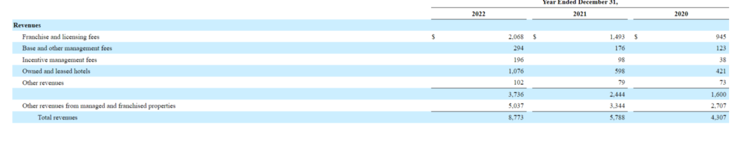
Hilton’s strategy to inspire trust and to bring confidence in travel and their brand comes in three categories product innovation, marketing creativity and customer connection. (Grano, 2021)
Hilton has been focusing on AI- led innovation as part of its digital strategy, whilst being involved in several strategic partnership’s collaborations and technology developments over the past few years for example Hilton introduced Xiao, Xi and the AI chatbot, this provided guests with relevant travel advice, tourist attractions, hotel amenities and dining recommendations. (Global Data, 2022)
The way forward is through technology according to a new Hilton report people are now wanting a frictionless flow throughout their travel journey in 2023, through self-service options which offer good choices, convenience and control whist still giving the guests the impression of a personalised human touch. Hiltons central reservation system which was updated in May 2020 was the first of its kind to run all reservations solely through the system, this significantly reduced in house costs and boost revenue management, and with another three added and more to come, for example with the new EV charging filter it resulted in 30% of users completing it online. (Stories From Hilton, 2023)
With all major big hotel groups improving technology and moving with the times it makes sense for Hilton to be innovative and compete against its rivals and have strategies in place to guide them through the process.

CURRENT BUSINESS PERFORMANCE
Hilton marked better than expected performance, with an international travel resurgence with earnings before interest, taxes, depreciation and amortization (EBITDA) of $448m for the first quarter, with a revenue per available room (RevPAR) increase of 80.5% for the reported quarter. With all segments doing well and navigating the pandemic and positioning the company for the future which in turn should see growth opportunities that lie ahead. (Hawkins, 2022)
Hilton’s revenue for the quarter ending March 2023 was $2.293B a 33.24% increase.
This revenue increase shows that Hilton’s current management has been working especially well, as during Covid the company’s revenue was one of the major factors effected.

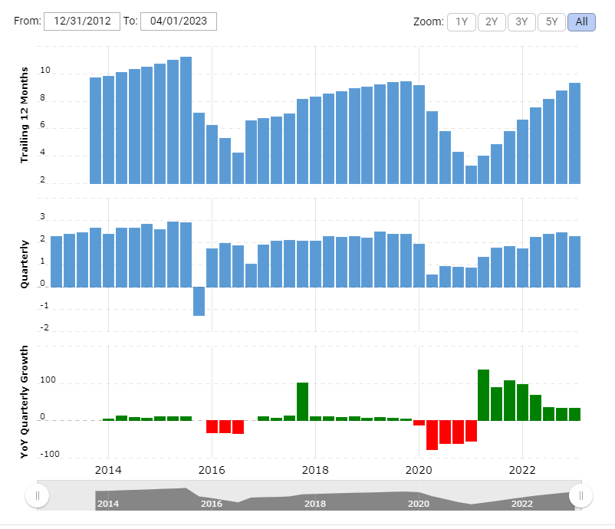
(Macrotrends, n.d.)

CONCLUSION
In conclusion this report has shown us that Hilton is well positioned as the top hotel, with their organisational structure culture and values embedded in the employees’ visitors and guests, with the change initiatives it has impacted the hotel well with growth in revenue and the strategic direction is a step forward to making the hotel profitable and give the guests the experience they are craving from hospitality. Recommendations for Hilton management would be to improve their approach to cleaning on request which has been mentioned by many articles with a lot of negative feedback. Regularly looking back on the goals set and keeping a close eye on customers wants and needs will help navigate the hotel and keep up with the consumer trends. All of this is very important in both management and organisational aspects for any hotel group and in this case Hilton.

Bibliography

Bailey, K. (2021) ‘Three companies decentralising with WeWork, WeWork, 11th March. Available at: https://www.wework.com/en-GB/ideas/workspace-solutions/case-studies/three-companies-decentralizing-with-wework (Accessed: 11 June 2023).

CFI Team (2020) ‘Centralization’, Corporate Finance Institute’, 12th July. Available at: https://corporatefinanceinstitute.com/resources/management/centralization/ (Accessed: 15 June 2023)

Cooper, D., Graybeal, P. and Franklin, M. (2019) Principles of Accounting, Volume 2: Managerial Accounting: OpenStax

Dudovskiy, J. (2016) ‘Hilton Organizational Structure’, Business Research Methodology, 27th August. Available at: https://research-methodology.net/hilton-organizational-structure/ (Accessed: 11 June 2023).

Gibson, A. (2021) ‘How to Perform a Hotel Revenue Audit in 4 Steps’, Upstay, 07th April. Available at: https://www.upstay.tech/how-to-perform-a-hotel-revenue-audit-in-4-steps/ (Accessed: 10 June 2023).

Global Data. (2022) ‘Hilton Worldwide Holdings Inc (HWHI) – Digital Transformation Strategies’, GlobalData, 27th June. Available at https://www.globaldata.com/store/report/hilton-worldwide-holdings-inc-enterprise-tech-analysis/#:~:text=Digital%20Transformation%20Strategies,-Hilton%20has%20implemented&text=Hilton%20is%20using%20predictive%20analytics,better%20and%20identify%20profitable%20customers (Accessed: 15 June 2023).

Grano, M. (2021) ‘Social Spotlight: Hilton’s pandemic strategy proves the business value of social’, Sprout Social [blog]. 22nd April. Available at: https://sproutsocial.com/insights/social-spotlight-hilton/ (Accessed: 10 June 2023).

Hawkins, E. (2022) ‘Hilton marks ‘better than expected’ performance as travel demand returns’, CityA.M., 03rd May. Available at: https://www.cityam.com/hilton-marks-better-than-expected-performance-as-travel-demand-returns (Accessed: 15 June 2023).

Henson, A. (2021) ‘CareerBliss on Culture: Hilton Worldwide Has Culture of Hospitality, Career Blis, 07th January. Available at: https://www.careerbliss.com/blog/careerbliss-on-culture-hilton-worldwide-has-culture-of-hospitality/ (Accessed: 12 June 2023).

Hilton (No date) Our Approach. Available at: https://esg.hilton.com/our-approach/ (Accessed: 14 June 2023).

Kenton, W. (2023) ‘Organizational Structure for Companies With Examples and Benefits’, Investopedia, 16th March. Available at: https://www.investopedia.com/terms/o/organizational-structure.asp/ (Accessed: 11 June 2023).

Kerencheva, E. (2022) ‘Hilton Sets Emissions Reduction Goal for Hotels’, ESG Today, 03rd August. Available at https://www.esgtoday.com/hilton-sets-emissions-reduction-goal-for-hotels/ (Accessed: 14 June 2023).

Lambrano, L. (2020a) ‘A Brief History of the Corporate Culture Transformation at Hilton — Part 2 | Alignment’, Medium, 18th May. Available at: https://libardolambrano.medium.com/a-brief-history-of-the-corporate-culture-transformation-at-hilton-part-2-alignment-3efb8e9af982 (Accessed: 12 June 2023).

Lambrano, L. (2020b) ‘A Brief History of the Corporate Culture Transformation at Hilton’, Linkedin, 8th May. Available at: https://www.linkedin.com/pulse/brief-history-corporate-culture-transformation-hilton-lambrano-ms-1e (Accessed: 12 June 2023).

Macrotrends (No date) Hilton Worldwide Holdings Revenue 2011-2023 | HLT. Available at: https://www.macrotrends.net/stocks/charts/HLT/hilton-worldwide-holdings/revenue#:~:text=Hilton%20Worldwide%20Holdings%20annual%20revenue,a%2034.39%25%20increase%20from%202020 (Accessed: 14 June 2023).
Mixson, E. (2021) ‘Inside Hilton Hotels Post-Pandemic Digital Reinvention’, Intelligent Automation Network, 05th November. Available at https://www.intelligentautomation.network/transformation/articles/inside-hilton-hotels-post-pandemic-digital-reinvention (Accessed: 14 June 2023).

Ollila, J. (2021) ‘Hilton “CleanStay” Ends & “DirtyStay” Begins’, LoyaltyLobby, 08th July. Available at https://loyaltylobby.com/2021/07/08/hilton-cleanstay-ends-dirtystay-begins/ (Accessed: 13 June 2023).

Organimi (No date) Hilton’s Organizational Structure. Available at: https://www.organimi.com/organizational-structures/hilton/#:~:text=Hilton%27s%20organizational%20structure%20can%20be%20described%20as%20divisional (Accessed: 10 June 2023).

Premier Inn (No date) Working from Hotel – The new meaning of WFH. Available at: https://www.premierinn.com/gb/en/business-blog/hybrid-working.html (Accessed: 14 June 2023).

Skift. (2021) ‘5 Reasons Why Hilton Continues to Grow Its Global Footprint, Despite Covid-19 Challenges’, Skift, 25th February. Available at: https://skift.com/2021/02/25/hilton-grows-global-footprint-despite-covid19/ (Accessed: 13 June 2023).

Stories From Hilton. (2022) ‘From Digital Keys to Contactless Payments, Here’s How Hilton’s Consumer‑Centric Tech Innovations Are Delivering a Frictionless Travel Experience’, Stories From Hilton, 17th January. Available at https://stories.hilton.com/innovation/hiltons-consumer-centric-tech-innovations-delivering-frictionless-travel-experience (Accessed: 15 June 2023).

The Strategy Story. (No date) ‘Hilton SWOT Analysis’, The Strategy Story [blog]. Available at: https://thestrategystory.com/blog/hilton-swot-analysis/ (Accessed: 10 June 2023).

