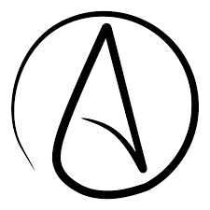

The Sunday Assembly and the rise of Atheism in the United Kingdom.
  - An analysis of the rise in Atheism seen in the uk with regards to the 2011 cencus.
Eilian Jones |Atheism and Non-Belief: From early atheist to the atheist church. | 15/12/18

Introduction.
This report will analyse the rise in Atheism within the United Kingdom. It will include an analysis of the 2011 census data and discuss the impacts this increase has had on life within the United Kingdom.
The purpose of this report is to explore the significance the rise of Atheism has had on the United Kingdom which historically has been classified as a Christian country with its morals and values following such tradition.
In order to complete this report, I will consult numerous newspaper articles, the 2011 census and multiple forms of academic writing such as journals, books and podcasts.
Background information.
Michael Martin provides two forms of Atheism which can be outlined below.
Negative | Positive
“Someone without a belief in God (who) need not be someone who believes that God does not exist.” | “An atheist is not simply one who holds no belief in the existence of a God or gods but is one who believes that there is no God or gods.”
These are the definitions of Atheism which shall be used in order to provide a concise understanding through the document. I have chosen to provide these as definitions as they encompass both forms of atheism. Those who believe there is no God, and those who do not believe in the existence of a God or gods therefor elaborating on the negative definition provided.
Atheism as a school of thought can be traced back to the Greek society pre-Christian period 500-300 (Before Chronological Era) BCE where Anaxagoras a Greek philosopher famous for his early scientific theories, claimed the sun was a mass of red-hot metal. Therefore, going against society at the time as religion and state were closely entwined. This was the first recorded entry in a dialogue which would continue discussing the themes of religion and science in the 5th Century BCE
In the early Christian period, the term Atheist became known as a way in which to describe a person’s enemy. In the Roman period were pagan religion and polytheism was profound, refusing to worship multiple deity’s was seen as uncommon and therefor classed as an atheist due to practitioners monotheistic beliefs. As a result, many took offence to the beliefs set out within Christianity therefor causing some spasms of imperial persecution and philosophical attacks by those such as Celsus.
By the Twentieth Century, Atheism and its varying school of thought caught more traction with broader philosophies such as humanism, nihilism and Marxism. Advocates for atheism such as Bertrand Russell rejected the belief in any form of God. In addition J.J.C. Smart also argued that God’s existence was neither logical nor necessary, whilst John Dewey argued the natural world could be the basis of everything therefore a creator being could not be held accountable for the universe.
The works of Marks and Engles highly influenced the early russion Soviet Union. Soviet Russia became the worlds first avowedly atheistic state despite there being high amounts of catholic and Jewish movement across the country. Later the policies of Stalinism turned towards repression of religion, often by violent means, which is not uncommonly seen within communistic government. The state also oppressed organized religion in a whole. This was made policy a policy which can be seen across all communist states such as the Peoples Republic of China, and Mongolia. In 1967, the Albanian government under Enver Hoxha (08/11/1941 – 11/04/1985) closed all religious institutions and declared Albania the world’s first officially atheist country. By 1970 all counties under the soviet union’s influence within eastern Europe were effectively atheist. Although some of the atheistic efforts made by the Soviet Union and Chinese communist government negatively effected the image of atheism
I would suggest that it is here where the clearest flip in the social standing of atheism is most clear. It is here where persecution of the state made a drastic flip between persecuting the views of believers and non-believers.
Atheism today is much changed from its grassroots with its ever growing following as after the Terrorist incident on the eleventh of September 2009 in the United States the faith of many Americans and those of other nationalities was challenged. Whilst many stated the study of religion became more important following the incident, some still argue that religions are not relevant in todays society. Those who classified themselves as atheist before the attack became more prevalent and vocal about their ideals, an example would include the publishing of Richard Drawings’ “The God Delusion” which has pushed boundaries with its thought provoking and intuitive ideas.

Cencus Data.
Each decade in the United Kingdom a general census is conducted In order to provide a complete overview of the United Kingdom allowing analyzation to be conducted between groups. The data collected is also use by the government, academics, businesses and various organizations in order to provide a representation of the population, employment, income, forms of housing and many more options.
The graph below shows the percentage of different religions seen in England and Wales according to the 2011 data collection set.
From this chart we can see that whilst Christianity in its multiple forms can still be seen as the dominant form of religion within the UK according the statistics at 59.3%. No religion however, was seen as the second most popular option on this data set with 25.1% choosing to state such.
Figure 1
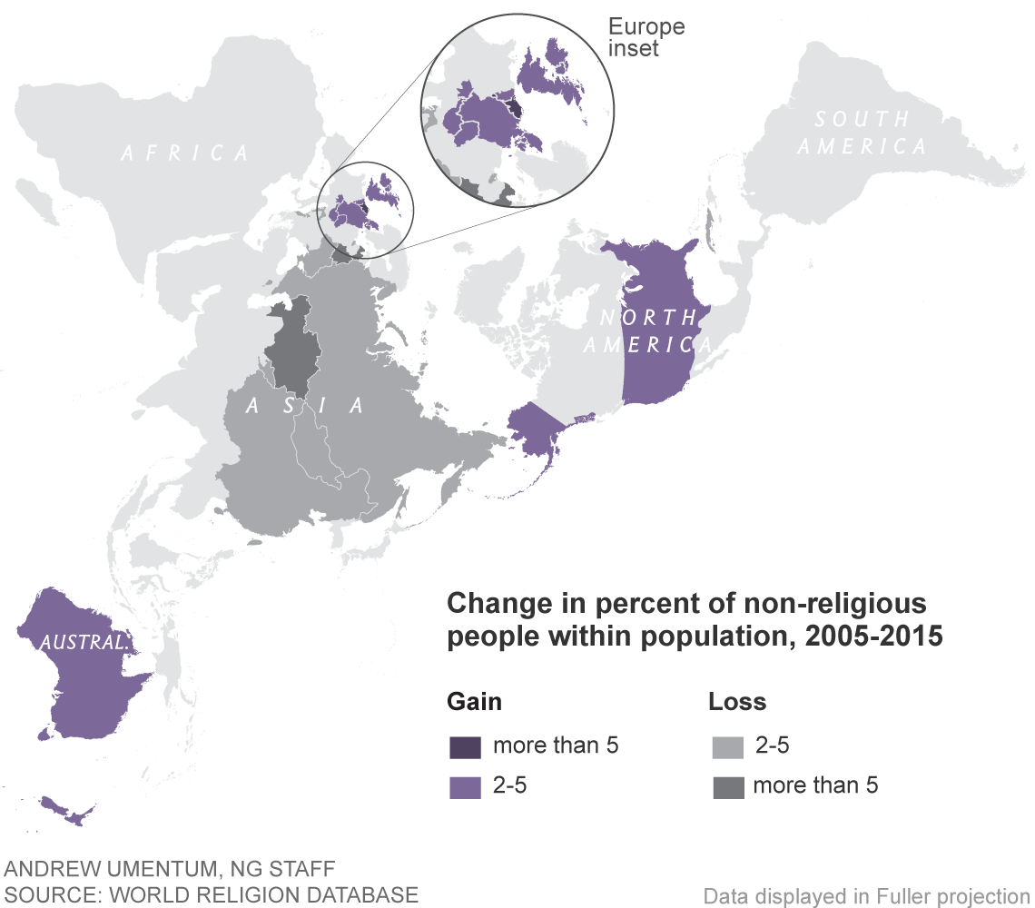
However, 2011 was the first year where an option was provided for those who did not wish to provide an answer had an opportunity to do so. As a result 7.2 % chose not to state what their religion was, therefor acting as a variable when comparing this set of data with that of 2001.
Figure 2
The rise in those answering in the negative when faced with the question of religion can be seen not only in the UK but globally. The religiously unaffiliated can be seen as the second largest denomination in Northern America and the majority of Europe, whilst in the United States, they are the most prevalent.

The Sunday Assembly.
The Sunday assembly is a non-profit non-religious organization established by comedians Sanderson Jones and Pippa Evans in January of 2013. Its first meeting which took part in Islington London was attended by over three hundred people but has since grown its congregation in London alone to over double that. Since then, the group have opened over seventy chapters in eight different countries including Australia, Dublin and the United States. In 2016 the group gained charitable status which alongside with its community is growing annually. The charity can be seen working within Australia, Belgium, Canada, France, Germany, Netherlands, New Zealand, United States and throughout the United Kingdom.
In their promotional videos which can be seen as more relaxed and informal than most religious promotion videos, Pippa and Sanderson state that the assembly is “all the best bits of church but with no god” emphasizing the way in which they have set up the congregation in order for those who wish to have communal experience without the need of religion. As the video continues, comedic nature is used in order to emphasize their message of not being a “cult” going as far as referencing Jim Jones and The Peoples Temple for comedic affect. They stress they meet in order to have talks, sing songs, help in the community and share tea and cake therefor living up to the statement of being “like a church but not quite.”
Services or meetings can be seen as one of the key comparisons between the assembly and many modern churches. Whist Christian churches will sing hymns or songs created by newer Christian groups such as Hillsong United, the assembly will sing pop songs such as the Pointer Sisters ‘I’m so excited’ and Elvis Presley’s ‘Always on my mind.’ As the service continues, a reading is done, and a speaker gives a ten minute talk on something for example how science has evolved over the past decades, leading to more knowledge about things such as the human brain. Therefor creating a second similarity between the Sunday Assembly and the established churches commonly seen not only in the United Kingdom but globally.
A third similarity between the secular group and most churches would be the collection. Whilst most churches will collect donations of various amounts, the charismatic leader Sanderson suggests a donation amount to those in attendance. Whilst many churches will use the collection for maintenance, donations and community projects, the assembly according to various sources will invest the money not only in the surrounding community but also in the lives of its attendees in the form of financial aid which is not commonly seen within many of the older churches.
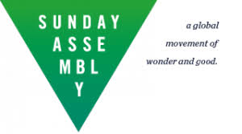
Although similarities can be seen between the assembly and churches, one of the differences seen can be depicted in their logo where an isosceles triangle with its narrowest point facing downward as seen in figure three. It is a stark contrast to what is seen and known within churches where the triangle often equilateral is seen to represent the father, the son, and the holy spirit. An integral part of the religion.
Fig 3

the godless revival.
Many religions such as Christianity have created branches for other groups to grow and deviate, the same can be seen to have happened within the Sunday assembly. According to the spectator, some former members of the New York chapter broke away and formed a group named “The Godless Revival in October of 2014.” It is believed this was done due to the “issue with atheism” the Sunday assembly held. The Sunday assembly see themselves as an atheist church with no belief in God. However, those who broke away stated that they should have a belief in no God, therefor proselytizing faith. Lee Moor, a founding member of the Godless revival wrote when discussing the reason for the separation:
“Ultimately, it is for the benefit of the community. One day, I hope there will soon be communities for every different type of atheist, agnostic and humanist. We are only one flavor of ice cream, and one day we hope there’ll be congregations for every godless palate.”
In this blog entry highlighted by Huffpoast, Moor describes how he felt his form of atheism was not being met. both founders believe that there is no god under which they serve however Moor is firmer with his belief of there being no god what so ever. Therefore, creating a basis for his decision to separate from the Sunday Assembly.
Moor furthers his decision by stating the founders of Sunday Assembly wanted the word atheism boycotted and the meetings to be hosted in a church like setting, not in the bar it was launched in. However a report in the spectator states the Sunday assembly denies stating that the words atheist or atheism were to be banned.
However, research suggests the godless revival has not had as much of an impact as the Sunday assembly had upon their first meeting. This assumption is made by the lack of evidence both scholarly and within the public eye. The only source of information is within their Facebook page which has little to no activity within recent years. Furthermore, their links directly to their internet page are no longer active.

Conclusion.
In conclusion, whilst it is clear atheism had had a standing not only in the United Kingdom but globally for may years, it is in more recent years the viewpoint on religion has become more varied and a part of a part of our popular culture. It can be argued, that as the thought has become more mainstream acceptance of the viewpoint has become more available.
The census, would suggest an increase in the standing viewpoints of atheism and further illustrates it validity as a choice and method and way of life. Whilst many churches and other religious buildings continue to close due to lack of funding, groups such as The Sunday Assembly are becoming more prevalent and accepted in modern day society, occasionally going as far as using a former church in order to hold meetings. Much to the dismay of members of the previously homed religion.
However, could it be possible that Atheism is a new fad in our ever-changing popular culture? I would suggest that although in modern times access to religious materials is now more readily available, access to non-religious materials may be even more available. With lives being shared on social media or general media, it is much simpler to argue a point than during the enlightenment or Greek times.
This document may be developed in the future by visiting an atheist group such as The Sunday Assembly and conducting interviews not only with members of the congregation but members of the leadership also. In addition, random questionnaires would be a useful tool within this report as a representation of atheist beliefs within the United Kingdom could be included as he censuses could now be deemed as out of date as religious preferences may have changed.
Finally, I believe his report may be of use to another as it provides a basis for work to be continued and adapted upon within the future.

Bibliography.
Bergin, Chris, the World's Newest Major Religion: No Religion, https://news.nationalgeographic.com/2016/04/160422-atheism-agnostic-secular-nones-rising-religion/ edn, 2018 vols (National Geographic, ) <https://news.nationalgeographic.com/2016/04/160422-atheism-agnostic-secular-nones-rising-religion/>
Cliteur, Paul, 'The Definition of Atheism', 11 (2009), 1-1-23, in Journal of Religion and Society [accessed 2018]
Hurtado, Larry, When Christians were Atheists, https://larryhurtado.wordpress.com/2016/12/13/when-christians-were-atheists/ edn, 2018 vols (NA: NA, 2016) [accessed 15.12.18]
Mastin, Luke, Arguments for Atheism, History of Atheism, http://www.argumentsforatheism.com/history.html edn, 2018 vols (2011)
What's Sunday Assembly? Dir. N/A, YouTube, 2017 [accessed 2018]
Office of National Statistics, Why we have a Census, https://www.ons.gov.uk/census/2011census/whywehaveacensus edn, 2018 vols () [accessed 15.12.18]
Pigott, Robert, Doing Church Withought God, https://www.bbc.co.uk/news/uk-24766314 edn, 2018 vols (BBC, 2013)
Sunday Assembly, Our Story, https://www.sundayassembly.com/story edn, 2018 vols (2018) [accessed 2018]
Watts, Andrew, The Church of Self-Worship: Sunday Morning Wih the Atheists, https://www.spectator.co.uk/2014/02/so-tell-me-about-your-f

Images
Figure 1- Census Data
Figure 2- World religion database
Figure 3- Sunday Assembly

Michael Martin, The Cambridge Companion to Atheism (Cambridge: Cambridge University Press, 2007), 1.
Curd, Patricia, "Anaxagoras", The Stanford Encyclopedia of Philosophy (Winter 2015 Edition), Edward N. Zalta (ed.), URL = <https://plato.stanford.edu/archives/win2015/entries/anaxagoras/>.
{{134 Hurtado, Larry 2016;}}
{{137 Mastin, Luke 2011;}}
{{136 Office of National Statistics;}}
{{138 Bergin, Chris;}}
{{139 Pigott, Robert 2013;}}
{{140 Sunday Assembly 2018;}}
{{141 N/A 2017;}}
{{141 N/A 2017;}}
{{142 Watts, Andrew;}}
{{142 Watts, Andrew;}}
https://www.huffingtonpost.com/2014/01/06/atheist-church-split_n_4550456.html
http://religion.blogs.cnn.com/2014/01/04/after-a-schism-a-question-can-atheist-churches-last/?sr=fb010514atheistchurches4p

