01/10/2025
Patricia Parkes
student number: 2435756

Report on Asthma
Module code: LCHS4008.
Module name: Introduction to public health.
Lecture name: Daniel Haruna.

Contents Page
Introduction 2
Levels of incidents 3
The impact on those with asthma 3
Factors of asthma 4
5
How is asthma controlled. 5
Treatment 6
Conclusion 6
Reference list 7

Introduction
Although it can occur at any age asthma typically manifests in the younger years. (NHS, 2021) A frequently encountered illness throughout the UK. Asthma is a long-term respiratory disease that is typically linked to hyperresponsiveness and inflammation of the air ways. There are many “clinical asthma phenotypes” (National Institute for Health and Care Excellence (NICE), 2024) that correspond to identifiable groups of clinical pathophysiological and even demographic traits. Allergic, nonallergic cough variant, late-onset. Obesity associated and ongoing restriction of air flow to name a few. (National Institute for Health and Care Excellence (NICE), 2024). Wheezing cough, shortness of breath, tight chest and a fluctuating expiratory air flow all of which can change over time and intensity are a few signs of symptoms of those suffering with asthma. (NHS, 2021)

Levels of incidents
Over 7.2 million people living in the UK are suffering with asthma illness that’s approximately 8% of the population (Chemist4U, (2025). 3.9 million people have been diagnosed of the illness alone in 2023/2024.by the end of 2024 the number of asthma related emergency hospital admissions rose by 17% to 85 (83-60) per 1000,000 population totalling 41.367 admissions compared to the prior year the rate is much greater. Although the hospitalisation rates vary geographically NHS within the midlands region had the highest rate up to 19% 108 (105-111) the year before. The east of England NHS region had the lowest rate of an increase of 18% 66(64-69) per 100.000 population over the previous year. (GOV.UK, 2025).
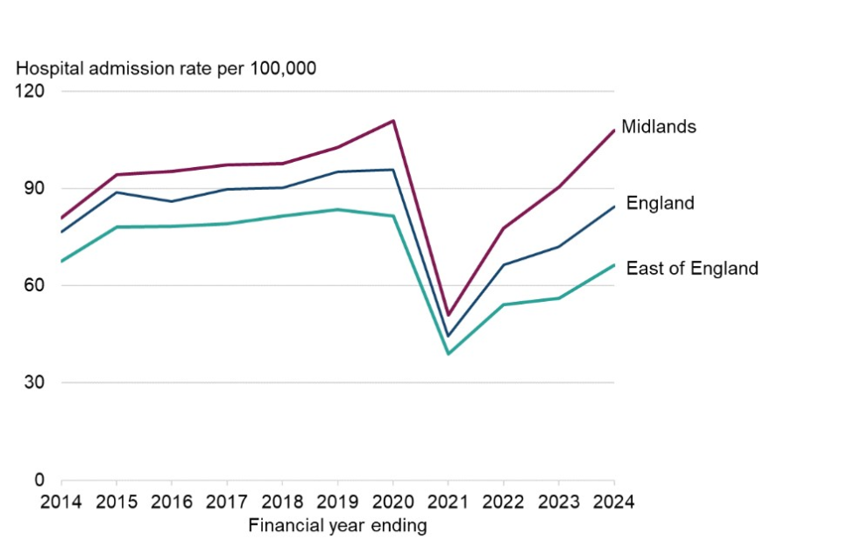
(GOV.UK, 2025).
In 2019 asthma impacted around 262 million individuals worldwide and resulted in 455,000 fatalities (World Health Organization, 2024).

The impact on those with asthma
Asthma prevalence has been a major concern especially in area with less developed economies. It can be argued that Asthma is frequently under diagnosed and under treated (World Health Organization, 2024). Individuals with untreated asthma may experience difficulties in concentrating, they may also feel fatigue during the day and suffer with disruption during sleep. People may argue that this can lead to other illness such as depression, anxiety and social life. People with asthma may fail to attend work/ school (Occupational asthma), caused by irritants in the workplace/ environment for things such as dust gasses or chemical fumes for example the chemicals used in farming, manufacturing, cleaners and decorators (Mayo clinic, 2024). A few examples of different work environments that can play a vital role on the occurrence of symptoms.

Factors of asthma
Although it is frequently challenging to identify a specific cause in relation to the development of asthma. There are several factors that have been connected, and it identifies an increased risk for individuals to suffer with the illness asthma. (World Health Organization, 2024). Genetics. If other family members suffer with asthma. Primarily close relatives for example parent or siblings. The chances of developing asthma would significantly increase (World Health Organization, 2024). People with other allergy disorders (Allergy induced asthma) provoked by air born materials including pollen, mould spores, excrement dried saliva and skin fragments from pets (Mayo clinic, 2024). Rhinitis (hay fever) and eczema are also far more likely to develop asthma. Asthma prevalence is higher in urban areas most likely because of various lifestyle variables and early life experiences. for example, smoking, alcohol consumption and diet (mayo clinic,2024). Several foods and drinks for instance prawns, processed foods, dried fruits beers and wines contain high levels of sulphites, histamines and preservatives (Mayo clinic ,2024). Asthma might exacerbate allergic reactions if you have a food allergy. Anaphylaxis, a dangerous allergic reaction, can result from both mild and severe symptoms. This reaction can get worse quickly and typically affects multiple body parts. For the best chance of recovery and to avoid major, potentially fatal consequences, anaphylaxis must be treated immediately. Breathing difficulties may result from a severe food allergy reaction. Differentiating between an asthma attack and a food allergy reaction can be challenging. (Asthma & Allergy Foundation of America, n.d.). Obesity also combines with asthma in 2023 a report was published by the UK Parliament stating that an estimation of 26% of adults in 2023 were obese with a further 3% of the population were overweight. with the rise in obesity has resulted in the increase of individuals within the population are now consequently suffering with respiratory conditions such as asthma (Pcrs-uk.Org, 2024) As a result Asthma and COPD are predicted to cost the UK's National Health Service (NHS) £3 billion and £1.9 billion annually, respectively. The NHS in the UK loses £11 billion a year as a direct result of lung diseases (asthma), including lung cancer. (NHS England, 2019). The illness known as Gastro-oesophageal reflux disease (Gerd) which causes stomach acids to travel back up through the throat. according to a comprehensive evaluation of 28 studies. Three hypothesised mechanisms—increased bronchial reactivity, tiny amounts of acid and other stomach contents into the upper airways and enhanced vagal tone—can account for bronchoconstriction caused by acid reflux. The "reflux theory," also known as a direct mechanism, and the "reflex theory," also known as an indirect mechanism, have been proposed by different authors as explanations for the connection between GERD and asthma. But the topic of whether asthma exacerbates GERD is still open. Or does GERD make asthma get worse (Grandes et al., 2022). Numerous factors, including as coughing and greater effort in breathing, hyperinflation of the lungs, diaphragm contractions, and an increased pressure gradient across the lower oesophageal sphincter, have been found to exacerbate GERD in asthmatic patients. Theophylline, β-agonists, and corticosteroids are among the medications used to treat asthma that may cause reflux (Grandes et al., 2022). Aspirin. betta blockers and nonsteroidal anti-inflammatory pharmaceuticals such as naproxen sodium and ibuprofen. (mayo clinic,2024). These factors and causes have an effect and can be harmful triggers on individuals throughout the population on developing or intensifying asthma. Side effects from long term adverse effects from the several drugs / medications used for treating asthma.

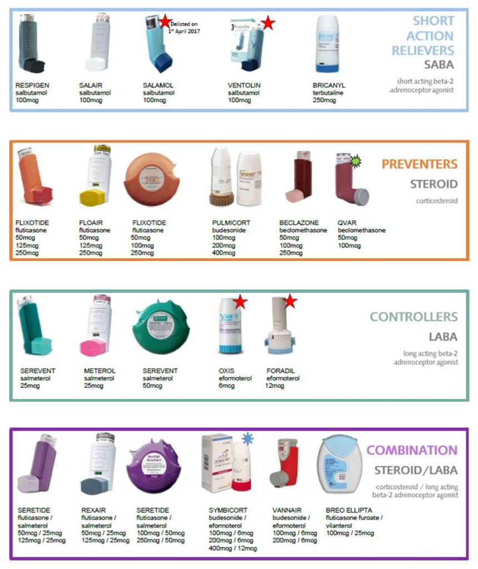
(Atherstonesurgery.co.uk,2025)

How is asthma controlled.
Asthma is diagnosed through breathing test and can also check for signs with blood tests (NHS, 2021). The peak flow handheld device is used for a period and monitors how efficient the lungs are in order. Spirometry test is used and gives an estimate of how the narrowing of the bronchial has been impacted (Mayo, 2025). These types of tests are required before and after treatment of medication such as albuterol. It’s likely the diagnostic of asthma would be if using the bronchodilator improved lung function (Mayo, 2025). Although it can take a while to be diagnosed with asthma as symptoms vary from each person. With other challenges such as gender, age environmental and lifestyle for example the weather. Many people suffer with colds and flues in the winter season in result suffer congestion and difficulty breathing. But whereas in the summer many people suffer with allergies (Hay fever) in result suffer coughs, congestion itchy throat which also makes it difficult to breath. Having to challenge difficulty in breathing can be generated from other underlying causes/illness (NHS,2021). Additional test such as imaging, allergy tests, nitric oxide test and sputum eosinophils to name a few (Mayo,2025). Doctors classify the severity of a patient asthma based on the frequency and intensity of the symptoms. The outcomes of the individual’s physical performance and diagnostic testing is considering ensuring the best action plan for the individual going forward. The severity of asthma varies over time, so this allows doctors to make necessary modifications to treatments (Mayo,2025)

Treatment
The method of treatment may differ. An anti-inflammatory reliever medication, steroids which reduces air way inflammation. Steroids reduce the likely hood of a heart attack, and the symptoms linked with it. These corticosteroids are put in devices for treatment and these steroids are replica steroids that our body naturally produce. It treats symptoms and asthma attacks (Asthma and Lung UK, 2021). These medication are typically administered via an inhaler this makes it more efficient for the medication to enter the air ways directly where it needs to go .Inhalers come in various variants , some offer a medication puff .these are metred dosage inhalers under pressure (PMDIS).Spacers are required when using PMDIS inhalers they aid in delivering the medication through to the appropriate parts of the air ways .Some allow to inhale the medication these are soft mist inhalers. And dry powder inhalers (DPIS) and spacers are not required for its use. Combination inhalers (MART) to be taken every day to help symptoms and prevent symptoms (Asthma and Lung UK, 2021). An acute or sub-acute worsening of lungs from a normal state or in some case an individual can present for the first time during an exacerbation, this is referred to as an asthma exacerbation. Sever flare ups of these symptoms can be fatal (National Institute for Health and Care Excellence (NICE), 2024). Although there is presently no cure for asthma, symptoms can be avoided if receiving the appropriate treatment.

Conclusion
To conclude asthma would always be a prominent case in the UK and worldwide. With new cases arising in young people. More interventions need to be in in place educating the population of the importance to health and how lifestyle challenges and the choices we make influence health and to tackle the causes to this. improving the health of ourselves and others. Not a step of one but a step of a nation.

Reference list

GOV.UK (2025). Respiratory disease profile: statistical commentary, June 2025. [online] GOV.UK. Available at: https://www.gov.uk/government/statistics/update-of-indicators-in-the-respiratory-disease-profile-june-2025/respiratory-disease-profile-statistical-commentary-june-2025.
Asthma And Lung UK (2021). How Is Asthma treated? | Asthma + Lung UK. [online] www.asthmaandlung.org.uk. Available at: https://www.asthmaandlung.org.uk/conditions/asthma/treatments/how.
NHS (2021). Asthma. [online] NHS. Available at: https://www.nhs.uk/conditions/asthma/.
Grandes, X.A., Talanki Manjunatha, R., Habib, S., Sangaraju, S.L. and Yepez, D. (2022). Gastroesophageal reflux disease and asthma: A narrative review. Cureus, 14(5). Doi: https://doi.org/10.7759/cureus.24917.
Peters, U., Dixon, A.E. and Forno, E. (2018). Obesity and asthma. Journal of Allergy and Clinical Immunology, [online] 141(4), pp.1169–1179. Doi: https://doi.org/10.1016/j.jaci.2018.02.004.
Mayo Clinic (2025). Asthma. [online] Mayo Clinic. Available at: https://www.mayoclinic.org/diseases-conditions/asthma/symptoms-causes/syc-20369653.
World Health Organization (2024). Asthma. [online] World Health Organization. Available at: https://www.who.int/news-room/fact-sheets/detail/asthma.
Anon, (2021). ASTHMA INFORMATION - Asthma and Allergy Foundation. [online] Available at: https://asthmaandallergy.org.uk/asthma-information/.
Chemist4U (2025). Asthma Statistics Report. [online] Guides. Available at: https://www.chemist-4-u.com/guides/research-insights/asthma-statistics/ [Accessed 14 Nov. 2025].
NHS England (2019). NHS England Respiratory Disease. [online] NHS England. Available at: https://www.england.nhs.uk/ourwork/clinical-policy/respiratory-disease/.
National Institute for Health and Care Excellence (NICE) (2024). Asthma: What Is it? [online] NICE. Available at: https://cks.nice.org.uk/topics/asthma/background-information/definition/.
Porsbjerg, C., Melén, E., Lehtimäki, L. and Shaw, D. (2023). Asthma. The Lancet, [online] 401(10379), pp.858–873. Doi: HTTPs://doi.org/10.1016/s0140-6736(22)02125-0.
Pcrs-uk.org. (2024). Obesity and its Impact on Respiratory Health and Primary Care | Primary Care Respiratory Society. [online] Available at: https://www.pcrs-uk.org/resource/current/obesity-and-its-impact-respiratory-health-and-primary-care.
Atherstonesurgery.co.uk. (2025). Asthma - The Atherstone Surgery. [online] Available at: https://www.atherstonesurgery.co.uk/pages/Asthma?Highlight=asthma [Accessed 14 Nov. 2025].

