REFLECTIVE PORTFOLIO
PROFESSIONAL CAREER DEVELOPMENT


STUDENT NAME | YORDANKA KANCHEVA
STUDENT NUMBER | 2017633
MODULE NAME, CODE | PROFESSIONAL CAREER DEVELOPMENT (BMSW4005_BIRM)
LECTURE NAME | MD NAZMUL HASAN

Table of Contents

Introduction 3
PART 1 4
Audit of personal skills and competencies 4
Identification of required skills and qualities 5
Personal Development Planning 6
Evaluation of personal qualities and skills necessary for the chosen role 8
Part 2 9
Reflection and assessment what has been learned in this module 9
Gibs reflective cycle 10
Driscoll’s What model of reflection 11
Personal reflections on the passed practical and theoretical tasks 12
Conclusion 14
List of references 15

Introduction

The individual development is a personal responsibility and continuous process throughout people's live through which they improve their knowledge and skills to be as effective as possible in their jobs or what they do. This does not always mean moving up, but also performing better and showing everything, they are capable of at every stage of their career.
The report will be focused on reflection to assess the different concepts from what has been studied. Attention will be paid to a personal development plan, assessment of personal competences and knowledge.

PART 1

Audit of personal skills and competencies

This part will reason all the necessary qualities and skills needed to fulfil a chosen career. A self-skill check will be made using studied analysis tool (PDP), as well as a self-assessment of one's own capabilities related to the chosen career.
Analysing and verifying one's own knowledge and skills is an important part of the process of personal and career development. This is a setting of the clock - where, at what stage and to what extent the given personality develops. It gives information about the possibilities and the choice of the suitable position that everyone wants and aims for.

Chosen career - Management
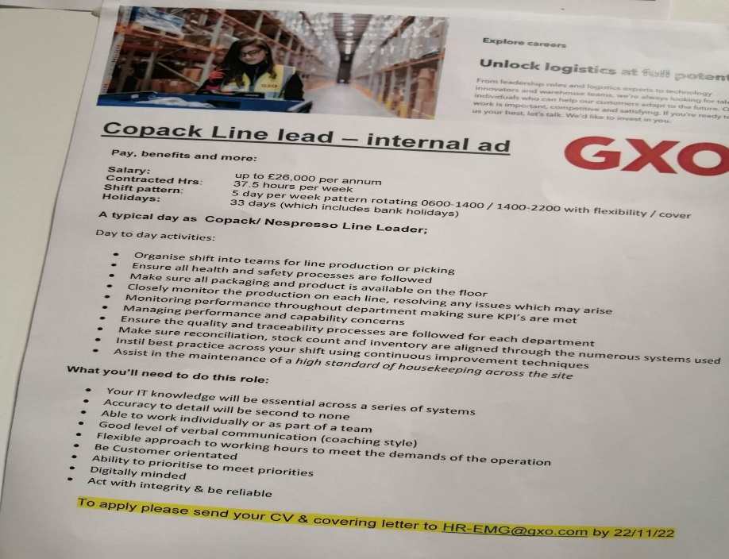

Identification of required skills and qualities

The essential knowledge and skills required for the chosen role can be qualified in the following two groups as both should be combined:
- Hard, technical skills:
- IT knowledge, MS Office; Digital oriented; Handling any equipment; Networks.
- Scheduling; Attention to details; Optimization; Implementation; Planning; Organizing; Delegation; Ability to prioritise.
- Time Management – Multitasking; Deadlines meeting
- Soft, Interpersonal skills:
- Problem and conflicts solving; Decision making.
- Good Communication including verbal and non-verbal: Written communication; Active listening; Digital communication; Empathetic.
- Successful Teamworking; Team motivation; Collaboration; Leadership; Negotiation
- Thinking - Analytical thinking; Critical thinking; Logical thinking

Technical skills
Conceptual skills
Management skills

Interpersonal skills

Personal Development Planning

As Morgan (2017) says, PDP is “A Plan intended to develop skills that are important to the work life”
By personal development planning (PDP), everyone can understand where they are now, what they want to achieve and what will help them get there. And thus, everyone can take advantage of the opportunities that open to him. The personal development planning process includes:
- Establishing short- and long-term career goals.
- Assessment of reality.
- Establishing the necessary skills and competence.
- Applying actions that will build or enhance this necessary knowledge.
- Setting deadlines for performance.
When planning the future one can understand what skills are needed and subsequently what actions need to be taken to achieve the set goals.

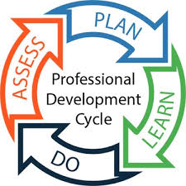

Short- and long-term goals | Deadline dates for action | Required actions | Success criteria | Resources – what or who would help me?
Short-term  To successfully complete my university course | End of November 2022 | -To fully complete the remaining two reports  - Finding additional materials to read in the University library | -Successfully passing both exams  - Good grades and feedback from the lecturers | -Support from the lectors  -Equipment as computer and printer  -Internet
Short-term  To successfully pass my upcoming interview for the new position as a line leader | End of December 2022 | -To use what I have learned from the current University course  - To read additional literature for a successful interview  - To upgrade my skills in the current position as a step-up Line Leader by requiring additional appropriate trainings  -Training others | -Successfully handling more new tasks  - Gaining more confidence in what I do  - Excellent feedback from employers because of the results achieved | - Support from colleagues  - Support from the employer to provide better training  -Books and articles  -Academic wear
Long-term  To fully complete my university education by covering the fifth and sixth levels | End of December 2024 | -Regular attendance of classes  -Do all activities  -Submitting all tasks on time  - Additional preparation at home by reading a lot of literature  -Reading adequate books and articles  -Participation in additional courses If necessary | -Successfully passed exams with excellent grade  -Good feedback from the lectors  - Gaining more confidence in myself and in the things I do | - Financial help from Student loan  -Support from lectors and University  - Technical equipment  -Internet  -Textbooks
Long-term  To be promoted to the position of manager | End of December 2023 | -Acquiring new knowledge, technical skills related to my work  -Accepting responsibility  -Implementing good ideas to improve the workplace  -Strengthening professional relationships with colleagues and superiors as well as creating new ones  -To significantly improve my spoken English  -Advanced English courses  -Relevant courses and trainings to renew and upgrade my knowledge  -Leading others | -Getting the desired promotion  -Successful relationships with colleagues and clients  -Getting the respect from everyone  -Improving my financial situation through an increase in salary  -Independence in decision-making | -Investing time and money in my education  -Investing funds in different courses  -Support from family, friends, and colleagues

Evaluation of personal qualities and skills necessary for the chosen role

Based on the knowledge, degree and qualifications held on the one hand and the life experience, strengths, and weaknesses on the other hand an evaluation of personal qualities will be conducted.
I have acquired Management, Law, Economics and Administration knowledge from my higher education diploma with a specialty in Business Management. in parallel, I have been issued certificates for sales skills, how to communicate successfully, as well as certificates for mastering foreign languages. This gives me the confidence that I am well prepared and have the necessary preparation to deal with the various challenges.
Considering my strengths such as being very conscientious and responsible, I am used to working in a fast-paced environment and can handle stress well, I have good attention to detail and rarely make mistakes, this puts me in an advantageous position over my competitors in the labor market.
With my many years of work experience, I have covered all aspects of office work - from cashier and assistant to accountant and manager, with which I have proven that I am reliable and tested.
As my weakness I can share my impatience and haste which have sometimes hindered me, but given that I have realized them, I am working towards dealing with them and making them even work to my advantage.
In summary, I can confidently say that I possess most of the above-mentioned skill requirements for the chosen role. But nevertheless, I know that every single person must constantly improve and upgrade himself, because life is very dynamic, and novelties flood us every day.

Part 2

Reflection and assessment what has been learned in this module

In her book, “The Reflective Journal “, Bassot, B. (2020) says: “Reflective writing, like our professional development, is always a work in progress and is never finished. It can be used ‘for inquiring, feeling, listening and connecting’ (Helin, 2019: 2), where the purpose is to explore the unknown rather than seeking to reach a specified goal.”
We can use different models of reflection for the purpose. Some more famous for example are Gibb’s reflective cycle; Driscoll model of reflection; ERA model - Jasper (2013); Kolb’s (1984) experiential learning cycle etc.

Gibs reflective cycle

To reflect on my experience on the study module I will use the Gibb’s reflective cycle by Gibb’s (1988)
The model provokes us to think about who we are and how our values affect us before we think about the experience.
By this model we learn through experience and the feelings are very important in the entire process. It involves six stages starting with a story what happened. Next expressing our feelings. In the next stage we consider the pros and cons from the experience. In analysis stage I understand what meaning I got out of the situation. After that I make a conclusion and finally, if it happened again, what would I change.
According to the Gibbs cycle I will analyse my experience from this Module.
In the third term of the University course, we studied Professional Career Development. I feel veryfulfilled because now I complitely understand all skills and knowledge that I needed to work effectively; I am able to establish goals of employment and how to develop a personal action plan. Also, I can analyse my strengths and weaknesses and using tools for professional development planning. I will apply what I have learned for a better and successful future career.

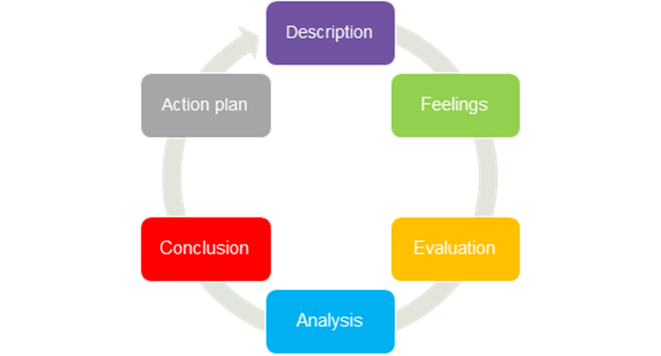
Gibb’s (1988)

Driscoll’s What model of reflection

Using Driscoll model of reflection, I will reflect on my experience from the recently completed learning module.
Studying Professional Career Development shows me different ways for personal reflection and career development planning. It gives me competence and confidence to be successful employee or businessperson. With this knowledge, I request to be a well-realized and career-successful person. It is already paying off, as my recent promotion as a Line-Leader shows. After his success I set a new higher goal - completing fifth and sixth levels at university and applying for an even higher management position.

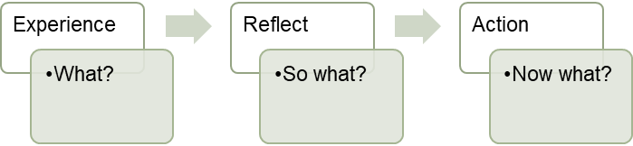

Driscoll (2007)

Personal reflections on the passed practical and theoretical tasks

Adhering to the reflection models cited above, I will reflect on my experiences during my studies through this module.
Description:
In the time of my studies through this module I went through several different stages including three different assessments. We started by preparing a plan for personal development (PDP), and the lecture included activities for an even better understanding of the material. In the third week, we had an open book assessment containing five hundred words, with topic - the consequences of Covid and remote work. In week six, we were asked to write a Cover letter and a CV, based on which we had a MOC interview, lasting 15 minutes, and the lecturer's role was that of an employer, and mine was that of an employee. The third last task refers to writing a reflective portfolio with a capacity of two thousand words, which consists of two parts, including an audit of personal skills and competences and a reflection on the various concepts studied during the module. Meanwhile, in each of the classes we had different activities.
Feelings: At first, I felt a little confused.
At first, I felt a little confused, but then things fell into place, and I got an idea of ​​what I am doing and what I am going to do. During the Open book exam, I was slightly worried because the topic we were given did not correspond to the one I had prepared for. Drafting CV and Cover letter was a challenge for me because it was the first time, I tried to make them professionally, according to all the standards as given to me by the lecturer. At the interview, I felt a little worried. The current report that I am currently writing has made me feel very anxious because I have not been able to plan my time due to being extremely busy with a full-time job every day. Evaluation:
During an open book exam, I made a big mistake in that I misjudged my time and wasted my time looking for unnecessary literature instead of concentrating on thinking for myself on the topic, which until recently was so relevant. The task of writing a CV and cover letter was especially useful for me because I learned and was able to prepare them professionally at the exact moment, I needed them and applied for a position that opened. For the Mock interview, in addition to the lecturer's advice, I read a lot of additional literature and understood how to master many subtleties. From the many of the activities, we have done in class (PDP) I learned how to put them into practice as an example I can give the PDP that I did in the first part of this report. The only challenge I faced in writing this report was poor time planning. But in other hand I understood better everything I have missed before that and now I can help to some of my friends who looks for a new job, to do their CV, Cover letter, PDP and what to do in Interview.
Action Plan:
After everything learned so far comes the natural moment to put it into practice. These are the actions necessary to achieve the goals. Based on the newly acquired knowledge and experience, mistakes that I have made, I have set several short-term and long-term goals that I intend to achieve in the next two years. To this end, I signed up for the fifth and sixth level for Leadership course at the University. In my spare time I will attend courses to improve my spoken English.

Conclusion

The results of the study show the need for a deep reflection on how and what the feelings of the experience of everyone who participated in this course. As a result of which everyone is able to analyse their development, be provoked and realize the need to prepare a plan for personal development; To understand patterns of reflection and their role in later results. The conclusion is that there must be reflection during training so that each one knows where he is, where he wants to be and how to achieve it.

List of references

- Atkins, S. and Murphy, K. (1994). Reflective Practice. Nursing Standard, 8(39) 49-56.
- Bassot, B. (2020) The Reflective Journal, London: Red Globe Press
- Driscoll, J (2007) Practising Clinical Supervision: A reflective approach for healthcare professionals, Edinburgh: Balliere Tindall, Elsevier
- Gibbs, G. (1998) Learning by Doing: A guide to teaching and learning methods, Oxford: Further Education Unit, Oxford Polytechnic
- Grossman, R. 2008. Structures for facilitating student reflection. College Teaching 57, no. 1: 1522.
- Kolb, D (1984) Experiential Learning: Experience as the source of Learning and development, Englewood Cliffs, NJ: Prentice Hall.
- https://latrobe.libguides.com/reflectivepractice/models
- Picture of cover page: inserted from stock images
- https://www.nottingham.ac.uk/nmp/sonet/rlos/placs/critical_reflection/models/johns_model.html
- Johns, C. (1994). Nuances of reflection. Journal of Clinical Nursing 3 71-75

