User Experience Design
Prototype Design
M6X01111
Robert James
P144088
BSc Applied Computing

Contents
1. Personas for UWTSD Face APP 3
1.1 Persona 1 3
1.2 Persona 2 4
1.3 Persona 3 5
1.4 Persona 4 6
1.5 Persona 5 7

2. Designing The Personas 8

3. Information Architecture 9

4. Wireframes 12

5. User Feedback 14

6. References 16

7. Appendix A 18

8. Appendix B 22
8.1 User Requirements 22
8.2 User Experience Requirements 23

9. Appendix C 24
Log On Page 24
Home Screen 25
Home Screen with Expanded Burger Menu 26
Student Timetable 27
SA1 Campus Map 28
Moodle Page 29
Student Results Page 30
Students Union Page 31
Student Services Page 32
Student Accommodation 33
Faculty Trips Page 34
Feature Lectures Page 35
Student Groups Page 36
Library Main Page 37
Student Email Inbox 38
SA1 Campus Main Page 39
SA1 Campus Maps 40
Calendar View Page 41

10. Appendix D 42

11. Appendix E 44

1. Personas for UWTSD Face APP
Personas have been created for the UWTSD FACE app to allow for the assessment of the app design, against a set of user goals and needs [1].

1.1 Persona 1
Name |   James Walters
Demographic | James is a first year student, studying for a BSc in computing. He’s tech savvy and uses his smart phone for everything other than writing his university assignments. He uses social media to stay informed and share his student life with his friends. James wants to show he’s making the most of his time at university by self-publicising what he’s involving himself in during his time in university.
Goals | - Knowing what extra circular activities, clubs and meet ups are available through the uni.  - To be informed of any changes to lectures, rooms, dates or assignments that affect him.  - To be able to view course content and related information  - Be able to message lecturers directly.  - To browse books available in the library.
Pain | - Lectures can get cancelled and moved at very short notice.  - Not knowing about events taking place around the uni.  - No consistent way of being notified of changes to timetables and lecturers. Some lecturers email, others put a note on Moodle before a lecture.
Media & Device Preference | - Smart phone for everything other than writing assignments. Then it’s laptop.  - Likes social media and instant messaging.  - Doesn’t like email.
Role & Responsibilities | - Works part time at a supermarket around university course.  - Lives in student house share.  - Is a student ambassador.
Tasks | - Check timetables.  - Search for books and journals using online catalogue.  - Locate facilities at new campus.  - Attend society meetings.

1.2 Persona 2
Name |   Lisa James
Demographic | Lisa is a part time student, who attends university 1 day a week. She has to travel for an hour to get to university. She needs to have up to date information specific to her course and wants to be notified if there are any changes. Lisa works on her assignments in the evenings and on weekends. She’s not able to attend any extra circular events, if they don’t coincide with her 1 day a week in university. Lisa’s not interested in student groups or wider university activities.
Goals | - Check my student email account for important emails.  - Easy access to browse books in the library  - Be able to be notified of changes to my lectures before I travel to university.  - Have a map showing me where my lecture rooms are because they sometimes change.
Pain | - Finding lecturers have been cancelled once I get to university.  - Knowing whether to bring or buy food.  - Missing out on extra circular talks and not getting to find out what was discussed/presented.
Media & Device Preference | - Uses smart phone for keeping up to date with life, work, and family.  - Uses tablet for general internet browsing and reading on the go.  - Uses cloud tools for storing work, notes and useful content for assignments.
Role & Responsibilities | - Has two teenage children that she’s mother and taxi driver for.  - Works full time for local NHS trust.  - Studying part time to boost career opportunities.
Tasks | - Check student emails inbox.  - Check assignment hand in dates and exam dates  - Search online library for journals and academic papers.

1.3 Persona 3
Name |   Archie Hamilton
Demographic | Archie has grown up in Swansea and is passionate about good design. He’s a 3rd year architecture student and who is on the autistic spectrum. Archie is provided with a teaching support who takes notes for him during classes and supports Archie with his studies during 1 on 1 sessions. Archie works on his assignments at home, where he lives with his parents, and in the architecture studio at UWTSD’s SA1 campus.
Goals | - To access course content alongside his notes, wherever he is working.  - To have an easy method of contacting his teaching support.  - To know when the studio at SA1 is available for him to go and work in it.
Pain | - Knowing when the studio is free.  - Moodle on a smartphone.  - When teaching support arrives part way through lecture and Archie is missing notes.
Media & Device Preference | - Uses smart phone for browsing the internet and staying in touch with friends and family.  - Uses laptop with specialist software for writing university assignments  - Likes using voice assistants to save him typing messages and typing in to google.
Role & Responsibilities | - Is a student ambassador for UWTSD Swansea  - Checks university emails daily for news and updates.  - Lives locally in Swansea at home with his parents.
Tasks | - Emails lecturers and support staff.  - Checks what free and discounted software is available  - Searches for available books in the library.

1.4 Persona 4
Name |   Chan Juan Cheng
Demographic | Chan Juan is an overseas student, studying full time for an MEng in Motorsport Engineering. Chan Juan is a competent user of modern technology, using video calling apps WeChat and WhatsApp to stay in touch with friends in the UK and back home in China. Chan Juan spends her time modifying her car and uses social media to share her life studying in another country with her followers. Chan Juan runs her life from her smart phone and uses it for navigation, browsing the internet, shopping for car parts and occasionally for help with translation.
Goals | - To keep on top of her university studies, knowing when she must submit her work by.  - To learn about UK culture and see as much of the UK as she can.  - To know what university services are available to her.  - To access module content on Moodle.
Pain | - Lectures do not start at the time they are due to start and are sometimes cancelled.  - Emailing lecturers but not getting a response.  - Understanding some of the acronyms and more technical language used in her lectures.
Media & Device Preference | - Smart phone  - Instant messaging  - Cloud storage for documents
Role & Responsibilities | - Member of student go-karting club.  - Member of formula student racing team.  - Member of the student union and contributes to student union activities.
Tasks | - Checks Moodle content for wider reading  - Checks student emails  - Upload assignments  - Prints documents in the library

1.5 Persona 5
Name |   Mark Thomas
Demographic | Mark is a developer within UWTSD’s IT department. Mark specialises in apps development and has been given the task of building UWTSD’s app for FACE students. Mark spends his spare time building native apps for iOS and is a big fan of Apple products. This will be Mark’s first time developing an app for both iOS and Android.
Goals | - To develop an operating system agnostic app.  - To balance the need to deliver against student requirements, with the desires of the university.  - To build an architecturally simple app that requires minimal support.
Pain | - Complex IT systems  - Poorly designed UI and UX  - Android
Media & Device Preference | - Smartphone (Apple) for day to day browsing and keeping in touch  - Cloud software  - Desktop with dual monitors for dev work.  - Java
Role & Responsibilities | - UWTSD website admin  - Lead dev for UWTSD FACE student app  - Father to anew born baby girl.
Tasks | - Develop app prototype  - Test app with users  - Build out app  - Maintain app

2. Designing The Personas
Before creating the personas for the FACE app, the potential users and stakeholders were mapped out, ensuring all user types and primary stakeholders were identified. See figure 1 below. This was not done from a project management point of view, where stakeholders need to be managed for the success of a project [2]. Instead, it was from a user experience design point of view, to consider who else would have a view or need relating to the design of the FACE student app.
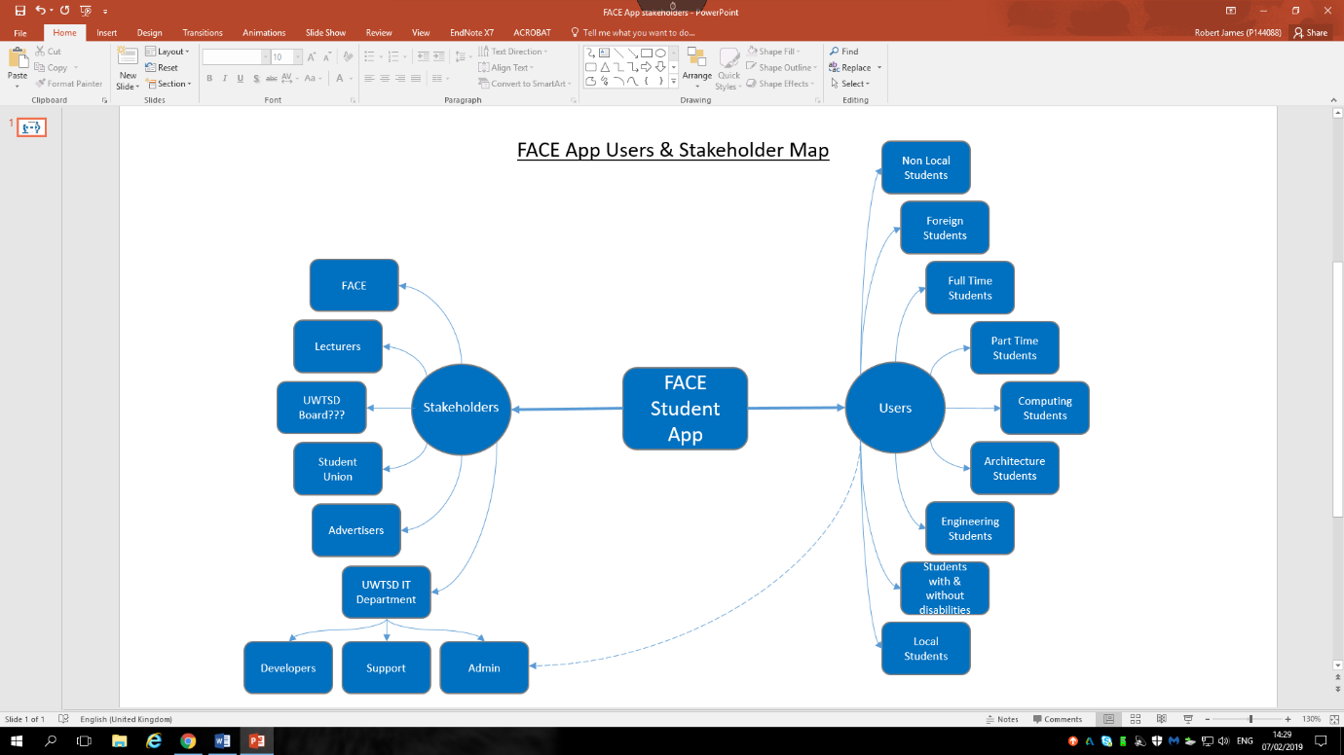
Figure 1

The four student personas have been created to be representative of the mix of students studying within FACE at UWTSD. They include full and part time students, male and female students, young and mature students, students with disabilities and overseas students. There is a fifth persona, the IT admin who will maintain the app. This is has been included to highlight that user experience (UX) relates to those who have to maintain the app, as well as those who browse and transact with an app.
The personas were created as a result of information gained through face to face interviews with lecturers and face to face interviews with students. Lecturers were interviewed to gather information about the different backgrounds of the students they teach and the challenges that they’re aware their students face. The author also contacted the university to obtain statistics on the proportion of disabled students and overseas students but at the time of writing, the author has been unable to obtain these figures.
The author used face to face questioning with FACE students, to gain an understanding of their background and personal stories. As well as their main aims when interacting online with UWTSD, their current pain points, their technology preferences and what they would likely use the app for. These face to face discussions were conducted with students, one on one to prevent false consensus bias [3].
In addition to the face to face interview and to enable the capture of a greater volume of data than face to face discussions allowed for, a questionnaire was created using Survey Monkey, and emailed to the author’s course coordinator to disseminate to FACE students. The questionnaire sought to understand what tasks users would likely use the UWTSD FACE app to achieve. The questions asked in this survey, along with the results can be viewed in Appendix A.
A hierarchical task analysis [4] was also conducted with students, using the current UWTSD web site to identify how they currently accessed the information that will be contained within the FACE app, for the purposes of understanding what they had to do to access the information currently and how they would like to be able to access it through a mobile app.
[4] states a task analysis ‘helps identify the tasks that your website and applications must support and can also help you refine or re-define your site’s navigation or search by determining the appropriate content scope’ [4]
As a result of this work, user requirements for the FACE ap were identified and grouped using the MoSCoW criteria [5]. These can be found in Appendix B.
The results of the survey, face to face interviews and task analysis showed:
- Students currently have to check multiple places to see if a lecture has been cancelled.
- Navigating on the current UWTSD web site is not easy. Students search for the pages they need such as Moodle and the library in Google because it’s quicker.
- The information students want to access is often buried deeper in to the website than users would expect to go to find it.
- All of the students surveyed indicated they would download the FACE app.
- How important a calendar function is to students.

3. Information Architecture
The information that the app needed to hold was identified from the face to face discussions with students and the survey. The information identified from these sources was placed on post it notes and students were asked to perform a card sort task. ‘Card sorting is a method used to help design or evaluate the information architecture of a website [6]. Numerous card sorts were conducted with different students, and when performing the task, they were asked to include any information they thought was missing by adding new post it notes.
Through this ‘library guide’ and ‘subject guide’ were added to the list of information. Some students had used these guides and found them very useful. Unsurprisingly, there were some differences in how the students categorised the information. Although there were largely common groupings. The most common ways of grouping the information was taken forward to create the information architecture.

Images from Card Sort Exercises
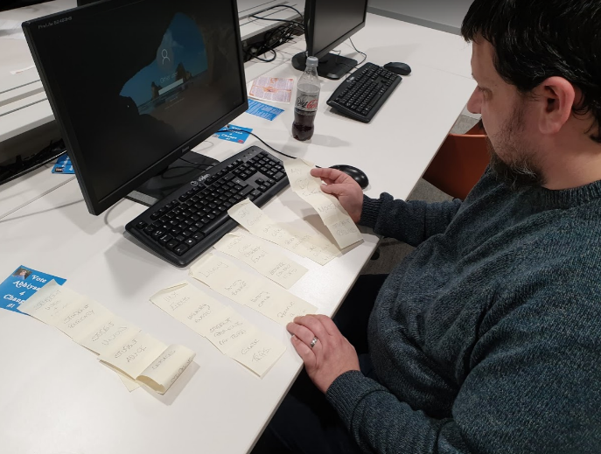
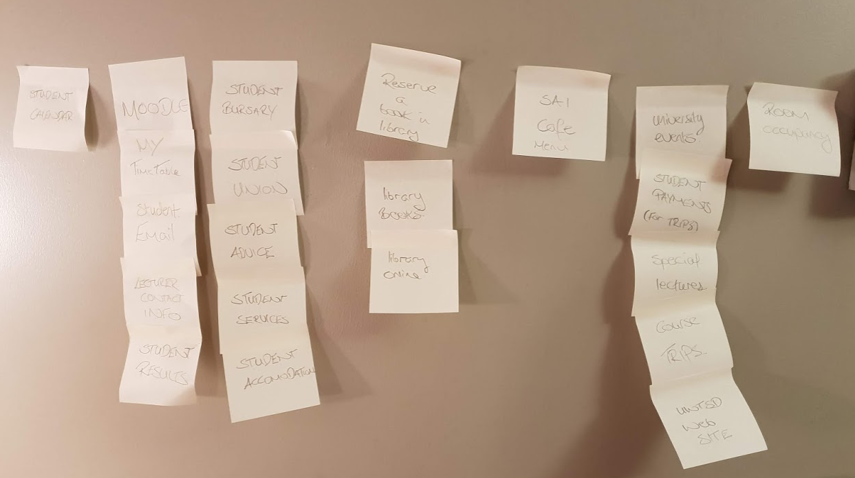

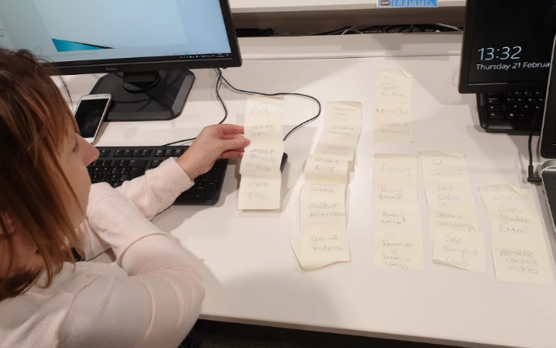
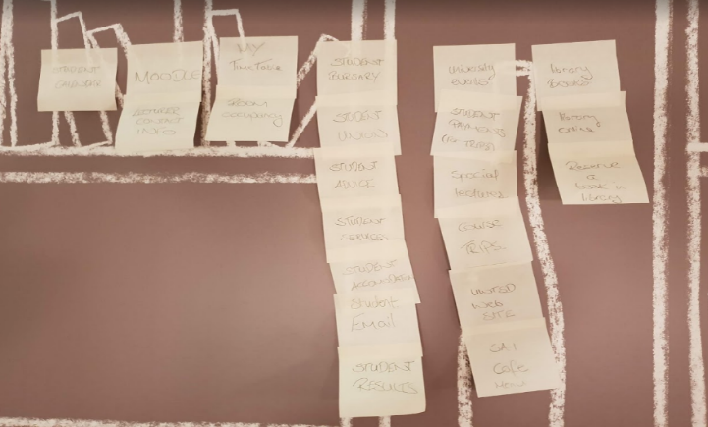

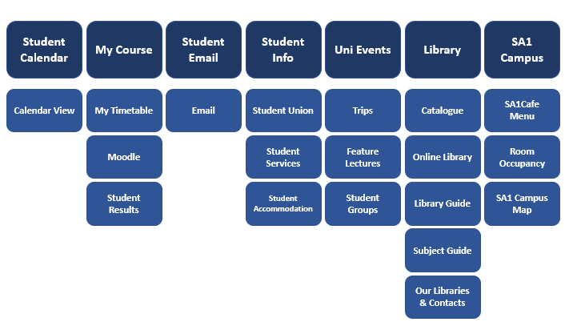
Groupings Resulting From Card Sort

Figure 2

The information architecture is mainly flat. Therefore, the content is quickly accessible by the user, adhering to the three click rule [7]. Additionally, mobile ‘users have become conditioned to scroll’ [8]. Therefore, it is possible to have a longer menu, than on a desktop web page navigation bar. The three click rule suggests users will not use a website or app if they have to make more than three clicks to access the content they want [7]. All of the content within the app is reachable within three clicks of the homepage. Most of the information is accessible with one or two clicks. The image below shows the information architecture of the FACE app.
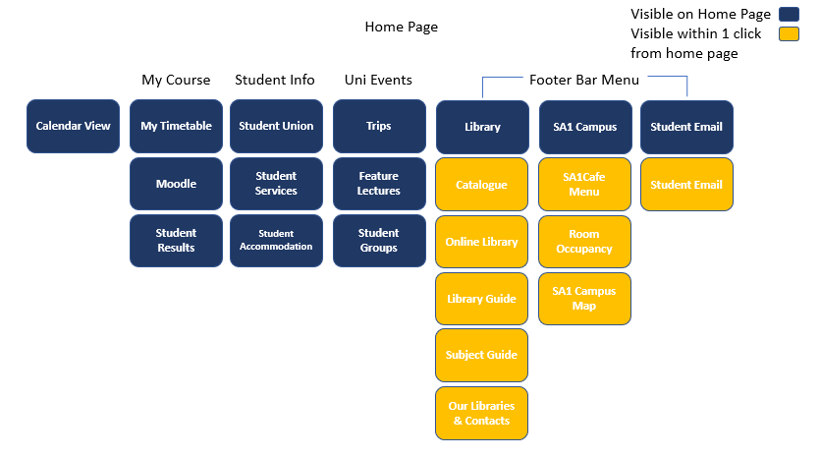

Figure 3

The information within the app that is location sensitive is the information relating to the SA1 campus, the campus map, available rooms and café menu. However, from the information contained in the UWTSD website all FACE students are located at the SA1 campus, therefore this information is applicable to all.

4. Wireframes
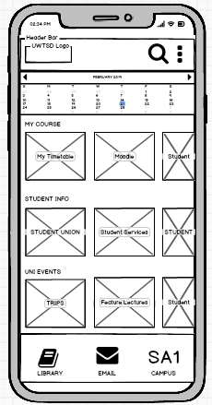
Nielsen’s 10 usability heuristics for user interface design [9] have been used as a basis for the design of the interface within the app. The app uses everyday language, has expected uses of common icons and minimalist design. Initial paper designs can be seen in Appendix E.
The home page has been designed with the main navigation bar at the bottom of the page, within the ‘thumb reachable zone [10].’ See figure 5. Within the menu bar is the information most likely to be accessed on a daily basis according to students surveyed.
‘Sequential menus’ [11] are used for navigation. Once a primary menu option is selected, the primary navigation options are then replaced with secondary menu options. This is a widely used technique in mobile apps [11].
The calendar is purposely displayed at the very top of the page, so that every time a student opens the app the important dates are prominent, such as the hand in date for an assignment or exam.
Although it is most convenient for users to navigate from the bottom of an app, users still scan an app visually from top to bottom, most commonly on non text pages in a ‘Z pattern’ [12].
The use of images as menu buttons is used to, aid memory recall [13] by allowing users to associate images to information and reducing the need on the user to read text when they can scan images.

Figure 4

By showing the menu options in the central part of the pages as scrolling menus under headed groupings, it has removed the need for users to make an additional click, such as if the user was presented with three high level menu options, ‘My Course’, ‘Student Info’ and ‘Uni Events.’
To interact with the menus in the middle section the user can either tap the screen to select an option or slide the menu to the left to fully view the third option. Under each heading, the number of options has been limited to three because it is harder for users to choose when provided with a high number of options [14] as per Hicks Law [15]. The menu uses affordance to communicate to the user that they need to swipe the menu, by only partially displaying the image and text in the third menu options.

Thumb Reachable Zone
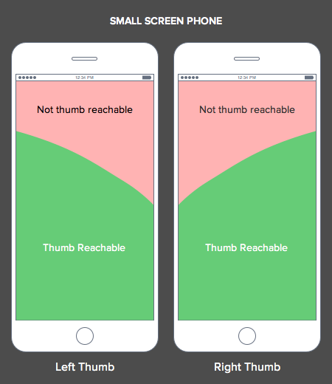

Figure 5

The page layout has been designed to place the most valuable information to the user within the ‘Z’ area. Moodle, a commonly accessed feature based on user feedback, was deliberately placed in the centre of the top sliding menu because a user was more likely to see it when scanning the page in a Z motion, than if it were the first menu option in ‘My Course’, which would place it at the top left of the page.
Although Moodle was rated as a highly accessed page by students, the students interviewed stated they likely wouldn’t access Moodle as much on a smartphone as they do other information such as emails, SA1 campus information and Library pages. Hence, it’s location within the central element of the page and not the most frequently accessed information at the footer menu bar.
The footer bar contains the three menu options for the most commonly accessed content and is displayed across all pages. Nielsen recommends “navigation should be available at all times, not just when we anticipate a user needs it [16].
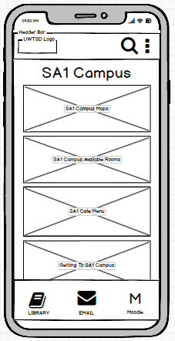
The icons used on the home page, (search, burger menu, email and book) are all commonly used throughout mobile apps, so these are expected to be familiar to our target user group. For the SA1 Campus, text has been used to create an icon to make it as clear as possible to the user what can be accessed by clicking on it.
The header and footer bar are constant across all pages. However, where the user clicks on an option from the footer menu, such as the ‘SA1 Campus’ icon, the user is taken to the SA1 Campus page. Therefore, it does not make sense to display the menu option for the page the user is already on, it’s likely to confuse the user. So when a user selects a page from the footer menu, the menu option changes accordingly. In each instance, the icon for the page the user is on, is replaced by the Moodle icon. Except for email, where staff contacts replace the email icon.
On the SA1 Campus page, the user is presented with four menu options. The user is prompted to swipe up the page to fully see the menu options by the bottom menu option being partially hidden behind the footer bar.
The hamburger menu is used for infrequently used options such as account settings and logging out. [17] suggests this is the most appropriate use of a burger menu.
The header bar is consistent across all pages and provides the user with a search icon which opens a search text box and the UWTSD logo which acts as a home button within the app, which is a standard convention on websites and mobile apps. Nielsen states having the organisation’s logo as a home button; is;

Figure 6

“is a long-standing web convention. Over time through trial and error, many people have learned that clicking on a site’s logo leads them back to the homepage. Following this standard on your site reduces confusion by matching your UI to users’ expectations” [18].

5. User Feedback
In order to gather feedback on the design, the author sought out FACE students who were representative of the personas created for this app. Students who were from the different schools within FACE, part and full time students, male and female students, young and mature students and an overseas student.
The author conducted a cognitive walkthrough [19] with the students, which involved the students having to use the app designs to achieve and outcome. The cognitive walkthrough asked users to;
- Access their course content within Moodle
- Find what lecture they are timetabled to be in on a Friday at 11am, and find a map showing the lecture room location.
- Find Student Accommodation information.
- Log out of the app
The author asked the student testers to think aloud and explain their thought process when navigating the app. The author noted down their feedback, so that reasons for students actions could be understood, such as whether or not a users expectation of an action resulted in that action being achieved or if it delivered a different result. Some extracts from the user feedback are shown below.
I found it straightforward to find my way around. The stuff I’d use the most is easy to reach.”
“How do I go back one menu and not all the way to the home page?”

“If the calendar is going to display the full month it’s way too small for my fat fingers. I’d want a week at a time.”
“I’m assuming I click the calendar to add an appointment, That’s how I use my current one.”

“It’s clean and easy to use. I like that the pictures are only half visible if there’s more to see.”
“I like that the menu at the bottom is always there.”

User feedback was overall very positive, which was certainly what was hoped for. Users liked the sliding menus, this was something many commented they’d encountered on other apps and found it easy to swipe through the menu options. Users commented they liked that images would be used for the menu options because it would save reading them, although they did comment that the images would need to be simple and obviously linked to what is behind them. Users stated they would like some kind of back button to go back a step, saving them from going all the way back to the home page and starting again was a useful discovery from the testing. One that has now been included in the design going forward for pages that are more than one click away from the home page. See Appendix D. A toggle view for the calendar for day, week or month, has also been added as a result of feedback. See Appendix D.

6. References

[1] Guo, A. and Ma, J. An Integrative and Precise Approach in Personality Computing Based on Ontic Personae Modeling. Presented at 2017 IEEE 15th Intl Conf on Dependable, Autonomic and Secure Computing, 15th Intl Conf on Pervasive Intelligence and Computing, 3rd Intl Conf on Big Data Intelligence and Computing and Cyber Science and Technology. 6-10 Nov. 2017 Orlando, Florida.

[2] Ielite, I. Olevsky, G. and Sadiulins, T. Identification and prioritization of stakeholders in the planning process of sustainable development of the smart city. Published in: 2015 IEEE Seventh International Conference on Intelligent Computing and Information Systems (ICICIS). 12-14 Dec. 2015. Cairo, Egypt.

[3] Mannion, R. and Thompson, C. Systematic biases in group decision-making: implications for patient safety. International Journals for Quality in Health Care, Volume 26, Issue 6, pages 606 - 612. 1st December 2014.

[4] Available at: https://www.usability.gov/how-to-and-tools/methods/task-analysis.html. Accessed 20.02.19

[5] Available at: https://www.agilebusiness.org/content/moscow-prioritisation. Accessed 05.03.19

[6] Available at: https://www.usability.gov/how-to-and-tools/methods/card-sorting.html Accessed 05.03.19

[7] Available at: https://www.usability.gov/what-and-why/glossary/3-click-rule.html. Accessed 20.02.19

[8] Available at: https://www.nngroup.com/articles/scrolling-and-attention/. Accessed 05.03.19

[9] Available at: https://www.nngroup.com/articles/ten-usability-heuristics/ Accessed 23.02.19

[10] Available at: https://uxmovement.com/mobile/why-mobile-menus-belong-at-the-bottom-of-the-screen/. Accessed 04.03.19

[11] Available at: https://www.nngroup.com/articles/mobile-subnavigation/ Accessed 04.03.19

[12] Available at: https://www.nngroup.com/articles/zigzag-page-layout/ Accessed 04.03.19

[13] Available at: https://www.nngroup.com/articles/recognition-and-recall/. Accessed 19.02.19

[14] Available at: https://www.nngroup.com/articles/simplicity-vs-choice/ Accessed 23.02.19

[15] Available at: https://www.interaction-design.org/literature/article/hick-s-law-making-the-choice-easier-for-users Accessed 20.02.19

[16] Available at: https://www.smashingmagazine.com/2016/11/the-golden-rules-of-mobile-navigation-design/ Accessed 18.02.19

[17] Available at: https://www.smashingmagazine.com/2017/05/basic-patterns-mobile-navigation/ Accessed 02.03.19

[18] Available at: https://www.nngroup.com/articles/homepage-links/. Accessed 05.03.19

[19] Spencer, R. The streamlined cognitive walkthrough method, working around social constraints encountered in a software development company. Published in Proceedings of the SIGCHI Conference on Human Factors in Computing Systems. April 01 – 06 2000. The Hague, Netherlands.

7. Appendix A
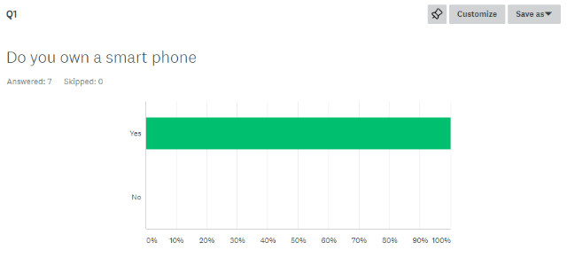

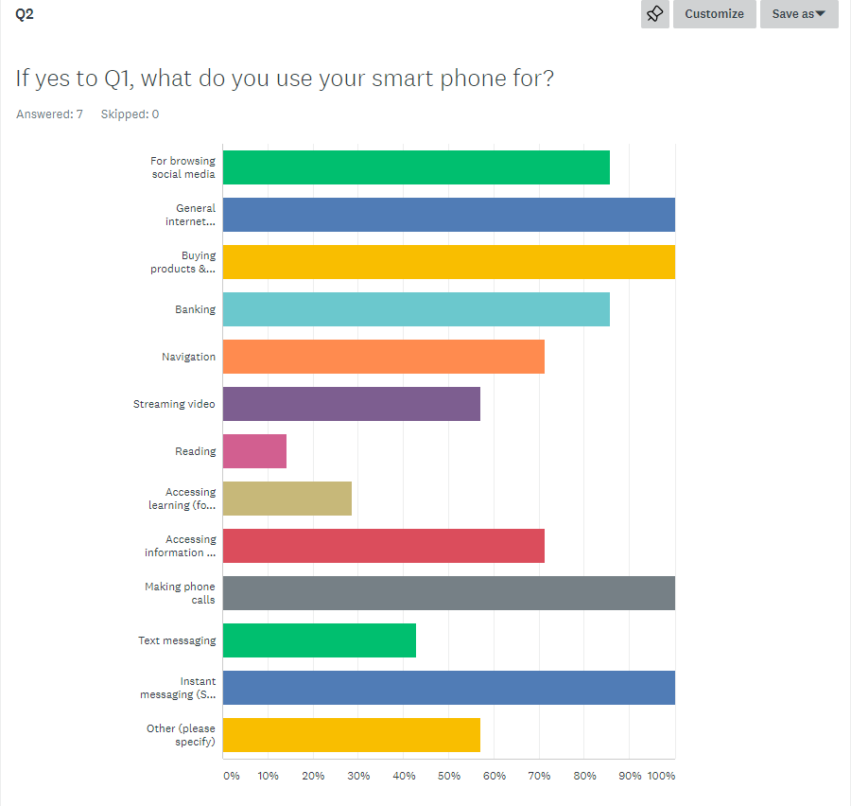

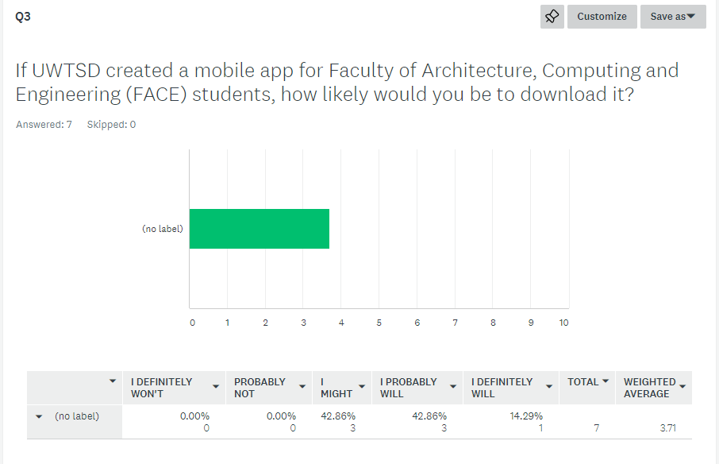

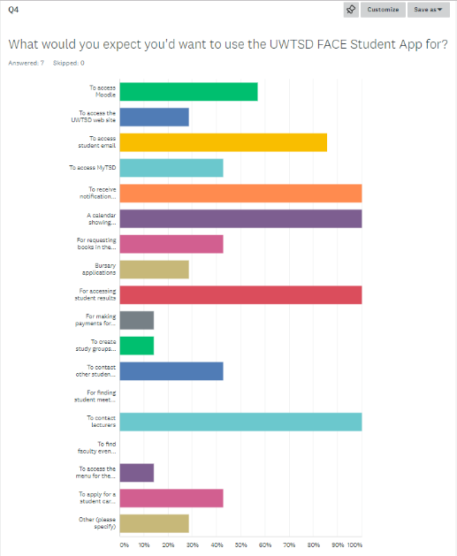

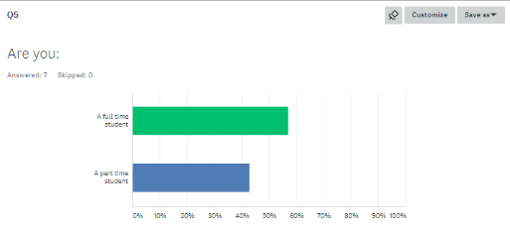

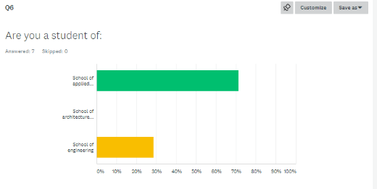

8. Appendix B

8.1 User Requirements
As a student I Must be able to… | - Access Moodle  - Access student timetable  - View and send emails from student email account.  - Email lecturers  - View lecturer contact information  - Access my results  - Receive a notification from my lecturer when a lesson; time changes, location changes or is cancelled.  - Not have to sign in to Moodle and my student email in addition to signing in to the app.  - Stay signed in to the app
As a student I Should be able to… | - View assignment hand in dates in a calendar.  - Apply for student bursary’s.  - Access student union – tsdsu.  - Access student advice and services.  - Access student accommodation information.  - View trips and special lecturers taking place.
As a student I Could be able to… | - Make a payment through the app for student trips.  - Browse books in the library through the app.  - Receive a notification when a book I want becomes available in the library.  - View the menu in the SA1 café.  - See when lecture rooms are unoccupied.  - See upcoming university events and activities.  - View a map of the university campus.  - View the menu for the café.
As a student I Will Not be able to… | - Store my credit or debit card information in the app.

8.2 User Experience Requirements
The FACE student app Must… | - Be intuitive to use.  - Be able to be viewed in different languages.  - Be easily understood by a screen reader.  - Conform to accessibility guidelines.  - Be recognisably UWTSD.
Should | - Use icons that are familiar to smartphone users.  - Be minimal clicks to access information.
Could | - Be fun to use – prizes for using app to incentivise students to use it.  - Could make use of augmented reality technology for navigation.
Will Not | - Use dark patterns  - Will not track users when they’re not using the app.  - Will not share users behaviour beyond the University itself.

9. Appendix C
i.

Log On Page
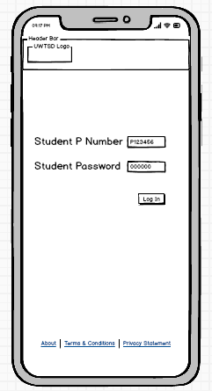

Text input box with suggested input type

Button to click to log in

Links to relevant information pages which can be viewed prior to logging in

ii.

Home Screen
Search icon button
Search icon button
Burger menu

Add calendar event
+
Swipe Calendar to view different months

Click on highlight to view event info

Click image to view information
Swipe left to fully view menu options

Clickable menu icons

iii.

Home Screen with Expanded Burger Menu
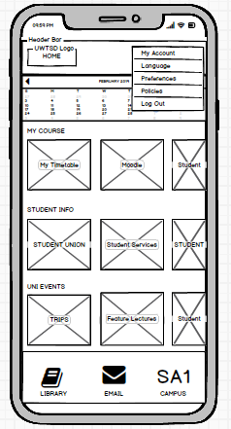

Expanded burger menu

iv.

Student Timetable
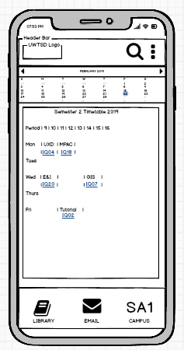

Room number is clickable link to view the room location on the SA1 Campus map

v.

SA1 Campus Map
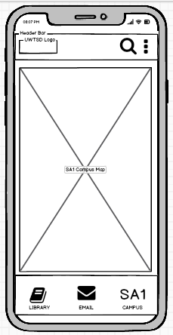

vi.

Moodle Page
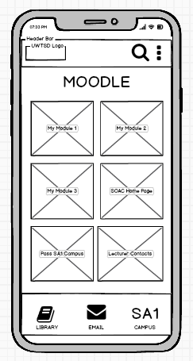

Page Heading

Clickable menu images

vii.

Student Results Page
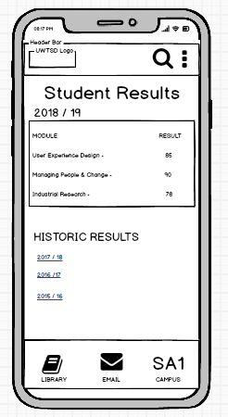

Page Heading

Clickable links to view historic results. Displayed in blue and underlined as standard text link visualisation

viii.

Students Union Page
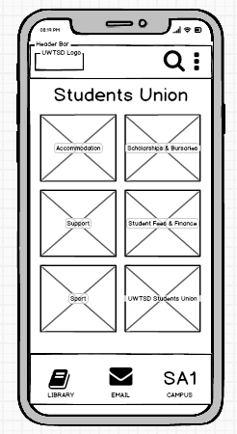

Page Heading

Clickable menu images

ix.

Student Services Page
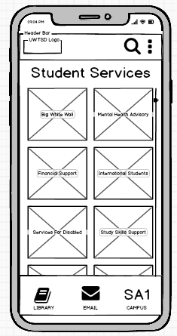

Page Heading

Scroll bar, indicating page extends down below what is visible

Clickable menu images

Partially visible images indicating user needs to scroll down to view content.

x.

Student Accommodation
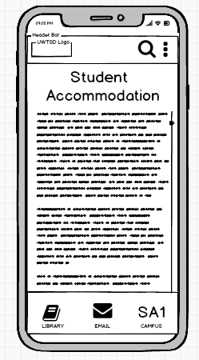

Page Heading

Scroll bar, indicating page extends down below what is visible

xi.

Faculty Trips Page
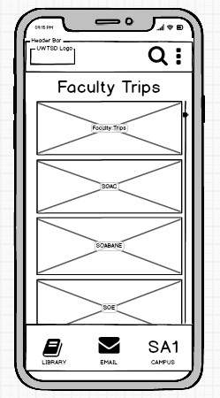

Page Heading

Scroll bar, indicating page extends down below what is visible

Clickable menu images

Partially visible images indicating user needs to scroll down to view content.

xii.

Feature Lectures Page
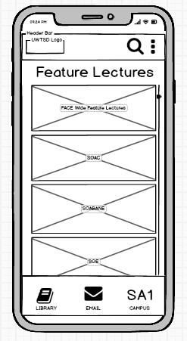

Page Heading

Scroll bar, indicating page extends down below what is visible

Clickable menu images

Partially visible images indicating user needs to scroll down to view content.

xiii.

Student Groups Page
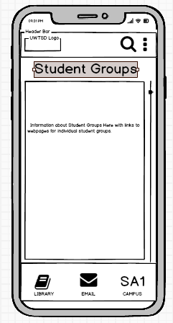

Scroll bar, indicating page extends down below what is visible

xiv.

Library Main Page
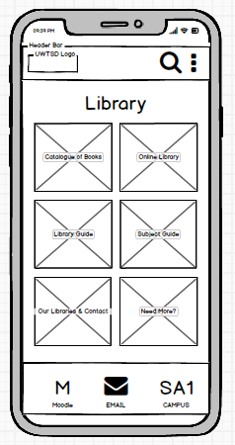

Page Heading

Clickable links

Library icon changed to Moodle icon as we’re on the Library page.

xv.

Student Email Inbox
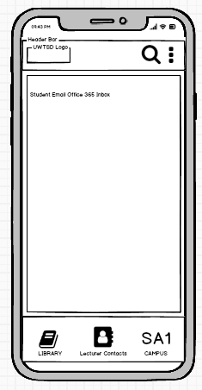

Usual Office 365 Outlook functionality. Create, Read and Delete functionality.

Email icon changed to Lecturer Contact info as on email page and lecturer contact info is likely of value to user at this point.

xvi.

SA1 Campus Main Page
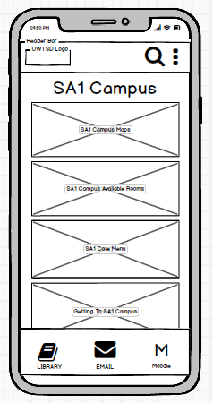

Clickable links

Image only partially visible suggesting user has to scroll down to fully view it

SA1 icon changed to Moodle icon as on Moodle page.

xvii.

SA1 Campus Maps
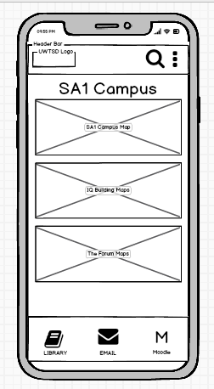

Clickable links

SA1 icon changed to Moodle icon as on Moodle page.

xviii.

Calendar View Page
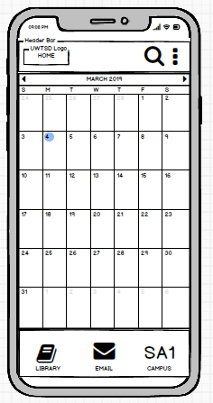

Full calendar view for the month

Cycle backward and forward between months

Highlight denotes event in calendar

10. Appendix D
i.
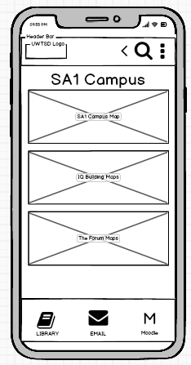
Pages with back button added to header bar.
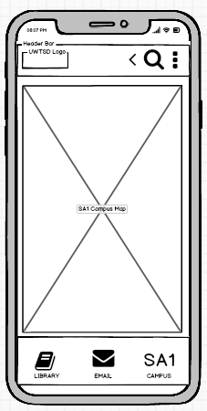
Back button icon

ii.
Calendar view now with toggle bar to select view of month, week or day.
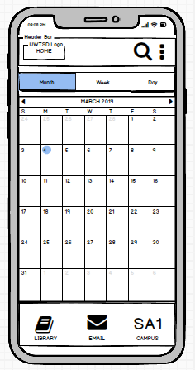

Toggle bar for month, week or day view.

11. Appendix E
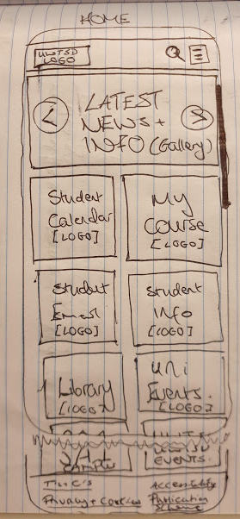
Early hand drawn designs of UWTSD FACE App page designs.


