Assessment component 2:

Introduction:

During the coaching practice, I will be working with a colleague who acts as a Professional Tutor in the Athrofa Professional Learning Partnership (APLP). In this role, my colleague supports student-teachers with their teaching practice and provides training and support to a range of school-based colleagues (including mentor training to mentors and senior leaders).

Prior to starting our coaching sessions, I asked my colleague to complete two assessments: ‘Values and Beliefs’ (see Appendix 1) and ‘Thinking about you’ (see Appendix 2), to ascertain his core beliefs and to establish what is of particular importance to him, as a colleague. It is noteworthy that he ranked ‘respect’, ‘success’ and ‘loyalty’ very highly in his ‘Values assessment’ and that ‘failure’, ‘worthlessness’ and ‘humiliation’ were values that he wished to ‘move away from’. His answers in his second assessment, based on Claus Moller’s work on personal development (1997), gave a ‘score’ of 55. It is notable that the guidance for the questionnaire states that ‘If you score considerably less than 70 points, you should work on developing your self-esteem and regard this task as an exciting challenge.’ I am hopeful that the choice of the STRIDE model is therefore appropriate to the coachee’s needs.

Reflective Journal:
In order to reflect purposefully and effectively on the coaching sessions that were carried out, I referred to Gibbs’s model of reflection (1988), as shown in Figure 1, below:

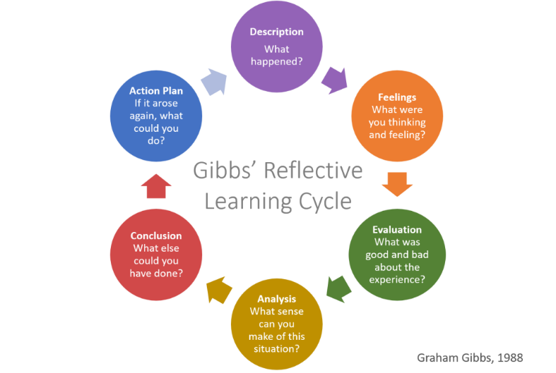

In this model, a framework is given to ‘examining experiences’ whilst allowing the practitioner to adapt and change as part of an ongoing cycle of reflection (University of Edinburgh, 2020). I found this model particularly useful as part of the reflective process on my coaching as I look towards further implementation of coaching strategies across the APLP. My self-assessment of each session can be found in Appendix 5, although the key themes and stages of reflection will be evident throughout this reflective journal.
As outlined in Appendix 4, the six sessions were planned using the STRIDE model, with particular emphasis being placed on the ‘strength’ stage of the process. This was largely due to the coachee being a new member of my team and the fact that he had stated that he had felt undervalued in his previous role. Additionally, the pre-coaching tasks (see Appendix 1 and 2) highlighted that he may have ‘low’ self-esteem.
During the first session, I ensured that the coachee was aware of their right to withdraw and reminded them of the confidential nature of our sessions. This was particularly important due to the close working relationship between us and took account of appropriate ethical considerations (Clutterbuck, 2004). Please see Appendix 3 for an anonymised copy of this contract.
Throughout the session, we discussed strengths in the coachee’s make up and I encouraged particular examples to be given through different forms of questioning, for example the use of ‘clarifying’, ‘reflective’, ‘summarising’ and ‘outcome’ questions at appropriate stages (Alison and Harber, 2009, pp.4-6). The use of this questioning strategy appeared to elicit a positive response in the coachee and he was able to articulate and reflect upon some notable strengths in his personal and professional life.
I was very aware that as friends and colleagues, I was in a potentially difficult position due to a perceived power imbalance. As a consequence, I was mindful to not offer opinions or judgements on the detail of what was being said, despite this being a challenging thing to do. At times, I felt the urge to offer reassurance and to compliment the coachee on the impact of their work, which was difficult.
In the second session, it became apparent that the target that the coachee and I had both assumed may be chosen (building self-esteem) was reframed into ‘obtaining a greater work/life balance’. This was an important development as it demonstrated that my making assumptions of what a target could or indeed should have been, was not appropriate. Gilbert and Whittleworth’s assertion that ‘coaching is the very opposite of telling somebody what to do’ (2009, p.7) particularly resonated in this regard. As I look to future coaching experiences that I may have, I will need to be mindful of this and resist the temptation to direct the coachee on what their targets should be, based on my opinions. Locke and Latham’s work on Goal Setting Theory (2012) will be an important text to support my understanding of this process.
Prior to the second session, I was aware that the use of setting SMART targets (mindtools.com, N.D) may have impacted negatively on the STRIDE model and future coaching sessions with the coachee. I tried to mitigate this by not overly focussing on the ‘time bound’ element of the SMART due to the cross over with elements of STRIDE, for example the later D session (‘decision / commit’). However, on reflection, I do not think I would conflate the two models again in the future. I found that I was trying to control the process too much, often for my own benefit rather than that of the coachee, and that the session was not as organic and free flowing as I would have liked.
During the third coaching session, which focussed on ‘reality’ and establishing where the coachee was currently in their journey of achieving their target, I was again aware that I was keen to offer reassurance as a colleague, rather than as a coach. For example, when discussing his desire to have his work acknowledged, I found myself making comments regarding the value that I personally attached to the work he had produced, particularly when the he cited that workload had had negative impact on their personal life. I was keen to offer praise and gratitude for what the coachee had brought to our team, perhaps at the expense of allowing the coachee the space to arrive at certain conclusions himself. However, it was notable that the coachee had met the intended outcomes of the session (see Appendix 5) and was able to articulate challenges that have been faced to date in balancing their professional and personal life. At times, the session became emotional as the coachee discussed the apparent need for validation from co-workers and leaders and it was clear that this had had a considerable impact on his self-esteem. On reflection, I was not expecting the coaching session to become emotional and I found maintaining the separation between coach, friend and colleague challenging.
The fourth session centred on considering what changes would be necessary in order for the coachee to achieve their target of obtaining a better work/life balance. The coachee had already considered some possible strategies prior to the session, and this was helpful to steer and guide the conversation. If I were to use the STRIDE model again, I would ensure that this was something that I advised coachees to do, to ensure that the session was as effective and discussive as possible.
The coachee suggested a variety of strategies, including reducing screen time and removing work emails from personal devices, not working past a certain time in the day and ensuring that weekends and holidays remained times which were dedicated to his family and hobbies. We discussed how these strategies could reframe his thinking around knowing when he had ‘done enough’, thus impacting on his self-esteem. As work/life balance has been a challenge for me personally, too, I was keen to share my own experiences. This again highlighted the fact that I was still learning exactly what the role of a coach is and that I need to undertake additional research to ensure that I am the need for clear boundaries. After the session, I read Mishraa’s article on ‘Boundaries in Coaching’ (2018) a particularly useful resource and I intend to be more conscious of these considerations in any future coaching that I do.
As mentioned previously, the fact that I had introduced SMART target setting as part of the second coaching session, had an impact when it came to identify definite steps forward in the ‘Decision/Commit’ session. I had been mindful to not focus too heavily on the time element of setting targets using the SMART model primarily because I knew that this would be a feature of the fifth session. On reflection, I was disappointed that I had used SMART earlier in the process so approached this session with a sense of frustration. However, the coachee was able to meet the intended outcomes and decided upon two targets in order to move toward their goal: removing work emails from their phone and resolving to not work past 5pm. As these were both ‘immediate’ targets, insofar as they could be acted on instantly, the coachee decided that the time element would focus evaluating any potential negative impact of taking these steps. This was an important consideration in light of the coachee’s concerns that his work could be viewed negatively or that he could be judged to be ‘not doing enough’. As a result, the coachee agreed to review if these steps had had a negative impact on his work. In this case, the fact that I was aware of his targets as a colleague, was particularly helpful as I could help in supporting them, for example, by not emailing after 5pm.
The final sessions were separated into two; evaluating to what extent the target had been achieved and how the steps taken had impacted upon the desired outcome; and what other steps could also be taken in the future to continue to make progress to this end. The coachee stated that the agreed steps had had a positive impact and that he had been able to dedicate more time to spending with his children. Additionally, he shared that the fact we had agreed for him to not work in the evenings and weekends, relieved his anxiety. In this case, the closeness of our relationship appeared to have been a positive feature of the coaching process.
At the end of the coaching process, I asked the coachee to complete an evaluation. I deliberately asked the coachee to complete this once we had undergone all six sessions, rather than after each individual session. I was concerned that an evaluation of each of the six sessions in isolation would not give an accurate reflection on the behaviours that were being developed over a period of time as part of the process.
From the coachee’s evaluation (Appendix 6), it was evident that he found the focus on identifying strengths helpful at the outset of the process. I was also pleased to see that he felt comfortable and at ease during the sessions and that we built a good rapport. Importantly, the coachee did not make any negative comments about the closeness of our relationship, although this is something that I would consider in any future coaching relationship I may have.
The coachee did comment that the use of the SMART target setting model was ‘slightly confusing’ and therefore, the use goal setting strategies are something that I would seek to develop in the future.
Critical review of coaching supervision
Prior to the coaching process, I completed an Insights assessment based on the work of Jung and Adler (2014). Insights is described as being ‘built to help people understand themselves, understand others, and make the most of the relationships that affect them in the workplace’ (Insights, 2023). It was noteworthy that I was deemed to be a generally positive and social individual who is ‘understanding, friendly and warm hearted’, which I hope are characteristics which are desirable in a coach. However, the Insights tool also highlighted the following potential weaknesses:
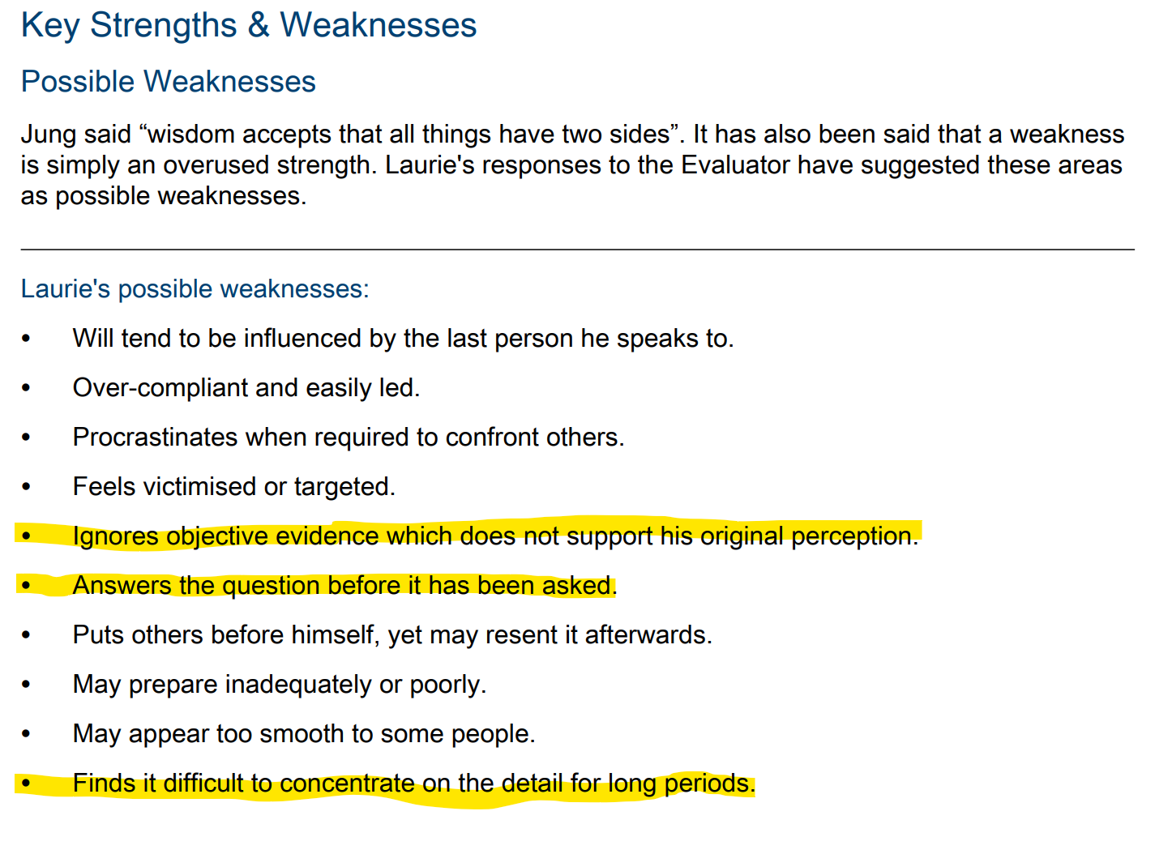
It is notable that the weaknesses highlighted may suggest that I needed to ensure that I utilised ‘actively listening’ during the sessions to ensure that I remained receptive to the comments and refrained from interjecting. As the coachee and I are friends and colleagues, this was particularly challenging, especially when the coachee commented upon shared professional experiences.
In the first, recorded session, it was obvious that the coachee had struggled with self-esteem as a result of his experiences in his previous role. I incorrectly assumed, that one of his targets would focus on building confidence in the workplace. This appears to exemplify the Insights ‘weakness’ where my tendency to leap to a conclusion is suggested.
I have also undertaken a DiSC assessment (DiSC, 2023) which provides information which may suggest a personality or behavioural ‘style’. My answers to the DiSC assessment suggested that I have an ‘i style’, the characteristics of which are outlined in the Figure 2 below:
Figure 2: DiSC Styles
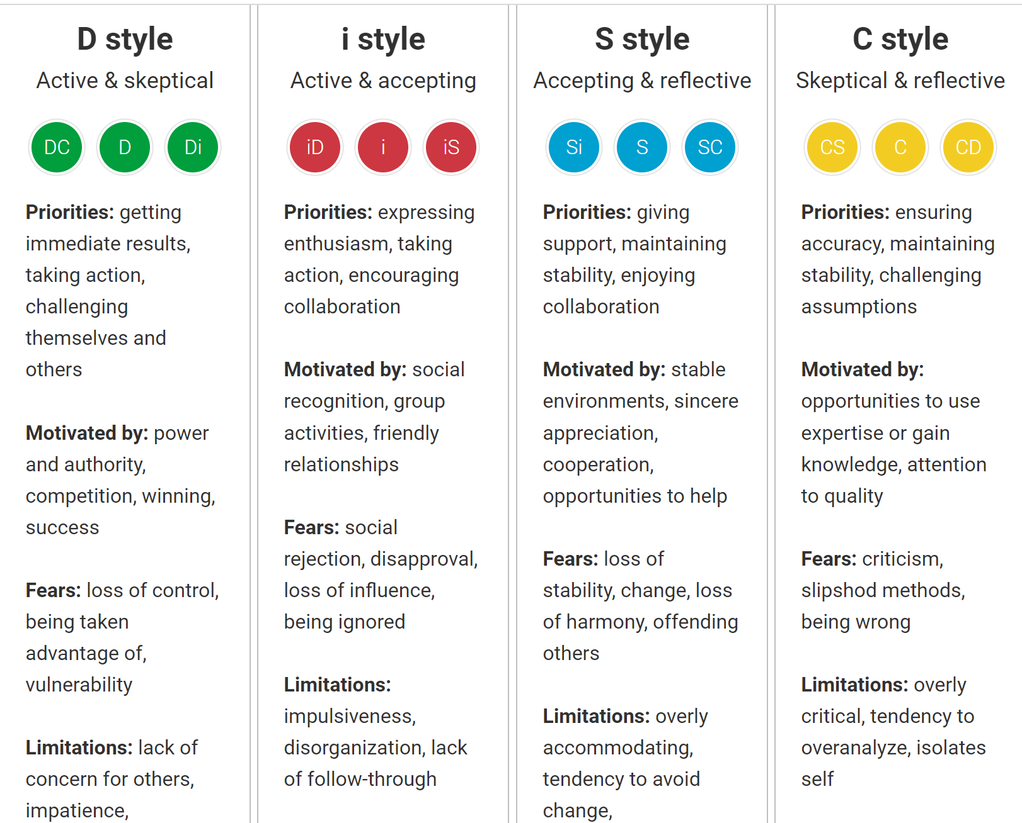

The assessment suggested that ‘you’re usually open and expressive with your opinions and emotions’ (DiSC, 2023). These traits would appear to support the findings of the Insights assessment, and add weight to the notion that I need to ensure that I listen purposefully in coaching sessions rather than attempting to impose my own behaviours onto the coachee.
Consequently, throughout the coaching sessions I attempted to ensure that I listened actively to what was being said, rather than making assumptions or engaging with only some of what was being communicated. In order to do this, I attempted to ensure that I was conscious of what Mindtools (N.D) suggested was effective practice when listening purposefully to the coachee ‘…Nor can you allow yourself to get bored, and lose focus on what the other person is saying.’

From the session evaluations (Appendix 5), it is evident that this is something I was able to do to varying degrees and this will inform my coaching development plan as I seek to make progress this with this area of my practice. Therefore, I will use the following visual resources prior and during sessions:
Figure 3 – Listening Skills ‘Hear what people are really saying’ (Mindtools, 2019):
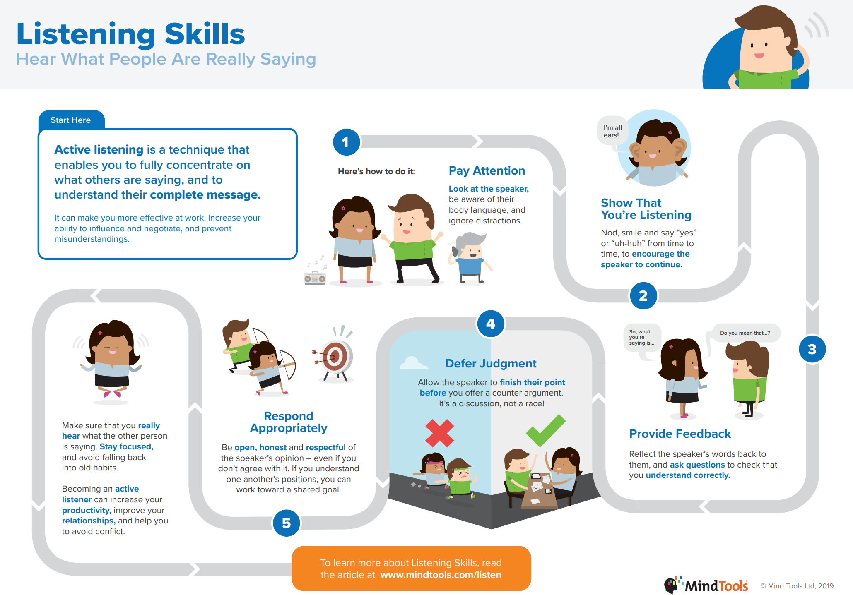

During the fifth coaching session, I utilised role play as a technique to help the coachee explore the issue of managing work/life pressures. Importantly, this was not something that was pre-planned, but rather occurred naturally as part of our session to help the coachee visualise the specific issue being discussed. Andrews (2021) advocates the use of “spontaneous” role play when the topic of conversation is “difficult to pin down”. In the context of my coaching session, I found this to be an incredibly powerful strategy and one which I would be willing to utilise to a greater extent in the future. On reflection, there were instances in some of the earlier coaching sessions with my coachee where this strategy may have offered additional insights.
In the final session, I was pleased to see that the coachee was able to reflect purposefully on their progress to date. However, if I were to use the STRIDE model again I would like to revisit the individual’s ‘strengths’ in order to emphasise the positives that had come from the process. In this instance, the model would be adapted to ‘STRIDES’.
Critical reflection on coaching/mentoring performance in the workplace
As outlined in component 1, the mentoring and coaching strategy in the APLP is still being developed. Due to the size and complexity of the partnership this is a very challenging task, although pockets of excellent practice are evident. At present, I have developed a range of resources and training materials for school-based mentors, which have been engaged with to varying degrees due to the time pressures on staff. The development of a ‘mentor handbook’ has been a particular development this year, as it contains a range of resources for mentors to utilise when supporting student-teachers. This includes a range of coaching models including GROW, FUEL and OSCAR. Having developed a working knowledge of how powerful the STRIDE model can be in forcing the coachee to identify strengths in their skill set, I am keen to utilise this to a greater extent with student-teachers. This is primarily due to the fact that student-teachers can often find this difficult, and can perceive feedback to be indistinguishable from personal criticism (Burn, Hagger, Mutton 2015, p. 45). Therefore, beginning the coaching process with an emphasis on strengths may help mitigate these risks.
One of the greatest challenges I face in my role is ensuring that there is appropriate ‘buy in’ from school partners to undergo coaching and mentoring training and to refrain from repeating strategies they may be familiar with from their own training. To this end, I have worked closely with the Wales Academy for Professional Practice and Applied Research (WAPPAR) to develop a three-tiered mentor development programme which is currently being piloted. I firmly believe that once the numerous benefits of this training are evident to school partners, it will be engaged with to an even greater extent.
I am keen to work more closely with Senior Mentors in school whose responsibility it is to oversee and assess standards of mentoring in their respective schools. The structure of mentoring in the APLP is complex and over time the Senior Mentor role has been diminished. Consequently, I have invited all senior mentors for additional training, which will incorporate an honest reflection on my use of STRIDE.

Personal Development Plan:
Area for further development | Objectives (what do I want to achieve?) | How can I achieve it (methods)? | What support and resources do I require? | Completion/ review date
To develop my understanding and use of active listening strategies | To ensure that I mitigate the potential for my interrupting or adding to coaching conversations. | Paraphrasing (as in action learning sets)  Deferring judgement on what is being said  Sitting comfortably in silence without trying to ‘fill’ them | Action learning set materials.  Revans, R. (2016). Action learning: Its origins and nature. In Action learning in practice (pp. 33-42). Routledge.  Figures 3 and 4 | Record and evaluate the first session of my next coaching session
To explore ways in which role-play can be used effectively in coaching sessions | To provide student-teachers and school-based mentors with the oppurtunity to explore challenges that are being encountered in order to deepen understanding | To integrate role play into any future coaching sessions that I carry out.  To observe school-based colleagues to learn how role play can become a feature of in-school training for student-teachers | To share resources such as: Microsoft Word - Scenarios.docx (brightmorningteam.com) with school-based mentors to inform and support role-play practice. | Observe coaching in schools next academic year
To consider how different forms of questioning can be used to support the coachee’s progress | To make best use of ‘clarifying’, ‘reflective’, ‘summarising’ and ‘outcome’ questions at appropriate moments. | If using a different model of coaching (depending on pre-coaching assessment outcomes), make use of question resrouces that are available  Utilise Bloom’s Taxonomy in a coaching context | If using GROW model, for example, select appropriate questions from existing resources such as:  Example Questions for the GROW Model (performanceconsultants.com)  Utilise Bloom’s Taxonomy to formulate my own higher order questions: | In preparation for next coaching process
To consider the circumstances around coaching a close colleague in future | To ensure there is no conflict of interest or potential for complication in a coaching relationship | Read more widely around the ethics of coaching colleagues.  Liaise with WAPPAR to consider the impact of this issue more widely (for school-based mentors / student-teachers) | Engage with literature and consider the ethical impact on coaching colleagues.  Thinking of Coaching a Friend? Read this First! (coachcampus.com) | Ongoing
Goal setting | To have a better understand of how goal setting theory sits within different coaching models  To consider how ‘strengths’ could be revisited at the end of the process – I.E STRIDES | Engage with literature around the topic of Goal Setting Thoery  Establish where goal setting in coaching models sits in the wider context of theory | Read more widely on the topic of goal setting and consider how this fits into common coaching models | Before next coaching round
References:
Alred, G., Garvey, B. and Smith, R (1998) Mentoring pocketbook. Alresford: Management Pocketbooks.
Andrews, M. (2021) Let’s role play it! by Malcolm Andrews, the good coach. Available at: https://the-goodcoach.com/tgcblog/2021/2/1/lets-role-play-it-by-malcolm-andrews (Accessed: 13 May 2023).
Bannor, Randhir, Dhaka, Mathur, Longo (2014), 247-259 , Volume 3 (6) An assessment of listening abilities of MBA students, International Journal of Social Science and Interdisciplinary Research
Bligh, M. C. (2011). Followership and Follower-Centred Approaches. In A. Bryman, D. Collinson, K. Grint, B. Jackson and M. Uhl-Bien (Eds.), The SAGE Handbook of Leadership pp. 425-436. SAGE Publications Ltd.
Cox, E., Bachkirova, T., Clutterbuck, D.A., (2014) The Complete Handbook of Coaching (2nd ed) Sage California: USA
Clutterbuck, D. (2004) Everyone Needs a Mentor: Fostering talent in your organisation. London: CIPD.
Competences (2015) EMCC. Available at: https://www.emccglobal.org/leadership-development/supervision/competences/ (Accessed: 26 May 2023).
Gordon, R. (2011). Leadership and Power. In A. Bryman, D. Collinson, K. Grint, B. Jackson and M. Uhl-Bien (Eds.), The SAGE Handbook of Leadership (pp. 195-202). SAGE Publications Ltd. Kindle Edition.
Gilbert, A., & Whittleworth, K. (2009). The OSCAR coaching model. Lulu. com.
Grant, Anthony M. "Is it time to REGROW the GROW model? Issues related to teaching coaching session structures." The Coaching Psychologist 7.2 (2011): 118-126.
Gibbs, Graham (1988). Learning by Doing. Oxford Polytechnic.
Holmes, M (2014) Beyond goals: effective strategies for coaching and mentoring, Action Learning: Research and Practice, 11:3, pp. 395-399
Insights discovery® - Our official flagship product and foundation. Available at: https://www.insights.com/us/products/insights-discovery/ (Accessed: 13 March 2023).
Jung, C. G., & Adler, G. (2014). The development of personality. London: Routledge.
Lindvall, P, Palmer, S, Fillery-Travis, A. (2022), Boss vs Coach: From conventional to post-conventional leadership. International Journal of Coaching Psychology, Vol 3, Article 4,
Locke, E. A., & Latham, G. P. (2012). Goal setting theory. In Motivation: Theory and research pp. 23-40 London: Routledge.
Mishraa, S. et al. (2018) Boundaries in coaching, International Coaching Federation. Available at: https://coachingfederation.org/blog/boundaries-in-coaching (Accessed: 17 May 2023).
Mitchell, C., Grimaldi, A. and Kato, S., (2022). Application of Coaching and Mentoring Strategies to Improve Well Being of Colleagues and Students in Education. Available at: Personal-factors-and-motivation-A-learning-advisors-experience.pdf (researchgate.net) pp.44-51
Optimus Education (2019). Coaching: The effective way to lead teaching and learning Available at: https://my.optimus-education.com/coaching-effective-way-lead-teaching-and-learning (Accessed: 3 May 2023).
Oviawe, J. (2020). Application of Graham Gibbs Model of Reflection to Improve Teaching Understanding among Technical Education Students in Ambrose Alli University Ekpoma Edo State. Sumerianz Journal of Education, Linguistics and Literature, 3(2), pp. 1201-2617.
Panchal, Sasikala, and Patricia Riddell (2020) "The GROWS model: extending the GROW coaching model to support behavioural change." The Coaching Psychologist 16.2: pp. 12-25.
Parsloe and Leedham (2009) Coaching and Mentoring: Practical conversations to improve learning. London: Kogan Page
Phillips-Jones, L. (2003), The mentor's guide : how to be the kind of mentor you once had - or wish you'd had. Grass Valley CA.: Coalition of Counseling Centers
Real Life Productions (2006). Mentoring and Coaching, Teachers TV/UK Department of Education. Available at https://video.alexanderstreet.com/watch/mentoring-and-coaching (Accessed 14 May 2023)
SMART Targets (no date) MindTools. Available at: https://www.mindtools.com/a4wo118/smart-goals (Accessed: 13 May 2023).
Thomas, W. and Smith, A. (2009) Coaching solutions: Practical ways to improve performance in education. London: Network Continuum Education.
The University of Edinburgh. Gibbs’ reflective cycle (2020) Available at: https://www.ed.ac.uk/reflection/reflectors-toolkit/reflecting-on-experience/gibbs-reflective-cycle (Accessed: 07 May 2023).
UWTSD (2023) PGCE primary with QTS, UWTSD. Available at: https://www.uwtsd.ac.uk/pgce-primary/ (Accessed: 13 May 2023).

Appendix 1:

Exercise: Values
The most successful individuals are those who hold positive beliefs and values about themselves and the people they lead and/or work with. Likewise, individuals most likely to achieve their goals are those who adopt a positive mindset. This personal reflection exercise highlights the power and influence that values and beliefs have on behaviour. It also encourages you to review your own values and beliefs and create your own positive mindset for success in your professional career.
Learning Objectives

You will be able to …
- describe the influence that beliefs and values can have on behaviour
- identify and discuss personal values and beliefs about yourself and others
- define a positive and empowering set of values and beliefs to improve effectiveness
- identify what steps to take to align these beliefs and values with actions

Guidance
This exercise is be ideal for experienced professionals to review their continuous personal development, and it is advised you choose a quiet time and space to reflect upon the activity.
Allow yourself around 40 minutes for completion.
What to do (15 minutes)
- Reflect truthfully on the beliefs and values that you currently have about yourself (Task Sheet 1, overleaf) and complete the first section of the task sheet; Moving Towards and Moving Away values.
Review activity (10 minutes)
Once the values activity has been completed, review these and decide how useful and positive they are.

Apply learning (15 minutes)
Consider what you will now do differently to align your beliefs and values to your actions. What beliefs and values will help you and assist you in your development and support of others?
Take ownership of these empowering values and beliefs and to use the ideas on the task sheet as a means of furthering your personal development back at work.

Beliefs and Values - Task Sheet 1
Identify 5 of the following statements as values that you hold most dear, and then rank the five in order of 1 being the most important to number 5 being the least important of these values.

Moving Towards Values:
Abundance | Curiosity | Intimacy | Respectful
Acceptance | Decisive | Intimate | Rewarding
Accomplishment | Eager | Involved | Romanic
Achievement | Easy Going | Joyful | Satisfying
Admiration | Encouraging | Kindness | Security
Adventure | Energetic | Leadership | Self-awareness
Affectionate | Enthusiastic | Learning | Selfish
Agreeable | Exciting | List Making | Selfless
Ambitious | Exuberant | Listener | Sense of humour
Appreciated | Faithful | Lovable | Sensitive
Approval | Feminine | Loving | Sensual
Attractive | Flexible | Loyal - 3 | Serenity
Balanced | Flirtatious | Magnificent | Service
Beautiful | Focused | Masculine | Sincere
Brave | Forgiving | Nurturing | Soft
Calm | Freedom | Obedient | Spiritual
Caring | Friendly | Open-minded | Spontaneous
Cheerful | Fun | Optimistic | Successful - 2
Clean | Gain | Organized | Supportive
Comfortable | Generosity | Passionate | Tactful
Committed | Genuine | Peace of Mind | Tender
Communicative | Giving | Peaceful | Thoughtful
Compassionate | Gratefulness | Pioneering | Thrifty
Competent | Gregarious | Planning | Tolerant
Completeness | Growing | Pleased | Trusting
Concerned | Happy | Pleasure | Trustworthy - 5
Confident | Helpful | Positive | Unconditional love
Connected | Honest - 4 | Powerful | Understanding
Considerate | Honoured | Praise | Volunteering
Contributor | Hopeful | Productive | Wellness
Cooperative | Humorous | Proud of Self | Whole
Courageous | In Control | Pure | Winner
Credible | Inner Peace | Quiet | Youthful
Creative | Innovative | Religious
 | Integrity | Respect - 1

Moving Away From Values:
Identify 5 of the following statements as values that you will do anything to avoid, and then rank the five in order of 1 being the strongest in terms of avoiding these to number 5 being the least important of these values.

Abandonment | Frustration | Out of Control
Anger | Guilt | Painful
Anxiety | Helplessness | Panicky
Bigotry | Hopelessness | Prejudiced
Blame | Hostility | Rejection
Cheating | Humiliation- 3 | Resentful
Conflict | Hurt | Shame
Complaining | Ignorance | Sorrowful
Confusion | Indecisive | Stressed
Contempt | Inferiority | Taken for granted
Deception | Insecure | Tense
Depression | Intimidating | Unimportant -5
Disapproval - 4 | Jealousy | Unloved
Dishonesty | Lonely | Victim-oriented
Dismissed | Loss | Violent
Disrespectful | Negative | Weak
Embarrassment | Needy | Worthless-2
Egotistical | Neglectful
Failure - 1 | Nervous

Appendix 2

Thinking about you
Source: Claus Moller; My Life Tree – a different book about personal development. 1997 TMI A/S;

Very often the way in which you relate to, and deal with others is influenced by the way you feel about yourself.
This is a short questionnaire about you. Answer the questions as honestly as you can without taking too much time to think about it. Place an ‘x’ in the column that most accurately represents how you feel about the statement.

How am I? |  | Agree | Partly  Agree | Dis-agree
I find it easy to accept recognition and praise without feeling embarrassed |  |  | X
I find it easy to make contact with other people |  | X
I reprimand others in a way that allows them to maintain their self esteem |  |  | X
I do not make others feel guilty |  |  |  | X
I do not need to prove that I am better than others |  |  |  | X
I am able to enjoy other people’s success |  |  | X
I do not feel inferior to others |  |  |  | X
I focus more on other people’s strengths than their weaknesses |  |  | X
I believe that other people’s intentions are good, until proven otherwise |  | X
My past actions seldom make me feel guilty |  | X
I fight for my own ideas and opinions |  | X
I am honest with myself |  | X
I don’t feel hurt when other people have different ideas and opinions to mine |  | X
I regard most problems as exciting challenges |  | X
I seldom play the ‘victim’ |  | X
I can be alone with myself and enjoy it |  | X
I don’t humiliate others |  | X
I am not afraid to admit my mistakes |  | X
I seldom fear the future |  |  | X
I don’t get upset about things I can’t do anything about |  |  |  | X
I don’t react in appropriately when I experience defeat or disappointment |  | X
I am self disciplined and when I decide to change a habit I stick to it |  | X
I rarely envy others |  |  | X
I rarely feel jealous |  | X
I rarely feel bored |  | X
I am not afraid of showing my innermost feelings |  |  | X
I don’t blame others for my feelings |  |  | X
I don’t blame others for my problems |  |  | X
I find it easy to recognise and praise others |  |  | X
 | Number of x’s | 15 | 10
 | Points | 45 | 10
 | Total | 55

Scoring

- Count the number of Xs in each column. Write the result in the space provided.

- Multiply the number of Xs in the agree column by 3. Put the result in the space marked points.

- Write the number Xs in the partially column in the space provided for points.

- Do not count the number of Xs in the disagree column.

- Add up the numbers in the two different ‘points’ spaces and write the sum in the space marked total.

The maximum number of points is 90.

- A score of more than 70 points indicates a high degree of self - esteem. In other words, you feel good about yourself and others.

- If you score considerably less than 70 points, you should work on developing your self-esteem and regard this task as an exciting challenge.

It can also be beneficial to ask others, your boss, colleagues, employees, friends and family to score this exercise as they see you. This will probably reveal some differences that are worth working with.

Appendix 3:
Template for Coaching Contract (adapted from Sage Hub: template_for_coaching_contract.pdf (sagepub.com)
This agreement is made between [Ian Jones] (the ‘coachee’) and [Laurence Thomas] (the ‘coach’) for a number of coaching sessions.
The coaching relationship
The purpose of the coaching relationship is to support the coachee to achieve their goals. The coach and coachee will first come to an agreement about the nature of coaching. Coaching is a non-therapeutic intervention intended for coachees who wish to enhance their performance or improve their work or personal situation. Either the coachee or the coach is able to exit the coaching relationship without giving any reason, subject to appropriate notice being given.
Coachee’s responsibilities
To attend coaching sessions as agreed
To select topics for discussion
To set and pursue meaningful goals Coach’s responsibilities
To manage the coaching process (including timekeeping)
To undertake regular professional coaching supervision To maintain confidentiality (subject to certain exemptions)
Number of sessions
The coachee and coach will meet for [six] sessions, each lasting for no longer than [30 minutes].
Rescheduling coaching sessions
Coaching sessions can be rescheduled by either the coachee or the coach with [2 days] notice.
Information about the coach
Relevant qualification in coaching [part of ongoing Level 7 qualification]
Style of coaching
Style of coaching [directive]
Permission to challenge or use silences [yes]
Note taking arrangements [coach]
This coaching contract should be signed by both the coach and coachee.
It should be referenced at the start of each coaching conversation.
Coachee Signature:………………………………………. Date:…………………… …………………. Coach Signature:………………………. Date:………………………………………….

Appendix 4: Coaching plan
Coaching session 1 – Planning notes

- Introduction:
Introduce one another and go principles of coaching and what coachee can expect from the process. Establish what coaching the coachee has done before and discuss their experience of this. Obtain consent to record the initial session.

- Establish working relationship
Discuss the role of the coach and coachee and how this may differ from mentoring. Remind coachee of the importance of the coaching contract and his right to withdraw at any stage. Additionally, emphasise the importance of confidentiality throughout the process.

- Introduce STRIDE model and discuss the reasons for its selection:
Explain the basic principle of STRIDE (focus on strengths at outset) and why this has been selected (Strengths, Target, Reality, Ideas, Decisions and Evaluation).

- Begin coaching session – focus on ‘S’ - Strengths
In light of the results in the coachee’s tasks, it is important that time is spent identifying particular strengths in his skill set. I will encourage the coachee to reflect purposefully on their motivations, values and strengths through the use of effective questioning.

- Close session
Offer chance to provide feedback and share ‘evaluation’ sheet. Explain that I will also complete a self-assessment in order to continue to improve the experience for the coachee ahead of the proceeding sessions.

Overview of Coaching sessions

Session | Length | Overview
1 – Introduction to coaching process, ethical considerations and STRIDE model. Focus on S – Strengths for this session.  Intended outcome:  - Coachee able to identify and celebrate strengths in their make up  - To discuss possible reasons for low self-esteem ‘score’ | 1 hour | Introduce coaching concepts and procedures. Discuss expectations and explain rationale for STRIDE model.  Establish what the coachee is hoping to gain from the experience.  Focus on S – Strengths, using the following questions (as appropriate to conversation):  - What has made you feel successful this week?  - What has been your best achievement of the year?  - What went well this week?  - What are you most proud of as a practitioner?  - When do you perform at your best?
2 – Target / Goal setting. Choosing a target that is appropriate, achievable and specific.  Intended outcome:  - To identify a specific goal, relative to coachee’s needs | 1 hour | Focus on T – Target. Discuss what the coachee would like to identify as a goal. Importantly, I will have to be conscious of my knowledge of his job role and refrain from making and comments which distort the coaching session.  The setting of SMART (specific, measurable, achievable, relevant, time-bound) target will be appropriate. It is important that his does not overlap with the STRIDE model, however.  Active listening to be used throughout.  Questions to support this process include:  - What would need to happen for you to walk away feeling this is time well spent?  - What exactly will make you feel successful in this?  - What are you building towards? / What do you really, really want?  - What don’t you want?  - What has to happen for you to feel successful?  - How do you know this goal is worth achieving?  - How will you know when you have achieved it?  - What will you see, hear and feel after having achieved it?  - What will achieving this goal do for you / give you?  - How would other people benefit if you reached your goal?  - What is important to you about achieving this goal?  - How much personal control do you have over your goal?  - What can you do yourself to achieve this goal?  - By when do you want to achieve it?  - How will you measure it?  - What’s your heart telling you about this dream / goal?  - What’s your dream outcome?
3 – Reality – identifying where the coachee currently is on their journey  Intended outcomes: -  - Discuss some of the reasons for the current ‘reality’  - Establish what efforts have been made toward achieving target to date | 1 hour | Focus on R – Reality.  Discuss current situation with coachee and where he is currently ‘at’ professionally. Explore obstacles, limitations, or external factors that may impact negatively on progress.  Use the following questions to scaffold the conversation.  Where are you starting from / What have you learned so far?  - What have you done so far about this dream / goal?  - How effective have your efforts been?  - What’s stopped you doing more?  - What have you learned from what you’ve done?  - What might you have done differently?  - What insights do you have about yourself / life in general that are relevant to this?  - What will happen if you do nothing?  - What other choices do you have?  - What do you have that you are not using?  - What is holding you back?  - What could stop you achieving your goal?  - What are you afraid of?  - What is not achieving your goal costing you?
4 – Ideas and options. Consider what may change in order for coachee to achieve their target.  Intended outcome  - To discuss possible steps and strategies to move toward achieving intended target | 1 hour | Focus on I – Ideas and options  Discuss what possible options or solutions are required and specific changes in order for them to achieve the identified goal. Use the questions below to inform session and guide the coachee’s thinking:  What could you do?  - What could you do differently from now?  - What must change for you to achieve your goal?  - What approaches have you seen used in similar circumstances?  - Who might be able to help you?  - Who could you learn from?  - What would a wise old friend suggest?  - What would you do if you had more time / less time / power / money / magic wand)?  - What is the simplest solution?  - What is the right thing to do?  - What is the most courageous step to take?  - If the constraints were removed, what would you do?  - What else could you do...and what else could you do... and what else could you do?  - What options would you like to act on?  - What could you do that would make the biggest difference?
5 – Decision / Commit  Work with the coachee to identify definite steps forward to achieve the desired goal  Intended outcomes  - To identify a set of actions that can help in achieving intended target | 1 hour | Focus on D – Decide / Commit  Discuss with coachee the need to make tangible steps to achieve the goal which had been identified. Start to break down the goal into manageable steps and identify barriers/risks to achieving it.  Explore potential solutions to any risks which are identified.  The following questions will be used support the session:  What’s the first logical step? What are the next steps? Precisely when will you do this?  - What will it cost you if you don’t take action?  - What will you gain if you do take action?  - What might get in the way?  - Who needs to know about this?  - What support do you need and from whom?  - How will you get that support?  - Rate on a 1-10 scale your motivation to take the agreed actions?  - What prevents you from being at a 10?  - What do you need to do to get your commitment up to at least 8?
6 – Evaluation  Intended outcomes:  - Evaluate to what extent target has been achieved  - To discuss possible next steps to continue to make progress | 2 x 30 minute sessions | Focus on E – Evaluate  Over two 30 minute sessions, evaluate the extent to which the coachee has made progress towards the goal and what can be reflected upon to enhance progress. The following questions will be used to support:  What did you do that was different?  - On a scale of 1-10, how hard did you try?  - What was the hardest thing?  - What was the impact – qualitative and quantitative?  - How did it make you feel?  - What has happened since?  - How have you changed?  - What will you do next?

Appendix 5: Coaching Performance – self assessment

Coaching Topic______Identifying Strengths____________Date__01/06/23________

What were the learning objectives?
- Coachee able to identify and celebrate strengths in their make up
- To discuss possible reasons for low self-esteem ‘score’
What went well?
- Coachee was able to identify key strengths in their skill set
- We had a good relationship and the session was positive
- The reasoning behind the choice of STRIDE model was explained and coachee agreed to its relevance in light of the pre-coaching tasks (low self-esteem)
- My use of open questioning elicited some good responses from the coachee
- Clear ethical boundaries were set, referred to contract between us and importance of confidentiality

What didn’t go so well?
- The closeness in our working relationship made some things challenging. For example, I found it difficult to not contribute to the discussion and offer compliments throughout
- I found myself interrupting at points rather than allowing the coachee to finish formulating their thoughts

What skills did I apply?
- Effective questioning (open)
- Active listening (although this can be developed further)

What style of coaching did I use?
- STRIDE, with a focus on S (identifying strengths)
Was it appropriate for the learner?

- In light of the pre-coaching tasks highlighting that the coachee had relatively low self-esteem, I felt it important to start with an emphasis on his positive attributes

Were the session objectives achieved?
- Yes

How has coaching helped to develop the learner?
- To keep the strengths in their skill set at the front of their mind and to take comfort in these successes.
- To improve self esteem by drawing attention to the positives of their professional life

What if anything will I do differently next time?
- Try to remain quiet once open questions have been asked and resist temptation to add to the points raised.
- To ensure that I stay in the role of a coach, and not a friend or a colleague

Coaching Topic______Identifying Targets / Goals____________Date__02/06/23________

What were the learning objectives?
To identify a specific goal, relative to coachee’s needs
What went well?
- A positive experience for the coachee – I like to think that I am an open and warm individual who makes coachees feel comfortable and at ease
- The target agreed upon was one that neither I nor the coachee were perhaps expecting. This organic and natural process is one which I was pleased occurred.
What didn’t go so well?

- I attempted to use the SMART target setting model to support the process, although this conflated two models and may have had an impact on the future session (D – determine how the goal will be achieved).
What skills did I apply?

- Open questioning
- Active listening (an ongoing target to develop)
What style of coaching did I use?
- STRIDE, with a focus on T (identifying targets)
Was it appropriate for the learner?
- Yes, please see section 1 for additional details regarding the ‘natural’ process evident

Were the session objectives achieved?
- Yes
How has coaching helped to develop the learner?
- Specific targets were identified which underpinned a more general issue around self-esteem. Breaking this issue down into smaller parts has hopefully made it more achievemable.
What if anything will I do differently next time?
- Not make assumptions about what the targets will be

Coaching Topic______Identifying Reality ____________Date__03/06/23________

What were the learning objectives?
- Discuss some of the reasons for the current ‘reality’
- Establish what efforts have been made toward achieving target to date

What went well?
- An open and honest discussion about where the root of a low self-esteem may have come from.
- The positive relationship between us continues to be evident in sessions
- I obtained a greater understanding of the coachee’s feelings and emotions (although this was only of use in my role as a colleague, therefore this is a by-product of the coaching rather than the intention).

What didn’t go so well?
- Active listening. I need to ensure that I continue to develop this skill to avoid interrupting or offering personal opinions on what is being said.
What skills did I apply?
- Open questioning

What style of coaching did I use?
STRIDE (R)
Was it appropriate for the learner?
Yes – it allowed us to discuss how the coachee had arrived at the position they were and what the reasons were for the current situation / feelings

Were the session objectives achieved?
- Yes

How has coaching helped to develop the learner?
- Today’s session deepened understanding

What if anything will I do differently next time?
N/A from today’s session

Coaching Topic______Ideas ____________Date__04/06/23________

What were the learning objectives?
- To discuss possible steps and strategies to move toward achieving intended target
What went well?
- A range of realistic and appropriate strategies were identified
- The coachee had arrived at the session having already thought of some possible strategies
- Role play of specific work scenarios
What didn’t go so well?
- I was keen to share my own experiences in relation to work / life balance, especially as we share similar responsibilities. Due to the closeness in our relationship it was a challenge to not offer my own personal advice in relation to specific work issues or scenarios.
What skills did I apply?
- Open questioning
- Active listening
- Role play
What style of coaching did I use?
STRIDE. (Role Play)
Was it appropriate for the learner?
Yes – it made it more realistic and purposeful for this specific stage of the coaching

Were the session objectives achieved?
- Yes
How has coaching helped to develop the learner?
- Tangible strategies were agreed upon which could be put into place immediately

What if anything will I do differently next time?

- Consider how role play can be used in other stages of the coaching model

Coaching Topic______Decide / Commit ____________Date__05/06/23________

What were the learning objectives?
- To identify a set of actions that can help in achieving intended target

What went well?
- Definite strategies decided upon
- Due to the fact that many of the strategies could be implemented immediately, we agreed a time frame to review their impact on the coachees work. This was important due to the fact being judged ‘as not doing enough’ was a theme which had been discussed in earlier sessions.

What didn’t go so well?
The session wasn’t as long as I would have hoped, although by stretching it out longer, I don’t feel it would have enhanced the experience for the coachee

What skills did I apply?
- Questioning ‘What would be a realistic time frame for you to review this?’
What style of coaching did I use?
STRIDE
Was it appropriate for the learner?
Yes
Were the session objectives achieved?
- Yes

How has coaching helped to develop the learner?
- Given specific strategies which could be enacted immediately.
- Gave the coachee ownership of the strategies chosen

What if anything will I do differently next time?
- The coachee arriving having already considered some appropriate strategies was really helpful, so I would consider asking any future coachee to do the same

Coaching Topic______Evaluate____________Date__06/06/23________

What were the learning objectives?
- Evaluate to what extent target has been achieved
- To discuss possible next steps to continue to make progress

What went well?
- Coachee was able to reflect purposefully on the strategies that had been implemented and evaluate their success against the target identified
What didn’t go so well?
- The sessions weren’t as long as I had planned and the discussion points were covered more quickly than anticipated

What skills did I apply?
- I asked the coachee to look at Gibb’s reflective model to support the discussion

What style of coaching did I use?
-Reflection – Gibbs (1988)
Was it appropriate for the learner?
- The coachee was familiar with the model from our shared work experience of teaching it

Were the session objectives achieved?
- Yes

How has coaching helped to develop the learner?
- Hopefully it gave the coachee some strategies to ensure that long term, there is a better work / life balance and that steps are being taken to build self confidence in his professional life
What if anything will I do differently next time?

- Have 1 session rather than two. The second session wasn’t necessary as a separate entity and could have been part of the first.

Appendix 6:
Coachee Evaluation
1. To what extent have the sessions to date been useful? Please give reasons for your answer.

My Coach asked powerful and thought-provoking questions that helped me explore my issues with self-esteem. Using a combination of open and closed questioning I was guided to exploring different aspects of my character and tendencies in order to realise the problems I faced and maybe have been hiding behind. I was encouraged to reflect regularly and I liked this as I was relating my feelings to real life situations I would come across on a daily basis.

I was provided with constant constructive feedback that helped challenge the negative self-perceptions I have about myself. This helped to reinforce the positive aspects of myself. My Coach offered encouragement and support throughout every session and really encouraged me to go from strength to strength.

The success of the coaching has definitely been due to establishing a strong rapport with the coach. I felt comfortable and trusted what he was saying and the process he had planned for me to follow. The environment that was created was a conducive environment for personal growth and my development

Your ability to provide constructive feedback and encouragement has been invaluable. You have consistently reinforced my positive qualities and helped me recognize and celebrate my achievements along the way. Your belief in me, even when I doubted myself, has been a tremendous source of inspiration and motivation.

I want to acknowledge your skill in creating a trusting and supportive space. Your patience, non-judgmental attitude, and genuine care have made our coaching sessions a place where I felt heard, understood, and empowered. Your ability to guide me through obstacles and develop practical strategies has equipped me with the tools to navigate challenges and continue on my path of self-discovery.

2. To what extent have you found the STRIDE Model of coaching helpful in supporting your progress?

I liked the emphasis on identifying strengths in particular as the coach was keen to get me to focus on these. The use of the deciding to commit was also helpful.
3. Which of the STRIDE sessions did you find particularly useful?

To share my thoughts and feelings was not easy for me but I was made to feel like I could do this in complete confidence that I wouldn’t be judged on what I was saying. Therefore, the strengths session was helpful. There was potential for a conflict of interest as we both work in the same part of the university but this wasn’t a difficulty.

Strengths – this really forced me to consider areas that I am proud of and that are a positive part of my skill set, although it wasn’t easy.

4. Which of the STRIDE sessions did you find particularly unhelpful and/or challenging?
Whilst identifying targets early on was helpful, I wanted to commit to it with a deadline. This came much later and I was keen to implement straight away.

I also felt slightly uncomfortable identifying strengths, particularly at first. This wasn’t an easy thing for me to do.
5. How could these sessions be improved?

I was keen to add a time deadline as part of the target setting as this was something I was familiar with. The use of SMART target setting also led us to discuss a timeframe, although this came up later, too. Perhaps clarifying this in future would help.

Your coaching sessions have been transformative, allowing me to explore and challenge my self-perceptions in a safe and nurturing environment. Your active listening, empathy, and insightful questioning have helped me uncover deep-rooted beliefs and patterns that were holding me back. Through our sessions, I have gained a deeper understanding of myself, my strengths, and my inherent worth.

Signature:

