UWTSD
Name - Judith Churcher
Course – Business and Management (BA)
Module – Distinctiveness and Regeneration (BMSP4005)
Assignment 1 Fieldwork Report – 21st February 2022

In this report I will be writing how Blaenavon became prosperous during the industrial revolution period. To convey this, I will be looking at factors that connected the processes. Blaenavon is situated in Abergavenny. ‘Matthew, (2008) says in the early industry, residence, which would mostly be farmers due to the remote location and small community, struggled to survive.’ The economy was certainly led by agriculture at this point but there was awareness of helpful resources before the industrialisation in the 1780’s. In 1565 the rights for use of timber and minerals between Pontypool and Blaenavon were exercised by the Hanbury family. People were employed to scour for iron and collect timber. In the 1780’s there was a radical change for the people of Blaenavon as at that time was the arrival of the capitalists. According to ‘Glamorgan-Gwent Archaeological Trust in 1788 Lord Abergavenny leased the common lands to three entrepreneurs which built a brand-new ironworks in Blaenavon.’
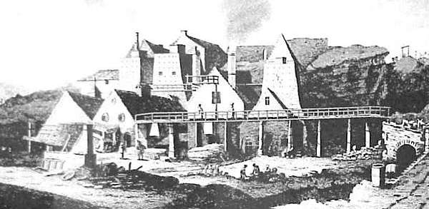
(Ball. J, 2001) Blaenavon Ironworks in 1798 (engraving based on drawing by Sir Richard Colt Hoare)
The above photo shows the ironworks from 1798 it became the first purpose-built multi-furnace ironworks in Wales. They put new technology into practice and developed on a large scale. Blaenavon was the best place for this to become the most important iron produces in the world. Blaenavon was rich in coal limestone and iron ore. To get the best out of their works the furnaces had been built into the side of the hills making it easier to tip the coke, limestone and iron-ore into the top from high ground. According to ‘Grace, 2020 at this point with the three furnaces working they were producing up to 5,400 tons of iron a year and then became the second largest ironworks in Wales.’ They soon had 5 furnaces running, this made the output of iron increase to 14,000 tons per year. This increase then brought people into Blaenavon for work and people moved from all over the UK increasing the population in a once small community.
To be able to deal with the high demand of iron, they needed a good transport system. Everything that was transported moved to the coast. ‘Blaenavon publications, 2022 says that Thomas Hill who managed Blaenavon ironworks in 1815, made great changes for the history and Blaenavon company.’ With his development of the railway, it not only helped create link with Brecknock and Abergavenny Canal but would transport limestone in but allowed pig iron to from the furnaces to the forge, that soon opened in 1817 at Granddyrys. In 1860 operations had ended as the expansion of the railways meant that they had quicker and cheaper transport. This was a
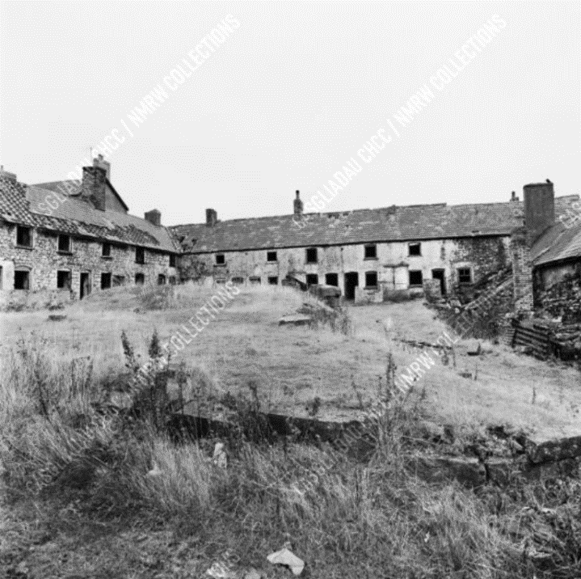
To keep up with the expansion and commuters that moved there for work, they needed space for all the key workers that were close enough to the works that were constantly in operation. With housing conditions decreasing and population rising they built a row of houses close to the ironwork site. The row of houses had its name ‘Stack Square’ and ‘Coflein, 2021 says it was a block of houses in a U shape which was originally called ‘Shop Square’.’ Not only did they build housing for their workers. In 1804 ‘Blaenavon Heritage, 2022, tells us that ironmaster Samuel Hopkins and Thomas Hill build St. Peter’s parish church which is now part of Blaenavon’s history.
Although the workers had all these on their doorstep to work, their working conditions were poor. Healthy and safety back in the 1840’s was not a key concern for them and the ‘Wales Museum, 2011 says that children from the age of 5 would have been working in the mines to fit into tight spaces until the government inspectors visited and made an enquiry into the State of Children in Employment.’
They would have special lights that would give them little direction when down the Big
Pit. Workers would do twelve hour shifts for
seven days a week. As the price in iron
(Coflein, 2021) Exterior view of Stack Square industrial fluctuated ‘Cadrw, 2022 says that they were
housing, Blaenavon. unsure if they would be put on the streets.’
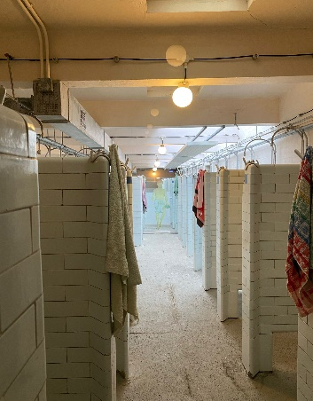
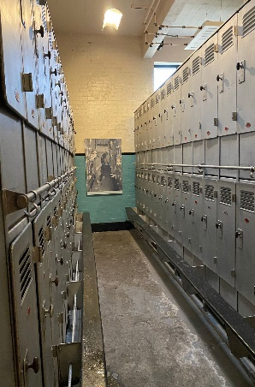
The miners at Big Pit had ‘Pithead baths’ put above ground for when they finished underground, they could come up and use the showers provided which would have made a massive impact to workers at the time. They also had lockers which they would use to keep their clean clothes in before going below. The ‘Wales Museum, 2022 says that they would have had two lockers, one dirty and one clean so they could leave the pits and go home washed.’
These were classed as luxuries, before these they would go home and must bath in steel bins our out the front of houses at all times of the year and any time of day.
The national economy during the industrial revolution fluctuated a great deal and the ironworks only saw a decline and the ownership changed over time. Despite there being a change in steel the coal industry was nationalised and production at the factory ended in 1904. ‘Timelines, 2022 says that the site was going to be demolished back in 1970 but was saved for the nation.’ The Big Pit Coal Museum, Pwll Du tram tunnel and Thomas Hill’s tramroad are now designated a World Heritage Site by UNESCO. It become one of the most important producers of iron in the world and was successful prosperous during the industrial revolution.

References.
Matthews, N. (2008) The development of Blaenavon Town. Microsoft Word - The development of Blaenavon Town (visitblaenavon.co.uk)
Glamorgan-Gwent Archaeological Trust (n.d) Blaenavon - Historical Processes, Themes and Background. Blaenavon Historical Processes, Themes and Background (ggat.org.uk)
Grace, G. (2020) Blaenavon Ironworks. Blaenavon Ironworks - Graces Guide
Blaenavon Publications. (2022) Thomas Hill’s Tram Road. Microsoft Word - Thomas Hill (visitblaenavon.co.uk)
Coflein. (2021) Site Record – Stack Square, Blaenavon. Stack Square, Blaenavon | Coflein
Blaenavon Heritage. (2022) Saint Peter’s Church. Saint Peter's Church - Blaenavon World Heritage Site (visitblaenavon.co.uk)
Museum of Wales. (2011) Children in Mines. Children in Mines | National Museum Wales
Wales Museum. (2022) Underground at Big Pit National Coal Museum. Underground at Big Pit National Coal Museum — Google Arts & Culture
Grundhauser, E. (2022) Blaenavon Ironworks. Blaenavon Ironworks – Blaenavon, Wales - Atlas Obscura
Cadwr. (2022) Danger: Children at work. More about Blaenavon Ironworks | Cadw (gov.wales)

Pictures.
Ball, J (2001). Old Ironworks, Blaenavon, Monmouthshire – Images of Wales. [Photograph] John's Homepage (jlb2011.co.uk)
James, F. (2005). Exterior view of Stack Square industrial housing, Blaenavon. DI2005_0336 - Coflein Digital Asset Management (ibase.media)
Big Pit Museum. (2022) Showers and locker room.

