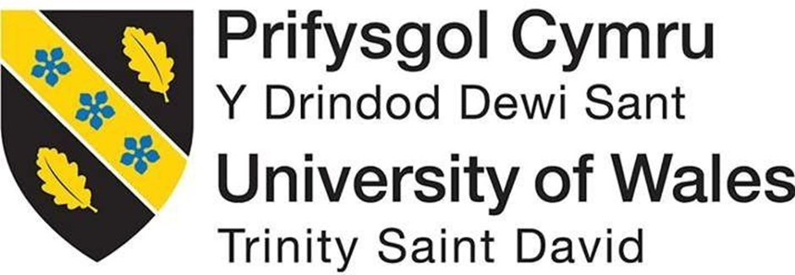

Developing a Business Plan

Alex Yesson
2414413
Degree Apprenticeship in Logistics and Supply Chian Management

9th October 2024

Business Plan ACMA 4015

Table Of Content’s
- Page 2 - Executive Summary
- Page 2 - Mission statement
- Page 3 - Industry at a glance
- Page 4 - Key External Drivers
- Page 5 - SWOT Analysis
- Page 5 - Market Analysis
- Page 6 - Competition analysis
- Page 6 - Marketing
- Page 7 – Management
- Page 7 – Operations
- Page 8 - Financial Highlights
- Page 11 - References

Executive Summary
SOCKWAVE is a new and upcoming business that caters to the on-field sports lovers’ community in the UK. Our focus is to provide all type of athletes with top of the range sportswear, focusing on high performance socks that are not only comfortable, but also convenient. Our socks, which are made from nylon, come with the option of having the full complete sock, or a sock with the heel to the toe cut off, providing more comfort whilst also looking the part. All of our socks come with a pocket on the inside, that enables the wearer to keep their shin pads in place without having to use other accessories to keep it in place.
Our intention is to dominate the market, by obtaining 50%+ market share over the next 10 years of football socks and expanding our business into selling a larger variety of sportswear and equipment. The Sockwave dream is to one day become a central hub for all athletes when looking to purchase new sportswear, and to become a household name.
Sockwave will expect sales to start slowly and ramp up as the name spreads to more people. For startup costs and to maintain afloat, Sockwave will need an investment of £50,000 pounds to purchase the necessary equipment and fund staff’s wages.

Mission statement
Sockwave’s mission is to provide the best quality performance enhancing football socks on the market, whilst simultaneously committing to providing the best service possible from order entry to order fulfilment. We plan to see every customer maximise their potential on the field, starting with the right sock for them.

Industry at a glance
The current football sock industry has seen a large growth of new brands and innovative designs over the past 5 years, as players are increasingly realizing the impact that a good quality sock can have on performance and comfort, thus driving the market growth. The rise of e-commerce has increasingly made football socks more accessible to the worldwide market, which has contributed to the overall market growth the industry has seen. The football sock market is dominated by a few companies, compiling of the likes of Nike, Adidas, Puma. As shown in Figure 1, we can see the football sock market is rising, and the projection from 2024 to 2032 is that the industry will grow by a further $400 Million US dollars, rising to a total worth of $1.2 Billion dollars.

Fig 1 - Global Football Socks Market Research Report.
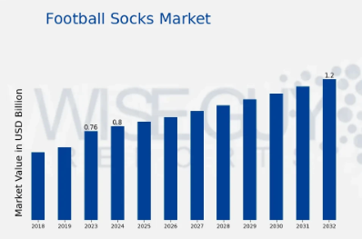

Key External Drivers (location, customers, employees)
The Sockwave intention is to operate out of a warehouse, in a retail park. The warehouse will have to have another room designed for office space, however the majority of the space will be needed for print machines and storage units to hold the product. The office space will be filled with desks, draws for copies of receipts, and basic office utilities and supplies. The floor plan will look as follows in figure 2,

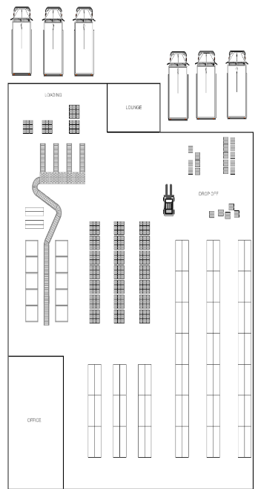

Figure 2 –

To startup Sockwave will work with a total of 3 full time employees, including the owner. As startup sales are expected to be slow with predicted rapid growth, the team will grow along this same growth trend. To start, Sockwave will need 1 full time employee to manage the warehouse, controlling all organisation of goods in and despatch, as well as storing the stock in a organised fashion. This employee will also need to print press the logo onto the sock after it is delivered to the warehouse. The second employee will work in the office alongside the owner. Their duties will be to manage the website, customer order take on, and customer service. Their role will compile of ensuring that order’s are correct, customers are dealt with in the proper polite conduct. This will be key to giving the customer an easy journey from placing an order to receiving the product. Finally the owner will be key to ensuring business can operate. They will manage deliveries of the base product, ensuring delivery services are set up, and finally marketing. The business is dependant on good marketing so this will be key to bringing in sales, and ultimately profit.

SWOT Analysis
Strengths and Opportunities –
1. Market Growth. As spoken about in the industry at a glance, the football socks industry is one that is growing, and as the popularity of football, both American football and Soccer, continues to grow globally, the demand for football socks will grow along the same lines as this trend. This provides new manufacturers and sellers, like Sockwave, the opportunity to increase sales and customers.
2. Uniqueness of Product. Considering the uniqueness of Sockwave’s product, offering the option for a precut sock, as well as a pocket for shinpads, it will help the business stand out from competitors, and in an industry where all the brands supply similar products, offering something distinctive and unique will capture customers interest and creative a competitive edge.
3. Expanding Distribution Channels. The number of distribution channels will grow along the same trend as the market will. This means that brands such as Sockwave have the opportunity to reach a wider audience, including more opportunities to supply our product online and through retail outlets further driving growth and customers.
Weaknesses and Threats –
1.Funding. The one threat that the Sockwave brand faces is securing adequate funding. If Sockwave does not secure sufficient funding it may cause cash flow problems, and the business will struggle to pay for direct costs such as payroll, inventory and rent. One important factor for Sockwave’s will be securing the correct funding for investors to allow for enough more to buy the necessary assets for the startup.

Market Analysis
Due to the uniqueness of our product and the benefits the product brings to a players performance and comfort, Sockwave is expecting to reach a large market, although this is expected to be a slow process. Sockwave will need to market correctly to ensure customers are drawn to the website and to create traffic.
Sockwave’s target market is for all on field athletes of all ages. The football socks are really only intended for sports athletes who want to improve comfort and performance. Our marketing and promotion will all be directed towards this target market, through social media and flyers at all local football clubs and pitches in the surrounding areas. This type of customer demand is slightly affected by the season, with an increase in the latter months of the year, as the football season begins again. However we expect our product to generate sales all throughout the year, as socks are needed throughout the entirety of the season.

Competition analysis
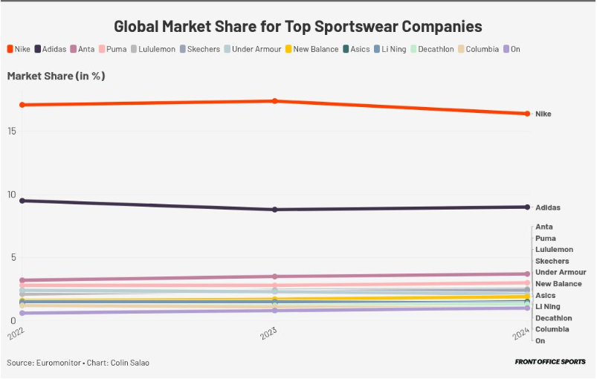
Nike, a global leader in sportswear and a household name, is commonly known for their involvement in football, and is known for some of their iconic football kits, obviously including the socks! Nike hold a large majority of the market share in the Sportswear industry, as shown below in Figure 4. Although Sockwave will not initially operate in all areas of the sportswear industry, it is a good example of how dominate they are.

Fig 3 – Front Office Sports
Adidas is the largest sportswear manufacturer in Europe and is second to only Nike worldwide, as per Statista.com, they have a brand value of over $15 billion US dollars, and had global net sales of around $21 billion US dollars. They are a brand who operate in all areas of the sportswear market, so will be a big competitor that Sockwave will need to lure customers from.

Marketing (7P’s)
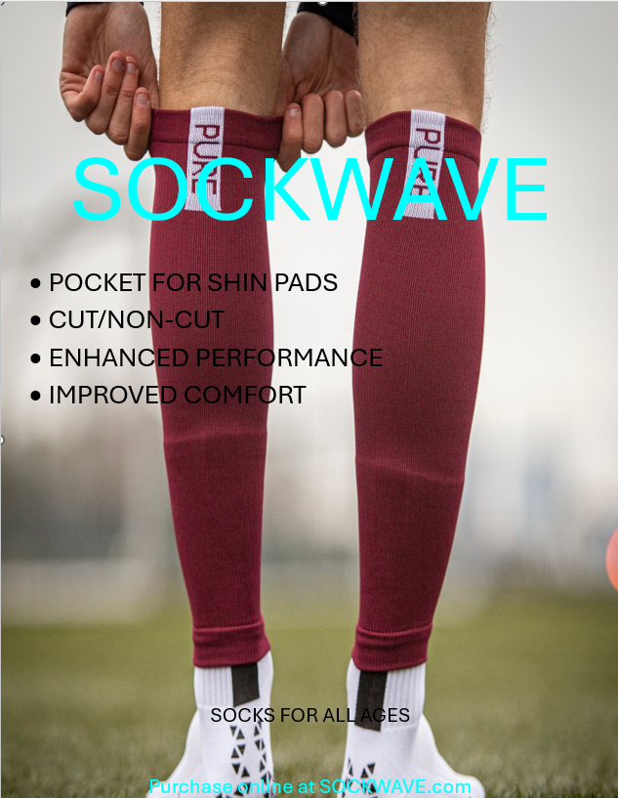
Marketing for Sockwave’s will be done through a variety of a website, print and the internet. The Sockwave plan is to directly reach local football clubs, appealing to what they want, good quality football socks that will increase performance and comfort. By printing an abundance of flyers and putting them up around the local football fields and clubs, sockwave will be able to market directly to our target market. See below figure 3, as an example of the flyer’s I will post around. On top of this, Sockwave will reach the target audience further from the local area by marketing on social media, as apps such as TikTok, Instagram and Twitter. Through a variety of showing off the product and showing the benefits our product brings, the hope is that the social media’s will put our posts on our target markets algorithm, further driving our brand awareness and sales. Finally, the most important factor of our marketing strategy is the website, which will be linked on all social media accounts, and displayed on flyers where customers will be able to read up more of our product and its design, as well as place orders.

Management (Year 1 personnel Forecast)
At the time of startup, the personnel plan calls for a minimum of 2 staff, in order to manage order take on and customer support and warehouse and stock management. As the owner, I will help all of these operations, and additional such as contract management and marketing. In the first year, the assumption is that the business will not have a high level of demand, and as demand increases, we will hire additional staff as need be. Specialised staff training will include proper warehouse conduct and machine usage to allow for all staff to help out in the warehouse moving goods and printing logos onto the product. I have based all salaries off UK’s average salary for the role.
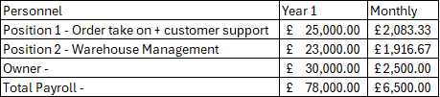

Operations (Procurement, Production, Distribution, Licenses)
The Sockwave business will need to require a license to own and operate inside a warehouse. The owner will consult with local authorities to ensure the correct compliance with all regulations. As Sockwave will keep copies of all customer receipts and details, the data protections act rules and regulations will need to be closely followed. Sockwave will ensure all staff will be taught the necessary information to comply with these rules. A copy of all customer information will be kept in a locked filing cabinet inside the office, which will also be looked at the end of every business day.
At the startup, Sockwave will employ a contractor to design the website, and teach the owner what is necessary to keep it operating. The website will include a tab to view all different colours and sizes of product, along with a order processing section. This will allow customers to pay online and track orders once they are despatched. This will be key to providing an easy experience for the customer.
I will procure the basic sock from a sub tier supplier, who will provide the sock with the pocket for the shin pad. After looking into different prices and costs I will be able to purchase a minimum order quantity of 10 units for a total price of £50, meaning the basic cost for 1 unit will be £5. Once the basic sock is delivered onto site, we will cut the bottom, and press on the business logos to the centre of the shin.

Finally, follows is our projected sales forecast for year 1, and then for the first 3 years.

Financial Highlights (Cast flow, revenue, break even, Balance sheet)
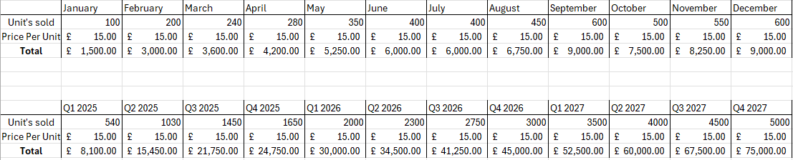
As follows, is my Revenue forecast for Year 1, and then followed by the first 3 years revenue’s forecast –

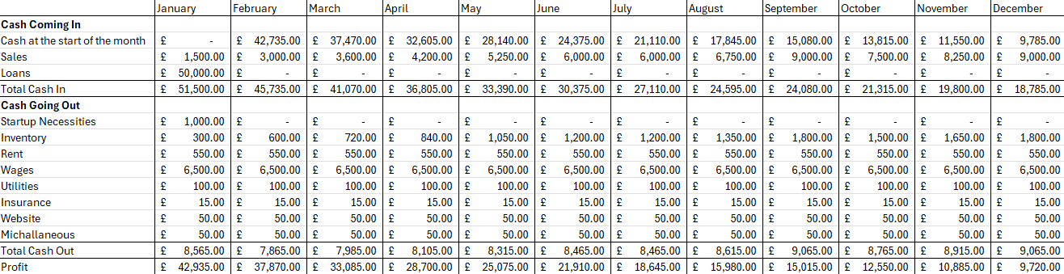
Following my Revenue forecast, is my Cash Flow Analysis followed by the 3 year forecast –
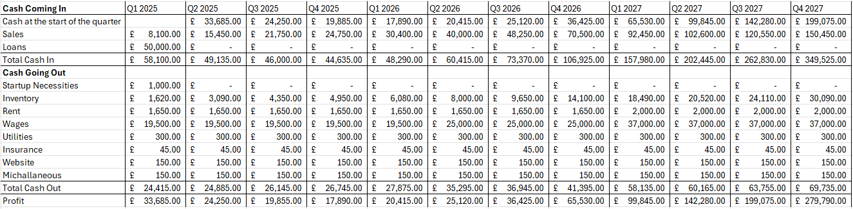

And performed a break even analysis to show the profit margins against Total costs. This shows Revenue on the Y axis and total units on the X axis. This shows Sockwave need to sell 757 units to break even.
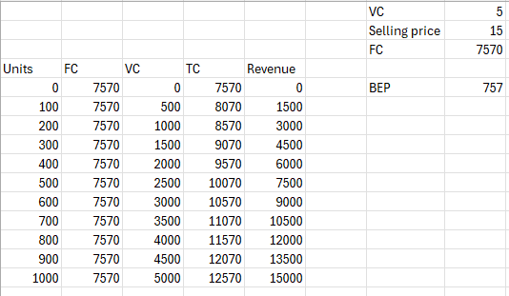
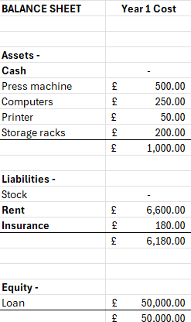
Finally, as follows is Sockwave’s balance sheet, showing all Assets, Liabilities, and Equity –

References
Fig 1 - Global Football Socks Market Research Report (2024) - at https://www.wiseguyreports.com/reports/football-socks-market
Fig 3 – FrontOfficeSports published by Lisa Scherzer October 2024 – at https://frontofficesports.com/nike-brand-struggles-but-dominant-market-share-still/
Statista published by D.Tighe May 2024 – at https://www.statista.com/topics/1257/adidas/#topicOverview

