Starbucks - premier roaster and retailer of specialty coffee

Smita Tamang (P148162)
[Email address]
Module: Strategic Management & Sustainability (M3X9111)
Project name: Starbucks – premier roaster and retailer of speciality coffee
Student number: P148162
Table of Contents
Executive Summary 3
1.0 Introduction 3
1.1 Report remit 3
1.3 Competitive advantage 4
1.4 Porters generic strategies 4
1.5 SWOT analysis 6
2 Main body 6
2.1 IMPLEMENTATION OF THE STRATEGY 7
2.2 Advantages and disadvantages of the strategy 7
2.3 ‘Stuck in the middle’ 8
2.4 ETHICAL ANALYSIS & THE IMPORTANCE OF CORPORATE SOCIAL RESPONSIBILITY 8
2.5 Brand perception 9
2.6 Research and development 10
2.7 Pest analysis 10
3.0 Conclusion 11
4.0 Recommendation 11
5.0 References 12

Executive Summary

This report aims to identify the competitive strategy that Starbucks has used to develop their competitive position using different strategies. It analyses and critically evaluated the strategies and recognises the advantages and disadvantages of its strategies in the current environment.

This report will:
- Identify the strategies of Starbucks
- Evaluates the strategies implied by Starbucks
- Offers recommendations based on the findings
- Swot Analyses

Introduction

Starbucks Corporation was established in 1971 in Seattle, Washington. At present, has about 27000 Starbucks location in around 70 countries around the world. It offers a choice of coffee, tea beverages as well as offers a selection of other premium teas and coffee, fine pastries, snacks and other tea and coffee-related products. Today, Starbucks is the third largest restaurant chain in the world, serving about 100 million people a week. The company goal is to grow their coffee under the highest standards of quality, using ethical sourcing practices.

Report remit

  - Business level strategy
Strategy is defined as “the direction and scope of an organisation over the long term: which achieves advantage for the organisation through its configuration of resources within a changing environment, to meet the needs of markets and to fulfil stakeholder expectation” (Johnson & Scholaes, 1999).It helps to achieve its mission and objectives that determines the long-run performance of a corporation. Whereas, strategic management is “the process by which organisations determine their purpose, objectives and desired levels of attainment; decide on actions for achieving this objectives in an appropriate timescale, and frequently in a changing environment; implent the actions; and assess progress and results” (Thompson & Martin, 2005).
The typical business firm usually considers 3 types of strategy: corporate, business and functional.
- Corporate strategy
- Business strategy
- Functional strategy
The strategy level that Starbucks has taken is competitive strategy.
“Their mission statement from the company profile is as follows: “Our mission is to inspire and nurture the human spirit – one person, one cup and one neighbourhood at a time” (Starbucks, 2017)”.
“Their core competencies can be defined as high quality coffee and products as accessible locations and affordable prices, provided a community to share in the coffee drinking experience and variety of choices” (Starbucks Coffee, 2013)”.
The company values ethics and good business practice and “for the 11th consecutive year, Starbucks has been names one of the World’s most Ethical Companies according to the Ethisphere Institute” (Company, 2017).

1.3 Competitive advantage

Figure 1.2 reflects that there are three distinct perspective of strategy analysis: page 19 strategic management awareness and change 5th edition john Thompson
- The strategic environment
- The competing organisation
- The individual strategist

Porters generic strategies

According to Michael Porter, a company needs to attain three kinds of generic strategies which are, namely, Cost leadership, Differentiation and Focus strategies. He analysed these strategies to examine how a company can compete in the industry to create and sustain a position of strength. For instance, a company should be realistic about their products and services where the link between the price and perceived quality must make sense (Thompson & Martin, 2005).

Figure 1: Porter’s model of generic strategies
Adapted from Slide Model (Slidemodel, 2014)

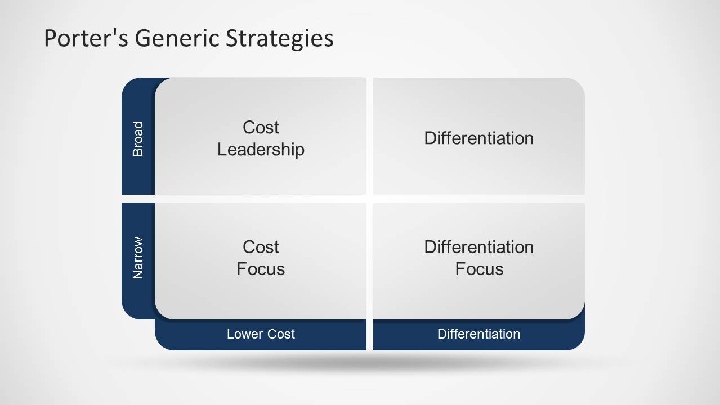

Threat of New Entrants: Moderate
Threat of Substitutes: High
Bargaining Power of Buyers: Moderate to Low Pressure
Bargaining Power of Suppliers: Low to Moderate Pressure
Intensity of Competitive Rivalry: High to Moderate

SWOT analysis

"An evaluation of an organisation’s strengths and weakness in relation to environmental opportunities and threats is generally referred to as a SWOT analysis” (Wheelen & Hunger, 2002, 2000).

Strengths:  - Strong Market Position and Global Brand Recognition  - Products of the Highest Quality  - Location  - Human Resource Management  - Use of Technology  - Customer base loyalty | Weakness  - Lots of competitors
Opportunities:  - Rising mobile purchases  - Growing middle class  - Growing coffee culture  - Brand extension  - Technology  - Transfers to coffee farmers | Threat:  - Changing Consumer tastes and lifestyle choices  - Rising availability of specialty coffee machines for home use  - Increasing employment regulation

Main body

“The generic strategy is manifested in the company’s culture as Starbucks uses its sustainable and responsible sourcing policy to differentiate its products from competitors” (THOMPSON, 2017). 99% of their coffee is ethically sourced as Starbucks launched C.A.F.E (Coffee and Farmer Equity) Practices in 2004 with Conservation International to create a long-term supply of high-quality coffee and positively impact the lives of coffee farmers (Starbucks, 2017).

IMPLEMENTATION OF THE STRATEGY

Differentiation strategy occurs when the company has a range of products or service which are different from other products in the industry and it adds value where the customers are willing to pay premium prices (Thompson & Martin, 2005) .
Differentiation can be achieved through different area, such as quality of materials, design, distribution, production, customer relations, technologies and administration. However, the strategy might be misunderstood buy the customers if the overcharged for the differentiation, buyers fails to recognize, appreciate or value. The company should be aware while implying the strategy as over-fulfilling needs might result in failing to achieve cost0effectiveness.
One of the way Starbucks has approached Differentiation strategy over the years is by using technology like Apple Pay and investing in research to gain consistently loyal customers through different schemes like writing customer names on the cups, making efforts to reduce wait times and introducing loyalty cards.

The company’s emphasis on specialty coffee easily differentiates Starbucks cafés from many other establishments that offer coffee. Fast food companies like McDonald’s and KFC emphasize low cost coffee, Starbucks coffee emphasize high quality at an affordable price with a warm friendly ambiance that people enjoys. However, the application of the broad differentiation generic strategy also extends to other areas of the business. For instance, Starbucks uses its sustainable and responsible sourcing policy to differentiate its products from competitors such as setting high level of Corporate Social Responsibility (CSR).

Advantages and disadvantages of the strategy

One of the advantages within the differentiation strategy is the products or service is unique from the rival products and if the customers values the cause of difference then it would be a successful strategy. Products which the competitors are not able to emulate can attract customers which they perceive as being more superior which leads to be more successful. Since, Starbucks has introduced writing their customers names on their cups, it has differentiated from the competitors and customers have perceived it as being a way of feeling recognised and friendly.
However, like the saying ‘every coin has two sides’, this strategy also has its disadvantages. By creating or doing things differently, there is a risk of imitation. Competitors might use similar resources to create substitution or duplication which has a higher risk of taking the costumers. Although, Starbucks has created different technologies to create a smooth service for their customers, there is a higher chance of imitation from its competitors in this growing technology world.
Starbucks promotes itself as a socially responsible business, citing its dealings with coffee growers and pickers in developing countries. And yet, the company gets singled out by environmental and other campaigners – because they believe that a company which promotes itself as responsible is a softer target and more easily influenced than one that is either hostile or ambivalent (Thompson & Martin, 2005).

‘Stuck in the middle’

Porter (Thompson & Martin, 2005)has stated that successful organisation will select and concentrate their efforts on effectively implementing one of the generics strategies that he identified; they will avoid being ‘stuck in the middle’.
The profitability of a firm depends not only on the typical rates of return in an industry but also depends on the firm’s position and competitive advantage within the industry. Nevertheless, he argued that competitive advantage derives from one of two strategies: cost leadership or differentiation of products or services (forbes, 2012).

“A stuck in the middle position happens when a business designed to be low cost starts adding little extra frills which don’t add a corresponding amount to the customer value of a product” (Simister, 2011).
Organisations that are stuck in the middle are generally in a poor strategic situation and performs poorly because of the lack of clear market. However, porter has stated that by effectively implementing one of the generic strategies, a company can avoid being ‘stuck in the middle’ (Thompson & Martin, 2005).

However, a business can ‘stuck in the middle’ and suffers the cost when applying differentiated strategy as a business comes under pressure when designed to be low cost but does not add amounts to the customer value of the product. Due to competitor, a market disruption might occur from new technology or low prices competitor and causes damage to the differentiation advantages. Similarly, as there are lots of competitors like fast-food restaurants selling coffee and cheap prices as low as 99p, Starbucks will have to be aware of the differentiation damage that might occur to the company.

For instance, Bang & Olufsen is a Danish manufacturer of hi-fi equipment and television which has an elite reputation for the quality of its products and tends to have loyal customers. During 1980s their performance detoriated and were see as niche competitor. Therefore, as a response the company launched slightly less expensive but exceptionally high-quality products (Four Differentiation Strategies: BMW, MIELE, BANG & OLUFSEN AND JAMES PURDEY, 2005).

2.4 ETHICAL ANALYSIS & THE IMPORTANCE OF CORPORATE SOCIAL RESPONSIBILITY

Corporate Social Responsibility is the detailed issues on which an organisation exceeds its minimum required obligation to stakeholders.
“Corporate Social Responsibility (CSR) is the continuing commitment by business to behave ethically and contribute to economic development while improving the quality of life of the workforce and their families as well as of the local community and society at large” (Baker, 2004). Therefore, adopting Corporate Social Responsibility is a core factor and a vital strategy for companies to survive and for the sustainable development in this unpredictable and complex market.

In the Starbucks newsroom (2013) employees are addressed as "partners" giving them a sense of belonging to a community where the relationship with management is more open than a classic employee position and are eligible to receive annual grant of company stock through their Bean Stock program (Starbucks, 2013).

Starbucks has always been ethical about their coffee growing and recently has announced new plans to support the next generation of coffee growers. “An expanded partnership with the United States Agency for international Development is aimed at providing 1,000 farmers in post- conflict zone with training in agriculture and climate resiliency programs and providing them access to technology to help them run their farms” (Starbucks, et al., 2017).
Recently on September 9, Employees in Starbucks (Japan) wore whimsical eyeglasses in the shape of “99” so that customer might be curious to enquire the reason for wearing those glasses. Hence, “they can explain that 99 percent of Starbucks coffee is ethically sources, ensuring that farmers are paid fair wages and that coffee beans are cultivated according to environmentally friendly methods” (Rochman, 2017).

2.5 Brand perception

Brand perception is a mental creation, which helps consumers to understand a company over another (Smith, 2015).
Since its founding, it has strived to build its brand identity by creating a place where one can think of as a third place between home and work and can relax, enjoy a cup of coffee and enjoy the experience.

Unlike other companies, Starbucks decided not to advertise its company as they focused on creating excitement among their employees to minimize their cost. They made its employees their partners and offers them stock options and health insurance.

The Starbucks brand philosophy is to be socially ethical. Therefore, the company creates opportunities for their employees through education and training. It also includes supporting farmer loans and also introduces environmental programs.
The Starbucks Foundation announced to fund $50,000 for staff development and training, uniform for students, activities for alumni and special events to promote the organisation (Sheppard, 2017).

According to Business Insider (Taylor, 2017), “Starbucks' brand has taken a beating since the company announced plans to hire 10,000 refugees worldwide in the next five years in response to Donald Trump's executive order intended to prevent refugees from entering the US”. While many consumers were supportive of the decision there were others who threatened to boycott and even posted on social media saying would no longer spend money at Starbucks. This shows that Brand perception might change when one does not live up to the consumers expectation and can be challenging to the company itself.

Pest analysis

The PESTEL/PESTLE analysis model is used to determine the most important issues that Starbucks must address in its business strategies.

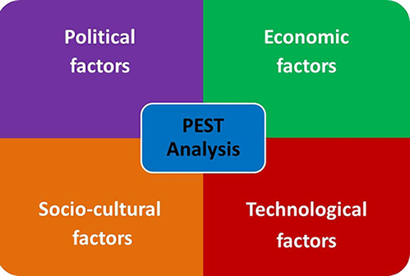
Figure 1.2 : Source adapted from (Slidemodel, 2014)
Political: The main political factor is about sourcing the raw materials.
Economic: global economic recession.
Starbucks needs to understand the fact that the consumers are now prone to buy low price coffee offered by many local and other competitors around. These changing trends should be considered by Starbucks in order to maintain the business.
Sociocultural: The social factors encompass many behaviour patterns of the people as well as the cultural influence.
Technological: As internet has become very important to customers nowadays, Starbucks has introduced free WI-FI and also power mat wireless charging in selected stores in Central London. Hence, the customers don’t have to worry about low battery and enjoy surfing web while sipping Starbucks coffee which has added value to the brand. It has also introduced mobile app where you can order ahead, pay through your app and skip the queue.

Conclusion

By using different strategies, Starbucks has been able to be successful for so many years in this competitive market. Since, its competitive advantage, even though slightly higher price compared to other coffee shops, it has been able to gain loyal customers and a successful business around the world.
Starbucks have used differentiation strategy by:
- Effectively incorporating CSR into their brand
- Ethically using high quality coffee
- Focusing on having a happy employee
- Most importantly focusing on their high-level products and services for their customers
- Has distance themselves for other coffee brands
- Gained competitive advantages by serving different high-quality products and services

4.0 Recommendation

- Starbucks can use its intensive growth strategy to develop their market and products in countries they have not yet opened. For instance, due to good market research, Starbucks has successfully launched in China “culture where there are primarily tea drinkers”.
- Starbucks should increase awareness on the things it does for the local communities as high level of CSR is what differentiates them from their competitors.
- The company should continue to keep their employees happy as keeping employee satisfaction high result in a very good customer service.

5.0 References

Bibliography
Company, C. a., 2017. Starbucks newsroom. [Online]
Available at: https://news.starbucks.com/news/ethical-companies-2017
[Accessed 2017].
forbes, 2012. Forbes. [Online]
Available at: https://www.forbes.com/sites/mattsymonds/2012/02/24/stuck-in-the-middle-take-the-flexible-approach/#36061e262ebd
[Accessed 15 11 2017].
Four Differentiation Strategies: BMW, MIELE, BANG & OLUFSEN AND JAMES PURDEY (2005).
Johnson, G. & Scholaes, K., 1999. Exploring Corporate Strategy. Fifth edition ed. Hertfordshire: Prentice Hall Europe.
Rochman, B., 2017. Starbucks newsroom. [Online]
Available at: https://news.starbucks.com/news/starbucks-99-percent-ethically-sourced-coffee
[Accessed 16 11 2017].
Sheppard, K., 2017. Starbucks newsroom. [Online]
Available at: https://news.starbucks.com/news/starbucks-foundation-opportunity-for-all-grant
[Accessed 16 11 2017].
Simister, P., 2011. Differentiate your business. [Online]
Available at: http://www.differentiateyourbusiness.co.uk/is-your-business-stuck-in-the-middle
[Accessed 14 11 2017].
Slidemodel, 2014. Slidemodel. [Online]
Available at: https://slidemodel.com/using-porters-generic-strategies-business/
[Accessed 2017].
Smith, K., 2015. Brandwatch. [Online]
Available at: https://www.brandwatch.com/blog/marketing-the-importance-of-brand-perception/
[Accessed 16 11 2017].
Starbucks Coffee (2013).
Starbucks, 2013. Starbucks. [Online]
Available at: https://news.starbucks.com/news/facts-about-starbucks-and-our-partners-employees
[Accessed 2017].
Starbucks, 2017. Starbucks. [Online]
Available at: https://www.starbucks.co.uk/about-us/company-information/mission-statement
[Accessed 2017].
Starbucks, Dahlstrom , L. & Rochman, B., 2017. Starbucks newsform. [Online]
Available at: https://news.starbucks.com/news/starbucks-support-to-colombian-coffee-farmers
[Accessed 15 11 2017].
Taylor, K., 2017. Business Insider. [Online]
Available at: http://uk.businessinsider.com/starbucks-brand-perception-falls-with-refugee-plan-2017-2
[Accessed 16 11 2017].
THOMPSON, A., 2017. Panmore. [Online]
Available at: http://panmore.com/starbucks-coffee-generic-strategy-intensive-growth-strategies
[Accessed 2017].
Thompson, J. & Martin, F., 2005. Strategic management awareness and change. Sixth ed. Bath: Southern-western.
Thompson, J. & Martin, F., 2005. Strategic Management Awareness and Change. fifth edition ed. London: Thomson learning.
Wheelen, T. L. & Hunger, J. D., 2002, 2000. Concepts in Strategic Management and Business Policy. Eighth ed. New Jersey: Pearson Education.

