Name: Paul Richards

Student No: 0251968

Course: Applied Computer Networks and Cybersecurity

Module: Network Operating Systems and Services
(ACCA5023)

Date:12/03/2021

Contents

Task 1: Prerequisite tasks 3

Task 2: Deploying Active Directory as a role or feature based installation 5

Task 3: Creating user account objects using Active Directory Users and Computers snap-in console. 15

Task 4: Object attributes of interest. 20

Task 5: Adjoining the domain and testing user logins. 24

Task 6: Observation Tasks 32
6 a. DNS 32
6 b. Critical Roles 37
DHCP 37
WSUS 40
6 c. Permissions 41
6 d. AGDLP and AGUDLP 42

Bibliography 46

Task 1: Prerequisite tasks

Step 1: Checked that the PublicNet connection on Server 1 had a static ip address and No DNS ip address.
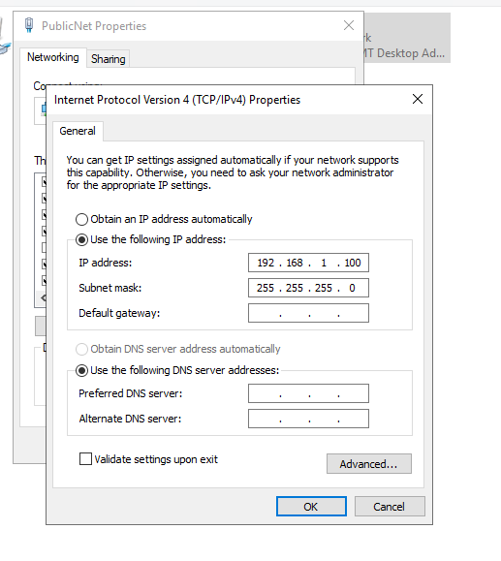
Step 2: Checked that the PrivateNet1 connection on Server 1 had a static ip address and No DNS ip address.
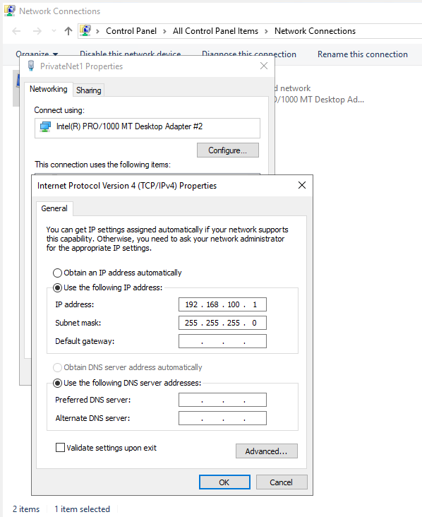
Step 3: Checked that the Windows Firewall was turned off on Server1
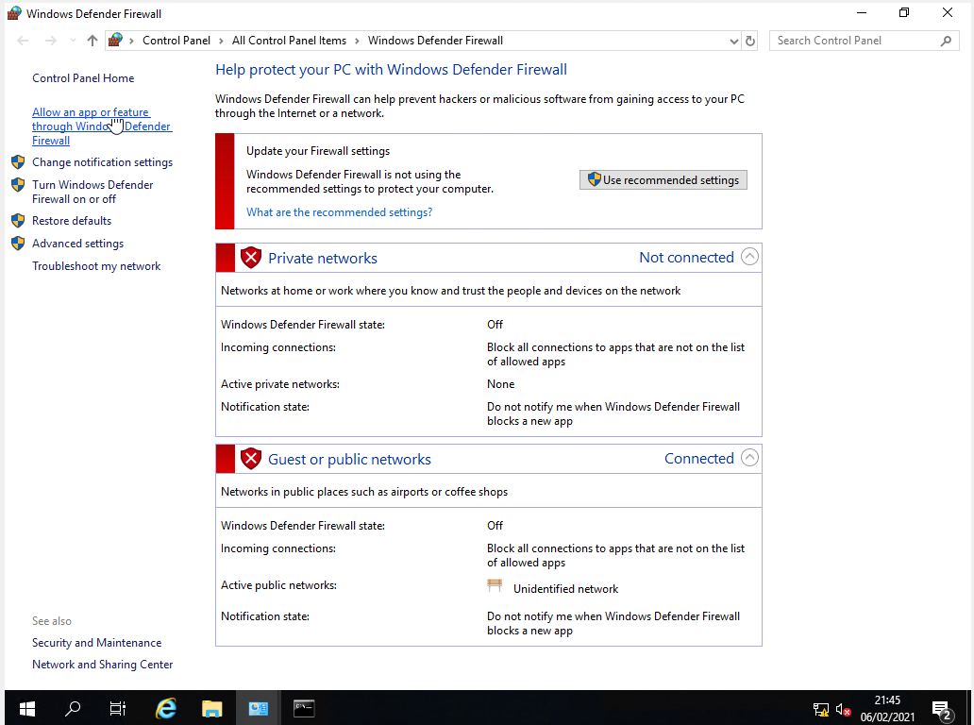

Step 4: Changed the computer name of Server 1 to DC1-NWT.
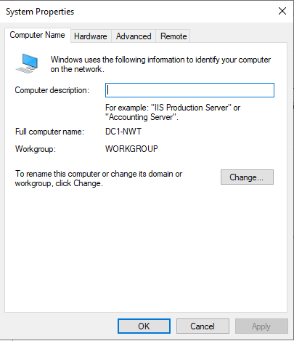

Task 2: Deploying Active Directory as a role or feature based installation

Step 1: Opened up server manager, clicked add roles and features.
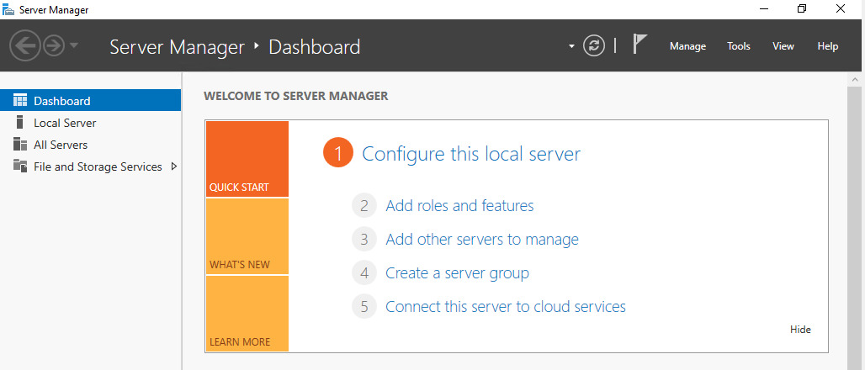

Step 2: On the Before You Begin screen, clicked on Next
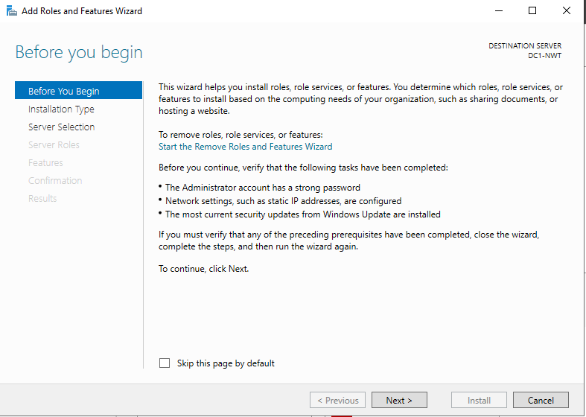

Step 3: On the Installation Type screen, chose the role-based or feature based installation and clicked next.
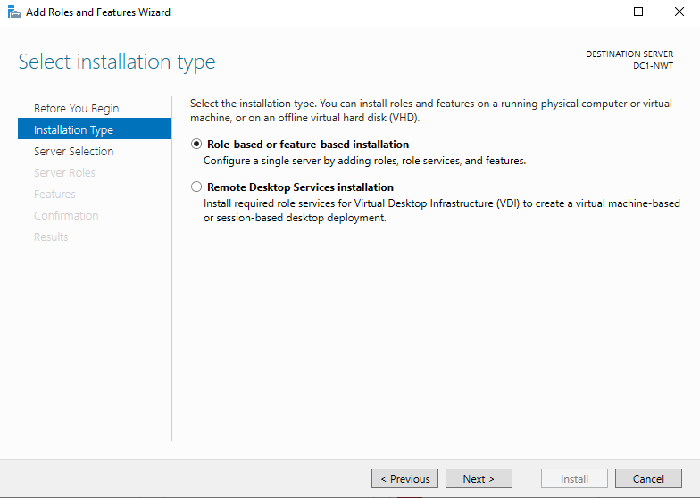

Step 4: On the Server selection screen, selected DC1_NWT or Server 1 and clicked next.
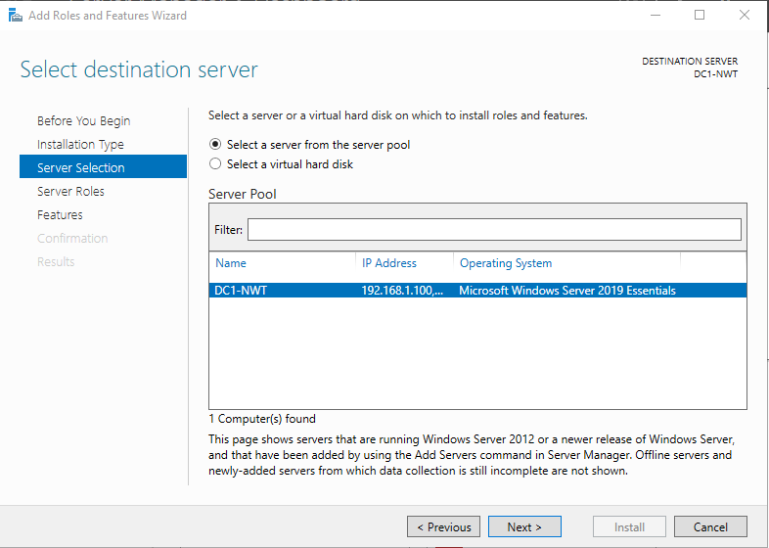
Step 5: In Server Roles screen, selected Active Directory Domain Services and clicked next.
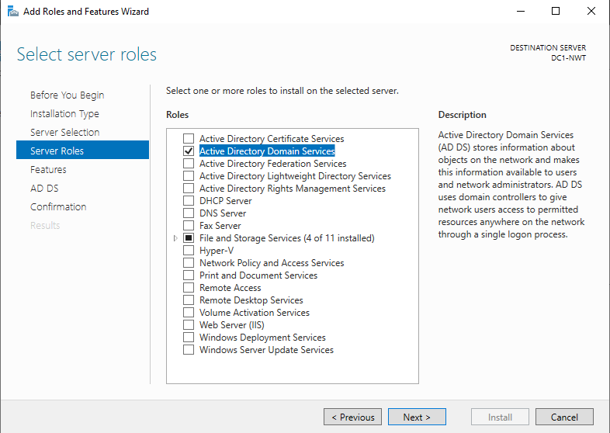

Step 6: When prompted to add features in the Add features that are required for Active Directory Domain Service screen, clicked add features

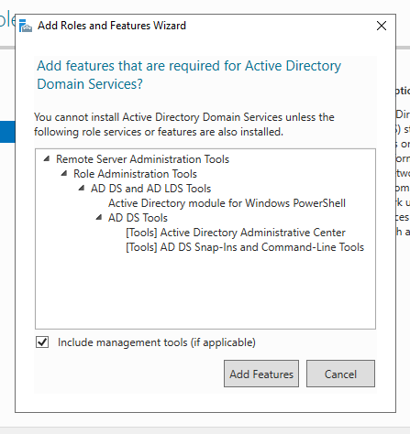

Step 7: Clicked on next when returned to the Server Roles screen.

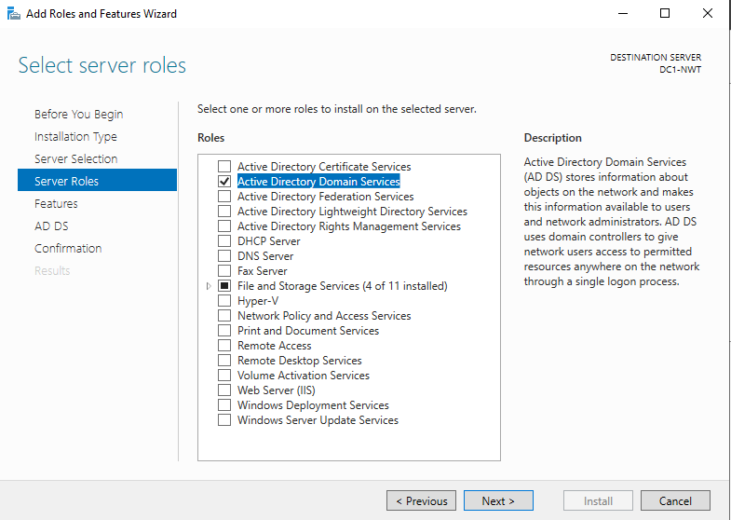

Step 8: On the Features screen, clicked next.

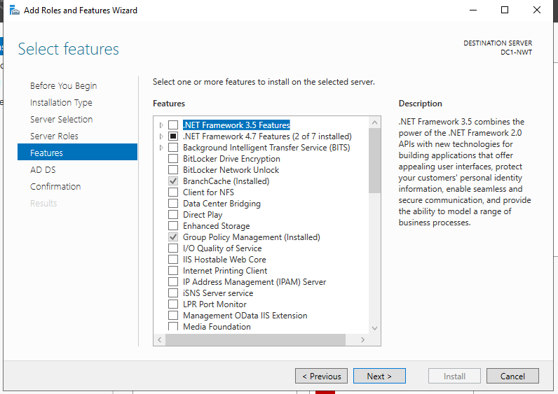
Step 9: On the Active Directory Domain Services screen, clicked on next.

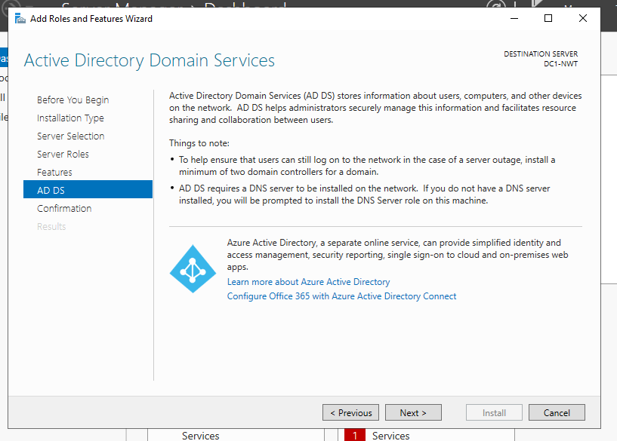

Step 10: On the Confirm installation selections screen, clicked install.
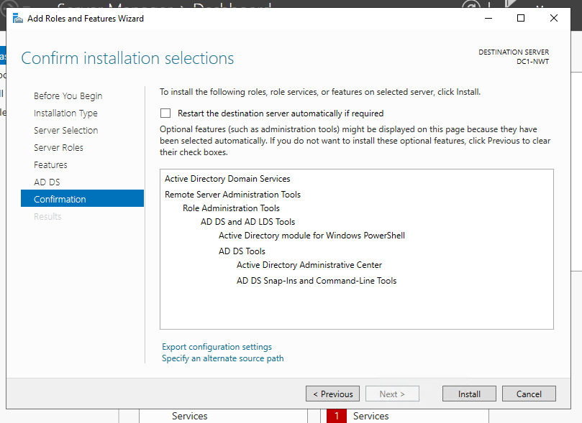
Step 11: Once the installation completed, clicked close.
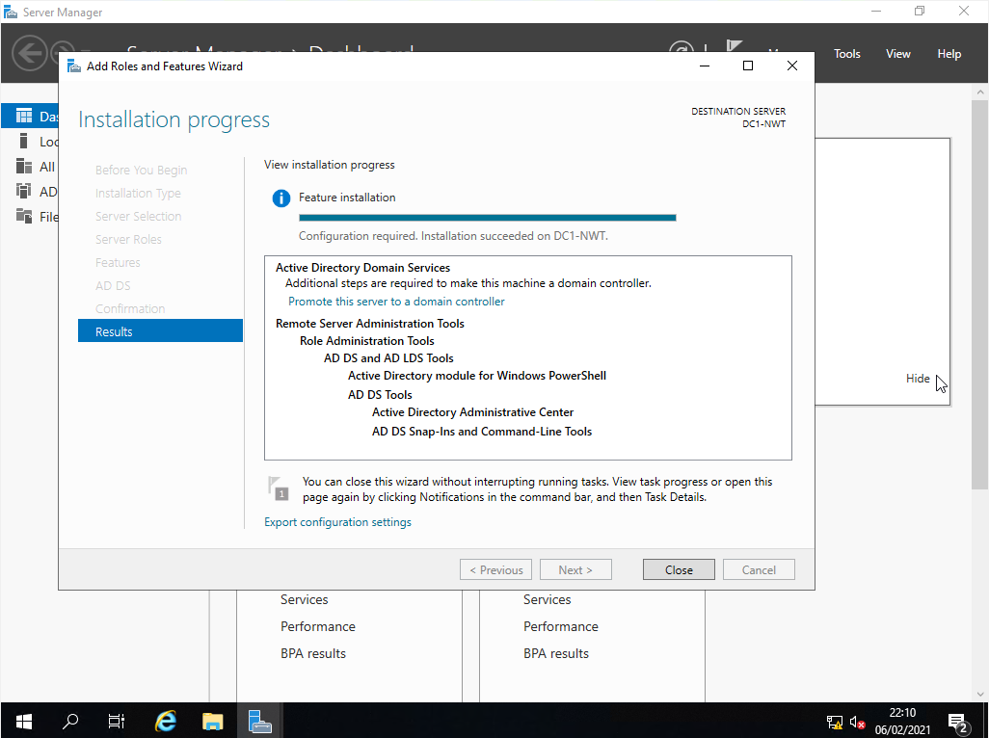

Step 12: On the Server Manager screen, clicked on the flag icon or yellow exclamation mark, and clicked on the Promote this server to a domain controller link.
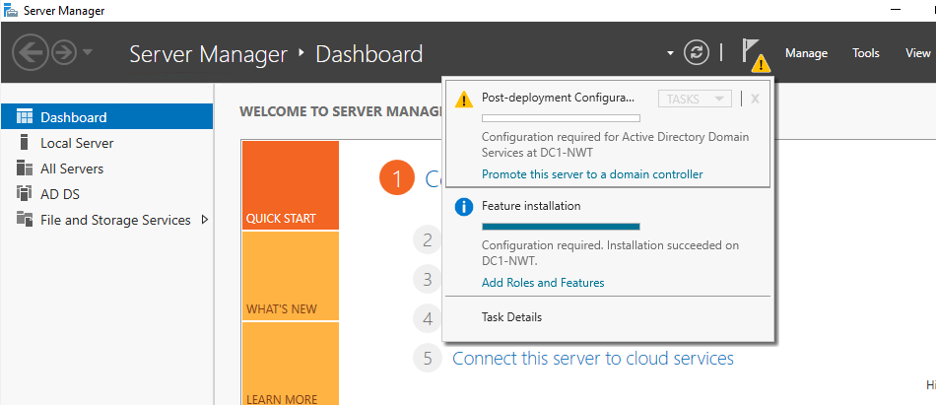

Step 13: On the Deployment Configuration screen, selected add a new forest and entered the root domain name, nwtraders.msft
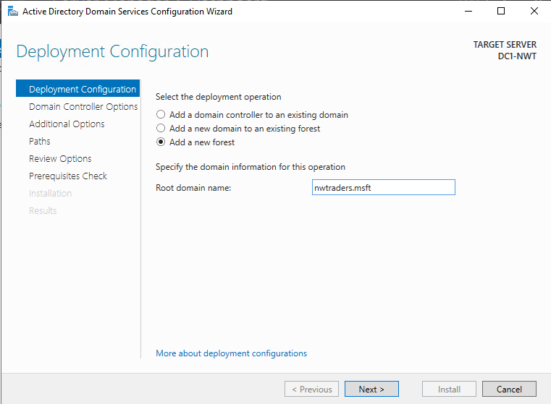

Step 14: On the Domain Controller Options screen, set the forest and domain functional level to Windows Server 2016. Checked the Domain Name System (DNS) server and global catalog checkboxes. Created a Directory Services Restore Mode password, called N3tw0rk1
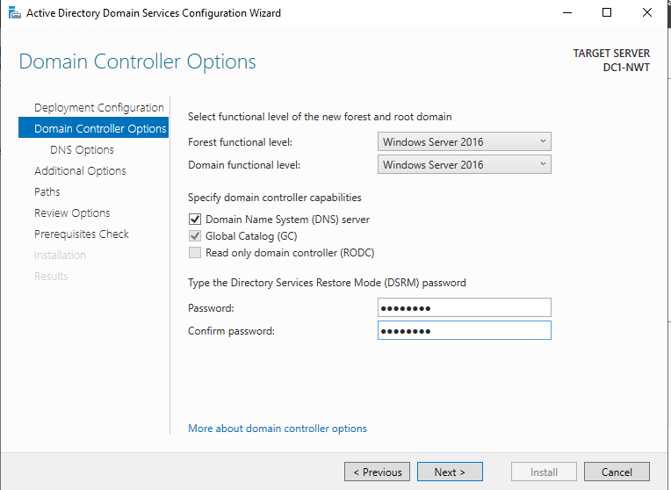

Step 15: In the DNS Options screen, left Create DNS delegation unchecked and clicked next.
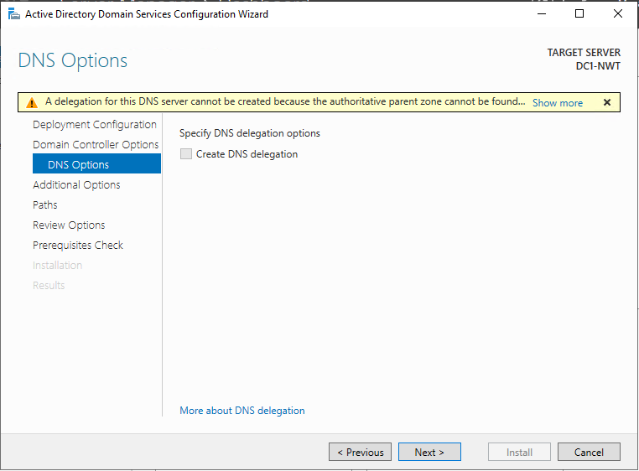

Step 16: In the Additional Options screen, left the NetBIOS domain name NWTRADERS unchanged and clicked next.

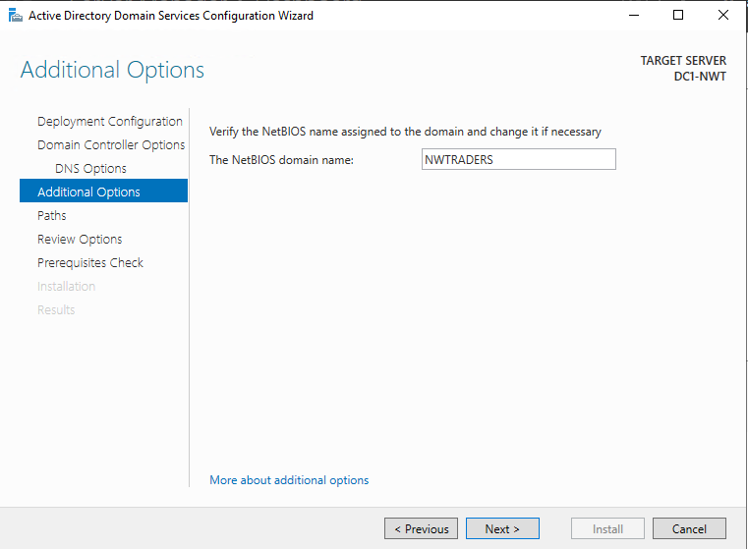

Step 17: On the Paths screen, left the Database folder, Log file folder and SYSVOL folder locations unchanged, and clicked Next.
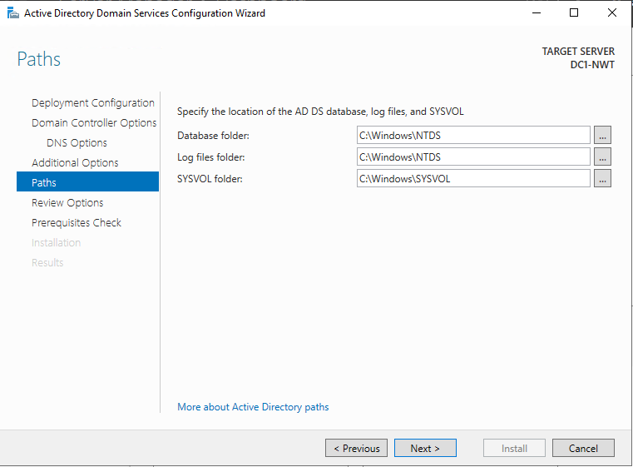

Step 18: On the Review Options screen, review the information and clicked next.

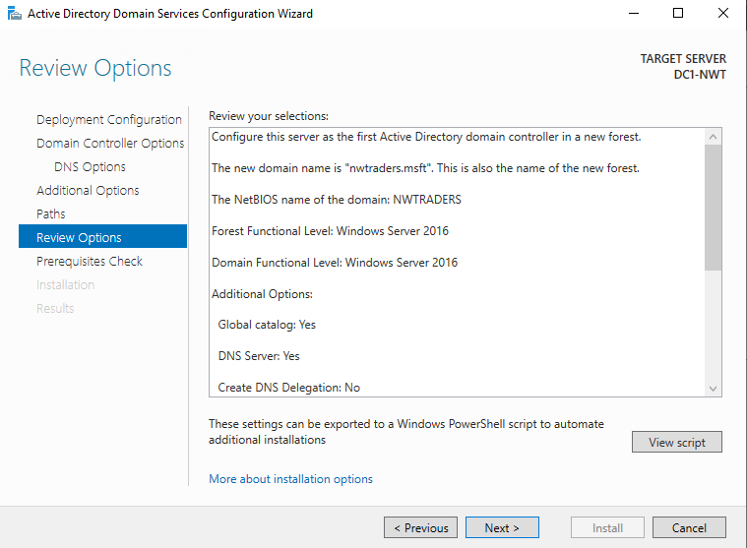

Step 19: On the Prerequisites Check screen, checked that all prerequisites had passed and click install to complete the domain controller installation.
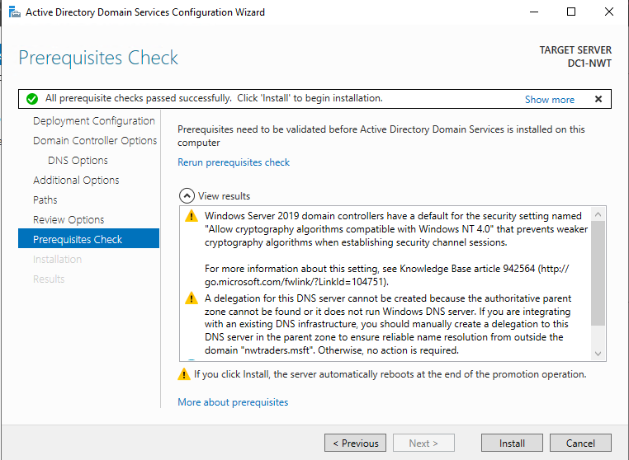

Step 20: After the installation completed and DC1-NWT automatically restarted, logged into the DC1-NWT using the NWTRADERS\administrator user account.
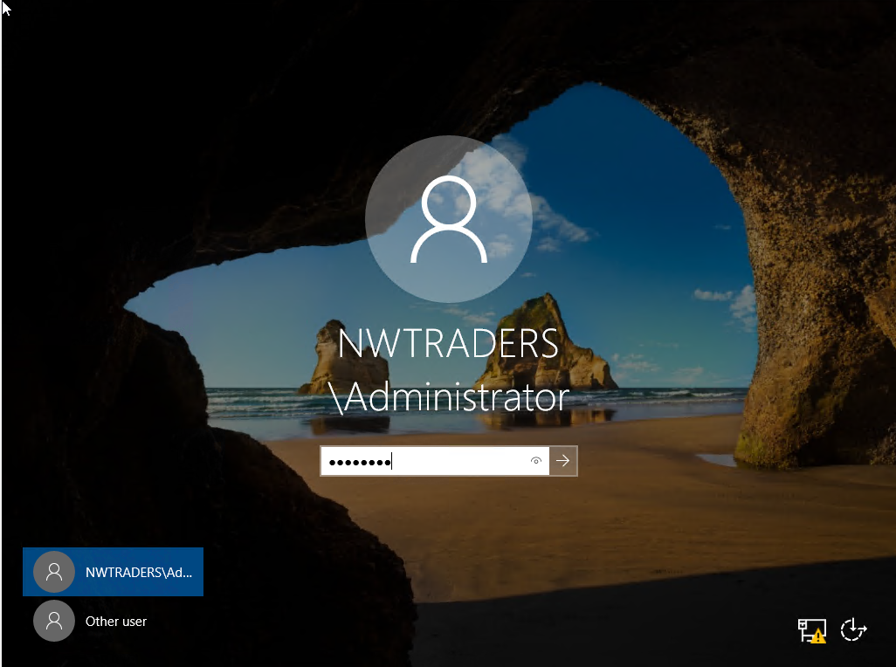

Task 3: Creating user account objects using Active Directory Users and Computers snap-in console.

Step 1: When logged into DC-NWT1, opened up Active Directory Users and Computers and expanded the nwtraders.msft domain.

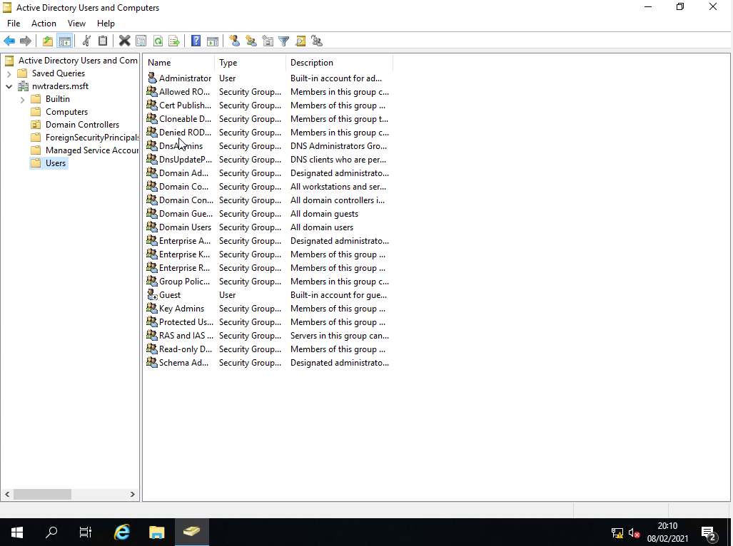

Step 2: Opened up the Domain Controller’s container and checked that DC1-NWT was present.
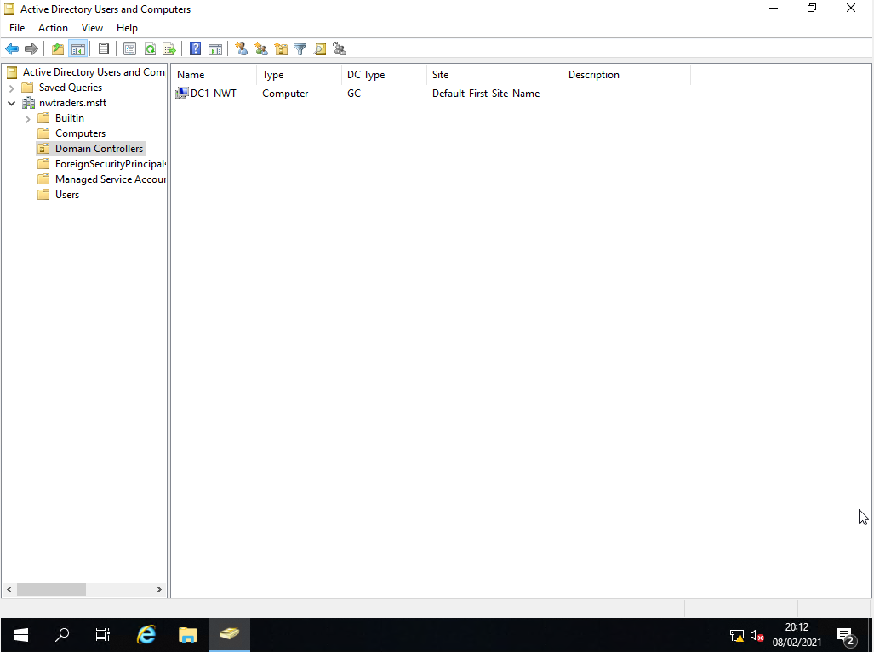

Step 3: Open up the Users container.
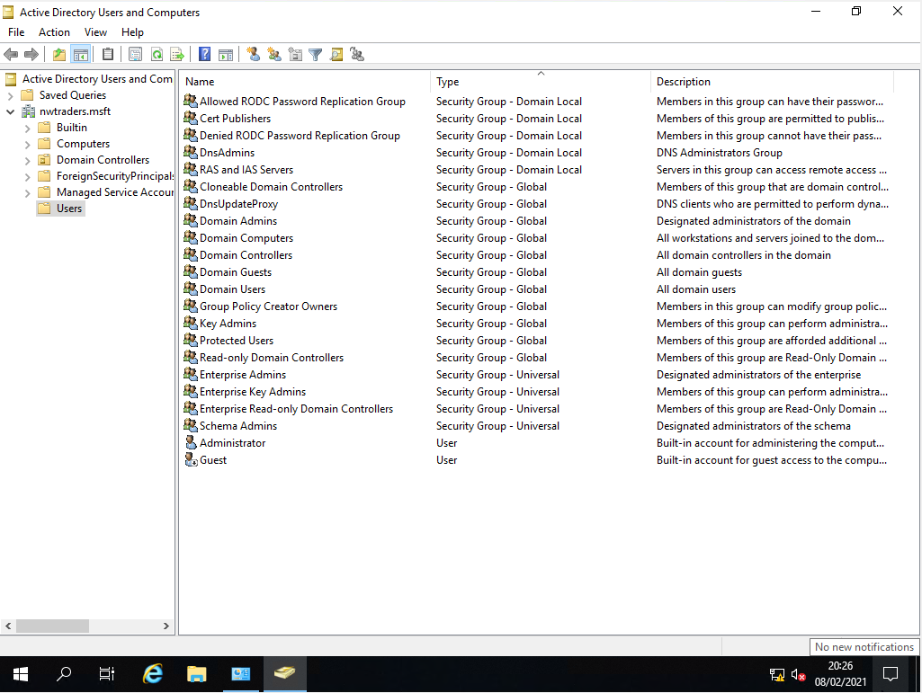

Step 4: Opened up the Domain Admins group and checked that the NWTraders\administrator account was present in the Members tab.
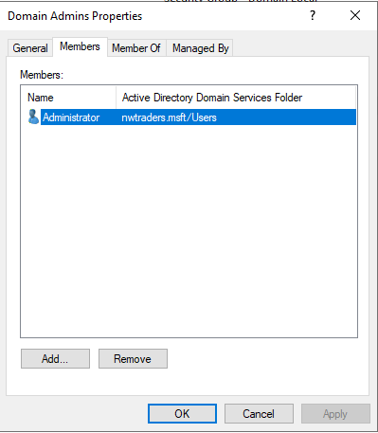
Step 5: In the Users container, run the new user account wizard by clicking on a white space, selecting new and user. Named the user Paul Richards and set the user id to NWT-PR.
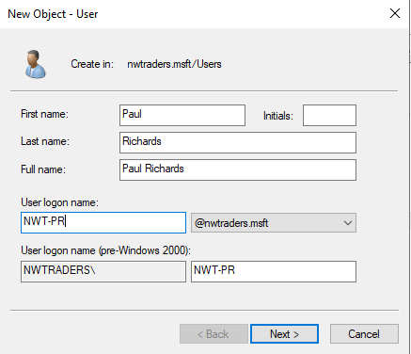

Step 6: In the second screen of the new user wizard, created a complicated password and checked the check box that the password never expires. Clicked next.
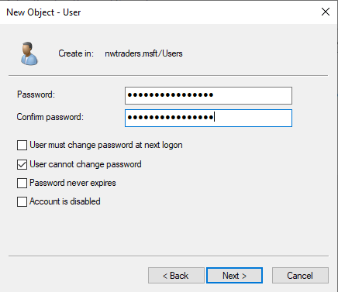

Step 7: Clicked finished on the final user wizard screen to create the user account.

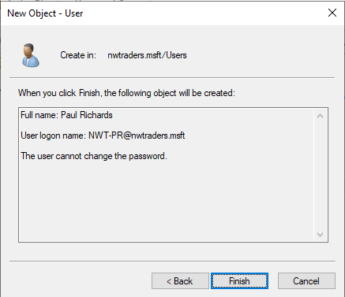

Step 8: In the Users container, opened up the domain admis group, clicked on the member tab and the add button. Entered the user Paul Richards and clicked check Name.

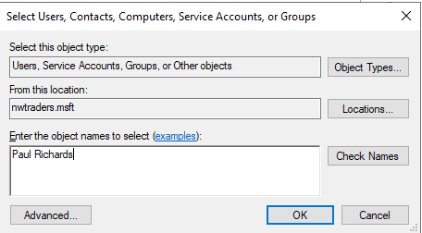

Step 9: Once the name Paul Richards become underline and NWT-PR@nwtraders.msft appeared next to in brackets, clicked ok.

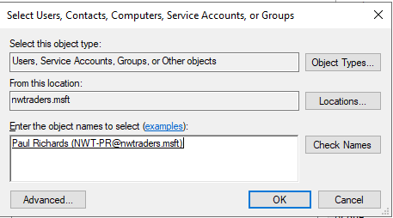

Step 10: On the Members tab of the Domain Admins group, clicked on apply and ok to complete the changes. Open up the Domain Admins group, and checked in the Members tab, that Paul Richards was present.

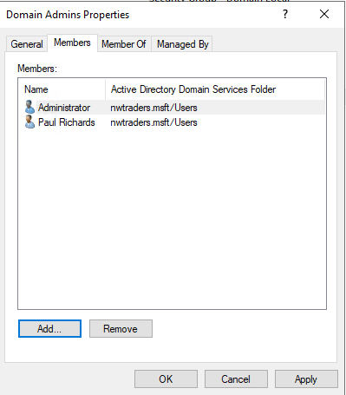

Task 4: Object attributes of interest.

Step 1: In the Users container, run the new user account wizard by clicking on a white space, selecting new and user. Named the user Kelly Meloni and set the user id to NWT-KM.

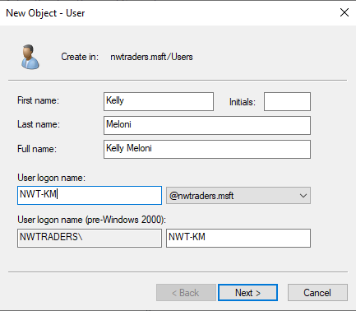

Step 2: In the second screen of the new user wizard, created a complicated password and let the checkbox user must change password at next logon checked. Clicked next.
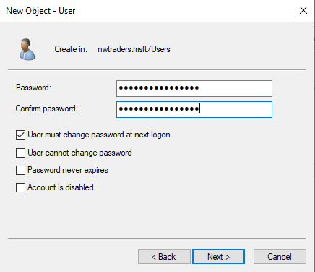

Step 3: Clicked finished on the final user wizard screen to create the user account.

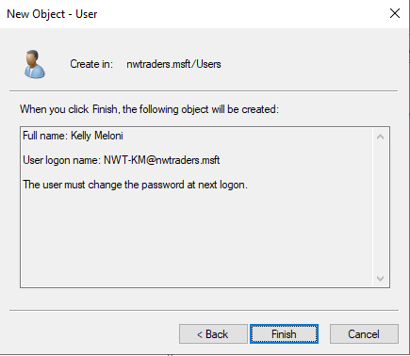

Step 4: Opened up the Domain Users group and checked that Kelly Meloni was present in the members tab.
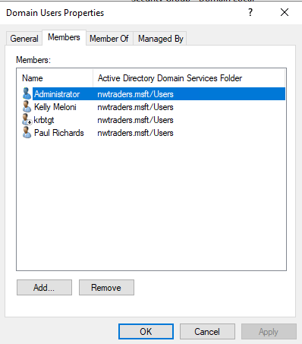

Step 5: Opened up the Properties of the user account Kelly Meloni.
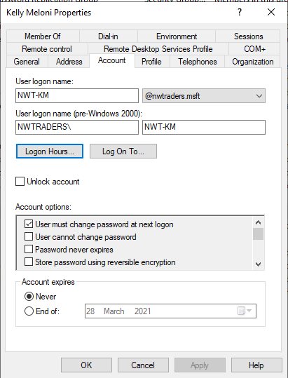

Step 6: In the account tab, clicked on the Logon Hours button. Clicked the Logon Denied radio button, and set the user specified that the user cannot log into the domain between 1 to 2 pm from Monday to Friday. Clicked ok to confirm changes.
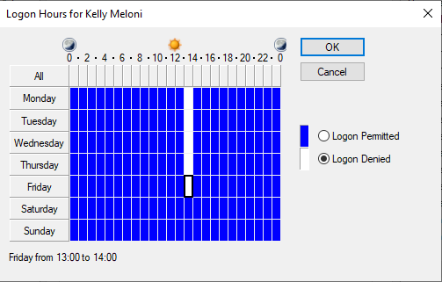
Step 7: In the account tab, unchecked user must change password at next logon. Checked user cannot change password. Clicked apply and ok to confirm changes.
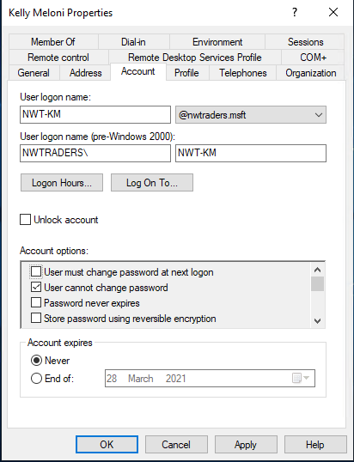

Task 5: Adjoining the domain and testing user logins.

Step 1: On DC1-NWT and in Active Directory Users and Computers, opened up the computers container, created a new computer account by right click on empty space and select new and computers In the new computer account wizard, named the computer account WS1-NWT and clicked ok.
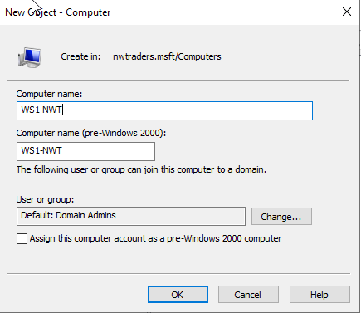

Step 2: Logged into Client 1 using the local administrator user account called Administrator
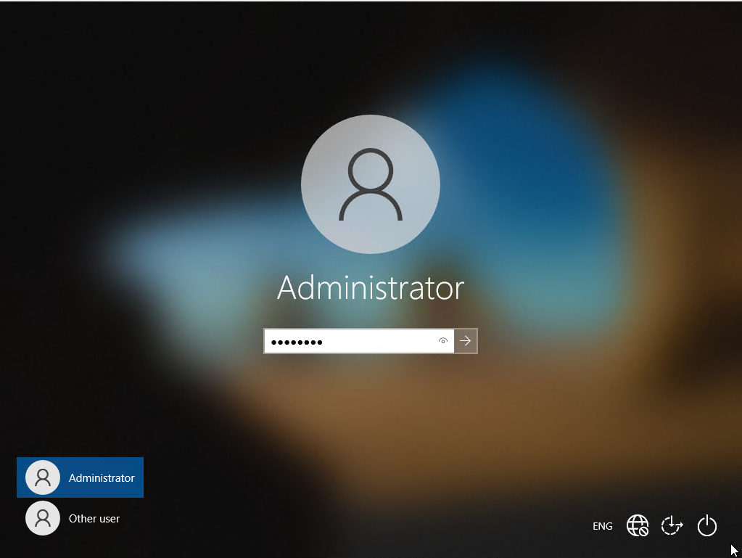
Step 3: Opened up the System Properties of client 1. Clicked on the computer name tab and the change button. Changed the computer name to WS1-NWT and clicked ok.

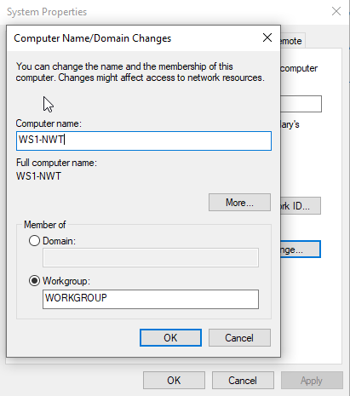

Step 4: A pop up appeared advising to restart the computer for changes to take effect. Clicked ok on pop-up.

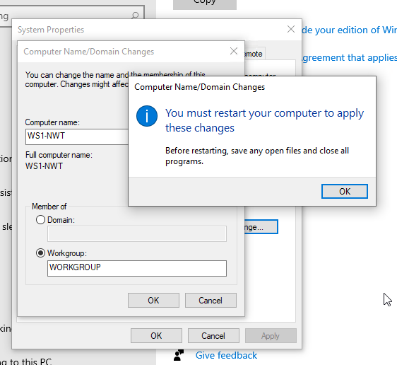
Step 5: Clicked Close when back on the computer name tab.

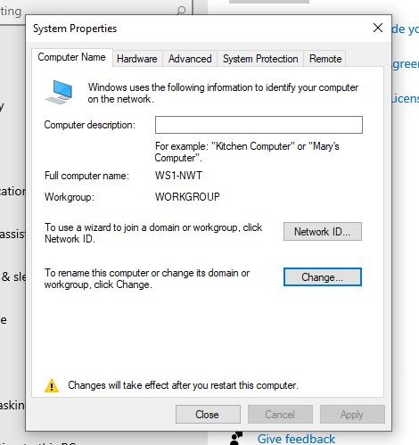

Step 6: A pop up appeared, clicked restart now to commit changes.
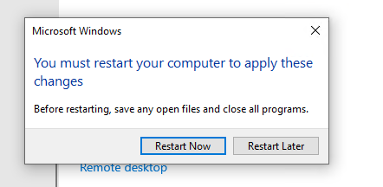

Step 7: Once computer restarted, logged back into the client 1and opened up the internet protocol version 4 properties and specified the DNS IP address 192.168.100.1
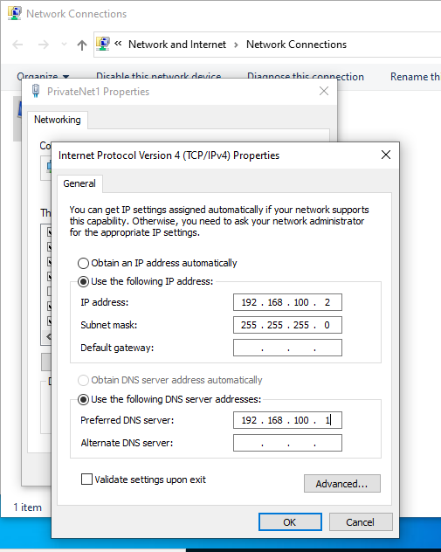

Step 8: Opened up the system properties of client 1. Navigated to the computer name tab and clicked change domain ID. In the computer name/domain changes screen, selected the domain radio button and entered the domain nwtraders.msft and clicked ok.
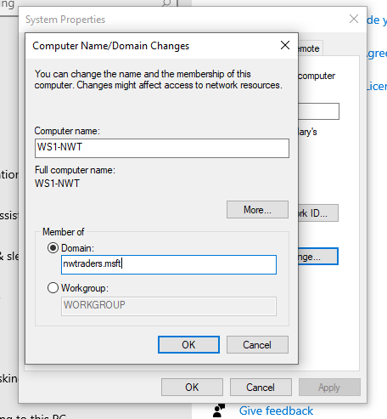

Step 9: Enter the traders\administrator user account credentials when prompted, and clicked ok to add the computer account to the nwtraders.msft domain.
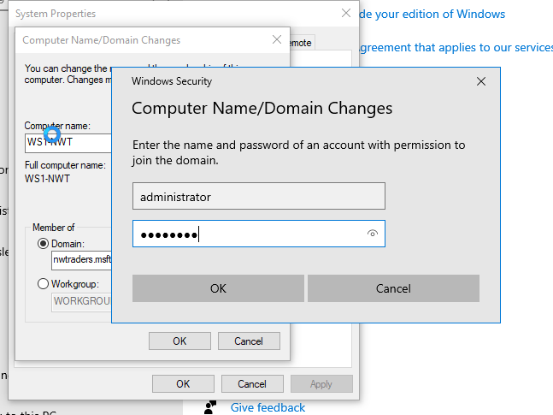

Step 10: A message appeared stated welcome to the nwtraders.msft domain. Clicked ok.
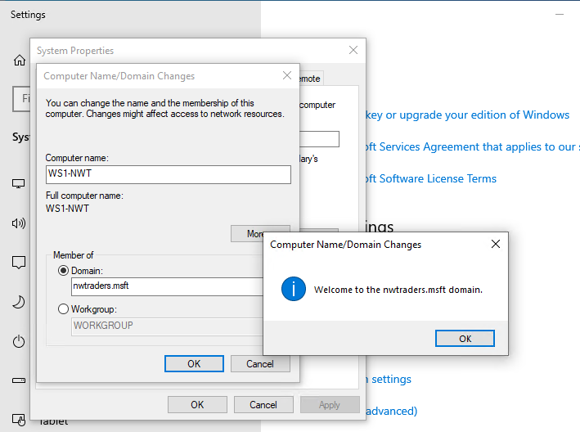
Step 11: A message pop-up advising to restart the computer to commit the changes. Clicked ok.
: 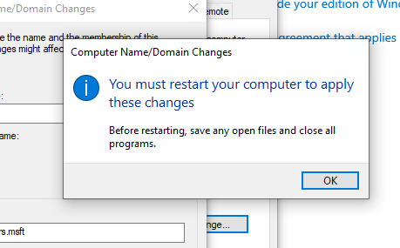

Step 12: Back on the system properties screen, clicked on close
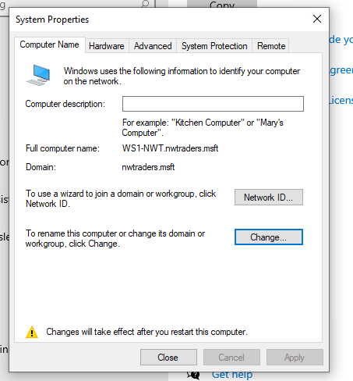

Step 13: A pop up appeared, clicked restart now to commit changes.

Step 14: After WS1-NWT had restarted, logged into the WS1-NWT using the non-administrator account Kelly Meloni..
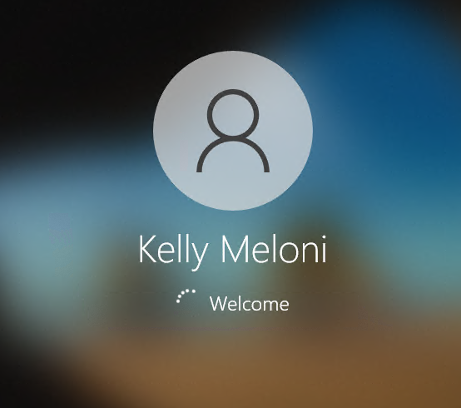

Step 15: When logged into WS1-NWT, hovered over the power button to confirm that I was logged into the computer as Kelly Meloni.

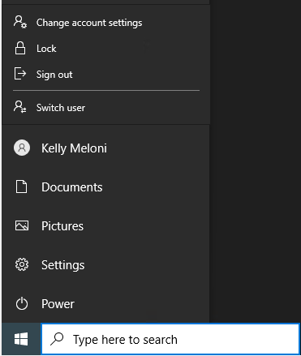

Step 16: Logged into DC1-NWT or Server1 using the Kelly Meloni user account. It would not allow the user to login because they were not part of the domain admin user group. Got the error ‘The sign-in method you’re trying to use isn’t allowed. For more info, contact your network administrator.’
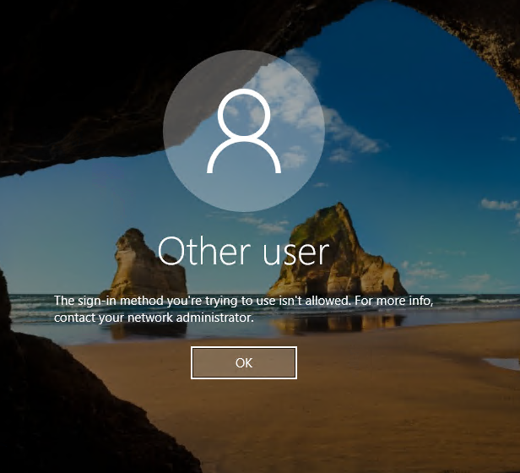

Task 6: Observation Tasks

6 a. DNS

According to Microsoft [1], computers communicate through numbers or IP address, but humans are not very good at remember numbers. They are better at remembering words. This is where DNS comes in. It bridges the gap between computers and humans. DNS (Domain Name Services) resolves IP address e.g. 62.125.96.21 into host names e.g. www.facebook.com . DNS is used to help identify and locate hosts on internal network or on the internet. The reason we use DNS is because it is lot easier to remember a host name or website like www.facebook.com than to remember an IP address, e.g. 62.125.96.21.
It is not possible for a single DNS server to contained all the DNS records for all available machines. DNS is a hierarchy namespace. When querying a website such as facebook.com, the DNS server queries a hierarchy of servers to find the website you are trying to locate. The illustration and the steps below explain how this process works.

Step 1 – The client searches for www.facebook.com. It query’s the Local DNS server for www.facebook.com. The local DNS server does not know who is www.facebook.com. The local DNS server forward the query to the ISP DNS server. The ISP DNS server does not know who is www.facebook.com .

Step 2 – The ISP DNS server, queries the root servers (which are standards for the internet) for www.facebook.com .

Step 3 - The root server does not know who is www.facebook.com, but it knows who manages the DNS servers for .com. The root server refers the lSP DNS server to the DNS servers who manage .com, by providing the lSP DNS server with the IP address of the .com servers.

Step 4 – The lSP DNS server queries the .com servers for www.facebook.com .

Step 5 - The .com server does not know the server for www.facebook.com, but knows the dns server for facebook.com. It refers the lSP DNS server to IP address of the DNS server for facebook.com .

Step 6 - The lSP DNS server queries the DNS server for www.facebook.com .

Step 7 - The DNS server for www.facebook.com provide a response to the lSP DNS server.

Step 8 – The lSP DNS server passes information onto local DNS Server, who forward the information to the client, who can now access the www.facebook.com site.

DNS is not only important in finding hosts on an internal network or on the internet, DNS also helps clients to locate domain controllers that provide active directory services. The DNS server accomplishes this through the use of host records and SRV(service location) records. The host records maps the IP address to the DNS name or FQDN (Fully Qualified Domain Name) of the domain controller. The SRV record maps the host name of the domain controller to a list of active directory services at a specific site. For example, if the client computer needs to authenticates a user with Kerberos. The Client queries the DNS server to find a Domain Controller that provides the Kerberos service. The DNS server provides the client with the details of the Domain Controller that provides the Kerberos service, the client sends a request to the domain controller to run the Kerberos service to authenticate the user.
The illustration and the steps below, explain how this process works.

Step 1 – A service on the client computer collects information about the client and the requested service. This information may include the name of the requested service, the name of DNS domain and the client site. The client service send the collection information in the form of a dns query to the DNS Server.
Step 2 - The DNS server returns a list of SRV records, which contains the domain controllers who provide the service requested.
Step 3 – The client service reviews the SRV records and selects a domain controllers based on the priority and weight assigned to the SRV record. The client sends a second DNS query requesting the IP address of the domain controller.
Step 4 – The DNS server returns the host record of the domain controller, which contains the domain controller’s IP address.
Step 5 – The client uses the details of the DNS record to contact the domain controller and to request the service the client is seeking.
Step 6 – The Domain Controller provides the requested service.

6 b. Critical Roles

DHCP

According to Microsoft [2], DHCP stands for Dynamic Host Configuration Protocol. Its goal is to assign unique IP addresses to hosts. It also provides other network address information, such as the subnet mask, the default gateway IP address and the DNS server IP address. It comes in two forms: a client or server. For example, two computers or hosts need IP address. Not any IP address, they both need a unique IP address. If they were given the same IP address, data that is pose to be going to host A would be going to host B. Data that is pose to be going to host B would be going to host A.

You do not necessary need DHCP, you could assign IP addresses statically or manually. This is fine on a simple network, but on large network this would be very time consuming and not practical.

Each computer runs a DHCP client and this will allow the computer to ask for an IP address from the DHCP server. The DHCP server can be run from a server or router. In a home network the DHCP server is stored on a router, but on corporate network the DHCP server will be running on a server. The illustration and steps below explain how DHCP works:

Step 1- DHCP Discover. When the PC boots up and looks for DHCP server, it sends a broadcast message to the whole network requesting a DHCP server to contact the PC. Hosts that are not running the DHCP server will drop the packet.

Step 2 - DHCP offer. When a DHCP server receives the message, it offers the DHCP client a IP address. If more than one offer is sent, the DHCP client will accept the first offer.

Step 3 - DHCP request. When the DHCP client accepts the DHCP offer, it will send a request to obtain an IP address of the DHCP server.

Step 4 - DHCP acknowledgement. The DHCP server provides a IP address to the host, along with the subnet mask, the IP address of the default gateway, and the IP address of the DNS. The DHCP server keeps a record of the lease of the IP address and the length of time of the lease. When a DHCP supplies a IP address, it provides the IP address for a given time. If the client still needs the IP address, the DHCP server renews the IP address. If the client does not need the IP address, the DHCP removes the IP address from the client and returns the IP address to the available pool of IP addresses. This ensures that no IP addresses are wasted when a machine becomes obsolete, or is disconnected from the network.

DHCP uses UDP ports to communicate on the network. The DHCP client use Port 68 and the DHCP server uses Port 67.

To summarize, DHCP automates the allocation of IP addresses. On a large network, this can be quite important, otherwise the network administrator would have to configured each IP address manually. This would be a time consuming and unnecessary. It also ensures IP addresses are not wasted. IP address are available on a lease for a given time period. When a host no longer requires a IP address after the lease has expired, the IP address is withdrawn from the client and allocated to a pool of available IP addresses for other clients.

WSUS

According to Microsoft [3] WSUS (Windows Server Update Services), is a server role that allows administrator to control Windows Updates on a network. Microsoft releases patches on a monthly basis, which are used to fix vulnerabilities and bugs in Microsoft Operating Systems. The administrator can use WSUS to control whether users should install certain updates.

There are a few ways that WSUS can obtain updates:

- The WSUS server can download updates directly from the Microsoft Website (if internet connectivity is available on the network).

- The WSUS server can download the updates from another WSUS server (referred to as an Upstream Server).

- Imported files copied onto your server (if no internet connectivity is available on the network). You can download the file from the internet onto a CD, then copy updates from the CD onto the WSUS server.

N.B. The WSUS server should never be installed on the domain controller, because you will have access issues on the database. To setup WSUS, you install the WSUS role on a member server, then create a group policy for clients to check in with the WSUS server for updates.

WSUS allows administrators to setup test computer groups to test updates. By using WSUS and test computer groups, administrators can identify issues with updates that could affect their network. This allows the administrator to come up with strategies to manage the updates or delay the deployment of the updates, until Microsoft release a further update to correct the issues caused by the update. Even although updates can solve problems, they can also cause problems too. WSUS protects networks from unwanted side effects from windows updates.

6 c. Permissions

According to Mike Meyers [4] security permissions are important in protecting an enterprise. Security permissions can protect an enterprise in the following ways.

- They can stop a malicious employees carrying out sabotage. E.g. removing data.

- It can stop users viewing sensitive data.

- It can stops users accidently modifying data.

- If a user account becomes comprised in a social engineer or phishing attack, by limiting the user’s permissions, the hacker can only cause limited harm.

There are many ways you can manage user’s security permissions or access. You can edit a user’s individual permissions e.g. if a you only want to grant a user only read access to document on file server, you could add the user to the document and set their permissions to read only. However, the floor with using this method of controlling user’s access is you have to alter each user permission when a user requires access the document. This can be a time consuming and inefficient. Most system administrator tend to use roles to control user’s access levels. This method of controlling user’s access through roles is referred to as RBAC (Role based Access Control). The way RBAC works is if a user requires read only access to a document, you assign a user a role to allow them only read only access to that document, rather than alter the user’s permissions.

RBAC can be implement in two ways:

- Assign a role to a user.

- Adding and removing users from a security group.

In windows, RBAC is implement through Groups. E.g. when we created the non-administrator user called Kelly Meloni, we do not want this user to have access to the domain controller. So windows automatically added her to the domain users group, which does not allow non-admin users to access the domain controller. As for the user account called Paul Richards, we wanted this user to have access to the domain controller, so we added him to the domain admins groups. In windows you can create your own security groups or use the built in user groups, below is a brief list of built in windows user groups.

- Domain Admins Group – used to configure servers, install software and configure permissions.

- Domain User Group – used for normal users. These would be for employee who log onto the network and do day to day work for the enterprise.

- Domain Guest user account – used to grant temporary access. E.g. a visitor.

- Enterprise Admins – this group, allows administrators to make changes to forests and domains etc.

6 d. AGDLP and AGUDLP
According to Sander Berkouwer [5] AGDLP stands for Accounts, global groups and domain local groups. AGDLP is a role based strategy that can be used to simplify day to day administration of user accounts and security groups. Role based permissions are based on the role or position a user holds in an organisation. The benefits of role base permissions is that the administrator does not need to specify permissions for each user, they can simply add the user to a security group and that will contain the permissions the user requires. AGDLP is a security management practise that uses security groups to control a user’s permissions. AGDLP is recommended for medium sized networks. Microsoft defines a medium network as one having 500 or more users. AGDLP is generally used for single domain and single forest environments, but can be used for multi-domains environments. However, it is recommended you use AGUDLP for mulit domain environments or forests. We will discuss AGUDLP later on.

The AGDLP security practice works in the following way:
- A: Create a User account.
- G: Create a global group and add the user to the global group.
- DL: Create a domain local group that contains the resource you wish to access e.g. network share or printer. Add the global group to the domain local group.
- P: Assign the permission for the resource to the domain local group.

The following scenario demonstrates how AGDLP works in practise. For example, say we have a network resource (a shared folder) called General ledger in a domain called sub.mycompany.com. You want to grant users in a parent domain called mycompany.com access to this resource.
- First create a global group called Accountants in mycompany.com. If the resource exists in a different domain, you need to create a global group to access this resource.
- Next create a domain local group in sub.mycompany.com called accounting. The global group called Accountants is added to domain local group called accounting. Domain local groups allow you to add global groups from other domains. Allowing non-local users to access local resources.
- Finally, configure the permissions for the accounting domain local group to access the network share, General ledger.

The benefits of AGDLP are listed below:

- You can grant users from other domains, access to local resources.

- Permissions can be easily changed. If a user changes roles or jobs in an organisation, you can change the security groups that the user belongs too. E.g. if a user gets promoted and needs access to more sensitive documents on a network share, you can add them to the security group that has access to these documents.

- Easier to audit user permissions. If you need to know what permissions a user has, you just check the user’s group membership.

AGUDLP is another security management practise that is used for mulit forest and domain environment. AGUDLP is usually recommended for large and complicated environments.

The AGUDLP security practise works in the following way:
- A: Create a User account.
- G: Create a global group and add the user to the global group.
- U: Create a universal group, add the global group to the universal group.
- DL: Create a domain local group that contains the resource you wish to access e.g. network share or printer. Add the global group to the domain local group.
- P: Assign the permission for the resource to the domain local group.

The following scenario demonstrates how AUGDLP works in practise. For example, say we have five domains that belong to the same company. You have a group of top sales people who are spread across the five domains. These sale people are so good, that the company wants them to visit other branches to help other sale people to improve their performance. In order to achieve this, the top sales people will need access to data in other domains. As an administrator, you only want to grant the top sales people access to sales data in other domains. You do not wish to grant access to the average sales person. To achieve this, the administrator takes the following actions:

- The administrator create a universal group at the forest level.
- The administrator creates five global groups for each domain.
- The administrator adds the top sales people to the global group.
- The global group is added to the universal group.
- The universal group is added to the domain local group.
- Security permissions are applied to the domain local group, to provide access to the sale data.

The reason for using AGUDLP as opposed to AGDLP in multiple forests and multiple domains environments, is because one administrator is not going to possess knowledge about every resource on a network. AGUDLP allows delegation of security control to local administrators who know what resources are available locally. A local administrator is a better position to manage access locally than an enterprise administrator who only manages the network from the forest level. In large corporations, it makes sense to delegate control to manage local resources, rather than trying to control them from one central point.

Most of the advantages of AGUDLP are the same as AGDLP. However there are a few additional benefits.

- Global groups allows distributed control. Local Domain administrators cab controls access to local resource e.g. network shares etc.

- The way in which universal group are used in AGUDLP, reduces replication between global catalogue servers. When you make a change to a universal group, this change needs to be replicated across all global catalogue servers. This can be problematic, when replicating, across a slow WAN link.

Bibliography

[1] | Microsoft, Exam 70-410 Installing and Configuring Windows Server 2012, Wiley, 2013, pp. 279-306.
[2] | Microsoft, Exam 70-410 Installing and Configuring Windows Server 2012, Wiley, 2013, pp. 258-277.
[3] | Microsoft, Exam 70-411 Administering Widnows Server 2012 R2, Wiley, 2014, pp. 33-64.
[4] | M. Meyers, CompTIA A+ Certification All-in-One Exam Guide, McGraw-Hill Education, 2019, pp. 527-574.
[5] | S. Berkouwer, Active Directory Administration Cookbook: Actionable, proven solutions to identitiy management and authentication on servers and in the cloud, Packt Publishing, 2019, pp. 249-272.

