
SSB ASSESSMENT 1
Software Solutions for Business

[1]

Mubeen Ahmed
2518097

Tabel Of Contents
Contents
Tabel Of Contents 1
Introduction 3
TASK 1: E-Commerce Website 4
WIX 4
Some of the major features of WIX are: 5
Create websites: Users can create as many free websites as they want. 5
Globally Operable: It can be used in any part of the world. 5
Accessible by mobile and computer: Users can access their website from any device, whether it be your mobile phone, computer, or Mac. 5
Free to All: It offers a free plan that can be used by anyone without paying even a single penny. 5
Easy Customization: The process of customization is very user-friendly and easy to operate. 5
Free and numerous templates: Users can create their own websites based on one of many templates or even create their own templates. 5
E-commerce: It supports online buying and selling of products. 5
Shopify 5
Shopify is used by individuals and companies because it is user-friendly, safe, and has all the features required to operate an online business. 6
Key Points 6
Task 2 A. Mind-Mapping 6
Task 2 B. My Creation of Mind-Map 7
Task 3a. Four Office Applications 8
Microsoft Word 8
Microsoft Excel 10
Microsoft Office 12
Microsoft PowerPoint 15
Task 3b. Test any two features 17
IF Function 17
Step 2: 18
Step 3: 18
VLOOKUP 19
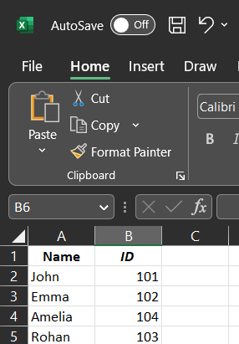 19
Step 2: 19
Task 4a. Communication and Collaboration applications 20
1. Introduction 20
2. Microsoft Teams – A Communication Application 20
Key Features of Microsoft Teams 20
Importance in Business Communication 21
3. Slack – An Online Collaboration Tool 21
Key Features of Slack 22
Role in Collaboration 22
Task 4B. Practical Test 23
Communication Application: WhatsApp Web 23
Collaboration Application: Google Drive 23
Step 1: 23
References 26
Bibliography 26



Introduction

This document contains all the answers to tasks to be completed for Assessment 1 of the module "Learning in the Digital Era". I'll try to give short and descriptive answers to all the questions.
I'll write the answers after doing the research and after gathering multiple points of view, and I'll validate them, finding the proof as well.
My goal is to write the best possible answers so that checkers/readers get the best quality, and I improve my ability to think and my ability to research fearlessly.

TASK 1: E-Commerce Website

E-commerce is an online transaction where buyers purchase products from sellers.
Websites
There are many websites created to carry out the buying and selling of items, including:
• WIX
• NIKE
• Shopify
• Walmart
eBay, etc.

WIX
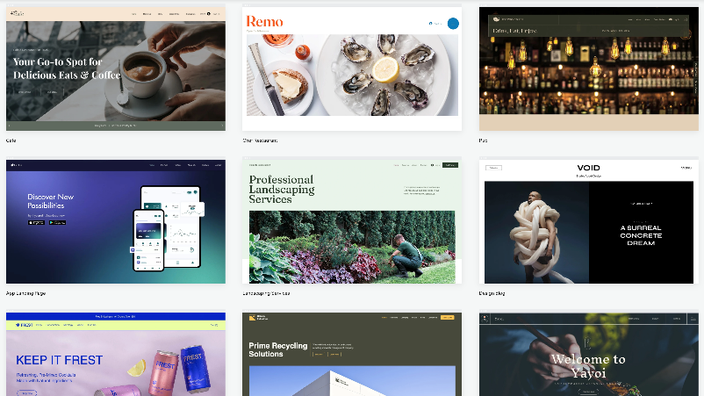
Fig2. “Shows interface of WIX Templetes” [2]
Wix.com Ltd. is an Israeli software company that provides a cloud-based web development platform that enables users to build websites and online stores without coding. [2]
WIX also makes available thousands of free templates, tools, and designs for the end. Users can enjoy a full experience designing and customizing their own websites.
It is a ground that lets users create their own websites, design them in their own style, and even publish them online, which is a great opportunity for beginners.
Key-Points
Some of the key features of WIX are:

Some of the major features of WIX are:

Create websites: Users can create as many free websites as they want.

Globally Operable: It can be used in any part of the world.

Accessible by mobile and computer: Users can access their website from any device, whether it be your mobile phone, computer, or Mac.

Free to All: It offers a free plan that can be used by anyone without paying even a single penny.

Easy Customization: The process of customization is very user-friendly and easy to operate.

Free and numerous templates: Users can create their own websites based on one of many templates or even create their own templates.

E-commerce: It supports online buying and selling of products.

Shopify
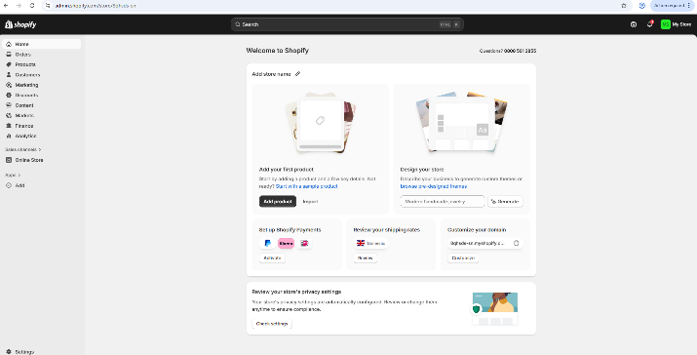
Fig2. “Shows interface of Shopify Dash-Board” [3]
Shopify is an all-inclusive, cloud-based e-commerce platform that enables anyone to set up and manage their own online store, sell goods, handle payments, and manage inventory without the need for coding knowledge. With website development, marketing, and sales through both online and offline channels, it caters to the needs of small businesses and international brands alike. [3]
A one-stop shop where you can create and host your store, alter designs using themes and apps, safely handle transactions, and sell on social media or online marketplaces like Amazon for a subscription fee. Without knowing how to code, it offers tools for managing orders, adding products, accepting payments, and setting up an online store.

Shopify is used by individuals and companies because it is user-friendly, safe, and has all the features required to operate an online business.

Key Points
Store Creation: It provides an easy-to-use tool with a variety of templates, known as themes, to create a polished online store without knowing any code.
All-in-one management: includes order management, hosting, security, and payments through PayPal and Shopify Payments, among other methods.

Multi-Channel Selling: This feature allows you to sell through social media sites like Instagram and TikTok, marketplaces like Amazon and eBay, or your own store.
e-Commerce Point of Sale: Connects online and physical store sales.
App Store: Thousands of third-party apps add features for shipping, marketing, SEO, and other areas.
Scalability: Fits all sizes, from entry-level features to enterprise-level tools for big brands like Shopify Plus and Tesla. Order and Customer Management: Shopify allows the business to manage orders right from when a customer makes a purchase. The store owner is thus allowed to view orders, fulfil them, print shipping labels, track delivery, and even view customer details.

Task 2 A. Mind-Mapping
Mind-mapping: what is it?
Mind mapping is a visual method of presenting information by setting the main idea in the middle and branching related ideas outwards in a connected, hierarchical fashion.
It makes it easier for them to understand and remember ideas and relationships of things through the visual representation of concepts.
Benefits
It works for businesses by clarifying information, enhancing decision-making, boosting creativity, and improving productivity. It enhances communication, teamwork, project planning, and strengthens strategic thinking.
Example
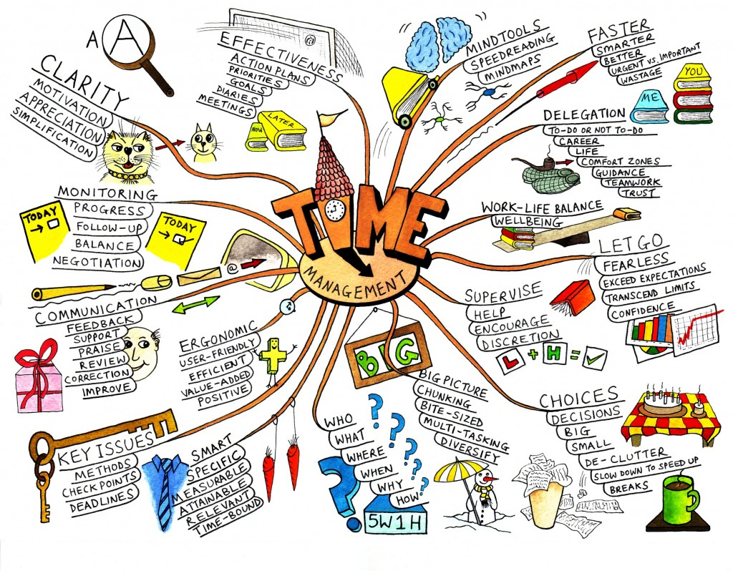
Fig3. “Shows a Mind-Map About Time Management” [4]

Task 2 B. My Creation of Mind-Map
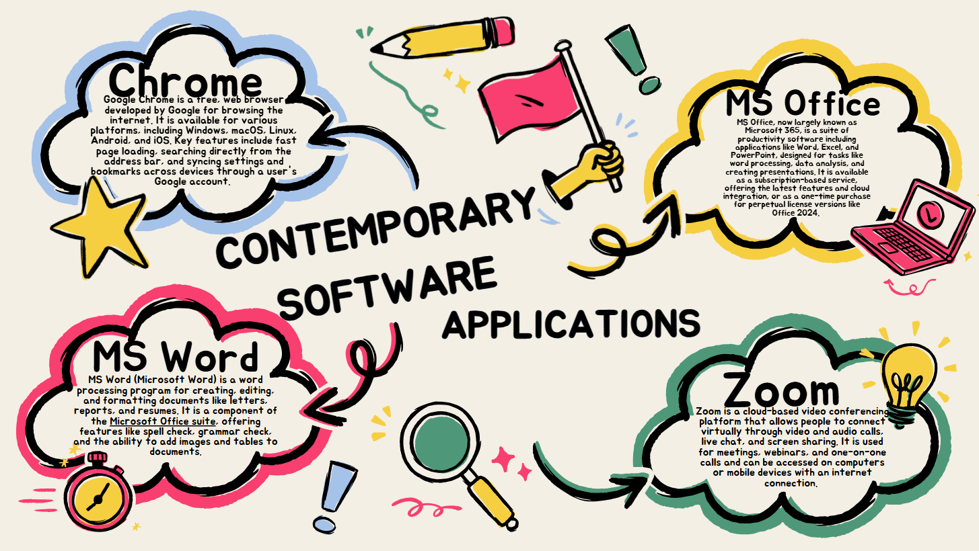
This Mind-Map shows some of the contemporary software applications used to support day-to-to-to-today business/organisation operations.
contemporary software applications
Some of the contemporary software applications shown in the mind-map are as follows.
1. Google Chrome
2._MS Office
3.Microsoft Word
4. Zoom

Task 3a. Four Office Applications

Microsoft Word
Microsoft Word, commonly known as MS Word, is one of the most widely used word-processing applications in the world. Developed by Microsoft as part of the Microsoft Office suite, it serves as a versatile tool for creating, editing, formatting, and managing text-based documents. [1] Whether for academic assignments, office reports, letters, or creative writing, MS Word provides a clean, user-friendly workspace that helps users produce professional and organized documents. Its powerful set of tools, along with cloud integration and modern AI assistance, makes it an essential program for students, teachers, professionals, and everyday users. Because of its reliability and efficiency, MS Word remains a leading choice for digital document creation across many industries and institutions.

Features
MS Word includes a wide range of features designed to improve both writing quality and document presentation:
Text Formatting Tools: Users can customize fonts, colours, alignment, spacing, and styles to make documents clear and visually appealing. Pre-designed themes and templates make it easy to start creating resumes, letters, reports, and more.
Insert Options: Word allows easy insertion of images, tables, charts, shapes, icons, and hyperlinks. These tools help create rich, informative, and interactive documents.
Review and Editing Tools: Built-in spelling and grammar checks, autocorrect, readability suggestions, and the Track Changes feature support error-free writing and smooth editing.
AI and Copilot Integration: With Microsoft’s AI tools, users can receive writing suggestions, generate summaries, and create content ideas. Voice-to-text dictation and Microsoft Designer also enhance productivity.
Collaboration Tools: Through OneDrive, users can collaborate in real time, share files, comment on documents, and view version history.
Security Features: Password protection, restricted editing, and Auto Recover help ensure document safety and prevent data loss.

Benefits
MS Word offers many advantages that make it suitable for academic and professional use:
Easy Document Creation and Editing: Users can start from scratch or use built-in templates. Formatting tools help organize content clearly, making documents professional and easy to read.
Advanced Assistance Through AI: Features like Copilot provide writing help, improve clarity, and speed up content creation. Dictation tools allow hands-free writing, improving accessibility.
Strong Collaboration Capabilities: Real-time editing, sharing, comments, and tracked changes make group work efficient. Version history ensures older drafts can be restored if needed.
Flexible Formatting and Design: Styles, themes, margin settings, page orientation options, and layout tools make it possible to create clean, visually appealing documents suited for various purposes.

Limitations
Despite its strengths, MS Word has some drawbacks:
Cost: A Microsoft 365 subscription is required for full access, which may be expensive for some users compared to free alternatives like Google Docs or LibreOffice.
Large File Sizes: Documents with many images or graphics can become large, making them harder to share and store.
Installation Requirements: The desktop version must be installed and updated regularly, which may be inconvenient for devices with limited storage or permissions.
Not Ideal for Advanced Publishing: Word lacks the sophisticated layout tools found in professional publishing software like Adobe InDesign.
Compatibility Issues: Formatting may change when opening files on different systems, and older versions may struggle with newer formats.

Microsoft Excel

Microsoft Excel is one of the most powerful and widely used spreadsheet programs in the world. Developed by Microsoft as part of the Microsoft Office suite, Excel helps users organize, analyse, and visualize data efficiently.
It is commonly used in schools, businesses, finance, engineering, and research because of its ability to handle everything from simple calculations to complex data analysis. [5] Excel provides a grid of rows and columns where users can enter data, apply formulas, create charts, and build detailed reports. With its strong computational tools and modern cloud-based features, Excel remains an essential tool for anyone working with numbers, data, or lists.

Features
MS Excel includes a wide set of tools designed for data management and analysis:
Spreadsheet and Data Organization: Users can store data in organized rows and columns, apply sorting and filtering, and group related information for easier interpretation.
Formulas and Functions: Excel provides hundreds of built-in functions—such as SUM, AVERAGE, VLOOKUP, IF, and COUNT—that allow users to perform calculations, analyse patterns, and process data automatically.
Charts and Data Visualization: Excel offers various chart types, including bar graphs, pie charts, line charts, scatter plots, and more. These tools help users turn raw data into clear and meaningful visuals.
Tables and PivotTables: With PivotTables and Pivot Charts, users can summarize large datasets quickly, compare values, and generate reports without manually calculating totals.
AI and Copilot Tools: Modern Excel includes AI-powered tools such as Copilot, which can analyse data, suggest formulas, create summaries, and help generate charts. Flash Fill and Quick Analysis also simplify repetitive tasks and data formatting.
Collaboration and Cloud Integration: Through OneDrive, multiple users can edit the same spreadsheet in real time, leave comments, and track changes.
Data Validation and Security: Excel allows users to restrict certain inputs, protect sheets with passwords, and control who can edit or view sensitive data.

Benefits
MS Excel provides several advantages that make it indispensable for data-related tasks:
Efficient Data Analysis: Formulas, functions, and PivotTables allow quick calculations and deep insights, helping users make informed decisions.
Automation and Accuracy: Excel reduces manual work by automating repetitive tasks through formulas, macros, and AI tools. This improves accuracy and saves time.
Powerful Data Visualization: Charts, conditional formatting, and dashboards help transform complex data into easy-to-understand visuals.
Flexibility Across Fields: Excel is used in accounting, budgeting, project management, inventory tracking, scientific research, and more. Its versatility makes it suitable for many industries.
Collaboration and Sharing: Cloud-based editing and file sharing make teamwork smooth, especially for group assignments or office projects.
Customizable Workspace: Users can adjust cell sizes, create templates, build charts, and personalize the spreadsheet layout to meet specific needs.

Limitations
Despite its strengths, MS Excel has several limitations:
Cost: A Microsoft 365 subscription is required for full access, which may not be affordable for all users.
Complexity for Beginners: The large number of formulas, functions, and tools can be overwhelming for new users.
Not Ideal for Extremely Large Data Sets: When handling very large datasets, Excel may slow down or crash. Databases like SQL are better for big data tasks.
Human Error Risk: Since Excel relies heavily on manual inputs, small mistakes in formulas can lead to incorrect results.
Limited Collaboration Compared to Online Tools: Although Excel offers real-time editing, tools like Google Sheets sometimes provide smoother simultaneous collaboration.
Less Suitable for Advanced Data Science: While Excel offers strong tools, it cannot match specialized software like Python, R, or Power BI for advanced analytics.

Microsoft Office

Microsoft Office is a powerful suite of productivity applications developed by Microsoft. It includes well-known programs such as MS Word, MS Excel, MS PowerPoint, Outlook, and others that help individuals and organizations create documents, analyse data, design presentations, manage emails, and perform a wide range of digital tasks. First introduced in the late 1980s, Microsoft Office has become a global standard for office productivity. Whether in schools, businesses, or homes, it remains one of the most widely used software suites in the world. [6]
With both desktop and cloud-based versions available through Microsoft 365, users can access their files, collaborate in real time, and work across multiple devices. Its combination of flexibility, user-friendly design, and advanced features makes Microsoft Office essential for students, professionals, and organizations of all sizes.

Features
Microsoft Office includes a rich collection of tools and applications; each designed for specific tasks:
Multiple Applications in One Suite: Core apps include Word (for documents), Excel (for spreadsheets), PowerPoint (for presentations), Outlook (for email and scheduling), and OneNote (for notetaking). Advanced plans may include Access, Publisher, and Teams.
Cloud Integration with Microsoft 365: Users can store files on OneDrive, enabling real-time collaboration, automatic saving, and access from any device.
AI and Automation Tools: Features like Microsoft Copilot assist with writing, data analysis, presentations, scheduling, and email management. AI-powered suggestions improve accuracy and speed.
Collaboration Features: Users can co-author documents, add comments, track changes, and share files instantly. Teams’ integration supports chat, video meetings, and group communication.
Security and Compliance: Microsoft Office provides data encryption, password protection, file recovery, and permission settings to protect sensitive information.
Templates and Design Tools: Ready-made templates for resumes, business cards, presentations, reports, and spreadsheets help users create professional-looking content quickly.

Benefits
Microsoft Office offers numerous advantages that make it a leading productivity suite:
Versatility Across Tasks: Whether writing reports, analysing financial data, designing slides, or managing schedules, the suite covers nearly all professional and academic needs.
User-Friendly Interface: The applications are easy to learn, with intuitive menus and familiar layouts that help users work efficiently.
Improved Productivity: Automation features such as macros, formulas, and AI assistance save time and reduce manual work.
Strong Collaboration Capabilities: Real-time co-authoring, cloud access, comments, and file sharing make teamwork smooth and convenient.
Cross-Device Availability: Office apps work on Windows, macOS, tablets, and smartphones, allowing users to work anytime, anywhere.
Reliable and Widely Compatible: Microsoft Office formats (.docx, .xlsx, .pptx) are widely accepted across industries, making file sharing easy and consistent.

Limitations
Despite its strengths, Microsoft Office has several limitations:
Cost: A Microsoft 365 subscription can be expensive, especially for individual users or students. Free alternatives like Google Workspace and LibreOffice may be more affordable.
Requires Installation and Updates: Desktop versions must be installed and updated regularly, which may be inconvenient for users with slow internet or limited storage.
Complexity for Beginners: Some apps, especially Excel and Access, have advanced tools that may be difficult for new users to learn.
Compatibility Issues with Older Versions: Older versions of Office may not open newer file formats properly, causing formatting errors.
Internet Dependence for Cloud Features: Real-time collaboration and cloud storage require a stable internet connection.
Resource Usage: Office applications can be heavy on memory and processing power, slowing down older devices.

Microsoft PowerPoint
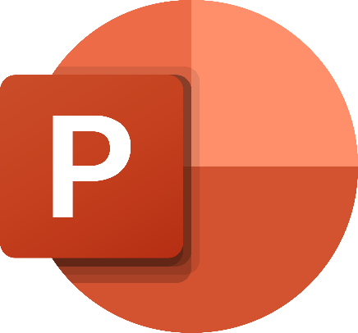
Microsoft PowerPoint, often called MS PowerPoint or simply PowerPoint, is one of the most popular presentation software programs in the world. Developed by Microsoft and included in the Microsoft Office suite, it is widely used by students, teachers, business professionals, and presenters to create visually engaging slideshows.
PowerPoint enables users to combine text, images, charts, videos, and animations to communicate information clearly and attractively. [7] Whether for classroom lessons, business meetings, project presentations, or seminars, PowerPoint helps users share ideas in an organized and visual format. With easy-to-use tools and a flexible design interface, PowerPoint continues to be a leading tool for creating impactful digital presentations.

Features
Microsoft PowerPoint offers a variety of tools that enhance creativity and improve presentation quality:
Slide Layouts and Templates: PowerPoint includes built-in templates and customizable layouts that help users design professional presentations quickly. Templates cover business, academic, and creative needs.
Insert Tools: Users can insert text boxes, images, charts, tables, icons, SmartArt graphics, audio, and video files. This makes presentations more engaging and visually appealing.
Transitions and Animations: PowerPoint provides a wide range of slide transitions and animation effects. These tools help emphasize key points and create smooth movement between slides.
Design Ideas and AI Tools: The Design Ideas feature uses AI to automatically suggest attractive layouts. Microsoft Copilot can assist with generating content, summarizing slides, and improving presentation structure.
Presenter Tools: Features like Presenter View, Notes, laser pointer, and timers help presenters deliver their message confidently and professionally.
Collaboration and Cloud Support: With OneDrive integration, multiple users can collaborate in real time, share slides, and comment on presentations instantly.
Export and Sharing Options: Presentations can be saved as PowerPoint files, PDFs, videos, or images, making it easy to share and present on different platforms.

Benefits
MS PowerPoint offers many advantages that make it a valuable tool for communication and presentations:
Easy to Use and Learn: Its simple interface allows beginners to create slides quickly while still offering advanced design options for experienced users.
Visually Engaging Presentations: The ability to combine text, images, colours, animations, and multimedia makes presentations more interesting and easier for audiences to understand.
Improves Communication: Slides help presenters organize information clearly and stay on track, making speeches more effective.
Flexible for Many Purposes: PowerPoint is used in education, business, marketing, training, and personal projects. It adapts to both simple and complex presentations.
Supports Collaboration: Real-time editing and cloud sharing make teamwork easier, especially for group projects or remote work environments.
Customizable Designs: Users can control themes, fonts, colours, backgrounds, and slide layouts, allowing full creative freedom.
Multimedia Integration: The ability to add videos, audio, and animations helps capture the audience’s attention.

Limitations
Despite its strengths, Microsoft PowerPoint has some limitations:
Cost: Full access requires a Microsoft 365 subscription, which may be costly for some users.
Overuse of Effects: Too many animations or transitions can distract the audience if not used carefully.
Can Encourage Text-Heavy Slides: Some users may overload slides with too much text, making presentations less effective.
Requires Good Design Skills: Users without design experience may struggle to create visually appealing slides without templates.
Not Ideal for Data-Heavy Reports: Excel or other tools are better suited for detailed numerical analysis.
Potential Compatibility Issues: Presentations may appear different on older versions of PowerPoint or on other devices.

Task 3b. Test any two features

IF Function
Step 1:
In this step, I created a simple table in Excel to input the raw data I need for the IF formula. The table contains two columns:
- Students (Column A)
- Marks (Column B)
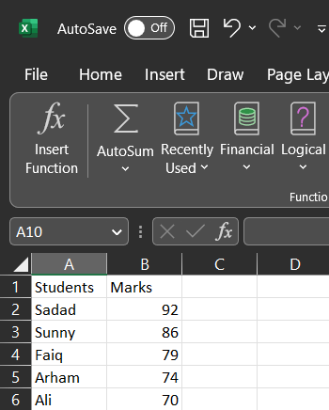

Step 2:
In Step 2, I selected the cell where I wanted the result of the IF formula to appear. This is the cell where I will show whether each student passes or fails based on their score.
I clicked on cell C2 because it's next to the first student's score (John's score). I will use this cell to show whether John passes or fails based on his score.
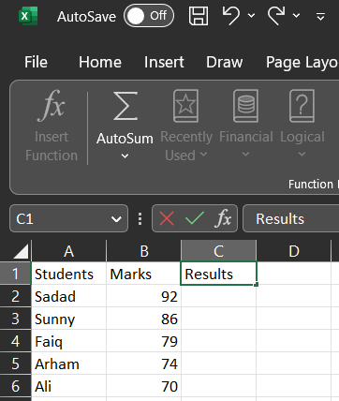

Step 3:
In Step 3, I applied the IF formula to check each student's score and determine whether they passed or failed.
The formula I used is:
=IF(B2>=70, "Pass", "Fail")


VLOOKUP
Step 1:
I created a table in Excel with Names in the first column and IDs in the second column.

Step 2:
I chose a cell to type the name I wanted to search (e.g., John in cell D2).
In the next cell (E2), I applied the VLOOKUP formula to find John’s ID:
=VLOOKUP(D2, A2:B5, 2, FALSE)

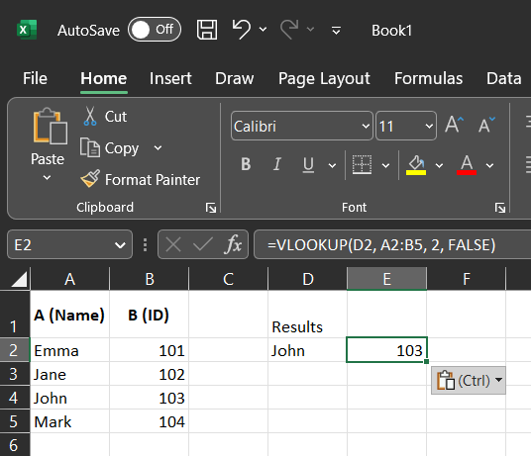

Task 4a. Communication and Collaboration applications

1. Introduction
In today’s digital era, effective communication and seamless collaboration are essential for business productivity and team success. Organisations now rely on advanced software tools that enable teams to communicate instantly, share information, and coordinate work regardless of location. This section analyses Microsoft Teams, a leading contemporary communication application, and Slack, a widely used online collaboration tool. We explore each tool’s key features, purpose in modern business environments, and how these tools help enhance workplace efficiency and teamwork.

2. Microsoft Teams – A Communication Application
Overview:
Microsoft Teams is an all-in-one communication platform developed by Microsoft. It is designed to support real-time communication between individuals and teams through messaging, voice and video calls, and online meetings. Teams forms part of the Microsoft 365 suite and integrates with other Microsoft products such as Outlook, Word, and SharePoint, providing organisations with extensive communication and productivity capabilities. [8]
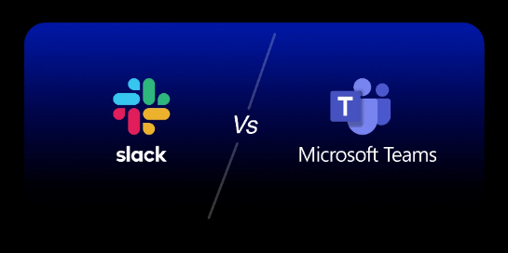
Fig4. “Shows the interface of comparison” [8]

Key Features of Microsoft Teams
1. Chat & Messaging:
Teams supports persistent chat where users can send instant text messages to individuals or groups. Chats can be organised by channels, making topic-based communication efficient.
2. Video Conferencing & Calling:
A major strength of Teams is its built-in video conferencing capabilities. Teams allows users to host meetings with many participants, with features such as breakout rooms, meeting recordings, and live captions. The platform also supports VoIP calls for direct audio communication.
3. Integration with Microsoft 365:
Teams integrates with apps like Word, Excel, PowerPoint, and OneDrive. This allows users to start a conversation about a document and edit it collaboratively without leaving the Teams environment.
4. File Sharing & Storage:
Teams incorporates SharePoint and OneDrive storage, allowing users to share files instantly in chats or channels. Permissions and version history are managed centrally, improving file security and accessibility.
5. Threads & Organisation:
Teams uses threaded conversations, which helps keep discussions focused and easy to follow. Users can follow specific threads and reduce clutter in busy channels.
6. Security & Compliance:
Built for enterprise environments, Teams offers advanced security features such as encryption, multi-factor authentication, and compliance tools to protect sensitive business data.

Importance in Business Communication
Modern businesses, especially large enterprises and remote teams, rely on Teams to centralise communication and reduce dependence on email. Teams supports real-time collaboration across global teams and simplifies organising meetings, chat conversations, and shared documents in one secure hub.

3. Slack – An Online Collaboration Tool
Overview:
Slack is a cloud-based collaboration tool used by teams of all sizes to communicate and work together. Designed to be intuitive and flexible, Slack organises interactions using channels for different projects, departments, or topics. It builds a digital workspace where messages, files, and app integrations create a central hub for collaboration. [9]
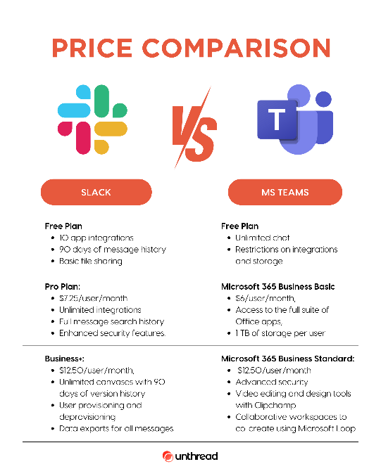
Fig5. “Shows the Price Comparison”

Key Features of Slack
1. Channels & Messaging:
Slack structures conversations using channels. Teams can create channels for specific projects or departments, making collaboration organised and reducing inbox clutter.
2. Direct Messaging & Huddles:
Users can message individuals or groups directly, and Slack includes “huddles,” which are lightweight audio/video sessions for spontaneous discussions.
3. File Sharing & Searchability:
Slack allows users to share files and media directly in conversations. All messages and files are stored and searchable, helping teams find information quickly.
4. Third-Party Integrations:
Slack connects with thousands of apps like Google Drive, Salesforce, Jira, and Trello. These integrations enable teams to pull data from other systems directly into Slack workflows.
5. Workflow Builder & Automation:
Slack’s Workflow Builder allows users to create automated processes without coding. Workflows can, for example, notify teams when tasks are updated or streamline approval processes.
6. AI-Powered Features:
Slack includes AI-assisted tools such as conversation summaries, helping teams catch up on discussions quickly.

Role in Collaboration
Slack is widely used for teamwork and coordination, especially in fast-moving environments like technology startups and creative agencies. It reduces email overload and centralises team discussions, shared files, and integrations for collaborative work.

Task 4B. Practical Test

Communication Application: WhatsApp Web
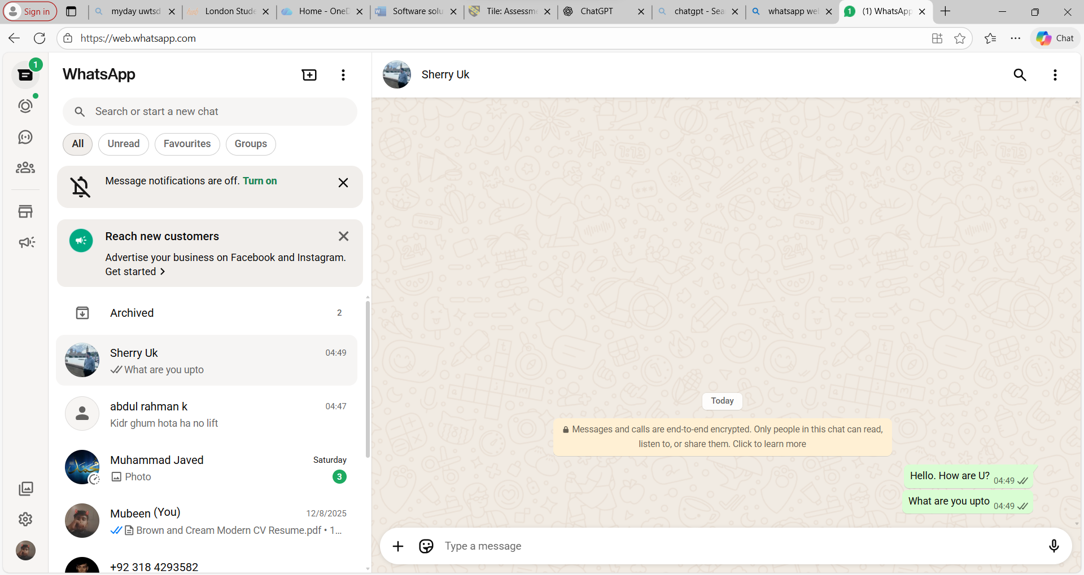
Description: Explain that WhatsApp Web allows instant messaging between contacts, supports emojis, images, and voice notes, making it a popular communication tool for businesses and individuals.

Collaboration Application: Google Drive

Step 1:
I uploaded a file from my computer to my drive
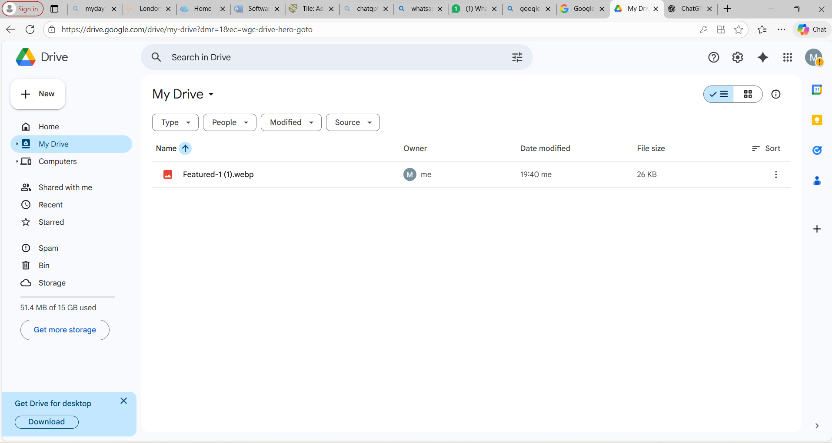
Step 2:
I shared the file ( link ) to one of my friends via email
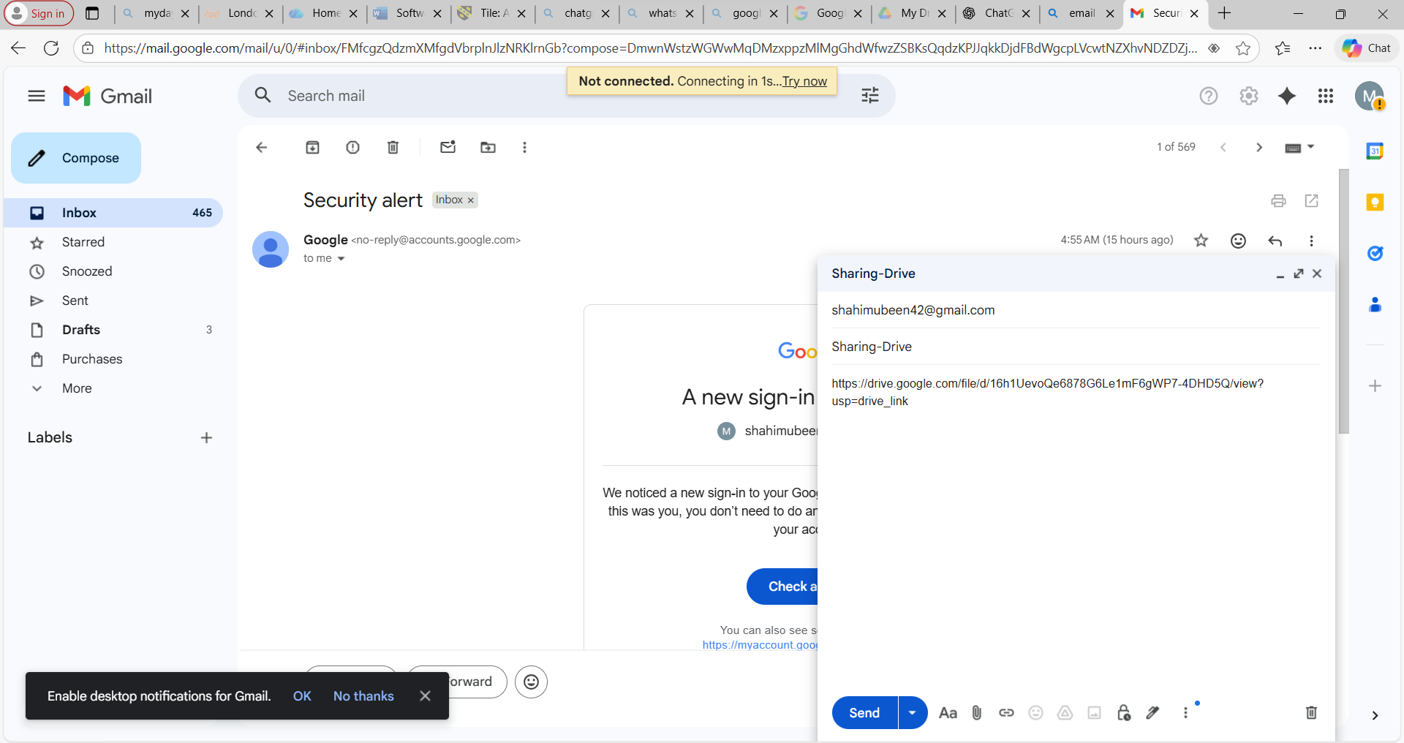

References

Bibliography

[1] | Microsoft, “Microsoft Word – Overview,” Microsoft, [Online]. Available: https://www.microsoft.com/en-us/microsoft-365/word. [Accessed 10 12 2025].
[2] | Wix.com Ltd., “Wix.com – Free Website Builder | Create a Website Today,” Wix.com Ltd., [Online]. Available: https://www.wix.com. [Accessed 26 November 2025].
[3] | Shopify, “Shopify Admin – Dashboard,” 10 January 2025. [Online]. Available: https://admin.shopify.com/store/. [Accessed 10 december 2025].
[4] | Iris Reading, “Mind Mapping: What It Is and How It Helps You Learn Faster,” Iris Reading, 2023. [Online]. Available: https://irisreading.com/mindmap/. [Accessed 26 11 2025].
[5] | Microsoft, “Microsoft Excel – Overview,” Microsoft , [Online]. Available: https://www.microsoft.com/en-us/microsoft-365/excel. [Accessed 10 12 2025].
[6] | Microsoft, “Microsoft Office – Overview,” Microsoft, [Online]. Available: https://www.microsoft.com/en-us/microsoft-365. [Accessed 10 12 2025].
[7] | MICROSOFT, “Microsoft PowerPoint – Overview,” MICROSOFT, [Online]. Available: https://www.microsoft.com/en-us/microsoft-365/powerpoint. [Accessed 10 12 2025].
[8] | M. Corporation, “Microsoft Teams features,” 2024. [Online]. Available: https://www.microsoft.com/en-us/microsoft-teams/group-chat-software. [Accessed 5 12 2025].
[9] | I. Slack Technologies, “Slack features overview,” 2024. [Online]. Available: https://slack.com/features. [Accessed 15 12 2025].

