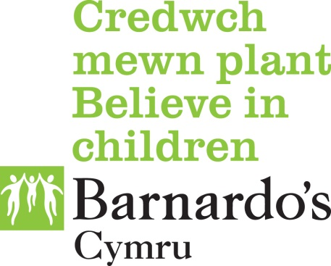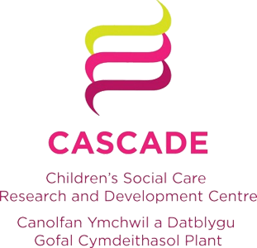

GWELLA PROJECT

Year 1

Aim: To reduce the risk of vulnerable children and young people experiencing Child Sexual Exploitation (CSE) or demonstrating Sexually Harmful Behaviour (SHB), through the development of a prevention model for use in Social Care, in order to improve the wellbeing of children and young people and respond to the Social Services and Wellbeing Act (SSWA) requirements.

Project rationale

There is a strong case for targeting children exposed to trauma with evidence based interventions in childhood and early adolescence to prevent the risk of sexually harmful behaviour or abuse through child sexual exploitation in later adolescence. There is also a need to support local authorities and other agencies to equip them in readiness for the SSWA requirements by developing a more informed approach to safeguarding practice with vulnerable adolescents before their risks are escalated to the point at which CSE or SHB manifest themselves as the outcomes of vulnerabilities: ‘If we do not recognise and work with adolescent agency and choice, it will remain a potent force in their various vulnerabilities’ (SSWA 2014).

Current response comes at a time when children and young people have been identified for their behaviour to others or have experienced sexual exploitation and when such historic factors of abuse and trauma have not been recognised and reconciled. Children and young people are referred to our Taith Service because of concerns around sexually harmful behaviour following a second or third incident of concern. It is common for no work to have been undertaken with the child or young person following the first or second incident of concern and before the third incident. Similarly, in the year ending 31st March 2015, a total of 515 SERAF forms were shared with our Seraf Service and 76% of these were
assessed as at significant risk of CSE. We know that pressure on resources means that very few multi-agency strategy meetings are held in relation to children and young people assessed as at moderate risk of CSE (in line with the All Wales CSE protocol) so that preventative work can be undertaken. Table 1 evidences the abuse histories of Taith and Seraf service users:

Table 1
 | Taith (SHB) | Seraf (CSE) | Child Protection Register
Exposure to domestic abuse | 62% | 43% | 21%
Reported sexual abuse | 40% | 29% | 7%
Reported physical abuse | 38% | 32% | 16%
Reported emotional neglect | 55% | 51% | 38%

This project will support the early identification of risk to CSE and SHB, through establishing risk indicators and required responses according to the appropriate level of need. It will develop a good practice solution-based approach for responding to victims of childhood trauma.

Research element

Children’s Social Care Research and Development Centre (CASCADE) at Cardiff University

The hypotheses:

1. That there is a link between childhood trauma, child sexual exploitation and sexually harmful behaviours.
2. That support for a child in their early years will reduce the likelihood of experiencing abuse through sexual exploitation, and/or displaying sexually harmful behaviours.

Overarching research questions

The research will aim to answer the following two questions:

RQ.1: What is the relationship between childhood trauma, child sexual exploitation and sexually harmful behaviours?
RQ.2: What approaches and interventions are successful in prevention and intervention work with children and young people who have experienced childhood trauma and about whom there are concerns regarding sexual behaviour?

These will be addressed through the following four areas of research and knowledge generation:

1. Literature review:
Aim: Undertake a scoping review of international evidence on the relationship between childhood trauma and CSE and SHB

- What are the parameters of the research in this field?
- What are the key publications?

2. Service mapping:
Aim: Service map the current processes, service offer and workforce capacity across Welsh regions, in relation to identification and responses to children who have experienced trauma and adolescents exhibiting risky sexual behaviour

- What provision for responses are available for children (4-12) and young people (13-18) who have experienced (i) childhood trauma and (ii) about whom there are concerns regarding sexual behaviours?
- What broader wellbeing interventions and projects exist for children and young people, which are deemed as relevant to addressing childhood trauma?
- How are children and young people who have experienced childhood trauma or about whom there are concerns regarding sexual behaviours identified as being in need of support?

3. Systematic mapping of interventions:
Aim: Conduct a systematic mapping of interventions with children who have experienced trauma and adolescents displaying risky behaviours

Develop a comprehensive ‘map’ of all available literature relating to interventions, responses and approaches to working with ‘at risk’ children and young people – including prevention approaches. This review of the literature will:

- make a distinction between children (4-12) and young people (13-18)
- include trauma models, restorative approaches, and strengths and risk-based approaches
- compare identified interventions and approaches to those being used in Wales, as identified through the service mapping.

4. Quantitative research:
Aim: Interrogate data held by the Barnardo’s Taith (SHB) and Seraf (CSE) Services, making an original contribution to existing knowledge

To conduct empirical research to respond to the two research questions, and provide a layered analysis for the research elements of the project. In addition, the research will provide information on the following:

- Who is referred?
- What do children and young people get referred for?
- What has been the trajectory of concern?
- What happens to children and young people after referral and intervention?

The practice element

Barnardo’s project delivery

A dedicated project team will be put in place and an allocated Programme Manager for Children’s Services within Barnardo’s Cymru with management responsibilities and expertise for the Seraf Service (CSE) and the Taith Service (SHB) will oversee the outcomes of the project.

Six project practitioners (social worker or equivalent) have been recruited on a regional footprint synonymous with the Regional Safeguarding Children Boards in Wales. These posts will be trained, supervised and managed by Barnardo’s.

There needs to be a clear relationship to support communication between the project, the regional Consultant Social Workers, the Regional Safeguarding Children Board for the region that they will cover, and local authorities.

Gwella aims to utilise the safeguarding boards in order to ensure that the project can extend its reach across Wales. From our relationships with key agencies across Wales, we understand that they face great pressure in finding effective ways of working with children and young people who are at risk of CSE, who display SHB and/or are displaying concerning risk taking behaviours. We hope that Gwella can provide an evidenced based solution for these issues.

In year 1 of the project, each Gwella practitioner is offered to the safeguarding board as a resource to support the board in delivering its key objectives in relation to CSE and SHB by undertaking the following functions:

- Reviewing the current processes in place in each board for identifying and responding to children at risk of CSE or displaying SHB.
- Supporting the implementation of the CSE Action Plan for each Safeguarding Board.

- Providing advice and support for practitioners working with a child or young person who is at risk of CSE or displaying SHB.

We hope that by utilising the practitioners in this way they will become accustomed to the ways of working locally and able to make the necessary contacts in order to achieve buy-in from the board and also to ensure dissemination of learning in years 2 and 3.

Outcomes

The principal aim of the project will be to build capacity in, and provide an evidenced practice model for, the multi-agency workforce that work with children, young people and their families so that they:

- are equipped to identify and respond to childhood trauma and abuse at the earliest opportunity to reduce the risks of CSE or SHB later in childhood/adolescence
- can respond to risky behaviours in adolescents in a way which prevents increased risks of CSE and SHB
- can identify when referral to more specialist services is appropriate.

Ceri Evans
Gwella Programme Manager
Barnardo’s Cymru
Neath Office
19-20 London Road
Neath
SA11 1LE
: ceri.evans@barnardos.org.uk
: 07971 485688

Gemma Bryant
Consultant Social Worker
Gwella Project
Barnardo’s Cymru
In partnership with Western Bay Safeguarding Children Board

01639 620771

gemma.bryant@barnardos.org.uk

