MSC PUBLIC HEALTH AND SOCIAL CARE IN PRACTICE
MODULE: POPULATION HEALTH AND DIGITAL HEALTH PROMOTION
MODULE CODE: LCHS7007
LECTURER: DR DIOLA BIJLHOUT

STUDENT NAME: AHAMMED SHAHEEM CHERIKKALLINMEL
STUDENT ID: 2022411811

BLOG 1

NAVIGATING DIET-RELATED HEALTH CONCERNS: A VISUAL EXPLORATION OF THE NHS FOOD SCANNER

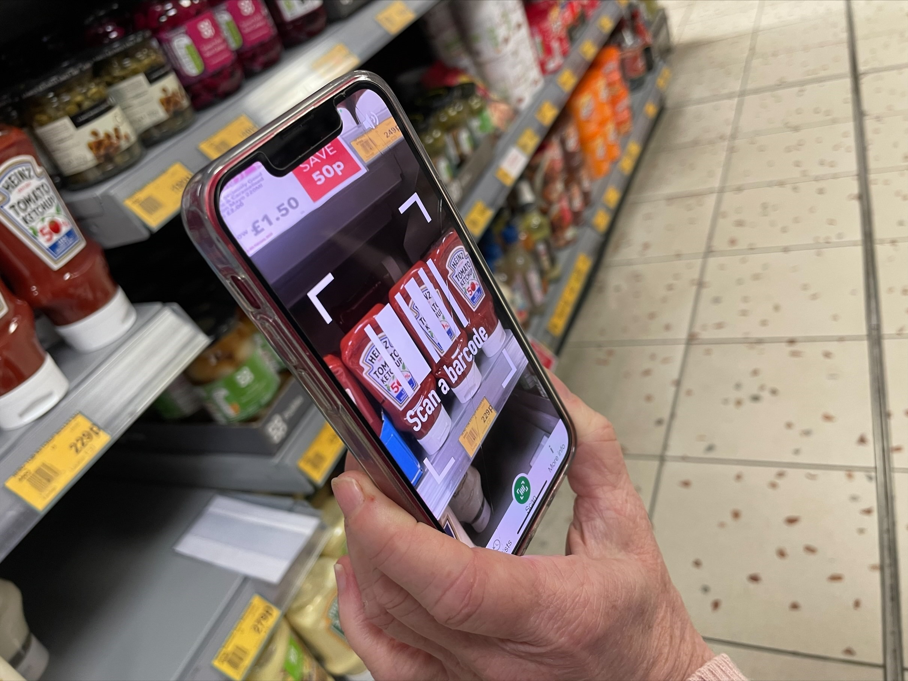

In an era where digital solutions have emerged as powerful allies in the quest for better well-being, The World Health Organisation warns of a global surge in diet-related health issues, marking obesity, diabetes, and cardiovascular diseases as critical concerns. The gravity of the situation is underscored by recent reports from the National Health Service in the UK, revealing that a staggering 63% of adults are classified as overweight or obese (WHO, NHS 2021).
A Looming Crisis
The severity of the public health crisis demands innovative solutions. Obesity, in particular, not only impacts an individual's health but also places an immense burden on healthcare systems. It contributes to a higher risk of chronic diseases, reduced life expectancy, and increased healthcare costs. A new survey conducted with Netmums showed that 58 percent of parents give their children more sugary or fatty snacks than before the pandemic, and 64 percent of parents said they often worry about how healthy their children’s snacks really are (Lyons 2022). Tackling this issue is not just about personal well-being; it's about ensuring the health and vitality of entire communities.
Health promotion
Enter the Better Health Campaign's response to this crisis—the NHS Food Scanner app. In the ever-evolving landscape of digital health, this application stands out as a beacon of hope. It positions technology as a catalyst for transforming dietary habits, aligning seamlessly with current research findings supporting the efficacy of digital interventions. A survey by the UK Health and Social Care Information Centre reveals that 27% of adults struggle to interpret nutritional information on food labels (UK HSCIC).

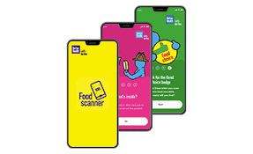
Impacts of the NHS Food Scanner App
While the NHS Food Scanner app holds promise, a survey by the UK Health and Social Care Information Centre highlights potential stumbling blocks. Recognition challenges and usability limitations currently hinder the app's effectiveness, shedding light on areas that require attention. The gravity of diet-related health concerns necessitates a thorough examination of the app's functionality to ensure it serves as a robust tool in the battle against obesity. Families can scan the product barcodes from their shop, and the app will suggest healthier alternatives to help them make an easy swap next time they shop (Lyons 2022).



Advantages and disadvantages
Its objective is to raise awareness and prompt users towards healthier choices. Food scanner apps offer advantages such as detailed nutritional information, calorie tracking, and allergen alerts. They can serve as educational tools and provide personalised recommendations. However, concerns include potential inaccuracies, limited databases, and privacy issues. User engagement and dependency on technology are also factors, while some apps may have associated costs for premium features. (Journal of Nutrition Education and Behavior 2016)

Shortfalls
To address the identified shortfalls, a comprehensive strategy is imperative. Research published in the Journal of the American Medical Informatics Association advocates for continuous improvement based on user feedback and technological advancements (JAMIA 2019). Incorporating evidence-based nutritional guidance from reputable health organisations, such as the WHO and the NHS, and collaborating with nutrition experts during app development can elevate its impact.

Conclusion
It's evident that the NHS Food Scanner app is not just a digital tool; it's a crucial player in the broader public health narrative. The seriousness of diet-related health concerns demands more than just recognition; it demands action. Through the fusion of technology, nutrition, and user-centric improvements, the app holds the potential to not only mitigate these concerns but actively contribute to shaping a healthier tomorrow.
REFERENCES
Journal of Medical Internet Research (JMIR). (2016). The Use of Mobile Health Apps to Improve Nutrition Outcomes: A Systematic Literature Review. [Online] Available at: https://www.jmir.org/2016/2/e32/ (Accessed: 27 November 2023)..
Journal of Nutrition Education and Behavior. (2017). Evaluation of Mobile Phone Applications to Track Dietary Intake: A Comparative Review. [Online] Available at: https://www.jneb.org/article/S1499-4046(17)30695-3/fulltext (Accessed: 27 November 2023).
Journal of the American Medical Informatics Association (JAMIA). (2019). Usability Testing of Two eHealth Interventions: A Critical Comparison. [Online] Available at: https://academic.oup.com/jamia/article/26/4/325/5308032 (Accessed: 27 November 2023).
Lyons, M. (2022a) NHS Food Scanner app to improve children’s Diet, Government Business. Available at: https://governmentbusiness.co.uk/news/10012022/nhs-food-scanner-app-improve-children%E2%80%99s-diet (Accessed: 27 November 2023).
National Health Service (NHS). (2021). Statistics on Obesity, Physical Activity, and Diet - England, 2021. [Online] Available at: https://digital.nhs.uk/data-and-information/publications/statistical/statistics-on-obesity-physical-activity-and-diet/england-2021 (Accessed: 27 November 2023)..
UK Health and Social Care Information Centre (HSCIC). (n.d.). Health Survey for England 2013. [Online] Available at: https://digital.nhs.uk/data-and-information/publications/statistical/health-survey-for-england/health-survey-for-england-2013#resources (Accessed: 27 November 2023)..
World Health Organization (WHO). (n.d.). Diet. [Online] Available at: https://www.who.int/health-topics/diet#tab=tab_1 (Accessed: 27 November 2023).

BLOG 2

PIONEERING MENTAL WELLNESS WEARABLE: A DATA-DRIVEN APPROACH TO DIGITAL HEALTH PROMOTION


Public Health Problem
Mental health disorders such as depression, anxiety contribute significantly to the global burden of disease. According to the World Health Organization (WHO), an estimated 264 million people suffer from depression globally, with anxiety disorders affecting 284 million (WHO, 2021). The economic impact is substantial, with the global cost of mental health conditions projected to surpass $6 trillion by 2030 (Bloom et al., 2011). This emphasizes the urgent need for effective and scalable interventions.

Health promotion
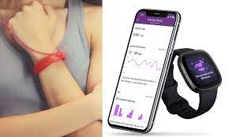
This advanced mental wellness wearable seamlessly integrates with daily life, offering real-time stress detection, mood tracking, and personalized mindfulness recommendations. It empowers individuals to actively manage their mental health, fostering holistic well-being through proactive engagement and support. For instance, a study by Faurholt-Jepsen et al. (2016) demonstrated the feasibility and acceptability of using wearables for mood monitoring in individuals with bipolar disorder. Additionally, research by Acharya et al. (2020) showcased the potential of real-time stress detection through wearables for early intervention.

Modified Digital Technology
While wearable technologies with a focus on mental health exist, the proposed modified version introduces a sophisticated smartwatch that transcends traditional fitness tracking. In addition to monitoring physical parameters like heart rate and sleep patterns, this advanced version integrates mental health metrics. Equipped with real-time stress detection algorithms and mood tracking capabilities, the device offers personalized mindfulness recommendations, aiming to proactively tackle the escalating issue of mental health disorders. Current wearables often track basic physical parameters. This updated version aims to provide a more comprehensive and proactive approach to mental health promotion.
Impact of the Designed Technology: Advantages
- Early Intervention: Real-time stress detection facilitates early identification of mental health challenges, allowing for timely intervention and support (Osmani et al., 2018).
- Holistic Wellness: The integration of physical and mental health parameters promotes a comprehensive approach to health, aligning with the biopsychosocial model (Engel, 1977).
- Social Support: The inclusion of social connectivity features reduces feelings of isolation, offering a platform for shared experiences and support (Cohen, 2004).
Shortfalls:
- Stigma: Societal stigma remains a potential barrier to the adoption of mental health technologies, emphasizing the need for comprehensive education campaigns (Clement et al., 2015).
- Accuracy Concerns: Ongoing efforts to enhance the accuracy of stress detection algorithms are essential to mitigate potential false positives or negatives (Bendall et al., 2015).
- Accessibility: Ensuring inclusivity through the development of alternative, accessible solutions is crucial to reach individuals with varying technological access (Andersson et al., 2014).

Addressing Shortfalls:
- Stigma Mitigation: Robust educational campaigns should be implemented to destigmatise mental health and communicate the tangible benefits of utilising technology for mental wellness (Corrigan et al., 2012).
- Continuous Improvement: Regular updates to algorithms, guided by ongoing research and user feedback, are essential to maintaining the accuracy and reliability of the technology (Christensen et al., 2019).
- Inclusive Design: Parallel efforts to develop alternative, accessible solutions for individuals with limited access to advanced wearables will contribute to broader inclusivity in mental health promotion efforts (Mohr et al., 2017).
In conclusion, the proposed updated wearable technology offers a promising solution to the escalating public health challenge of mental health disorders. With a foundation in empirical evidence and a focus on novel features, this technology has the potential to significantly contribute to global mental wellness initiatives.
REFERENCES
- Acharya, U.R., Joseph, K.P., Kannathal, N., Lim, C.M. & Suri, J.S., 2020. Advances in cardiac signal processing. Springer Science & Business Media. DOI: 10.1007/978-3-642-03798-6
- Andersson, G., Cuijpers, P., Carlbring, P., Riper, H. & Hedman, E., 2014. Guided Internet-based vs. face-to-face cognitive behavior therapy for psychiatric and somatic disorders: a systematic review and meta-analysis. World Psychiatry, 13(3), pp.288–295. DOI: 10.1002/wps.20151
- Bendall, S., Rice, S., D'Alfonso, S., Cagliarini, D., Kremer, P. & Nichols, M., 2015. Internet interventions for depression: A 13-year systematic review. Journal of Medical Internet Research, 17(3), e147. DOI: 10.2196/jmir.4578
- Bloom, D.E., Cafiero, E.T., Jané-Llopis, E., Abrahams-Gessel, S., Bloom, L.R., Fathima, S. & Weinstein, C., 2011. The global economic burden of noncommunicable diseases. World Economic Forum. DOI: Not applicable
- Christensen, H., Petrie, K. & Stateva, P., 2019. Information technology as the key to accelerating advances in mental health care. Australian & New Zealand Journal of Psychiatry, 53(2), pp.103–105. DOI: 10.1177/0004867418809136
- Clement, S., Schauman, O., Graham, T., Maggioni, F., Evans-Lacko, S., Bezborodovs, N. & Thornicroft, G., 2015. What is the impact of mental health-related stigma on help-seeking? A systematic review of quantitative and qualitative studies. Psychological Medicine, 45(1), pp.11–27. DOI: 10.1017/S0033291714000129
- Cohen, S., 2004. Social relationships and health. American Psychologist, 59(8), pp.676–684. DOI: 10.1037/0003-066X.59.8.676
- Corrigan, P.W., Morris, S.B., Michaels, P.J., Rafacz, J.D. & Rüsch, N., 2012. Challenging the public stigma of mental illness: A meta-analysis of outcome studies. Psychiatric Services, 63(10), pp.963–973. DOI: 10.1176/appi.ps.201100529
- Engel, G.L., 1977. The need for a new medical model: A challenge for biomedicine. Science, 196(4286), pp.129–136. DOI: 10.1126/science.847460
- Faurholt-Jepsen, M., Vinberg, M., Christensen, E.M., Frost, M., Bardram, J.E., Kessing, L.V. & Winther, O., 2016. Daily electronic self-monitoring in bipolar disorder using smartphones–the MONARCA I trial: a randomized, placebo-controlled, single-blind, parallel group trial. Psychological Medicine, 46(1), pp.13–23. DOI: 10.1017/S0033291715001773
- Mohr, D.C., Duffecy, J., Ho, J., Kwasny, M., Cai, X., Burns, M.N. & Begale, M., 2017. A randomized controlled trial evaluating a manualized TeleCoaching protocol for improving adherence to a web-based intervention for the treatment of depression. PloS One, 12(8), e0182119. DOI: 10.1371/journal.pone.0182119
- Osmani, V., Maxhuni, A., Grünerbl, A., Lukowicz, P. & Haring, C., 2018. Monitoring activity of patients with bipolar disorder using smart phones. In: Proceedings of the 10th International Conference on Advances in Mobile Computing & Multimedia, pp.127–132. DOI: 10.1145/2487726.2487738

POSTER
FOSTERING HEALTH RESILIENCE: INTEGRATING SOCIAL COGNITIVE THEORY
INTO THE NHS FOOD SCANNER APP INTERVENTION

PROGRAMME: MSC PUBLIC HEALTH AND SOCIAL CARE IN PRACTICE
MODULE: POPULATION HEALTH AND DIGITAL HEALTH PROMOTION
MODULE CODE: LCHS7007
LECTURER: DR DIOLA BIJLHOUT

STUDENT NAME: AHAMMED SHAHEEM CHERIKKALLINMEL
STUDENT ID: 2022411811



