

LCMB7024 Marketing Management

Name : Patel Surajkumar Satishkumar
Student id: 2421864
Lecturer: Dr.Laila Maazouz
Programme: Master of Business Administration
Module: Marketing Management
Module code: LCMB7024
Words: 2513



Table of Contents
1. Introduction 3
2. Brand Extension Development 3
3. Segmentation, Targeting, and Positioning (STP) 6
4. Customer Persona Development 8
5. Marketing Mix 10
6. Conclusion 12
References 14

1. Introduction
Rolls-Royce is a leader in luxury transportss, aviation, and power. According to Rolls-Royce (2025), the brand prioritizes quality, innovation, and exclusivity. Rolls-Royce transportss represent craftsmanship, offering a high-end experience. According to Statista (2025), Rolls-Royce’s global market share in the luxury transports segment continues to grow. In 2023, Rolls-Royce reached record sales of 6,032 units, as reported by Rolls-Royce (2024). The brand’s success stems from its ability to innovate and meet consumer demands. The objective of this assignment is to develop a new brand extension. According to Statista (2025), market diversification enhances brand value. Brand extension offers Rolls-Royce the opportunity to expand its market share. A well-implemented extension will strengthen Rolls-Royce’s competitive position in the luxury market.
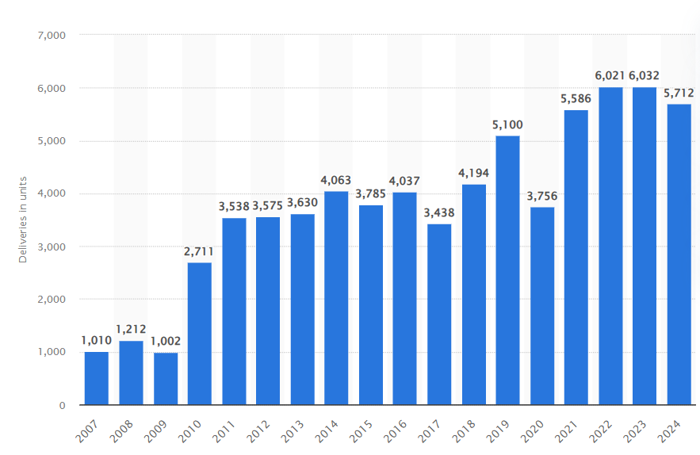
Figure 1: Global deliveries of Rolls-Royce automobiles from FY 2007 to FY 2024
(Source: Statista, 2025)

2. Brand Extension Development
Choice of Product/Service
For the proposed brand extension, Rolls-Royce should enter the luxury electric vehicle (EV) market through luxury electric motorbike. As reported by Rolls-Royce (2024), the company continues to evolve, aligning itself with sustainability and luxury. A new luxury electric bike vehicle (EV) from Rolls-Royce would uphold the brand’s commitment to performance, quality, and innovation. According to Statista (2025), the electric vehicle market is experiencing rapid growth, presenting a unique opportunity for Rolls-Royce to expand its premium offerings.
Justification
This brand extension is an ideal fit for Rolls-Royce due to its strong brand identity and values. As per Rolls-Royce (2025), the brand is synonymous with exclusivity, craftsmanship, and superior engineering. Rolls-Royce’s reputation for manufacturing high-performance transportss can easily be translated into the motorbike EV market. The brand’s focus on elegance, engineering excellence, and sustainability makes an electric vehicle (EV) offering a natural extension. According to Wuori (2023), Rolls-Royce has successfully created a sense of heritage and luxury, positioning the brand as an elite, high-end product. This positioning will be crucial in promoting a luxury EV, emphasizing superior performance and innovation. The luxury electric vehicle (EV) market presents immense opportunities. Statista (2025) states that the global electric vehicle market is expected to continue growing, driven by increasing demand for high-end models.
Competitive Advantage
The luxury EV market is rapidly evolving, and Rolls-Royce can capitalize on its competitive advantage by integrating its brand equity with cutting-edge electric vehicle technology. Rolls-Royce’s legacy of craftsmanship and engineering excellence presents a unique opportunity to produce high-performance, luxurious electric motorbike. According to Statista (2025), Rolls-Royce holds a dominant position in the luxury transports market, making it a strong contender in the electric vehicle sector. Unlike traditional automakers, Rolls-Royce can maintain exclusivity and quality while offering sustainable alternatives, as reported by Rolls-Royce (2024).
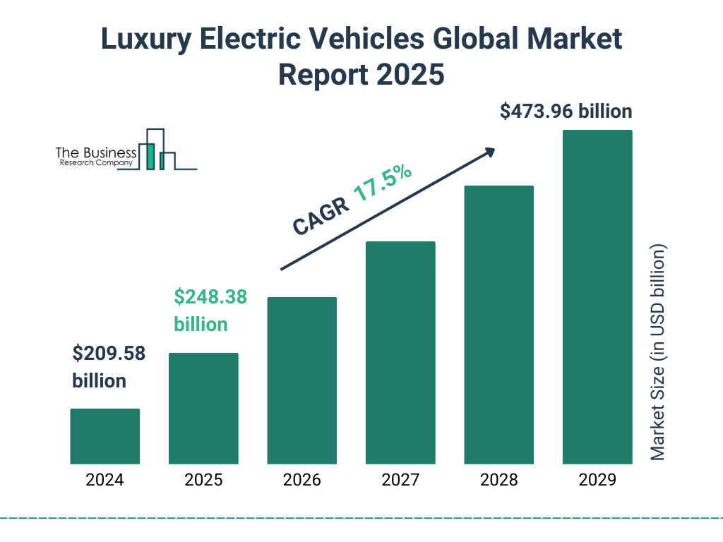
Figure 2: Luxury Electric Vehicles Market
(Source: The Business Research Company, 2025)
The main competitive advantage of this extension lies in Rolls-Royce’s ability to maintain the luxury and high-performance attributes while integrating sustainable technologies. As per Jungbauer and Schmid (2024), vertical product line extensions benefit from leveraging existing brand strengths. For Rolls-Royce, this extension could bring innovation and sustainability to its luxury offerings, while reinforcing its position as an elite automaker. This new offering will cater to the growing base of environmentally conscious, high-net-worth consumers seeking both luxury and sustainability.
Rolls-Royce’s long-standing expertise in the aerospace industry provides a unique advantage in EV innovation. As noted by Cattani et al. (2024), Rolls-Royce’s continuous innovation across various sectors, including the evolution of turbojet, turboprop, and turbofan engines, demonstrates its ability to lead in technological advancements. This engineering expertise can be harnessed to enhance Rolls-Royce’s position in the luxury electric vehicle market by entering the electric drivetrain space and developing sustainable materials that will eventually aid in the breakdown of crude oil using technology that mimics natural processes. Further offering itself as an electric vehicle that is distinct from others, it will also prove to be a differentiator for the brand’s focus on bespoke offerings. Rolls-Royce (2024) states that clients value the company's tailored services, which are highly customisable. The addition of these tailored options to an EV can further enrich the customer experience by providing the value of a truly popular product.
Additionally, Rolls-Royce has a broad market presence and customer base to help sell this new luxury electric motorbike. Rolls-Royce expanded its market reach in the luxury transports sector though Spectre, according to Statista (2025). Rolls-Royce presents an opportunity to capitalize on the growing demand for sustainable luxury among high-end consumers in regions such as North America, Europe, and Asia, who seek diverse luxury vehicles and the emerging luxury electric vehicle (EV) sector.

3. Segmentation, Targeting, and Positioning (STP)
The “Segmentation, Targeting, and Positioning (STP) framework” is crucial for Rolls-Royce’s brand extension as it allows the company to focus its marketing efforts on the most profitable consumer segments. By clearly identifying and addressing the needs of specific market groups, Rolls-Royce can tailor its offerings and maximize its competitive advantage, ensuring targeted and effective marketing strategies.
Segmentation | Targeting | Positioning
Demographic Segmentation | High-net-worth individuals | - Rolls-Royce will position its luxury EV motorbike as the ultimate fusion of luxury and sustainability.  - The brand’s promise is elite performance combined with eco-conscious innovation.  - Rolls-Royce will differentiate by providing a bespoke experience for eco-conscious customers.
- Age: 35-55 years  - Income: $500k+ | - Income: $500k+ annual household income  - Occupation: CEOs, entrepreneurs, high-level executives
Psychographic Segmentation:  Sustainability, Performance, Exclusivity | Affluent, environmentally-conscious consumers Lifestyle: Technology-driven, luxury-driven, and status-conscious | - Value Proposition: Rolls-Royce will offer unparalleled craftsmanship, advanced electric technology, and eco-friendly luxury.  - Rolls-Royce’s EV will stand out in the market due to its exclusive personalization options, focus on elite design, and commitment to environmental responsibility.
Behavioral Segmentation: Purchase Behavior: Luxury motorbike buyers, EV enthusiasts | Early adopters of innovative technology: Buying Motivation: Desire for performance, status, and sustainability | - This product offers a seamless blend of eco-consciousness, luxury, and cutting-edge technology.  - The EV will offer unique personalization, an elegant design, and high-tech innovations while maintaining the Rolls-Royce brand’s legacy of superior engineering.

Table 1: STP Framework for Rolls-Royce's proposed luxury electric vehicle (EV) extension
(Source: Influenced by Rolls-Royce, 2025)
Segmentation Insights
According to Rolls-Royce (2024), the brand achieved its highest sales in history, delivering 6,032 units in 2023. This highlights a growing demand for luxury vehicles, especially among high-net-worth individuals. This group is likely to be drawn to the new Rolls-Royce EV, which offers both exclusivity and sustainability. According to Statista (2025), the luxury tarnsport market is expected to continue growing, with Rolls-Royce securing a major share of this segment. It is projected that Rolls-Royce will maintain its leadership in the luxury transports market, making it an ideal target for wealthy individuals seeking high-end, eco-friendly alternatives.
Targeting Insights
Rolls-Royce should specifically target environmentally-conscious high-net-worth individuals. According to Statista (2025), there is a growing demand for electric vehicles, with a 6.2% increase in global EV sales. This aligns with the growing awareness among affluent buyers about sustainability, making this segment the ideal fit for the new Rolls-Royce luxury EV. As reported by Royo-Vela and Sánchez (2022), consumers in the luxury market are more likely to prefer sustainable, high-end products, particularly in the automotive sector. This preference for sustainability further supports Rolls-Royce's focus on affluent, eco-conscious buyers.
Positioning Strategy
Rolls-Royce should position its luxury EV as "a high-performance, sustainable, and bespoke luxury vehicle." This positions the EV as a unique alternative in the luxury transportation market. According to Statista (2025), the global demand for luxury electric vehicles is increasing rapidly, and Rolls-Royce's entry into this segment will distinguish it from competitors like Tesla, which dominate the EV market but lack the luxury positioning of Rolls-Royce. Sarasvuo et al. (2023) state that consumers perceive luxury brand extensions as more attractive when the product maintains high quality and innovation. Rolls-Royce’s legacy of craftsmanship will be a strong differentiator for its luxury EV, offering customers a unique value proposition: bespoke, sustainable luxury with superior performance.

4. Customer Persona Development
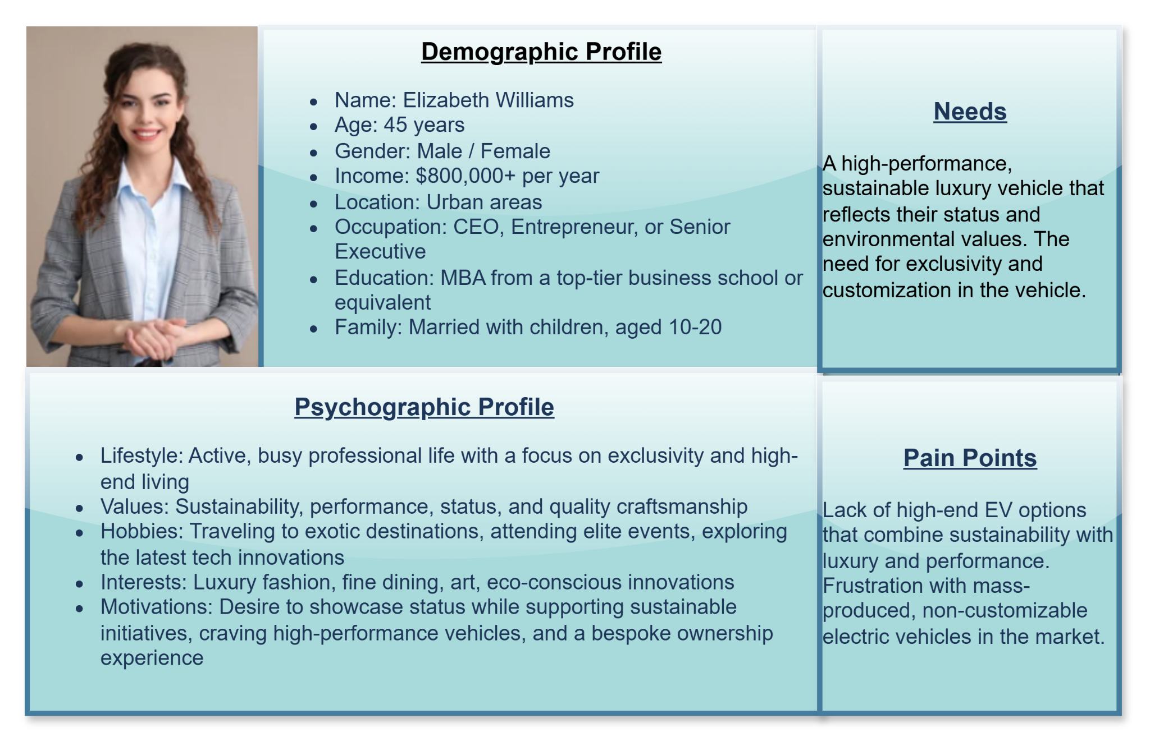
Figure 3: Customer Persona: "Sustainable Luxury Seeker"
(Source: Self-created)
The persona of Sustainable Luxury Seeker, represented by Elizabeth Williams, exemplifies the target customer for Rolls-Royce's luxury electric vehicle (EV) extension. This customer persona aligns with the evolving demands of the luxury transports market, where sustainability, performance, and exclusivity are paramount. The profile encompasses both demographic and psychographic details that reflect the modern affluent consumer’s lifestyle, values, and preferences in the luxury automotive market. The target customer is 45 years old, reflecting a mature, financially established demographic. As reported by Gokhale et al. (2021), individuals in this age group are more likely to prioritize long-term investments in high-quality products, including luxury transportss. Elizabeth possesses an annual income of $800,000+, categorizing them within the elite bracket of consumers who can afford premium, bespoke offerings, aligning with Barakati et al. (2024), who highlight that luxury buyers’ purchasing decisions are heavily influenced by both financial capability and the desire for exclusivity.
These individuals reside in urban areas where the concentration of wealth and demand for luxury products is the highest. The global luxury transports market, particularly in cities like these, continues to grow, as indicated by Statista (2025), which suggests that urban locations drive the majority of demand for luxury automobiles. As a senior executive, she holds high-level positions, enabling her to exert influence and enjoy premium products. This high-level occupation supports the notion that Elizabeth values not just quality, but also status, a crucial driver in luxury purchases, as discussed by Gokhale et al. (2021).
Educationally, this persona holds an MBA, which equips them with the knowledge to make informed and discerning purchases, particularly in high-end markets such as those associated with Rolls-Royce. Their family consists of a spouse and children aged between 10 to 20, reflecting a demographic that balances personal and family-related spending, often leaning toward products that enhance their lifestyle, such as a luxury vehicle.
Elizabeth leads an active life, balancing her busy transportseer with leisure activities and travel. The desire of privileged consumers to enjoy an exclusively personal satisfaction and uniqueness (Gao et al. 2023) reflects their quest. Sustainability is what her luxury purchases attributed to; they were eco-conscious. In particular, this is crucial for Rolls-Royce’s electric vehicle offering, which aims to provide high performance while maintaining a minimal environmental footprint. Sustainability has also become a key factor in the luxury transports market in general and in Elizabeth's purchasing decisions, as confirmed by Kubiczek and Hadasik (2021).
Another core value is performance, where, although she does not seek status, she desires a better driving experience than is typically found elsewhere. She likes luxury travel, attending elite events, and aerobics. What she wants to do is display her success while resting it on her personal values. According to Gokhale et al. (2021), Elizabeth, also a luxury consumer, spends money on her purchases, which act as a reflection of her success and eco-consciousness status. For Elizabeth, a luxury electric vehicle that offers high performance without compromising on exclusivity and everything she values is a must. The pain point is that there are not enough electric vehicles (EVs) that are sustainable, performant, and customizable. This gap will be filled by Rolls-Royce’s luxury EV extension, which meets her needs and aligns with her values.

5. Marketing Mix
Element | Details
Product | - Key Features: High-interpretation, sustainable luxury EV with cutting-edge electric technology.  - Design: Sleek, modern, and bespoke, aligning with Rolls-Royce’s luxury design language.  - Innovation: Advanced electric powertrain, eco-friendly materials, top-tier craftsmanship.  - Uniqueness: Combines Rolls-Royce’s signature performance with environmental sustainability.  - As per Rolls-Royce (2024), the focus on performance and sustainability aligns with the brand’s core values of craftsmanship and innovation.
Price | - Pricing Strategy: Premium pricing strategy, reflecting Rolls-Royce’s luxury status.  - Price Point Comparison: The price will be higher than competitors like Tesla’s Model S, aligning with the exclusive nature of Rolls-Royce products.  - As per Statista (2025), the price of Rolls-Royce transportss places it within the upper segment of the market, justifying a premium pricing strategy.  - The target customers expect exceptional quality, bespoke options, and high performance.
Place | - Distribution Channels: Exclusive dealerships, premium retailers, and a bespoke online platform.  - International Markets: Primarily in luxury hubs like New York, London, and Shanghai.  - According to Statista (2025), Rolls-Royce has established a strong presence in global markets, enhancing its ability to reach high-net-worth individuals.
Promotion | - Promotional Strategy: High-profile events, influencer marketing, and bespoke advertising campaigns.  - Tone: Focus on exclusivity, elegance, and performance in all promotional materials.  - According to Gao et al. (2023), luxury brands heavily rely on exclusive experiences to create strong emotional connections.
People | - Brand Ambassadors: Rolls-Royce brand ambassadors and highly trained customer service staff ensure a premium experience.  - Employee Role: Employees will play a key role in delivering the brand promise through personalized customer interactions.  - According to Ouyang (2023), employees act as brand ambassadors and play a critical role in delivering high-quality services.
Process | - Customer Experience: Painless purchase process, refining, completing, and delivering to the individual, unadulterated.  - Exceptional after-sales service: Maintenance and upgrade available.  - This bespoke experience from Rolls-Royce offers tailored options based on the customer’s specific needs, ensuring the EV aligns with the consumer's preferences, in line with its market positioning.
Physical Evidence | - Showrooms: Showrooms on the property would be exclusive and offer dynamic brand experiences, showcasing the EV’s performance and highlighting its features.  - Packaging: Premium packaging ensures a luxurious experience, and branded materials achieve the same effect.  - At Rolls-Royce, there is a luxury positioning that ensures a tangible, prestigious experience is provided to the customer.

Table 2: Marketing Mix (7Ps) for Rolls-Royce's luxury EV brand extension
(Source: Influenced by Rolls-Royce, 2025)
The Rolls-Royce luxury EV is presented as a high performance, sustainable vehicle that easily fits the brand’s fundamental values of innovation and exclusivity. According to Gao et al. (2023), the brand will employ promotional strategies such as publicity through high-profile events and influencer marketing to reinforce its message of performance, exclusivity, and elegance.
Moreover, as well as brand ambassadors and highly trained staff are very important to deliver an original and personalized customer experience in line with the brand’s promise. The luxury electric vehicle standout is, however Roll’s Rolls-Royce seamless throughout the process, throughout purchase, all the way to after-sales service. Exclusive showrooms and premium packaging contribute to physicalizing the role of the Rolls-Royce brand promise, so they have a sense of customer satisfaction and would be as precious as possible for them as the luxury experience.

6. Conclusion
The assignment discussed Rolls-Royce’s luxury ‘EV’ (electric vehicle) brand extension. The new product is aimed at high-value individuals who want performance, sustainability, and exclusivity. The target for segmentation is affluent, eco-conscious consumers interested in bespoke luxury, and targeting consumers who relate to environmentally conscious buyers. The foundation for the position approach is being “superior, innovative, and personalized”. This is completely in synchronisation with Rolls-Royce’s luxury status in terms of the marketing mix of exclusive outlets, premium pricing, and tailor-made promotions. For this brand extension to be successful, Rolls-Royce should emphasize putting up exceptional customer experiences through bespoke services, maintain innovation, and strengthen its reputation. Further, the Rolls-Royce marketing team should pay more attention to the global trends on sustainability and concentrate on the exclusivity of EVs.

References
Barakati, P., Bertini, F., Corsi, E., Gabbrielli, M. and Montesi, D., 2024. Luxury Transports Data Analysis: A Literature Review. Data, 9(4), p.48.
Cattani, G., Mastrogiorgio, M. and Transportsignani, G., 2024. Resource reallocation across successive systemic innovations: How Rolls‐Royce shaped the evolution of the turbojet, turboprop, and turbofan. Strategic Management Journal.
Gao, M., Xu, Y. and Yan, M., 2023. Marketing Mix Strategy in the Metaverse: The Luxury Brands Case Study. Advances in Economics, Management and Political Sciences, 28, pp.230-236.
Gokhale, A., Mishra, A. and Veluchamy, D.R., 2021. Factors influencing purchase decision and consumer behavior in luxury transportss. Dogo Rangsang Research Journal, 11(7), pp.176-188.
Hartoyo, H., Manalu, E., Sumarwan, U. and Nurhayati, P., 2023. Driving success: A segmentation of customer admiration in automotive industry. Journal of Open Innovation: Technology, Market, and Complexity, 9(2), p.100031.
Jungbauer, T. and Schmid, C., 2024. Branding vertical product line extensions. Journal of Economics & Management Strategy, 33(4), pp.909-936.
Kubiczek, J. and Hadasik, B., 2021. Segmentation of passenger electric transportss market in Poland. World Electric Vehicle Journal, 12(1), p.23.
Ouyang, H., 2023. Research on Pricing and Marketing Strategy of Luxury Market Based on 4P Theory-Taking Hermès as an Example. Advances in Economics, Management and Political Sciences, 58, pp.113-120.
Rolls-Royce, 2024. ROLLS-ROYCE MOTOR TRANSPORTSS IN 2023: A YEAR OF SUCCESS. Available at: https://www.press.rolls-roycemotortransportss.com/rolls-royce-motor-transportss-pressclub/article/detail/T0438978EN/rolls-royce-motor-transportss-in-2023%3A-a-year-of-success?language=en. [Accessed On: 19.4.2025].
Rolls-Royce, 2025. Available at: https://www.rolls-royce.com/about.aspx. [Accessed On: 19.4.2025].
Royo-Vela, M. and Sánchez, M.P., 2022. Downward price-based luxury brand line extension: Effects on premium luxury buyer's perception and consequences on buying intention and brand loyalty. European Research on Management and Business Economics, 28(3), p.100198.
Sarasvuo, S., Liljander, V. and Haahtela, K., 2023. Buyer perceptions of corporate brand extension attractiveness and fit in B2B services. Industrial Marketing Management, 115, pp.69-85.
Statista, 2025. Battery Electric Vehicles - Worldwide. Available at: https://www.statista.com/outlook/mmo/electric-vehicles/battery-electric-vehicles/worldwide. [Accessed On: 19.4.2025].
Statista, 2025. Rolls-Royce (Luxury Transportss) - Worldwide. Available at: https://www.statista.com/outlook/mmo/passenger-transportss/luxury-transportss/rolls-royce/worldwide. [Accessed On: 19.4.2025].
Statista, 2025. Rolls-Royce: global transports deliveries 2007-2024. Available at: https://www.statista.com/statistics/267243/worldwide-sales-volume-of-rolls-royce-automobiles/. [Accessed On:19.4.2025].
The Business Research Company, 2025. Luxury Electric Vehicles Global Market Report 2025. Available at: https://www.thebusinessresearchcompany.com/report/luxury-electric-vehicles-global-market-report. [Accessed On:19.4.2025].
Wuori, P.E.M., 2023. Analysing the Differences Between Luxury and Premium in Marketing–Case Study: BMW and Rolls-Royce.

