

A Pearl in Time Celebration – Report
Nia Moores
2200282
Live Events Project
Deborah Jenkins
Word Count – 3,000

Table of Contents
Introduction 3
Main Body 5
Planning Techniques 5
Market Research 6
Expected Expenditure 7
Risk Assessment 8
Evaluation 9
Limitations 10
Conclusion 10
References 11

Introduction
My group and I are holding an event for the 30th anniversary of the tourism degree at the University of Wales Trinity St David’s. When creating the concept for the event, we took into consideration the 5 W’s. (Goldblatt,1997) This was so, no basic need for the event would be left out. This event will be held for students, on the 21st of February at the Dylan Thomas Centre. I created the name of the event which is “A Pearl in Time Celebration” This is because traditionally pearls are gifted to those celebrating 30 years as pearls represent Purity, honesty and wisdom. (EternityRose) Since in the theme of pearls we decided to create a blue and white theme throughout the event as a nod to under the sea, this is our theme. We have tried to encourage a blue and white dress code for the event. Our event will involve entertainment, drinks and food.

We have also stuck to a formal theme for the event, as this will help tie in the anniversary to stay sophisticated. We will have live entertainment throughout the night including speakers from the degree and also music. We have put together a buffet with the help of the gastronomy students. This lets the university discipline work together and utilise all skills throughout the number of degrees at the university.

The event is taking place on Friday the 21st of February 2025. We decided this day as it is at the end of the week so people can relax and enjoy the event without the idea of university the next day. One of the original dates we choose was Friday the 14th of February, however we believed this would not work as it is valentines day so a lot of people would already have plans in place. Also during this week is the ITT future you event which all students on the tourism degree are taking part in. We have the House Party event on Saturday the 15th of February. So, it is already a very busy week for the Tourism Students.

The event is taking place in the Dylan Thomas Center. This building is part of the University of Wales Trinity St Davids. Here is the home of the student support (UWTSD) however there are some subjects that take place in the venue. We decided this venue would work well, as the gastronomy students are able to help out and gain placement experience, as they spend a lot of time here during lectuers. Since the university pushes for practical learning, this is important that we all work together as students. (UWTSD, Student Placement Protocol) The venue also offers great parking facilities that are normally private but have been made public for our event. (Swansea Council)

The running order of our event will be a 7pm start which will then finish at 11pm. My group and I will be in the venue from 3:30pm to start decorating and setting up, the DJ is planned to start setting up at 5pm so we will be ready for a 7pm start. Our guest speakers will be at 7:30pm then we will carry on with music, food and entertainment for the rest of the night.

The aim of the event is to create an atmosphere where students can mingle and celebrate the degree they are currently on and everyone who has come before them. This is to create the community atmosphere that the degree strides for. I have used smart goals when it comes to the objectives. This is so the goals are easy to understand and have a layout to create better understanding. (Robins )

To make the event a success I have tried to stick to the EMBOK framework. This is the event management body of knowledge; this helps manage the different areas of a successful event. There are five sections including design, administration, marketing, operations and risk. This brings together the theming, finance, social media campaigns, logistics and finally health and safety. (EMBOK )

Main Body

Planning Techniques
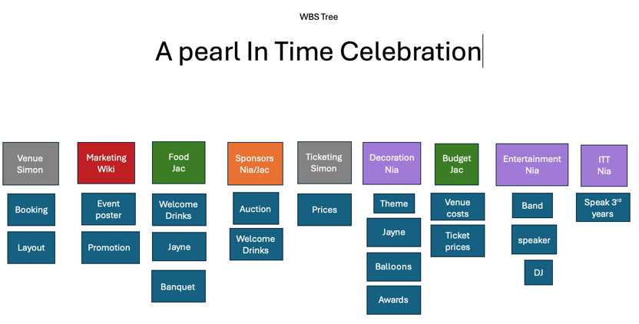
As a group we decided that planning techniques would be a smart way to organise the group work. There are a range of methods that we could of choose but we decided that a work breakdown structure also known as a WBS Tree would be a smart idea of where to start. This creates smoother communication between everyone taking part. (Li et al.)
We organised ours with colours and sections. As it has been found that breaking events into smaller sections allows work to be easily managed. (O’Toole and Mikolaitis, 2002) I was in charge of Decorations, Entertainment and also ITT. I shared responsibility when it came to Sponsors as me and Jac took charge of different sections. Creating different areas allowed us to have better understanding on who we needed to contact regarding different parts of the event. We also colour coded the sections to keep a theme throughout the work. So, I was purple, wik was red and so on.

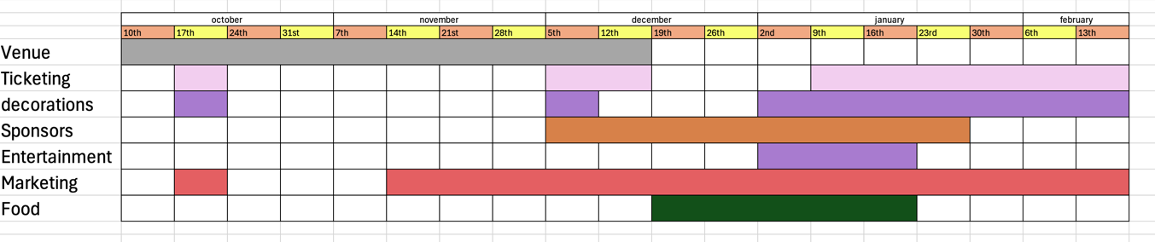
We then continued this colour code system into our Gantt chart, similar to a WBS tree they are used to help communications in projects. However, Gantt charts involve timings for sections of the project to be completed by. (Geraldi and Lechter)
As you can see from the chart our main section is marketing as it has been going on the longest. The difference between the WBS tree and the gantt chart is that I haven’t included ITT this is because we came to a realisation very quickly that it wouldn’t work to include ITT with our event. One of our original plans was to hold the event after the level 6’s ITT event. However, this would have not worked as there is already a lot going on and majority of our customers who are students will be already busy.
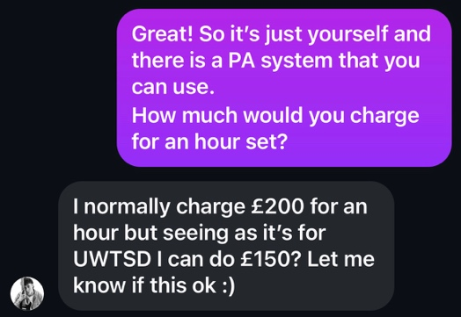
Another thing that didn’t work out like planned is our entertainment. The first plan was to have Brook Fox as a singer as he is a music student within the university and has performed at events run by tourism students in the past. (Fox) The main issue was his pricing, he asked for £150 for an hour set which we seemed unreasonable within our budget. As it was only an hour set, we would have needed to find other entertainment. Even though that was his discounted price.

I have now found a DJ for £140 for a 4-hour set. Which is better value for money as we can have the DJ (Elfyn) for the whole event for the same price as an hour of Brook’s time. I messaged a range of DJ’s before settling for Elfyn this is because I was recommended to get into contact with him. His prices are better suited for our budget compared to majority I contacted.

Market Research
Before marketing our event, we had to do market research to decide who our demographic are. Market research lets the team have a better understanding of who we want to advertise the event to and solve the issues that will appear. (Patino et al.) The demographic for our event are university student within the Swansea area. A market segment for our event is tourism, this is because it is a celebration of the tourism degree. Majority attending will have an interest in tourism and events.

I worked closely with marketing to create a theme and also help with marketing posters. The theme we chose was under the sea so this would need to come through in our marketing. Wik done a good job with this she also made sure everyone had a say, so we all contributed to aspects.

Expected Expenditure
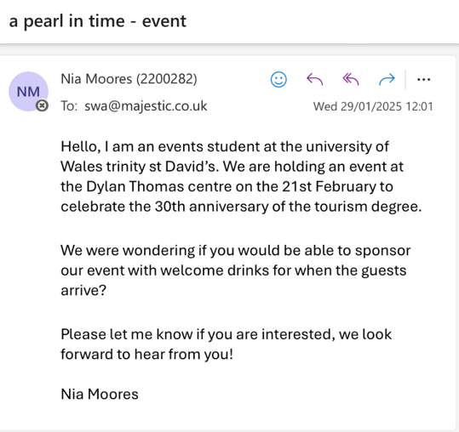
We are holding our event through the university, so a large section of our resources are all coming from the same area. The venue has provided us with staff, security and food this is very helpful as it has taken a lot of pressure of finding external companies. I have contacted a range of external suppliers for different reasons. A large area of people I emailed was for welcome drinks. This unfortunately didn’t go well as people did not want to help us. However, there was a local business in the Swansea area who couldn’t help with free drinks, but they did offer us a discounted price on welcome drinks. (Majestic Wine Merchant)

Decorations I have gathered from a range of locations and stores. The venue are providing table clothes and chair covers however we are decorating and creating the theme and bringing it to life. A lot of our decorations I have decided to make on my own. I have a balloon arch I can use for the event. Also banners and old photographs that will bring back the nostalgic feeling of the last 30 years of the degree.

I have also created awards for best dressed. This was a good idea from the team as guests will be excited to get involved and as there is a prize there is something to work towards. It creates a motive.

Risk Assessment
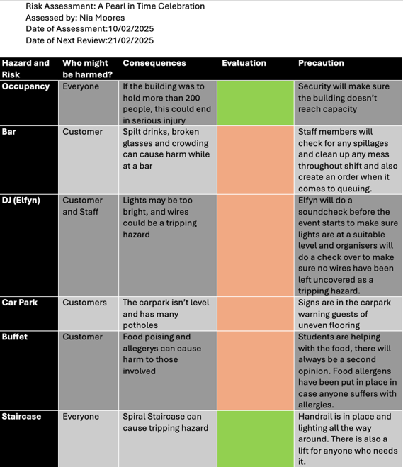
I have created the risk assessment for our event. Risk assessments are a crucial part of running an event. It helps reduce the uncertainty of unknown risks that could appear. It helps to improve understanding of health, safety and security. (R and V.M) After considering the issues at hand and evaluating I decided that the staircase and Occupancy would be the least likely risks. This is because the staircase has all needed facilities in place to create a safe space such as handrails and lighting and also has an alternative elevator. When it comes to occupancy the security are from the venue so will know how to keep everyone safe and what needs to be put into place to stop any issues occurring.

The other risks I have considered as moderate. This is because precaution can be put into place however these things might still appear. An example is the Bar, drinks can be split and cause a mess, as much as the staff try to get around this it’ll still happen and could cause injuries.

Emergency plans will already be in place for the venue such as evacuation points. Legally venues must listen to fire safety laws, this includes clear marked escape routes and a safe meeting point for all staff. We will have a briefing with venue staff on the day to know this information. (Government Digital Service)

When it comes to events there always need to be a contingency plan, this is so the organisers are flexible with whatever situation is thrown at them. (Dover Council) The main issues we came across was the entertainment as our financial sector informed us that brook was not in our budget we had to come together and think other a plan B. This is where I found Elfyn who will DJ for us.

We also had issues when it comes to ticket sales, since our event is on a Friday it seems that a lot of people will be away for the weekend but also this time of year people don’t have the money for luxuries. Events are classified as a luxury when it comes to Maslow’s Hierarchy of needs. (Maslow 370–396) This means this will be the last thing people will pay for when in a money crunch.

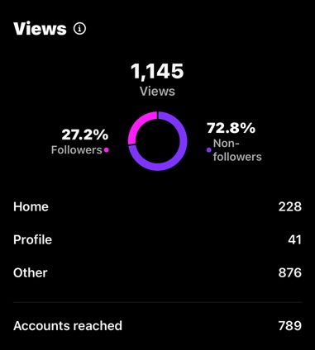
Our goal was to reach 50 tickets otherwise we would unfortunately cancel our event. This led to me helping with the marketing to create a push for ticket sales. If I was the person in charge of marketing I would’ve used SOSTAC to understand the marketing planning to help me understand the situation and reach the goals of 50 tickets. (SOSTAC) We came up with the idea of having a competition. We gave away a ticket to a winner, they needed to help promote the event by tagging friends and also sharing our poster to their story. As you can see from the post insights this post reached 789 people with 72.8% being non-followers. This post was successful in reaching a new audience. (Pearl.In.Time2025)

Evaluation
An event evaluation is the rough idea of the outcome of the event and also the unexpected outcome of the event. While considering ways management can improve in the future. (Getz) The events aim is to provide fun through a themed event for students. This creates a celebration to bring students together and to enjoy a night without the stress of university.

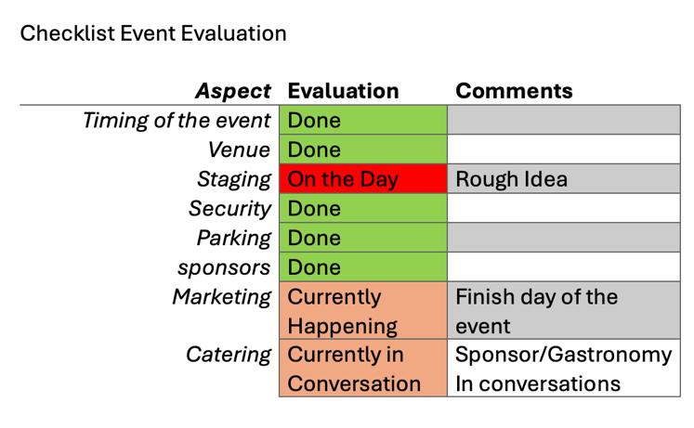
When it comes to the event evaluation, a check list is commonly used to ensure everything has been met and completed before the event. This helps everything stay smooth in the run up. (Almeida) . I have added a traffic light system. Green means completed; Orange is currently underway then Red is on the day. The ones in orange will be completed before the event however my team and I are still in communication with the catering team and the marketing will be taking place until the night before the event.

People also do an evaluation after the event. This can be done from the organisers view but also customers to gather a broader understanding. This helps the hosts to see if the event was successful from both point of views and how it can be better for next time.

Lessons I have learnt from creating this event is that organisation is very important in creating a successful event. If things aren’t organised enough, it will cause a lot of stress. It has been proven that stress can not only lead to short term effects. This could lead to long term events which will have a negative outcome on future events organisers might host. (Updegraff and Taylor) I have also learnt that sometimes people may need help in certain areas. For example, wik needed help with marketing and I listened to what her ideas were and helped her bring them to life. Over all these events have given me an insight to the events sector.

Limitations
Limitations are bound to happen, at the start of this project this happened frequently. There were issues including the venue and struggling to be on the same page as the venue managers which lead to our event changing from a sit-down meal to a buffet. Which has seemed to work a lot better now. When creating events, it is all about adapting. Other limitations faced are dates, this event would have been perfect at the end of the year as this could have been an anniversary event and a celebration of completing this section of the degree. However, we had a time limit with the assignment being due.

If I was to do this event again, I would like to do the social media aspect. I believe I could use my skills to create a better atmosphere and get people engaging with the Instagram account. I also enjoyed thoroughly the parts of marketing that I have helped with.

Conclusion
From going back over the work, we have done within the team. I have come to the conclusion that we have all focused on our own sections very well. I have put a lot of time into messaging DJ’s and sponsors. While also creating different ideas for the decorations. I have worked with the team to put in different viewpoints for new areas of the event to be the best we can. I also feel like I have gained control over the group documents such as the WBS tree, Gantt Charts and also the risk assessment. This was originally meant to be a group effort however I took responsibility as we did not have the time to do it as a group. Hopefully closer to the event we come together as a team and can help each other where necessary. Rather than just working alongside one another.

References
Almeida, Adriano. “Kubik’s Pre-Event & Post Event Checklist.” Kubik, 16 Feb. 2023, thinkubik.com/news/preparing-big-event-pre-event-post-event-checklist/.
Dover Council. “Event Planning: Contingency Planning.” Www.dover.gov.uk, www.dover.gov.uk/Community/EventPlanning/A-Z/ContingencyPlanning.aspx.
EMBOK . 2005.
EternityRose. “The Eternity Rose UK.” The Eternity Rose UK, 2021, www.eternityrose.co.uk/30th-anniversary-gift-themes. Accessed 7 Feb. 2025.
Fox, Brook. “Brook Fox (@Brookfoxmusic) • Instagram Photos and Videos.” Instagram.com, 2020, www.instagram.com/brookfoxmusic?utm_source=ig_web_button_share_sheet&igsh=ZDNlZDc0MzIxNw==. Accessed 10 Feb. 2025.
Geraldi, Joana, and Thomas Lechter. “Gantt Charts Revisited: A Critical Analysis of Its Roots and Implications to the Management of Projects Today.” International Journal of Managing Projects in Business, vol. 5, no. 4, 2012, pp. 578–594. Researchgate, https://doi.org/10.1108/17538371211268889.
Getz, D. “ Event Evaluation: Theory and Methods for Event Management and Tourism. .” Goodfellow Publishers Ltd., 2018.
Goldblatt, J (2006) ‘Special Events: Event Leadership for a New World’ Wiley: New Jersey
Government Digital Service. “Fire Safety in the Workplace.” GOV.UK, 3 Oct. 2012, www.gov.uk/workplace-fire-safety-your-responsibilities/fire-safety-and-evacuation-plans.
Li, Yashuai, et al. “Developing a Quantitative Construction Waste Estimation Model for Building Construction Projects.” Resources, Conservation and Recycling, vol. 106, Jan. 2016, pp. 9–20, https://doi.org/10.1016/j.resconrec.2015.11.001. Accessed 23 Oct. 2019.
Majestic Wine Merchant. Majestic Swansea, 2025, www.majestic.co.uk/stores/swansea.
Maslow, A. H. A Theory of Human Motivation. 1943. Lanham, Start Publishing LLC, 1943, pp. 370–396.
O’Toole and Mikolaitis, 2002
Patino, A, et al. “Social Media’s Emerging Importance in Market Research.” Journal of Consumer Marketing, pp. 233–237.
Pearl.In.Time2025. “(@Pearl.in.time2025) • Instagram Photos and Videos.” Instagram.com, 2025, www.instagram.com/pearl.in.time2025?utm_source=ig_web_button_share_sheet&igsh=ZDNlZDc0MzIxNw==. Accessed 10 Feb. 2025.
R, Zimmerman, and Bier V.M. “Risk Assessment of Extreme Events.” Risk Management Strategies in an Uncertain World, Apr. 2002.
Robins , E.M. “An Instructional Approach to Writing SMART Goals.” Community Worldwide Online Conference., 24 Apr. 2014.
SOSTAC. 1990.
Swansea Council. “Dylan Thomas Centre - Swansea.” Swansea, 2025, swansea.gov.uk/dtc?lang=en. Accessed 7 Feb. 2025.
Updegraff, J.A, and S.E Taylor. From Vulnerability to Growth: Positive and Negative Effects of Stressful Life Events. In Loss and Trauma . Routledge. ed., 2021.
UWTSD. Student Placement Protocol . 2024, www.uwtsd.ac.uk/media/1628/download?attachment.
---. “Student Support & Wellbeing.” University of Wales Trinity Saint David, 17 Dec. 2024, www.uwtsd.ac.uk/study/experience-facilities/student-support-wellbeing.

