
Skills for the Workplace
Module Assignment Submission
Student Name: | Liza Nassrin
Student Number: | 1818727
Module No: | BMSK4006
Module Title: | Part 1 Business Plan

Statement of Confirmation of Authenticity
By the act of making this submission, the student declares that this is the work of the student named above. The work has not, in whole or in part, been knowingly presented elsewhere for assessment, or where assessment has been built on a previous assessment, this has been identified. Where materials have been used from other sources it has been properly acknowledged. If this statement is untrue, the student acknowledges that an assessment offence has been committed.
Attention is drawn to the plagiarism and unfair practice policies of both the University and of ILM.

BUSSINESS PLAN

ONLY MASKS
BY
LIZA NASSRIN
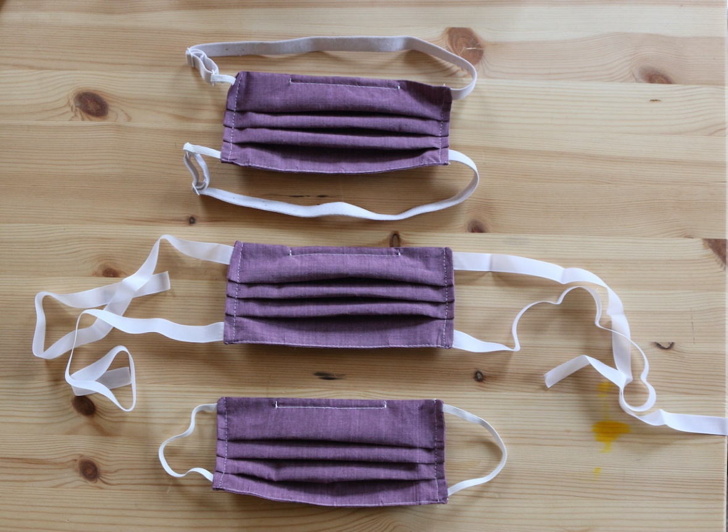
This Photo by Unknown Author is licensed under CC BY-SA-NC

Table of Contents
Executive Summary 4
Business Overview 4
Markets and Competition 5
Target Markets 5
Competition 5
Sales and Marketing 5
Product Positioning 6
Marketing 6
Sales 6
Management 7
Key Personnel 7
Advisors and support services 7
Operations 8
Premises and Equipment 8
Employees 8
Suppliers 8
Financial Forecast 9
Sales 9
Cashflow 9
Profitability 9
Financing 10
Appendix A 10
Appendix B 12
Appendix C 13
Appendix D 14
Appendix E 15
References 16

Executive Summary

My believe is anyone can be independent anywhere if they want to. I always wanted open my own business.my main priority will be my customer satisfaction. I was not sure at the beginning which kind of business I should start then in recent pandemic situation when everyone started panicking about own safety that time I think of idea to create kids mask.in recent situation anyone easily can buy adult mask where it is very difficult to get kids mask. I had 15 years retail experiences with also I loved doing sewing from my little age.my experience more to understand my customer needs. I start my business with my own saving and also I will prepared for my success by researching my area kids population interest in mask.my creation of kids mask not only save the children from viruses it will also protected them from dust in current pollution environments.

My premises will be opening on white ladies’ road that has high foot traffic as it is a high street based in Bristol. During the research of this busy high street, it was brought to my attention on an average month. This is minimum of 9000 potential customers that will be walking pass my establishment. I have worked out that around 20% of the foot traffic will walk into my location and approximately 18% of them will purchase an item.

(Cityzenspace,2012).

on start-up I will be investing my own savings of £20,000 to meet working capital requirements.

Business Overview
My business idea came to mind after I saw an uproar in the sales of masks, but I noticed that there were not any proper masks for children. Which led me to open Only Masks, which produces masks for children, between the ages 5-11.
My plans for the future are to expand my business to not only my local area, I would like to expand and produce masks for the whole of Bristol’s primary school, the finance I raise will help me to be able to produce more masks and it will let me arrive to school festivals.

One main problem that I may have to face is that, during the September period I might have to employ seasonal staff if I have a high number of orders. Another problem could be that if there is not enough interest, I will have to expand right away which will lead to an increase in transport and time, but I have kept money aside just in case that happens.

Markets and Competition

Target Markets
My target market is children that are around the age of 5-11 and that attend primary schools in my area. In my local post code (BS8) there are currently over 20 primary schools which have almost over 4000 pupils. First, I will provide free samples to the school to distribute to their students and a I will send through video clips to the schools to explain why children need masks during this pandemic. The video will also be available to view on my social media’s as well.
(Schoolswebdirectory, 2020).

Competition
Currently, I hold the monopoly in my area, but there are online retailers which can deliver to houses. The disadvantages of the online retailers are that the masks can most definitely be too big or too small for the children and the delivery times can be long and it can be lost or delayed from their courier but, one advantage the online retailers have is that if buyers are unhappy they can get an instant refund without being asked questions but for me, I have to assess the problems and fix them with the customers.
The target customers will come to me because my product is able to be washed. My mask is also able to be customised to the school’s needs. it is also reusable. Unlike the online retailers I will make sure my customers are well informed about my masks to do this, I will upload videos explaining why children should wear our masks, in the video I will also point out aspects such as the health rating on the masks and how it will protect against bacteria and also dust. The aim of the advert video will be to make sure parents and schools know why it is important for their children to wear masks for their safety.
In my research I found number of competitors in Bristol area and their details will be available in my Appendix A.

Sales and Marketing

My main customers will be primary school pupils and during the start of my business I will want to only attract the attention of local primary school children, I will attract their attention by giving an assembly in their school, this assembly will include me presenting some sample masks, details of my business and also the importance of wearing masks. At the end of the assembly I will provide leaflets with prices and sizes of masks and of course my contact details.
I will generate more sales by promoting myself on social media platforms to make sure everyone knows about my business and what I offer.

Product Positioning
My mask fit in the market map as a cheap but high quality product, I will also provide great customer service because I’ve had experience with dealing with retail customers, I will always make sure the customer is happy and I will take feedback on board, at the end of every purchase I will provide sheets where customers can tell me how satisfied they were with the product and service.
My cheap and high quality mask fits in with the customers want for cheap and high quality masks, on the market I found after conducting some research that most disposable masks tend to sell for around £1-2 and they can only be used at most for 3 times before it needs to be replaced, the masks are also quite flimsy and can be torn quite easily.

(FDA,2020).

My customers need is that they require a mask for children which is very hard to find. And I provide them with the solution.
After looking at these factors I conducted research to find out what materials are the best for masks that are both cheap and have high quality, I found that 1 layer of cotton plus 2 layers of chiffon works best.
I can guarantee that the product will not tear easily, and I will happily replace or refund the customers if they encounter any tears.

Marketing
Firstly, I will promote my business by advertising it on my social media and getting my web link shared by my family then I will print out flyers to hand out at the schools. Within the flyer, I will include various things such as, the links to my online site, there will also be a brief explanation of the safety of wearing my mask and what it made of. After that I will call in at schools and make meetings with the headteachers and show them my sample masks, I can be sure that my promotions will be received by my targets and convince them to act because the leaflet has all the information they need and also my email is attached on it as well, they can also view my website for even further queries they have. I also plan to advertise through school uniforms shops, newspaper and social media. Due to the current climate over COVID-19, I am sure to appeal to parent and schools throughout to Bristol and Gloucestershire area.

(Hootsuite,2019).

Sales
In order to actively sell my masks I will call up the schools and ask if they are interested in the products, then if they are, I will go ahead and meet the head teacher and explain my business and also discuss the assembly, I will identify the right school by observing how many students they have, for example if it was a large school and had loads of pupils then it would be a great opportunity for me to present my masks there due to them being more likely to buy the product. I think it would not take that long to convince the schools to buy the masks because they already have an idea of how affective using a mask is and the teachers would also be more safer if children wore masks. I aim for schools to start ordering masks after 1-2 weeks of me talking to them. Currently I have some interest from my children’s primary school, and I have made them some masks for their year 6 students. To ensure I get repeat business, I will be able to customise the masks to the schools style and I will make sure the service I provide is impeccable, I will also give schools warranty on the mask just in case the straps on the masks break and I will replace them free of charge but, some terms and conditions will apply. With the school’s first order I will give free masks to the teachers as a gift.
to further grow my business in the future I will expand by customer base outside my local area and I will attend events with schools.

Management
The right team needs to be successful by having the will to do anything to expand their business. My team can work at any hours and they will not stop until the customer is satisfied and until we have completed the work. I will be able to work day and night to show the commitment that I have for the business to my customers and I will ensure by business is a success by quality testing all masks before they are received by the customers.
After researching, I know that September will be the busiest time period for my business due to it being the start of school, my team and I have already taken this matter onboard and have prepared extra materials so that there is no issue in making the masks. Under all this pressure my team is still able to provide an 100% customer service.

(Impoff,2019).

Key Personnel
I will be a sole trader which means I will be responsible for the business.

(Smallbusiness,2019).

I will make sure that all stock is available and that all the customers are satisfied, I already have had experience with dealing with retail customers and I am great with communicating with my customers. Even though, this is a sole trader business, I will treat it like a family run business, I have happily employed 2 members of my family which have a great background in sewing and in retail, I have employed them because they will, without a doubt support me day and night. They have the responsibilities of checking orders and completing them before the time frame.
I am very committed to this business and have left my current job in order to fulfil this business, I have invested from my savings.

Advisors and support services
At first, I sought help from a lawyer who would check the premises and change the lease into my name, he also checked that the business was not in debt and if it had a clean sheet. He also gave me advice on where I should open the business and we discussed on areas that had affordable rent and had a large enough store front, this advice really helped me because I had no past experience. I will also appoint an accountant who will submit my annual year tax return to HMRC.my solicitor and accountant details will be available in my Appendix B.
I also use an accountant who submits my returns every year to the HMRC.my accountant details will be available in my appendix
I also use Microsoft excel to keep my incoming and outgoing expenditure balanced.

Operations

Premises and Equipment
My premises is located on White ladies road Bristol, I chose this place because it’s very popular and there are a lot of highly educated people who live nearby, also there are various other retailers on the street which are expensive and have high quality, which I think my shop will blend in with the surroundings.

(BristoLive,2020).
The shop is 754sq which is enough space to have 6 sewing machine and there is also a small basement, where I can store any stock.
my selected shop which I want to lease for my sewing business details will be available in my Appendix C.

At the beginning I will need to purchase the 6 sewing machines and 6 chairs and tables to rest them on, I will need to also produce leaflets to hand out, but I already have got a printer. I need to pay an engineer to design the shop to be suitable for the employees and for it to be comfortable, the store front also needs to be following the government guidelines about the distancing. I want to make the area capable of sitting up to 6 people even though I will only hire 2 at the beginning.

Employees
I will only need 2 part-time employees to run my business during the start, both employees will require training of how to create masks and some experience with retail. The employees also need to be flexible with working hours if there is a rise in orders, but seasonal staff can be arranged.
My CV will be available in my Appendix D.

Suppliers
My key suppliers are based in London and Birmingham, they are quite reliable and they always provide the fabric as soon as I need it, if one were to go out of business, I won’t be stuck because I always keep at least 6 months stock in advance, this will give me enough time to look for a new supplier. My supplier details will be available in my Appendix E.

Financial Forecast

Sales

My target is initially for the first year I would like to sell 300-400 masks every month. Based on the size of our market and current demand of kid masks I have projected my first year annual revenue would be around £57,600 and then the 2nd year if trading I would like to keep the same customers but increase the sales by approaching new customers. I have also projected that the sales growth rate of 62% per year for the first four years. One mask has a fixed price of £4.99 and every customer will potentially buy two. If I achieve this sale target, then I am confident about my success.

Cashflow

I will set up a cash flow plan to get the idea of my profit. Cashflow forecasting is very helpful tool to run a business.it can done so many ways. Creating a cashflow forecast in a spreadsheet can be very difficult because I never done it before so I use online tool to create a cashflow forecast where it will show my profit After working out with my income and cost of goods.

(Float,2019).

Profitability

My profit showing in loss for first year but then it will be profit in following years which will show in my financial projection.it will not affect much in first year of sales because I will use enough capital to carry on following year to get profit for my business. When I will have profit coming from my business I will put all of it in my profit pot to survive my business in emergency situation such as in recent corona virus pandemic affected badly to business and this is unplanned situation.my business will gradually grow by time to time. my plan for future to open another business in another area and the start-up finance will come from profits from the first mask business.
I will give full details of my financial forecast below where it will show my income, cost of goods, balanced sheet and profit in details.

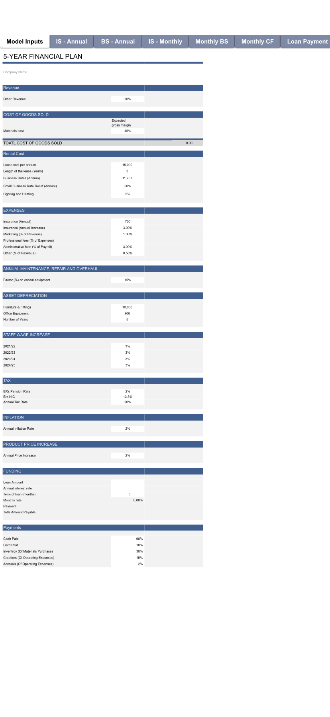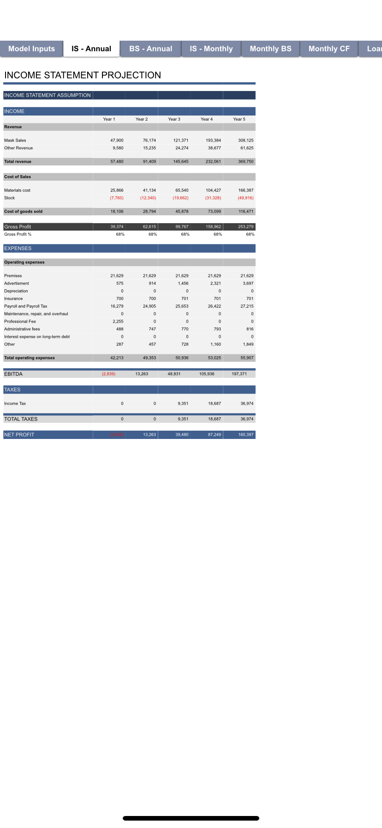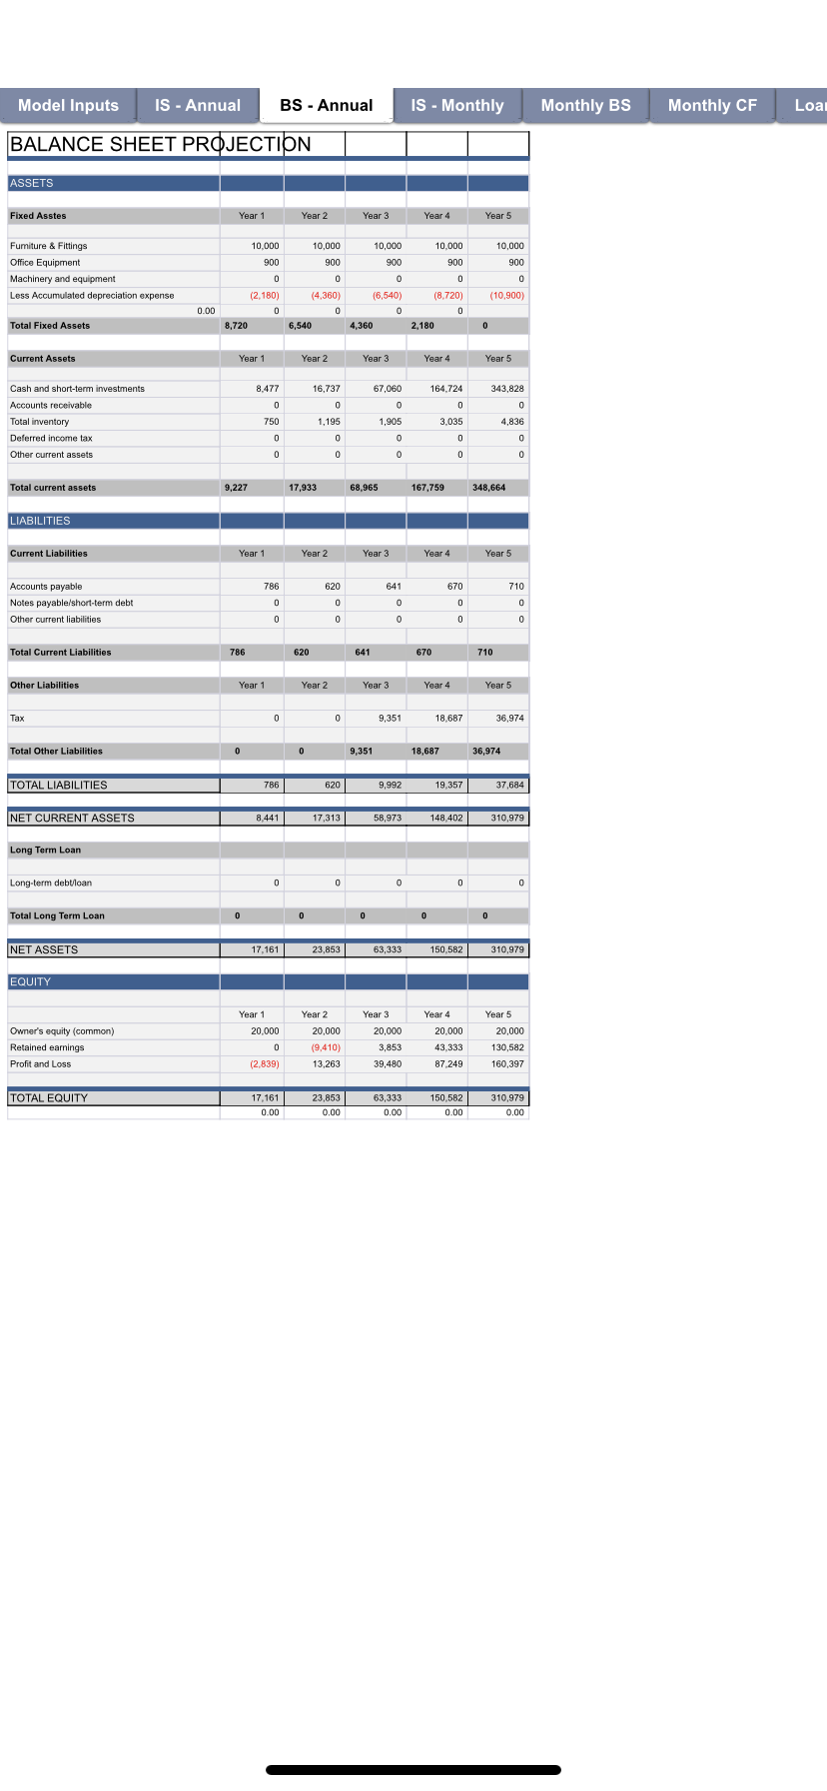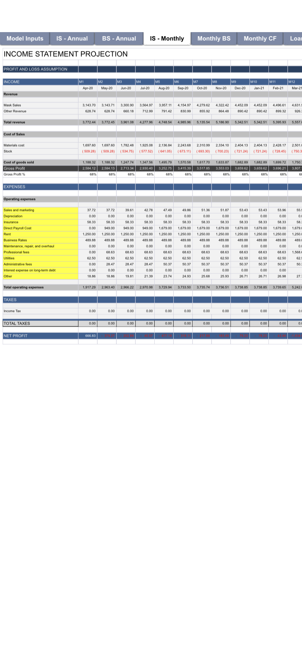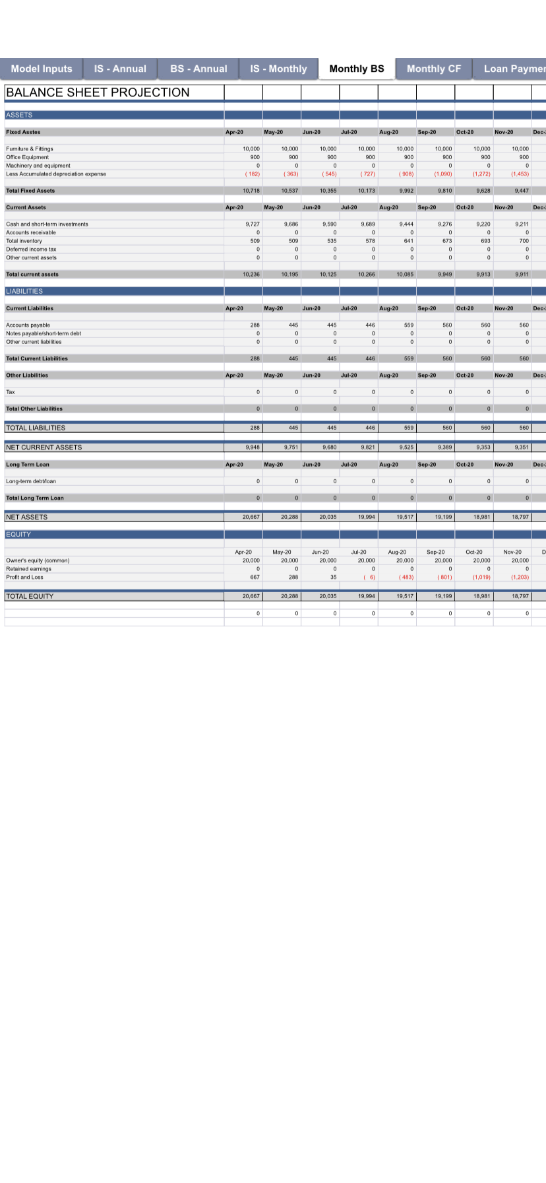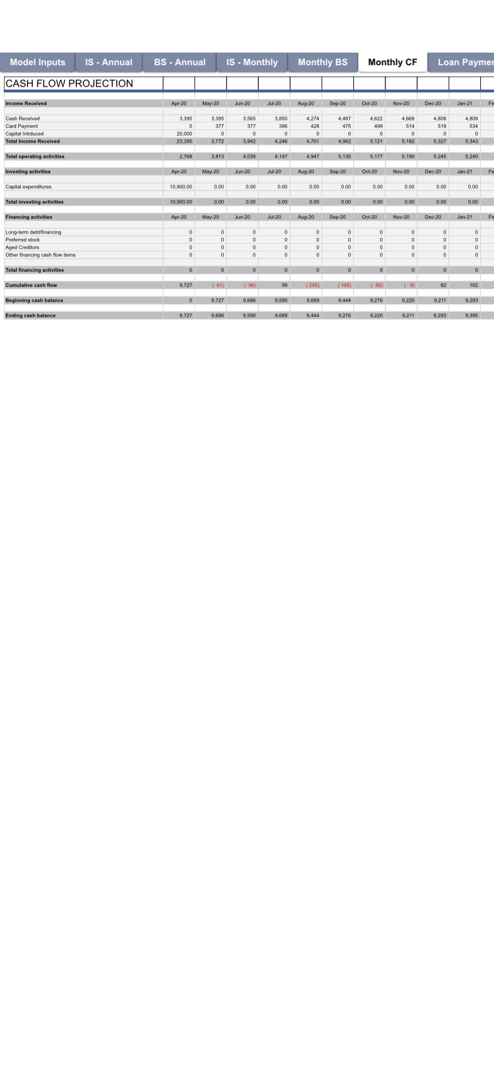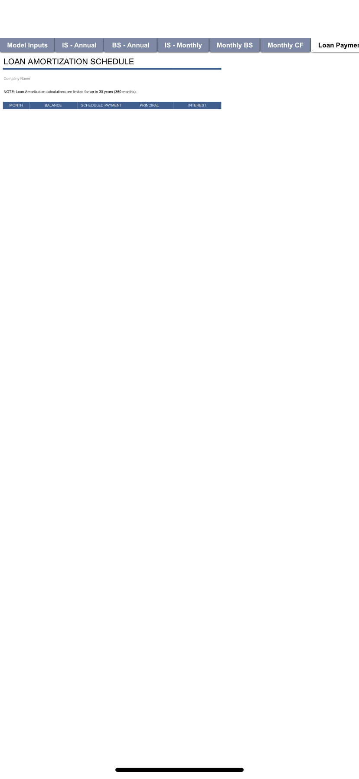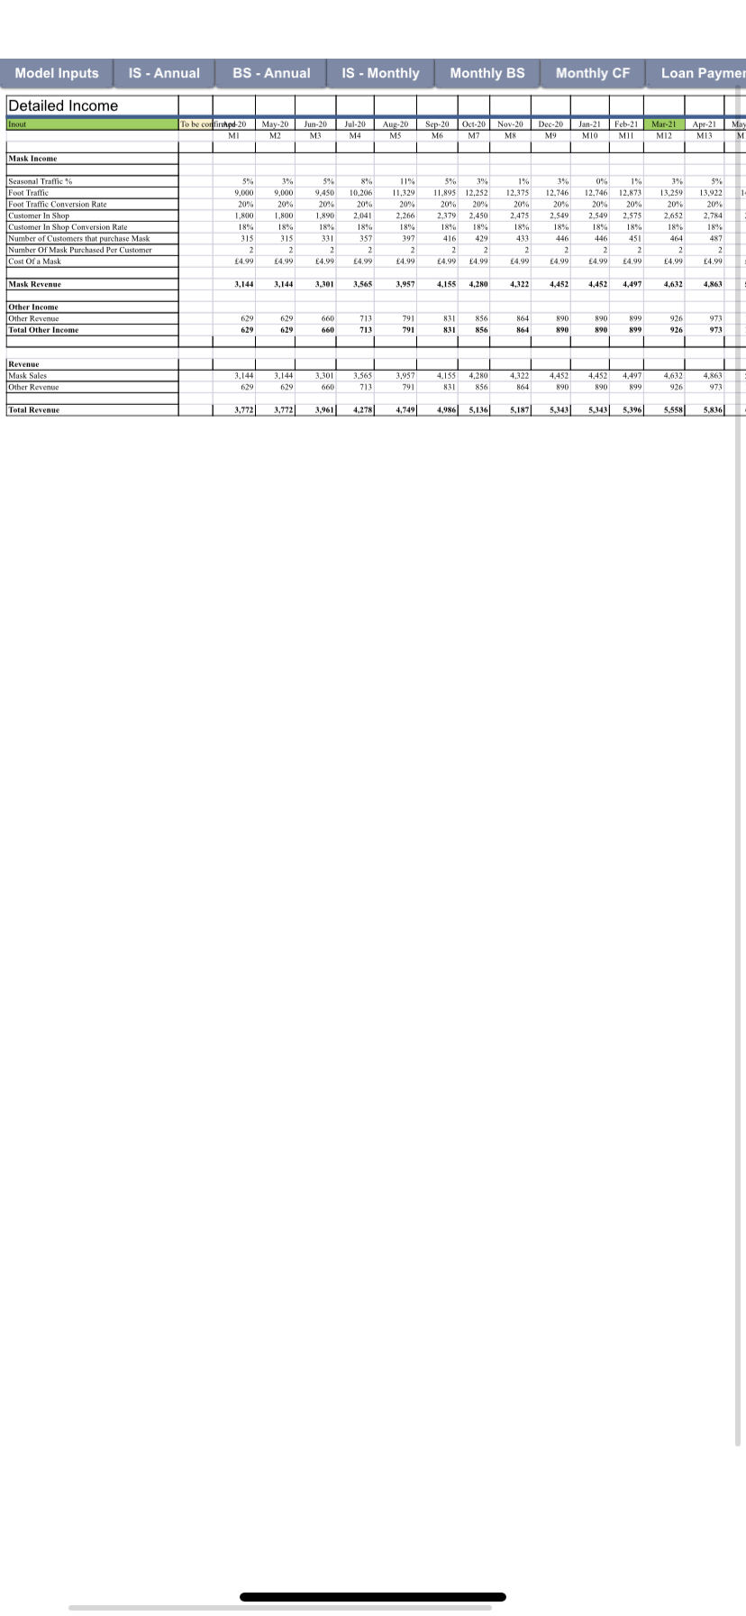

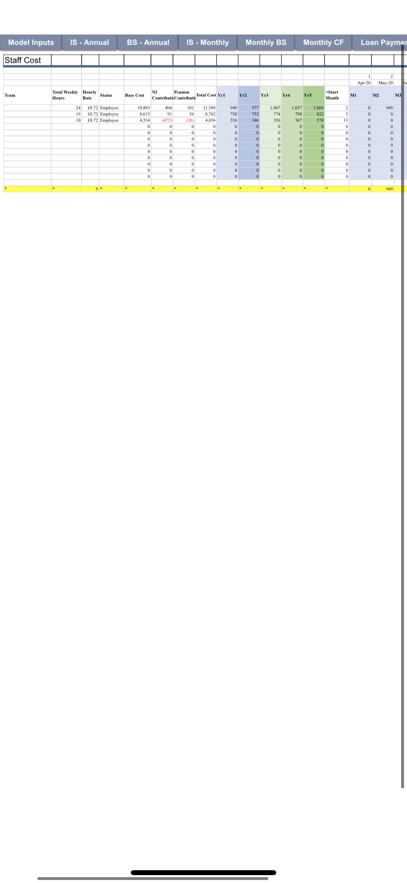

Financing
I will be investing my own savings into the business to initially start it up. I will use this capital to cover the expenses of opening the business up such as legal fees and the 3 months deposit, I will also buy all the equipment and I will decorate the premises. Also, I have kept the first month costs in the bank so that it can clear if I have a slow start. There is also some money left behind just in case I need to arrange different plans. I have estimated the start-up capital to be £20000 My own saving will be my capital for Only Mask bussiness.as start up I will use this capital for expense for my business which will be able to pay for solicitor legal fee,3 months deposit for the premises the equipment for business, decoration cost, and also for first month salary, energy supplies bills, water bills etc. will keep some money separately for unexpected situation in case my plan does not work then I will money aside to change my target customer to make successful my business.

(smallbusiness,2019).

Appendix A
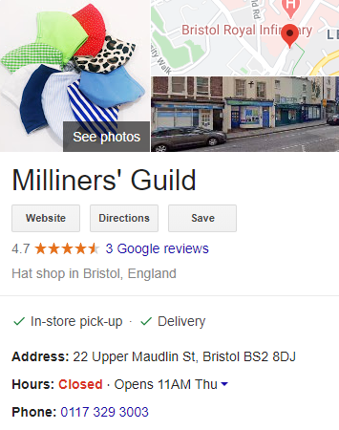

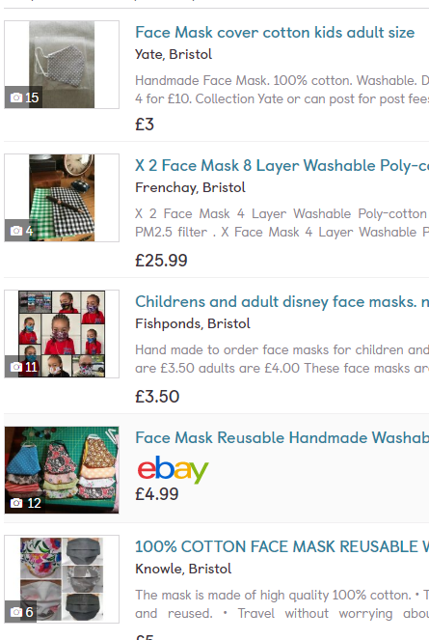

Appendix B

Rowlands Accountancy: Whitsun lease, Charlton Hayes, Bristol, BS34 5GJ
T: 07975845554 E: info@rowlandsaccountancy.co.uk

Star Legal solicitor ,3 Richmond Hill, Clifton, Bristol, BS8 1AT
T:01179059262.

Appendix C

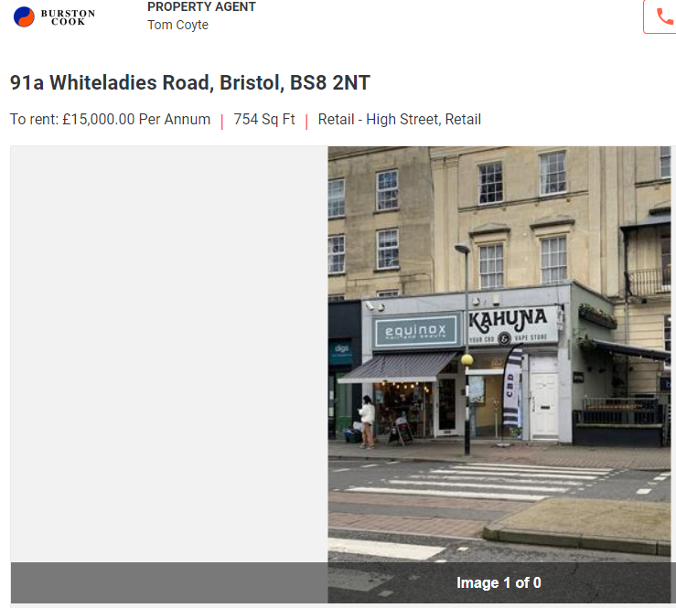

Appendix D

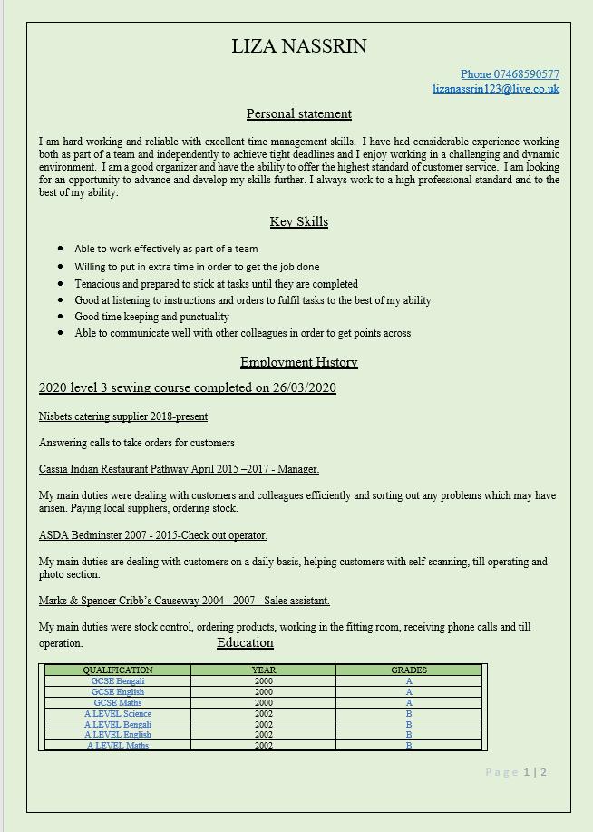

Appendix E

Fabric UK

Address: 112, 132 Saltley Rd, Saltley, Birmingham B7 4TH

Phone: 0121 359 2349.

Fancy Fabric

Address: 109 Digbeth, Birmingham B5 6DT

Phone: 0121 643 1954
Flame Pro Manufacturing
Address: Unit 26a Hive Development Centre, Factory Rd, Birmingham B18 5JU

Phone: 0121 551 1400

References
Citizenspace (2012) white ladies’ road proposed pedestrian
crossing update. Available at: https://bristol.citizenspace.com/consultation-research-intelligence/whiteladies-road-pedestrian-crossings/
(Accessed:30 June 2020)

Schoolswebdirectory (2020) UK schools and collages database
Available at: http://schoolswebdirectory.co.uk/leasearch.php?lea=Bristol
(Accessed:27 June 2020)

(FDA,2020). N95 respirators surgical masks and face mask
Available at:https://www.fda.gov/medical-devices/personal-protective-equipment-infection-control/n95-respirators-surgical-masks-and-face-masks
(Accessed:30 June 2020)

(Hootsuite,2019). Social media advertising 101: how to get the most out of your Ad budget
Available at: https://blog.hootsuite.com/social-media-advertising/
(Accessed:30 June 2020)

(Impoff,2019).https://impoff.com/importance-of-management/
(Accessed:30 June 2020)

(Smallbusiness,2019). What is definition of sole trader and being self employed
Available at: https://smallbusiness.co.uk/what-is-the-definition-of-a-sole-trader-and-being-selfemployed-254775/
(Accessed:10 June 2020)

(BristoLive,2020). What is the truth about black boy hill and white ladies’ road?
Available at: https://www.bristolpost.co.uk/news/bristol-news/what-truth-blackboy-hill-whiteladies-4218076
(Accessed:12 June 2020)

(Smallbusiness,2019). What is definition of sole trader and being self employed
Available at: https://smallbusiness.co.uk/what-is-the-definition-of-a-sole-trader-and-being-selfemployed-254775/
(Accessed:10 June 2020)

(Float,2019). 7 advantages of a cash flow forecast
Available at: https://floatapp.com/blog/7-advantages-of-cash-flow-forecast/
(Accessed:05 July 2020)

