Component 2: Poster and Pitch Complete Assignment
Student name: Kossiwa Seyram Dele
Student number: 2336282
Programme: BSc (Hons) Health and Social Care
Module: Changemakers: Creativity and Value Creation
Module code: BMHP5014
Lecturer's name: Laila Surani and Caroline Salami
Submission date: 14th August 2026

Table of Contents

Part 2: Written Pitch 3

1.0 Introduction 3

2.0 Background 3

3. Innovation Description 3

4. Impact on Health and Social Care 4

5. Public and Stakeholder Involvement 4

6. Policies, Services, and Professional Links 5

7. Conclusion 5

Reference 6

Part 1
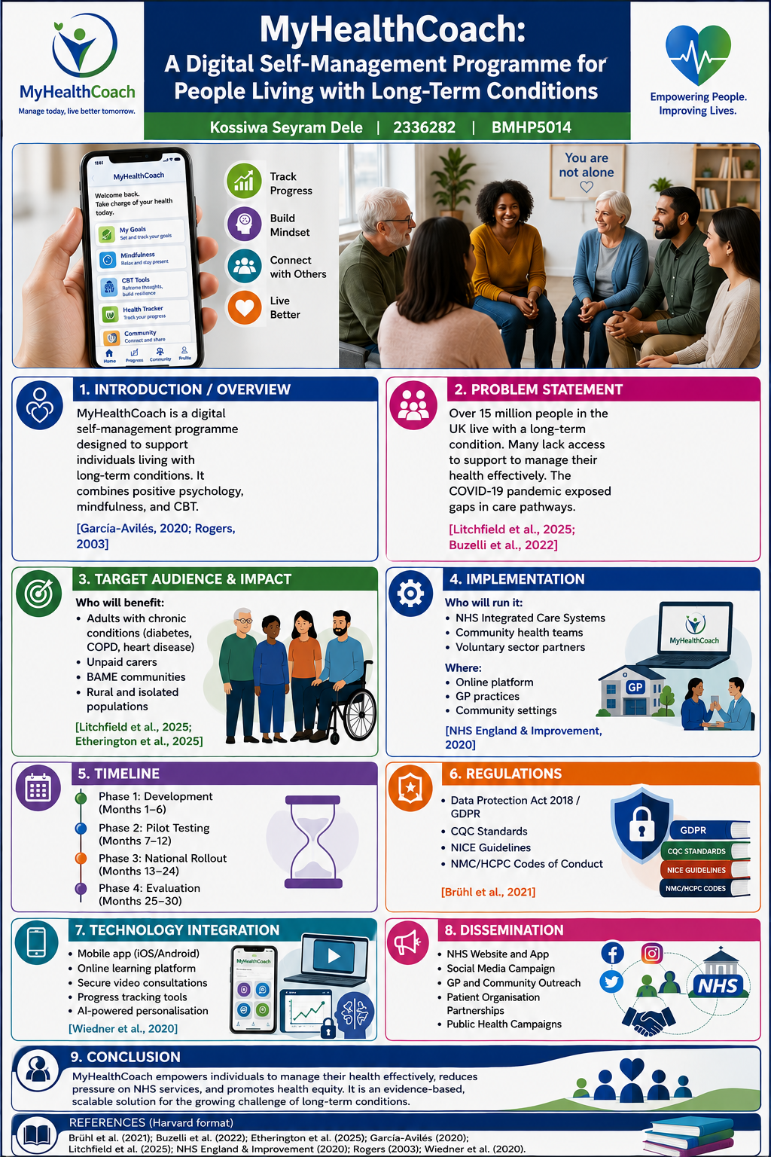

Part 2: Written Pitch

1.0 Introduction
MyHealthCoach is a novel idea to create a digital self-management tool that could be utilized by individuals with long-term diseases in the UK. This innovation comes as a response to an urgent need arising from the increasing numbers of people with chronic illness in combination with a lack of sufficient access to evidence-based and effective tools that could help patients in managing their own health. According to Buzelli et al. (2022), currently, there are over 15 million citizens of the UK who suffer from long-term conditions.
The Diffusion of Innovation Theory developed by Rogers (2003) and García-Avilés (2020) states that novel healthcare ideas spread in the course of time due to the usefulness, ease of usage and advantage for patients and nurses of this innovation. The main principles of the NHS Long Term Plan (2020) created by NHS England & Improvement could also be applied. These principles presuppose a digital transformation and a shift towards patient-centeredness. The main benefits of MyHealthCoach would involve a relief for NHS services in combination with individual empowerment.

2.0 Background
The country faces an increasing threat associated with rising numbers of long-term conditions that account for a significant part of the NHS expenses and affect millions of people. According to Buzelli et al. (2022), there is growing concern among the general public about problems connected with accessibility and effectiveness of health and social care services, where many perceive them as being more stretched than ever before. The situation is compounded by continuous increase in numbers of patients with long-term conditions posing an enormous demand for healthcare. The Fairer Futures Fund was evaluated by Litchfield et al. (2025) in terms of its effectiveness at solving the issue of health inequality through its intervention worth £22.2 million. It shows that some effects can be seen, but there are still many obstacles preventing from achieving a greater success in the matter. In turn, Etherington et al. (2025) investigated the effects of austerity on inequalities and poverty experienced by coalfield populations, thus showing how the reduction in the economy and budget spending exacerbated health disparities in the country.
Also, Hurley-Wallace et al. (2025) provided a mixed-methods scoping review of patients' experience with urgent and emergency cancer care and found out the presence of considerable deficiencies in timely diagnosis and treatment of those patients. In another study by Drake et al. (2020), the effects of hospitalization for COVID-19 on interstitial lung disease patients were researched and it turned out that it affected a vulnerable group. Wiedner et al. (2020) suggest that healthcare systems can be a source of innovative ideas during crises.

3. Innovation Description
MyHealthCoach stands for a complete self-management tool for people with various health conditions available as an app and web-based system, thus providing opportunities for everybody regardless of their physical location. The innovation utilizes several evidence-based practices such as positive psychology, mindfulness, and cognitive behavioral therapy. As mentioned in Brühl et al. (2021), the assessment of the care processes' quality requires a multi-dimensional scale approach. MyHealthCoach includes the following components:
- Personalized learning paths: individually tailored content
- Modules: interactive video classes, exercises and activities that are meant to improve participants' skills
- Peer Support Networks: online forums for participants' discussion
- Progress tracking: tools to monitor the level of well-being and set personal goals
- Care provider support: a dedicated portal for clinicians to follow the participants and help if needed

What makes MyHealthCoach innovative is the co-production approach that ensures relevance, accessibility and culturally sensitive content. It corresponds to the strategy outlined in the NHS Long Term Plan (2020) and stresses the importance of personalization and the patient-centered approach to care provision. According to Wiedner et al. (2020), the use of improvisational mechanisms in crises situations can create innovations in the healthcare system, which is reflected in MyHealthCoach: the lessons gained during the pandemics were translated into digital solutions that could have a lasting effect.

4. Impact on Health and Social Care
MyHealthCoach is likely to produce significant positive impacts at various levels of health and social care.
Service Users: Those taking part in this programme are expected to experience positive health benefits, develop higher self-efficacy with managing their condition, and improve quality of life. According to Hurley-Wallace et al. (2025), patients prefer prompt, easily accessible and person-centred care, which is available within this programme.
Carers and Families: Carers who offer unpaid help to those who suffer from chronic diseases will have additional sources of support at their disposal, thus relieving their burden and promoting well-being of their families.
Health Care Professionals: This programme will allow patients to become actively involved in their health care, therefore helping to decrease load of GPs, hospital visits, and usage of other NHS services. As stated by Buzelli et al. (2022), perceptions of quality of care in terms of accessibility and responsiveness will be raised through this programme.
System Wide Benefits: This programme helps in prevention of hospital admissions and ED visits, thus contributing to future sustainability of the NHS. Prevention of disease and patient self-management are key priorities outlined in the NHS Long Term Plan (NHS England & Improvement, 2020).
Common Good Contribution: MyHealthCoach promotes equity by engaging people from underserved communities, including patients living in rural areas and those lacking mobility. Litchfield et al. (2025) call for a focused intervention to eliminate health inequalities, whereas Etherington et al. (2025) demonstrate that overcoming deprivation is crucial for better health results. Providing accessible and evidence-based support to patients, MyHealthCoach creates opportunities for flourishing of all individuals.

5. Public and Stakeholder Involvement
Stakeholders and public participation will be key for the success of MyHealthCoach. MyHealthCoach will be developed with the collaboration of the target audience including people who receive service from healthcare organizations, patients, family members of those patients and healthcare workers (Litchfield et al., 2025).
Public Engagement: Through the means of conducting workshops in communities, focus groups and pilot studies, we will be able to reach out to the targeted users in order to develop and improve our intervention. This aligns well with the findings of Litchfield et al. (2025), who suggest that community participation is a necessary strategy for overcoming inequality in health.
Co-Production: Patients will serve as co-designers and peers in mentoring and developing the intervention. Hurley-Wallace et al. (2025) state that understanding the experience of the patients should be considered as a necessary element while developing interventions.
Advocacy: In addition, working with patient and charity groups will be important for advocating our intervention. As Brühl et al. (2021) show us, quality of care will improve if we engage stakeholders in our work.

6. Policies, Services, and Professional Links
MyHealthCoach aligns with key UK health and social care policies and frameworks:
Legislation: The programme supports the principles of the Care Act 2014, which emphasises wellbeing, prevention, and person-centred care. It also aligns with the Equality Act 2010 by promoting accessibility and reducing health inequalities.
Existing Services: The programme complements existing NHS services, including primary care, community health services, and mental health support. NHS England & Improvement (2020) set out the strategic direction for science and innovation in healthcare, which MyHealthCoach supports.
Professional Roles: The programme supports healthcare professionals including nurses, GPs, occupational therapists, and social workers by providing them with tools to support self-management. Drake et al. (2020) demonstrate that multidisciplinary approaches improve patient outcomes.
Professional Codes: The programme complies with NMC, HCPC, and GMC standards, ensuring it supports rather than replaces professional clinical judgement. Brühl et al. (2021) highlight the importance of quality measurement in professional practice.

7. Conclusion
MyHealthCoach can be considered an important and evidence-based solution to the key problem faced by the UK’s healthcare system: the growing number of people suffering from chronic diseases. Thanks to the combination of new technologies with proven therapy methods, the program will help individuals gain more independence concerning their health and take the pressure off the National Health Service (Buzelli et al., 2022; Litchfield et al., 2025). With its co-production, the initiative becomes relevant and available to a wider range of people, and the method is scalable.

Reference

Brühl, A., Sappok-Laue, H., Lau, S., Christ-Kobiela, P., Müller, J., Sesterhenn-Ochtendung, B., Stürmer-Korff, R., Stelzig, A., Lobb, M. and Bleidt, W., 2021. Indicating Care Process Quality: A Multidimensional Scaling Analysis. Journal of Nursing Measurement.
Buzelli, L., Cameron, G., Duxbury, K., Gardner, T., Rutherford, S., Williamson, S. and Alderwick, H., 2022. Public perceptions of health and social care. The Health Foundation. https://www. health. org. uk/reports-and-analysis/reports/public-perceptions-of-health-and-social-care-what-the-new-government.
Cant, C. and Lee, M., 2026. The Future in Our Past: The General Strike, 1926/2026. Verso Books.
Dolea, A.E., Maglan, A., Trandafoiu, R., Comper, M., Burcu, O., Irimie, C., Toma, T., Gonczol, R., Bica, M.C. and Cront, B., 2026. The Romanian diaspora’s contributions to the British economy and society (pp. 1-68). Bournemouth University.
Drake, T.M., Docherty, A.B., Harrison, E.M., Quint, J.K., Adamali, H., Agnew, S., Babu, S., Barber, C.M., Barratt, S., Bendstrup, E. and Bianchi, S., 2020. Outcome of hospitalization for COVID-19 in patients with interstitial lung disease. An international multicenter study. American journal of respiratory and critical care medicine, 202(12), pp.1656-1665.
England, N.H.S. and Improvement, N.H.S., 2020. Science in healthcare: Delivering the NHS long term plan. The chief scientific officer’s strategy.
Etherington, D., Gray, M. and Buchner, L., 2025. Still Digging Deeper: The Impact of Austerity on Inequalities and Deprivation in the Coalfield Areas. University of Staffordshire.
García-Avilés, J.A., 2020. Diffusion of innovation. The international Encyclopedia of media psychology, 1(8), pp.1-8.
Hurley-Wallace, A.L., Defty, J., Richardson, A. and Wagland, R., 2025. Mixed methods scoping review of patients’ experiences of urgent and emergency cancer care. Supportive Care in Cancer, 33(3), p.208.
Litchfield, I., Knight, A., Howell-Jones, R., Miller, D., Sweeney, Z., Walsh, M. and Harper, L., 2025. Mixed-method evaluation of the Fairer Futures Fund: a£ 22.2 m public health initiative designed to reduce health inequalities in Birmingham and Solihull (UK). Frontiers in public health, 13, p.1658646.
Patel, J., 2026. Universities and the Purpose of Higher Education: Expansion and Development in Post-War Britain. Taylor & Francis.
Wiedner, R., Croft, C. and McGivern, G., 2020. Improvisation during a crisis: hidden innovation in healthcare systems. BMJ leader, pp.leader-2020.

