HR Management Priority area of
General Motors

Module: Human Resource Management(BMMB7007)
Assignment 1
Name:Guiqing Jin-2215446
Lecture:James Moore
Word count: 2,628 words

Executive Summary
Regardless of the type of industry, employees are a crucial component of businesses. Proper employee development primarily contributes to organizational development. To deliver the results, you must effectively understand this flow. Additionally, it is noted that employee management is required for a deeper comprehension of the strategies. Strategic initiatives can help develop employees. One such activity that focuses on outlining the results for success is employee performance management. Here, performance management has been interpreted as the strategy being used to improve employee outcomes. The goal of this study is to comprehend these practices at General Motors Company. Understanding these practices is essential because they affect every aspect of the organization. GM was regarded as one of the US-based car manufacturers. The study that produces better results conducts an investigation of the organization. The management of employees' performance was found to be plagued by a variety of problems. NICE Performance Management (NPM) version 7.0 to comprehend performance management within the organization To effectively manage performance management procedures, this system provides an improved reporting structure, cutting-edge coaching resources, and agent self-correction. But it is still possible to observe absenteeism, turnover, employee dissatisfaction, and sales declines. These are consequent organizational resource wastes. Additionally, time wastage and rising costs may be noted. Due to a lack of incentives, employees are not motivated. The company's management of performance shows no discernible pattern. As a result, the study has determined the effects of this deficiency on the company as well as the necessary recommendations to produce better results. Competitors were identified in the industry (such as Toyota, Ford, and Tesla). The competitors are performing well in the industry. Understanding their initiatives, such as lean HR practices, is necessary for organizational growth in employee management. GM has not included modern practices in this area. Thus, the study has identified and mentioned many such strategies that could be used in the development of employee performance management within the organization.

Table of Content
1. Introduction 5
2. Organizational Description 6
3. Discussion 7
3.1 Employee Performance Management in General Motors 7
3.2 Current Issues in Performance Management in General Motors 7
3.3 Impact of Issues in Employee Performance Management on Organizational Performance 8
3.4 Benefits of Improving the Employee Performance Management 11
3.4.1 Benefits to the Organization 11
3.4.2 Benefits to the Employees 11
3.4.3 Benefits to the Stakeholders 12
4. Conclusion 13
5. Recommendations 14
6. References 16

List of Figures
Figure 2-1: General Motor’s Revenue 6
Figure 3-1: Stock Price Fluctuations 9
Figure 3-2: Production losses in automobile sector 10
Figure 3-3:Market share of GM for light vehicles in 2021 10

Introduction
The foundation of any company is its employees. The effective development of employee performance management, a crucial HR function, is required for the successful development of the employee pool (Swanson, et al., 2020). General Motors (GM) has been chosen for the study's investigation of the HR functions. In this instance, the investigation has been expanded to include employee performance management. The study has provided a clear explanation of the results pertaining to the GM performance management system. To produce better results, the organization's issues have been effectively understood and identified. Additionally, it is noted that the study also outlines the advantages of sound performance management procedures in order to comprehend successful results. The company, its workers, and its stakeholders all gain from this. These sections were all correctly identified. For the proper management of the HR functions within the organization, it is essential to comprehend these practices. The current study has outlined all of the elements that contribute to performance management's internal success as well as the changes that must be made for this system to be effective.

Organizational Description
One of the most prosperous auto companies in the world is General Motors. One of the multinational businesses with an American base is this one. The organization has a lengthy history. The company was started in 1908. There are 167 000 + employees working in year 2022 (Annual Report , 2022). The company has undergone numerous developments and manages a number of brands. $156.7 billion in net revenues are obtained as a result in 2022. It has been determined that $9.9 billion in net income has been distributed to the stakeholders (Annual Report , 2022). Due to a number of issues, including COVID-19, the organization had been experiencing a decline in revenue in recent years. The following graph displays the evolution of revenue over the previous years.
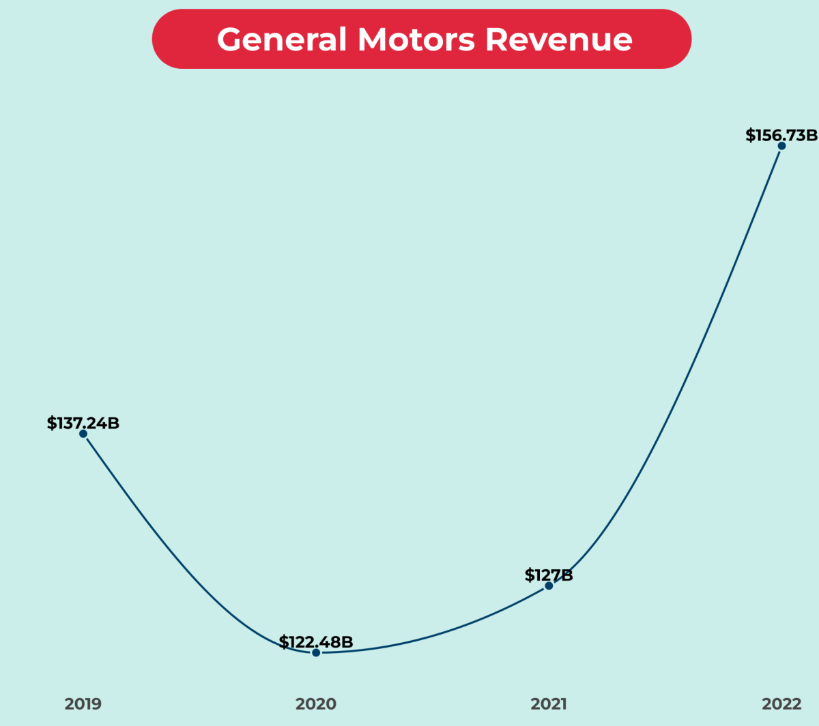
Figure 2-1: General Motor’s Revenue
Source: (Cuofano , 2023)

The company is having the competition with Toyota, Tesla, Honda and Ford. Toyota is leading the market and having higher competition to the GM. Its processes in TPS (Toyota Production System) and application of TQM (Total Quality Management) practices makes its significant development (Annual Report , 2022). GM also need to apply such higher tech applications to deliver the necessary outcomes. GM is behind these competitors. Thus, the organization is highly needed to practice better strategies to develop in the industry (Cuofano , 2023).

Discussion

Employee Performance Management in General Motors
GM is a US-based manufacturer of automobiles. There are different methods used for the performance management of the organization. Employee management and employee performance management are necessary facts for the development of operations (UKEssays, 2018). The company has used the general methods of performance management within the organization. Currently, it has introduced NICE Performance Management (NPM) version 7.0 for the organization (Cooper, 2019). This has been applied in 2019, and it has allowed the organization with different advantages to manage the workforce more effectively. Supervisors and agents are guiding the employees' performance levels with this system, and it is a significant development and application for a successful outcome generation in employee management (Cooper, 2019). This system is now used in entire organization and it has resulted following facilities.
- Advanced reporting system
- Advanced coaching toolset
- Agent self-correction
With the aid of this system, GM was able to train and motivate its workforce in accordance with their level of performance. The organization employs a sizable number of people. It is crucial to comprehend and implement better results for these employees. With this recently implemented system, GM lacks an appropriate process for gathering feedback or keeping track of it. This is a shortcoming of the system of performance management that is currently in use.

Current Issues in Performance Management in General Motors
Companies all over the world are dealing with a variety of management problems, and in the modern business environment, General Motors is no exception. The dollar's fluctuation has caused the company a variety of issues (StudyCorgi, 2021). Effective price decisions have not yet been made by the organization, which has a significant impact on a number of management procedures. Money management and effective budgeting are essential (UKEssays, 2018). However, GM is still lacking a sensible pricing strategy. Performance management must follow a specific format and framework. Since the GM was unable to accomplish this, no efficient performance management was carried out (Kayanda, 2016). Businesses like Toyota (the best automaker) have adopted lean HR strategies. Lean HR effectively raises employee performance. Employee demotivation is a problem with complex tasks and unclear processes, and GM hasn't used this kind of performance management (Lean HR) ( Afande, 2015).
A higher staff turnover rate is another problem. This results in frequent hiring and recruiting. The length of time it takes to conduct performances varies accordingly for each employee (Hashim, 2014). Regular performance management processes are not offered in the company because it is difficult to follow up on this for every employee. The employees are becoming dissatisfied as a result of this (Cascio & Boudreau, 2016). The management has little power in the decision-making process because there is a centralized ruling system. Consequently, performance management also utilizes a common system (Arena & Uhl-Bien, 2016). Employee demotivation is a component of the performance management system because variations are not presented. There are favors for the known. The performance management system's partiality results in unfair decisions for the other employees (UKEssays, 2018).
Another problem in the organization is poor communication. This is a very large organization, and there are many departments as well. Still, communication between departments is made through different media as per the comfort levels of the employees (StudyCorgi, 2021). Thus, management practices in performance management of employees have an irregular nature in some situations. This is another issue. Further, job descriptions have not been made properly, and thus, performance management is facing issues ( Afande, 2015). The employees are busy and have many responsibilities. There is a process of supervisory feedback in performance management. Inadequate feedbacks also causing problems in the performance management practices.

Impact of Issues in Employee Performance Management on Organizational Performance
Organizational performance is disturbing due to the impacts of these poorly managed employee performance management systems. It has been noted that General Motors has a higher rate of employee turnover (Maiorescu, 2016). This keeps driving up the cost of hiring new employees. As a result, decreased organizational performance may result from rising costs. Additionally, there is a higher absenteeism rate, which slows down regular business operations. Additionally, the organization's profits and revenue are decreased as a result (Jindal, et al., 2015). Due to ineffective performance management, there is no suitable system for rewarding employees. The employees are becoming less motivated as a result of this. Employees who lack motivation don't perform as well as they should. As a result, organizational performance may suffer (Wang, et al., 2020). The organization's goals and objectives have no bearing on the employees. The employees do not fully comprehend this connection. Additionally, this has a significant impact on the organizational outcome.
GM is a bigger company. As a result, proper quality management and process standardization are required. It was determined that Toyota currently competes with GM. Managing human resources and even managing the organization are major problems for GM (Kasych, et al., 2020). As a result, performances are showing declines. Lean management, which reduces waste and redundancies, has been linked by Toyota to its human resources policies and practices (Jindal, et al., 2015). The effectiveness of the organization is greatly affected by this. A waste of money and resources results from GM's lack of such practices with regard to HR policies and functions (UKEssays, 2018). The organization's performance level is being directly impacted by this. The future will be significantly impacted by the lack of an appropriate method for gathering feedback for the performance management of newly hired employees (StudyCorgi, 2021). Employees have a major impact on company. In light of employee performance, KPI development has been carried out. Therefore, measuring these performances and providing the necessary development avenues is a necessity for future development. GM has failed with human capital management in many such areas. Strategic HR practices are linked to achieving KPIs ( Afande, 2015). The absence of these is resulting in lower performances in the organization. This is a highly important consideration for the organizational development.
Following gives the comparison of stock price fluctuations in both GM and Toyota in 2018. Continuous dropping has recorded.
Figure 3-1: Stock Price Fluctuations
Source: (Rosevear , 2019)
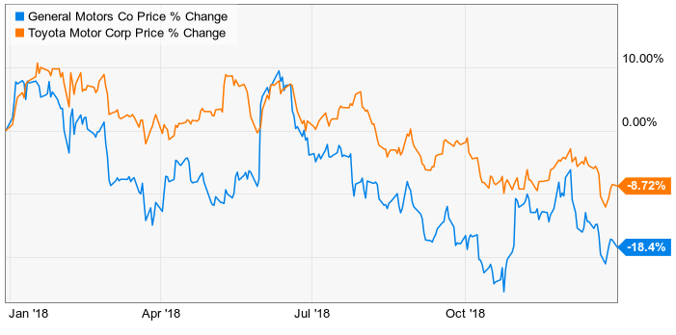

There are production losses due to the issues prevailing in the GM. Performance management issues are also resulting these failures. Following gives the failures in 2021.
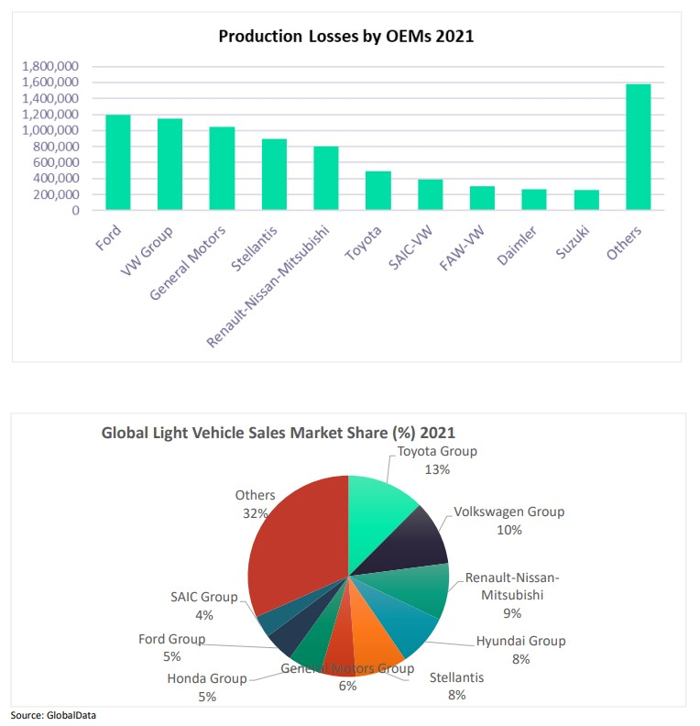
Figure 3-2: Production losses in automobile sector
Source: (Just Auto, 2021)

This is directly affecting to the KPIs and the performance of the organization. Thus, overcoming the issues is necessary for successful developments in the organization. GM has poor management practices resulting the deceleration in the success.
Following data are providing the evidences for this fact. It shows that only 6 % of market share is there for GM while many other brands leading the market. These are the results of the issues prevailing in the company. Thus, these are affecting directly for the performance level.
Figure 3-3:Market share of GM for light vehicles in 2021
Source: (Just Auto, 2021)

Benefits of Improving the Employee Performance Management
There are several benefits for the organization with a better performance management for the employees. These benefits can be arranged as per the organizational benefits, employee benefits and the stakeholder benefits.

Benefits to the Organization
The issues of high absenteeism and employee turnover have a significant impact on GM. A good performance management system for the employees can help to overcome these. A better performance management system raises employee morale and motivation (Khoreva, et al., 2017). As a result, these employees can produce better results. The right performance management system also makes it simpler to identify training needs (Albrecht, et al., 2015). By determining the training requirements before hiring and building a skilled employee pool within the company, organizations are gaining more advantages (Deery & Jago, 2015). Less waste results, saving money and time that can be used for other company processes. The foundation of any organization is its workforce. For the company to perform better, it is crucial to comprehend how the employees are developing (Khoreva, et al., 2017). As a result, businesses benefit from a developed talent pool. This identification is crucial. Organizations can benefit from the development of effective performance management systems by increasing sales, improving profits, increasing outputs, cutting waste, and more (Albrecht, et al., 2015). As a result, in order to maximize benefits for the company, employees must have proper performance management.

Benefits to the Employees
Managing the results of an employee's development has a number of advantages. With the incorporation of suitable employee performance management systems, the career paths of the employees can be effectively developed (Iqbal, et al., 2015). Employees can also pinpoint the areas that require improvement. Together with the performance management programs, the employees effectively manage the skills and qualities that need to be developed (Krishnan & Scullion, 2017). This serves as a crucial identification for staff members as they grow within the company. Additionally, the worker is growing more assured in their abilities. Employees who are more confident work harder. As a result, organizations must have employee performance management programs (Eliyana & Ma’arif, 2019). Employees are becoming more motivated by themselves and are aligning with organizational goals. This is yet another benefit that the workforce derives from the performance management systems.

Benefits to the Stakeholders
The people who have an impact on the organization and are affected by it are called stakeholders. In order to have more fruitful outcomes for organizational development, stakeholder satisfaction is required (Khoreva, et al., 2017). Thus, it is essential to comprehend organizational development and enhance performance. Better performance by the organization has benefits for the stakeholders as well. They feel satisfied by the business's success, which also encourages them to make investments (Krishnan & Scullion, 2017). Additionally, the companies' main objective is to maximize stakeholder wealth, which is emerging as the most significant identification in the business world (Eliyana & Ma’arif, 2019). Better performance in the performance management programs can also help achieve this goal. These procedures result in organizational success, which leads to the creation of stakeholder needs and desires.

Conclusion
The report focuses primarily on the results of the employee performance management system at General Motors. It has been determined that the GM performance management system has a number of issues that have a big impact on the company. It was further discovered that the organization uses NICE Performance Management (NPM) version 7.0 to comprehend performance management within the organization. This system offers an improved reporting structure, cutting-edge coaching resources, and agent self-correction to efficiently manage performance management procedures. Compared to rivals, GM is not doing well. Toyota is the market leader. Toyota has developed a number of techniques that are applied to lean HR management and even quality standard maintenance. There are several drawbacks to such practices not existing in GM. These are also effectively considered. During the study discussion, all necessary results were succinctly explained. There are suggestions made to improve the effectiveness of the company's performance management system. This is yielding results for the organization.

Recommendations
Practice a better performance management system within the organization to get the benefits of employee management. There are several recommendations for GM to use in employee performance management. Understanding the GM processes and understanding shortfalls is critical to providing these recommendations. Following are some of these recommendations.
- Implementation of Lean HR techniques within the business. Toyota uses lean HR techniques. It has benefited from the appropriate employee management outcomes. Applying lean HR practices within GM is advised as well. This makes reducing waste and properly aligning employees with the company's objectives possible.
- Another suggestion is to set clear expectations at the outset. The expected results of employee performance management should be understood. Understanding the level of employee performance or the employees' training needs may be involved. Similarly, reasonable expectations must exist.
- Development of the objective. Every HR initiative needs goals. To effectively achieve the results, employee performance management also requires the development of objectives. Critical outcomes in the organization's employee performance management are increased by the development of clear objectives that are SMART in nature.
- It was necessary to implement performance management procedures and integrate them into the prevailing culture. It should be a crucial and necessary step in the better development of the outcomes. Therefore, every employee is participating voluntarily and with motivation.
- Prioritization is required for inclusion, trust, and respect. Employees must have faith that the performance management system is objective. This is a crucial requirement for good management practices.
- Different phases and steps can be involved in performance management. GM must set up a unified system for handling performance management. This had to be a uniform and equitable system for each employee.
- Leading performance management outcomes depend on the development of leadership and skills. With this leadership development, there can be no mistakes and developed performance management actions can be acquired.
- Another aspect is keeping an eye on things and getting feedback. The organization's performance management procedures are not subject to GM's regular feedback sessions. Therefore, it is not possible to generate ideas during a brainstorming session or to develop a system. It ought to be integrated into the management system.
- Transparency is yet another essential element. To produce better results, the organization should work to increase the transparency of the evaluators and the evaluation process.
- Diversity should be promoted.
- A performance management system should be connected with a rewarding system, and appreciation should be used.

References
Afande, O. F., 2015. Effectiveness of Staff Performance Management in the Motor Industry in Kenya: A Case Study of General Motors (East Africa) Limited. Journal of Poverty, Investment and Development, Volume 15.
Albrecht, S. L. et al., 2015. Employee engagement, human resource management practices and competitive advantage: An integrated approach. Journal of Organizational Effectiveness: People and Performance.
Annual Report , 2022. Annual Report , s.l.: General Mortors.
Arena, m. J. & Uhl-Bien, M., 2016. Complexity leadership theory: Shifting from human capital to social capital. People and Strategy, 39(2), p. 22.
Cascio, W. F. & Boudreau, J. W., 2016. The search for global competence: From international HR to talent management. Journal of World Business, 51(1), pp. 103-114.
Cooper, b., 2019. eneral Motors Implement New Performance Management Technology. [Online]
Available at: https://www.callcentrehelper.com/general-motors-implement-performance-management-137462.htm
[Accessed 21 03 2023].
Cuofano , G., 2023. General Motors Revenue. [Online]
Available at: https://fourweekmba.com/general-motors-revenue/
[Accessed 21 03 2023].
Deery, M. & Jago, L., 2015. Revisiting talent management, work-life balance and retention strategies. International Journal of Contemporary Hospitality Management.
Eliyana, A. & Ma’arif, S., 2019. Job satisfaction and organizational commitment effect in the transformational leadership towards employee performance. European Research on Management and Business Economics, 25(3), pp. 144-150.
Hashim, M., 2014. Organizational change: Case study of GM (General Motor). Journal of Business Administration and Management Sciences Research, 3(1), pp. 001-005.
Iqbal, N., Anwar, S. & Haider,, N., 2015. Effect of leadership style on employee performance. Arabian journal of business and management review, 5(5), pp. 1-6.
Jindal, S., Laveena, L. & Aggarwal, A., 2015. A comparitive study of crisis management-Toyota v/s General motors. Scholedge International Journal of Management & Development, 2(6), pp. 1-12.
Just Auto, 2021. Why Toyota leads the global automotive sales chart, s.l.: https://www.just-auto.com/features/why-toyota-leads-the-global-automotive-sales-chart/.
Kasych, A., Vrbka, J., Rowland, Z. & Glukhova, V., 2020. Modern Human Resource Management Models: Values, Development Approaches, Transformation. Quality-Access to Success, 21(179).
Kayanda, M. S., 2016. Organizational Learning, Knowledge Management and Continous Improvement a Case of General Motors East Africa (Doctoral dissertation, University Of Nairobi).
Khoreva, V., Vaiman, V. & Van Zalk, M., 2017. Talent management practice effectiveness: investigating employee perspective. Employee Relations.
Krishnan, y. N. & Scullion, H., 2017. Talent management and dynamic view of talent in small and medium enterprises. Human Resource Management Review, 27(3), pp. 431-441.
Maiorescu, R. D., 2016. Crisis management at General Motors and Toyota: An analysis of gender-specific communication and media coverage. Public Relations Review, 42(4), pp. 556-563.
Rosevear , J., 2019. Better Buy: General Motors vs. Toyota, s.l.: https://www.fool.com/investing/2019/01/09/better-buy-general-motors-vs-toyota.aspx.
StudyCorgi, 2021. General Motors Company’s Poor Management Issues, s.l.: https://studycorgi.com/general-motors-companys-poor-management-issues/.
Swanson, E. et al., 2020. The effect of leader competencies on knowledge sharing and job performance: Social capital theory. Journal of Hospitality and Tourism Management, Volume 42, pp. 88-96.
UKEssays, 2018. Performance Management At General Motors (GM), s.l.: https://www.ukessays.com/essays/business/performance-management-at-general-motors-europe-business-essay.php.
Wang, C. N., Tibo, H. & Nguyen, H. A., 2020. Malmquist productivity analysis of top global automobile manufacturers. Mathematics, 8(4), p. 580.

