
Sports Independent Project
Applied Portfolio

Student Name  Naj Babikr | Project Title  Sports Independent Project  Applied Portfolio
Project Aim (1)
The creation of a consultancy report to support the development of female football in Sudan.

Objectives (3/4)
- The development of a virtual proposal and completion of a university ethics form.

- Discuss key literature in the field of sports interventions, participation and pathway
development.

- Development of a consultancy report that creates a pathway for community and professional developments, including player, coach, facility, equipment and financial requirements to support female football players in Sudan.

Contents Page

Element 1 - Individual Presentation (5 minutes – Online)
Element 1 – Ethics Form (All Pages)
Element 2 - Literature Review (3000 words)
- Section 1 – Aim and Objectives
- Section 2 – Introduction
- Section 3 – What is a Consultancy Report
- 3.1 – Applying consultancy reports to the sports landscape
- Section 4 – Developing Sports in Emerging Nations
- 4.1 Sports Participation
- 4.2 Infrastructure developments
- 4.3 Interventions
- 4.4 Pathway Development
- 4.5 Financial Support
- 4.6 The current situation of Sport in Sudan
- Section 5 - Football in North East Africa
- 5.1 - Football in Sudan
- 5.2 - Women’s Football in Sudan
- Section 6 – Conclusion and Justification

- Section 7 - References
Element 3 – 5000 Word Document or 30 minute Video

The Creation of a Consultancy Report to Support the Development of Female Football in Sudan
Project Aim
Objectives
Introduction
Background and Context
Historical Overview
Current State of Female Football in Sudan
Key Challenges in Developing Female Football
1. Cultural and Societal Barriers
2. Lack of Infrastructure and Facilities
3. Limited Funding and Sponsorship in Female Football in Sudan
4. Inadequate Coaching and Training Programs
5. Absence of Youth Development Programs
Recommendations for Supporting Female Football Development

6.Changing Cultural Perceptions and Advocacy
7. Enhancing Infrastructure and Facilities
8. Securing Funding and Sponsorship
9. Coaching Development and Training Programs
10. Creating Youth Development Programs
11. Conclusion
12. References

Element 1 - Individual Presentation (5 minutes – Online)
Video URL – Put youtube link here!!! https://youtu.be/SbyQSbXAggk

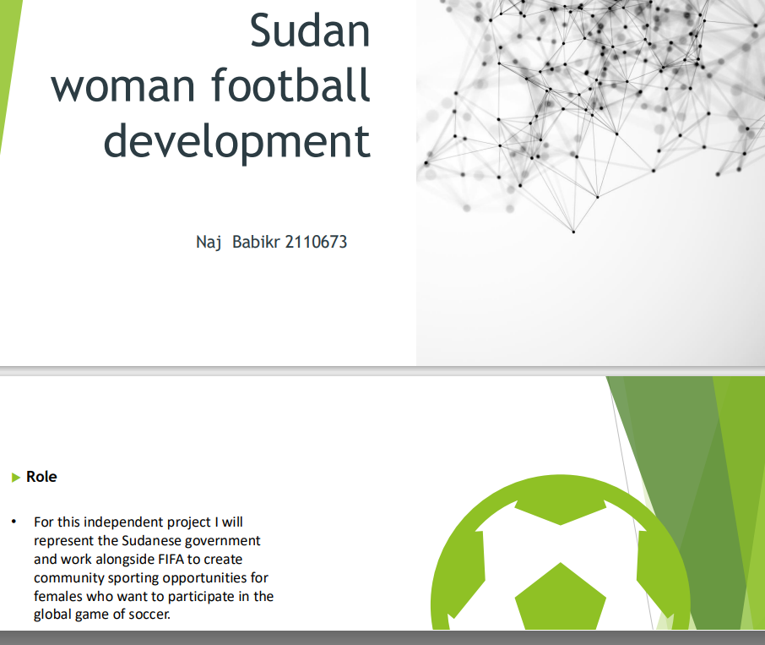

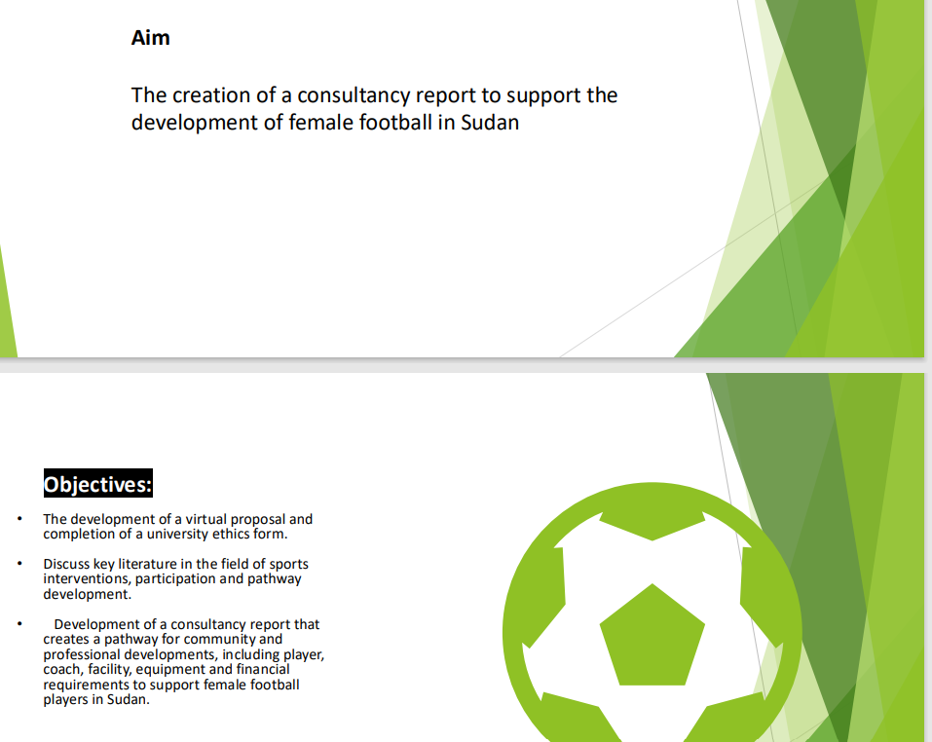

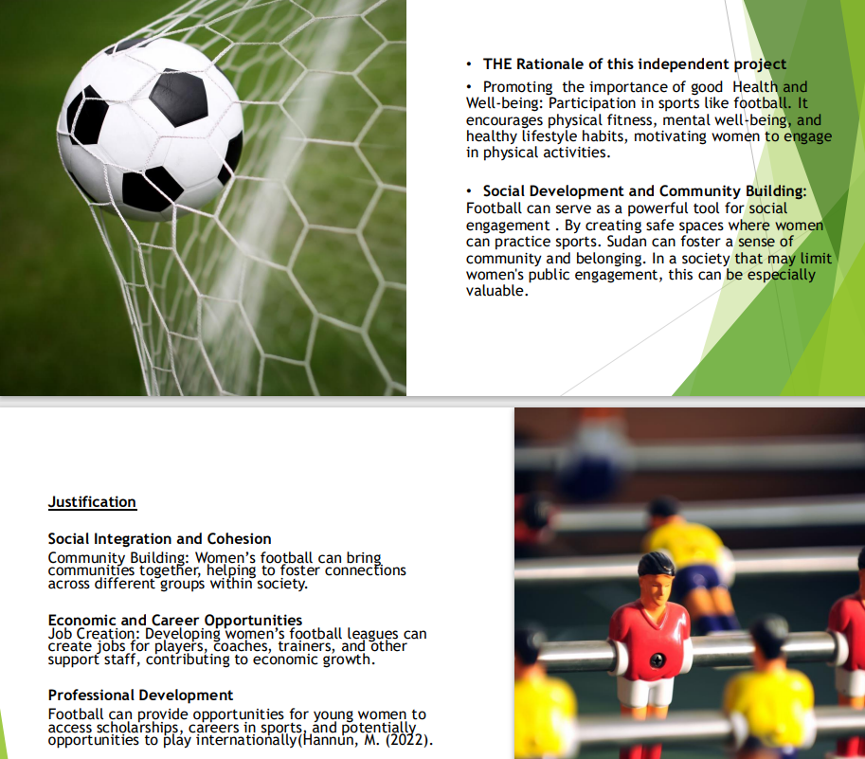

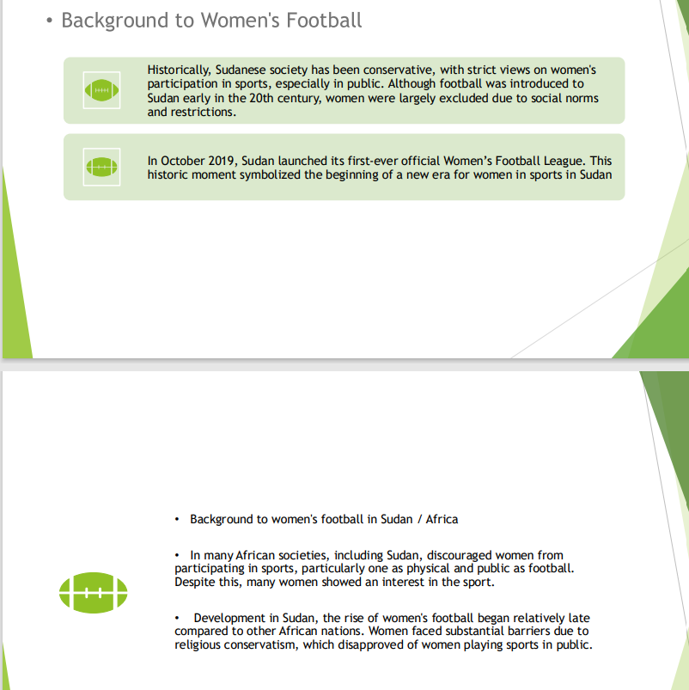

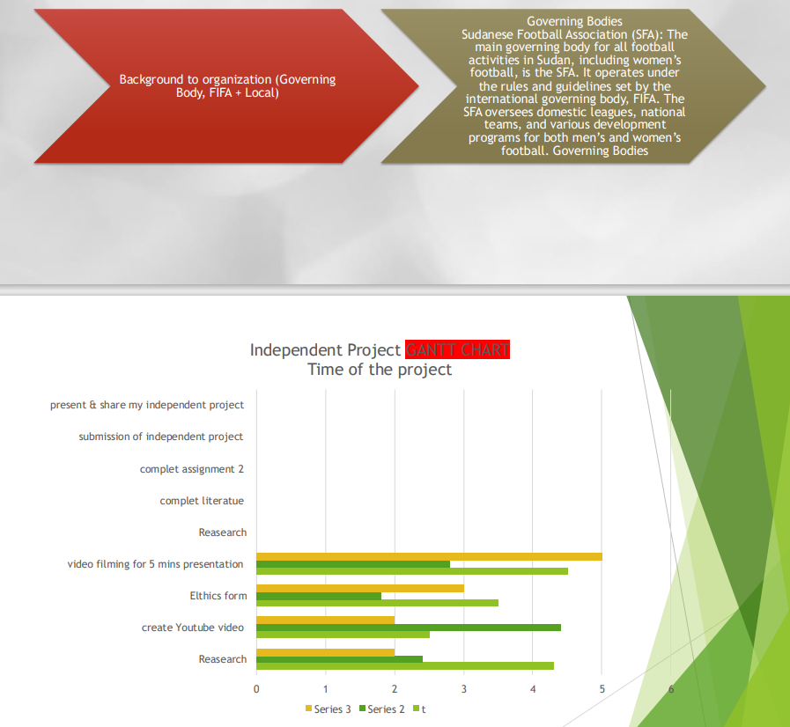

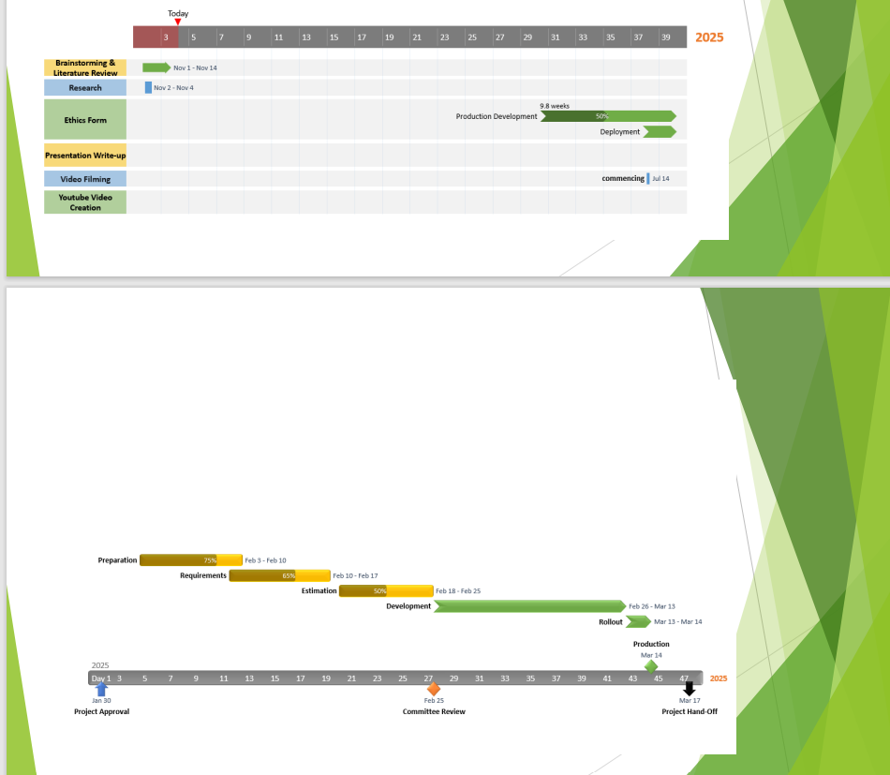

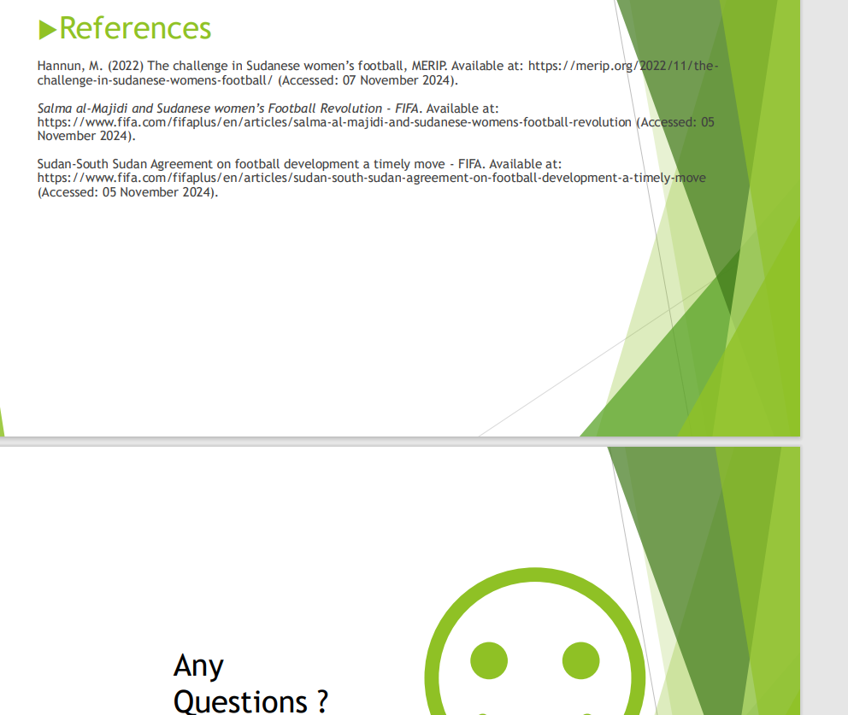

Element 1 – Ethics Form (All Pages)
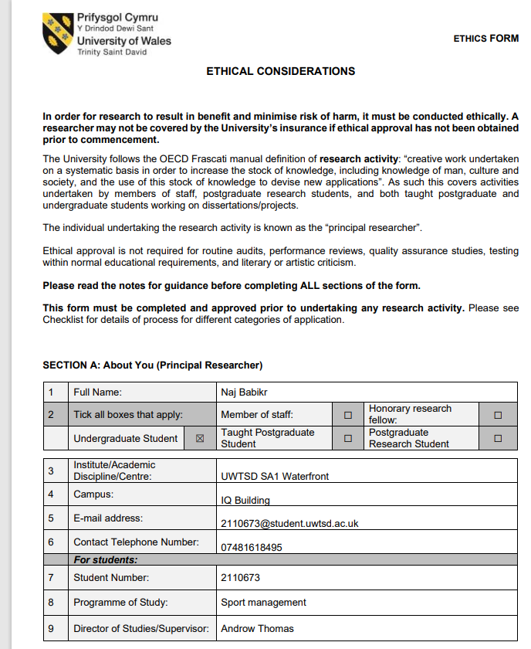

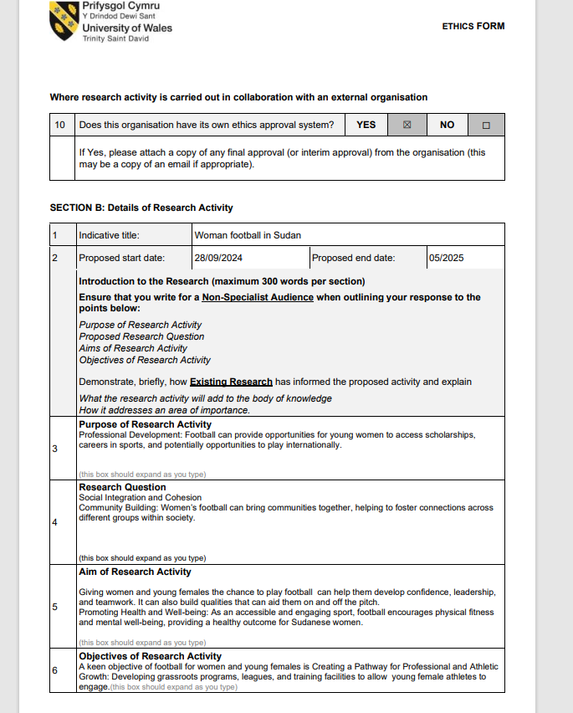

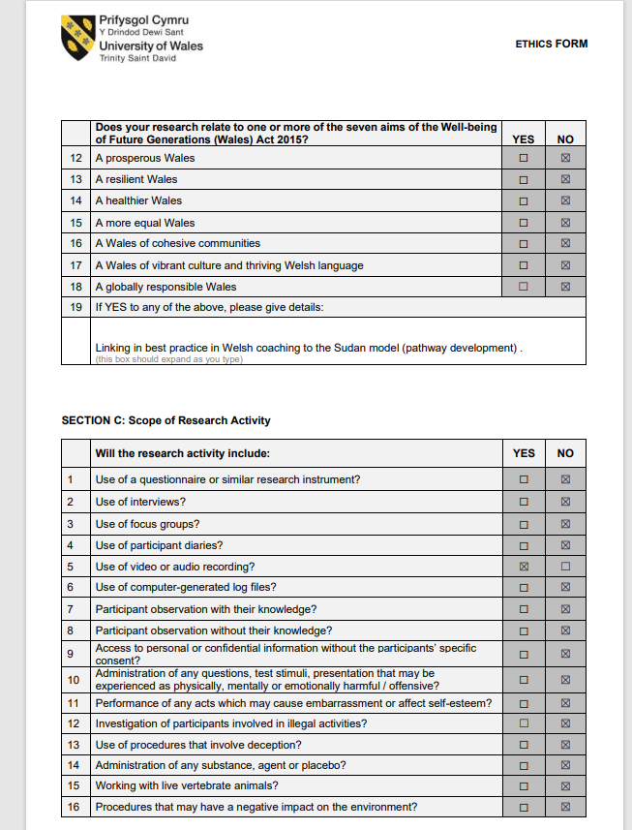

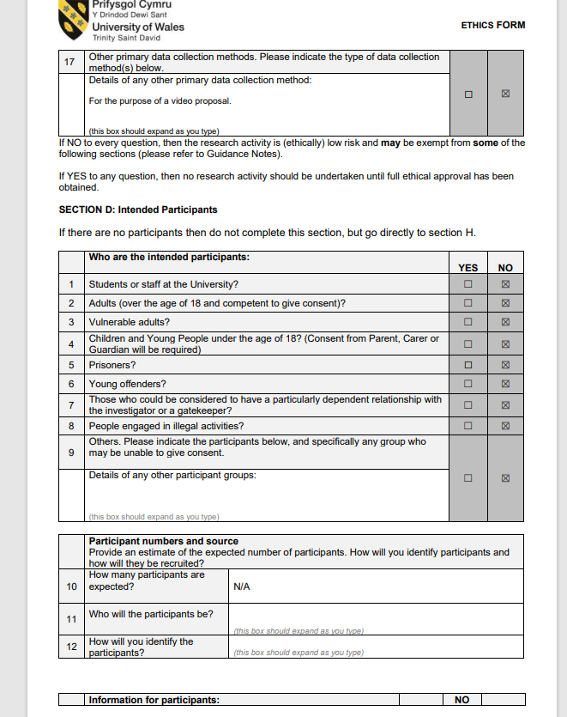

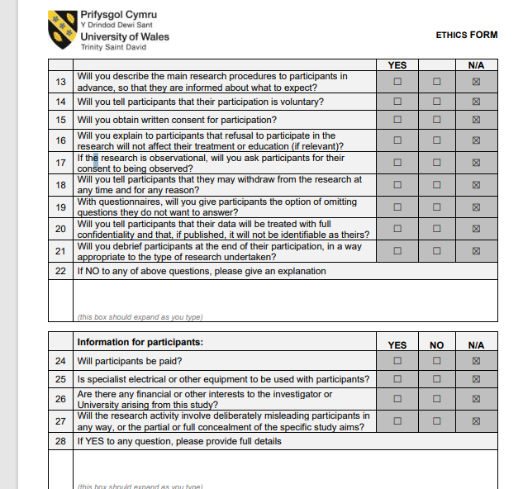

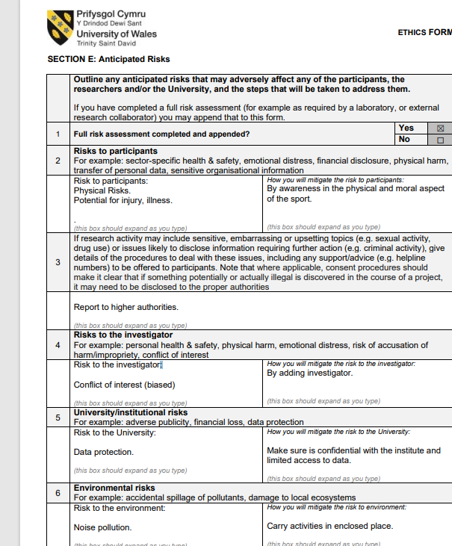

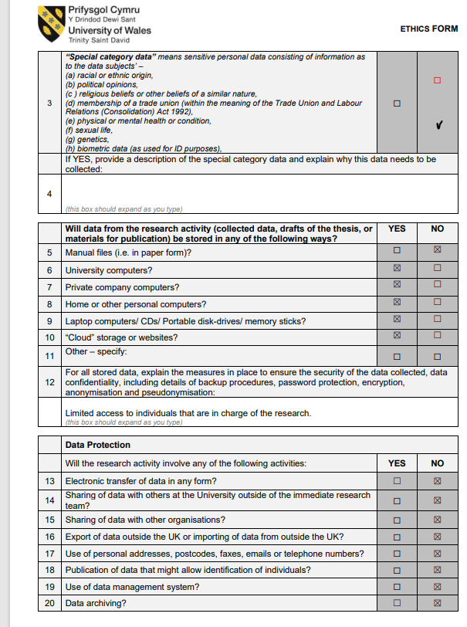
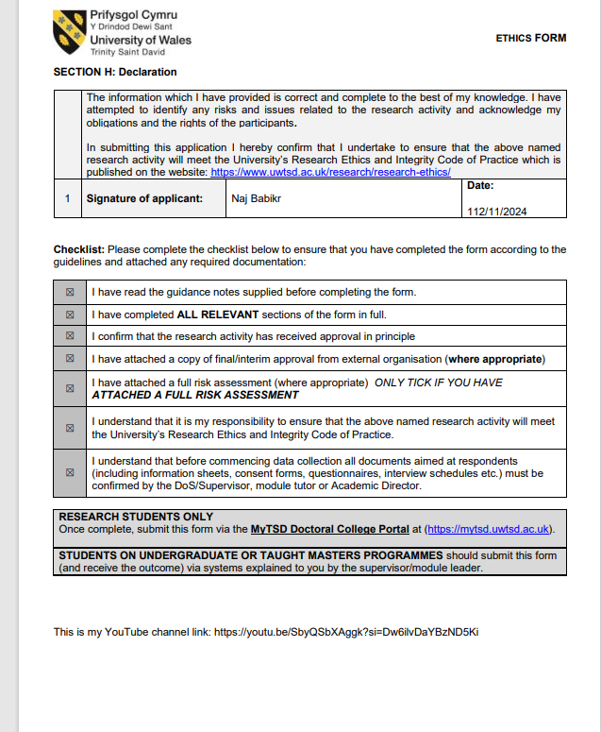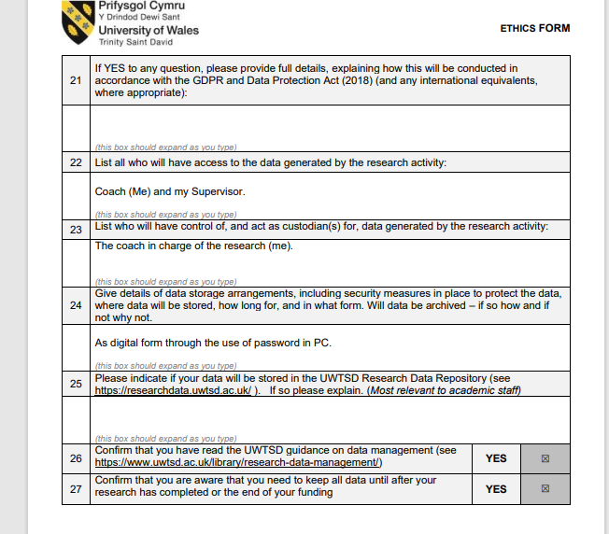

Element 2 - Literature Review (3000 words)

Section 1
Aim
- The creation of a consultancy report to support the development of female football in Sudan
Objectives:
- The development of a virtual proposal and completion of a university ethics form.
- Discuss key literature in the field of sports interventions, participation and pathway development.
- Development of a consultancy report that creates a pathway for community and professional developments, including player, coach, facility, equipment and financial requirements to support female football players in Sudan.
Section 2 – Introduction
Women's football in Sudan has encountered numerous challenges, rooted in cultural and societal barriers that limit opportunities for female athletes. Traditional norms and conservative attitudes towards gender roles have significantly impacted the participation of women in sports, creating a challenging environment for the development of women's football. One major hurdle has been the deep-seated societal expectations that prioritise traditional gender roles over women's involvement in sports. This has led to a lack of acceptance and support for female athletes, making it difficult for them to pursue a career in football. Cultural barriers have also contributed to a lack of visibility and recognition for women's football, preventing the sport from gaining the attention and respect it deserves (Tounsel et al., 2018).
Limited infrastructure poses another significant challenge. The lack of proper facilities, training grounds, and equipment hampers the growth and development of women's football in Sudan. Without adequate resources, female players face difficulties honing

their skills and competing at a high level. This infrastructure gap not only affects the quality of training but also restricts the organisation of competitive leagues and tournaments. Financial support remains a critical issue for women's football in Sudan. The lack of investment and sponsorship opportunities hinders the ability of women's teams to thrive and compete at both national and international levels. Financial constraints affect player development, coaching programmes, and overall infrastructure improvement, creating a cycle of limited progress. Despite these challenges, there have been commendable efforts to promote and develop women's football in Sudan. Women's football teams and leagues exist, showcasing the dedication and passion of female players and coaches. Individuals and organisations within Sudan are working tirelessly to break down barriers and advocate for gender equality in sports (Tounsel et al., 2018).
The Sudanese Football Association (SFA) has played a pivotal role in promoting women's football and encouraging participation at various levels. The association's involvement demonstrates a commitment to fostering inclusivity within the sport and addressing the obstacles faced by female players.
To gauge the status and recent developments in women's football in Sudan, it is advisable to consult up-to-date sources such as news reports, official statements from sports organisations, or women's football advocacy groups. Given the dynamic nature of sports landscapes, staying informed about the latest initiatives and progress in women's football will provide a more accurate picture of the current situation in Sudan (Tounsel et al., 2018).
Section 3 – What is a Consultancy Report
Sport development primarily centres on enhancing a particular sport and is often spearheaded by international federations or overarching organisations like the IOC, FIFA, and UEFA. This process entails strategic investments, heightened publicity, or other approaches to foster the growth of a specific sport or a chosen set of sports. The goal is to engage more individuals in various roles, including players, fans, sponsors, or advocates.

While the impact can be both positive and negative, successfully promoting a specific sport can lead to increased appreciation, participation, and involvement as coaches or volunteers, positively influencing the social well-being of a community. However, there are potential drawbacks, such as neglecting traditional games or creating a negative perception through flashy media representations, which may discourage certain individuals.

Applying consultancy reports to the sports landscape
This strategy outlines plans to enhance the Ministry of Youth and Sports' role in achieving national objectives related to youth engagement and sports development. It emphasizes organizing the sports sector, improving facilities, and broadening participation to achieve both local and global excellence.

Section 4 – Developing Sports in Emerging Nations
Sudan's government and other non-governmental organisations recognise the importance of sports in youth development and community cooperation. Initiatives to promote grassroots sports, develop new talent, and establish contemporary sports infrastructure have gained traction. Local leagues, tournaments, and academies have cropped up across the country, giving young athletes the opportunity to exhibit their skills and maybe make a name for themselves on a global scale. Sudan's participation in international sporting events not only demonstrates the country's physical skill but also provides a source of great pride. Sudanese athletes, whether competing in the Olympics, the African Cup of Nations, or regional basketball tournaments, excite the country with their perseverance, skill, and commitment (Times, 2023).
4.1 Sports Participation
Football, as it is known in some areas of the world, remains the most popular sport in Sudan. Local and national teams attract massive crowds of devoted supporters, transforming stadiums into brilliant displays of colour and energy. Basketball, athletics, and volleyball are also popular, and they have produced many outstanding athletes who

have helped Sudan achieve international reputation. The country's long legacy in wrestling, traditional Nuba sports, and equestrian activities highlights the varied range of sports that resonate with Sudanese people (Times, 2023).
4.2 Infrastructure developments
Football infrastructure in the future will need to incorporate innovation and sustainability into its design and construction. More sustainable infrastructure, whether in the form of new stadiums or renovated training facilities, will provide long-term environmental advantages while also leaving a legacy for local communities (UEFA, 2025).
4.3 Interventions
Understanding the Impact of War on Sudanese Football Sudan is currently embroiled in a devastating civil war that has resulted in the loss of approximately 150,000 lives and displaced over 14 million people from their homes. Amidst this chaos, football emerges as a beacon of hope and humanity, providing moments of relief for a war-torn nation. The ongoing conflict has transformed football grounds in Khartoum into silent memorials, yet the spirit of the sport continues to prevail, illustrating the profound connection between sports and society even in the darkest times (Football, 2024).
4.4 Pathway Development
Our player route offers young players aged five to sixteen the opportunity to advance their talents and develop their football abilities. We provide a pathway for development from invitation centres to advanced training centres and finally to our elite centres (for boys) and regional talent centres (for girls), which are located directly beneath Khartoum Sudan academy structure (Pathway, 2025).
4.5 Financial Support
FIFA President Gianni Infantino gave some critical messages during his visit to Khartoum, Sudan's capital, including increased investment and a pledge to additional support. The FIFA President had notable meetings with the Chairman of the Transitional Sovereignty

Council, Abdel Fattah al-Burhan, the Minister of Youth and Sports, Yousif Adam Aldai, and the President of the Sudan Football Association (FIFA, 2022).
The visit allowed the FIFA President and his party to revisit Sudan's rich football legacy. Sudan, a founding member of CAF alongside Egypt, Ethiopia, and South Africa, served as the organization's first headquarters and hosted the inaugural African Cup of Nations in 1957 (FIFA, 2022).
Closing the resource gap between men's and women's football remains a pressing concern. Increased investment in women's football infrastructure, coaching, and player development is essential to create a level playing field. International collaborations and partnerships can play a pivotal role in securing the necessary resources and expertise. The involvement of corporate sponsors, both local and international, can significantly contribute to the financial sustainability of women's football programs. This support can fund initiatives at all levels, from grassroots development to professional leagues, providing the necessary infrastructure and opportunities for female players (Shehu,2021).
4.6 The current situation of Sport in Sudan
Sudan Emergency Appeal: what is happening in Sudan?
Children are at risk as armed violence escalates in Sudan. Children have been murdered, injured, or displaced from their homes. The war is jeopardising essential services on which families rely, At the same time, a hunger is affecting children and families in northern Darfur, where a camp of 755,000 displaced persons exists (Sudan, 2024).
Where is Sudan?
Sudan is in northeast Africa and is one of the continent's largest countries, covering 1.9 million square kilometres (734,000 square miles).
Sudan's population is mostly Muslim, and its official languages are Arabic and English. Sudan was already among the world's poorest countries before the war began. In 2022, its 46 million people had an average annual income of $750 (£600) per.
Who is fighting who in Sudan
Following the 2021 coup, Sudan was governed by a council of generals, led by the two military officers at the core of this dispute: Gen Abdel Fattah al-Burhan, the leader of the armed forces and, effectively, the country's president. His deputy and the leader of the Rapid Support Forces (RSF), Gen Mohamed Hamdan Dagalo, also known as "Hemedti. They clashed on the country's future course and the intended transition to civilian administration. The primary issues were plans to incorporate the 100,000-strong RSF into the army and who would lead the new force. Both generals were suspected of wanting to maintain their positions of authority, unwilling to lose wealth and influence.
How has the world responded to the war?
Accusing the international community of "forgetting" the African nation, the UN and other prominent humanitarian organisations have issued several alarming warnings over the situation in Sudan.
Other nations have also tried to set up talks between the RSF and the army. Bahrain and Saudi Arabia have held multiple rounds of peace negotiations, but none of them have succeeded. The UN and the African Union share the goal of bringing the army and RSF together and establishing a ceasefire (BBC, 2024).
On his first visit to Chad-Sudan, Foreign Secretary David Lammy witnessed the impact of UK aid on nearly 800,000 people in the border town of Adre. The UK also addressed upstream migration drivers as part of the FCDO's efforts to secure borders. Refugees escaping war-torn Sudan will receive increased UK aid to enhance food production and critical sexual and reproductive health services, as Foreign Secretary Boris Johnson announces £20 million in additional money during a visit to Adré on the Chad-Sudan border (GOV.UK, 2025).

This follows the UK's November tripling of aid to Sudan to £226.5 million to meet the humanitarian disaster. These UK funding are providing emergency food assistance to approximately 800,000 displaced persons, with women and children accounting for more than 88%, as well as boosting access to shelter, drinking water, emergency health treatment, and education (GOV.UK, 2025).

This aid is not only critical for humanitarian reasons, but it will also help people stay in their immediate region, making it easier for them to return when conditions allow. Since the crisis began, 3.6 million refugees have fled to surrounding countries, with a large number moving on to Europe and the United Kingdom (GOV.UK, 2025).

- Section 5 - Football in North East Africa
However, African countries have had modest success in international tournaments. East African countries have not qualified for the World Cup, Olympics, or Africa Cup of Nations. Countries that have represented Africa at the FIFA World Cup include some of the continent's best. East African teams from Kenya, Uganda, and Tanzania face challenges in qualifying due to a restricted number of nations. It is hardly surprising that no East African team has qualified for the World Cup or won the Africa Cup of Nations. Despite consistently participating in regional competitions, East African teams have yet to break through (Wycliffe, 2014).
Sudan Early Adopter: Sudan was one of the founding members of the Confederation of African Football (CAF) in 1957.
National Team: Though not as dominant now, Sudan won the Africa Cup of Nations in 1970.
Key Clubs:
Al Hilal Omdurman and Al Merrikh are the country’s top clubs, with a fierce rivalry.
Football remains popular, but infrastructure and development challenges have limited recent international success.
Historical Success: Ethiopia was another founding CAF member and won the AFCON in 1962.
Passion for Football: While domestic football struggles with limited resources, the Ethiopian Premier League has a loyal fan base.
National Team: The Walia Ibex have seen limited recent success, but they are working to reclaim their place in African football.
The love for European leagues, especially the English Premier League, is strong among Ethiopian fans.
Football in Eritrea is less developed compared to its neighbours due to political and economic challenges.
National Team: Eritrea has struggled to make a significant mark internationally. However, football remains a popular pastime, particularly among the youth.
Many Eritrean players who have emigrated contribute to the sport abroad.
Football Culture Regional Rivalries: Matches between countries in North East Africa often carry immense significance and passion. Youth Development: Across the region, youth football is growing, with efforts to harness raw talent and improve grassroots structures. European Influence: Many players and fans from North East Africa are deeply connected to European football, with leagues like the Premier League, Serie A, and La Liga being widely followed.
- 5.1 - Football in Sudan
It's interesting to note that once Sudan joined FIFA in 1948, it was one of the founding members of the Confederation of African Football (CAF). Sudan was kept in the dark by a conservative society and stringent legislation, while women's football saw growth in the other founding members, South Africa and Egypt. The 2018–18 Sudanese revolution brought positive developments for women's football. A women's league including 21 teams from various cities was founded in September 2019. It was the first action taken by the interim administration to increase the social acceptance of female athletics. Reuters described how the Elta Hadi and Eldifaa teams adorned the nation's oldest sports stadium in the capital, Khartoum, for the league's debut match in October, to the cheers of both male and female fans in the grandstand (Neys et al., 2023).
- 5.2 - Women’s Football in Sudan
Women's football development in Sudan has been navigating a landscape marked by a complex interplay of cultural, societal, and institutional challenges. As of my last knowledge update in January 2022, concerted efforts have been made to overcome these hurdles and foster the growth of women's football in the country. Sudan, much like many other regions, grapples with deeply entrenched norms that historically hindered the progress of women in sports, particularly in the competitive realm of football. However, positive strides have been taken to address these issues and promote inclusivity within the sport (Kirk et al., 1982).
Following Sudan's independence in 1956, men's football continued to thrive and play an important role in the development of football in Africa. The first Africa Cup of Nations was held in 1957 in Sudan, which had recently gained independence. Sudan, along with Egypt, Ethiopia, and South Africa, founded the Confederation of African Football (CAF), with Khartoum serving as the organization's inaugural headquarters. Under Omar al-Bashir's Islamist government (1989-2019), the number of registered football teams and stadiums increased throughout the country. The rivalry between Sudan's two largest men's clubs, Al-Merrikh and Al-Hilal, became a popular spectator sport, with games frequently drawing sold-out crowds (Al-Hassan, 2022).
In the 1990s, both the CAF and FIFA began encouraging African football associations to form female teams, and the sport began to flourish considerably in the early 2000s. Unlike the men's game, al-Bashir's Islamic authorities made multiple clear attempts to restrict women's football. Sudan's Islamic Fiqh Council issued a series of fatwas in 2006, 2012, and 2016 that targeted women's football. The 2012 fatwa, given explicitly in response to women's requests to establish a football league for women in Sudan, said that: A woman is allowed to participate in sports that protect her health." Football should only be for men; it does not fit ladies (Al-Hassan, 2022).

Element 3 – 5000 Word Document or 30 minute Video

Project Aim
The creation of a consultancy report to support the development of female football in Sudan.

Objectives
• The development of a virtual proposal and completion of a university ethics form.

• Discuss key literature in the field of sports interventions, participation and pathway
development.

• Development of a consultancy report that creates a pathway for community and professional developments, including player, coach, facility, equipment and financial requirements to support female football players in Sudan.

Introduction
Football is the most popular sport in Sudan, yet female participation has faced numerous cultural, social, and logistical barriers. While football has long been ingrained in Sudanese society, its accessibility and acceptance for women remain limited due to deeply rooted societal norms, lack of institutional support, and inadequate infrastructure. The development of female football in Sudan requires a structured and strategic approach to address these challenges and create a sustainable environment for growth. This consultancy report aims to provide a comprehensive framework to support the development of female football in Sudan by assessing the current landscape, identifying challenges, and recommending actionable strategies for long-term success.

Historical Overview of Female Football in Sudan
Female football in Sudan has struggled to gain recognition due to deep-rooted cultural perceptions, lack of institutional support, and limited infrastructure. While men's football has enjoyed relatively widespread acceptance, women have historically been discouraged from participating in sports. However, in recent years, efforts have been made to change this narrative, culminating in the Sudanese Football Association (SFA) launching the first official women's football league in 2019. Despite this milestone, significant obstacles remain (Furukawa, M., 2023, September).
Historically, sports in Sudan, including football, have been largely male-dominated, influenced by conservative societal norms that emphasise traditional gender roles. Women’s participation in sports has often been met with resistance, with many believing that athletic activities are inappropriate for women. This mindset has contributed to the lack of development in female football, as opportunities for women to play and train have been extremely limited. Before the formal establishment of women’s football structures, informal and underground teams existed in Sudan, formed by women passionate about the game. These teams often played in private settings, away from public scrutiny, as there was no official recognition or support from governing bodies. Women who attempted to engage in football faced societal backlash, discouragement, and even threats, further marginalising their presence in the sport (Osman Ali Ahmed, A., 2012).
Current State of Female Football in Sudan
The Sudanese women's league comprises multiple teams across different regions, yet it continues to face significant challenges due to inadequate funding and a lack of consistent organisational support. Many teams struggle with poor training facilities, limited access to professional coaching, and societal barriers that discourage women's participation in sports. The lack of proper infrastructure means that teams often train in substandard conditions, with insufficient equipment and minimal financial backing (Tounsel, C., 2018).

Despite these obstacles, there has been a notable rise in interest from young girls eager to play football. Their enthusiasm highlights a growing passion for the sport, fuelled in part by international exposure and social media. However, the absence of a structured development system makes it difficult for these aspiring players to receive proper training and competitive opportunities. Many promising athletes are forced to abandon their ambitions due to financial constraints and societal expectations.
In recent years, efforts have been made by local activists and organisations to promote women's football in Sudan. Some clubs have received limited sponsorships, and tournaments have been organised to showcase talent. International bodies such as FIFA have also expressed interest in supporting women's football development in the country. However, long-term sustainability remains uncertain without a dedicated national strategy to nurture female athletes and integrate them into the mainstream sports culture (Onwumechili, C., 2024).
To ensure the growth of the Sudanese women's league, increased investment and support from both the government and private sector are necessary. Establishing training academies, improving facilities, and fostering a more inclusive sports environment will be key steps in advancing women's football in Sudan. By addressing these challenges, the league can provide greater opportunities for talented female athletes and inspire a new generation of players.

1. Cultural and Societal Barriers

Sudanese society is deeply rooted in conservative traditions, where gender roles play a significant role in shaping social expectations. One area where this is particularly evident is in women’s participation in football. Many families discourage their daughters from playing the sport, believing it to be unsuitable for women. This opposition is driven by cultural norms that associate physical activity, especially competitive sports, with masculinity. As a result, young girls interested in football often face resistance from their families and communities. The stigma surrounding women in sports in Sudan creates numerous challenges. Girls who express a desire to play football may be met with criticism, social ostracisation, or even restrictions imposed by their families. Some are told that sports will interfere with their education or future responsibilities as wives and mothers. The lack of societal support significantly reduces the number of women who pursue football, leading to low participation rates (Busse, J. and Wildangel, R., 2023).
Despite these barriers, some women in Sudan have defied traditional norms to pursue their passion for football. Over the years, female footballers and advocates have worked tirelessly to challenge stereotypes and create opportunities for women in the sport. The establishment of Sudan’s women’s national football team was a groundbreaking step, showcasing the potential and determination of female athletes. However, progress remains slow due to limited resources, societal pressures, and lack of institutional support.
For Sudanese women’s football to grow, there needs to be a shift in cultural perceptions, increased investment in women’s sports, and supportive policies that encourage female participation. Role models, awareness campaigns, and community engagement can help change attitudes and promote inclusivity. While challenges persist, the determination of Sudanese women to play football highlights the potential for gradual societal transformation (Busse, J. and Wildangel, R., 2023).
2. Lack of Infrastructure and Facilities

First Football Stadium Built in Sudan: A New Era for Sports Development.
Get ready, Sudan! The roar of the crowd, the thunderous applause, and the exhilarating atmosphere—these are no longer distant dreams. Sudan has officially inaugurated its first-ever football stadium, marking a significant milestone in the country’s sports development. This historic project stands as a testament to the nation’s growing passion for football and its commitment to fostering a thriving sports culture (Osman Ali Ahmed, A., 2012).
For decades, football has been a beloved sport in Sudan, played in open fields and improvised spaces. However, the absence of a dedicated, modern football stadium has hindered the growth of the sport at both grassroots and professional levels. The construction of this stadium signals a new chapter, one that promises to redefine the landscape of sports in Sudan and provide opportunities for aspiring footballers to train and compete at an international standard.

The stadium is equipped with state-of-the-art facilities, including a well-maintained pitch, modern seating arrangements, high-quality lighting, and top-tier security measures. It is designed to host both domestic and international matches, offering Sudanese football teams a much-needed home ground to showcase their talent. This development is expected to attract international teams and tournaments, bringing global attention to Sudan’s football scene.

Despite this remarkable progress, challenges remain, particularly concerning inclusivity in Sudanese football. Most existing football facilities in Sudan are designed exclusively for men, leaving female players with limited access to training grounds, changing rooms, and playing fields. This severe shortage of women-friendly sports infrastructure has long hindered the development of women’s football in the country.
With the construction of the new stadium, there is hope that Sudanese authorities and sports organisations will take proactive steps to promote gender-inclusive policies. Advocates are calling for designated spaces and equal opportunities for female footballers, ensuring that the stadium becomes a symbol of inclusivity and progress in Sudanese sports.
This landmark achievement is just the beginning. The first football stadium in Sudan represents not only a victory for sports enthusiasts but also a catalyst for further infrastructure development. As the stadium opens its doors to passionate fans and dedicated players, it paves the way for a brighter future where football thrives and unites people across the nation.
3. Limited Funding and Sponsorship in Female Football in Sudan
The development of female football in Sudan faces significant challenges due to a lack of financial support from both the government and private sponsors. Without sufficient funding, clubs struggle to cover essential expenses such as equipment, travel costs, and salaries for coaching staff. This financial strain directly affects the growth and quality of the sport, limiting opportunities for female players to develop their skills and compete at higher levels (Osman Ali Ahmed, A., 2012).

One of the primary reasons for this funding gap is the limited investment from the government in women’s sports. While men’s football receives relatively more attention and financial backing, women’s teams are often left with minimal resources, making it difficult for them to train effectively or participate in national and international tournaments. The lack of government funding also impacts grassroots programmes, which are crucial for identifying and nurturing young female talent.

Private sponsorship is another major challenge. Many businesses hesitate to invest in female football due to societal perceptions and a perceived lack of commercial returns. Without corporate backing, clubs find it difficult to secure high-quality facilities, medical care, and other essential resources. This discourages talented female athletes from pursuing football as a viable career, further weakening the development of the sport. The absence of consistent financial support also affects media coverage and public interest in women’s football. Limited visibility reduces the chances of attracting new sponsors or increasing fan engagement, creating a cycle of underfunding and low participation (Furukawa, M., 2023).

To overcome these challenges, it is crucial for both the government and private sector to recognise the potential of female football in Sudan. Increased investment, sponsorship deals, and media exposure can help strengthen the sport, empowering female athletes and fostering a more inclusive football culture in the country.

4. Inadequate Coaching and Training Programs
One of the major challenges facing women's football in Sudan is the shortage of qualified female football coaches. The development of any sport depends heavily on the quality of coaching and training programmes, but in Sudan, female teams often rely on volunteer coaches with little or no professional training. This lack of expertise directly impacts the quality of play, player development, and the overall competitiveness of women's football in the country (Kalliovaara, T., 2024).

Due to limited investment in women’s sports, there are few training programmes specifically designed to develop skilled female coaches. Many aspiring coaches face financial and societal barriers that prevent them from pursuing formal coaching certifications. Additionally, there are cultural and institutional biases that discourage women from entering the coaching profession. As a result, many teams are led by individuals who may have a passion for the game but lack the necessary technical knowledge and tactical skills to effectively train and develop players.
The absence of structured training programmes also affects player development. Young female footballers do not receive the same level of tactical and technical instruction as their male counterparts, limiting their ability to compete at higher levels. This gap in coaching quality makes it difficult for Sudanese women’s teams to perform well in regional and international competitions. To address this issue, there is a need for targeted initiatives to train and certify more female football coaches. Football federations, NGOs, and international organisations should invest in coaching education programmes, providing scholarships and mentorship opportunities for women interested in coaching. Additionally, partnerships with established football associations could help bring in experienced trainers to enhance coaching standards. By improving the quality of coaching, Sudanese women’s football can reach its full potential and gain greater recognition on the global stage (Kalliovaara, T., 2024).

5. Absence of Youth Development Programmes
The lack of youth development programmes is a major obstacle to the growth of women’s football in Sudan. Unlike men’s football, which benefits from well-established academies and structured training pathways, there are very few grassroots initiatives dedicated to nurturing young female talent. This absence significantly limits the pipeline of skilled players, making it difficult to sustain and develop the sport in the long run.

Without proper training from an early age, aspiring female footballers struggle to reach their full potential. The lack of investment in youth programmes means that many talented girls either abandon their dreams due to a lack of opportunities or face significant challenges in
progressing to professional levels. Additionally, the absence of structured competitions for young female players further discourages participation and growth. Grassroots development is essential for building a strong foundation for any sport. If Sudan wants to improve women’s football, there must be efforts to establish youth academies, school programmes, and local leagues that provide young girls with proper coaching, facilities, and competition. Encouraging investment in youth development will ensure a steady flow of talented players, ultimately strengthening women’s football and paving the way for future success on national and international stages (ASTEWEL, M., 2023).

6. Changing Cultural Perceptions and Advocacy
To foster a cultural shift towards the acceptance of women’s participation in football, awareness campaigns should be strategically implemented to educate communities on the numerous benefits of female involvement in sports. These campaigns can highlight how sports help build confidence, leadership skills, and a sense of belonging, breaking down stereotypes that limit women’s roles in society (ASTEWEL, M., 2023).
Engaging religious and community leaders plays a crucial role in changing cultural norms. These leaders have significant influence and can act as advocates for women's football, emphasising its potential to empower women and contribute to broader social development. By framing football as a tool for personal growth, unity, and societal progress, these leaders can help shift traditional views that discourage female participation in sports. Furthermore, leveraging media platforms is essential for spreading awareness and inspiring the next generation of female athletes. Showcasing the success stories of Sudanese female footballers can serve as a powerful tool to inspire young girls. Highlighting these athletes as role models not only motivates others to follow in their footsteps but also helps normalise women in sports. The visibility of successful female athletes challenges prevailing gender norms and demonstrates the transformative power of sport. By amplifying these stories through television, social media, and other platforms, a greater sense of possibility can be instilled in young girls, motivating them to pursue football and other sports without fear of judgement or limitation (Furukawa, M., 2024).

7. Enhancing Infrastructure and Facilities

To support the growth and development of women’s sports, it is essential to prioritise the construction of women-friendly sports facilities. Investing in these facilities will not only provide female athletes with spaces to train and compete, but it will also encourage more women to get involved in sports. These facilities should be designed with female athletes’ needs in mind, including proper lighting, locker rooms, showers, and access to physiotherapy and medical services. This infrastructure investment helps create an environment where female athletes can thrive and feel respected (Osman Ali Ahmed, A., 2012).

In addition, forming partnerships with schools, universities, and local communities is crucial to providing accessible playing fields for female footballers. By ensuring that these fields are available for use and are of high quality, we can give female athletes the opportunities they need to practise and play. Schools and universities can play an important role in making these fields more accessible and promoting sports among young women.
Lastly, ensuring safe and secure environments for female athletes is non-negotiable. Whether it’s for training, competitions, or practice sessions, female athletes must feel safe and supported in their sports environment. This includes implementing measures to protect against harassment, providing secure transportation, and establishing clear policies to address safety concerns. Creating an environment that promotes both physical and emotional security will empower women to pursue their athletic ambitions without fear or hesitation. Together, these efforts will enhance the overall experience for female athletes and foster their growth in the world of sports (Osman Ali Ahmed, A., 2012).

8. Securing Funding and Sponsorship

Securing funding and sponsorship is critical for the growth and sustainability of women’s football. One of the most effective strategies is to encourage private sector investment by highlighting the commercial potential of the sport. As the popularity of women’s football continues to grow globally, businesses are increasingly recognising the value of supporting women’s sports as part of their corporate social responsibility and branding efforts. By showcasing the financial success stories of women's leagues and players, we can attract more corporate sponsorships and investments (Osman Ali Ahmed, A., 2012).
Additionally, seeking international funding and grants is another vital avenue. Organisations such as FIFA, along with various NGOs that support gender equality in sports, offer financial backing and development programmes for women’s football. These grants are often designed to promote inclusivity and provide resources for the growth of the sport at all levels, from grassroots to professional leagues.

On a national level, governments can play a significant role by establishing policies that mandate financial support for female sports initiatives. This can include earmarking specific funds for women’s football programmes, providing tax incentives for sponsors, and ensuring that financial resources are distributed equally between men’s and women’s sports. Such policies can provide the necessary foundation to ensure long-term investment in the development of women’s football. By combining these efforts, it is possible to create a more sustainable financial ecosystem for women’s football, helping to drive its continued growth and success (Osman Ali Ahmed, A., 2012).
9. Coaching Development and Training Programmes
To elevate the quality of coaching for women in football, it’s essential to develop comprehensive and accessible training programmes. These programmes should be designed specifically for female coaches at all levels, ensuring they receive high-quality, relevant education and development opportunities. Such programmes can cover various aspects of coaching, including technical skills, leadership, tactical knowledge, and communication. By offering flexible training formats such as online courses, workshops, and hands-on coaching sessions, we can cater to different learning styles and schedules, enabling coaches to thrive. Partnering with international football organisations to offer accredited coaching certifications for women is another critical step. This collaboration can provide female coaches with globally recognised qualifications that enhance their credibility and career prospects. Access to these certifications will help close the gender gap in football coaching, ensuring women have the same opportunities as men to advance in their careers (Tounsel, C., 2018).

In addition to formal training, mentorship programmes should be encouraged and established. Experienced coaches, especially those who have excelled in the field, can serve as mentors, guiding and inspiring young female coaches. These mentorship relationships would provide invaluable insights into the realities of coaching, professional growth, and overcoming challenges. By facilitating such programmes, we can create a supportive network of female coaches who inspire and uplift each other. This sense of community is vital for the long-term success and development of women’s football coaching. By focusing on education, certification, and mentorship, we can build a stronger, more inclusive coaching environment for women.
10. Creating Youth Development Programmes
Establish Grassroots Football Academies Specifically for Young Girls:
Recruit experienced female coaches to act as role models and mentors for the girls, ensuring they have relatable figures to look up to. Offer scholarships or financial support for girls from lower-income families to make sure economic barriers don't prevent talent from being discovered. Create a safe and inclusive environment where girls of all skill levels feel welcome and encouraged to participate. Focus on personal development alongside football skills, teaching life skills such as teamwork, leadership, and discipline. Integrate Football into School (Saavedra, M., 2003)
Curricula to Promote Early Participation:
Work with education authorities to incorporate football into physical education lessons, ensuring all students, regardless of gender, have access to the sport.
Organise after-school football clubs or leagues where girls can practise and play regularly.
Offer coach education to school teachers so they can provide a quality football experience and actively encourage girls to participate. Collaborate with universities and sports organisations to create pathways for students who excel in football at the school level to continue their development (Saavedra, M., 2003).
Organise Youth Tournaments to Identify and Nurture Young Talent:
Host age-specific tournaments that allow young players to showcase their skills in competitive environments, providing scouts with the opportunity to spot talent early.
Create regional or national competitions for girls, so they can compete against peers from different areas and test their skills at higher levels.
Develop player development programmes linked to tournaments, where players receive feedback from experienced coaches and are supported in improving their skills (Saavedra, M., 2003).
Short-Term Goals (1-2 Years)
Conduct Awareness Campaigns and Workshops on Female Football:
Raise awareness about women's football by organising campaigns and workshops. These initiatives will focus on highlighting the benefits of football for women, addressing gender stereotypes, and encouraging more female participation. Engaging local communities, schools, and universities will help build a solid foundation for long-term growth (Okada, C., 2024).

Identify and Rehabilitate Existing Facilities for Women’s Football:
Assess and identify underutilised or inadequate facilities that can be refurbished to meet the needs of women’s football teams. This includes improving fields, locker rooms, and training equipment. Upgrading these facilities will provide women with safe and professional environments for training and competition, encouraging more girls and women to take up the sport (Okada, C., 2024).
Launch Training Programmes for Female Coaches and Referees:
Develop specialised training programmes aimed at empowering women as football coaches and referees. By providing these programmes, we’ll help bridge the gender gap in coaching and officiating, ensuring that women can progress to leadership roles within the sport. The training will be designed to attract aspiring coaches and referees from all backgrounds.

Secure Initial Sponsorship Deals to Support Club Operations:
Work towards obtaining sponsorships from local businesses and larger organisations to secure financial backing for the club’s operations. These partnerships will be crucial in covering costs for equipment, coaching staff, and tournament participation. Establishing sponsorships in the early stages ensures the sustainability of the club.
Medium-Term Goals (3-5 Years)
In the next 3 to 5 years, the primary goal is to expand the women’s football league across Sudan, incorporating more teams from diverse regions to create a broader and more inclusive league structure. This expansion will help elevate the visibility of women’s football throughout the country. Alongside this, there will be a focus on establishing at least three major female football academies in different regions of Sudan. These academies will aim to nurture young talent and provide specialised training for women at all levels, ensuring that the pipeline for future professional players remains strong. To support these efforts, partnerships with international football organisations will be strengthened to secure funding and provide training resources, contributing to the overall growth and professionalisation of women's football in Sudan (Okada, C., 2024).

Long-Term Goals (5+ Years)
Over the long term, the vision is to develop a comprehensive national strategy for women’s football that aligns with FIFA's broader women’s football strategy. This strategy will serve as the roadmap for the growth and development of the sport in Sudan. Another key objective is the establishment of a professional women’s football league, which will have sustainable revenue streams, ensuring that it can operate independently and continue to grow. Additionally, the ultimate goal is to see Sudan’s women’s national team qualify for major international tournaments, such as the African Women’s Cup of Nations or the FIFA Women’s World Cup, showcasing the progress of the sport in the country (Osman Ali Ahmed, A., 2012).

Reflection / Conclusion / Recommendations (key learning points)

Section 6 – Conclusion and Justification
The development of women's football in Sudan represents a vital step toward gender equality and social progress, overcoming significant cultural, societal, and infrastructural barriers. The challenges facing women's football in Sudan include deeply rooted societal norms, limited resources, inadequate infrastructure, and a lack of financial investment. However, the resilience and passion of female players, coupled with the efforts of organisations like the Sudanese Football Association (SFA) and international bodies such as FIFA, highlight the potential for progress.

To create a sustainable pathway for women's football, it is essential to invest in infrastructure, coaching, player development, and financial support while promoting grassroots initiatives. Collaboration between governmental and non-governmental organisations, corporate sponsorships, and international partnerships will be crucial in providing the necessary resources and expertise. Additionally, fostering community engagement and addressing cultural barriers can help create a more inclusive environment for women in football.

Despite the ongoing civil war and its devastating impact on the country, football remains a unifying force and a beacon of hope for Sudan. Initiatives to support female players, coaches, and leagues must persist, leveraging football’s potential to inspire resilience and drive social change. By addressing these challenges and building on recent developments, Sudan can establish a vibrant and sustainable framework for women's football, fostering talent and promoting gender equity within the sport.

The development of female football in Sudan represents both a challenge and an opportunity, requiring a multifaceted approach that addresses cultural, financial, and infrastructural barriers. Despite the progress made in recent years, the journey toward fully integrating women into the country’s football landscape remains complex. However, with commitment from stakeholders including the government, private sector, international organisations, and local communities, Sudan can foster a supportive environment for female footballers. One of the most significant barriers to female football development in Sudan is cultural perception. In many parts of the country, societal norms discourage women from participating in sports, viewing it as an activity primarily suited for men. These traditional mindsets create resistance to change, making it difficult for female athletes to gain recognition and respect. However, as awareness about gender equality grows and more success stories of female athletes emerge, these perceptions can gradually shift. Education campaigns, media representation, and advocacy from influential figures can play a crucial role in changing attitudes and normalising women’s participation in football (Abur, W., 2018).
In addition to cultural challenges, Sudan lacks adequate infrastructure for female football. The limited number of facilities dedicated to women’s sports makes it difficult for female players to train and compete at a high level. Many clubs and academies are underfunded, and the absence of well-maintained fields, locker rooms, and training equipment further restricts opportunities for female athletes. To address this, investments in sports infrastructure must be prioritised, ensuring that women have access to safe and appropriate facilities. Partnerships with international sports organisations and NGOs could provide the necessary resources to improve training grounds and build new stadiums specifically designed to support female athletes. Securing sustainable funding is another crucial factor in the growth of women’s football in Sudan. Many female teams struggle due to a lack of financial support, limiting their ability to participate in national and international competitions. Government funding, private sponsorships, and partnerships with global football organisations could provide the necessary financial backing to sustain female teams. Establishing a structured financial model—where revenues from men’s football contribute to the development of the women’s game—could also help create a more balanced and sustainable system.
Furthermore, incentivising businesses to invest in women’s football through tax benefits or public recognition could encourage corporate sponsorships and donations (Abur, W., 2018).

Coaching and technical development are equally vital in ensuring female footballers receive high-quality training. The presence of skilled coaches, specifically trained in women's football, will improve player performance and help build a competitive national team. Implementing coaching programmes, scholarships for female coaches, and exchange programmes with other countries could enhance the quality of training available to Sudanese women in football. Additionally, mentorship from established female footballers can inspire young players and provide valuable guidance. Youth development programmes play a crucial role in sustaining the future of female football in Sudan. By introducing football at the grassroots level, young girls can develop their skills early and gain confidence in pursuing a football career. Schools should integrate football into their physical education curriculum, and local football clubs should actively encourage female participation. By creating accessible pathways for young girls, Sudan can build a strong pipeline of talent that will eventually contribute to the national and international football scene. Ultimately, the development of female football in Sudan is not just about sports; it is a movement toward gender equality, social inclusion, and national progress. A structured, well-supported approach will not only empower women in sports but also challenge societal norms, promote economic opportunities, and enhance the global image of Sudanese football. By embracing change and committing to long-term development, Sudan can unlock the full potential of its female footballers, ensuring a brighter future for women in sports (Osman Ali Ahmed, A., 2012).

Reference List (use relevant numbers of pages)
Section 7 – Reference List.
Shehu, J., 2021. African Women in Sports: A Critical Analysis of Selected Media Discourses. In The Palgrave Handbook of African Women's Studies (pp. 2011-2028). Cham: Springer International Publishing.
Al-Hassan, S., 2022. The Challenge in Sudanese Women’s Football. [Online]
Available at: https://merip.org/2022/11/the-challenge-in-sudanese-womens-football/
[Accessed 14 01 2025].
BBC, 2024. happening, Sudan war: A simple guide to what is. [Online]
Available at: https://www.bbc.co.uk/news/world-africa-59035053
[Accessed 10 01 2025].
FIFA, 2022. FIFA. [Online]
Available at: https://inside.fifa.com/organisation/president/news/support-for-sudan-discussed-in-landmark-visit
[Accessed 20 01 2025].
Football, G., 2024. Football Amidst War: How Sudan’s National Team Inspires Hope in Times of Despair. [Online]
Available at: https://g3.football/football-amidst-war-how-sudans-national-team-inspires-hope-in-times-of-despair/
[Accessed 22 01 2025].
GOV.UK, 2025. Sudan must not be forgotten: David Lammy announces political and humanitarian action to address 'catastrophe' in Sudan. [Online]
Available at: https://www.gov.uk/government/news/sudan-must-not-be-forgotten-david-lammy-announces-political-and-humanitarian-action-to-address-catastrophe-in-sudan
[Accessed 25 01 2025].
Pathway, F., 2025. Brighton & Hove Albion Foundation. [Online]
Available at: https://bhafcfoundation.org.uk/football-participation/developing-talent/football-pathway/
[Accessed 22 01 2025].
Sudan, D. n. t. p. c. i., 2024. UNICEF UK. [Online]
Available at: https://www.unicef.org.uk/donate/sudan-appeal/?msclkid=492a3144b34912edcca756ca456150a7
[Accessed 11 01 2025].
Times, T. S., 2023. Sudan’s love for sports. [Online]
Available at: https://thesudantimes.com/sudan/sudans-love-for-sports/
[Accessed 15 01 2025].
UEFA, 2025. Infrastructure sustainability. [Online]
Available at: https://www.uefa.com/sustainability/environment/infrastructure-sustainability/
[Accessed 16 01 2025].
Wycliffe, N., 2014. The history and identity of East African football within the African context. Identity and Nation in African Football, Issue London: Palgrave Macmillan UK, pp. 67-80.
Hannun, M. (2022) The challenge in Sudanese women’s football, MERIP. Available at: https://merip.org/2022/11/thechallenge-in-Sudanese-womens-football/ (Accessed: 07 November 2024).
Salma al-Majidi and Sudanese women’s Football Revolution - FIFA. Available at:
https://www.fifa.com/fifaplus/en/articles/salma-al-majidi-and-sudanese-womens-football-revolution (Accessed: 05
November 2024).
Sudan-South Sudan Agreement on football development a timely move - FIFA. Available at:
https://www.fifa.com/fifaplus/en/articles/sudan-south-sudan-agreement-on-football-development-a-timely-move
(Accessed: 05 November 2024). Tounsel, C., 2018. Before the Bright Star: football in the Anglo-Egyptian Sudan. Journal of Eastern African Studies, 12(4), pp.735-753.

Tounsel, C., 2018. Before the Bright Star: football in the Anglo-Egyptian Sudan. Journal of Eastern African Studies, 12(4), pp.735-753.

Osman Ali Ahmed, A., 2012. The role of sports in achieving peace in Sudan: A case study of Al-Hilal Football Club visit to the war-torn Darfur region.

Furukawa, M., 2023, September. The effect of national sports events on women and gender in sports in Juba, South Sudan. In Forum for Development Studies (Vol. 50, No. 3, pp. 489-511). Routledge.
Osman Ali Ahmed, A., 2012. The role of sports in achieving peace in Sudan: A case study of Al-Hilal Football Club visit to the war-torn Darfur region.
Tounsel, C., 2018. Before the Bright Star: football in the Anglo-Egyptian Sudan. Journal of Eastern African Studies, 12(4), pp.735-753.
Onwumechili, C., 2024. Women's Football in Africa. Taylor & Francis.
Busse, J. and Wildangel, R., 2023. The rebellious game: The power of football in the Middle East and North Africa between the global and the local. The International Spectator, 58(2), pp.75-91.
Osman Ali Ahmed, A., 2012. The role of sports in achieving peace in Sudan: A case study of Al-Hilal Football Club visit to the war-torn Darfur region.
Abur, W., 2018. Settlement strategies for the South Sudanese community in Melbourne: An analysis of employment and sport participation. Victoria University.
Furukawa, M., 2023. Creating a safe space for peaceful coexistence through national sporting events in South Sudan. Journal of Peacebuilding & Development, 18(1), pp.68-83.
Furukawa, M., 2023. Applying Intergroup Contact Theory to a National Sporting event in South Sudan. Asian Development Perspectives, 14(2).
ASTEWEL, M., 2023. Challenges and Prospects Of Women Football Player In Bahir-Darcity.
Saavedra, M., 2003. Football feminine–development of the African game: Senegal, Nigeria and South Africa. Soccer & Society, 4(2-3), pp.225-253.
Kalliovaara, T., 2024. The development and commercialization of women’s football.
Furukawa, M., 2024. Perceptions of sport and women among athletes at a South Sudan national sport event. Development in Practice, 34(1), pp.21-36.
Okada, C., 2024. Gender and Sports for Peace Promotion: The case.



Sports Management Portfolio

Independent Project

UWTSDSport

