
Student Number: 2440033
Course Title: Network and Operating System
Submission Date: 24 July 2026
Lecturer Name: Md Abrar Jahin Almazi Bipon

Introduction
This report consists of the configuration and implementation of the NOSS LONDON 2026. The network is divided into two parts: Birmingham and London. The Birmingham site uses a Windows server as the main domain controller, DNS server, DHCP server and Remote Desktop Services server. The London site uses a Debian server as a domain member and a DHCP server. This task aims to configure routing, domain services, DHCP, DNS services, user accounts, file sharing and remote access on both sites. The Birmingham and London networks are connected using routing, allowing clients and servers in both networks to communicate. The configuration also include fire wall rules, domains and IP addressing and testing to confirm that the network is fully operational. Screenshots are included throughout the report as evidence of successful task completion.

Practical Deployment with Screenshots
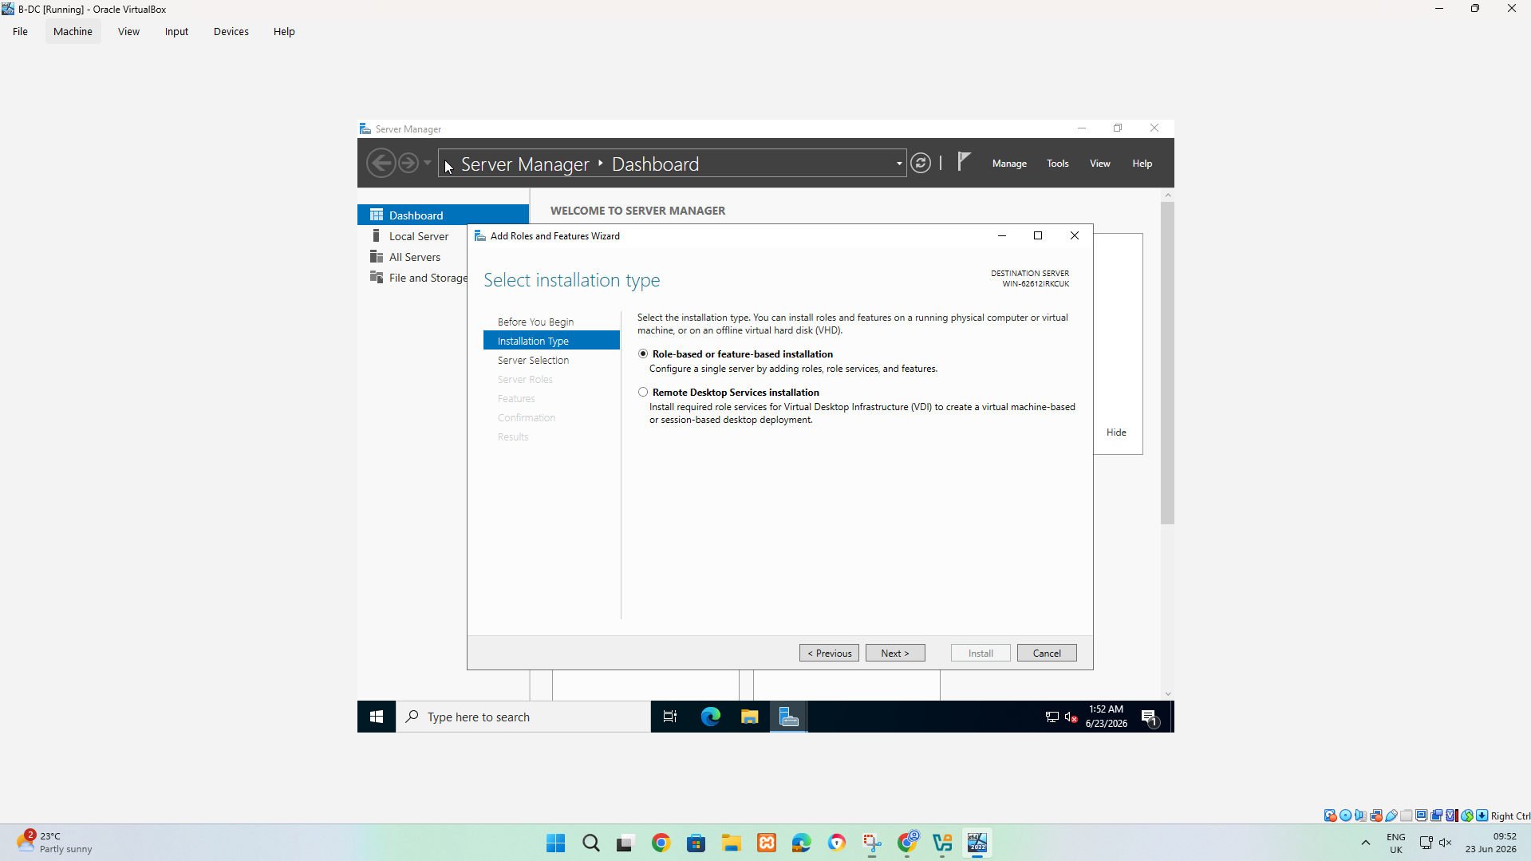
Picture 1: This screenshot shows the Add Role and Feature wizards in Windows Server Manager. Windows Server is being added as a normal server role.
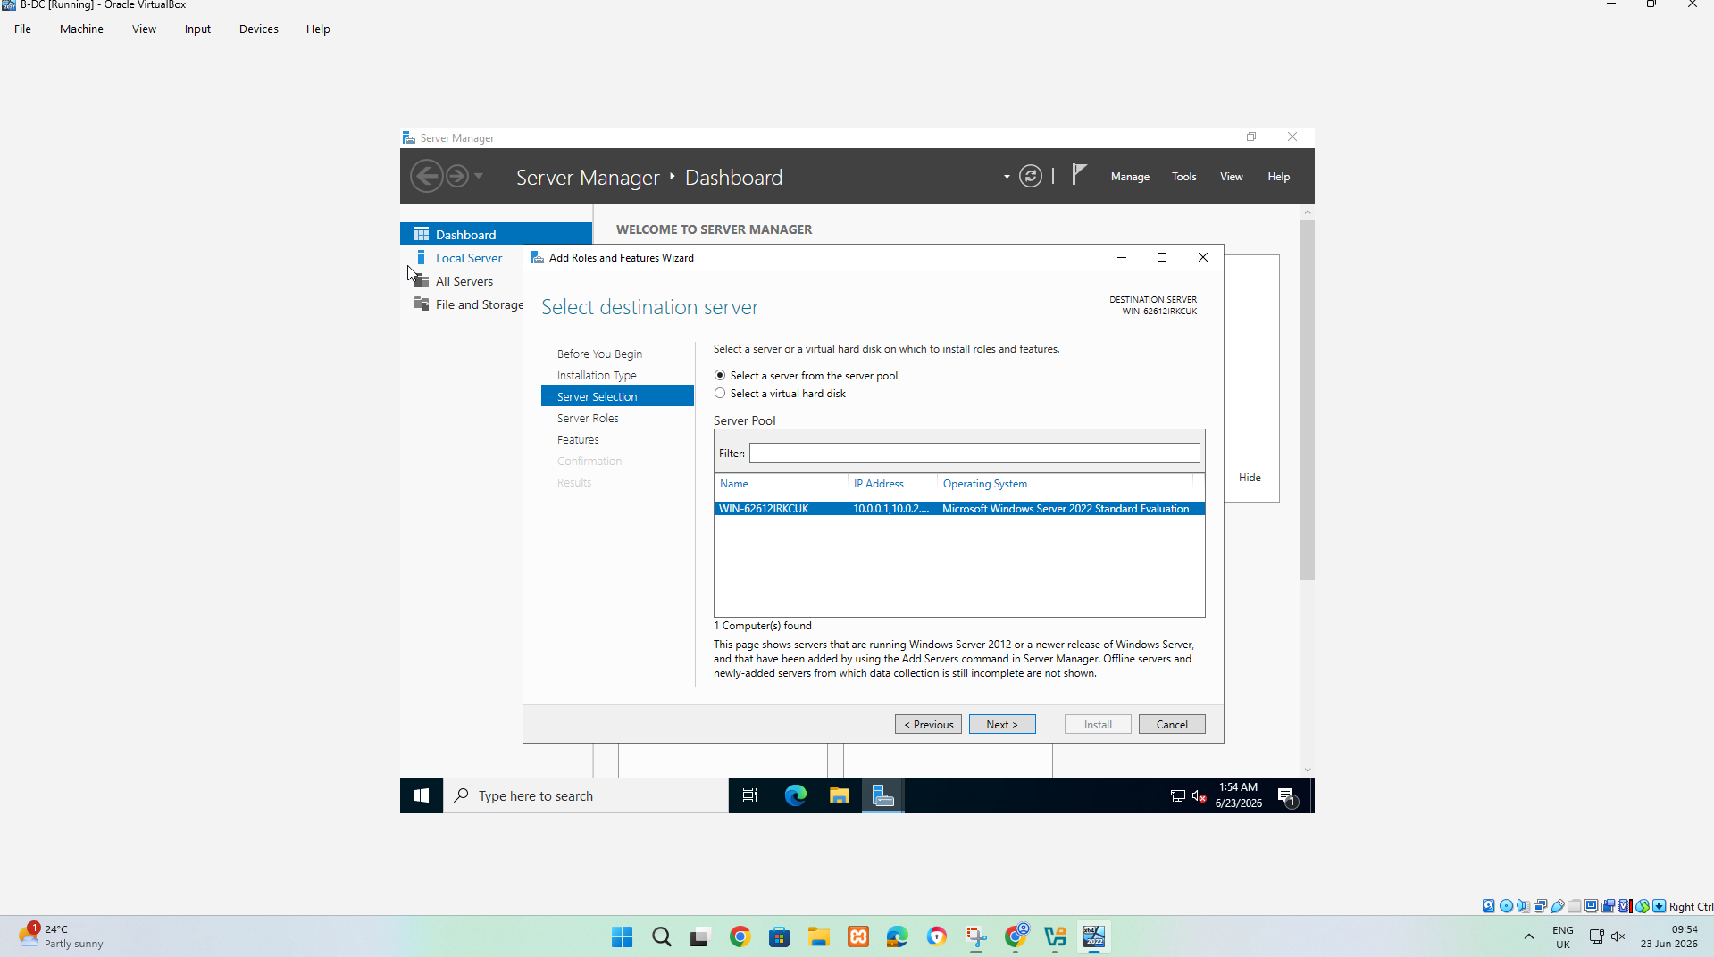
Picture 2:This is the process of server selection. In this process, it is very important to select the correct server destination roles, such as Remote Access and Routing and Remote Access Service.
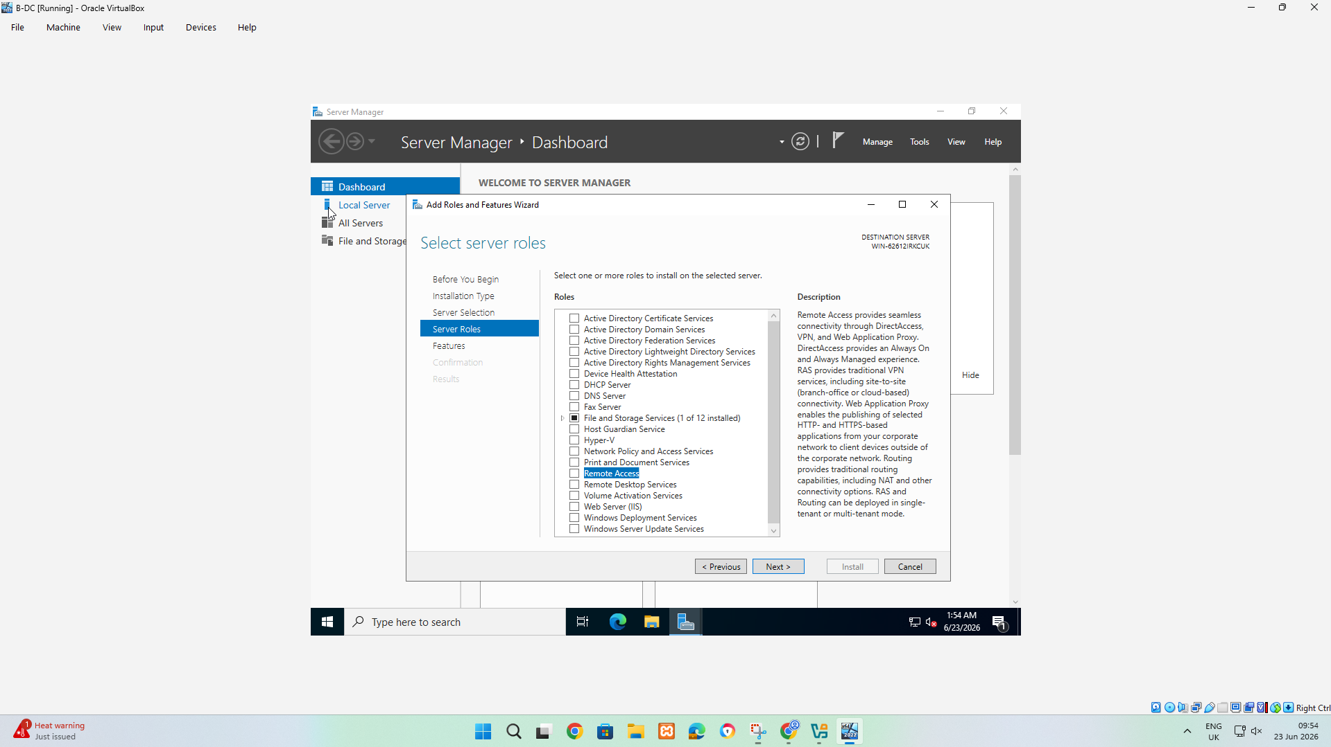
Picture 3:this screenshot shows the server role being added in Windows Server Manager. For this task, Remote Access is very important because it allows the server to later install and configure the Routing and Remote Access service.
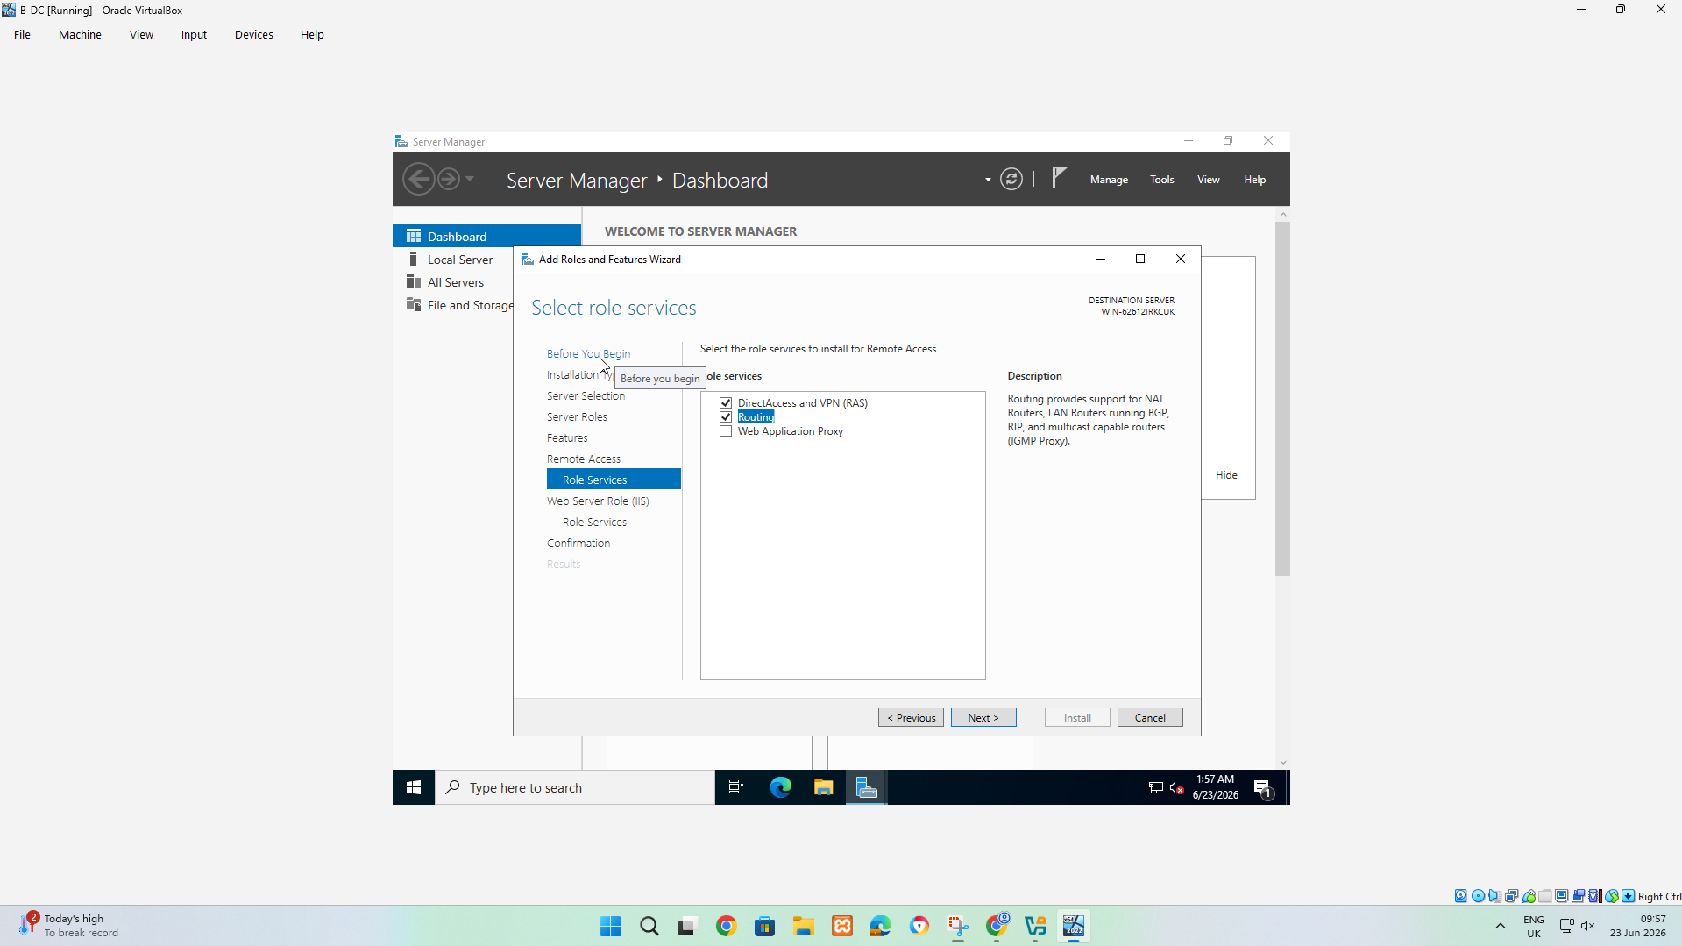
Picture 4:This screenshot shows the |role services stage for the Remote Access role in Windows Server Manager. The server is being configured with the services needed to act as a router.
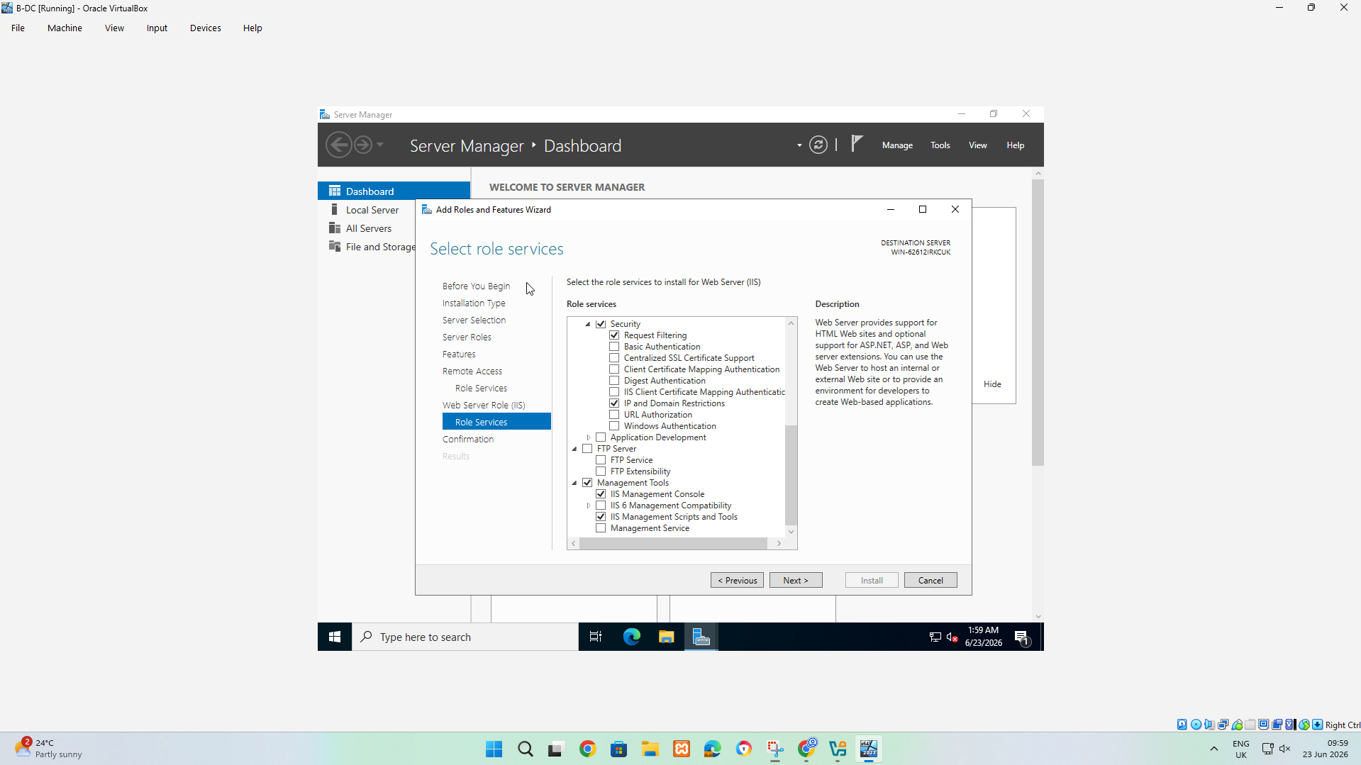
Picture 5:this screenshots shows additional supporting web server components that Windows Server will install alongside the remote access role.
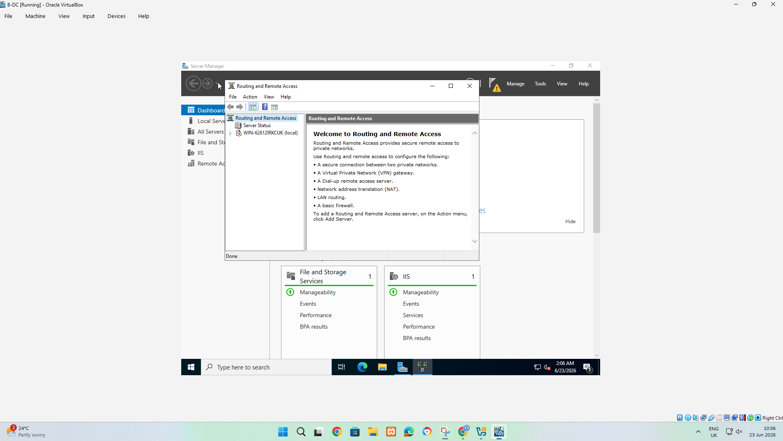
Picture 6:This screenshot shows Routing and Remote Access management after the Remote Access role is installed.
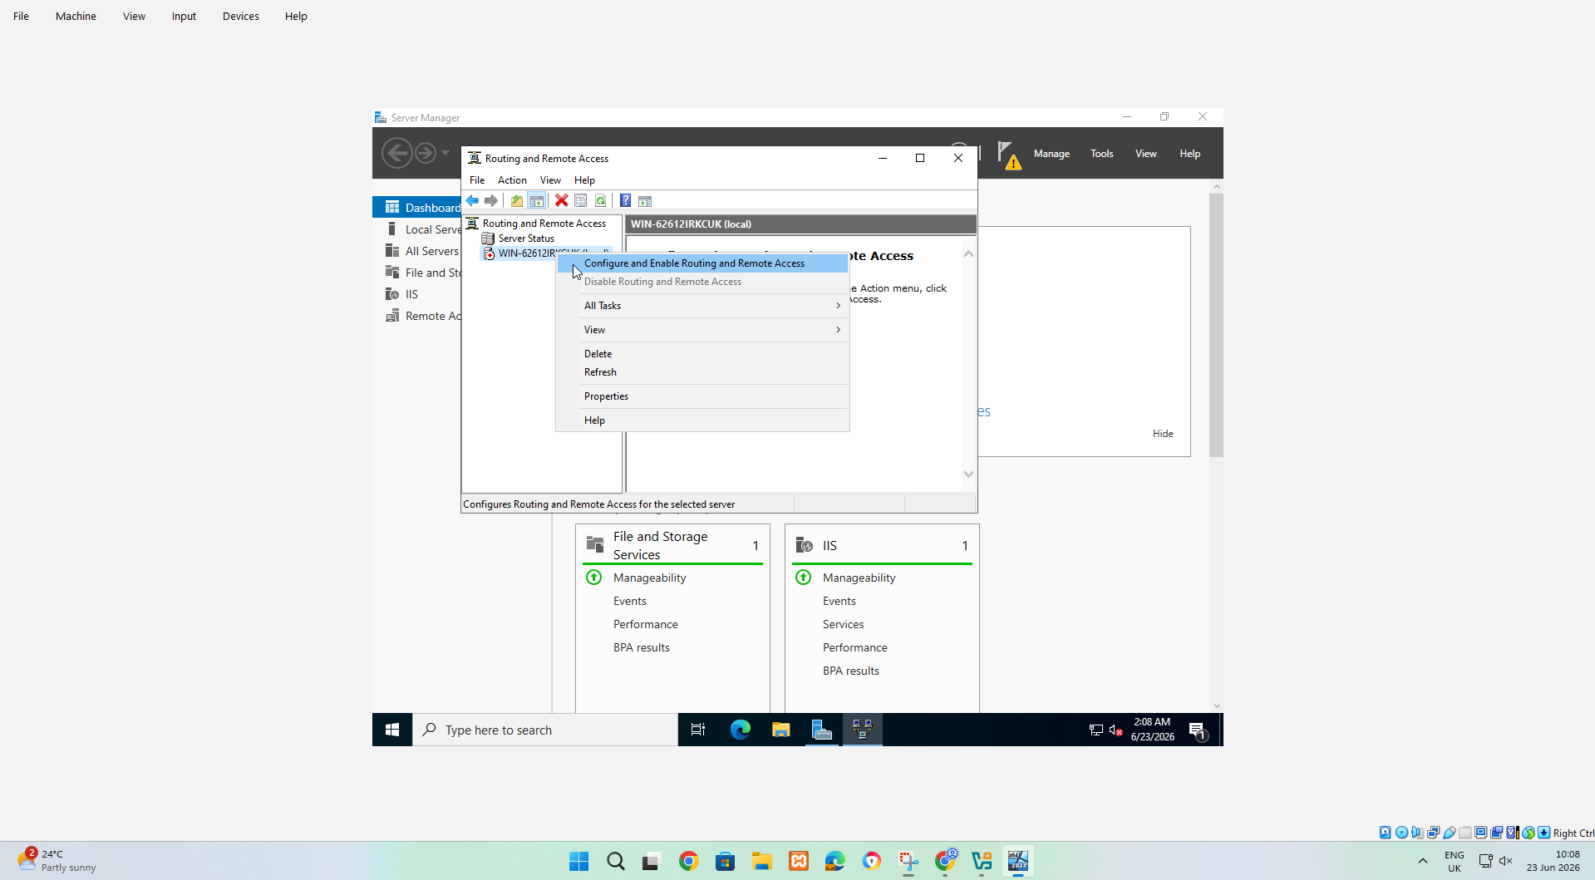
Picture 7:this step starts the process of activating RRAS so the server can function as a router, rather than having the role installed.
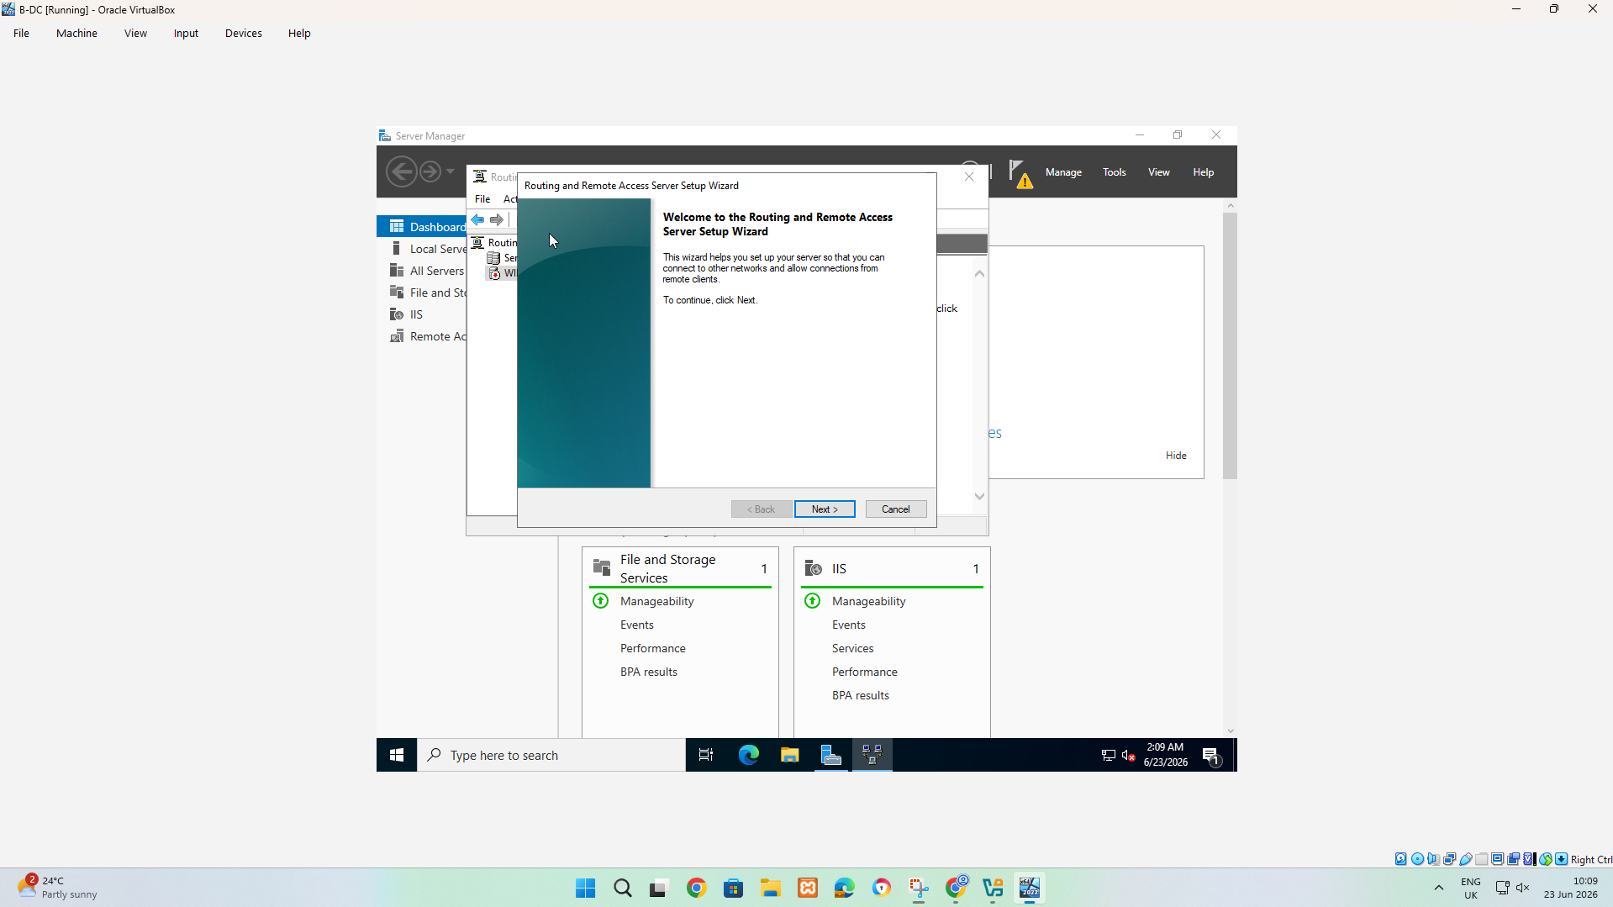
Picture 8:This screenshot shows the welcome page of the RRAs setup wizard.
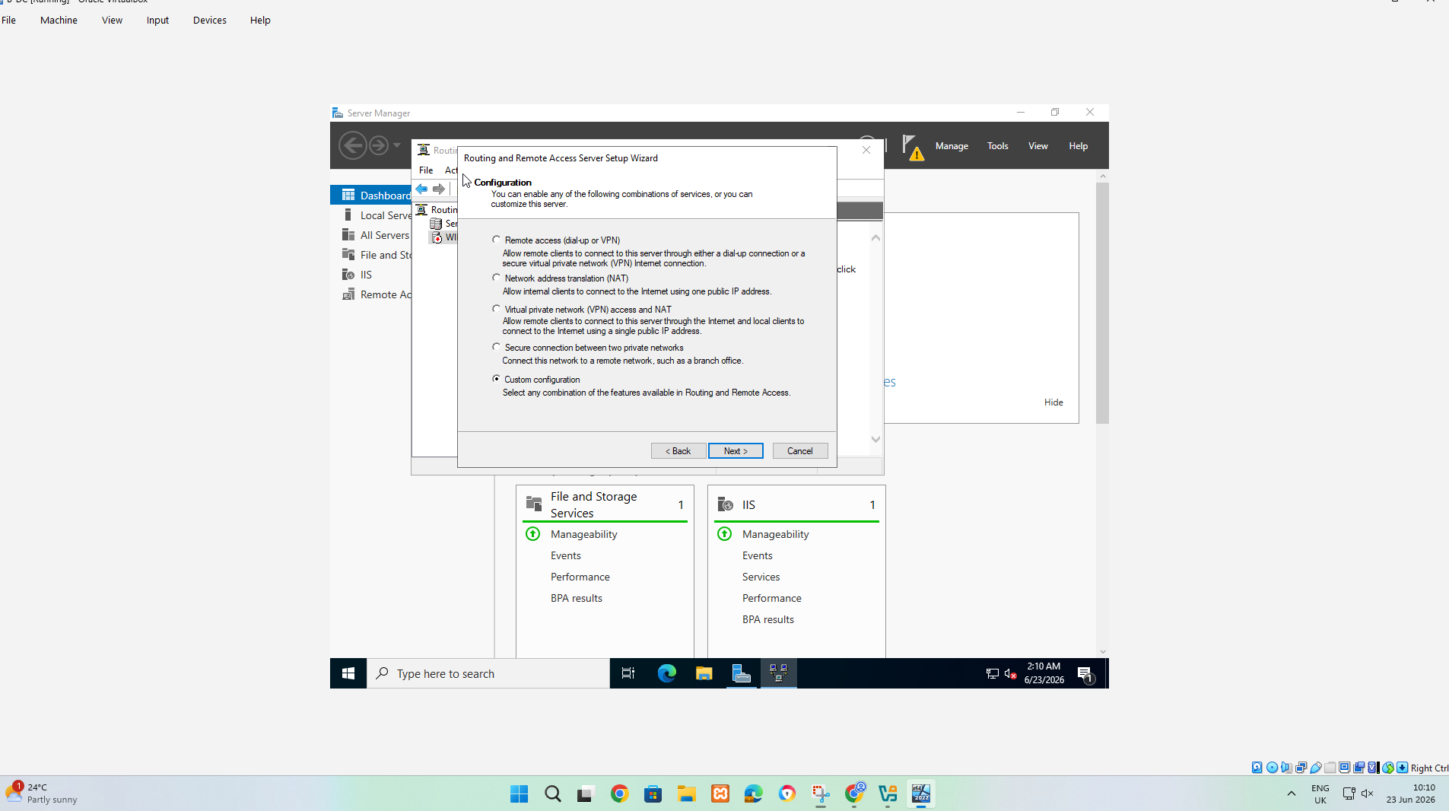
Picture 9:This screenshot shows the defined role of the RRAS server.
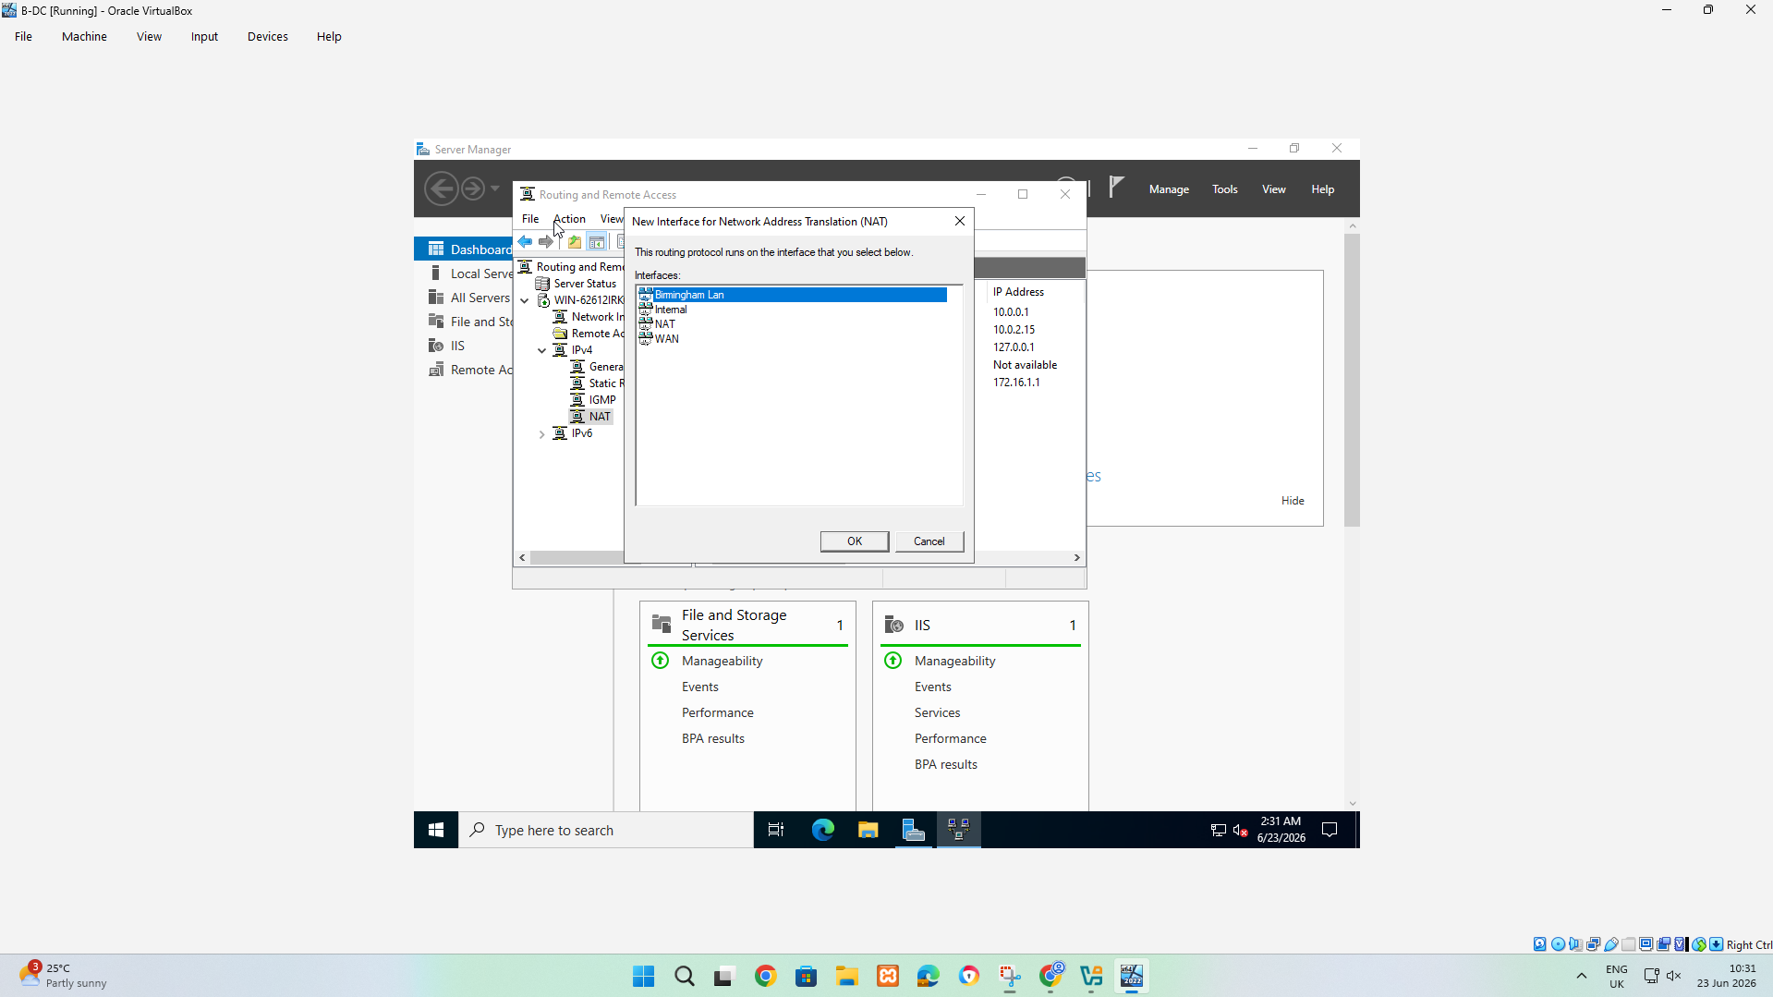
Picture 10:This screenshot shows the new Interface for Network Address Translation(NAT). At this stage correct interface must be chosen.
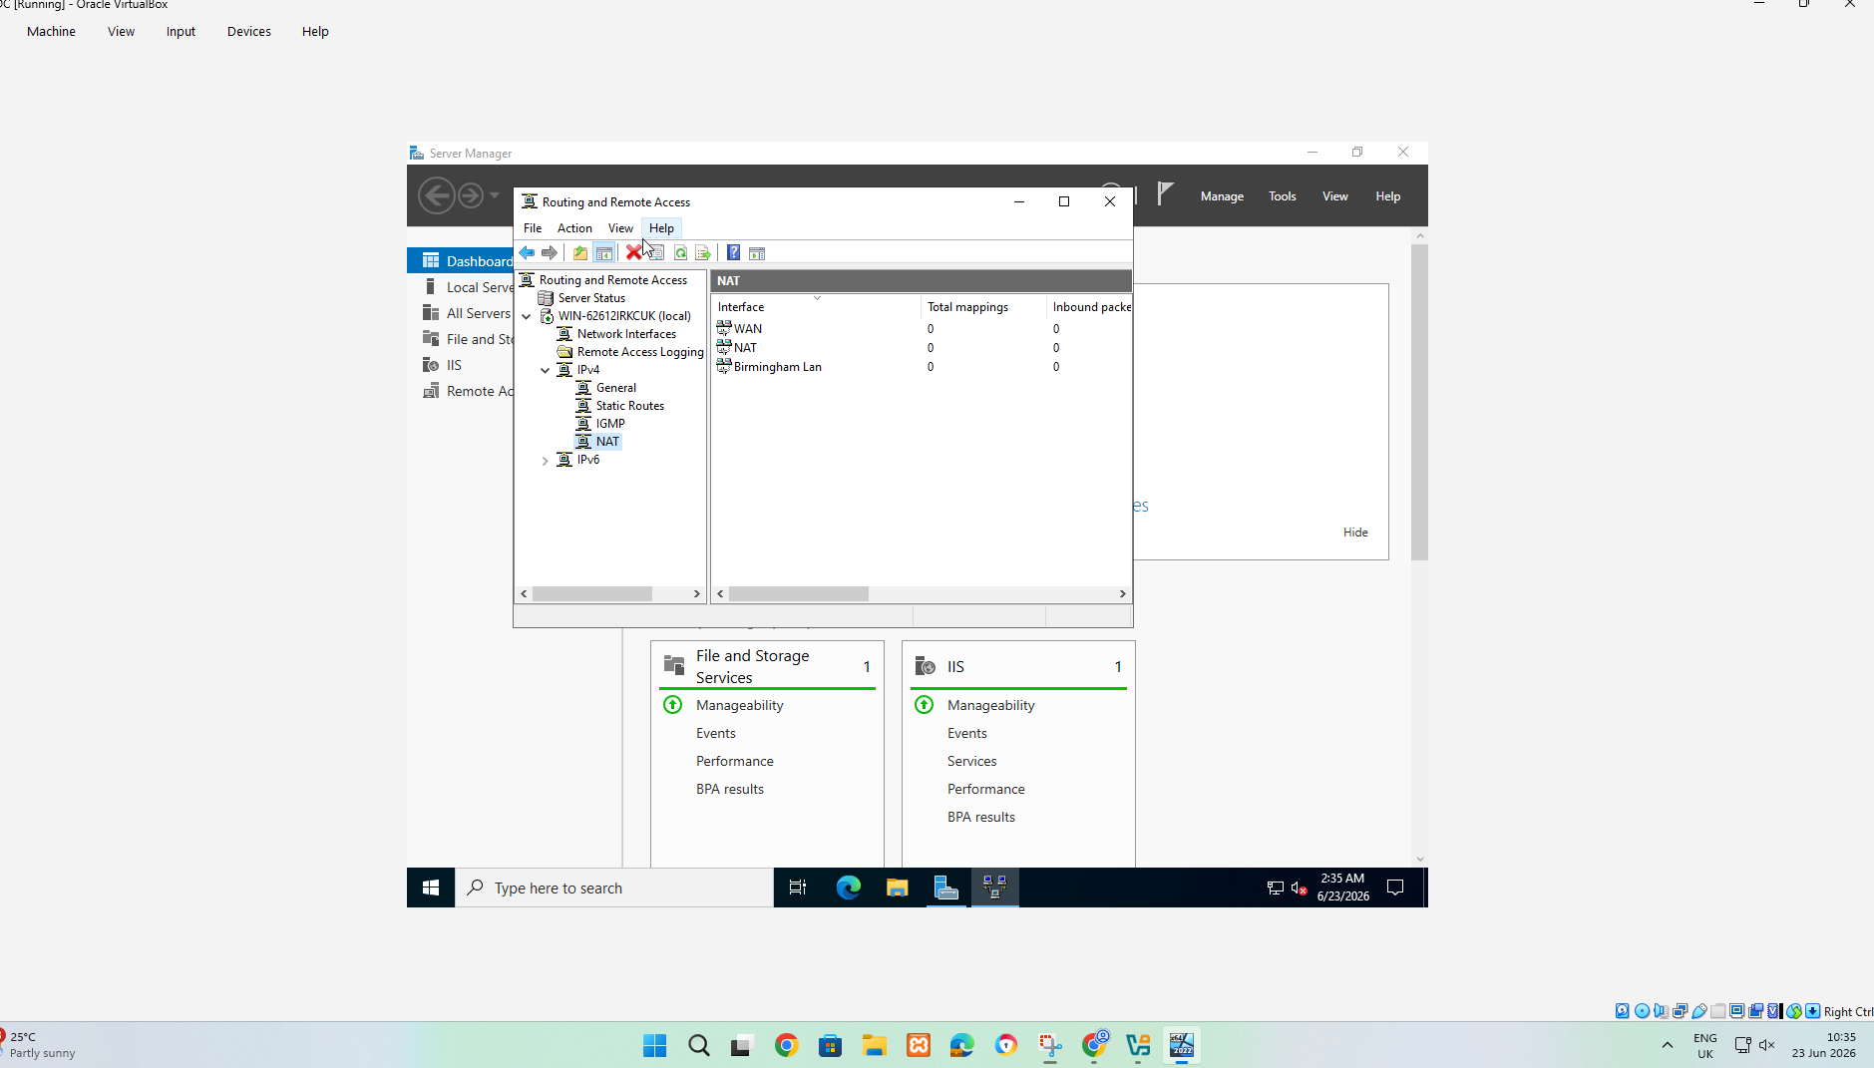
Picture 11:this screenshot shows the NAT section inside the Routing and Remote Access console. The purpose of NAT is to allow devices on a private network, such as the Birmingham LAN.
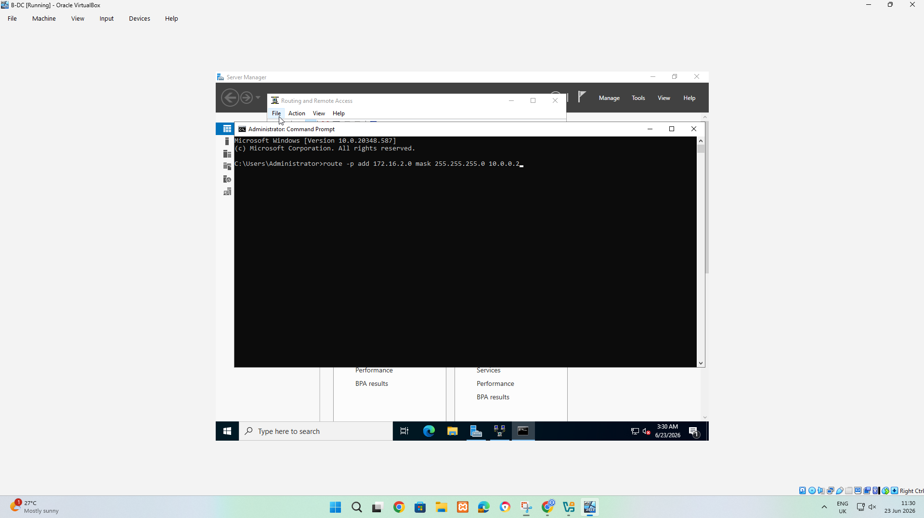
Picture 12:This screenshot shows an Administrator Command prompt being used to add a static route on windows server. This step is telling server where to send traffic for the remote network.
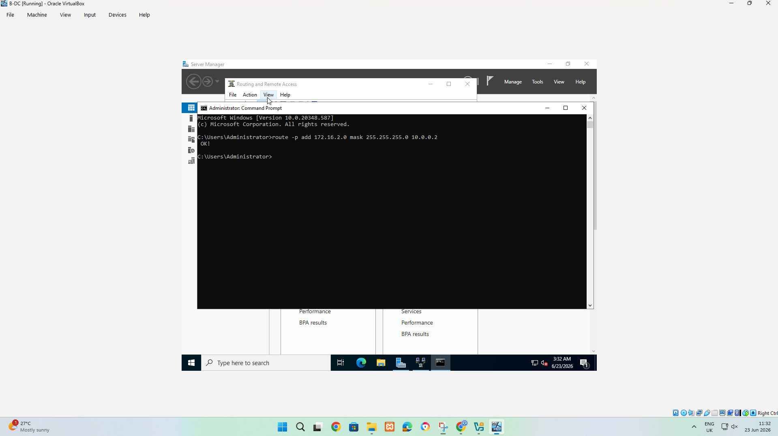
Picture 13:This screenshot shows that the static route command has been executed successfully in Command Prompt. This proves the Windows server knows how to reach the 172.16.2.0 network.
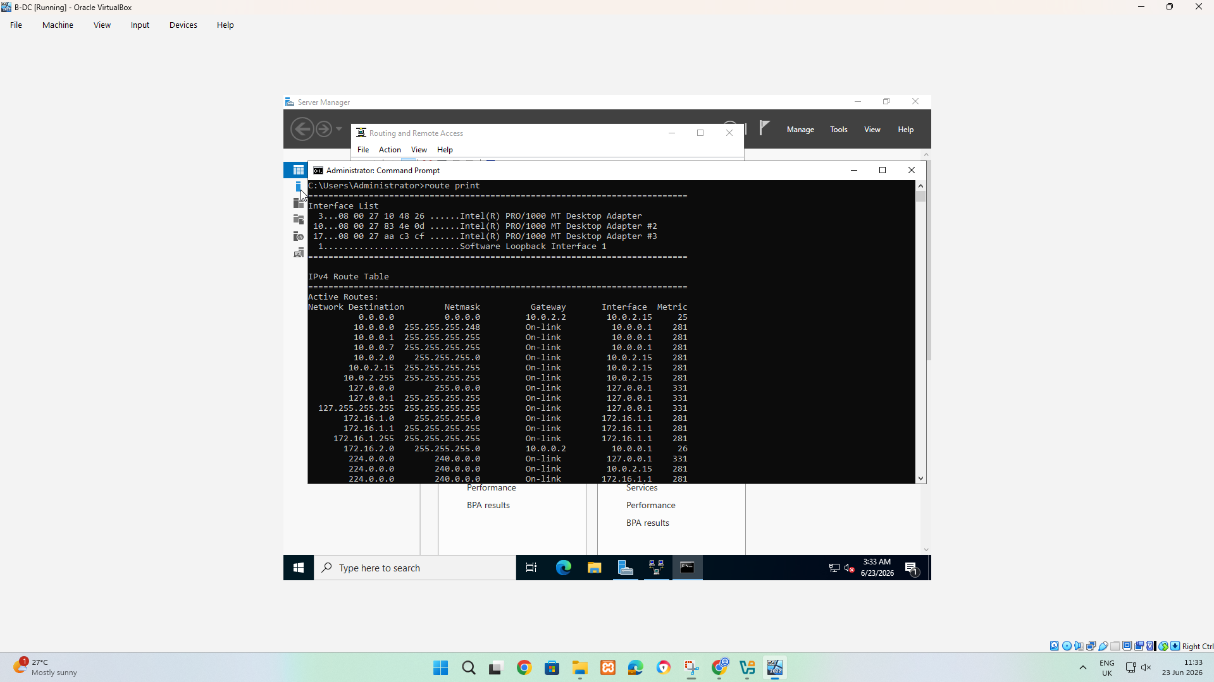
Picture 14:this screenshot shows the output of the command route print in the command prompt. This allows the network to check whether the static network was added correctly.
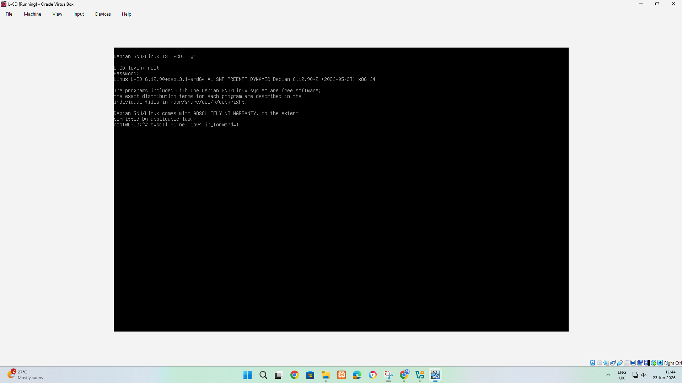
Picture 15:This screenshot shows the Debian CLI server being configured for IP forwarding through the Bash command. This screenshot server has been configured to forward IPV4 traffic, allowing it to support network topology.
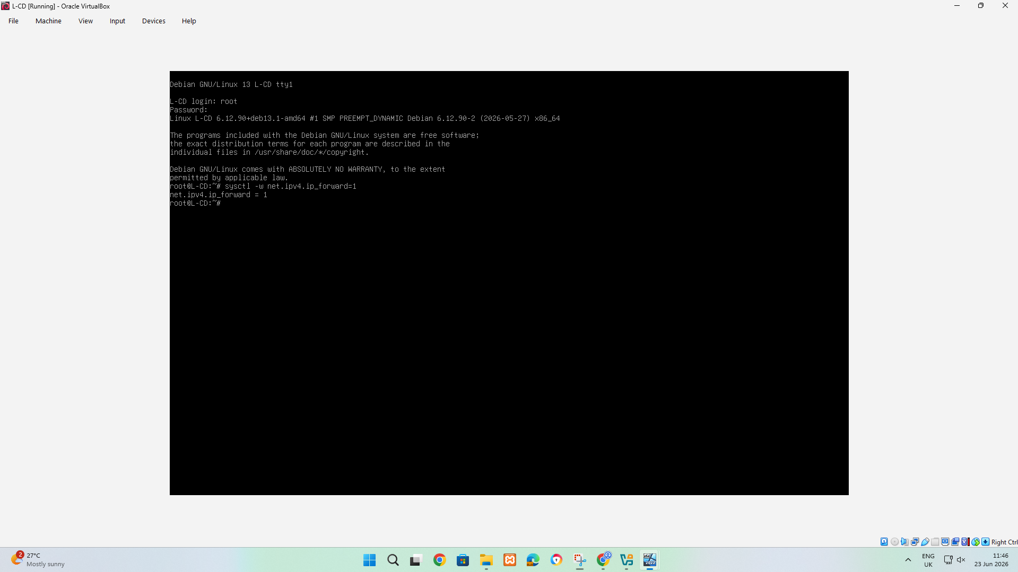
Picture 16:This screenshot confirms that IPV4 forwarding has been enabled on the Debian server.
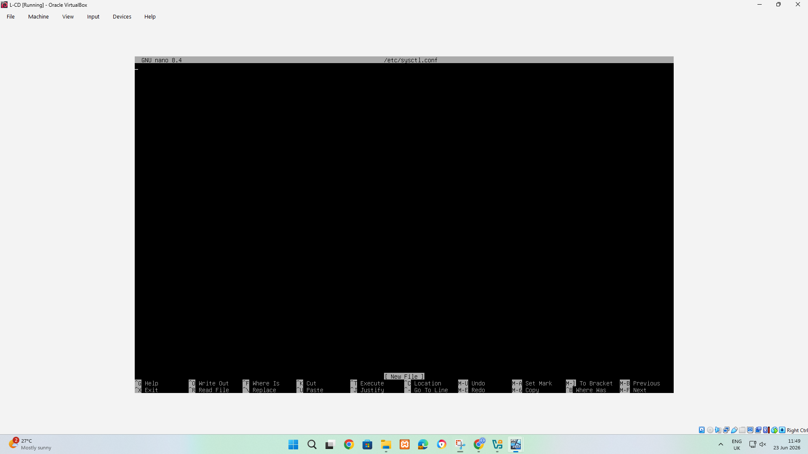
Picture 17:This screenshot shows the Debian server opening the sysctl configuration file in nano editor. This shows the administrator preparing to save the routing permanently on the Debian server.
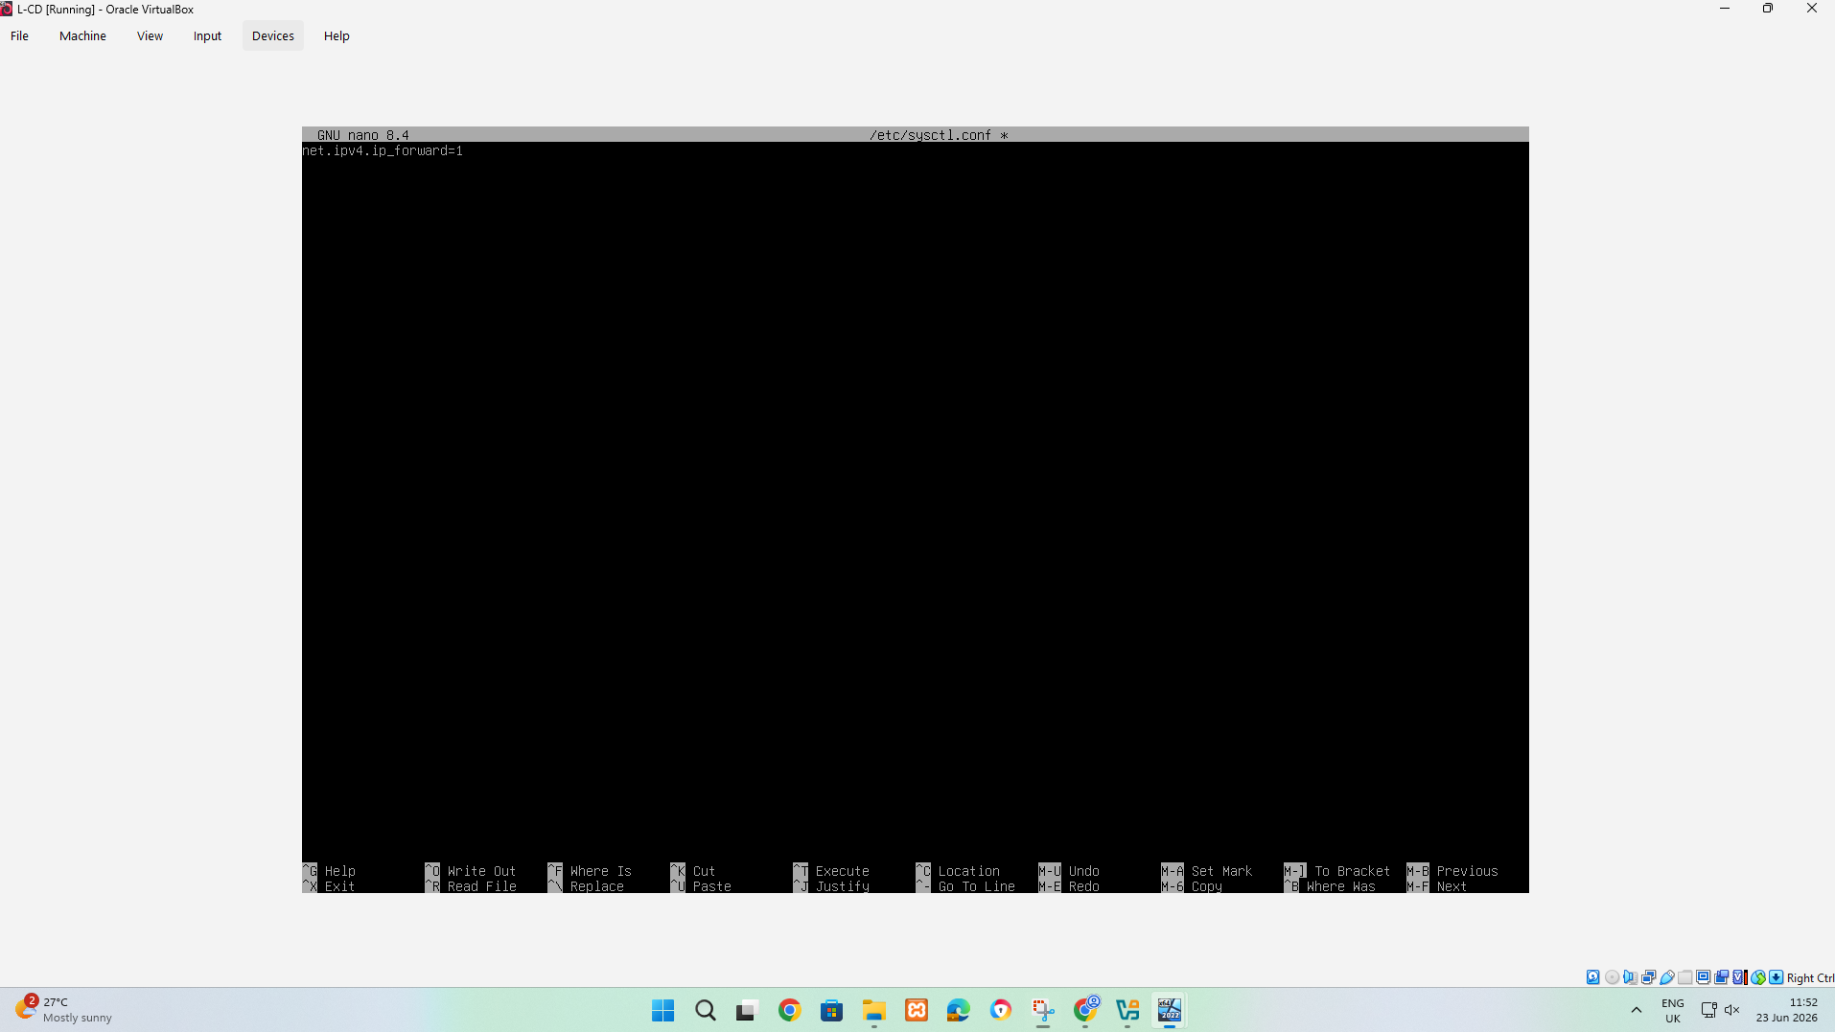
Picture 18:This screenshot shows the IPv4 forwarding being added to the Debian server using nano.
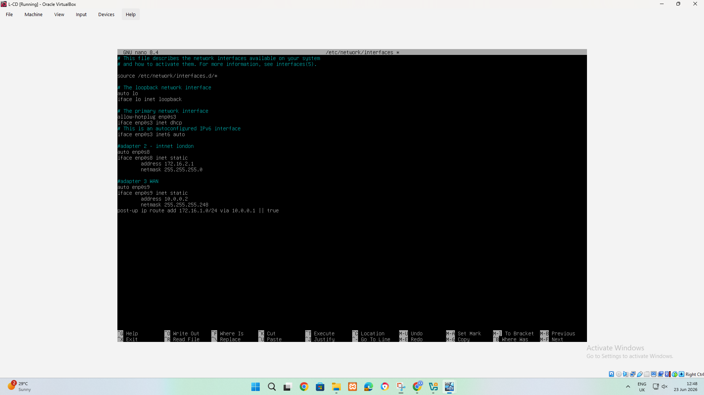
Picture 19:the process is configuring the Debian network interface and adding routing information. The file shows the loopback interface first, and then the network interface using DHCP and then an additional static interface.
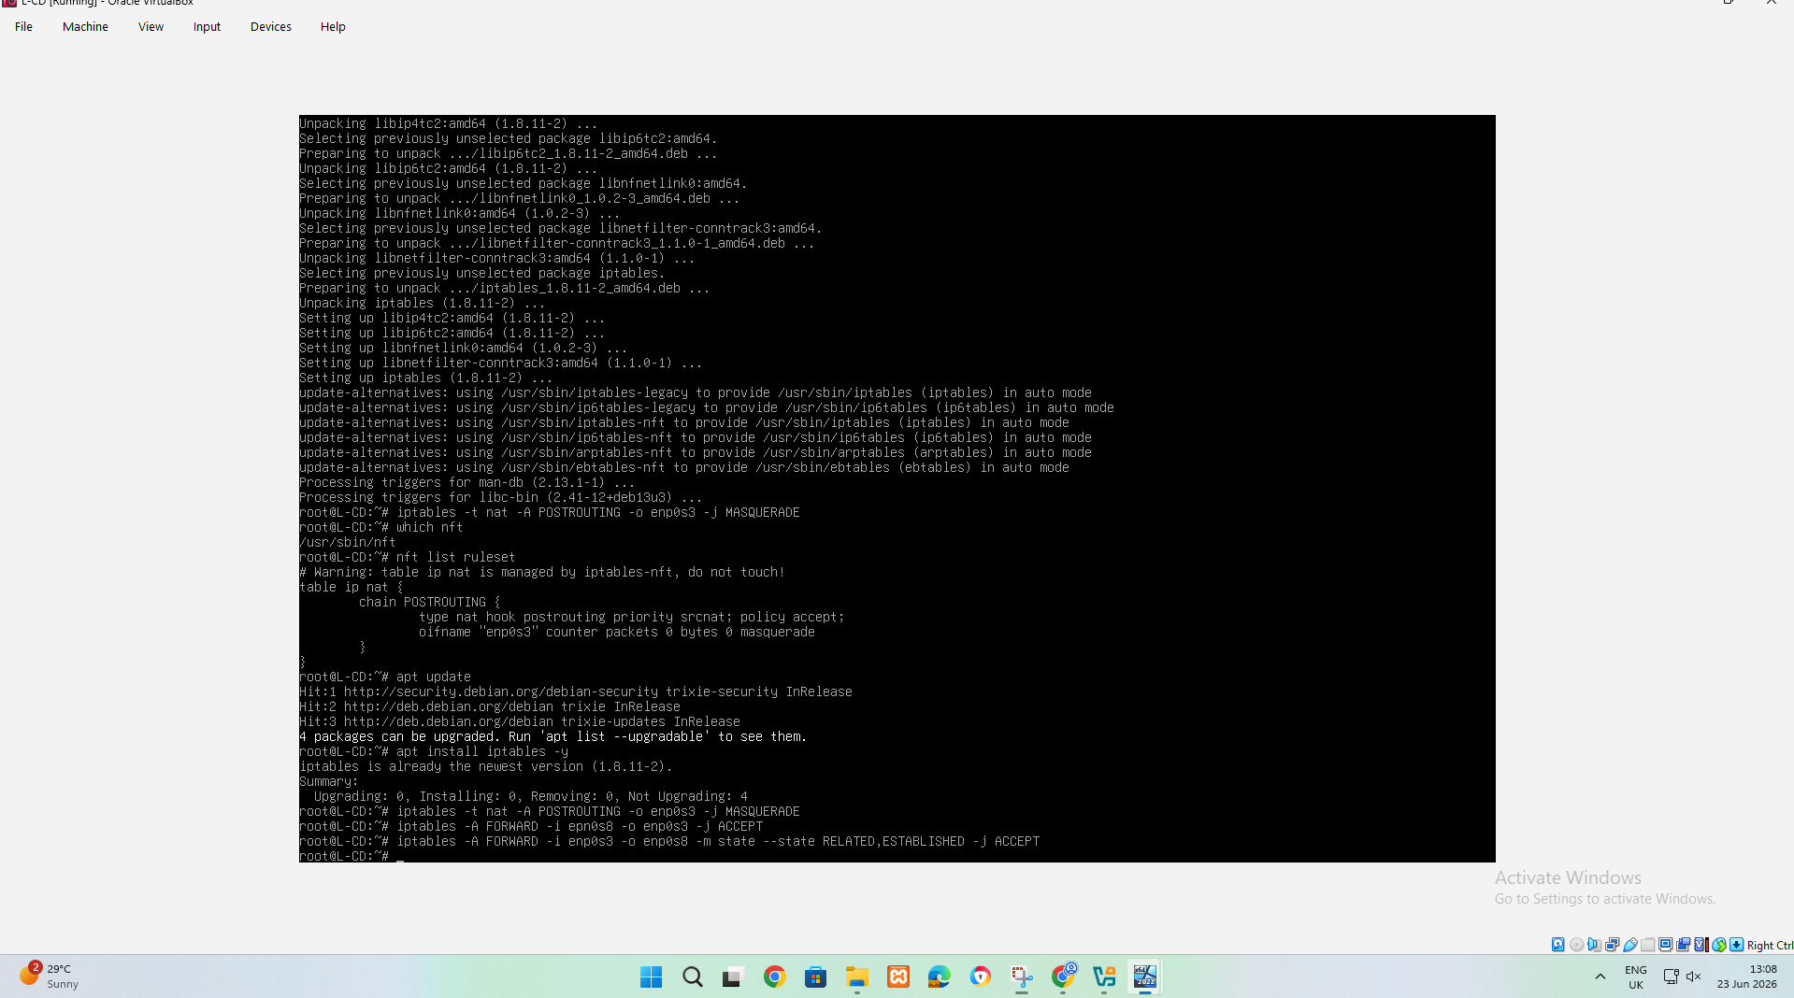
Picture 20:this screenshot shows a Debian server configuring NAT and forwarding rules using iptables. This step configures the Debian server to translate and forward traffic between interfaces, allowing devices on one network to reach another network through the Debian server.
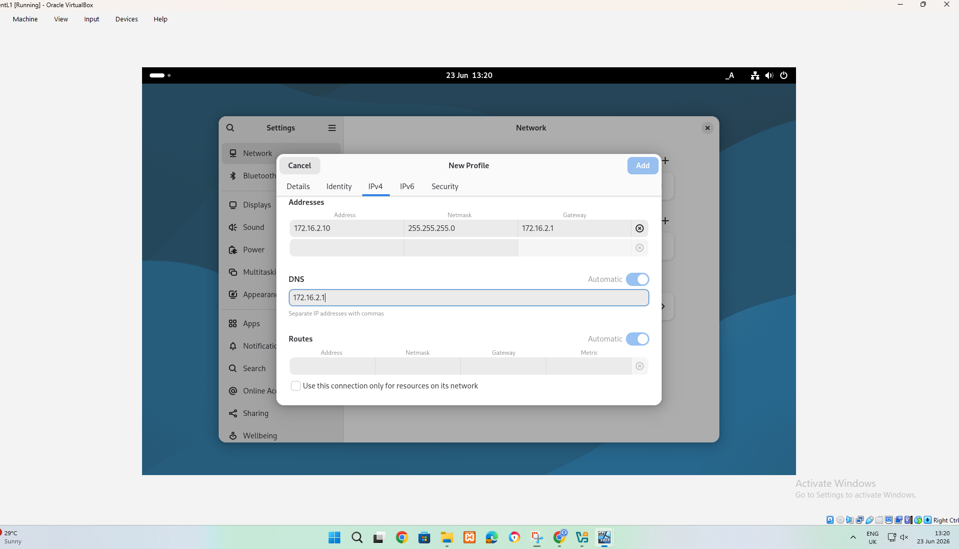
Picture 21:This screenshot shows the Linux client network profile being manually configured in the Network Settings window. This step configures the client with a fixed IP address and tells it to send the traffic outside to the local network through 172.16.2.1.
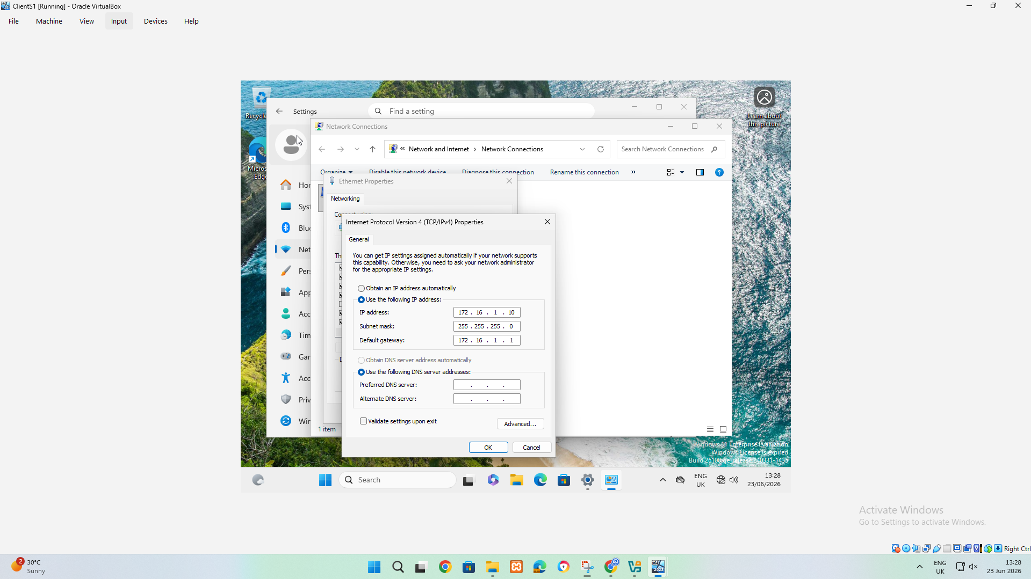
Picture 22:This screenshot shows Windows Client IPv4 configuration is set through the Ethernet adapter. This step gives Windows Client a fixed network identity and points it to the correct gateway.
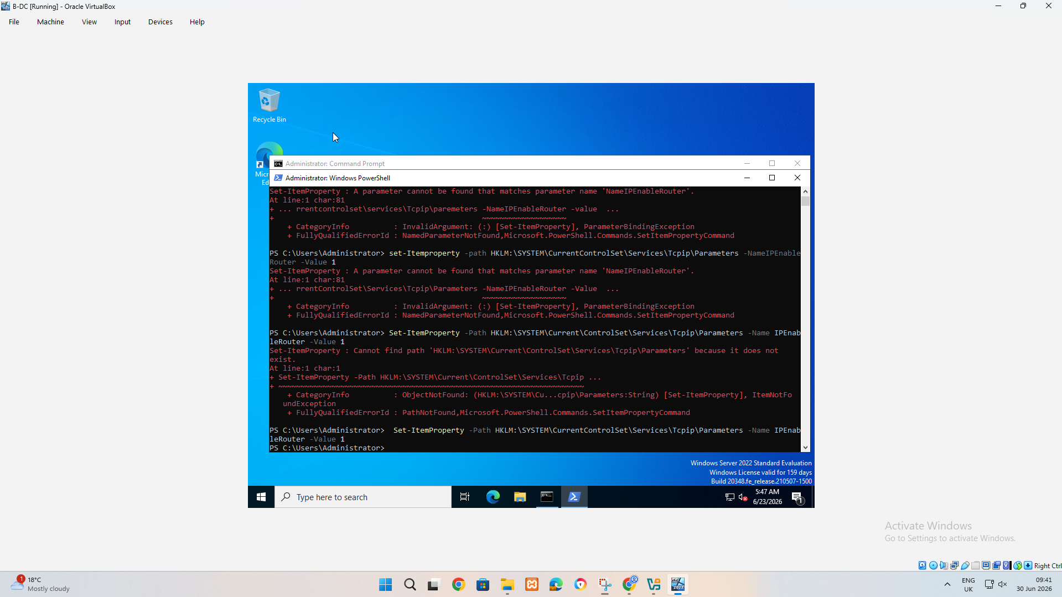
Picture 23:This screenshot shows Administrator Windows PowerShell is used to enable routing on windows server. This command sets the Windows registry value IPEnableRouter to 1, which enables IP forwarding at Windows TCP/IP, allowing the server to forward packets between networks.

TASK 1
Birmingham Routing
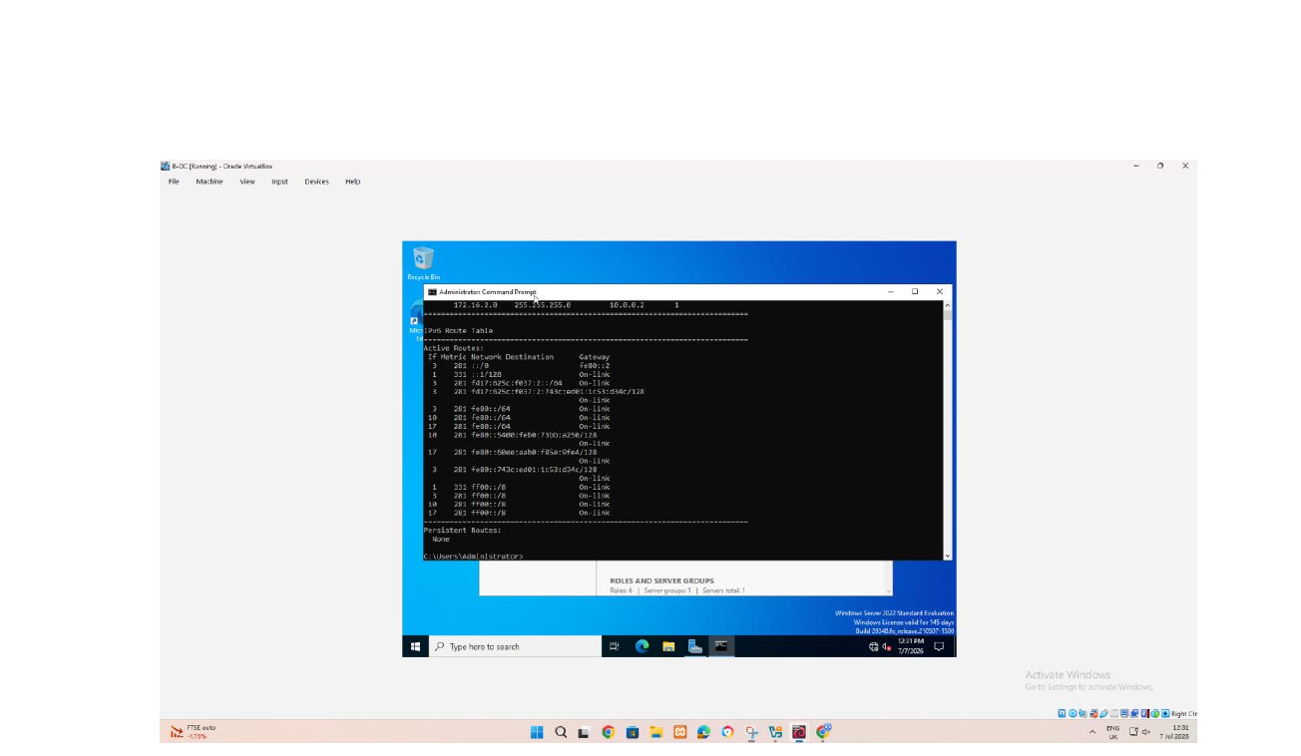
Picture 1:windows routing table
The command prompt displays the ipv4 and IPv6 routing tables.
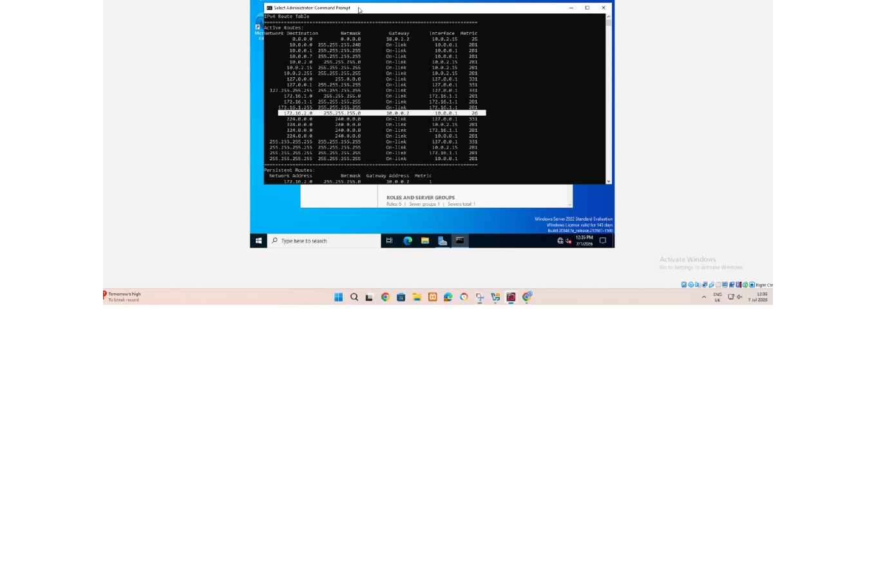
Picture 2:Windows routing table shows a persistent route
The route print output shows persistent routes and connected routes.
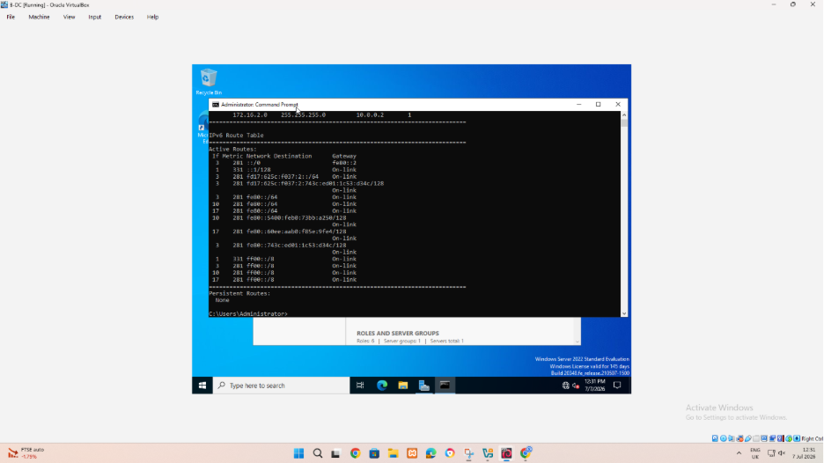
Viewing the windows routing table.the route print active IPV4 routes and gateways and interfaces on windows server.this is used to verify routes exists for Birmingham and London networks.
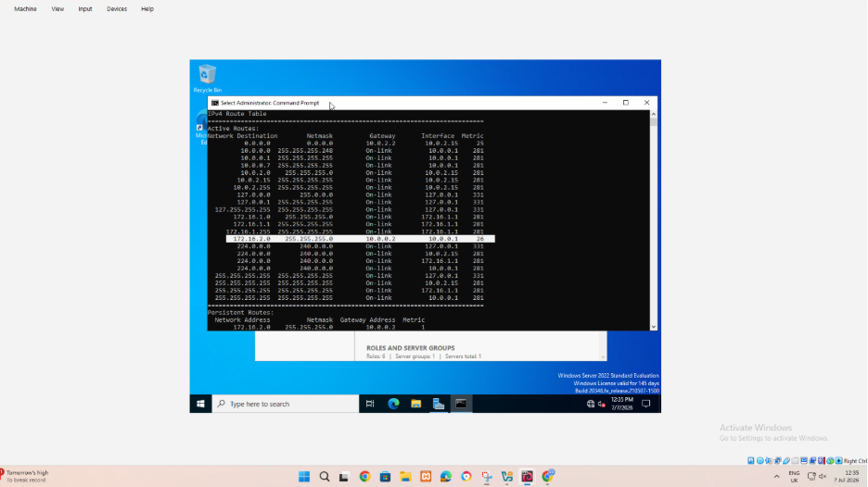
The lower section of route print is used to inspect persistent routes.A persistent route remain after a restart and is therefore important for reliable communications between sites.
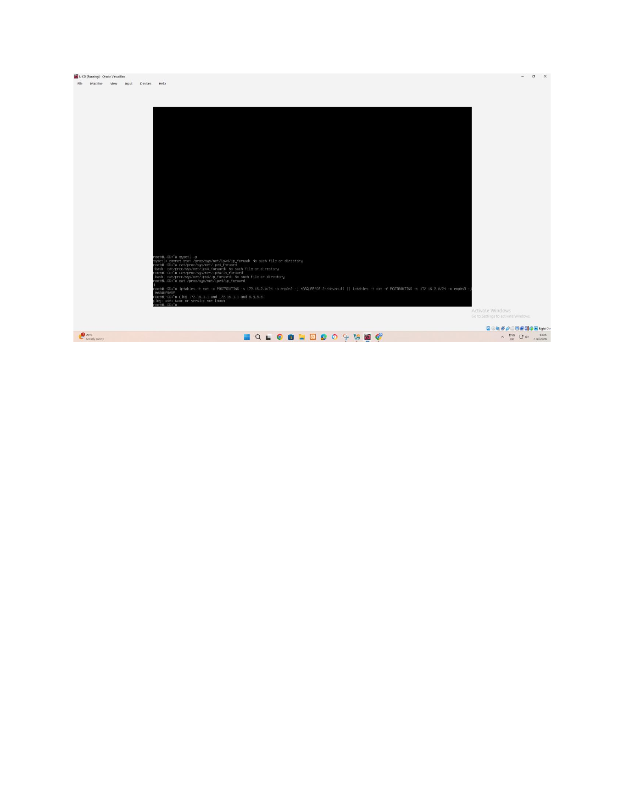
Task 2
London Routing
Picture 3:Linux forwarding and NAT command on L-CD
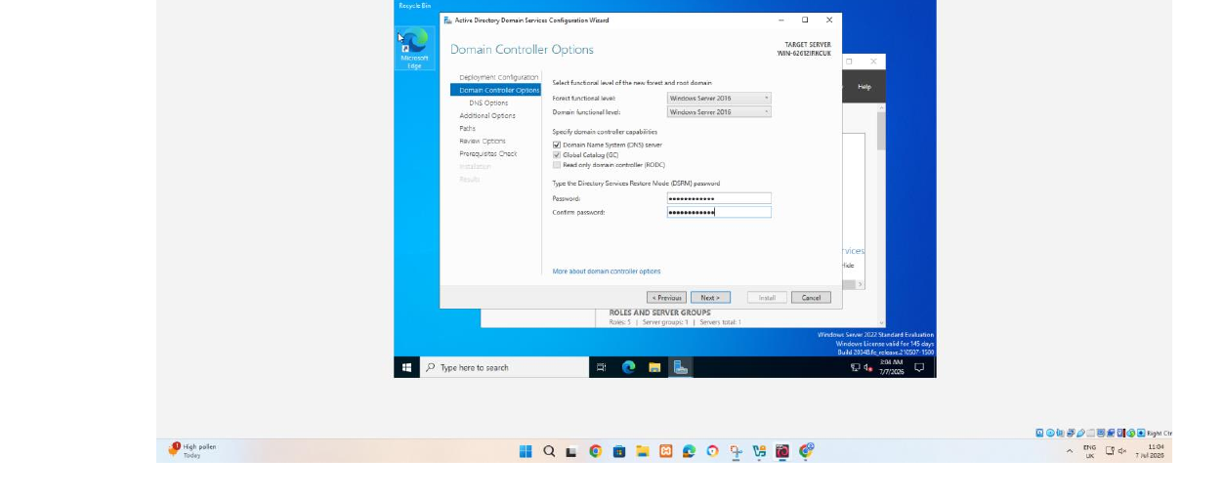
Picture 4:selecting domain controller options
Good configuration options, password is hidden as it should be.
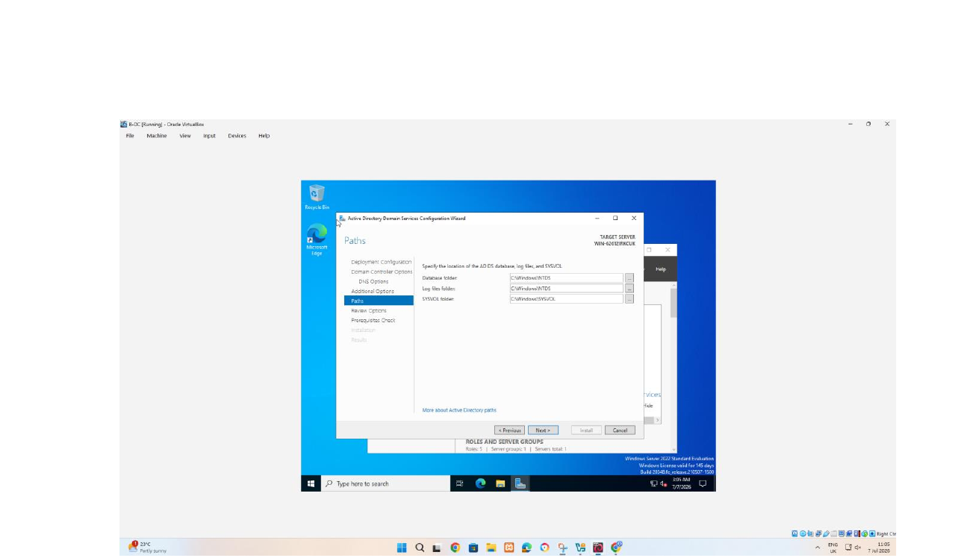

Picture 5: confirming AD DS database
The default paths are retained for active database log files and the sysvol folder.
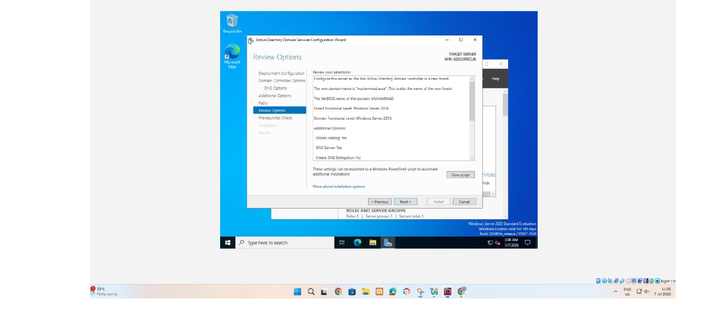
Picture 6:Reviewing the active domain controller confugration
The review page will confirm that the server will become the first active folder in the new forest with DNS and global catalogue enabled.
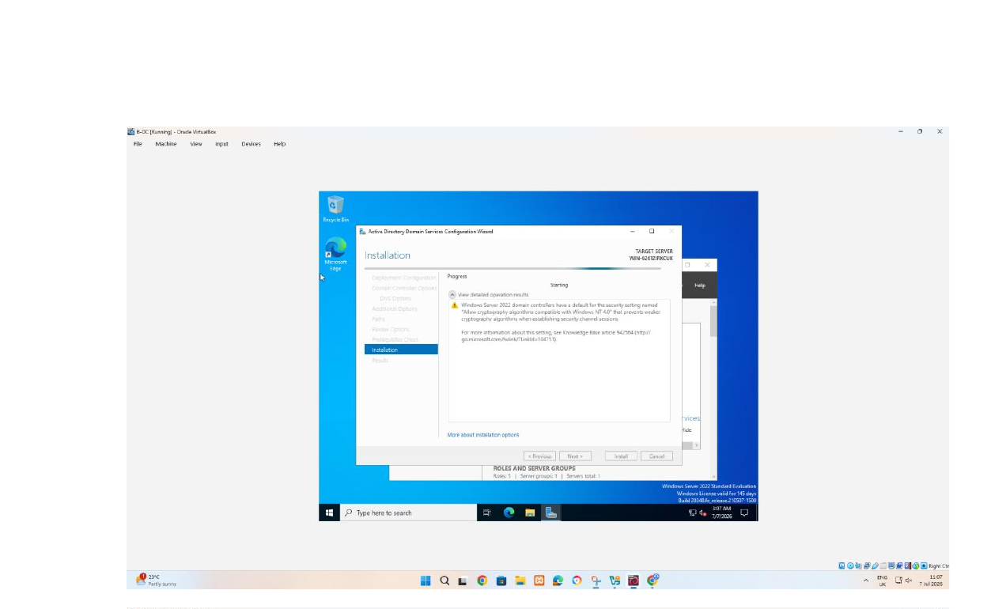
Picture 7:installing active directory domain services
The installation page shows that the domain controller process begins.
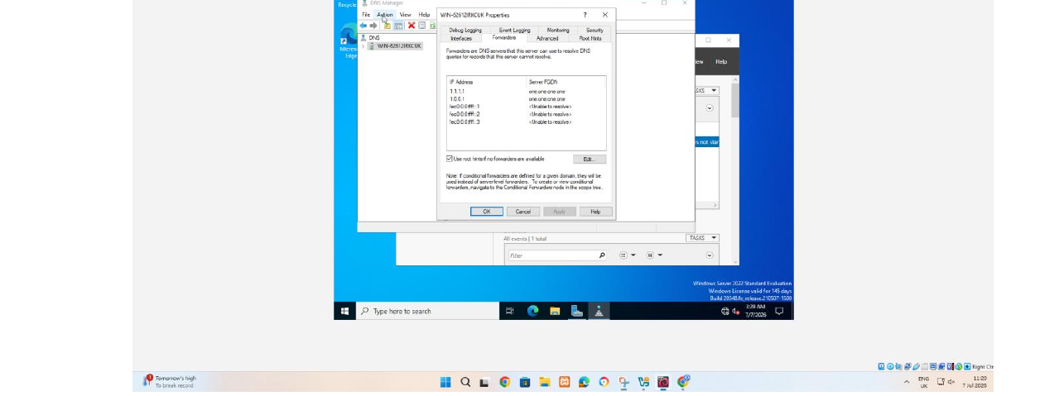
Picture 7: inspecting DNS forwarder settings
Forwarder allows the DNS server to resolve external names that are not hosted in muhammad.acca zone
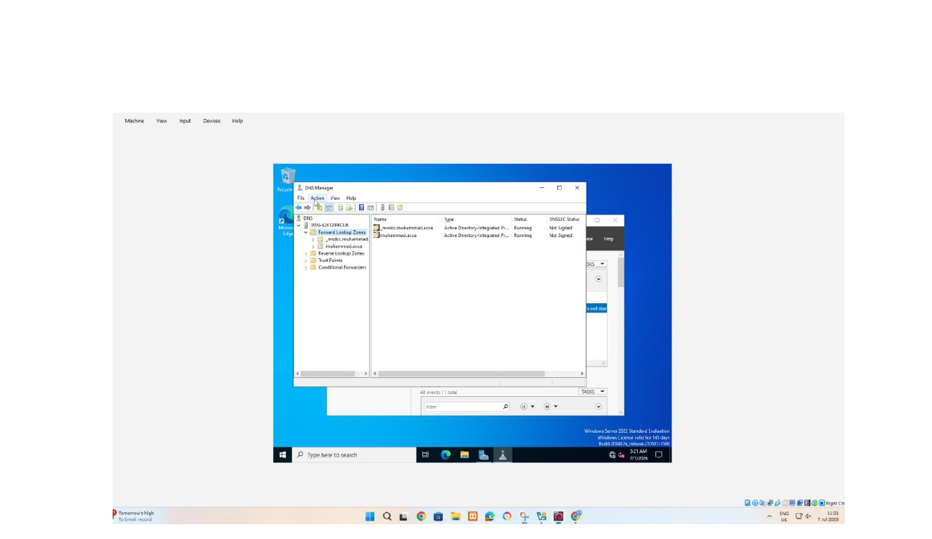
Picture 8: confirming the forward lookup zone.
DNS manager confirming the forward lookup zone as active directory integrated and running. This zone stores the name to IP record for domain support and integration with Active Directory.
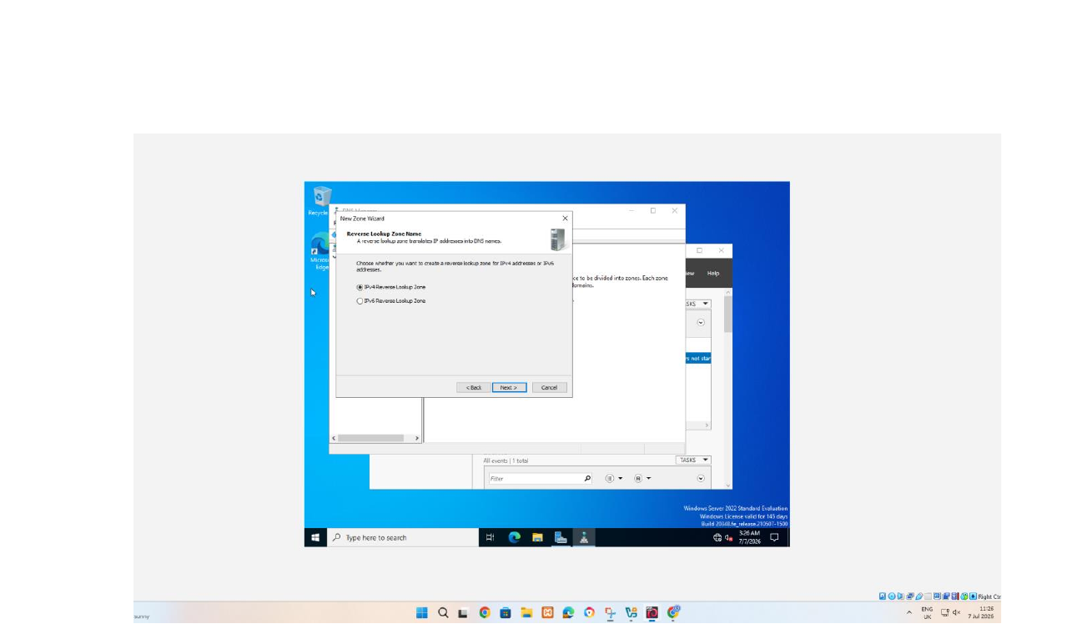
Picture 9:starting creation of IPV4 reverse lookup zone
The new zone wizard is configured for a reverse lookup zone for IPV4 reverse lookup zone. A reverse lookup converts IP addresses into hostnames.
Task 7
Test and troubleshoot
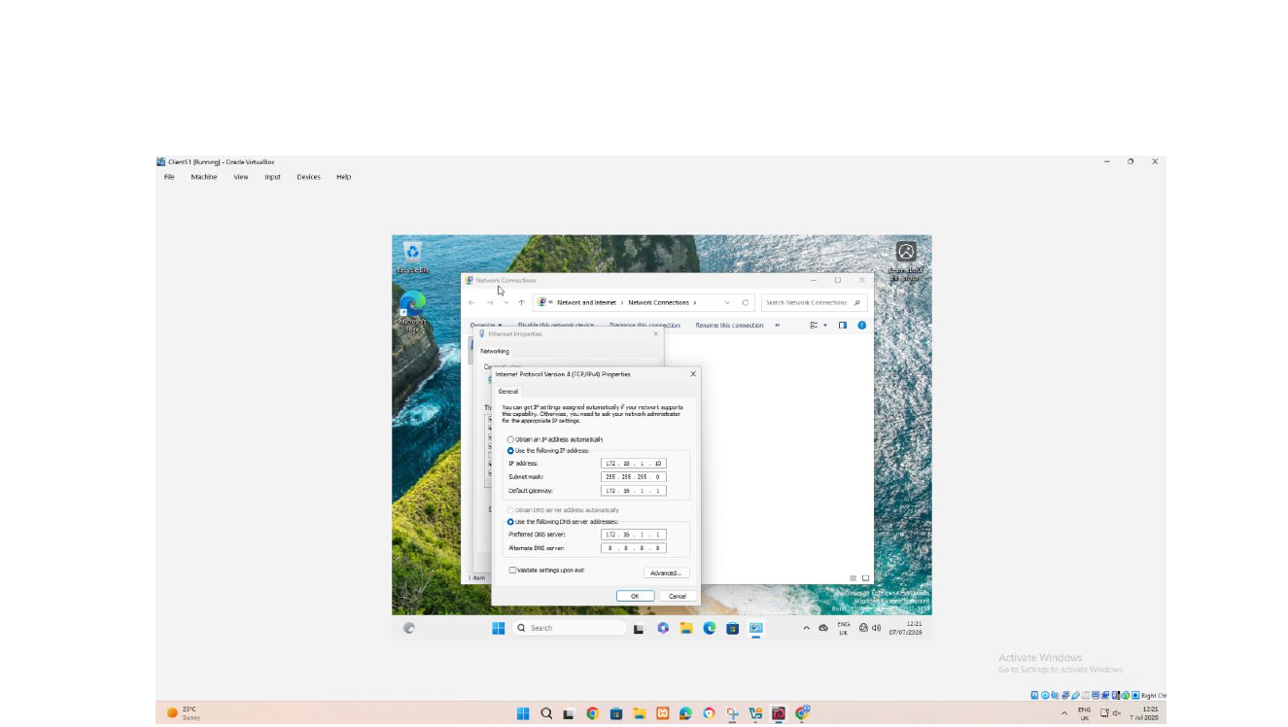
Picture 10: Configuring IPv4 settings
The address is instantly consistent for the Birmingham subnet. For domain operations client should use the internal DNS server rather than bypassing it with public DNS.
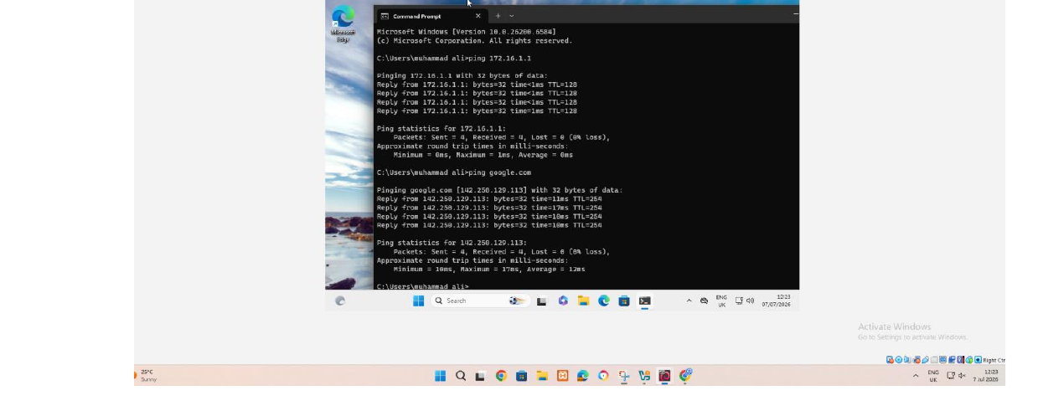
Picture 10: Testing the gateway and connectivity
The command prompt successfully pinged 172.16.1.1 and google.com with zero packet loss. this confirm local gateway reachability.DNS resolution and external connectivity from the client.
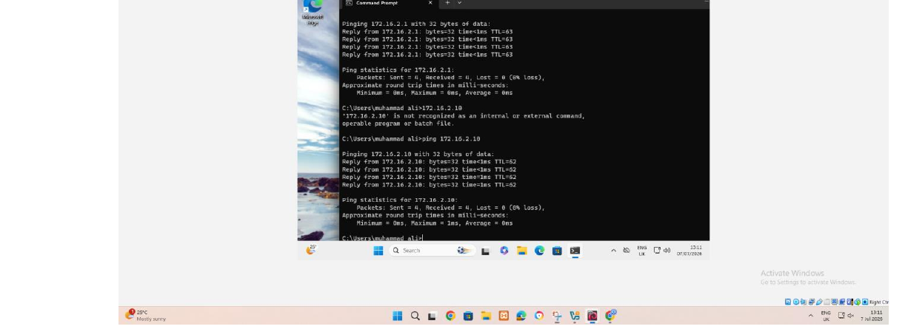
Picture 11: testing the London gateway or remote gateway address
The client successfully pinged 172.16.2.1 with zero packet loss after reaching google.com.this suggest traffic can reach 172.16.2.1/24 network through the routing path.
Task 8
Disk drive and file share
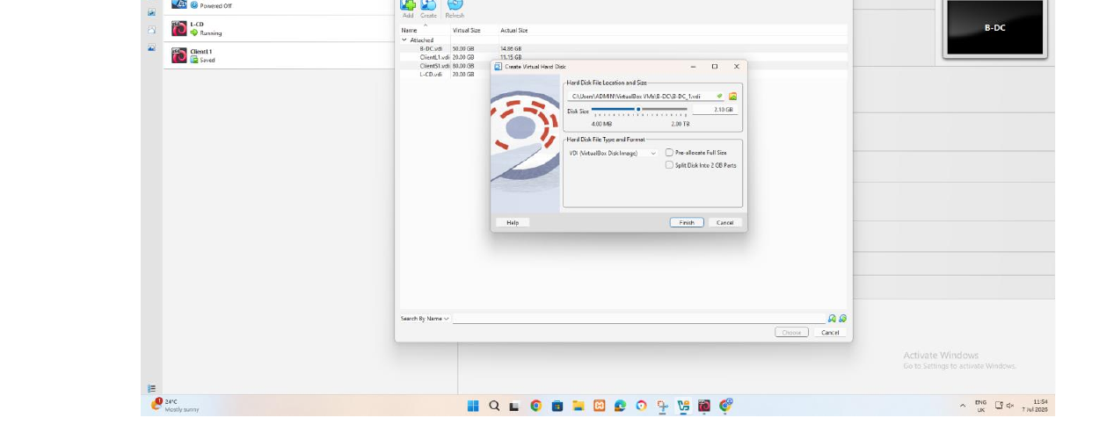
Picture 12: Creating and attaching a second virtual disk
VirtualBox is used to create new virtual hard disk for approximately 2.10 gb for b-dc.Attaching a disk can provide storage for later use as E and use for Birmingham files.
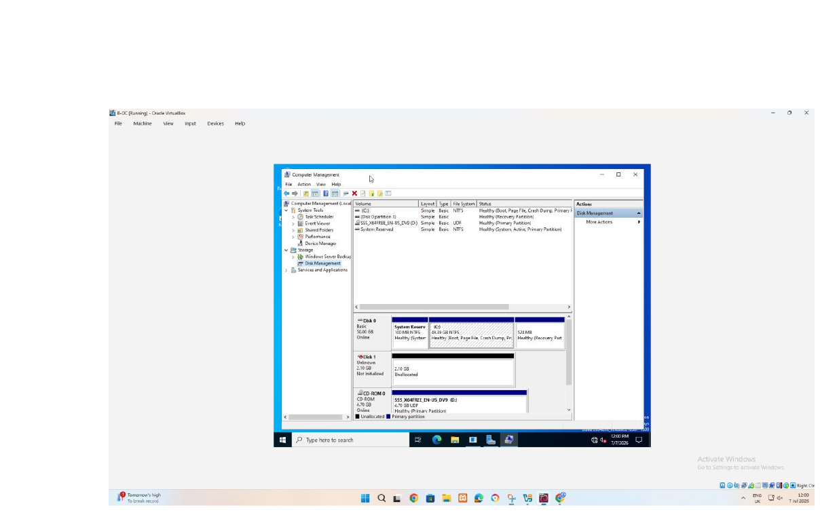
Picture 12 : Detecting the new disk in Disk Management.
This picture shows the new disk before final configuration.
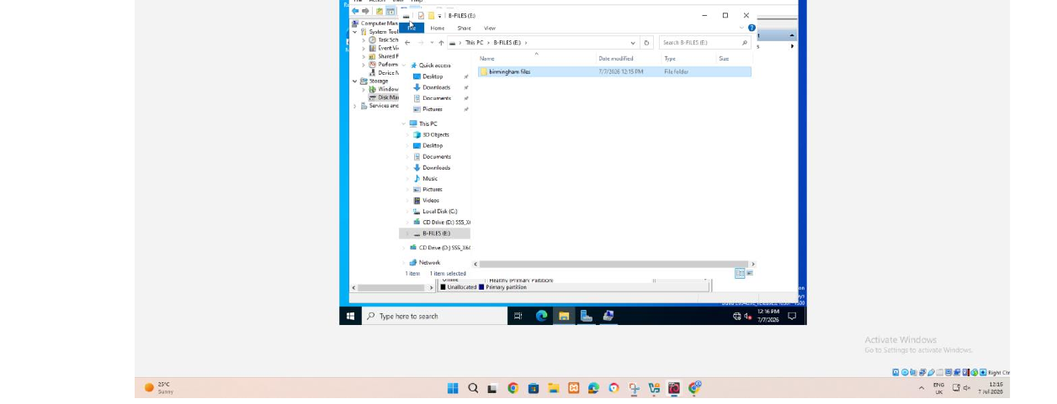
Picture 13 : creating the Birmingham files folder on E.
File explorer shows E files and folder named Birmingham files.this creates the storage location that will be shared with users across network.
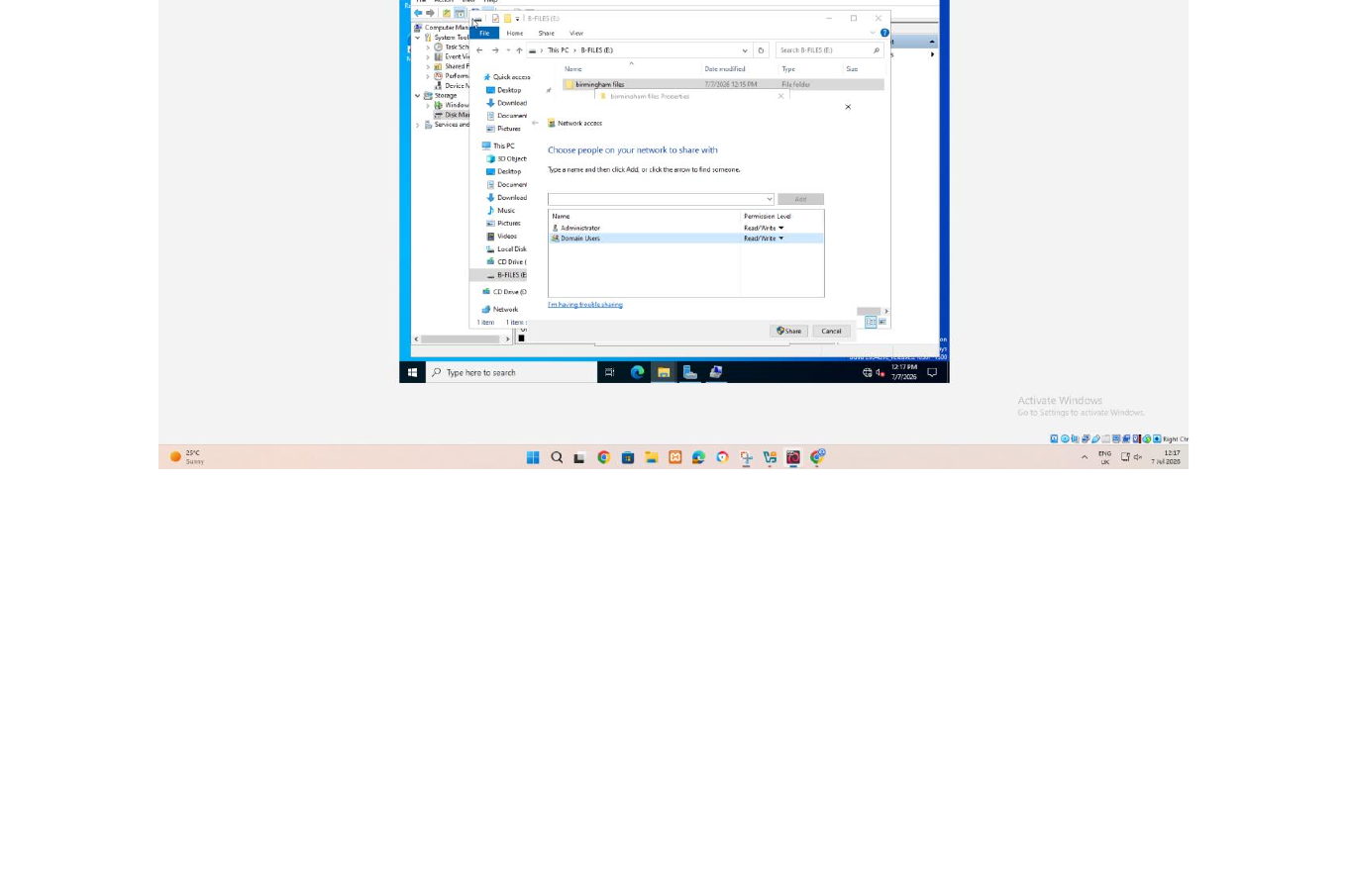
Picture 14: selecting users or groups for the share.
The sharing wizard opens the select users or group dialogue so domain user can be added.the correct domain location should be selected.
Picture 15 :Assigning sharing permission.
The brief ask domain user to have a full control and other network users to read only allowing users to read and modify shared files.
Task 9
IIS server
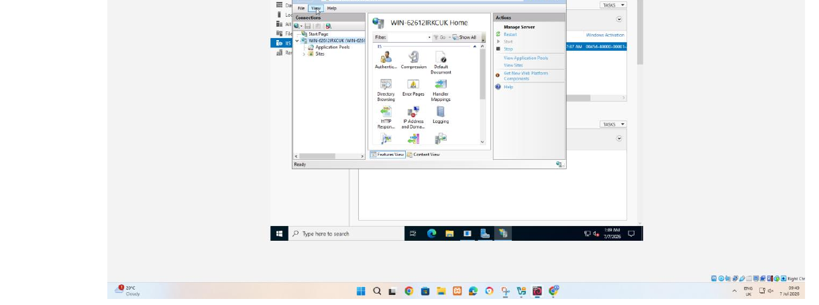
Picture 16 :opening IIS manager.internet operation service manager is open and display server.application pool and site nodes.
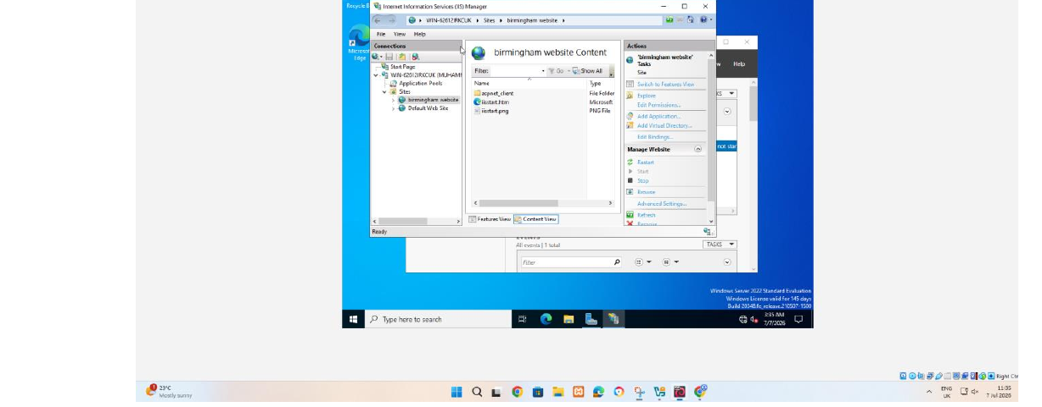
Picture 17: viewing the Birmingham website content.IIS manager display a site named Birmingham website and its content directory.this confirm that website or site folder have been created.
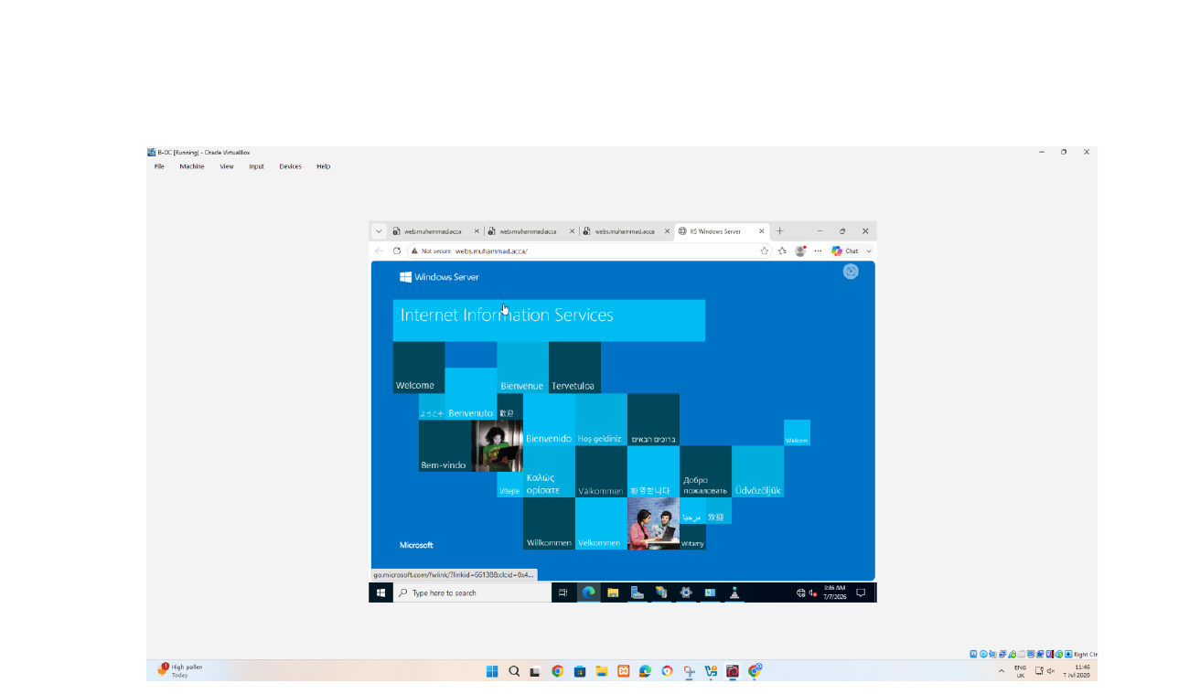
Picture 18 :testing the website in browser.The browser opens muhammad.acca and display its content.DNS name resolution and basic HTTP access are all working.
Task 10
Remote desktop services
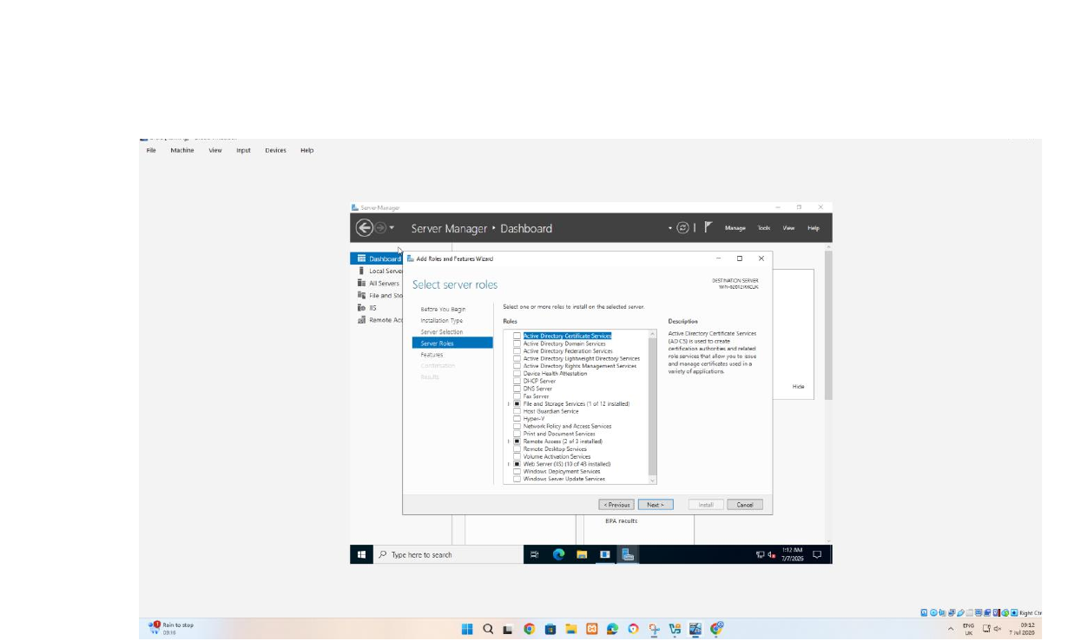
Picture 19 :selected server role and certificate related component.the ad role and feature wizard is open on server role page with active directory certificate services highlighted.
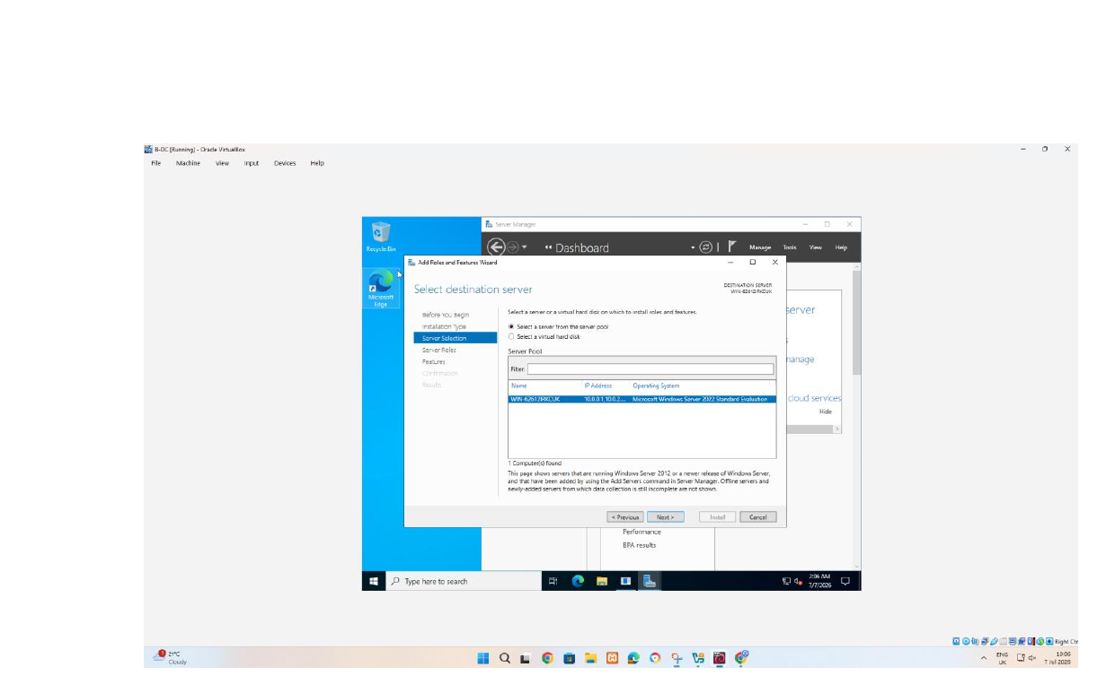
Picture 20 :selecting the destination server.the wizard targets the local window server 2022 system at 10.0.0.1.selecting the correct destination prevent RDS and web component from being installed on wrong machine.
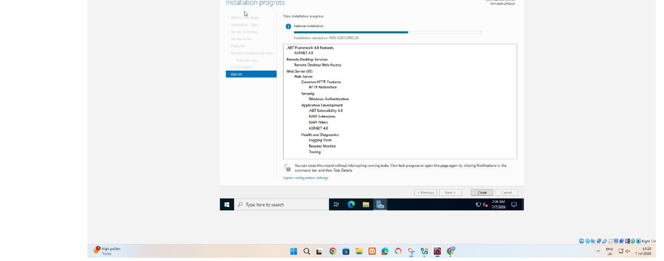
Picture 21 :installing RDS web access and IIS server component. The installation page lists remote desktop service and remote desktop web access , IIS windows authentication and supporting web contents.these component are necessary for RD web portal and integrated authentication.
Domain server and DNS
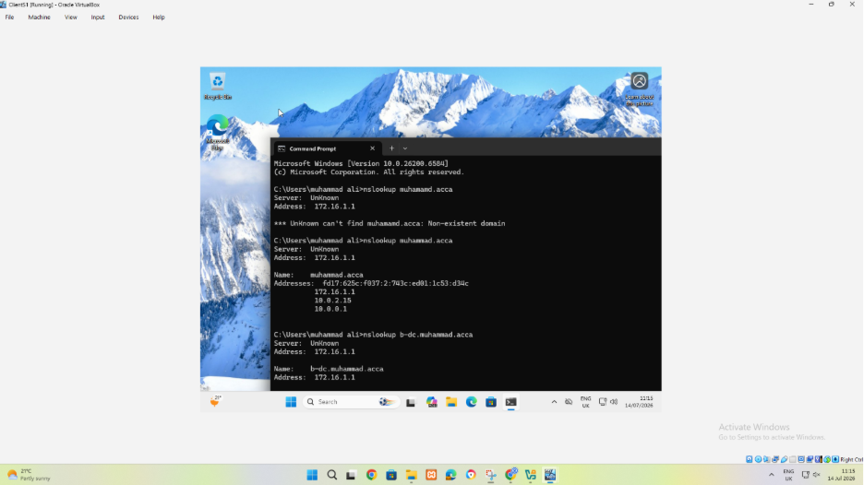
Picture 22:testing forward DNS resolution. The nlookup command queries the domain/DNS record and return DNS address.this test weather client is using the domain DNS server and wheather an A record can translate.
Task 4 users
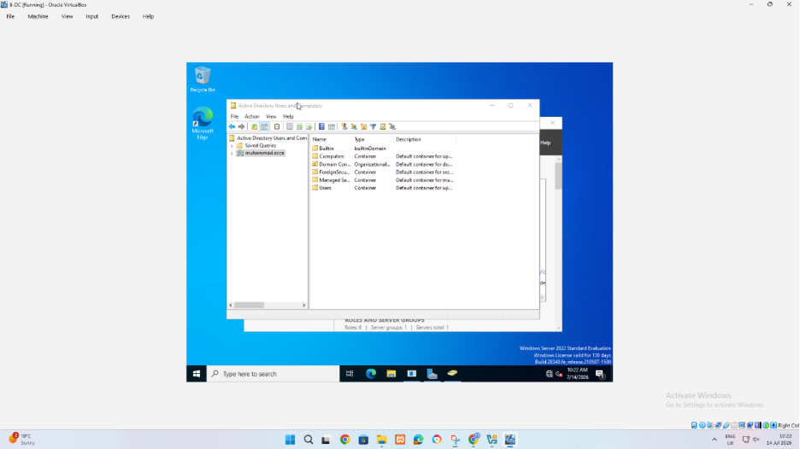
Picture 23 :review the active directory structure.active directory user and computer display the domain containers and organizational unit.this is where domain user and computer object can be verified.
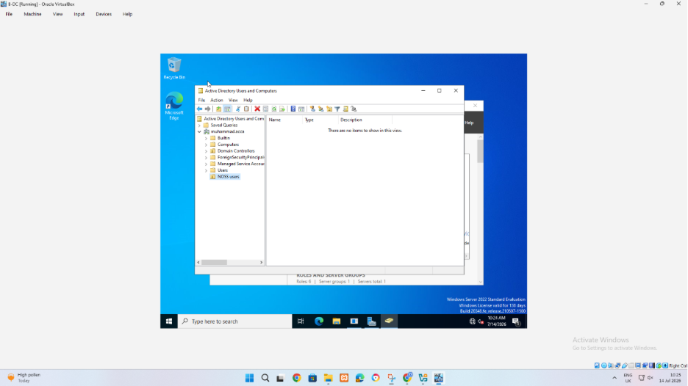
Picture 24 :the selected organizational unit is opened to check where the user account will be stored.
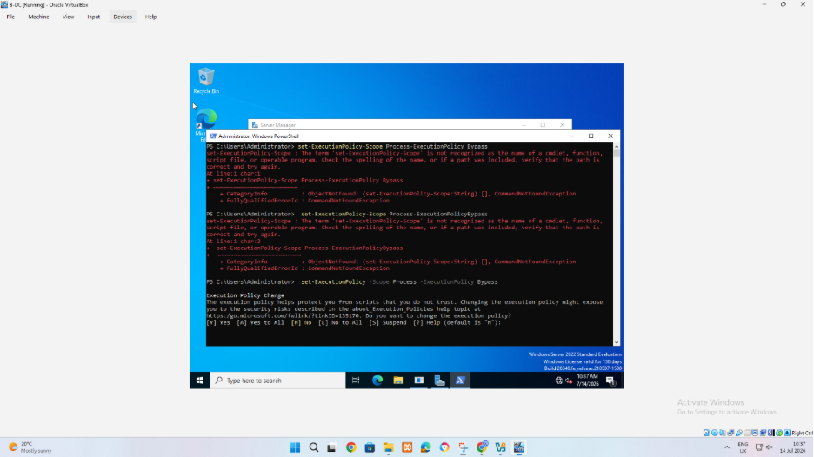
Picture 25 :running the bulk user power shell script in this screenshot.powershell is used to store data and create account auomatically.
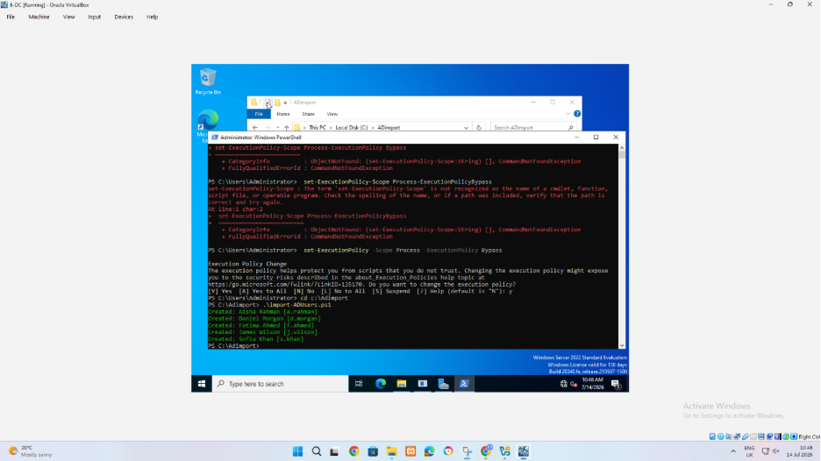
Picture 26 :this powershell screen shows successful output.indicating that account is being created
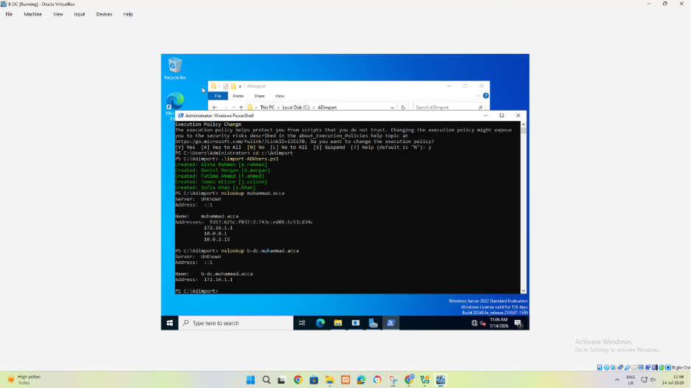
Picture 27 :verifying created user details.powershell output is used to query and display user account/account information after creation.this help confirm that imported name and account exist.
Task 5
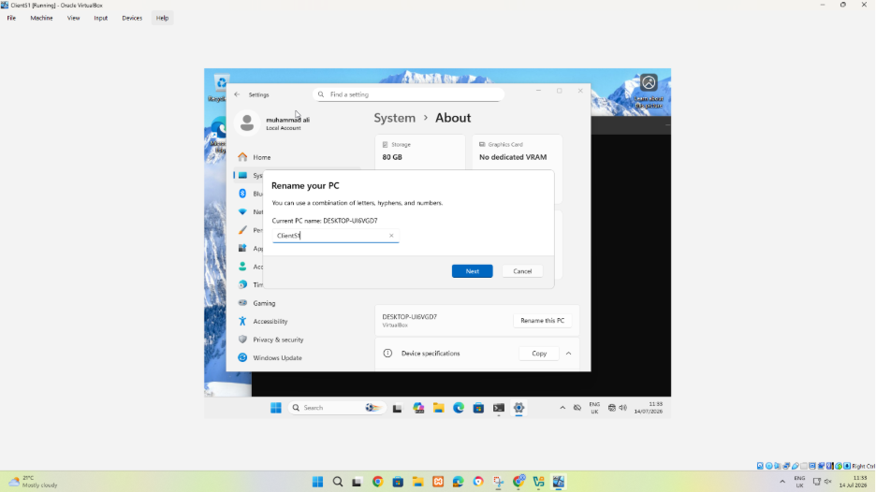
Picture 28 :renaming the windows client.the windows setting rename .restart and final name must be verified.
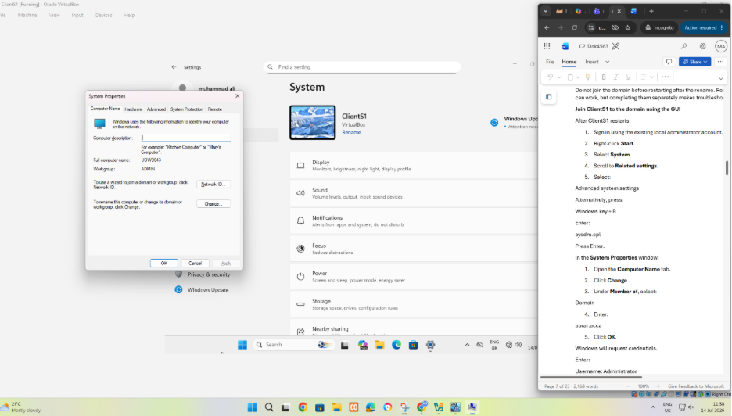
Picture 29 :opening the computer name settings.system properties is opened so computer name and domain can be changed.
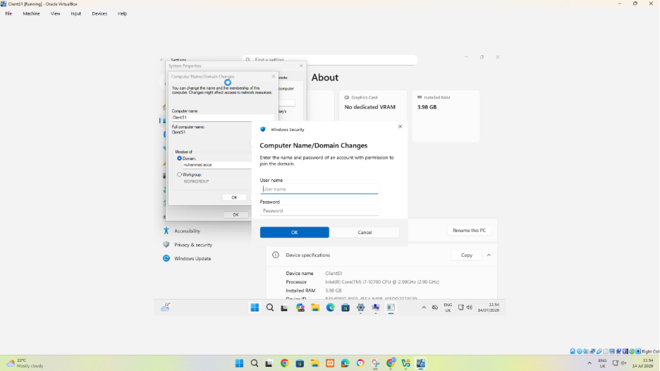
Picture 30 :entering the domain details.computer name and domain changes is used to select domain yourname.acca.
Task 6
DHCP server and relay
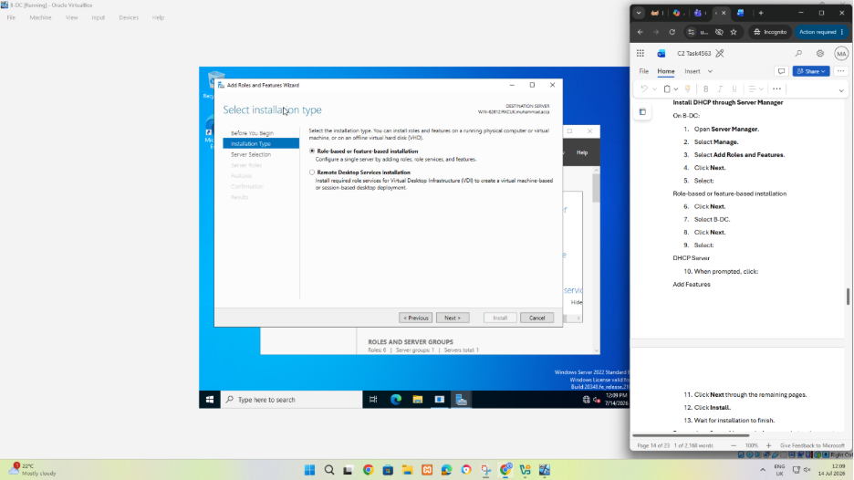
Picture 31:starting installation of DHCP server.the ad role and feature wizard is open on B-dc to install the server role needed for central Ip address location.
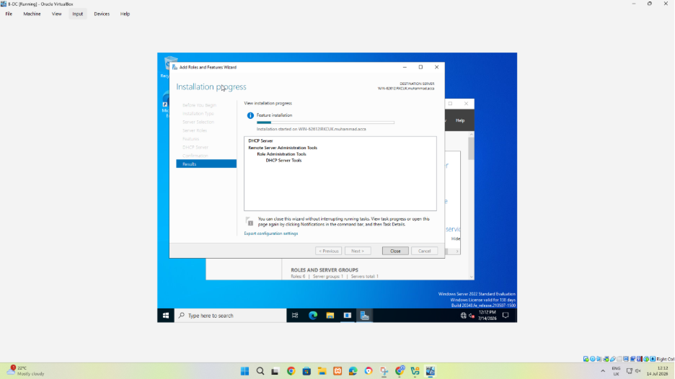
Picture 32 :the installation progress shows the selected role being installed.this prepare B-dc server for DHCP services.
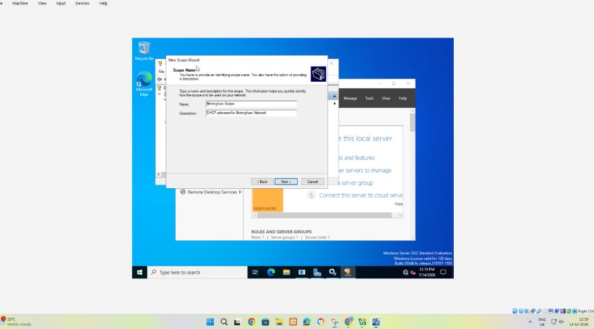
Picture 33:creating new scope and naming the new scope.install wizard shows new scope is being created.A name and description make it clear whether scope is belong to Birmingham or London.
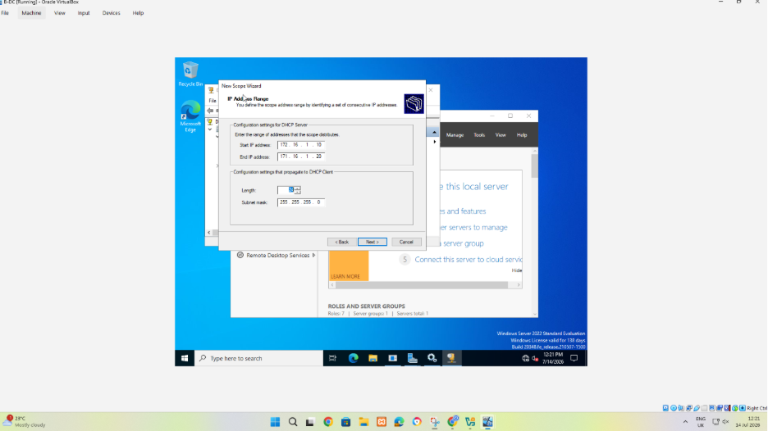
Picture 34:describing the DHCP server range in this screenshot.this screenshot defines IP address start and end and subnet masks.
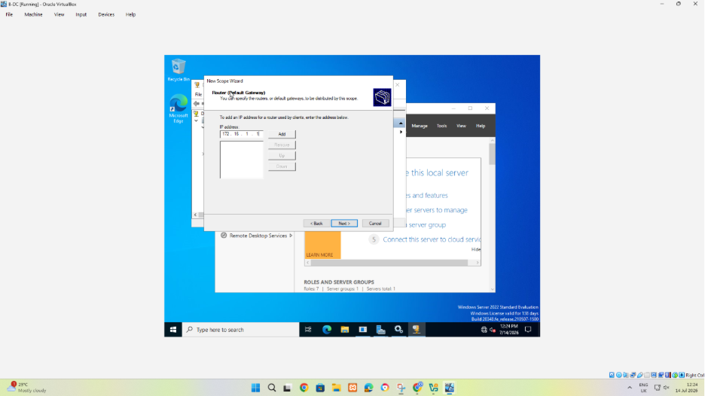
Picture 35:this page reserve address that DHCP must not lease.this DHCP should match the given topology.
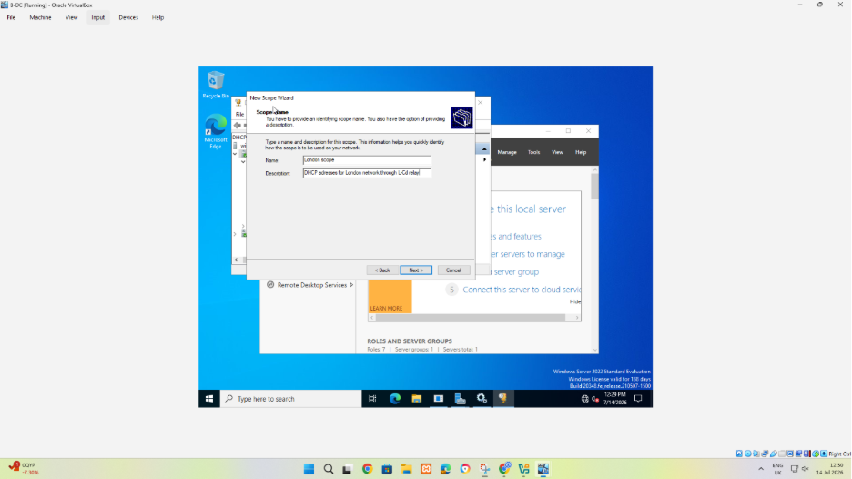
Picture 36 :the duration control how long a client keeps an address before renewal.A suitable duration balance stability with small address pool.
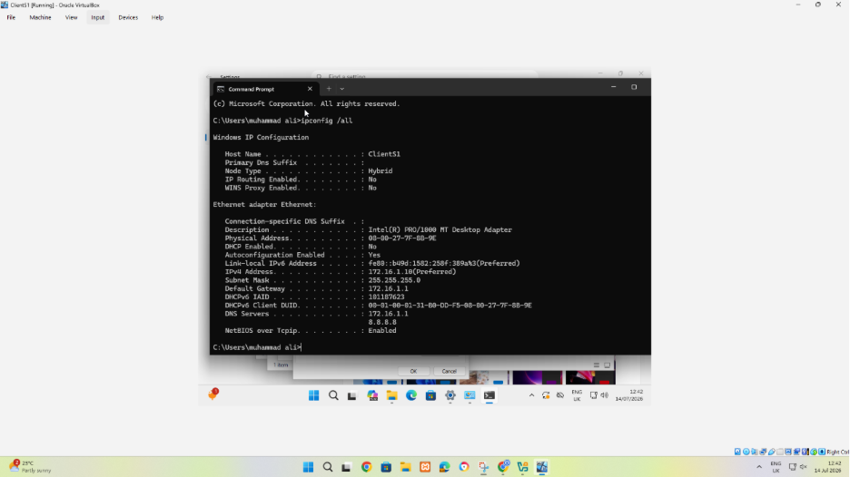
Picture 37 :The Ipconfig/all output verifies the client address gateway and DNS server , DHCP status and lease information.it is the final client side check after the scope and relay have been configured.

