An E-Portfolio for A Plan to Create a Person-Centred Care Services for Vulnerable Lone Elders (VLE) in Greater Banjul Area the GAMBIA
By
Student: Tuty Jallow Sarr - student number - 2027118
Module: Changemakers: Creativity and Value Creation
Module Code: BMHP 5014_BIRM
Lecturer: Azora Hurd

Table of Contents
Introduction 3
Mind Map to Brainstorm Ideas 4
1.1: Mind Map Description 5
2: A Blog to interact with Target Group and Stakeholders 7
3: Appendixes 9
3: Reference List 10

Introduction

The e-portfolio is evidence of learning by creating a new pilot project of Person-Centred Care Service (PCCS) for Vulnerable Lone Elders in greater Banjul area the Gambia; to close the gap in the Health and Wellbeing Services facing VLE
This e-portfolio consist of two artefacts- - 1 Mind Map to brainstorm the ideas; 2 Blog to interact with stakeholders to help and support towards the success of this important project.

Mind Map to Brainstorm Ideas
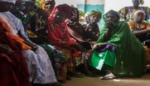

(ShutterStock.com, 2022)
2 Stakeholder analysis to Collaboration and Network for successful outcome
(www.facebook.com, 2022)
1: Identify my Targe group



Plan to Develop a PCCS for
VLE in Greater Banjul Area the Gambia

(VectorStock.com, 2022)
6. Cost involve – administrative work

3: Campaign/Advocacy to Gain Confidence, trust, and relationship


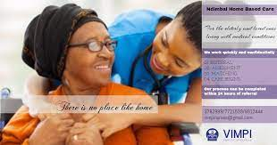
(www.facebook.co m, 2022)
5: Staffing for standard and quality services
(FutureLearn, 2022)
4: Services available to meet induvial needs and wants

1.1: Mind Map Description

Person-Centred Care Services is where the voices of patients, their families and those working with them are listened to, valued and respected (Fazio, S et al, 2018). focus is on what is best for the patient in a collaborative and well-coordinated manner (Engagement, 2019).

The greater Banjul area has a with diverse ethnicity of 400,00 out of the 2,471,000 population of the entire country. Life expectancy is 63.3 years, (Gbos, 2021; Worldometers.info, 2021). Ageing population has been consistent since 1955, as opposed to UK’s fast ageing population growth with life expectancy of 85 years. (Gobs, 2022; Hu, Hancock and Wittenberg, 2020) Care services are little or none-existence, with only one care home in Banjul the capital city but has been turn into TB clinic (Phone enquiry, June 2022). The extended family settings that used to help in looking after VLE is no longer there creating a big gap in the system. The pilot project will problem-solved this gap and if successful, will spread to other parts of the country (E-Learning Materials, 2022).

1: Identify target group - Target group will be the guardians of potential patients particularly those in the diaspora facing difficulties of getting carers for their loved ones; family, friends, and carers of potential patients; elderly people; community and religious leaders; my family and friends; government policy makers (E-Learning Materials, 2022).
As target group clarified, the next step is to analyse stakeholders for collaboration and networking for the divers needs and aspirations of service users.

2: Stakeholder Analysis – as there is clarity of target group, brainstorm for stakeholders to network and collaborate in meeting the diverse needs and aspiration of service users (E-Learning Materials, 2022). Stakeholders are Community/Religious leaders, my family and friends, Government policy makers, Mistry of Health and Social Welfare, WHO, UNESCO, World BAMK, NGOs – (Pease Corps, Action Aid, Caritas, GamWork), guardian of VLE, family, friends, and carers of VLE, elderly people. Categorise them according to their level of interest, power, and influence on the project’s outcome (E-learning Materials, 2022).

Stakeholders and target groups are clarified, next to gain trust, confidentiality, and relationship with them to get the required help and support for successful outcome (E-Learning Materials, 2022; Experience, 2021).

3: Campaign/Advocacy – in building trust, confidentiality, and relationships, organise workshops om the importance of PCCS in promoting health and wellbeing; awareness and sensitisation programmes on Gambia radio and television service (GRTS), face book, community hub – the blog and twitter on the subject matter. Use these activities seek for volunteers to help promote and potentially staff the project. Appeal for donations. Once trust, confidentiality and relationship gained, develop a service to meet the diverse needs of service users.

4: Services Offered – in gaining trust and confidence it is safe to formulate services based on specific needs and wants assessment (Engagement, 2019). Services include domiciliary, Day-Care, live-in care, and support programmes. Once the services are in place, select staff from volunteers to run the services.

5: Staffing –as a pilot project, use volunteers for staffing; the professional will train staff for standard and quality services. All the above activities involved cost, get t financial support

6: Cost - all the above activities involve cost to run it. Seek donations – (Go-fund-me) via the blog

2: A Blog to interact with Target Group and Stakeholders
5 Staffing and Training

  Working Together to  Help our elders | Join Us and help us help our Vulnerable Lone Elders live a better life
Tutsan’s Care Services with a difference
Person-Centred Care Services (PCCS)  Person-Centred Care Services (PCCS) is a Health and Social (HSC) services with a difference geared towards the individual’s needs and wants, the family and those caring for them (Fazio, et al 2018). This is a pilot project for greater Banjul area, the Gambia. The project is motivation of a childhood problem of caring for vulnerable sick mother and father. | 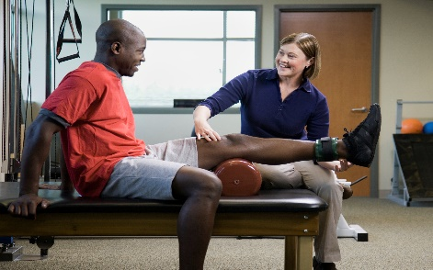  From Word 365 stocked pictures
The Gambia  The small under-develop country in west Africa, the capital is Banjul. the greater Banjul area is diversly populated with 400,000 out of the of 2.417 million of the population. (Gbos, 2022).  The ageing population has been consistent since 1955; life expectancy of 63.3 years as opposed to UK’s fast ageing population growth with life expectancy of 85 years (Gbos, 2022; WHO, 2021; ons, 2022). Most of the health and wellbeing activities focuses on children and women (GDC, 2021). This and the socio-economic conditions ad situations, political instability could be a contributing factor for early deaths. | 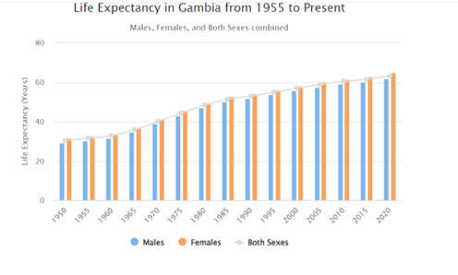
The Story  Greater Banjul area, ethical values, traditional practices, and cultural beliefs stigmatise placing elders in need of care into a care home. The only care services are expensive and run by retired nurses who had no training on HSC The only memories of a care home is a place in Banjul called the ‘Old People’s Home’. However, today it is very disheartening as the care home has fallen to a detrimental condition. Today, it has changed to a TB clinic. Care services is little or none-existence for VLE. The extended family settings that used to help looking after VLEis is no longer there. This can cause an alarm for ourselves and our loved elders as we will aged. Presently, the community is struggling with implementation of proper health and wellbeing services for VLE. I believe a care service for VLE with a difference can go a long way in closing the gap the care and welfare services.  It is important to understand that we are in a fast-moving world, let move with time and be initiative-taking and change our mentality of looking after our loved ones (E-Learning Materials, 2022). | 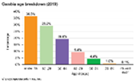 (www.gbosdata.org. 2022)  Services Available  domiciliary cared for at their own home, a day-care service, support programme and living-in care based on individual’s specific needs and assessment.  View A similar services to get a better understanding of PCCS https://nourishcare.co.uk/what-we-do/person-centred-care/?gclid=CjwKCAjw_ISWBhBkEiwAdqxb9ijAGBv1DtoSB8p4kuwCjNGgg6MBzkXJcn_P1wr4ad--7dUgugVOahoC9Z0QAvD_BwE  To help us help our loved ones and problem-solve this alarming situation, click on our website to donate or email us to be a volunteer  For information and support contact our wonderful diverse team to all stakeholders. Contact the via Website: www.togethernesscare.com  Email address: sainenor@gmail.com  Follow us on Facebook, Twitter, Instagram, and community hubs.
3: Reference List

Encyclopaedia Britannica. (2022). The Gambia - Demographic trends. [online] Available at: https://www.britannica.com/place/The-Gambia/Demographic-trends. (Accessed 18th June 2022).

Engagement, D. (2019.). Improving our person-centred care with Picker. [online] NHS Dorset CCG. Available at: https://www.dorsetccg.nhs.uk/improving-our-person-centred-care-with-picker/ (Accessed 9 Jun. 2022).

E-Learning, (2022. Unit 1 topic 1, session 2: innovation and society. [online]. Available at: https://moodle.uwtsd.ac.uk/mod/forum/view.php?id=283692 (Accessed 30th May 2022).

E-Learning, (2022. Unit1 topic 2, session 2:social influence. [online]. Available at: https://moodle.uwtsd.ac.uk/mod/forum/view.php?id=283692 (Accessed 30th May 2022).

E-Learning, (2022. Unit 3 topic 1, session 1: establishing a support network [online]. Available at: https://moodle.uwtsd.ac.uk/mod/forum/view.php?id=283692 (Accessed 7th July 2022).

E-Learning, (2022. Unit 3 topic 1, session 2:stakeholder analysis [online]. Available at: https://moodle.uwtsd.ac.uk/mod/forum/view.php?id=283692 (Accessed 7th July 2022).

Experience, W.L. in R.-B.U. (2021). Stakeholder Analysis for UX Projects. [online] Nielsen Norman Group. Available at: https://www.nngroup.com/articles/stakeholder-analysis/ . (Accessed 5th July 2022).

Fazio, S et al, (2018). The fundamentals of person-centred care for individuals with dementia. The Gerontologist, 58(suppl_1), pp. S10-S19. Available at: https://academic.oup.com/gerontologist/article/58/suppl_1/S10/4816735 (Accessed 18th June 2022).

FutureLearn, (2022). Health literacy and person-centred care. [online] Available at: https://www.futurelearn.com/info/courses/working-health-literacy/0/steps/143242 (Accessed 26 Jun. 2022)

GDC, (2021). Comprehensive Health and Social Care System – Gambia Democratic Congress (GDC). [online] Available at: https://www.gdc.gm/manifesto/comprehensive-health-and-social-care-system/ (Accessed 8th May 2022)

Hu, B., Hancock, R. and Wittenberg, R. (2020). Projections of Adult Social Care Demand and Expenditure 2018 to 2038 care policy and evaluation centre cpec cpec Working Paper 7. [online] Available at: https://www.lse.ac.uk/cpec/assets/documents/cpec-working-paper-7.pdf (Accessed 9 Jun. 2022).

www.gbosdata.org. (2022). Reports/Fact Sheets – Gambia bureau of statistic. [online] Available at: https://www.gbosdata.org/downloads/reports-fact-sheets-76 (Accessed 17th June 2022).

Shutterstock.com. (2022). Business People Making Pile Hands Soft Stock Photo (Edit Now) 414838831. [online] Available at: https://www.shutterstock.com/image-photo/business-people-making-pile-hands-soft-414838831. (Accessed 3rd Jul. 2022).

Telephone Enquiry, (2022). Telephone research with ministry personnel of the of health and social welfare in the Gambia.

VectorStock. (2022). Business tools financial support icon editable vector image on VectorStock. [online] Available at: https://www.vectorstock.com/royalty-free-vector/business-tools-financial-support-icon-editable-vector-37325319 (Accessed 3rd Jul. 2022).

The World Bank, (2021). Population, total - Gambia, The | Data. [online] Available at: https://data.worldbank.org/indicator/SP.POP.TOTL?locations=GM (Accessed 18th June 2022).

The World Bank. (2022). Overview. [online] Available at: https://www.worldbank.org/en/country/gambia/overview#:~:text=The%20Gambia%20is%20a%20small (Accessed 3rd Jul. 2022).

www.worldometers.info. (2022). Gambia Demographics 2020 (Population, Age, Sex, Trends) - Worldometer. [online] Available at: https://www.worldometers.info/demographics/gambia-demographics/#pop (Accessed 3 Jul. 2022). (www.worldometers.info., 2022).

